Mickey Party Invitations

Print the invitations and cut them out. Fill in the information, send them in A2-sized envelopes and get ready for the party!
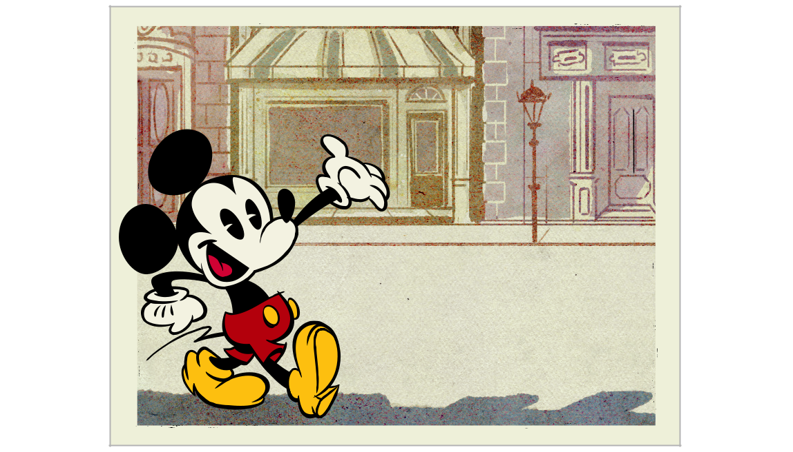

Oh Boy! It’s a Party!

What:

When:

Where:

RSVP:

© Disney
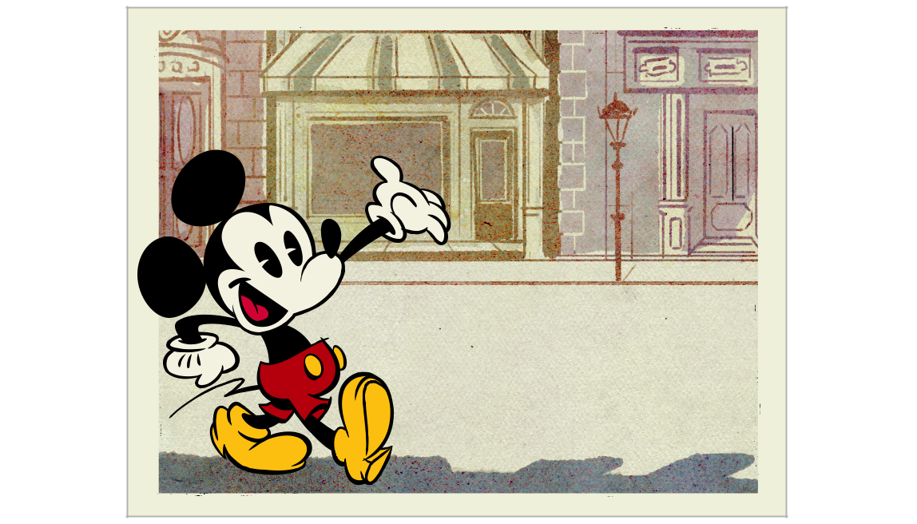

Oh Boy! It’s a Party!

What:

When:

Where:

RSVP:

© Disney

© 2015 Disney

Mickey Bookmark Template

Print on white cardstock.

Use these pieces for

an Extra Jumbo Craft Stick (1 inch wide).
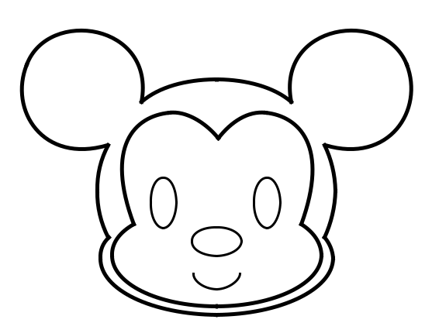

Mickey face/head

Cut out and

color in according to the directions.
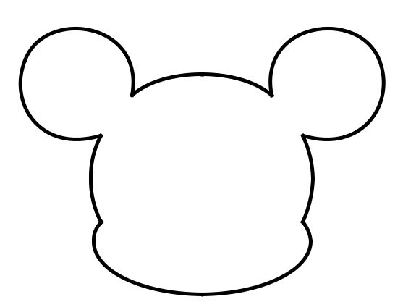

Mickey head backing

Cut from black cardstock.

Mickey shirt

Cut from black cardstock.

Use these pieces for a

Jumbo Craft Stick (3/4 inch wide).
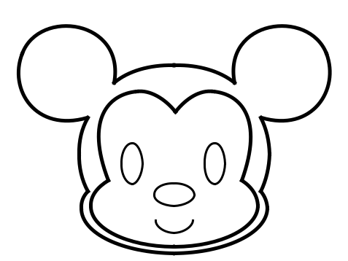

Mickey face/head

Cut out and

color in according to the directions.
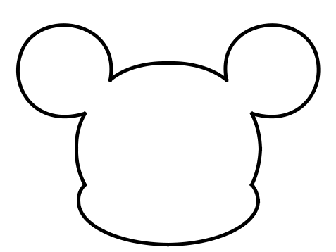

Mickey head backing

Cut from black cardstock.


Mickey shirt

Cut from black cardstock.

© 2015 Disney

Mickey Bookmark Template
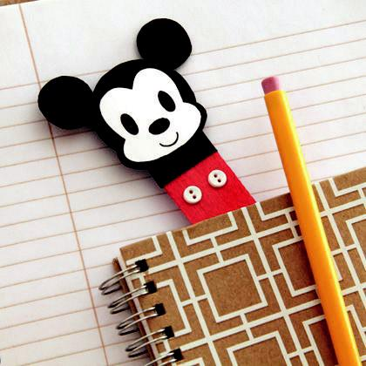

© 2015 Disney

