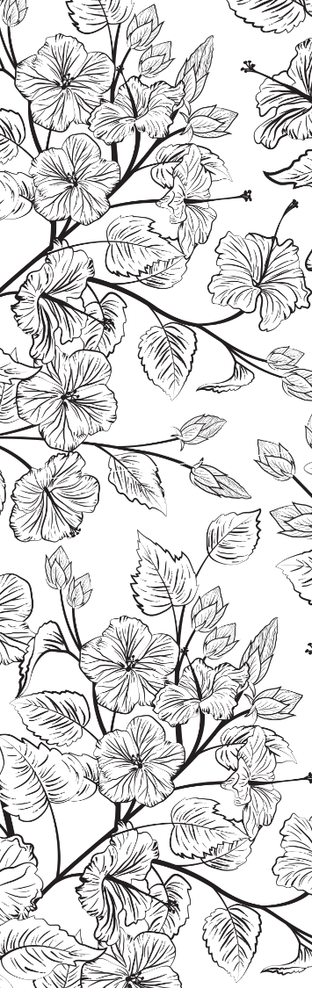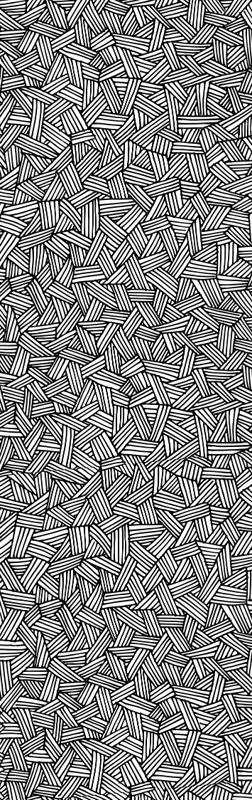

Replace these pictures with your own photos

Write your own bookmark messages

Use a hole puncher to punch a hole and tie a ribbon through it.

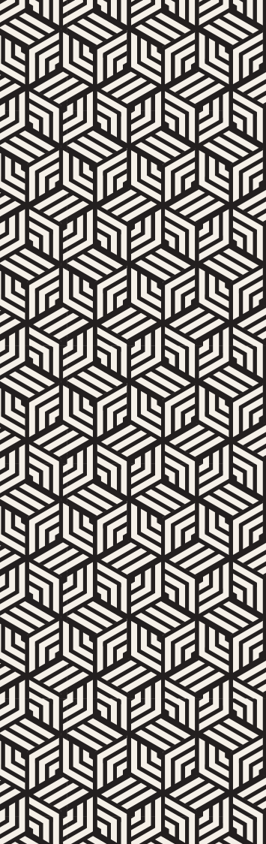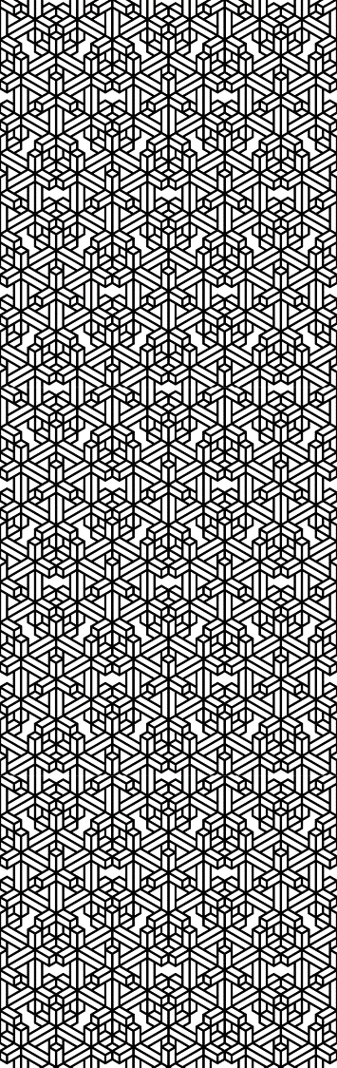

## Replace these pictures with your own photos

## Write your own bookmark messages

## Use a hole puncher to punch a hole and tie a ribbon through it.

|  |  |  |  |  |  |  |  |  |  |  |  |  |  |  |  |  |
| --- | --- | --- | --- | --- | --- | --- | --- | --- | --- | --- | --- | --- | --- | --- | --- | --- |
|  |  | | | |  |  | | |  |  | | |  |  | | |
|  | A Special Book for a Special Friend | | | |  | The More You Read, The More You Want To Read | | |  | Life Gives Us Books, We Turn The Pages | | |  | Just One More Page! | | |
|  |  | Two friends hugging |  |  | |  | A woman paging through a book |  |  |  | A woman in bed reading a book |  |  |  | Mother and daughter reading a book |  |
|  |  |  |  | |  |  |  |  |  |  |  |  |
|  |  |  |  | |  |  |  |  |  |  |  |  |