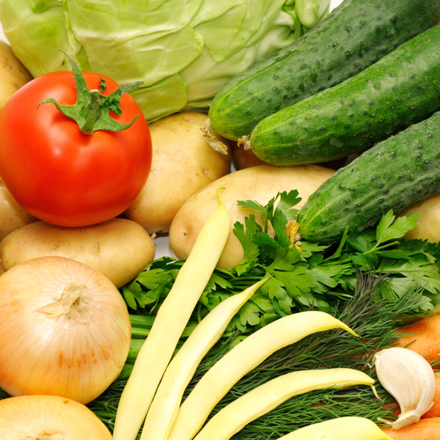

Recipe Title

***Recipe Card Template***

____________________________________________________________________________________________________________________________________________________________________________________________________________________________________________________________________

__________________________________________________________________________________________________________________________________________________________________________________________________________________________________________________________________________________________________________________________________________________________________________________________________________________________________________________________________________________________________________________________________________________________________________________________________________________________________________________________________________

**Steps:**

**Ingredients:**