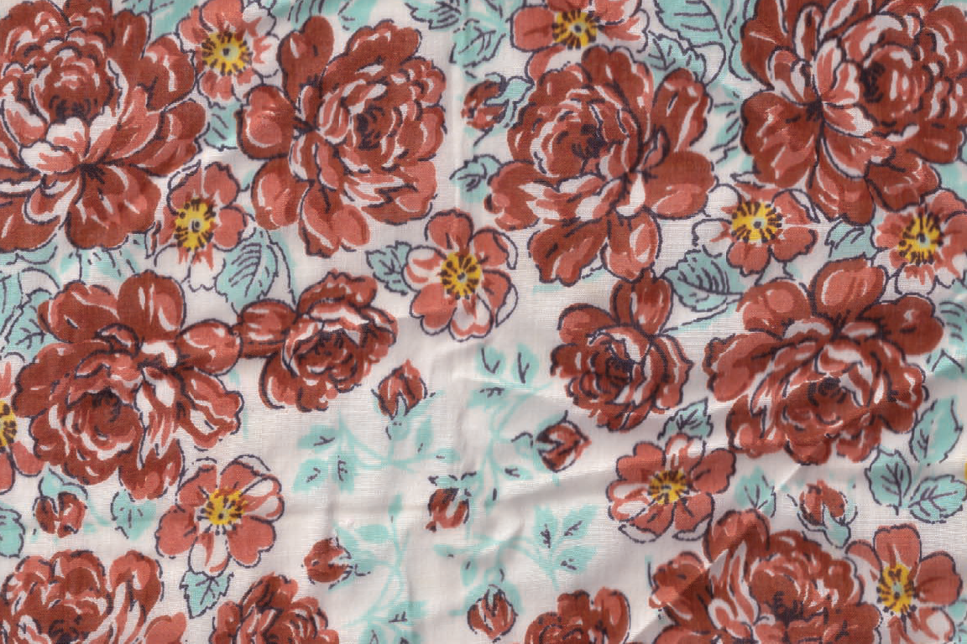

Recipe for: from: Serves:

Ingredients

Directions

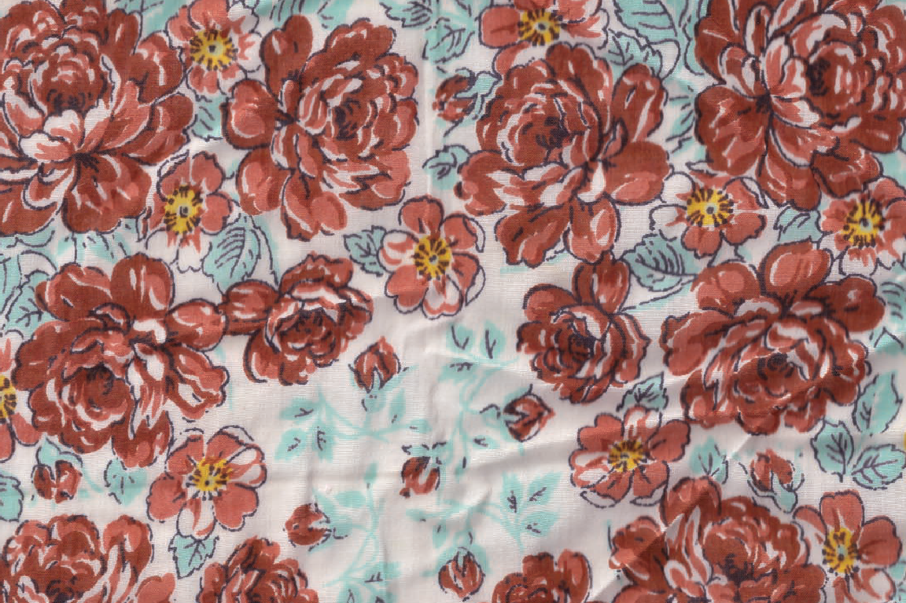

Recipe for: from: Serves:

Ingredients

Directions

Recipe for: from: Serves:

Ingredients

Directions

Recipe for: from: Serves:

Ingredients

Directions

**

Recipe for: from: Serves:

Ingredients

Directions

Recipe for: from: Serves:

Ingredients

Directions

**