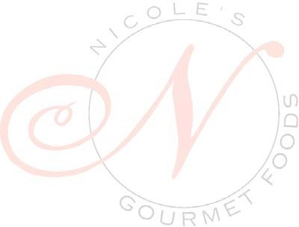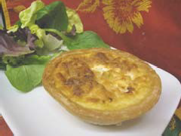

**Ingredients:**

2 eggs

2 cups milk

1 tsp. salt

1/4 tsp. pepper

Your favorite fillings Tart shells

Servings 4-6

**Preparation:**

Whisk together eggs, milk, salt, and pepper. Set aside.

Arrange tart shells on a baking sheet.

Fill frozen tart shells with your favorite ingredients. Then pour the egg mixture into the shells.

Carefully place quiche’s into the oven and bake at 350˚F for 15-20 min. or until toothpick inserted into the center comes out clean.

**Nicole’s**

**Shopping List**

*Frozen tart shells

*Gruyere

*French ham

*Goat cheese

*Salt

*Pepper

Nicole’s Gourmet

Foods

Phone: 626.403.5751

Fax: 626.403.5016

Recipe collection #4

Nicole’s Gourmet Foods

Quiche

*When you purchase all listed recipe ingredients at Nicole’s Offer expires March 30, 2009

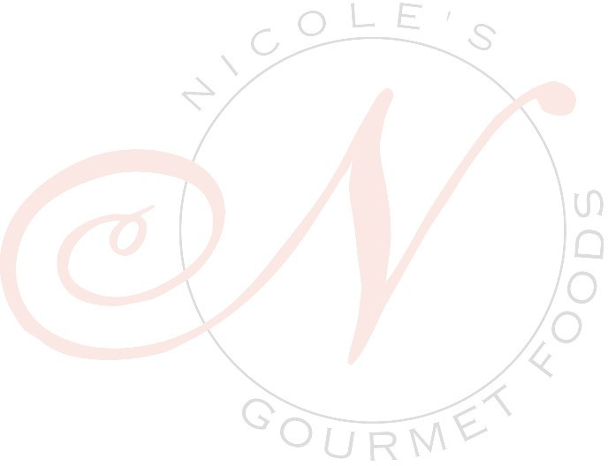

10% OFF*