

Project progress report template

2016 April

PROJECT PROGRESS REPORT template

------------------------------------------------------------------------------------------------------------------------------------------------------------

This document displays the screens seen by the researcher at each step of the project progress report (PPR) questionnaire (years 2013 onward). You should consult the CFI Policy and program guide for complete information on requirements and guidelines related to the PPR.

Table of Contents
Project overview | 1
Project summary | 2
Achievements | 2
Challenges | 2
Attraction of researchers | 3
Retention of researchers | 3
Highly qualified personnel | 4
Technical personnel | 5
Training | 5
Infrastructure quality | 5
Useful life of infrastructure | 6
Utilization of infrastructure | 6
Funding | 7
Operation and maintenance of the infrastructure | 8
Research advancement | 9
Research outputs | 10
Research collaboration | 11
Research agreements | 12
Technology transfer | 13
Spin-off companies | 14
Benefits for Canadians | 15
Benefits for Canadians (details) | 16
New job creation | 17
Contact information | 18
Comments | 18



Note:

This page will be prepopulated
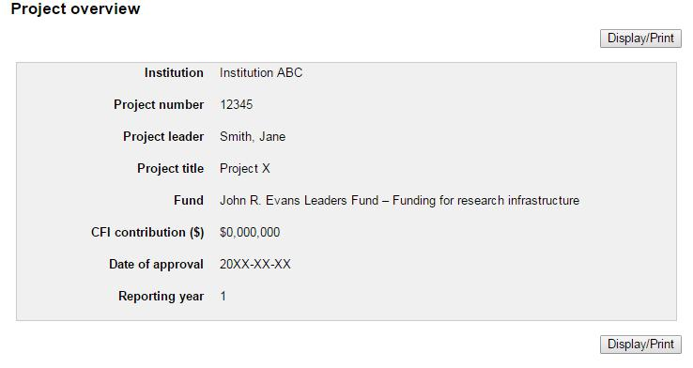

1
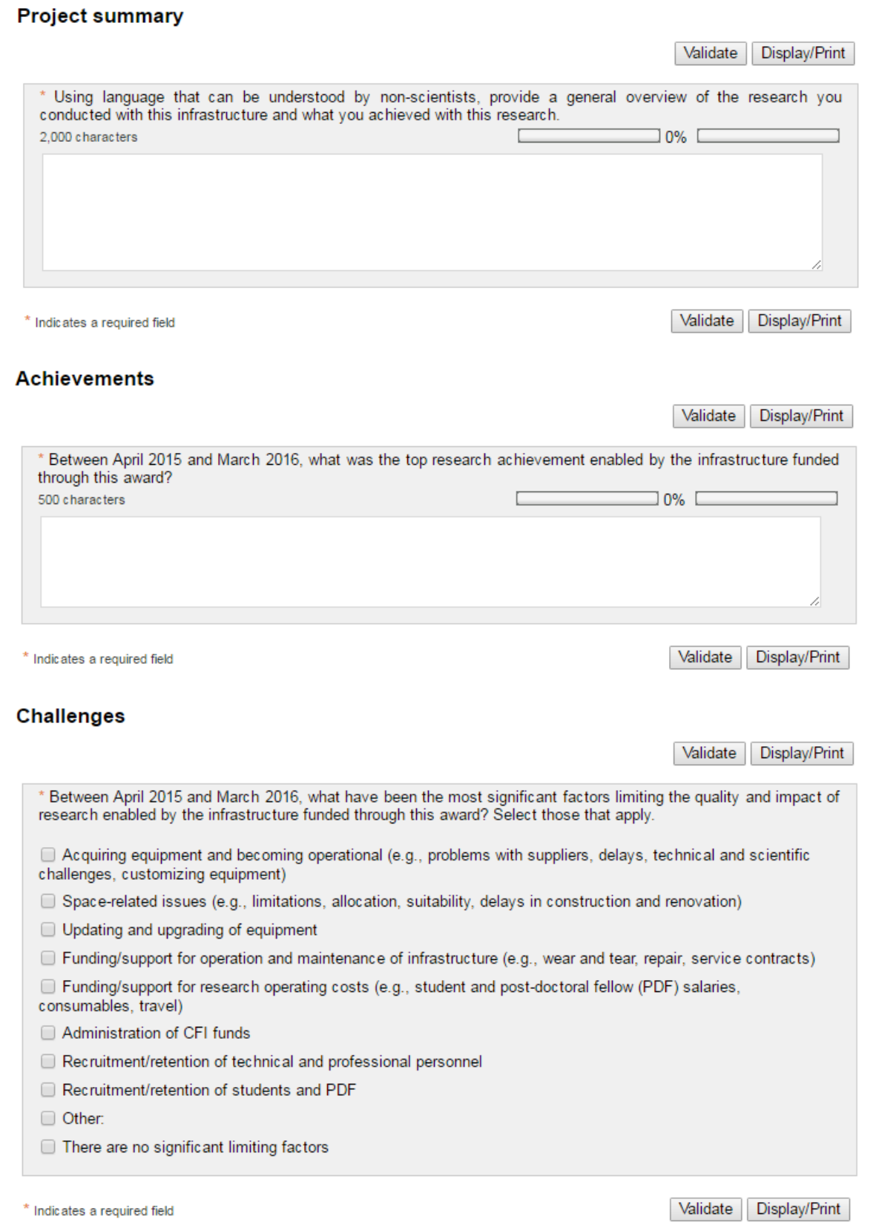

2
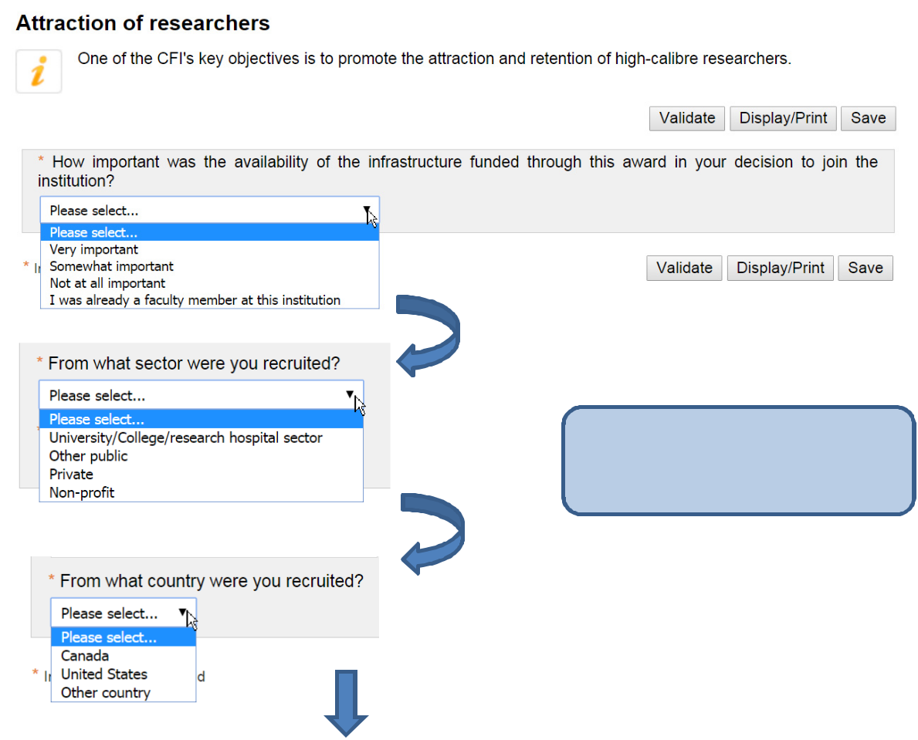

Note:

The “Attraction of researchers” section only appears to those filling out the report for the first time for a particular project.
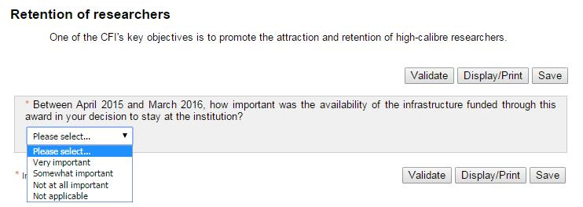

3
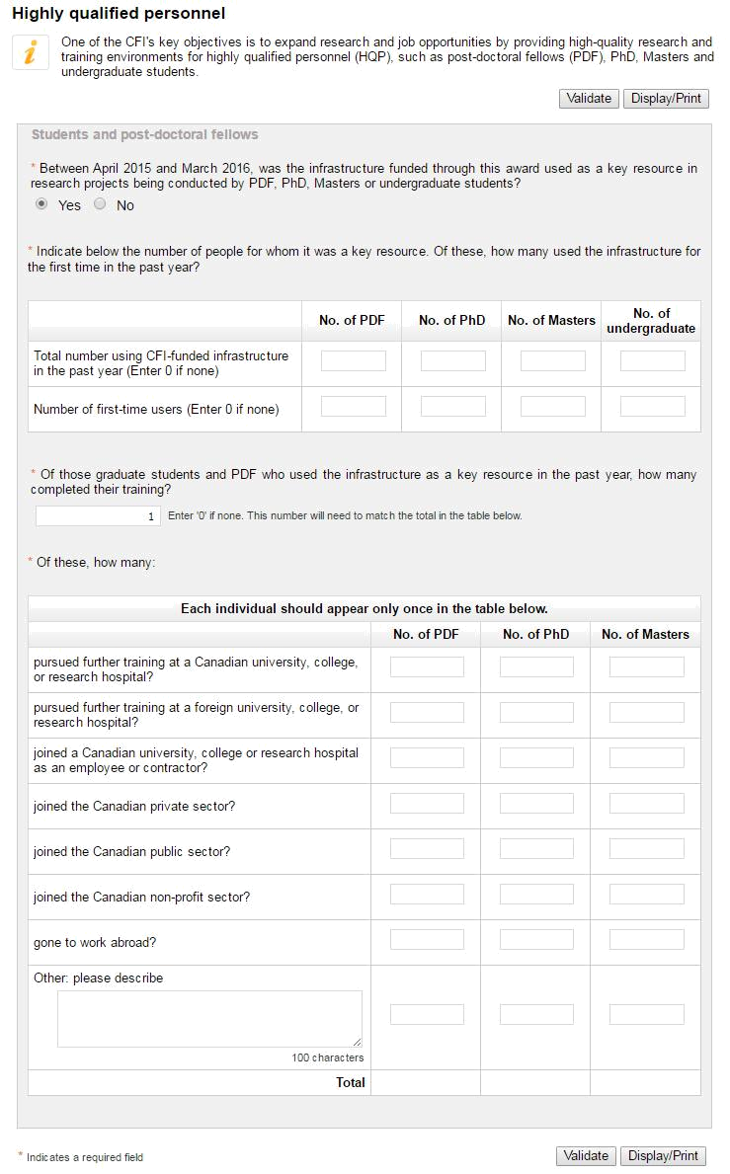

4
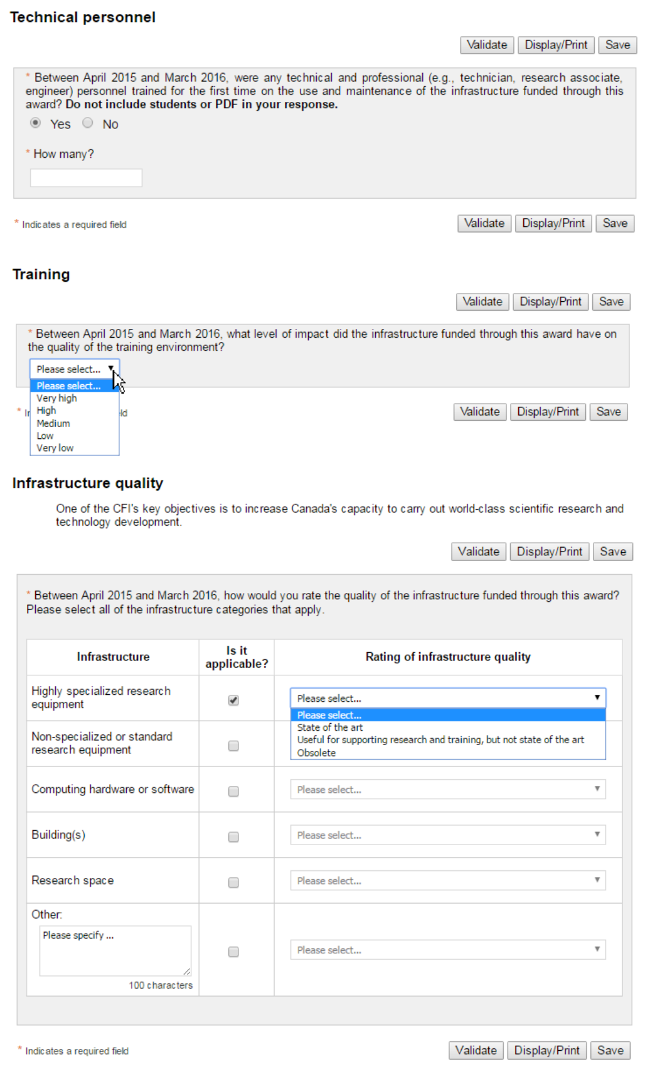

5
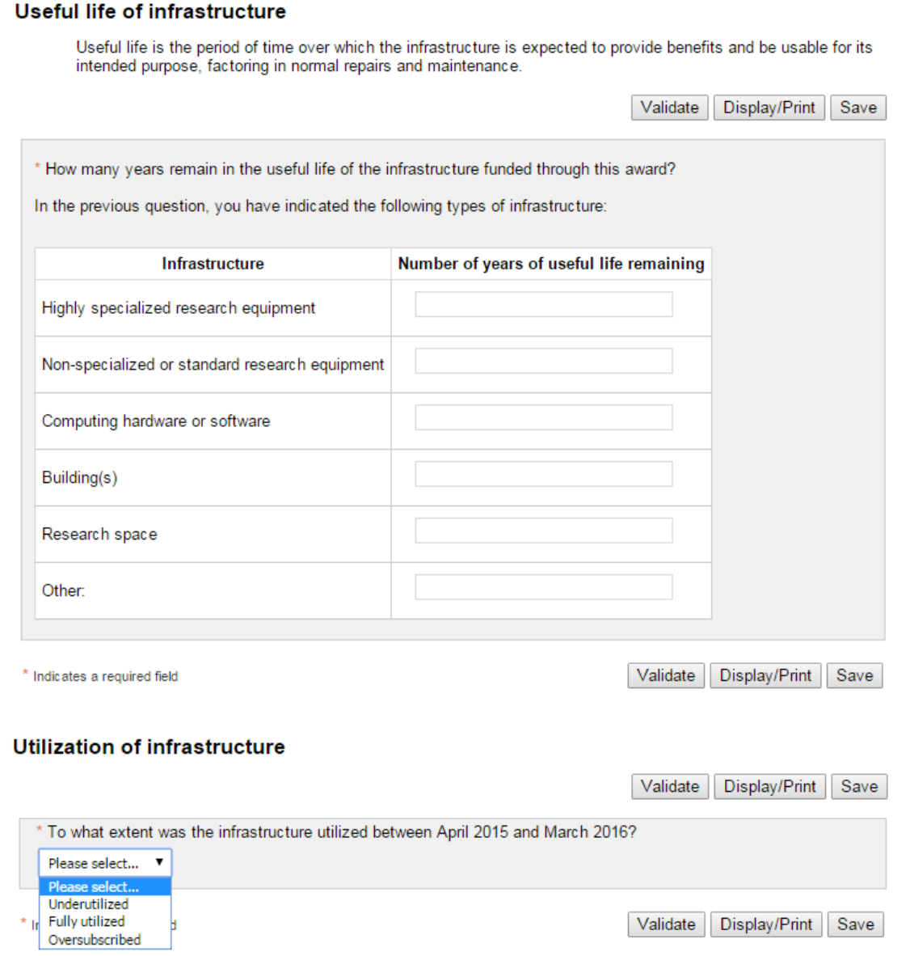

6
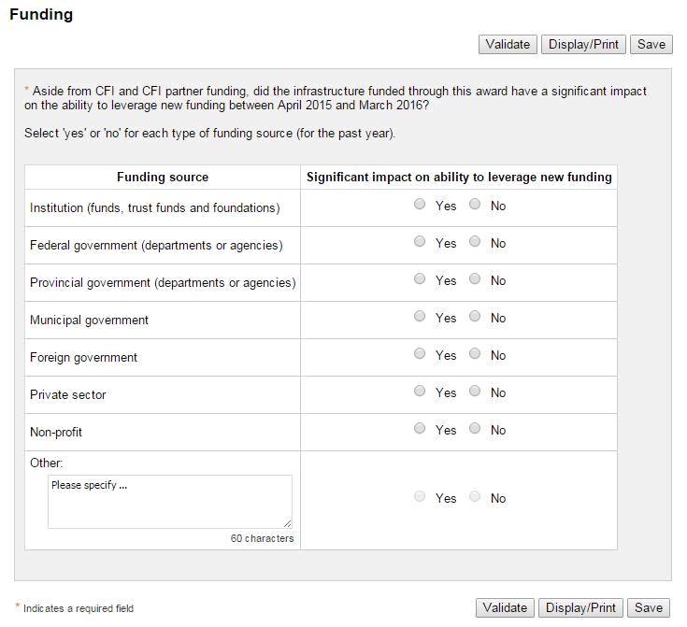

7
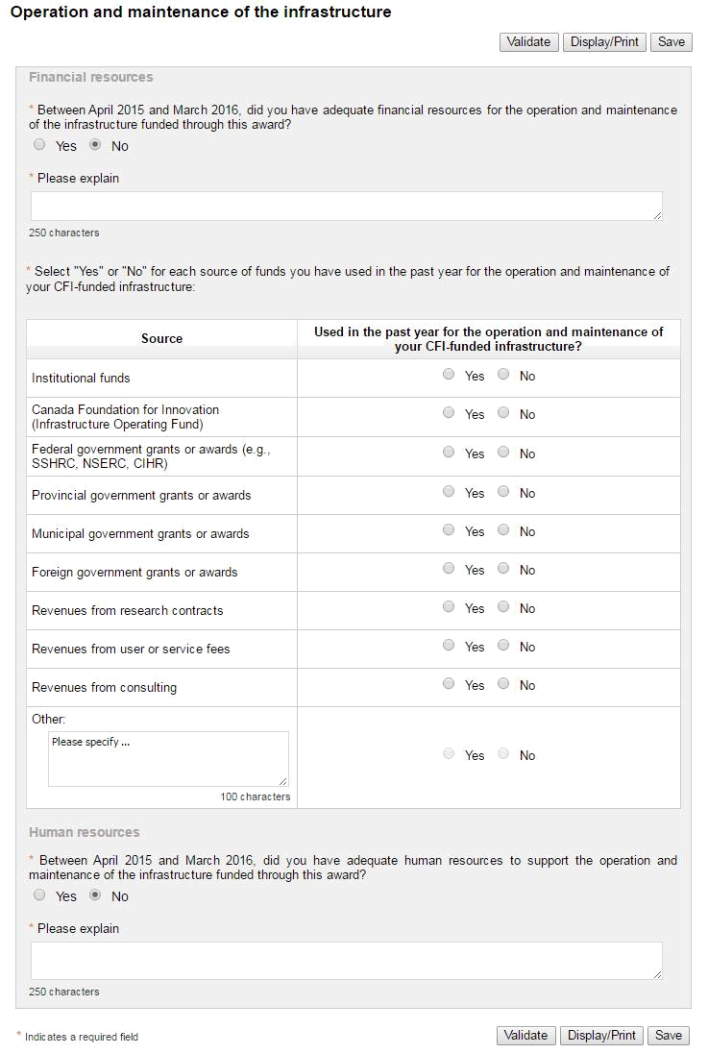

8
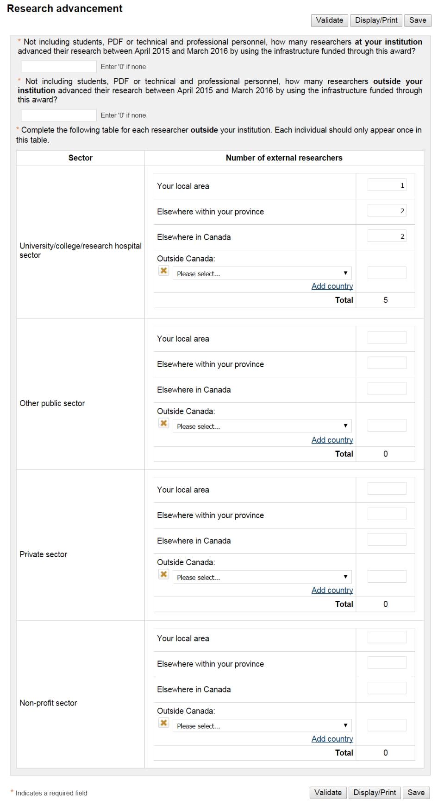

9
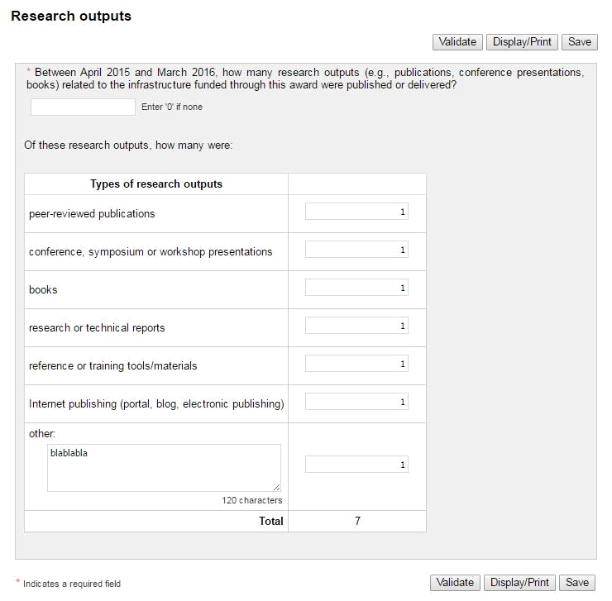

10
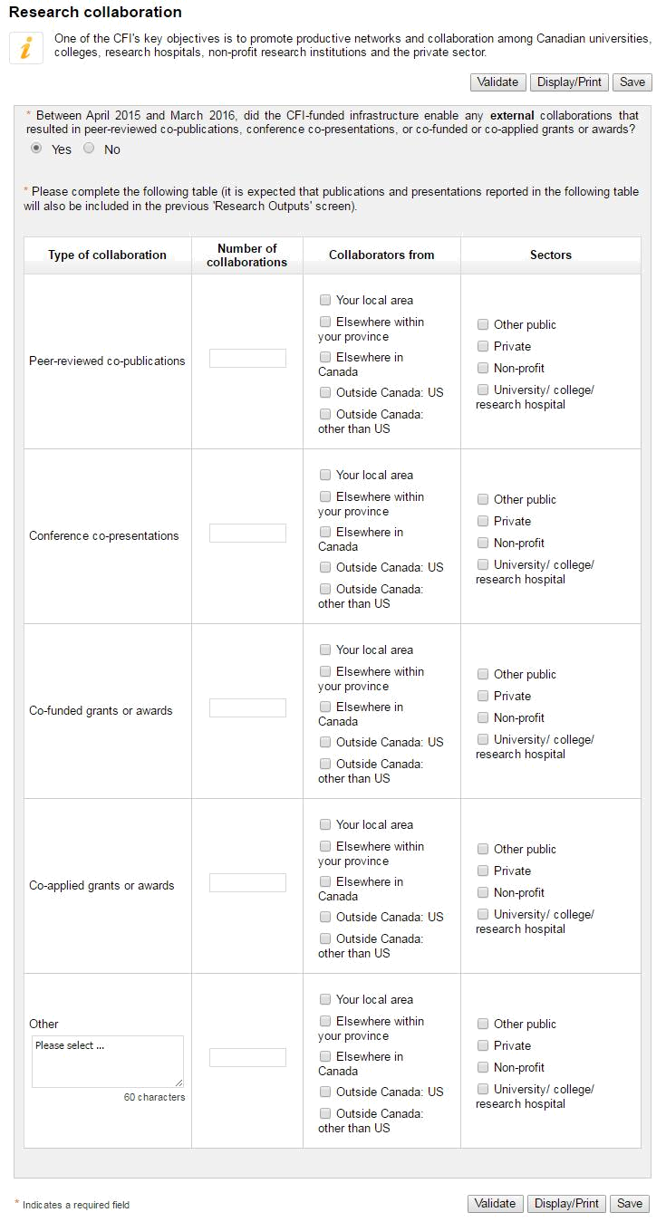

11
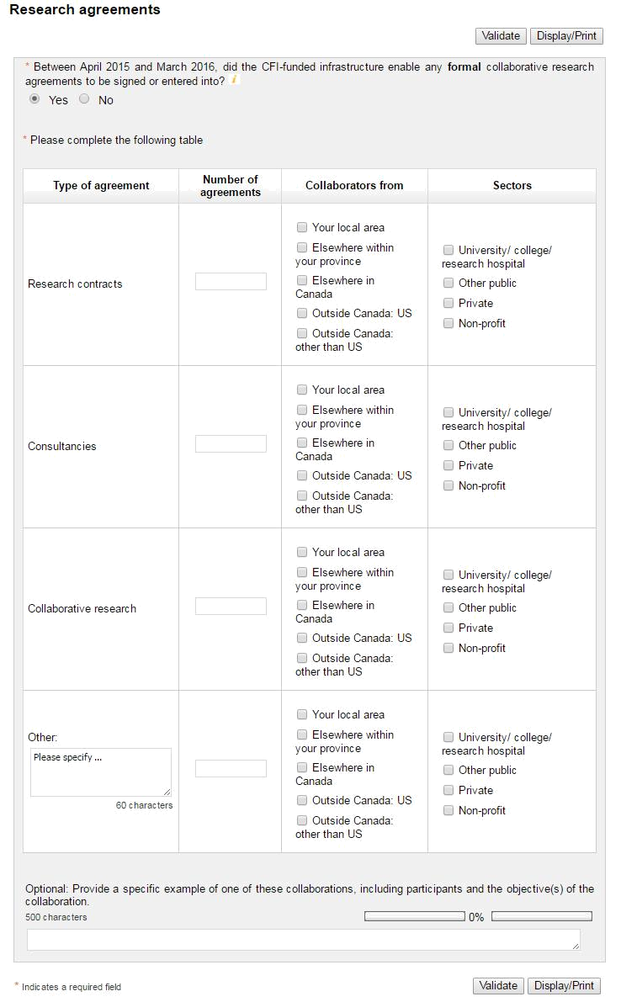

12
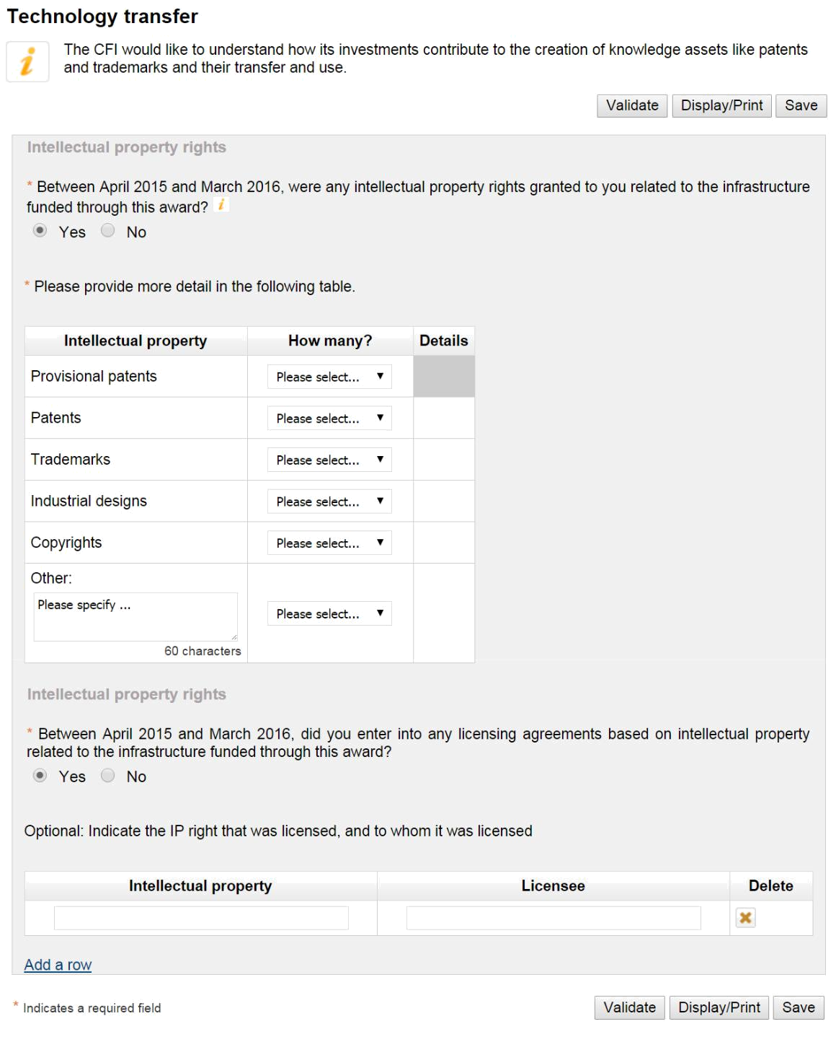

13
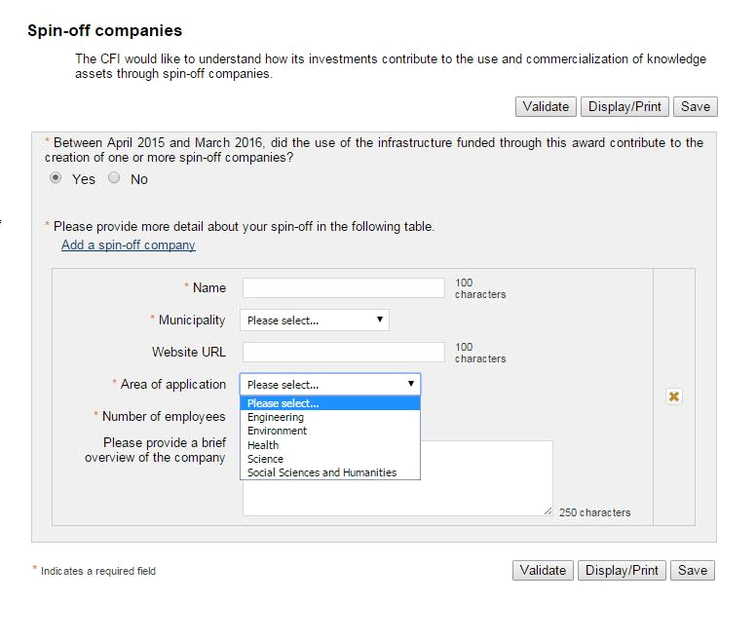

14
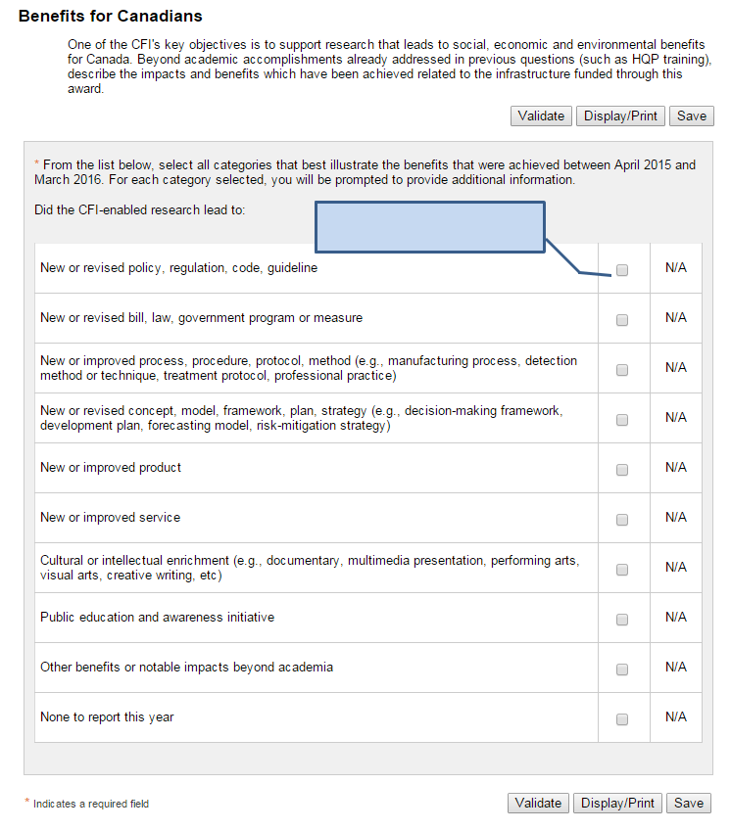

Leads to detailed screen for this

benefit

15
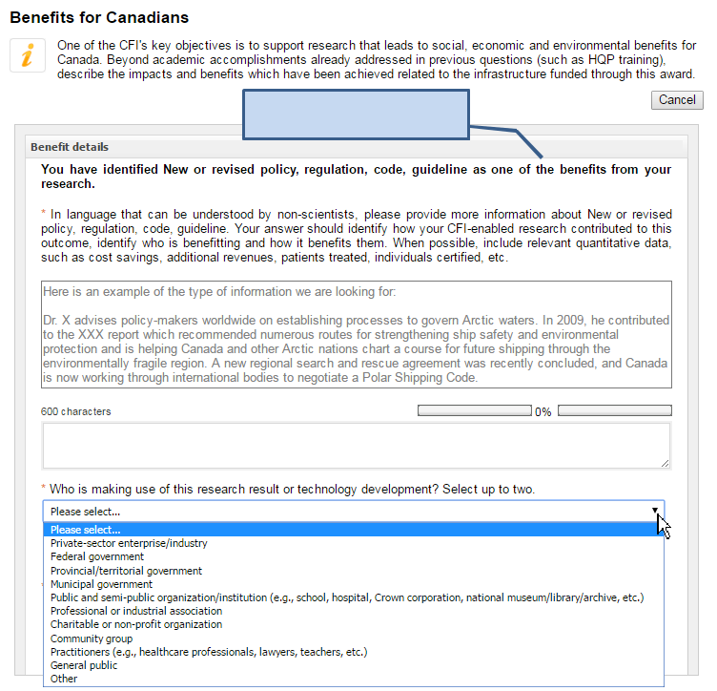

Detailed screen for this benefit, if

selected from previous screen


16
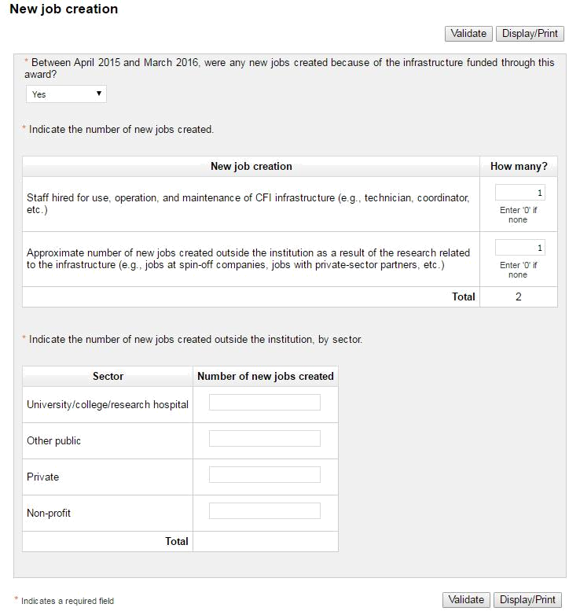

17
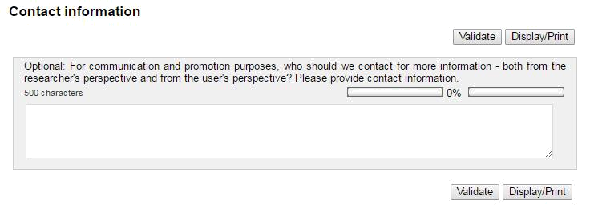
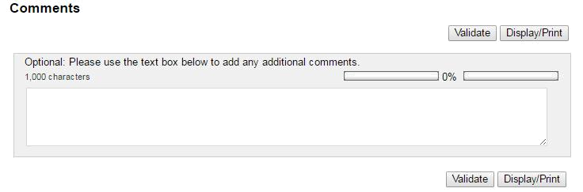


18

