

University of Tennessee, Knoxville

Trace: Tennessee Research and Creative Exchange

University of Tennessee Honors Thesis Projects University of Tennessee Honors Program

5-2016

The Munch: An Integrated Business Plan

Alexandra Barton

The University of Tennessee Knoxville, abarton9@vols.utk.edu

Follow this and additional works at: https://trace.tennessee.edu/utk_chanhonoproj  Part of the Entrepreneurial and Small Business Operations Commons

Recommended Citation

Barton, Alexandra, "The Munch: An Integrated Business Plan" (2016). University of Tennessee Honors Thesis Projects. https://trace.tennessee.edu/utk_chanhonoproj/2014

This Dissertation/Thesis is brought to you for free and open access by the University of Tennessee Honors Program at Trace: Tennessee Research and Creative Exchange. It has been accepted for inclusion in University of Tennessee Honors Thesis Projects by an authorized administrator of Trace: Tennessee Research and Creative Exchange. For more information, please contact trace@utk.edu.

The Munch Business Plan

Lexie Barton

GLS Final Thesis

Advisor: Dr. Daves

Table of Contents

Executive Summary and Problem Formulation

Industry Analysis

Company Description

Market Analysis

Economics of Business

Marketing Plan

Design and Development Plan

Operations Plan

Management and Team Structure

Pro Forma Financials

Appendix

2
Executive Summary and Problem Formulation

For this project, I will be developing a detailed business plan for a food-based company, “The Munch.” This business is designed to utilize the mobility and convenience of a food truck to capitalize on the college-aged market’s desire for affordable food on the go. This company will begin in Knoxville, Tennessee and then will be designed for franchisee expansion for application in college-aged markets across the United States if applicable. I designed this business and developed the concept after doing research on the thriving “food truck” industry in the culinary market, the psychographics and demographics of the college-aged market, and in discussions with my peers. In many major cities across the United States, the “food truck” phenomenon can be witnessed. People are placing more value on the ability to get quality food at a convenient and mobile location that offers them a good value. There is also an increased infatuation with the “unique experiences” in life, as we move into a more experience-oriented market. People are becoming less likely to value “fitting into the mold” as they are searching for boutique experiences that they can share with those around them. In addition, the growth of social media is allowing companies such as food trucks to reach new audiences for free and make their locations and menus more accessible. In younger markets, food trucks are becoming a frequent alternative for lunch and brunch in all seasons.

In addition to the growing trend of food trucks and mobile cuisine, campuses are fighting a constant battle against drunk driving. While conducting preliminary interviews with my peers and through my own observation, I noted that college-aged students were frequently leaving parties to drive to a fast-food location on the strip for emergency sustenance. Excessive drinking is also a frequent problem that many universities face. By offering a food service that is mobile and affordable, “The Munch” could be a valid alternative to help better both of these issues on The University of Tennessee campus. Instead of traveling to a fast-food establishment on Cumberland Avenue, students would have an option that could travel to the general area of their location and provide them with food quickly and for an affordable price. “The Munch” is designed as a part-time solution for drunk driving on campus, but also as a sustainable business that is able to operate in the Knoxville area.

3
Industry Analysis

Size, Growth Rate, and Sales Projections

According to an Ibis Industry Report from 2015, the food truck industry is one of the best performing segments in the foodservice sector and is in the growth phase of implementation. The revenue growth for this year was about $856.7 million, and they saw a growth rate of 3.5% in revenue from 2014. The industry is expected to grow for the next two to three years, until it slowly starts declining as revenues increase. Overall, the Food Truck Industry in the US is very attractive at this point for start-up entry and is expected to grow 3.1% over the next five years. However, there is a high rate of competition and some of the business can suffer under municipalities. For this industry to remain attractive for entry, “The Munch” would have to enter the market relatively quickly, before there are increased barriers for entry and the regulation level increases.

Structure of the Industry

The primary suppliers that affect this industry are meat and produce wholesalers. Food Trucks typically purchase their materials and food from wholesalers as they have a business license and move through large quantities. They are also downstream of their local government, as they are responsible for complying with local regulation. In terms of power flow, suppliers are only more powerful when the agricultural price index is high because it increases the overhead costs. A large part of the Food Truck Industry’s business depends on keeping their product prices relatively low, so when the index is high there is a serious threat on the industry.

The industry is currently succeeding due to a growth in consumer spending. Consumer spending has increased in general since the recession, but consumer spending on food trucks and street vendor type services maintained spending levels in general through the recession due to their ability to offer continuously variable menus and low-overhead costs. Because they run a low-cost business by nature, they are able to offer affordable prices that increase the convenience and appeal of their products. Food truck sales can also increase during a recession because their low-cost offerings look more appealing as a dining alternative. When consumer spending is high, they are more likely to dine out in general, including in food truck fashion. Consumer spending is expected to grow in 2016, which makes the industry increasingly more attractive in the upcoming year.

However, this industry is highly susceptible to consumer spending trends. Some of the growth in this industry can be attributed to the growth of gastronomy in the US in general. As the economy ebbs and flows and spending trends change, this industry will directly impacted. The success of a food truck business is entirely dependent upon consumer tastes and spending trends. Possible trend indexes that will be impacting the food truck business are: healthy eating index, consumer spending, and consumer confidence index.

4
Key Success Factors

According to the same IbisWorld industry report, some key factors they have identified are: the ability to control stock on hand, have proximity to key markets, being licensed, having effective quality control, and offering a differentiated menu. By having the ability to manage stock on hand, they have the ability to maximize profit by limiting waste, and can eventually reduce purchase costs. They must also be next to key markets in order to increase foot traffic and reach their target market. Since food trucks have been shown to appeal to those that are “on the go” but wanting a unique meal experience, being close to these crucial areas is extremely important in the grand scheme of things. The food trucks licensing is an important issue, as it is essential that they meet all due requirements annually. It is also important that they have effective quality control so that they meet regulation requirements and can differentiate themselves among the high level of competitors by offering great food, and a unique menu that sets them apart.

“The Munch” in Knoxville would have similar success factors. Most of the city’s food trucks are either self-stocked, such as Cruze Dairy Farms, or get their produce locally and feature seasonal menus, so managing stock on hand will be extremely important. According to a recent study done Gregg Cebrzynski in Nation’s Restaurant News, 18-24 year olds account for 28% of the late-night dining industry. Therefore, “The Munch” can expect similar percentages as this is the primary target market and demographic of the food truck location. Although there is not an existing zone in the campus region, vendors are able to operate on properties that are privately held, such as residences and commercial properties that already have existing food preparation licenses. The food trucks mainly operate in the downtown area, near Market Square and The Old City. Food trucks have also been known to frequent areas down Kingston Pike, and be staples at local events and markets.

However, there are currently no food trucks operating in the direct campus area. The only areas currently available for late night catering, according to the “Mobile Food Zones – Phase 1” file located on the city website, are the areas of State Street and South Gay Street. However, there are more zones being proposed as the prevalence of the food truck industry grows in Knoxville. In the city of Knoxville, there are two types of Vendor Permits for food trucks: “Right of Way” Permit, which is $400, that allows food vendors to operate within the zones and “Private Property” Permit which allows vendors to operate on Private Property. “The Munch” would be required to have both, as it would operate in the zones but also on private properties around campus. “The Munch” will differentiate itself in process execution, but also being the only delivery service to feature grilled cheese, aside from Gus’s, which has a $10 minimum for delivery.

Industry Trends

Food trucks typically have low operating costs, unlike brick-and-mortar restaurants, so they are able to respond quickly to changing customer tastes and provide them with a relatively low-cost

5
alternative to dining in or dining at a traditional establishment. According to the report, there have been multiple consumer preferences that have influenced the growth in the industry and created prevalent trends: Income and weather, health consciousness, and convenience. Due to the fact that food trucks can offer customers a better value on their food, customers did not decrease their discretionary spending on food trucks through the recession. Convenience and health consciousness have also been major determining factors that have driven consumers to increase their usages of mobile food. Food trucks are able to adapt their menus easily due to their simple supply chains and low overhead costs, so they can offer menus that align with the current customer taste demands. Furthermore, their mobile ability allows them to appeal to a wider audience.

In Knoxville, there is a strong initiative within the food truck and downtown community to source locally. This has led to food trucks offering locally sourced menus and operating on a mostly seasonal basis. Their ability to source locally also has the added benefit of being able to operate on a “just-in-time” supply chain. Since suppliers are so close, trucks are able to restock when need be instead of having to order large quantities of non-perishable food and getting faced with stock-outs or un-utilized inventory.

Long-term Prospects

According to the IbisWorld Industry Report on Food Trucks, the growth path for the food truck industry is expected to slowly decline after three years, but there is a still a feasible opportunity to enter the market now. In the City of Knoxville, the city government has just established a “Mobile Food Vendor Pilot Program” that launched in April 2014. Although the overall food truck industry is expected to decline, I believe that opportunities for growth in Knoxville will be ripe for at least the next five years. Under the current “Mobile Food Unit Proposed Ordinance,” food truck operation zones will be spread across Knoxville. In my initial primary research local entrepreneur, Patrick Sinthavong, has plans to establish a “Mobile Food Park,” where food trucks can open for business during the day in one concentrated area, outside of allotted events such as the Farmer’s Market. There are also multiple pivoting strategies for this food truck in the future that align with current trends. According to a recent article titled, “Universities Glom Onto Food Trucks,” published in the Foodservice Director, many universities are beginning to open food trucks of their own, as either a part of their traditional campus dining sources or by contracting with local vendors to serve their population much like in healthcare. At Michigan State University in East Lansing, they have created their own food truck service in part of their university dining offerings that serves over 200 customers a day, not including event days such as home games and other major sporting events. At the time of this article, university respondents to their survey noted that 15% of universities are planning to start their own food truck within the next three years. Because of this data, I believe that long-term there will be the opportunity to make this a franchised business model. Through this business model, “The Munch” would establish basic procedures and the brand would be available for licensing, and franchisees would have control over local price points and purchasing the food trucks and ingredients,

6
and have local menu offerings. I believe that a business like “The Munch” has the opportunity to be become the unofficial late-night university mobile food service in the future.

This opportunity is also available for The University of Tennessee. If I decided that “The Munch” was best served amongst the UT community and did not have a desire to make it a formal franchise, I believe that there is still an opportunity to partner with The University and become UT’s “officially unofficial” food truck source.

There is also the opportunity for “The Munch” to expand and provide service during the day as many of the other food trucks in the area, and attend the local farmers markets and events per usual. If this expansion were to happen, there would be an increased menu listing and product offering.

7
Company Description

Mission Statement

“The Munch” is a fully operating food truck specializing in late-night dining and traditional and gourmet grilled cheese sandwiches. “The Munch” attempts to offer students a comparable alternative to fast food and delivery restaurants on “the Strip” and therefore decrease the incidence of drunk driving on campus.

Products and Services

“The Munch” will focus its menus offerings around the traditional grilled cheese. The traditional Grilled Cheese (bread, butter, cheese) will be available for $3 (full sandwich) and $5 for a “double” (a double decker grilled cheese). These will simply be referred to as “The OG” and “The OG Double.”

- This cost was determined by looking at similar businesses, such as “Tom+Chee” which brands itself as a grilled cheese and tomato soup shop, and “Grilled Cheese and Co.” that offers a similar range of products and has similar costs. In addition, it is competitive to the current fast food and late-night delivery options such as “Jimmy Johns,” who offer their most basic sandwich starting at $5.95.

Gourmet Grilled Cheese Offerings: “The Smokey Sandwich” – The traditional grilled cheese with 2x the cheese and bits of smoked sausage or bacon; “The Bonnaroo” – The traditional grilled cheese with avocado, tomato, and spinach; “The 1998” – The traditional grilled cheese with 3x the cheese. All available for $5 for a regular and $7 for a double.

- This cost was determined by considering the increased cost for making the product, the additional ingredients cost additional in overhead, and also by comparing the offerings at Jimmy John’s and Cookout that offer comparable food for a similar price.

Drink offerings will be available. There will be Large Sweet Teas, Lemonades, and Waters for $1, all which will be made in house.

- This price was determined by the average fast food drink prices for these types of drink offerings, such as McDonald’s.

The menu is designed to offer students a legitimate late night food option, but to keep my supply chain and stocking strategy simple. I want to be able to offer these students a comparable price to other delivery and fast food establishments as incentives for them to stay off the road, while also offering them a satisfying product

Current Growth Status and Legal Status

8
Right now, “The Munch” is in its initial phases of start-up. I have completed primary and extensive secondary research to determine the viability of this project, however I have not created any minimally viable products or drafted and initial prototype. My next steps will be to purchase the food truck, and apply for all trademarks and licenses I will need from the city. This will be a sole proprietorship, as it will be operating on a small scale initially and in a local area.

Key Partnerships

Currently, there have not been any extensive partnership discussions with local businesses, but I have made contact with several suppliers to determine what supplier options were available for local dairy and bread. However, I have conducted initial partnership contact with local entrepreneur, Patrick Sinthavong, who as previously mentioned plans to open a food truck park. I will be working in tandem with him to promote his park while he provides me with legal help, as he is knowledgeable about the licensing system, and serves as an executive member of “The Munch” Mobile Food Service.

A future key partnership will also be The University of Tennessee, should I expand to campus property. Local businesses will also be a crucial aspect to this food truck, as I will need their consent in order to operate on their premises under my private property license.

9
Market Analysis

Market Segmentation and Target Market Selection

“The Munch” will differentiate itself within the food truck industry primarily through hours of operation, location, and product offerings. While there are established brick-and-mortar restaurants that currently sell grilled cheese on campus: Gus’s Good Time Deli and Cook Out; There are currently no operating food trucks in the Knoxville and campus area that focus their menus exclusively on grilled cheese. Furthermore, there are no current late night food truck options that are immediately available for students, and only a few delivery sources for late-night food.

Students’ ages 18 to 27 will be my main target market, both male and female. This is primarily due to my experience with this target market category, but also due to the research behind the food truck industry and campus dining habits. According to the IbisWorld report, consumers in this age group make up 63.1% of the food truck industry. More importantly, according to research done at the Pew Research Center, social networking site use is highest among consumers ages 18 to 29. This is important to the success of “The Munch” because we will do most of our promotion and location notification through social media. This same age group spends the most time at food trucks, according to the report, because of their use of social media even though they have the lowest disposable income.

Buyer Behavior

Student buying habits regarding late night dining have been consistent for multiple years. According a case study of university late night dining options done by “Nation’s Restaurant News,” there are multiple universities that have adapted to offer late-night food options. In the article, Frank Gladu, the operator of The University of Notre Dame’s “Huddlemart” notes, “the Huddlemart can do an average of 250 transactions an hour during the late-night period.” The University of Colorado Boulder opened “The Pit Stop,” in an effort to fuel student’s late night dining needs under Richard Hennessey, who says, “We have between 1,600 and 2,000 students coming through a night.

The University of Tennessee also has late night dining options available, but only until 12am, and only on Saturdays and Sundays at Panda Express and Cane’s Chicken. Although I do not have concrete data on the usage of these restaurants, I have requested them from Aramark. Studies based on other university dining facilities, there is a large buyer demand for late night dining on campus Competitor Analysis

The main competitors for “The Munch” are local late night delivery services and fast food options. There are currently no food trucks operating within the campus area in Knoxville that offer late-night cuisine, therefore they do not fall in direct competition with our business. The main competitors I

10
have identified are: Gus’s Good Time Deli, Cookout, McDonald’s, and Jimmy John’s. This is simply because these restaurants have offer a similar low-cost food product, and exist within the campus area during late-night dining hours.

McDonald’s is clearly a powerhouse in the fast food industry, with the closest location being on Cumberland Avenue. There current comparable deals would be the “Choose 2 for $5” and the “Dollar Value Menu.” However, there is no delivery option available, so they are not in direct competition with the truck. The dining room closes at 12am, but the drive-thru is available for 24-hour service. McDonald’s will be a strong competitor, but they will not be able to compete on delivery. “The Munch” will have to compete by convenience to capture McDonald’s customers, because they will not be able to compete in product offerings or 24-hour service. The financials are also not comparable, as McDonald’s is a large national firm that has extended operating hours. This is a similar analysis to Cookout, which is currently the most popular late night option for The University of Tennessee students. The most popular product offering they have for students is the “Cookout Tray” which offers students three times for $5. They can also add a milkshake for only an additional $2. Cookout will most likely be “The Munch’s” highest competitor, because it is so popular among college students. However, they do not offer a delivery option and can be contended with the convenience of the mobile food aspect.

“The Munch’s” direct competitors would be Gus’s Good Time Deli and Jimmy John’s. Jimmy John’s has extensive late night delivery hours, as they are open for delivery until 4am. Gus’s Good Time Deli is also available until 4am as well. Because these restaurants offer both late night hours and delivery, “The Munch” will have to compete on price. The current price points are undercutting both restaurants product offerings, and will have the additional benefit of no delivery charge or required tip. Both offer a similar product – Jimmy John’s focuses on sandwich sales and Gus’s offers a grilled cheese option – but “The Munch” is still able to compete based on price and convenience.

11
Economics of Business

Revenue Drivers and Profit Margins

“The Munch” will gain revenues through sales of their grilled cheese product. There will not be any current advertisement revenue options, because we will be doing most of our promotion and location tracking. Later on, there will be an app developed that will have tracking abilities.

Current profit margins will be determined once final suppliers have been decided upon. The average cost of making a grilled cheese is $0.43, according to industry standards. For “The OG,” that is an average profit of $2.57 per sandwich (85.6% profit margin), and for “The OG Double,” assuming double to cost, $0.86, it would equal to a $4.14 profit on each sandwich (82.8% profit margin). The average cost of making a gourmet grilled cheese with vegetables is $0.93, according to industry standards, which would be $5 for a regular (81.4% profit margin) and (82.8% for a double). The average cost of a gourmet grilled cheese with meat is $1.43, and by charging around $6 for a “Smokey Sandwich” we achieve a profit margin of 76.2%.

Although sandwich sales will be our main driver of revenue, we could also open up to different advertising opportunities within the area and with our potential partners. “Pocket Points” is an app that is popular among college students, our decided upon target market, that frequently offers food discounts and coupons for the accumulation of points. This is a potential opportunity for “The Munch” to get the word out, but also emulates a similar advertising strategy that “The Munch” could employ in order to gain more revenue, as our popularity increases.

Fixed and Variable Costs

Fixed costs for the food truck would include: food supplies, license fees, and commissary, app development, and Internet service. Variable costs would include: gas, maintenance, marketing promotions, labor, paper products and serving materials. The benefit of the food truck industry is that there are very low fixed costs associated, as after the initial purchases you do not have standard expenses such as rent. Due to the nature of our “Just-In-Time” supply strategy, we are also planning to keep variable costs relatively low as well. By keeping menu offerings limited, we ensure that there will be low variation in ingredients and can keep our variable costs just as low as our fixed.

Start-Up Costs

Average start up costs for food trucks can range from $28,100 to $114,100, according to a Forbes article titled, “The Cost of Starting a Food Truck.” For “The Munch” startup costs would be as follows:

12

Food Trucks, Wrap, & Equipment: $30,000 (see sources)

Initial Product Inventory: $1,000 (industry estimate)

Permits and Licenses: $400 (from the City of Knoxville website)

Website and App Development: $7,500 (industry estimate – smartphone app and graphic design)

Facebook/Twitter: Free

POS: $1,000 (industry estimate)

Uniforms: $0

Licensing: $32.50

Legal and Accounting Fees: $310.00

Paper Products: $174.32 (industry estimate)

Misc Expenses: $1,500 (industry estimate – menu board, branding, etc.)

Smallwares: $223.46 (industry estimate)

Fire Extinguisher: $129.98 (industry estimate)

TOTAL: $42,270.26 rough estimate

As per other startup industries, it is expected that we would hit a break-even within the first three years of business. Because this type of product is new to the area, it is hard to estimate based on similar businesses, but because they will initially have decreased hours of operation, it may take up to four years to break even. Based on our expected sales of 500 sandwiches per night, we would break even relatively quickly at around 30 weekends.

Current Assets

Currently, “The Munch” has current assets of $60,800. This makes this project financially feasible, but because it will be primarily financed by myself and my business partner, there is significant room for investor financing in replacement of some personal financing. These assets include three main sources of income: car loans, personal loans, and combined partner assets. Although we do not have any tangible assets such as a truck and related food products, we have a large percentage of liquid assets that allow us to finance the truck if need be.

13
Marketing Plan

Overall Strategy

“The Munch” will be primarily marketed through social media, and through the use of the app we will be developed. Most of the food truck industry business is run through social media accounts, as it is a free medium that reaches a large amount of customers. There will also be plans to partner with local bars, and have word-of-mouth advertising by being present on campus. The app will be an important addition to the marketing plan as it will be a “one stop shop” for “The Munch.” There will be a map of the truck’s location, as well as an estimate as to when it will be at the next stop and schedules for the remainder of the weekend. This is similar to the technology used by UTK currently to help students effectively use their transportation system. As a result, students will already be accustomed to the technology and will not have problems using the app. They will also be able to view current coupons and possible advertisements from our partners.

We will also make efforts to partner with student led committees to cater their events in addition to our social media advertisement. Much of “The Munch” marketing will be done through foot traffic. The more present we are, the easier it will be to make students aware of our service and the easier it will be to gain students’ attention through word of mouth.

Pricing

As mentioned earlier, these are the current prices for “The Munch” menu:

“The OG” - $3

“The OG Double” - $5

“The Smokey Sandwich” - $5 to $7

“The Bonnaroo” - $5 to $7

“The 1998” - $5 to $7

Lemonade, Tea, Water - $1

These prices were designed to be competitive with other delivery fast food businesses in the area, but still be sustainable for the business itself and provide high operating margins that will help us maintain our current means of operation.

Sales

14
“The Munch” is designed to sell itself. Although there are pricing strategies in place, it will be primarily promoted through social media and sales will depend on the amount of foot traffic during any given night. The main operation period will be from Thursday through Saturday, until we expand to daytime operation. With cooperation with private businesses, we have identified strategic places that will be the most lucrative for a late-night food service provider

15
Design and Development Plan

Development Status and Tasks

Currently, “The Munch” is largely in the ideation stage of implementation. We have yet to have tangible development, but have drafted a solid plan to move forward with development. The first task of development would be to receive quotes on supplies and purchases the appropriate licenses for business operations. Although I have completed an initial pro forma, a more detailed sourcing strategy will be needed in the future. Once those have been obtained, I will seek investor funding and take out a loan for my operations and purchase of the truck and materials. I will then contract my desired supplier based on final quote and relative prices. Currently, I will be sourcing from a “Sam’s Club” and buy my materials in bulk. Once I have significant growth or decide to expand my operations to include week and daytime hours, I will open this back up to consider more local and traditional suppliers as I will be forced to move away from a precise “Just-In-Time” system. I will then begin moving forward with my app development and continue contacting local businesses to judge availability of parking and service, and I will continue to move forward in making my entrepreneurial firm. I will aim for launch for the end of summer and beginning of fall semester to capture the most amount of market share.

Challenges and Risks

The main challenges in this endeavor will be complying to city ordinances and regulations and cooperating within the University’s guidelines. The startup will be fairly simple and standard per the industry, however there are many restrictions to working on a university campus, even when you are on off campus territory. Another major risk will be the ability to serve on campus, with the new “strip” development plans that the City of Knoxville is moving forward with. It is entirely possible that the businesses in existence now will not be there within the next three years, and the new building codes may very well not allow for private parking. In addition, city ordinances have recently dictated that food trucks cannot be within a certain footage of residential housing, in reference to trucks that have a smoker attached. The City has not officially voted on this ordinance, but it would likely affect my operation despite the fact that I will not have a smoking component to my truck or menu.

16
Operations Plan

General Approach

“The Munch” will mainly be in operation Thursday, Friday, and Saturday nights 5pm – 3 am. It will be primarily staffed by myself and my business partner, and we will pay ourselves a small percentage of the tips collected from the night’s sales. We will stock the truck on Wednesday’s and have our location schedule published by Thursday afternoon, after talking with local businesses during the day. I will most likely go to pick up supplies by Wednesday morning, and will maintain books and continue developing our marketing plan and strategy throughout the rest of the week. On the truck, we will have three stations: prep, cook, and register.

We will employ a POS system to keep a detailed record of sales account for stock management, and sandwiches will be made to order. We will prep each day before opening the truck, but since grilled cheese is best when served “hot off the grill,” it does not make sense for me to pre-make the sandwiches before we open the truck, even though I have the data to estimate how many units we would need of each sandwich. We want to ensure quality food and keep our customers happy with hot and tasty sandwiches. Inventory will be done on Sunday afternoons, as well as deep cleaning and maintenance. Stations will be cleaned per usage and cleaned thoroughly each night after closing.

We will have a roving business location that will vary night-to-night but not weekly. We will most likely have the same schedule of locations each week, which will be communicated to consumers through our app. “Headquarters” will be at my apartment on campus.

Aside from our food truck, we will only have equipment to manage and no other facilities. Equipment will be cleaned and have routine tune-up every six months by a professional company, and small equipment pieces such as pots and pans will be replaced as needed. The benefit of keeping a just-in-time supply chain strategy is that it will allow me to keep relatively low variable costs, as I will be able to replace materials on an as need basis. This prevents against the potential spoilage of produce, and also ensures that we maintain a fairly efficient inventory stocking process.

17
Management Team and Structure

The management team will consist of two employees: my business partner and myself. I will be serving as CEO, CMO, and CFO while my partner will be serving as Co-CMO, Head Chef and COO. I have a business background in academia and have been an employee for the local “Sweet and Savory” food truck for three festival seasons. I have also taken multiple entrepreneurship classes, and have both social media and business development experience through internships, making me qualified to run a social media campaign for my new service. I am involved in multiple planning committees on campus that have contracted food trucks and catering with the University, so I have experience in university contracts and catering stipulations with Aramark. I will be in charge of the marketing plan, app management, register, local business relations and in dealings with the City of Knoxville.

Patrick Sinthavong, my business partner, will be responsible for cooking and selecting suppliers, as well as physically driving the truck. He has an extensive kitchen background, working in his home restaurant in Memphis, and has helped his family select suppliers for their small businesses. He will also be in charge of menu creation, and will have a better idea of how much and what materials we will need. He is also a marketing major, which will help him aid me in our marketing strategies. He is also an avid entrepreneur, and has done extensive industry and market experience for his own food truck project, and therefore has solid understanding of building and road codes for The City of Knoxville as well as licenses that we will need to acquire.

For the social media and app development, we will be outsourcing to a local student in efforts to save money. The average app costs about $10,000 to develop according to Pricenomics, and as none of the management team has experience in app development, we will be planning to outsource as needed.

Hopefully, by using at University of Tennessee student to help develop our core app, we will not only be able to make our business as local as possible and provide UT students with the chance to build their resume and become involved in their local business community, but also be able to save money and bootstrap where possible. As our company develops, we will also hire multiple employees to work the truck, but also a financial advisor to manage the company growth.

18
Pro Forma

Sources of Funds

This financial statement gives a brief overview of our start-up funds and allocations. I will be contributing $10,300 of my own savings into our start-up fund and will also be taking out a loan of $15,000 from UT Federal Credit Union that will be financed at 1.25% interest. My business partner will also be contributing $5,000 of his own money into our start up fund. We both have current kitchen equipment valued at $200 for use on our truck, and we will be taking out a Vehicle Loan from TVA, financed at 2.50% interest, in order to cover our the rest of our vehicular and equipment expenses.
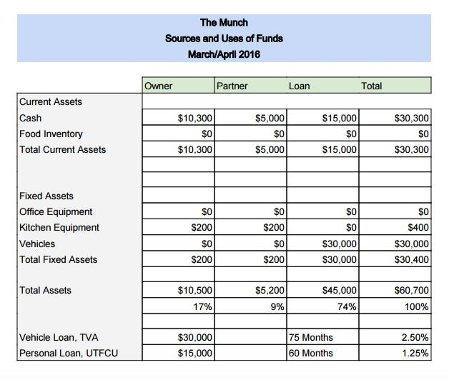

19
Start-Up Costs

As discussed in our “Economics of Business” section, “the Munch” has an average startup cost of $41,536. This includes our vehicle, wrap, and kitchen equipment as well as all of our initial operating costs such as internet and electricity. This also includes our initial investments in legal, accounting, and website and app development. In order to break even in our desired amount of time, we will need to average $782.50 per month to cover these costs. Many of these costs are just one-time purchases or yearly purchases, as they are investment expenses.
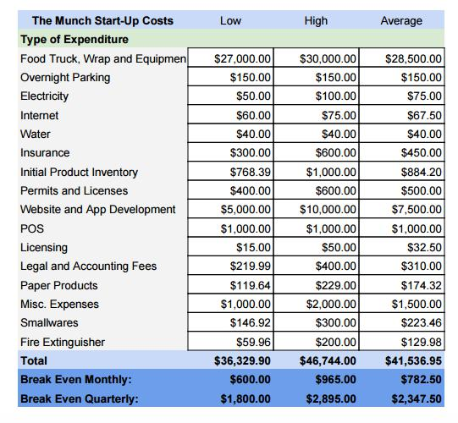

20
Invest Expenses

The Investment Expenses financial sheet gives a detailed description of our investment activities within the first year, as well as a specific picture of our food inventory and the kitchen and office equipment that we will be purchasing.
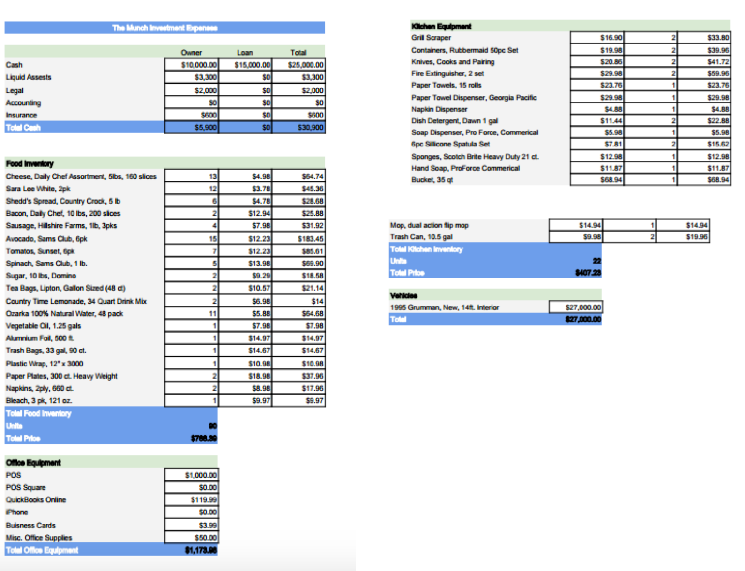

21

Statement of Cash Flows, Quarterly

The statement of Cash Flows incorporates the information from the previous sheet and details our spending activity for through our first two years. It includes our financing, operating, and investing cash flows. Our inventories fluctuate throughout the years based on food and as we expand operating hours and activities. We will have long-term debt due to our loans, but will be paying extra against the principle each month in an effort to decrease this over time. We will have fixed assets due to our investing cash flow in the first quarter, as we will be purchasing our truck and other equipment.
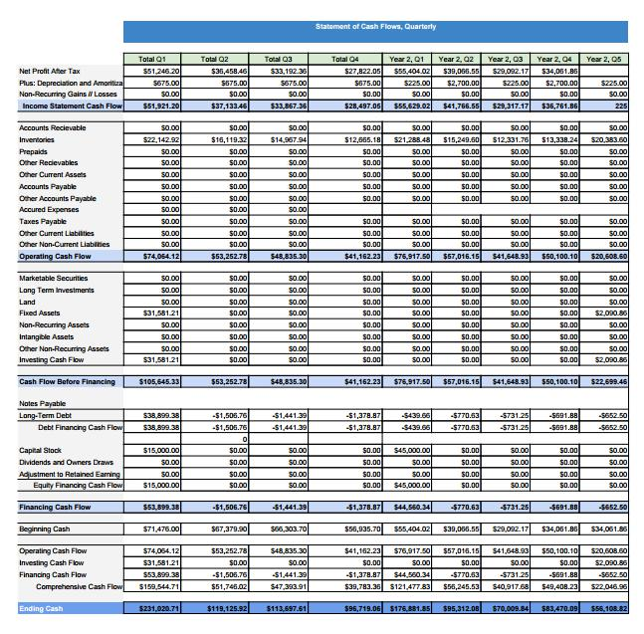

22
Balance Sheet

This statement gives an accurate financial picture through opening day until the end of our second year. We estimated our cash on opening day to be the liquid assets that we will have from our personal investments and loans after we invest in our equipment, inventory, and vehicle. We hope to sell out of our inventory each year, and have no plans to hold inventory since most of our stock is perishable. For opening day, we also included our first month’s payment plus interest for both our truck and our personal loan in our prepaid expenses. Our long-term investments include our truck loan and our personal loan, as well as some more investments that we are planning for our second year as we expand operations. We included our investment for our kitchen equipment each year, as well will most likely have replace them annually. We have intangible assets on opening day through some of our investing activities, but none by the end of the first or second year. We included our interest payments and monthly bills for our personal and vehicle loans in our “accounts payable” section, and we altered our personal investment through the years to ensure that we will stay profitable until we are fully sales-sustaining.
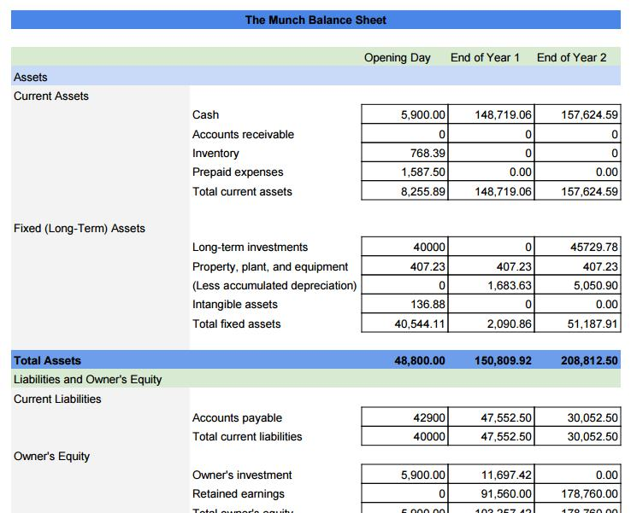

23
Income Statement

Below is or income statement and demand projections through Q12, or our first three years. Demand was estimated by our nightly expected sales for the weekend, multiplied by four to include all weekends of the month. For each sandwich category, we used the data we collected through our market research survey to determine what percentage of each menu item would be order per night. We assumed that everyone would purchase a drink with their sandwich, as naturally there will be some customers that do not but some that purchase multiple. Demand was also adjusted seasonally, and with football season and event seasons in mind. We expect to sell more during football months, simply because there will be more people out and about on Cumberland Avenue and in the vicinity of our truck. We also included a yearly maintenance fee on our truck, and tiered our parking expenses based on our sales. As a part of our strategy to partner with local businesses in order to park our truck on their property, we will agree to pay them 5% of our nightly sales. Fuel and propane needed were also adjusted in tandem with demand, as well as the amount of cleaning supplies needed. There is also a detailed breakdown of the interest expenses owed on both our personal and vehicle loan, and how much is to be owed each quarter.
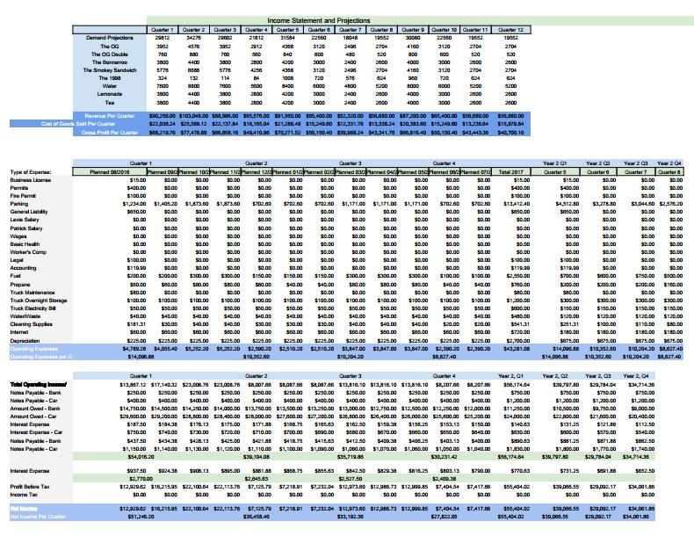

24
Appendixes

References –

Boston Food Truck Blog. “Food Truck Wraps: Cost, Designs and Alternatives.” Web. 31 Mar 2016. http://www.bostonfoodtruckblog.com/food-truck-wraps/

Burg, Natalie. “How $3 Grilled Cheese Sandwiches Became a Big Business.” Forbes Magazine. Web. 5 Feb 2016. http://www.forbes.com/sites/capitalonespark/2013/12/24/how-3-grilled-cheese-sandwiches-became-big-business/#41eea34c5b80

Cebrzynski, Gregg. “’Fourthmeal’ Spurs QSR Late-Night Dining Push.” Nation’s Restaurant News.

40.19 (2006): 6-123. Business Source Complete. Web. 2 Feb. 2016.

Craigslist. “Brand New Food Truck - Business Listing.” Web. 31 Mar 2016.

https://knoxville.craigslist.org/bfs/5473583626.html

Damast, Alison. “Food Trucks And College Business Majors: A Most Delicious Match.”

Fortune.Com (2014): N.PAG. Business Source Complete. Web. 2 Feb. 2016

Davidson, Ellis. “The Average Time to Reach Profitability in a Startup Company.” Demand Media.

Web. 4 Feb 2016.

Food Truck Economics.” Priceonomics. Web. 4 Feb 2016.

http://blog.priceonomics.com/post/45352687467/food-truck-economics

Grilled Cheese Company. “Menu.” 4 Feb 2016. http://www.ilovegrilledcheese.com/menu

IbisWorld. “Industry Report, Food Trucks.” Web. 4 Feb 2016. http://clients1.ibisworld.com/reports/us/industry/currentperformance.aspx?entid=4322 https://www.google.com/search?q=vehicle+loan&espv=2&biw=1280&bih=601&site=webhp& source=lnms&tbm=isch&sa=X&ved=0ahUKEwjxq_Xy3InMAhUEFR4KHbMkCkEQ_AUIBigB #tbm=isch&q=food+license&imgrc=UKOB-pju6T2hiM%3A

“iPhone Development Costs.” OSX Daily. Web. 5 Feb 2016. http://osxdaily.com/2010/09/07/iphone-development-costs/

Ivestopedia. “The Cost of Starting a Food Truck.” Forbes Magazine. Web. 5 Feb 2016.

25
http://www.forbes.com/sites/investopedia/2012/09/27/the-cost-of-starting-a-food-truck/#44233db22930

Jimmy John’s. “Menu.” 4 Feb. 2016. https://online.jimmyjohns.com/#/menu.

Salvagno, Jason. “Switch-It-Up Business Plan.” Web. 30 Mar 2016. http://foodtruckempire.com/wp-content/uploads/2013/12/Swich-It-Up-Business-Plan-for-Submission.pdf

Sinthavong, Patrick. “Grub Park Balance Sheets.” Web. 18 April 2016.

Statista. “Share of consumers who would patronize a food truck of their favorite restaurant in the United States as of November 2014, by age group.” Web. 30 Mar 2016. http://www.statista.com/statistics/384925/consumers-who-would-patronize-a-food-truck-of-their-favorite-restaurant-us/

“The Complete Breakdown of Food Truck Operation Costs.” Foodtruck Empire. Web. 5 Feb 2016. http://foodtruckempire.com/how-to/costs/

The Culinary Review. “The Basic Grilled Cheese Sandwich.” Web. 5 April 2016. http://www.christonium.com/culinaryreview/Basic_Grilled_Cheese_Sandwich

Tom and Chee. “Menu.” 4 Feb 2016. https://tomandchee.brinkpos.net/order/menu.aspx

Tuttle, Brad. “Is Grilled Cheese the Next Big Thing in Fast Casual Restaurants?” Time. Web. 4 April 2016. http://business.time.com/2012/10/19/is-grilled-cheese-the-next-big-thing-in-fast-casual-restaurants/

Universities Glom Onto Food Trucks.” Foodservice Director. 25.12 (2012): 42 – 43. Business Source Complete. Web. 3 Feb. 2016.

University of Tennessee Campus Dining. “Volunteer Dining.” Web. 4 Feb 2016.

http://ut.campusdish.com/

26

