

Bid Package – ISSUED FOR BID

Harkins Bridge Replacement Project

Purisima Creek Open Space Preserve

San Mateo County, California

Date: May 30, 2017

Harkins Bridge Replacement
Bid Package – Cover Page & Bid Package Contents

Page 1 of 4

(Page left intentionally blank)

Harkins Bridge Replacement
Bid Package – Cover Page & Bid Package Contents

Page 2 of 4

BID PACKAGE CONTENTS

- Project Narrative

- Bidding Documents
  - Invitation to Bid
  - Instructions to Bidders
  - Location Map of Bid Opening

- Bid Forms
  - Bid Proposal Form
  - List of Subcontractors
  - Noncollusion Affidavit
  - Bid Bond

- Agreement Forms
  - Form of Agreement - at time of execution, Agreement will include:

    - Exhibit A: Agreement Scope of Services (Contractor Bid Proposal Form)
  - General Condition of the Agreement

    - Exhibit 1: Labor and Materials Payment Bond

    - Exhibit 2: Performance Bond

    - Exhibit.3: Worker’s Compensation Certificate

    - Exhibit 4: Proposed Change Order Request Template

    - Exhibit 5: Change Order Template

  - Supplemental Conditions of the Agreement

    - Exhibit 1: Location Map

    - Exhibit 2: Site Access Map

    - Exhibit 3: Construction Drawings

    - Exhibit 4: Permits

- Project Scope Documents
1. Project Specifications

Harkins Bridge Replacement
Bid Package – Cover Page & Bid Package Contents

Page 3 of 4

(Page left intentionally blank)

Harkins Bridge Replacement
Bid Package – Cover Page & Bid Package Contents

Page 4 of 4

A. PROJECT NARRATIVE

Project Description

The Project involves the removal and replacement of a rail road car bridge crossing over Purisima Creek. This bridge is now showing signs of rusting and deterioration. The Project would replace the existing bridge with a new bridge that will be relocated approximately 100 feet upstream of the current bridge site.

Project Location

The existing Harkins Bridge is located in the Purisima Creek Open Space Preserve at the end of Purisima Creek Road, in the County of San Mateo, California.

Project Characteristics

Project implementation would involve removing the 60-foot long, steel bridge and replacing it with a 50-foot-long, prefabricated steel bridge just upstream of the current location. The project is shown in drawings. The existing bridge is deteriorating and can no longer safely carry significant vehicle loads. The current bridge serves as crossing for patrol, fire, and other emergency vehicles. These vehicles can be quite heavy, so the bridge has to be able to carry those loads safely. The new bridge will entail the construction of structural concrete abutments, and maintaining adequate turning radius and grades on the new approaches to the bridge. Portions of the Whitmore Gulch Trail will be realigned.

The bridge replacement project involves working in a 200-foot reach of Purisima Creek that is approximately 20 to 50 feet wide. The project footprint is approximately 3,500 square feet (0.08 acres).

The Project site extends approximately 20 feet upstream and 180 feet downstream of the new bridge location. In the river reach the river banks are 8 to 10 feet high; however the channel bottom is significantly wider downstream of the proposed new bridge. The slope along the reach is approximately 2.2%. The large downed redwood tree immediately downstream of existing bridge restricts high storm flows. This restriction causes storm flows to back up and flood the adjacent parkland and approach to the existing bridge.

The existing bridge will be replaced with a new bridge approximately 100 feet upstream of the existing bridge. This new bridge will be sized so that it spans the channel. In addition to the removal and replacement of the bridge, the design includes the restoration of the old bridge location with native vegetation, and new bio-technically stabilized slopes. More detailed information regarding the various phases of the proposed project is provided below.

Harkins Bridge Replacement
Bid Package – A. Project Narrative

Page 1 of 4

a. Construction Timeline. Construction activities will commence approximately July 31, 2017, and must be completed before October 6, 2017.

b. Demolition. As part of the proposed project, the existing bridge and access road would be demolished and the rubble would be hauled off site to an appropriate refuse disposal facility. Demolition of the affected portion of the road would generate approximately 200 cubic yards of waste. The existing bridge is a 60-foot long, 12 -foot wide old RR car steel bridge that would be demolished and hauled offsite. Tarps would be placed underneath the bridge during demolition to prevent debris from entering the creek. Dirt from the bridge fill would be temporarily stored on an adjacent staging area, and suitable soil would later be used as backfill fill for the restoration of the old bridge site. Generally, significant trees on the site are being avoided; however the project will entail the removal of two alder trees.

c. Staging. Once the bridge, fill, and road are removed from the site, a temporary dirt access road to the channel bed will be constructed to allow access to the other side of the creek. Two, 18 inch pipes will be installed across the active creek and a temporary crossing will be constructed to allow for construction traffic to the north abutment. Clean gravel and soil fill will be used to construct the temporary crossing. A staging area will be established on the southern bank where materials and equipment will be stored.

d. Project Site Dewatering. A creek flow bypass will be required during the majority of construction activities. The proposed flow bypass system will collect all of the creek flow and provide a temporary crossing for construction equipment at the original bridge location. A series of silt fence and water barrier will be installed at the base of the banks of each new bridge abutment. These fences will direct the flowing water away from the work away so a dry working environment can be preserved. The anticipated length of channel flow control is approximately 180 linear feet. The Contractor will develop a dewatering plan and ensure that all materials and equipment will be available for the water diversion and dewatering system prior to the commencement of work. The water bypass and dewatering system should include the following components:

- Confinement Structure

- Bypass Piping/Pipeline

- Point of Discharge Protection (as needed)

Upon completion of the construction the all diversion and temporary crossing material will be removed from the streambed.

e. Temporary Trail Access. A temporary access trail will need to be retained. The Contractor will construct a safe temporary pathway to access to the Whitmore Gulch trail. The temporary trail will be posted with caution messages and mandate cyclists walk their bikes.

f. New Bridge Installation. Once removal of the bridge and temporary road crossing is complete, abutment construction and installation the bridge will begin. The bridge will be supplied by the District and will be available for delivery August 31, 2017. See plan sheets for bridge details.

Harkins Bridge Replacement
Bid Package – A. Project Narrative

Page 2 of 4

Vertical and denuded banks downstream of the bridge will be stabilized and replanted using locally harvested willow and alder stakes in combination with bio degradable erosion control products. The new bridge will be founded on two new lateral foundations from either top of bank. The bridge structure itself will be a prefabricated metal bridge 60 feet long and 15 feet wide. The foundations will be completed first, and then the bridge is assembled on-site and craned into place. New approach roadway will be graded and roadways. Backfill will be placed and compacted; road base will then be installed in the last 6 inches of depth. All disturbed areas will be seeded and/or planted. Impacted bank slopes will be seeded and covered with erosion control blankets.

Erosion Control. Channel erosion potential would change over time as the planted vegetation matures. Typically, the erosion potential of the channel and banks decreases as the project ages, and mature, stable vegetation is established. Approaches that integrate vegetation and biodegradable products such as fiber blankets, bio-blocks, and coir products will be used. The biodegradable products are used to provide temporary erosion protection and allow for the vegetation to mature and provide the primary erosion control within 3 to 5 years, giving re-vegetation plantings time to establish. The channel banks along the riffles and grade control structures will be planted with willow and alder stakes to ensure that vegetation cover becomes part of the overall channel structure. Additional riparian planting will be completed on the floodplain and channel banks to ensure long term stability of the channel.

Project Location

The Harkins Bridge Replacement Project (the Project bridge is located approximately 100 yards east of the intersection of Higgins Canyon Road and Purisima Creek Road, on the Whittemore Gulch Trail, in the Purisima Creek Open Space Preserve. Figure 1, Area Map, shows the regional context of the project site.

Project Schedule

Award of Contract is anticipated to occur on July 12, 2017. Permit conditions stipulate that on site activities cannot commence prior to July 1, 2017. The contractor must have obtained all requisite permits and complied with all pre-construction submittal requirements prior to the start of construction activities. On site construction activities are anticipated to take approximately six to eight weeks. Project must be substantially complete no later than October 6, 2017.

Project Budget

Total project cost has been estimated to be approximately $150,000 which includes the cost of General Conditions, mobilization, demolition and associated site construction.

Harkins Bridge Replacement
Bid Package – A. Project Narrative

Page 3 of 4

(Page left intentionally blank)

Harkins Bridge Replacement
Bid Package – A. Project Narrative

Page 4 of 4

B. BIDDING DOCUMENTS

Harkins Bridge Replacement
Bid Package – B. Bidding Documents

Page 1 of 14

(Page left intentionally blank)

Harkins Bridge Replacement
Bid Package – B. Bidding Documents

Page 2 of 14

1. INVITATION TO BID

Notice Is Hereby Given that the Midpeninsula Regional Open Space District will receive bids at the Office of the Midpeninsula Regional Open Space District, 330 Distel Circle, Los Altos, CA on or before 11:00 a.m. on Wednesday, June 21, 2017 for the furnishing of all labor, materials and services required for the following designated scope of work:

- Project:

Harkins Bridge Replacement Project

- Scope of Work:

The Project involves the removal and replacement of a rail road car bridge crossing over Purisima Creek. This bridge is now showing signs of rusting and deterioration. The Project will replace the existing bridge with a new bridge supplied by the District that will be installed approximately 100 feet upstream of the current bridge site.

Type A Contractor license required.

There is a mandatory pre -bid meeting and site visit. ALL BIDDERS MUST ATTEND. The site visit is scheduled for 10:00 a.m. on Thursday, June 8, 2017. Reservation Required: RSVP to Melissa Borgesi at 650-691-1200 or mborgesi@openspace.org by 11:00 a.m. on Wednesday, June 7, 2017 to receive directions to the meeting location and notice of any weather delays or changes.

Complete project information is contained within the project Bid Package, which is available online, at the office of the District, and at local Builders Exchanges. Please visit the District's Request for Bids page at http://www.openspace.org/news/request_for_bids.asp.

For additional information, contact Matt Brunnings, Capital Project Manager, Midpeninsula Regional Open Space District, 330 Distel Circle, Los Altos, CA 94022-1404; (650) 691-1200.

Harkins Bridge Replacement
Bid Package – B. Bidding Documents

Page 3 of 14

(Page left intentionally blank)

Harkins Bridge Replacement
Bid Package – B. Bidding Documents

Page 4 of 14

2. INSTRUCTIONS TO BIDDERS

To be considered, bids must be made in accordance with these Instructions to Bidders.

1. CONTRACT DOCUMENT AVAILABILITY

Each bid proposal shall be made in accordance with the Bid Package documents on file, included in this package, and available for inspection by the end of the day on May 30, 2017 at the District website at http://www.openspace.org/news/request_for_bids.asp and at the locations below:

 | Builders Exchange of Santa |  |  | Peninsula Builders Exchange |  | Santa Cruz County Builders
 | Clara County |  |  | 735 Industrial Road #100 |  | Exchange
 | 400 Reed Street |  |  | San Carlos, CA 94070 |  | 1248 Thompson Avenue
 | Santa Clara, CA 95050 |  |  | 650.591.4486 |  | Santa Cruz, CA 95062
408.727.4000 |  |  |  | 650.591.8108 fax |  | 831.476.3407
 | 408.727.2779 fax |  |  | www.constructionplans.org |  | 831.476.6349 fax
 | www.bxscco.com/ |  |  |  |  | www.scbuild.com/index.cfm
 | Builders Exchange |  |  | The San Francisco Builders
 | of Alameda County |  |  | Exchange
 | 3055 Alvarado Street |  |  | 850 S. Van Ness
 | San Leandro, CA 94577 |  |  | San Francisco, CA 94110
510.483.8890 |  |  |  | 415.282.8220
 | 510.352.1509 fax |  |  | 415.821.0363 fax
 | www.beac.com |  |  | www.bxofsf.com

Electronic copies of the Bid Package are available and may be downloaded from the following link: http://www.openspace.org/news/request_for_bids.asp

A hard copy of the Bid Package document may be reviewed at the District administrative office located at 330 Distel Circle, Los Altos, CA 94022. Bidders can download and print / plot hard copies or order them through the Builders Exchange. A CD containing the Bid Package can be requested by contacting Melissa Borgesi at 650-691-1200. Please allow 24 hours and CD must be picked up at the District administrative office.

2. MANDATORY PRE-BID MEETING INFORMATION

All bidders must attend the mandatory pre-bid meeting which will be held at 10:00 A.M. on June 8th. Participants will meet at a prearranged parking location at or near the Preserve. To receive directions to the meeting location and notice of any weather delays, bidders must RSVP to Melissa Borgsei at (650) 691-1200 no later than 11:00 a.m. on June 7th. Due to logistical constraints, a maximum of 2 representatives per company will be permitted. The mandatory pre-bid meeting will include a tour of the site. Tour participants should allow a minimum of two hours and should wear suitable footwear and appropriate dress for the open space conditions. Extreme weather conditions or other unforeseen conditions could cause the tour to be cancelled and re-scheduled. You will be sent an e-mail the afternoon before the pre-bid meeting if it is cancelled. The pre-bid meeting and site walk will take at least 2 hours,

Harkins Bridge Replacement
Bid Package – B. Bidding Documents

Page 5 of 14

not including your travel time to arrive at the meeting location. The District will provide water, but attendees should bring their own food.

3. TENTATIVE PROJECT SCHEDULE

5/30/2017 | Request for Bids issued
6/8/2017 | Mandatory Pre-Bid Meeting, 10:00 a.m. RSVP is Mandatory
6/8/2017 | and must be completed by 11:00 a.m. on June 7th.
6/14/2017 | 11:00 a.m. - Deadline for Bidders to pose questions.
6/15/2017 | 5:00 p.m. - Final Addendum to Bid Package issued
6/21/2017 | Bid Opening, 11:00 a.m. 330 Distel Circle, Los Altos, CA, 94022
7/12/12017 | Award of Contract by District Board of Directors Regular
7/12/12017 | Meeting, begins at 7:00 p.m.
7/13/2017 | Written Notice of Award of Contract
 | Pre-Construction Meeting and deadline to submit Labor and
7/2017 | Materials Payment Bond, Performance Bond, Proof of Insurance,
 | and signed Agreement
7/31/2017 | Written Notice to Proceed issued by District
October 2017 | Work on site complete
Late October 2017 | Project Close Out & Completion

4. BID PROPOSAL GENERAL REQUIREMENTS

Prior to submitting his/her proposal, the Bidder shall thoroughly examine the Contract Documents and shall participate in the mandatory pre-bid conference and site walk to understand the site conditions and scope of Work. Any questions, concerns, errors or ambiguities noted by the Bidder during said examination shall immediately be called to the attention of the District Representative prior to a submission of a bid. The District will issue addenda with interpretation of the cited questions, concern, error or ambiguity. No subsequent claim for extra work will be allowed on account of claimed misunderstanding of the meaning or intent of the Contract Documents, site conditions, or any other documents included in this Bid Package if the item occasioning the claim appeared in, or was inferable from, said documents or from site investigations mandated for bidding purposes.

Examination of Site. Attention is directed to Bidder's obligation to examine the Work site; compare the site with the Plans and Specifications; determine any site variation that affects the Bid; and investigate the conditions of existing clearances, restrictions, or limitations that affect access to the Work. Bidder’s failure to do any and all of the above shall not be a basis for claim of additional monies or extension of time.

Examination of Contract Documents. Bidder shall examine the Contract Documents to verify that there are no missing pages or sheets and shall obtain and examine any and all missing material prior to submitting the Bid.

Contract Documents Addenda. Explanations or interpretations will be made by District in the form of addenda to the documents and furnished to all bidders. Oral explanations and

Harkins Bridge Replacement
Bid Package – B. Bidding Documents

Page 6 of 14

interpretations made prior to the Bid opening shall not be binding. All questions to the District must be made by the General Contractor. No questions from proposed Subcontractors will be received. Written addenda modifying Bid Package documents will be emailed, mailed or faxed to the Builders Exchanges listed above and to all prospective Bidders that attend the pre-bid meeting or otherwise submit a written request for notice of addenda.

Addenda will also be posted on the District’s website at
www.openspace.org/news/request _for_bids.asp. The final Addendum will be furnished no less than 72 hours prior to the opening of Bid Proposals. Addenda must be referred to by number and date on the Bid Proposal form. It is the Bidder’s obligation to consider all addenda before submitting a Bid Proposal.

Form and Delivery. The Bid Proposal must be submitted on the Bid Proposal form supplied with these instructions. Alterations to the printed text are not permitted. Every blank on the enclosed

Bid Proposal form should be filled out completely (or provided in another format). Either cross out or insert "N/A" in the blanks that are not applicable. Bid Proposals containing blanks may be disqualified, at the District’s sole discretion. The Bid Proposal must be delivered (with enclosures, if any) to the following address, in a sealed envelope marked “Harkins Bridge Replacement Project”:

Midpeninsula Regional Open Space District
Attention: Matt Brunnings
330 Distel Circle
Los Altos, CA 94022-1404

Bid Proposals will be received only at the address identified above. If the Bid Proposal is mailed via the United States Postal Service, it must be sent by certified or registered mail, return receipt requested; if sent by courier or commercial carrier, it must have a tracking number or proof of receipt, and be received by the District prior to 11:00 a.m. on June 21, 2017. Bid Proposals will

not be accepted via fax or email.

Bid Proposal Opening Information. Sealed Bid Proposals shall be publicly opened at 11:00 a.m. on June 21, 2017. Any Bid Proposal not delivered before the time set for the opening of bids will be returned unopened. Incomplete Bid Proposals may result in bid rejection, in District’s sole discretion. Bid Proposals are expected to be presented to the Board of Directors of the District at their regular meeting on July 12, 2017. The Board will take formal action at that time to determine whether, and to whom, to award the contract.

5. BID SUBMITTAL

Bidders shall execute and submit the attached Bid Proposal form. Each Bid Proposal must give the full business address of the Bidder, and be signed by him/her. Bid Proposals by corporations must identify the legal name of the corporation, be signed by an authorized officer of the corporation, and include a corporate resolution conferring such authorization. Bid Proposals by partnerships must furnish the full name of all partners and must be signed by one of the partners. After the signature, the Bid Proposal shall designate the position of the person signing.

Harkins Bridge Replacement
Bid Package – B. Bidding Documents

Page 7 of 14

The following forms are to be executed and submitted by Bidders with Bid. Bid Proposals must include the following:

  - Attachment 1: Bid Proposal

  - Attachment 2: List of Subcontractors

  - Attachment 3: Noncollusion Affidavit

  - Attachment 4: Bid Bond

- BID NON-REVOCABLE

In consideration of District's reliance on and investigation and consideration of the Bid Proposal of the undersigned, the undersigned agrees that such Bid shall be irrevocable and shall not be withdrawn for sixty (60) calendar days following the Bid opening even though an award is made to another Bidder. Thereafter, such Bid shall be automatically relieved.

7. BID GUARANTEE

No Bid will be considered unless accompanied by a guarantee in the amount of ten percent (10%) of the Total Base Bid, which shall be one of the following: (a) a Bid Bond supplied in the enclosed Bid Form written by an admitted surety satisfactory to the District in its sole discretion,

- a certified or cashier's check made payable to the District, or (c) a cash deposit. In the event a successful Bidder fails to satisfy all conditions for accepting the award within the stated time limits, the District may declare the Bidder's Bid Guarantee in default. Bidder acknowledges that the amount of actual damages the District would suffer in such event is extremely difficult and impractical to determine at this time by reason of the uncertainties, lapse of time, expense and loss of likely bidders resulting from the probable need to re-advertise and call for new bids. Bidder agrees that if a default occurs, the amount of such Bid Guarantee shall be kept by the District as liquidated damages and agrees that the District may then award the work to any other bidder or may call for new bids. All Bid Guarantees will be held until after an award is made, an Agreement entered into, and required bonds and proof of insurance provided for the Work, at which time they will be returned.

8. NONCOLLUSION AFFIDAVIT

No bid will be considered unless accompanied by a fully executed Noncollusion Affidavit, which is supplied with these instructions.

9. LICENSE REQUIREMENTS

Under California Business and Professions Code §7000 through § 7145, commonly known as the “Contractor’s License Law”, Contractor must possess an appropriate license that is current and valid at the commencement of and throughout the Term of the Agreement for the Work. The License required for this Agreement is Class A, General Building Contractor. All subcontractors must possess an appropriate license that is current and valid at the commencement of and throughout the Term of the Agreement.

Harkins Bridge Replacement
Bid Package – B. Bidding Documents

Page 8 of 14

10. INELIGIBLE CONTRACTORS

No contractor or subcontractor who is ineligible to Bid on a public works project pursuant to Section 1777.1 or 1777.7 of the Labor Code may Bid or work on the Interim Tower Repair Project.

11. BOND AND INSURANCE REQUIREMENTS

The successful Bidder shall obtain and maintain in full force, workers compensation insurance (California Labor Code §§ 1860 & 1861) and commercial general liability and automobile insurance as further described in the Agreement. Bond and Insurance requirements are further described in the Agreement.

12. PREVAILING WAGES

As required by law, the Contractor shall pay all workers California prevailing wages for each trade or classification on the job during the term of this project. These rates include employer payments for health and welfare, pension, vacation, travel time, subsistence pay and apprenticeship or training. Prevailing wage information can be found at the following website: http://www.dir.ca.gov/dlsr/DPreWageDetermination.htm.

As of March 1, 2015, contractors and subcontractors listed on bid proposals must be registered with the California Department of Industrial Relations (DIR) in order to be eligible to work on public works projects (Cal. Lab. Code §§ 1725.5, 1771.1). Work performed on public works projects is subject to compliance monitoring and enforcement by the DIR. More information can be found at the following website: http://www.dir.ca.gov/Public-Works/PublicWorks.html

13. NON-DISCRIMINATION

The successful Bidder and its subcontractors must comply with all applicable state and federal equal employment opportunity and affirmative action laws throughout the term of the Contract.

14. RESPONSIBLE BIDDER

It is the intention of the District to award the contract to the responsible Bidder with the lowest responsive Bid. Public Contract Code §1103 defines “responsible bidder” as “a bidder who has demonstrated the attributes of trustworthiness, as well as quality, fitness, capacity and experience to satisfactorily perform the Contract.” This includes the ability to complete projects on time, specifically when working on multiple projects concurrently. A bidder that is determined by the District not to be responsible due to a failure to meet these requirements shall have his/her Bid disqualified.

15. RESPONSIVE PROPOSAL

The District will award the contract to the lowest responsible bidder submitting a responsive proposal based on the information contained in the bid. The lowest bid shall be the lowest bid

Harkins Bridge Replacement
Bid Package – B. Bidding Documents

Page 9 of 14

price on the Total Base Bid. District may contact firms to clarify information contained in their proposal. The District reserves the right to reject any or all proposals and to waive any conditions or formalities.

Every blank on the enclosed Bid Proposal form should be filled out completely (or provided in another format). Either cross out or insert "N/A" in the blanks that are not applicable. Bid Proposals containing blanks may be disqualified.

Before contract is awarded the District may, at its discretion, require from the bidders further evidence of qualification, ability to perform, and financial responsibility, and may consider such evidence in making the decision on the award of such proposed contract. In addition, District may require that Contractor submit a complete disclosure of contractor’s staffing level, current and anticipated workload, and affirm that they can meet all project requirements and have the personnel and equipment to complete the project within the budget and schedule stipulated in the Contract Documents. Notwithstanding Contractor’s affirmation that they can meet the project requirements, if District, in their review of Contractor’s past performance, finds documented evidence of inability to meet project schedule or cost requirements, District will have cause to reject the Bid. Refer to Item 16.

Criteria for a responsive proposal from a responsible bidder include but are not limited to the following requirements:

  - Qualifications and appropriate licensing of assigned personnel & listed subcontractors

  - Ability to perform work within the specified project schedule and budget

  - Proposed fee and overall cost effectiveness of the bid

  - Experience completing similar work

- RIGHT TO REJECT BIDS

The District reserves the right to reject any or all Bid Proposals, to waive any informality, minor technical defect, or irregularity in Bid Proposals, and to accept or reject any items of a Bid Proposal. The District, at its discretion, may reject as incomplete any bid which is in any way conditional, includes exceptions, alterations or omissions, or includes reservations to the terms of the Bid Proposal form, drawings, specifications, or other contract documents. The District reserves the right to reject any and all bids. District will reject bids from any contractor for whom there is documented evidence of project schedule delays and cost overruns and / or documented inability to meet project performance requirements.

17. WITHDRAWAL OF BIDS

Bid Proposals may be withdrawn prior to the opening only by a signed, written notice received by the District Representative prior to the commencement of the Bid Proposal opening.

18. BID PROTESTS

A bidder who intends to protest the apparent low bid must submit the protest to the District project manager within five (5) working days after the District’s issuance of the Memorandum of

Harkins Bridge Replacement
Bid Package – B. Bidding Documents

Page 10 of 14

the Bid Opening, excluding Saturdays, Sundays and District holidays. The Memorandum of the Bid Opening is normally issued by District staff on the day of the Bid Opening to all bidders, identifying the apparent low bidder.

- The bid protest must be a complete written statement detailing the basis for the protest, including reference to specific facts, portions of the bid or contract documents, or reference to specific statutes, that form the basis for the protest. The protest must be signed by the party filing the protest. Failure to give written notice by Close of Business on the fifth working day following issuance of the Memorandum of the Bid Opening shall waive the right to protest.
- Notification by personal delivery, overnight courier, email and/or facsimile is sufficient. If the written protest is sent by facsimile, Protesting Bidder must provide a FAX (facsimile) number and verify that the pages were all received by the District project manager.
- The protest may be withdrawn at any time while under consideration by the District.
- Review by District
  - The District project manager will notify the apparent low bidder of the bid protest.
  - The District will afford the apparent low bidder the opportunity to submit a response to the written protest.
  - The District will review timely protests prior to awarding the contract. The District is not be required to hold an administrative hearing to consider a bid protest, but may do so at the sole option of the Assistant General Manager, or if otherwise legally required. The AGM or his/her designee shall consider the merits of any timely protests and make a final determination thereon.

19. BASIS OF CONTRACT AWARD

Definitions:
- The Total Base Bid is the contractor’s Bid for all items listed in the Bid Proposal;
- For a definition of Responsible Bidder, see Instructions to Bidders, Item 14.

The contract will be awarded to the lowest Responsible Bidder, as defined above under
Responsive Proposal considering the following factors:

- If the lowest Total Base Bid is equal to or less than the Project Budget (as stated in Instructions to Bidders), the contract will be awarded to that Bidder;
- If the lowest Total Base Bid is greater than the Project Budget, that Bidder may be awarded the contract, or, all Bids may be rejected, at the sole discretion of the District;
- In the event of a tied low bid, the award would be based on a coin toss or equivalent random selection process.
- The District reserves the right to reject any or all of the Bids at its sole discretion.

20. NOTICE OF AWARD

Immediately after Board action, the District Representative will notify the Contractor in writing of award of the contract. Contractor shall provide District Representative a Labor and Materials Payment Bond, Performance Bond, Proof of Insurance, and signed Agreement within ten (10) calendar days of Award of Contract.

Harkins Bridge Replacement
Bid Package – B. Bidding Documents

Page 11 of 14

(Page left intentionally blank)

Harkins Bridge Replacement
Bid Package – B. Bidding Documents

Page 12 of 14

3. LOCATION MAP OF BID OPENING
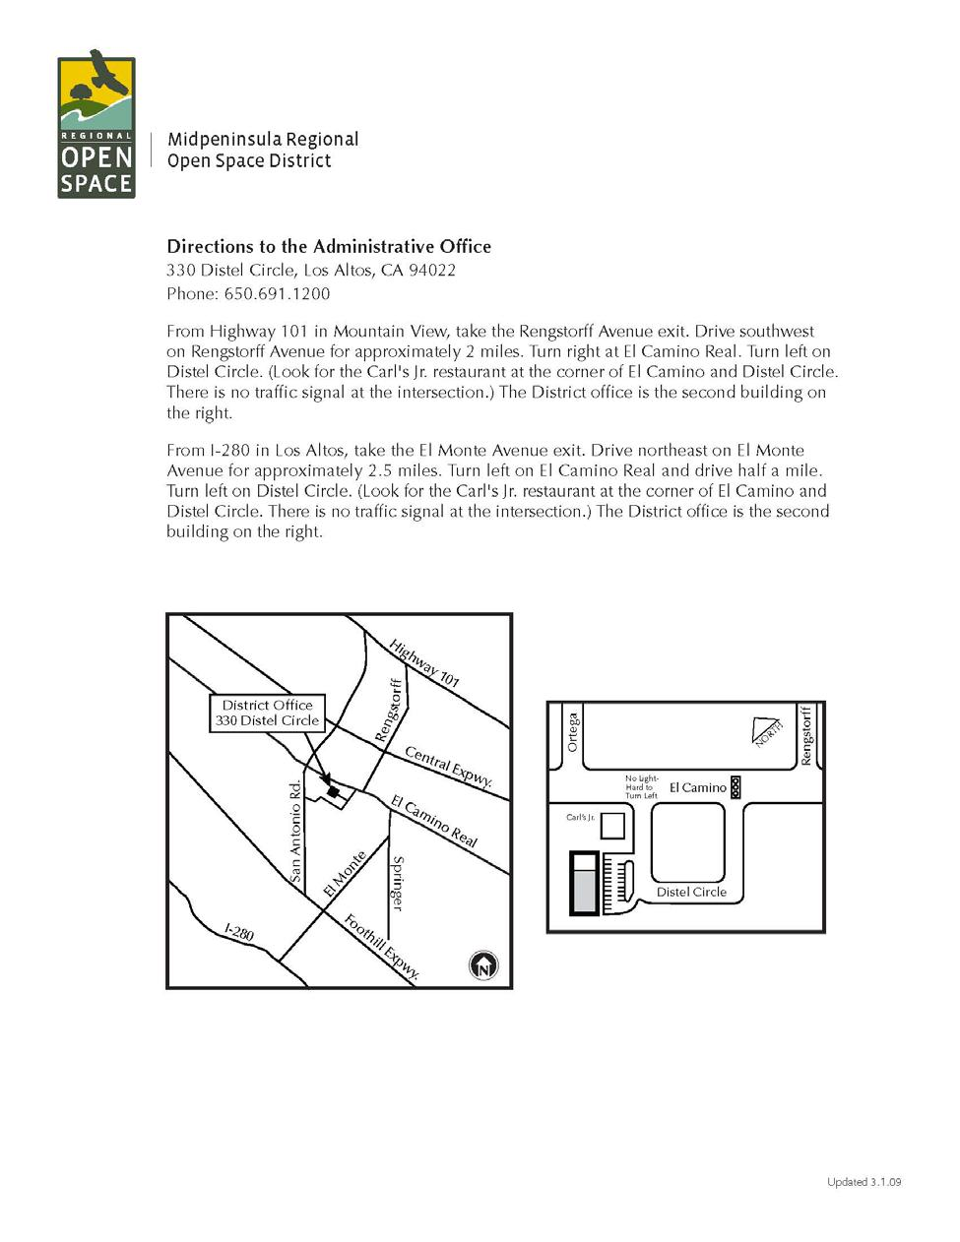

Harkins Bridge Replacement
Bid Package – B. Bidding Documents

Page 13 of 14

(Page left intentionally blank)

Harkins Bridge Replacement
Bid Package – B. Bidding Documents

Page 14 of 14

C. BID FORMS

Harkins Bridge Replacement
Bid Package – C. Bid Forms

Page 1 of 2

(Page left intentionally blank)

Harkins Bridge Replacement
Bid Package – C. Bid Forms

Page 2 of 2

1. BID PROPOSAL FORM

(To be executed by Bidder and Submitted)

Project Name:

Location:

Harkins Bridge Replacement Project
Purisima Creek Open Space Preserve

Scope of Work:

The removal and replacement of a rail road car bridge crossing over Purisima Creek. The Project will replace the existing bridge with a new District supplied bridge that will be installed approximately 100 feet upstream of the current bridge site.

District
Representative:

Matt Brunnings
Midpeninsula Regional Open Space District

330 Distel Circle
Los Altos, CA 94022
(650) 691-1200

The undersigned has carefully examined the site conditions for the Work, attended the Mandatory Pre-Bid Meeting, reviewed all documents in the Bid Package, including the Drawings, Plans and Specifications, accepts all terms and conditions of the Agreement, and has reviewed the following Addenda (fill in blanks below as appropriate to the number of Addenda issued for the project):

Addendum No._______________________, dated _______________________, 20________,

Addendum No._______________________, dated _______________________, 20________,

Addendum No._______________________, dated _______________________, 20________.

1. BASE BID

Bid Proposal will be evaluated based on Total Base Bid. District may opt to award additional work based on unit pricing submitted herein. Bidders proposed Duration for Completion shall be for Total Base Bid.

Harkins Bridge Replacement
Bid Package – C. Bid Forms
Attachment 1 Bid Proposal Form

Page 1 of 7

Item | Spec | Item Description | QTY. | Unit | Unit | Total
No. | sec. | Item Description | QTY. | Unit | Price | Total
1 | 01505 | Mobilization | 1 | LS | $ | $
2 | 01500 | Traffic Control | 1 | LS | $ | $
3 | 01400 | Site Survey and Layout | 1 | LS | $ | $
4 | 02140 | Creek Water Management | 1 | LS | $ | $
5 | 02110 | Straw Wattles (furnish and | 100 | LF | $ | $
5 | 02110 | install)
6 | 02110 | Silt Fence (furnish, install and | 250 | LF | $ | $
6 | 02110 | remove)
7 | 02110 | Seed Disturbed surfaces | 1 | LS | $ | $
8 | 02110 | Erosion control fabric | 850 | SF | $ | $
9 | 02100 | Clearing/Grubbing | 1 | LS | $ | $
10 | 02050 | Remove and dispose of | 1 | LS | $ | $
10 | 02050 | Bridge, misc demolition
11 | 02050 | Bridge Unloading and | 1 | LS | $ | $
11 | 02050 | Installation
12 | 03500 | Bridge deck/concrete | 23 | CY | $ | $
13 | 02520 | Structural Concrete Footings, | 27 | CY | $ | $
13 | 02520 | Stem Walls
14 | 02520 | Construct piles (6) | 125 | LF | $ | $
15 | 02200 | Engineered backfill and | 200 | CY | $ | $
15 | 02200 | Compaction
16 | 02200 | Terrace and light channel | 30 | CY | $ | $
16 | 02200 | earthwork
17 | 02200 | Class II AB - Aggregate Base | 40 | CY | $ | $
18 | 02380 | Rock Slope protection- bridge | 40 | TON | $ | $
19 | 02270 | Willow staked revetments | 80 | LF | $ | $
20 | 02950 | Planting | 1 | LS | $ | $
 |  |  |  |  | $

TOTAL BASE BID $

Proposed Duration for Completion of the Work
on site, including Demolition and bridge
installation:
Calendar days

Harkins Bridge Replacement
Bid Package – C. Bid Forms
Attachment 1 Bid Proposal Form

Page 2 of 7

- EXPERIENCE. List three recently (within last 5 years) completed jobs of comparable scope, the contract amount, names, and telephone numbers of contract officers. Use additional sheets as necessary.

Job/Project Name

Owner |  |  |  | Year |  |  | Contract Amt $
Contact |  |  |  |  |  | Phone
Project Description

Job/Project Name

Owner |  |  |  | Year |  |  | Contract Amt $
Contact |  |  |  |  |  | Phone
Project Description

_________________________________________________________________________

Job/Project Name

Owner |  |  |  | Year |  |  | Contract Amt $
Contact |  |  |  |  |  | Phone
Project Description

- NONCOLLUSION CERTIFICATION. the Noncollusion Affidavit (Attachment Section 7106.

The undersigned has executed and hereby submits 3), in accordance with Public Contracts Code

Harkins Bridge Replacement
Bid Package – C. Bid Forms
Attachment 1 Bid Proposal Form Page 3 of 7

- BID GUARANTEE. No Bid will be considered unless accompanied by a guarantee in the amount of ten percent (10%) of the Total Base Bid), which shall be either a BID BOND (Attachment 4) written by an admitted surety satisfactory to the District in its sole discretion, a certified or cashier's check made payable to the District, or a cash deposit. In the event a successful bidder fails to satisfy all conditions for accepting the award (i.e. executed Agreement, provision of required bonds and proof of insurance) within the stated time limits, the District may declare the bidder's Bid Guarantee in default. Bidder acknowledges that the amount of actual damages the District would suffer in such event is extremely difficult and impractical to determine at this time by reason of the uncertainties, lapse of time, expense and loss of likely bidders resulting from the probable need to re-advertise and call for new bids. Bidder agrees that the amount of such Bid Guarantee shall be kept by the District as liquidated damages and agrees that the District may then award the work to any other bidder or may call for new bids. All Bid Guarantees will be held until after an award is made, an Agreement entered into, and required bonds and proof of insurance provided, at which time they will be returned.

- DISCLOSURE. The names of all persons financially interested in this Bid Proposal are as follows:

Bidder, or any partner of Bidder, is a corporation, provide the legal name of the corporation, the state of its incorporation and the name and address of the President and of the Secretary. If Bidder is a partnership, provide name of the firm and names and addresses of all individual co-partners. Use additional sheets as necessary. If Bidder is an individual, provide the first and last name and address.

Name of Corporation:

State of Incorporation: ______________________________________________________

Name of Officer/ShareholderTitleAddress

Harkins Bridge Replacement
Bid Package – C. Bid Forms
Attachment 1 Bid Proposal Form

Page 4 of 7

Name of Bidder(s)/Partner(s) (If not a corporation)

- WITHDRAWAL OF BIDS. Bids may be withdrawn prior to the opening of bids only by a signed, written notice received by the District Representative prior to the commencement of the bid opening. In consideration of District's reliance on and consideration of this Bid Proposal, the undersigned agrees that such Bid Proposal shall be irrevocable upon opening and shall not be withdrawn for sixty (60) calendar days following the bid opening even though award may be made to another bidder. Thereafter, such bid shall be automatically relieved.

I make the above Bid and declare under penalty of perjury that the statements made in this Bid Proposal are true and correct.

FULLY EXECUTED at |  |  |  |  |  |  |  |  |  |  |  |  |  |  |  | ,
 |  |  |  |  |  |  | City |  |  |  |  |  |  |  |  |  |  |  |  |  |  | State
 |  |  |  |  |  | on |  |  |  |  |  |  |  |  |  | ,
 |  |  |  |  |  |  |  | Month |  |  |  | Day |  |  |  |  |  | Year
Signature¹ |  |  |  |  |  |  |  |  |  |  |  |  | Title
Name (please type or print)
Federal Employer I.D. Number
License Type
License Number |  |  |  |  |  |  |  |  |  |  |  |  | Expiration Date
Name of Firm
Mailing Address
City |  |  |  |  |  |  |  |  |  |  |  |  | State |  |  |  |  |  |  |  | Zip

- An authorized person for the Bidder must sign this Bid Proposal. If the Bidder is a partnership, a general partner must sign. If the Bidder is a corporation, an authorized officer of the corporation must sign and a corporate resolution conferring such authority must be provided.

Harkins Bridge Replacement
Bid Package – C. Bid Forms
Attachment 1 Bid Proposal Form

Page 5 of 7

Phone (Bus) Phone (Cell)

Email

Harkins Bridge Replacement
Bid Package – C. Bid Forms
Attachment 1 Bid Proposal Form

Page 6 of 7

(Page left intentionally blank)

Harkins Bridge Replacement
Bid Package – C. Bid Forms
Attachment 1 Bid Proposal Form

Page 7 of 7

4. LIST OF SUBCONTRACTORS
(To be executed by Bidder and Submitted with Bid)

Contractor must set forth the name, address, phone number, type and cost of work, and proof of required license for each subcontractor who will perform work or render services in any amount exceeding one-half percent (1/2%) of the total bid according to provisions of the California Public Contract Code §4100 through §4113. Each subcontractor must be licensed by the State of California Department of Consumer Affairs for the portion of work they perform in accordance with Contractor's License Law. Please attach as many sheets as necessary.

Company Name:

Contact:

Address:

Phone Number:

Type of Work:

Cost of Work:

Required License:

Company Name:

Contact:

Address:

Phone Number:

Type of Work:

Cost of Work:

Required License:

Company Name:

Contact:

Address:

Phone Number:

Type of Work:

Cost of Work:

Required License:

Harkins Bridge Replacement
Bid Package – C. Bid Forms
Attachment 2 List of Subcontractors

Page 1 of 2

(Page left intentionally blank)

Harkins Bridge Replacement
Bid Package – C. Bid Forms
Attachment 2 List of Subcontractors

Page 2 of 2

- NONCOLLUSION AFFIDAVIT
(To be executed by Bidder and Submitted with Bid)

State of California

County of

(Name of party bidding), under penalty of perjury, deposes and says that he or she is of , the party making the foregoing bid that the bid is not made in the interest of, or on behalf of, any undisclosed person, partnership, company, association, organization, or corporation; that the bid is genuine and not collusive or sham; that the bidder has not directly or indirectly induced or solicited any other bidder to put in a false or sham bid, and has not directly or indirectly colluded, conspired, connived, or agreed with any bidder or anyone else to put in a sham bid, or that anyone shall refrain from bidding; that the bidder has not in any manner, directly or indirectly, sought by agreement, communication, or conference with anyone to fix the bid price of the bidder or any other bidder, or to fix any overhead, profit, or cost element of the bid price, or of that of any other bidder, or to secure any advantage against the public body awarding the contract of anyone interested in the proposed contract; that all statements contained in the bid are true; and, further, that the bidder has not, directly or indirectly, submitted his or her bid price or any breakdown thereof, or the contents thereof, or divulged information or data relative thereto, or paid, and will not pay, any fee to any corporation, partnership, company association, organization, bid depository, or to any member or agent thereof to effectuate a collusive or sham bid.

Signature Title

Date

Harkins Bridge Replacement
Bid Package – C. Bid Forms
Attachment 3 - Noncollusion Affidavit

Page 1 of 2

(Page left intentionally blank)

Harkins Bridge Replacement
Bid Package – C. Bid Forms
Attachment 3 - Noncollusion Affidavit

Page 2 of 2

6. BID BOND
(Note: Bidder must use this form if Bid Guarantee is a Bond)

KNOW ALL PERSONS BY THESE PRESENTS THAT [name of Bidder] (hereinafter Principal), as Principal, and [name of Surety], a corporation organized and doing business under and by virtue of the laws of the State of
______ and duly licensed for the purpose of making, guarantying or becoming sole surety upon bonds or
undertakings required or authorized by the laws of the State of California, as Surety, are held and firmly bound unto the Midpeninsula Regional Open Space District, a California Special District, (hereinafter called the Obligee) in the

just and full sum of Dollars ($ ) lawful money of the United States of America, for the payment of which we hereby bind ourselves and each of our successors and assigns, jointly and severally, firmly by these presents.

THE CONDITION OF THIS OBLIGATION IS SUCH THAT, WHEREAS, the Principal is about to hand in to the Obligee a Bid for the project known as Harkins Bridge Replacement Project in accordance with the Contract Documents filed in the office of the Obligee and under the notice inviting proposals therefor.

NOW, THEREFORE, if the Bid as submitted by said Principal shall be accepted, and the contract for such work or supplies be awarded to the Principal, and the said Principal shall fail, neglect or refuse to enter into a contract to perform said work or deliver said supplies, and furnish good and sufficient bond and proof of insurance therefore, then the amount of this bond shall be declared to be forfeited to the Obligee, Midpeninsula Regional Open Space District.

IN WITNESS WHEREOF, Principal and Surety have caused these presents to be duly signed and sealed this day of _______, 2016.

Signature of Principal Signature of Surety

Attorney-in-Fact

State of California,

County of | )
On | before me, ___________________________________________________

(insert name and title of the officer)

personally appeared __________________________________________who proved to me on the basis of
satisfactory evidence to be the person(s) whose name(s) is/are subscribed to the within instrument and acknowledged to me that he/she/they executed the same in his/her/their authorized capacity(ies), and that by his/her/their signature(s) on the instrument the person(s), or the entity upon behalf of which the person(s) acted, executed the instrument.

I certify under PENALTY OF PERJURY under the laws of the State of California that the foregoing paragraph is true and correct.

WITNESS my hand and official seal.

Signature Seal

Harkins Bridge Replacement
Bid Package – C. Bid Forms
Attachment 4 - Bid Bond

Page 1 of 2

(Page left intentionally blank)

Harkins Bridge Replacement
Bid Package – C. Bid Forms
Attachment 4 - Bid Bond

Page 2 of 2

D. AGREEMENT FORMS

Notice to Bidders:

Documents in the following section are not to be submitted with Bid Proposal. They will be signed and submitted at time of Award of Contract.

Harkins Bridge Replacement
Bid Package – D. Agreement Forms

Page 1 of 2

(Page left intentionally blank)

Harkins Bridge Replacement
Bid Package – D. Agreement Forms

Page 2 of 2



D.1 AGREEMENT

Harkins Bridge Replacement Project

Purisima Creek Open Space Preserve San Mateo County, California

May 30, 2017

Level 4 Agreement Page 1 of 10

(Page left intentionally blank)

Level 4 Agreement Page 2 of 10


LEVEL 4 AGREEMENT
CONTRACT INFORMATION SHEET

- Name of Project:Harkins Bridge Replacement Project

- Project Description: Remove existing Harkins Bridge in Purisima Creek Redwoods OSP and replace with a new bridge approximately 100’ upstream.

- Working Days to Complete: 60 days

- License(s): Class A – General Engineering Contractor

- District Representative: Matt Brunnings, Capital Project Manager

Project: Harkins Bridge Replacement Project

Purisima Creek Open Space Preserve

San Mateo County, California

Date: 5/30/2017

Level 4 Agreement Page 3 of 10
AGREEMENT
Level Four

- Project Name: Harkins Bridge Replacement Project

- Parties:

District:
Midpeninsula Regional Open Space District

Attn: Matt Brunnings, District Representative

330 Distel Circle
Los Altos, CA 94022-1404
(650) 691-1200

      - 691-0485 (facsimile)

Contractor: TBD

- Scope of Work.
  - Project Description. Contractor agrees to obtain all necessary permits and furnish all labor, materials, services, and equipment necessary to accomplish the following Project as more specifically set forth herein and in the Contract Documents fully incorporated herein as though attached hereto (the “Work”) and generally described as follows:

    - Remove existing bridge and replace with a new bridge approximately 100’ upstream.

  - Contract Documents. The Contract consists of the following:

Level Four Agreement

- Exhibit A: Agreement Scope of Services (Contractor Bid Proposal Form) General Conditions of the Agreement

- Exhibit 1: Labor and Materials Payment Bond

- Exhibit 2: Performance Bond

- Exhibit.3: Worker’s Compensation Certificate

- Exhibit 4: Proposed Change Order Request Template

- Exhibit 5: Change Order Template

Supplemental Conditions of the Agreement/ Attachments

- Attachment A: Location Map

- Attachment B: Site Access Map

- Attachment C: Project Work Area Maps

Project Scope Documents
- Click here to enter text.
  - “Not in Contract” (N.I.C.) Items. Any portions of the Project identified by the notation “N.I.C.” on Drawings, Maps, and Specifications will be performed before or after Contractor’s Work and are not part of the Work.

Level 4 Agreement Page 4 of 10

- Term.
The Term of this Agreement shall commence on the date of execution hereof by District’s General Manager and shall end upon the filing of the Notice of Completion by District Representative as more specifically set forth in the General Conditions and Supplemental Conditions, attached hereto and incorporated herein by this reference.

- Contract Price.
As full compensation for the Work, District agrees to pay Contractor the sum of $ TBD as further described and set forth in Contractor’s Bid Proposal attached hereto and incorporated herein as Exhibit A. The Contract Price includes the Base Bid and Additive Alternate(s). Contractor agrees to delete or add Work tasks not covered by the provisions thereof, either under provisions for “ADD OR DEDUCT ALTERNATES” or for “UNIT PRICES”, pursuant to the methods otherwise provided herein for Change Orders.

- Cash Allowances.
Contractor declares that the Contract price includes all expenses (including permit fees) and profit. Contractor shall make no demand for additional expenses and/or profit for work in this Contract.

- Beginning and Completion of Work.
Contractor shall provide District Representative with all certificates and licenses required for performance hereunder within ten (10) days of the commencement of the Term of this Agreement, not including County permits. Contractor agrees that permit application(s) to the County shall be submitted within five (5) working days from the date of issuance of a written Notice to Proceed with Permitting. Contractor agrees that the Work shall be fully completed to District Representative’s satisfaction within sixty (60) working days from the date of issuance of a written Notice to Proceed with Construction. Contractor shall not start any onsite construction work until such Notice to Proceed with Construction is issued. Working days shall mean every day except Saturday, Sunday, and Legal Holidays as hereinafter defined.

- Licensing.
Under California Business and Professions Code §7000 through § 7145, commonly known as the “Contractor’s License Law”, Contractor must possess an appropriate license that is current and valid at the commencement of and throughout the Term of this Agreement. The Licenses required by this Agreement: Class A – General Engineering Contractor.

- Insurance and Bonds.

Contractor shall provide, and keep in full force and effect during the Term of this Agreement, at Contractor's sole cost and expense, policies of insurance with companies licensed to do business in the State of California that are acceptable to District for the Coverages as more particularly set forth below. Contractor shall keep all required policies in full force and effect until final acceptance of the Work by District.

  - Certificates of Insurance. Contractor shall, within five (5) calendar days after Notice of Award, supply District with an acceptable Certificate of Insurance. An authorized insurance agent or broker must complete, execute and provide District with a Certificate of Insurance (ACORD 25-S, or a successor or comparable form, subject to prior approval by District)

Level 4 Agreement Page 5 of 10
before a Notice to Proceed may issue. District reserves the right to cancel the contract if these requirements are not met within 30 calendar days of the Notice of Award.

- Endorsements. The General and Automobile Liability policies must be endorsed to name District as an additional insured and must be on a primary non-contributing basis in relationship to any other insurance available to District. All policies taken out by Contractor insuring work and materials supplied must list District as an additional insured and be payable to Contractor and District. All policies shall contain a provision that they shall not be canceled or materially changed without thirty (30) calendar days' prior written notice to District. No cancellation provision in any insurance policy shall be construed in derogation of the continuous duty of Contractor to furnish the required insurance during the term of the Agreement.

- Coverages.
  - Workers' Compensation Employer's Liability coverage as required by statute, in full compliance with California Labor Code §3700, and containing a waiver of subrogation in favor of District. Contractor hereby acknowledges having read and understood the provisions of the California Labor Code §3700, which require every employer to be insured against liability for workers' compensation or that they undertake self-insurance in accordance with the provisions of that code, and Contractor agrees to comply with such provisions before commencing the Work. Acknowledgment shall be in the form included herein and attached hereto as

Exhibit 3.

  - Comprehensive or Commercial General Liability, including coverage for Bodily Injury and Property Damage in the amount of $2,000,000.00 per occurrence, $2,000,000.00 aggregate.
  - Business Automobile Liability coverage including owned, non-owned and hired vehicles in an amount of no less than $1,000,000.00 per occurrence.
  - Subcontractor(s) Insurance Requirements. Contractor shall either require each subcontractor to procure and maintain during the life of its subcontract all insurance of the type and in the amounts specified above or insure the activities of subcontractor(s) under its own policy or policies.

- Contractor's Indemnification of District.
  - Contractor agrees to indemnify, hold harmless, defend, and protect District, its officers, directors, agents and employees from any and all claims, losses, damages, demands, liabilities, suits, costs, expenses (including all reasonable attorney's fees), penalties, judgments or obligations whatsoever arising out of or in connection with any injury, death, or damage to any person or property or pecuniary or monetary loss that results from, arises out of, or in any way relates to the activities of Contractor both on and off the Project, including but not limited to claims related to the presence, use or disposal of hazardous materials, except for injury or damage resulting from the sole negligence or willful misconduct of District.
  - Claim. In the event a Contractor becomes aware that a claim has been, or is likely to be, made against District, its officers, directors, agents or employees, or they or District is named a co-defendant in any action concerning the Contract, Contractor shall immediately notify District. District may retain legal counsel at Contractor's sole

Level 4 Agreement Page 6 of 10
expense and Contractor shall reimburse District for all legal expenses, including reasonable attorney's fees, spent in representing District.

  - Apportionment of Liability. In the event that a judge in a court of competent jurisdiction makes an apportionment of liability between District and Contractor, neither District nor Contractor shall request that a jury determine apportionment of liability. Contractor shall indemnify and hold harmless District as set forth above, unless the court determines that the injury or damage resulted from the sole negligence or the intentional and willful misconduct of District.
  - Waiver. Contractor hereby waives all claims and recourse against District, including the right of contribution for loss or damage to property, and hereby releases District from any and all liability related to or in any way connected to Contractor's activities or Contractor's use of the Project site, premises or facilities.
  - Contractor Responsibility. Contractor and its subcontractors shall have sole responsibility for the safety of their equipment, property and personnel (including, but not limited to, its employees, agents, and officers) from any and all injuries, deaths or damages.
- Mutual Responsibility of Contractors. If Contractor causes damage to the work or others, or willfully or negligently delays another contractor or subcontractor in the performance of other work, Contractor is hereby obliged to attempt to settle such claim with such contractor or subcontractor by agreement. If a contractor or subcontractor serves written notice on District of Contractor's failure to meet this obligation or to settle the claim by agreement, District shall notify Contractor in writing of the pending claim. Contractor shall defend itself (and District if included in claim) at Contractor's sole expense, including the payment of District’s attorney fees. Contractor shall pay all costs, expenses and liabilities incurred by District as a result of any judgment in favor of another contractor.

Contractor further agrees to the District General Conditions for Indemnity and Assumption of Risk as detailed in Article 5 of the General Conditions attached hereto and incorporated herein by this reference.

- Laws Applicable to District Incorporated.
  - This Contract is subject to all Federal, State and local laws, regulations, ordinances, and governing codes, controlling, affecting, or enacted by the Midpeninsula Regional Open Space District. All such laws, regulations, ordinances, and codes are made a part of this Contract as if set forth fully herein.

  - In compliance with California Government Code §4552 and California Public Contract Code §7103.5, the text of those codes are herein reproduced in full:

GC §4552. Submission of bids to public purchasing body; agreement to assign

In submitting a bid to a public purchasing body, the bidder offers and agrees that if the bid is accepted, it will assign to the purchasing body all rights, title, and interest in and to all causes of action it may have under Section 4 of the Clayton Act (15 U.S.C. Sec. 15) or under the Cartwright Act (Chapter 2 commencing with Section 16700) of Part 2 of Division 7 of the Business and Professions Code), arising from

Level 4 Agreement Page 7 of 10
purchases of goods, materials, or services by the bidder for sale to the purchasing body pursuant to the bid. Such assignment shall be made and become effective at the time the purchasing body tenders final payment to the bidder.

PCC §7103.5. Unfair business practices claims; assignment to awarding body

- As used in this section:

“Public works of contract” means a contract awarded through competitive bids by the state or any of its political subdivisions or public agencies, on whose behalf the Attorney General may bring an action pursuant to subdivision (c) of Section 16750 of the Business and Professions Code, for the erection, construction, alteration, repair, or improvement of any structure, building, road, or other improvement of any kind.

In entering into a public works contract or a subcontract to supply goods, services, or materials pursuant to a public works contract, Contractor or subcontractor offers and agrees to assign to the awarding body all rights, title, and interest in and to all causes of action it may have under Section 4 of the Clayton Act (15 U.S.C. Sec. 15) or under the Cartwright Act (Chapter 2 (commencing with Section 16700) of Part 2 of Division 7 of the Business and Professions Code), arising from purchases of goods, services, or materials pursuant to the public works contract or the subcontract. This assignment shall be made and become effective at the time the awarding body tenders final payment to Contractor without further acknowledgement by the parties.

- Assignment.

Contractor shall not assign its rights or obligations under this Contract without the prior written consent of District Representative, which consent shall not be unreasonably withheld. Contractor shall not assign any monies due Contractor without the written consent of District. Any assignment or delegation without the written consent of the other party shall be void.

- Taxes.

Contractor agrees and states that all taxes arising incidental to this Contract shall be paid in a timely manner by Contractor and are included in the Contract price.

- Federal Manufacturer's Excise Tax.

District is exempt from Federal Manufacturer's Excise Tax. The manufacturers of items subject to such tax are entitled to a refund or credit for that tax on presentation of District's exemption certificate for items furnished exclusively to District. Contractor shall not be entitled to claim any additional monies for taxes paid where this exemption is available.

Level 4 Agreement Page 8 of 10
- Attorneys' Fees.

If legal action shall be brought by either of the parties, the party prevailing in said action shall be entitled to recover from the party not prevailing the costs of the suit and reasonable attorney's fees. For purposes of this Agreement, the reasonable fees for attorneys who are employees of District shall be based on the fees regularly charged by private attorneys with an equivalent number of years of experience in the subject matter area of the law actively practicing within the San Francisco Bay Area.

- Notice.

Any notice required or desired to be given under this Agreement shall be in writing and shall be personally served or, in lieu of personal service, may be given by (i) depositing such notice in the United States mail, registered or certified, return receipt requested, postage prepaid, addressed to a party at its address set forth above; (ii) transmitting such notice by means of Federal Express or similar overnight commercial courier (“Courier”), postage paid and addressed to the other at its street address set forth below; (iii) transmitting the same by facsimile, in which case notice shall be deemed delivered upon confirmation of receipt by the sending facsimile machine’s acknowledgment of such with date and time printout; or (iv) by personal delivery. Any notice given by Courier shall be deemed given on the date shown on the receipt for acceptance or rejection of the notice. Either party may, by written notice, change the address to which notices addressed to it shall thereafter be sent.

- Miscellaneous.

  - Should any provision of this Agreement prove to be invalid or illegal, such invalidity or illegality shall in no way affect, impair or invalidate any other provision hereof, and such remaining provisions shall remain in full force and effect.
  - Time is of the essence with respect to the performance of every provision of this Agreement in which time of performance is a factor.
  - Any executed copy of this Agreement shall be deemed an original for all purposes.
  - This Agreement may be executed in counterparts, which counterparts shall together constitute one agreement if signed by both parties.
  - This Agreement shall be construed and enforced in accordance with the laws of the State of California.
  - The language of this Agreement shall be construed as a whole according to its fair meaning, and not strictly for or against either party.
  - Except to the extent that it provides a part of the definition of a term used herein, the captions used in this Agreement are for convenience only and shall not be considered in the construction or interpretation of any provision hereof nor taken as a correct or complete segregation of the several units of materials and labor.
  - When the context of this Agreement requires, the neuter gender includes the masculine, the feminine, a partnership or corporation, trust or joint venture, and the singular includes the plural.
  - The terms “shall,” “will”, “must” and “agree” are mandatory. The term “may” is permissive.
  - When a party is required to do something by this Agreement, it shall do so at its sole cost and expense without right to reimbursement from the other party unless specific provision is made otherwise.
  - Where any party is obligated not to perform any act, such party is also obligated to restrain

Level 4 Agreement Page 9 of 10
any others within its control from performing such act, including its agents, invitees, contractors, subcontractors and employees.
- The recitals to this Agreement are incorporated in this Agreement by this reference thereto.
- No responsibility either direct or implied will be assumed by District for omissions or duplications to Contractor or any subcontractors due to real or alleged error in arrangement of material in the Contract Documents. This Agreement with all attachments and the Project Scope Documents (e.g., General Conditions, Supplemental Conditions, the Agreement with all Exhibits, and the project Specifications, Drawings, and all Addenda, Clarifications and Modifications incorporated herein by reference or listed in the Agreement), constitute the "Contract Documents" and together represent the entire, integrated Agreement as to the Work contracted for between the parties. It supersedes all prior negotiations, representations or agreements, whether written or oral. The Contract Documents are complementary. Work shown on the Plans and not mentioned in the Specifications, or vice versa, is to be executed as if in both.

Contractor: __________________________________
Name and Title (please type or print)

Signature
_____________ | _____________________
Date | Federal Employer I.D. Number
______________ | _______________
License Number | Expiration Date

Fully executed at Los Altos, California for the
Midpeninsula Regional Open Space District:

_________________________________
Stephen E. Abbors, General Manager

_______________________________
Date

Approved as to form:

_______________________________
Sheryl Schaffner, General Counsel

Attest:

_______________________________
Jennifer Woodworth, District Clerk

Level 4 Agreement Page 10 of 10
TABLE OF CONTENTS

ARTICLE ONE – DEFINED TERMS
1.1 Defined Terms 9

ARTICLE TWO – CONTRACT DOCUMENTS
2.1 Contract Documents Defined 10

2.2 Intent of Contract Documents 11

2.3 General Specifications 11

2.4 Discrepancies Errors and Omissions 11

2.5 Division of Work 11

2.6 Clarifications 12

2.7 “For Construction” Contract Documents 12

2.8 Ownership and Use of Documents 12

ARTICLE THREE – DISTRICT GENERAL REQUIREMENTS
3.1 Authority of the District Representative 11

3.2 Separate Contracts 12

3.3 Boundaries 12

3.4 Inspection 12

3.5 Work, Examination, Re-examination 12

3.6 Correction of Work 13

3.7 Testing / Inspection Services 14

ARTICLE FOUR – CONTRACTOR’S PERFORMANCE OF THE WORK
4.1 General Obligations of Contractor 14

4.2 Examination of Site and Contract Documents 15

4.3 Permits and Regulations 16

4.4 Subcontractors 16

4.5 Joining, Cutting, Patching and Digging: Defects 18

4.6 Use of Premises 18

4.7 Project Cleanliness 19

4.8 As-Built Documents 19

4.9 Water and Air Pollution; Environmental Protection; Erosion Control 19

4.10 Protection of Historic Resources and Human Remains 21

4.11 Hazardous Materials 21

4.12 Safety 22

Level 4 Contract General Conditions Page 1 of 36
Rev. 11-22-16
4.13 Time Limits on Work 23

4.14 Employees, Work Day, Apprenticeship, Non-Discrimination and Wages 24

4.15 Work Schedule 26

4.16 Submittals 27

4.17 Materials 29

4.18 Public Convenience 29

4.19 Fire Hazards and Prevention 30

4.20 Emergencies 30

4.21 Utilities 30

4.22 Protection of Work and Property 31

ARTICLE FIVE – INSURANCE, BONDS AND INDEMNIFICATIONS
5.1 General Insurance Requirements 31

5.2 Specific Insurance Requirements 32

5.3 Guarantee Bonds 32

5.4 Contractor’s Indemnification of District 33

5.5 Assumption of Risk 33

ARTICLE SIX – PAYMENT AND COMPLETION
6.1 Schedule of Values 34

6.2 Application for Payment 34

6.3 Claims 36

6.4 Final Inspection and Acceptance of Work 37

6.5 Guarantee; Correction of Work After Final Payment 37

ARTICLE SEVEN – CHANGES IN THE WORK
7.1 Change Orders 38

7.2 Changes in Character of Work 40

7.3 Extra Work 40

7.4 Contract Price Adjustments 41

7.5 Contract Time Adjustments 42

7.6 Claims for Extras 42

ARTICLE EIGHT – TERMINATION OF THE CONTRACT
8.1 Termination for Default and Acts of Nature 42

8.2 Contractors Abandonment 43

8.3 Abandonment 43

Level 4 Contract General Conditions Page 2 of 36
Rev. 11-22-16
EXHIBITS
- Labor & Material Payment Bond
- Performance Bond
- Workers Compensation Certificate
- Proposed Change Order Request Template

- Change Order Template

Level 4 Contract General Conditions
Rev. 11-22-16

Page 3 of 36

(Page left intentionally blank)

Level 4 Contract General Conditions
Rev. 11-22-16

Page 4 of 36

GENERAL CONDITIONS
of the Agreement

Harkins Bridge Replacement Project

ARTICLE ONE

DEFINED TERMS

1.1 Defined terms. For the purposes of the Contract Documents, the following terms shall have the meanings set forth below.

Addendum: A document containing supplementary details, instructions or information issued by District prior to execution of the Agreement, which modifies, clarifies, supersedes or supplements one or more of the other Contract Documents.

Agreement: The Agreement between the District and the Contractor to which these General Conditions are attached.

Clarification: A document containing supplementary details, instructions or information, issued by the District after execution of the Agreement which modifies, clarifies, supersedes or supplements one or more of the other Contract Documents. Clarifications shall not give rise to a change in the Contract Price or Contract Time.

Contractor shall mean person, persons, firm, partnership, corporation, and assignees, licensed by the State of California, Department of Consumer's Affairs, named as such in the Agreement.

District: Shall mean the Midpeninsula Regional Open Space District.

District Representative: Designated person authorized to act on behalf of the District to the extent provided in the Contract documents or as otherwise specified by the District in writing.

Drawings: The graphic and pictorial representations of the design, location, character, dimensions and details of the Work, generally including plans, elevations, sections details, schedules and diagrams, as identified in the Agreement and as modified pursuant to Addenda, Clarifications, and Change Orders.

Day shall mean calendar day, including Saturday, Sunday, Legal Holidays or Inclement Condition Days.

Inclement Condition Day shall mean any day that, because of weather or site conditions, Contractor cannot work with seventy-five percent (75%) or more of Contractor's labor and equipment force for at least five (5) hours. In the event of inclement weather, Contractor shall be prepared, at the direction of District Representative, to secure the Project site and the Field Office building (if one is used for the Project), erect all necessary erosion control and water protection measures including covering all exposed soils, stockpiles, and building material if total rainfall exceeds 0.5 inch of rain within a 24-hour period.

Level 4 Contract General Conditions
Rev. 11-22-16

Page 5 of 36

Legal Holidays for the purposes of this Agreement are New Year's Day, Martin Luther King, Jr. Day, President’s Day, Memorial Day, Independence Day, Labor Day, Veteran’s Day, Thanksgiving Day, Day after Thanksgiving, Christmas Eve, and Christmas Day.

Notice to Proceed: The written notice issued by District directing Contractor to commence performance for the Work. The commencement date set forth in the Notice to Proceed shall be the date from which the Substantial Completion and Contract Time are calculated.

Subcontractor: The person, firm, partnership, corporation, and assignees, licensed by the State of California, Department of Consumer's Affairs, listed in Attachment 2 to Contractor’s Bid Proposal, and having a binding agreement with Contractor to perform specific portions of the Work. Definition extends to all second and third tier subcontractors.

Work: The term “Work” shall mean and include all demolition, excavation, grading, remediation, construction and other activities described in the Contract Documents or reasonably inferable from the Contract Documents as necessary to produce the intended results and includes all labor, materials, tools, equipment, supervision, coordination, and all other items necessary for the full and proper execution thereof.

Working Day or Work Day shall mean any day, except Saturday, Sunday, Legal Holidays or Inclement Condition Days. District Representative shall be the sole judge of a Working Day.

ARTICLE TWO

CONTRACT DOCUMENTS

2.1 Contract Documents Defined. Contract Documents shall mean these General Conditions, Supplemental Conditions, the Agreement with all Exhibits, and the project Specifications, Drawings, and all Addenda, Clarifications and Modifications incorporated herein by reference or listed in the Agreement, which together constitute the "Contract Documents" and represent the entire, integrated Agreement as to the Work contracted for between the parties. It supersedes all prior negotiations, representations or agreements, whether written or oral.

2.2 Intent of Contract Documents. The intent of the Contract Documents is for the Contractor to provide, for not more than the contract Sum, all labor, supervision, materials, water, power, fuel, tools, plant, equipment, transportation and other items as may be necessary or appropriate for proper execution of the Work (except to the extent expressly provided otherwise in the Contract Documents). The Contract Documents are complementary, and what is shown within one shall be as binding as if shown within all. For example, anything referenced in the Specifications and not shown on the Drawings, or shown in the Drawings and not referenced in the Specifications, shall be of like effect as if shown or referenced in both.

Level 4 Contract General Conditions
Rev. 11-22-16

Page 6 of 36

2.3 General Specifications. In the event the Specifications or any directions given by the District Representative pursuant to the Contract Documents require materials or other Work for which no detailed specifications are provided, the following general specifications shall apply:

The materials shall conform to the usual standards for first-class materials or article of the kind required with due consideration of the use to which they are to be put. Work shall conform to the usual standards for first-class work of the kind required, and shall be subject to the approval of the District Representative.

2.3.1 Specification References. Any material or method specified by reference to the number, symbol, or title of a specific standard such as a Commercial Standard, a Federal Specification, a trade association standard or similar standards, shall comply with the requirements in the latest revision thereof, including any amendments or supplements thereto in effect on the date of Request for Bids, except as limited as to type, class, or grade or modified in such reference.

2.4 Discrepancies, Errors and Omissions. The Contract Documents are not complete in every detail and in some cases may show only the purpose and intent. Contractor shall not avail itself of any manifest error, omission, discrepancy or ambiguity in the Contract Documents, or in the instructions given or in work provided by others. Contractor shall notify the District Representative in writing immediately upon the discovery of any such error, omission, discrepancy or ambiguity and the District Representative shall address the matter within a reasonable period of time, issuing a Clarification or Modification if appropriate. In the event of a discrepancy between documents, the most restrictive requirement shall govern. If Contractor proceeds with any Work-related activity involving an error, omission, discrepancy or ambiguity which Contractor knew of or reasonably should have known of, without first giving such notice, Contractor shall be responsible for all defects, delays, damages, and additional cost to District arising from or relating thereto, including without limitation all costs of correction, inspection testing, supervision and Project administration.

2.5 Division of Work. The organization of the Specifications and arrangement of the Drawings shall not control Contractor in dividing the Work among subcontractors or in establishing the extent of Work to be performed by any trade. Similarly, any table of contents, titles and headings contained in the Contract Documents are provided solely to facilitate reference to various provisions of the Contract Documents and shall in no way affect or limit the interpretations of the provisions to which they refer, or be construed as a proposed segregation of the various units of the Work. Contractor shall arrange, divide and delegate its Work in conformance with sound trade practices, and shall be solely responsible for the division of the Work and establishment of subcontractor limits and scopes of work.

2.6 Clarifications. The District Representative may issue Clarifications to Contractor as necessary or desirable to clarify requirements of the Contract Documents. Contractor shall request a clarification from the District Representative through a Request for Information (RFI) if Contractor or any Subcontractor believes that (a) any Work is not sufficiently detailed or explained in the Drawings and Specifications, (b) there is a conflict between the Drawings and Specifications, (c) there is a conflict between the Drawings and/or Specifications and field conditions, or (d) any other questions arise that require direction from the District

Level 4 Contract General Conditions
Rev. 11-22-16

Page 7 of 36

Representative. Prior to submitting and RFI, Contractor shall complete a thorough review of the Contract Documents and inspect the Site to confirm that the grounds for an RFI exist.

2.7 “For Construction” Contract Documents. District shall furnish Contractor with one hard copy and five (5) CD copies of the final “For Construction” Contract Documents, including Plans, Specifications and any Addenda.

2.8 Ownership and Use of Documents. All Plans, Specifications, Models, and Samples furnished to Contractor are the property of District. Plans, Specifications, Models, and Samples are not to be used by Contractor on any other work. All such Plans, Specifications, Models, and Samples shall be returned to District upon request and in any event at the end of the Term unless otherwise directed by District Representative.

ARTICLE THREE

DISTRICT GENERAL REQUIREMENTS

3.1 Authority of District Representative. During the term of this Agreement, District Representative or his or her designee is fully authorized to represent District in all contractual matters. District Representative shall make all decisions as to the intent of the Plans and Specifications, the amount and quality of work performed and materials furnished, the manner and rate of work performed, the fulfillment of the Contract, and any compensation due Contractor. Disputes or claims between Contractor and District arising from this Contract valued at $375,000.00 or less shall be governed by the claims resolution procedures of California Public Contract Code Section 20104 et seq.. District Representative has the authority to reject any Work or material that does not conform with Contract requirements and to stop Work deemed necessary for such rejection and without cost to District. District Representative is authorized to require Contractor to immediately correct any unsafe or unsuitable condition to District Representative's satisfaction at Contractor's expense. District Representative may furnish additional instructions needed for the proper execution of the Work. District Representative has the authority to require minor field adjustments in the Work not involving extra cost. Contractor shall not relocate Contract items without District Representative's written approval. The District Representative for this Agreement is the person designated above unless Contactor is provided with oral or written notice of the designation of another person.

3.2 Separate Contracts. District reserves the right to let other contracts in connection with this Project. Contractor shall afford other contractors reasonable opportunity for storage of their materials, access to their work sites and execution of their work and shall properly connect and coordinate Work under this Contract with their works. Any dispute arising under the obligations imposed by this paragraph shall be resolved as provided for herein.

3.3 Boundaries. District shall establish Project boundaries in the field whether or not shown on the Plans.

3.4 Inspection.

3.4.1 District Access . District and its duly authorized agent(s) shall have unrestricted access to the Work whether it is in preparation or in progress. District and its duly authorized agent(s)

Level 4 Contract General Conditions
Rev. 11-22-16

Page 8 of 36

shall at all times reserve the right to inspect and/or test for compliance with the Contract Documents any or all materials and/or work provided to or installed in the Work. Contractor shall provide safe and proper facilities for access and inspection.

3.4.2 Required Inspections and Testing. If any law, regulation, ordinance, public authority, specification or District Representative requires any part of the Work to be specially inspected or tested, Contractor shall notify District Representative three (3) working days prior to the Work's readiness for testing or inspection.
3.4.3 Inspection of Phases. Contractor shall notify District Representative two (2) working days in advance of each phase set forth in the Plans or Specifications for inspection.

3.5 Work, Examination; Re-examination. District Representative may order and Contractor shall comply with the examination or re -examination of work. Contractor shall not cause any work to be covered or enclosed without approval of District Representative. Any work enclosed or covered before approval shall be uncovered. After inspection Contractor shall restore all work to its original condition at Contractor's expense.

3.6 Correction of Work.
3.6.1 Removal; Replacement. Contractor shall promptly remove from the site all materials or Work rejected by District Representative. Contractor shall promptly replace material or Work, without cost or expense to District, and shall make good any Work destroyed or damaged by removal of condemned Work.
3.6.2 District Right to Remove Material; Deductions and Accounting. If Contractor does not remove rejected Work or materials within a time prescribed by District Representative, District may remove and store salvageable Work or materials at Contractor's expense. If Contractor does not pay the expense of removal within five (5) calendar days, District may, after providing ten

- days prior written notice, sell Work or materials at auction or private sale. District shall give an accounting of the net proceeds from the sale after deducting all costs and expenses including auction or sale expenses.

3.6.3 Deductions for Uncorrected Work. If District determines not to require corrective Work, the Contract price shall be reduced by an amount equal to the estimated cost of making the Work conform to the Contract Documents as determined by District Representative, plus an administrative fee of fifteen percent (15%) of that cost.

3.7 Testing/Inspection Services.
3.7.1 District. District may require that specialized test(s) and/or inspection(s) of the Work be performed by an independent testing/inspecting service of its choice. District shall pay for initial specialized tests or inspections. Contractor shall pay for any re-test or re-inspection that is thereafter required as a result of a failed test or inspection due to nonconformity with Contract requirements.
3.7.2 Contractor. When Contractor is required by Contract or regulation of government authority having jurisdiction over the Work to provide certification by an independent testing/inspection service, Contractor shall be responsible for, and promptly pay, all costs thereof. District Representative must approve any independent testing/inspection service proposed for use by Contractor prior to employment of such service. All tests required by the Contract shall be made promptly so as not to delay the Work. Contractor shall furnish three (3) copies of all resulting testing/inspection reports.

Level 4 Contract General Conditions
Rev. 11-22-16

Page 9 of 36

ARTICLE FOUR

CONTRACTOR’S PERFORMANCE OF THE WORK

4.1 General Obligations of Contractor.

4.1.1 Contractor shall complete all work in accordance with the Contract Documents and any subsequently executed Change Orders and written Field Directives. Contractor shall do all work and furnish all labor, materials, tools, appliances, equipment, fuel, power, light, heat, telephone, water, sanitary facilities, temporary facilities, all other facilities, and incidentals necessary to furnish, perform, test, start-up, and complete the Work within the time set forth in the Agreement, except as otherwise specifically expressed within the Contract Documents.

4.1.2 The right of general direction by District does not render Contractor an agent or employee of District; Contractor understands and acknowledges that Contractor’s liability for any damages to persons or to public or private property arising from Contractor's execution of the Work shall not be lessened due to District general direction to Contractor.
4.1.3 Neither the presence of any District officer, director, agent, employee, consultant, or independent testing/inspection service hired by District, nor their general review or approval of any work shall relieve Contractor from its obligations to perform the Work in accordance with the Contract Documents.

4.1.4 Superintendent. Contractor shall submit the name, and the qualification resume of the competent superintendent and Project Manager who shall have the authority to represent and act for Contractor at the pre -construction meeting. The superintendent (or a competent assistant previously approved by District Representative) shall be on the Project site at all times while Work is in progress. The superintendent shall be changed only upon written consent of District Representative or if the superintendent ceases to be in Contractor's employ. Any replacement must be approved by District Representative. The superintendent, Project Manager and assistant shall be able to communicate with District Representative in English, as necessary for the safe and efficient execution of the Work.
4.1.5 Pre-construction Meeting. A pre-construction meeting attended by Contractor, District Representative, and others as appropriate, will be held within five (5) calendar days of Notice of Award to discuss the Work. All required documents, requests, and proposals must be submitted at or before this meeting.
4.1.6 Review Work Site and Contract Documents. Upon award of contract, Contractor shall again carefully compare work site conditions, all drawings, specifications, and other instructions and shall promptly report in writing to District Representative any error, inconsistency or omission at the pre-construction meeting.
4.1.7 Monuments. Contractor shall take reasonable measures to prevent dislocation or destruction of monuments before Contractor starts work. Contractor must protect benchmarks monuments and reference points from displacement or damage.
4.1.8 Plans at Work Site. Contractor shall at all times keep a complete and accurate set of the Agreement, and all Plans, Specifications, Addenda, Change Orders and shop drawings on the Work site (in good order) for use by District Representative.
4.1.9 Daily Journal & Photo-Documentation. Contractor shall maintain a daily journal of all activities on site, including but not limited to: deliveries to site; number of contractor personnel working on site; number of subcontractor personnel working on site; equipment operating on site; construction activities and work accomplished.

4.1.9.1 The journal shall include date and time stamped photo-documentation of the work described in the daily journal;

Level 4 Contract General Conditions
Rev. 11-22-16

Page 10 of 36

4.1.9.2 The daily journal shall commence on the date that the Contractor first starts work on site, including but not limited to brushing, clearing, mobilization, delivery of equipment or materials, etc. Following the first day of activity on site, Contractor shall log all work completed on a daily basis; 4.1.9.3 If no work is completed on site on a specific day, Contractor shall document “No Work on Site” in the daily journal for that date;
4.1.9.4 Contractor shall have daily journal with him/her at all times at the jobsite to ensure that work progress is being accurately documented as it is being completed;
4.1.9.5 District Representative may request to review daily journal at any time to confirm that Contractor is complying with daily journal requirements;
4.1.9.6 Two signed copies of the daily journal must be submitted with each Pay Application for the dates covered by the Pay Application. Pay Application will not be processed without submission of the daily journal.

4.2 Examination of Site and Contract Documents.
4.2.1 Examination of Site. By executing the Agreement, Contractor acknowledges having examined the Work site; compared the site with the Plans and Specifications; determined any site variation that affects the scope, cost and schedule of the Work; and investigated the conditions of existing clearances, restrictions, or limitations that affect access to the Work. Contractor's failure to do any and all of the above shall not become a basis for claim of additional monies or extension of time.
4.2.2 Transportation/Access. Contractor shall investigate the conditions of the existing public and private roads for clearances, restrictions, and other limitations to transportation, and the ingress/egress at the job site. The unavailability of transportation facilities or limitations thereon shall not become a basis for claims against District or extension of time for the completion of work.
4.2.3 Examination of Contract Documents. Contractor shall examine the Contract Documents to verify that there are no missing pages or sheets and shall obtain and examine any and all missing material prior to commencing the Work. District shall not allow any claim based on errors in the Contract Documents which Contractor has reason to recognize, unless Contractor gives prompt notice of the error to District Representative in writing.
4.2.4 Contractor's Failure to Examine. No allowance shall be made on behalf of Contractor due to neglect, failure or error in acquainting itself with the Project and existing conditions or any and all of the Contract Documents.
4.2.5 Contractor's Notice to Subcontractors. Contractor's failure to provide all subcontractors with all information received shall not become a basis for monetary claim, extension of time or change to contract requirements.

4.3 Permits and Regulations.
4.3.1 Compliance with Regulatory Requirements. Contractor is directed to review and comply with any and all regulatory requirements of all agencies and jurisdictions having authority over the Work.

4.3.2 Contractor shall be responsible for securing and paying all permits, fees and/or licenses necessary to complete the Work. A copy of all permits and agreements must be displayed at the Work site. Contractor shall give all notices, pay all fees, obtain and pay for all permits, licenses, inspections, and certificates required by any governmental authority having jurisdiction over any part of the Work, unless otherwise relieved of such obligation in the Contract Documents.
Contractor shall comply with all applicable laws, ordinances, rules and regulations. Before District Representative issues the certificate for final payment, Contractor shall deliver to District

Level 4 Contract General Conditions
Rev. 11-22-16

Page 11 of 36

Representative all licenses, permits and certificates of inspection.

4.4 Subcontractors.
4.4.1 Listing of Subcontractors. Contractor has set forth in the Bid Form of the Agreement the name, address, phone number, type and cost of work, and proof of required license for each subcontractor who will perform work or render services in any amount exceeding one-half percent (1/2%) of the total bid according to provisions of the California Public Contract Code §4100 through §4113. Each subcontractor shall be licensed by the State of California Department of Consumer Affairs for the portion of work they perform in accordance with Contractor's License Law.
4.4.2 Failure to Specify. If Contractor fails to specify a subcontractor, Contractor must be fully qualified and licensed and shall perform that work. Contractor shall not sublet or subcontract any portion of work that was not designated to a subcontractor in the original bid. If Contractor subcontracts any portion of work after Award of Contract to an undesignated contractor, Contractor shall be subject to penalties according to the California Public Contract Code §4110. 4.4.3 Substitution of Subcontractors. Contractor shall not substitute any subcontractor for another listed in the original Bid Proposal without the written consent of District Representative. Consent may be granted in any of the following situations:

- Contractor demonstrates to District that the subcontractor listed was the result of an inadvertent clerical error, subject to the provisions of the California Public Contract Code §4107.5.
- The subcontractor listed refuses to execute a written contract with Contractor.
- The subcontractor listed is not licensed and in good standing pursuant to the provisions of California Business and Professions Code §7000 through § 7145.
- The subcontractor fails or refuses to meet bond requirements of Contractor.
- The subcontractor becomes bankrupt or insolvent.
- The subcontractor is substantially delaying or disrupting the progress of the Work.
- District Representative determines that work performed by the subcontractor is substantially unsatisfactory and not in accordance with the Contract Documents, or is failing or refusing to perform his subcontract.
- District determines that a listed subcontractor is not a responsible contractor.
- The listed subcontractor is ineligible to work on a public works Project pursuant to California Labor Code Section 1777.1 or Section 1777.7.

4.4.4 Notice and Hearing. Prior to substitution of a subcontractor, District Representative shall give written notice to the listed subcontractor of Contractor's request to substitute and the reasons for that request. Written notice shall be served by certified or registered mail to the last known address of the listed subcontractor. The subcontractor shall have five (5) working days to file with District written objections to the substitution. Failure to file written objections shall constitute the listed subcontractor's consent to substitution. If written objections are filed, District shall give five (5) working days’ written notice to Contractor and subcontractor of a hearing by District on Contractor's request for substitution.
4.4.5 Subcontractor Assignment. Contractor shall not permit a subcontractor to assign, transfer or convey the performance of work to another subcontractor without the written consent of District Representative.

- Violation; Penalty. In accordance with California Public Contract Code §4110, District may consider the violation of any portion of this paragraph a breach of contract and cancel this Contract or penalize Contractor ten percent (10%) of the amount of the subcontract involved. Contractor shall be entitled to a public hearing as described above. District will give written

Level 4 Contract General Conditions
Rev. 11-22-16

Page 12 of 36

notice of the hearing five (5) days in advance. All recovered funds shall be paid to District's General Fund.

4.4.6 Contractor's Responsibility for Subcontractors. Contractor agrees to be fully responsible to District for the acts and omissions of any and all subcontractors and for persons either directly or indirectly employed by them. Contractor shall coordinate all subcontractors to complete all the Work in accordance with the Contract Documents.
4.4.7 Non-Contractual Relationship. Nothing contained in the Contract Documents shall create any contractual relationship between any subcontractor and District.

4.5 Joining, Cutting, Patching and Digging; Defects.
4.5.1 Joining of Parts. Contractor shall cut, fit or patch Contractor's work as required to make its several parts come together properly with the work of other contractors and shall do all that is necessary in the joining of all parts in a neat and workmanlike manner to the satisfaction of District Representative. Contractor shall not damage or endanger any portions of work fully or partially completed.
4.5.2 Consent Required. Contractor shall not cut, dig or otherwise alter the work of another contractor without the prior written consent of District Representative.
4.5.3 Defects. If Contractor's work depends upon the work of another contractor, Contractor shall inspect and promptly report to District Representative any defects that could prevent proper performance. Contractor's failure to inspect and report shall constitute acceptance of the other contractor's work. No claim by Contractor of prior defects affecting the Work will be considered after work has started. Contractor will make all corrections at own expense. Prior defects affecting Contractor's work discovered after starting shall be reported immediately to District Representative.
4.5.4 Measurement of Work in Place. Contractor shall measure work already in place and shall report promptly in writing to District Representative any discrepancy between existing work and the Plans and Specifications.
4.5.5 Costs. Any costs resulting from defective or out of sequence work shall be borne by Contractor.

4.6 Use of Premises.
4.6.1 Physical Limits of Materials, Operations. Contractor shall confine all machinery, tools and other apparatus, the storage of materials and the operations of Contractor's workers to limits indicated by law, ordinances, permits or directions of District Representative. All personal vehicles shall park within the project boundaries and not trespass onto adjoining properties.
4.6.2 Temporary Storage. Contractor shall not use the Project site or any area set aside as a temporary construction yard as a site for the temporary storage of equipment, appliances, vehicles, or other materials, that are not or will not be used in the Work.
4.6.3 Dangerous Loads. Contractor shall not load or permit any part of the Work to be loaded with a weight that will endanger its safety or the safety of any person or property.
4.6.4 Signs and Advertising. Contractor shall comply with and enforce District Representative's instructions regarding placement of signs and advertising on and about the Work site. Advertising signs or name labels of any description shall not be placed on or near the Work site without District Representative's prior written approval.
4.6.5 District Occupancy Prior to Acceptance. District reserves the right to occupy or use any part, parts, or the entirety of the Work when District Representative deems it safe. The exercising of this right shall in no way constitute an acceptance of any part of the Work, nor shall it in any way affect the dates and times when payments become due Contractor; nor shall it in any way

Level 4 Contract General Conditions
Rev. 11-22-16

Page 13 of 36

prejudice District's rights in the Contract. The Contract shall be deemed completed only when District Representative, in writing, accepts all the Work contracted for.

4.6.6 Field Office. If a job site office is used, District Representative must approve the facility and its location before installation. District makes no representations as to the feasibility of access to the Work area for a job site office or secured storage facility due to the nature of the site which may hinder or prevent such transportation.

4.7 Project Cleanliness.

4.7.1 Requirements. Contractor shall keep the Project and surrounding areas free from accumulations of waste material and rubbish generated by employees and subcontractors. Contractor shall remove all rubbish, tools, equipment and surplus materials leaving the area "broom clean" at the completion of the Work, unless a different nature of cleanup or repair is specified elsewhere in the Contract Documents. Trash and rubbish must be stored in animal-proof containers, transported daily from site and legally disposed of. Contaminated or dangerous materials must be removed and promptly disposed of if encountered. No materials may be burned, buried or otherwise disposed of on site. Tools, equipment, and site protections measured are to be removed when Work is completed and when authorized to do so by District Representative.
4.7.2 Disputes. If a dispute arises between Contractor herein and any other contractor(s) retained by District (excluding any subcontractor(s) of Contractor herein) as to responsibility for removal of rubbish or other waste, District may remove the rubbish or other waste and charge all or any portion of such costs to Contractor as District Representative determines to be reasonable.

4.8 As-Built Documents. Contractor shall maintain a complete and updated set of “As-Built” drawings and supplementary documents that shall be corrected daily and show every change from the original drawings and specifications, as well as the exact locations, sizes and kinds of equipment as actually installed. This set of drawings and documents shall be kept on site and shall be used as a record set. Updates must occur both on hard-copy and electronic version of “For Construction” documents.

4.8.1 These drawings shall also serve as work progress sheets, and neat and legible annotations shall be made daily as the Work proceeds, showing the Work as actually installed. These drawings shall be available at all times for inspection and shall be kept at the worksite in a location designated by District Representative.
4.8.2 Contractor will meet on a regular basis with District Representative to confirm the correctness and completeness of the “As Built” documents. Under no circumstances shall trenches be backfilled until District Representative has verified the “As Built” plans relating to such trenching. If, in the sole opinion of District Representative, Contractor fails to provide accurate and verifiable information, a survey crew may be retained by District at Contractor's sole expense.

4.9 Water and Air Pollution; Environmental Protection; Erosion Control.
4.9.1 Water Pollution. Contractor shall exercise every precaution to protect streams and bodies of water from pollution by fuels, oils, salts or other hazardous materials as defined herein. Contractor shall minimize muddying and silting of any stream or body of water. Contractor shall, at District Representative's direction, perform work in small units or use modified construction procedures when necessary, to provide effective water pollution control. Contractor shall prevent any construction equipment, material, and debris from falling, landing, or reaching any adjacent creek drainage. At the pre-construction meeting, Contractor shall submit to District Representative in writing, a program to control water pollution. Contractor shall provide, at no

Level 4 Contract General Conditions

Rev. 11-22-16

Page 14 of 36

cost to District, temporary dikes, basins, ditches, straw, seed, or other appropriate device, when, in the opinion of District Representative, they become necessary as a result of Contractor's operations. District Representative may require Contractor to revise Project operations and the Work Schedule at no additional cost to District if Contractor's water pollution control measures are ineffective.

4.9.2 Dust Control. Contractor shall control dust resulting from Contractor’s performance of the Work either by applying water or a dust palliative without additional costs to District. Use temporary enclosures, coverings and water sprinkling, or combinations thereof, as necessary to limit dust to lowest practicable level, consistent with the Project’s Erosion Control and Pollution Prevention Plan, except do not use water to the extent that it causes flooding, erosion, or contaminated runoff. District Representative has full authority to suspend Work wholly or in part should Contractor fail to perform to the satisfaction of District Representative.
4.9.3 Sudden Oak Death (SOD) Precautions. Prior to the start of construction work, the Construction Superintendent shall inform construction personnel that they are working in a potential SOD-infested area, the implications of the disease, and the need to prevent further disease spread. Non-English speaking personnel shall be provided the appropriate written or verbal translations. To the extent practical, avoid locating equipment and material near host plants and trees, especially if showing disease symptoms. Route all equipment away from host plants and trees, especially if they exhibit any disease symptoms. No plants, trees, soil, duff, or other natural on-site material shall be removed from the Preserve without prior approval from District Representative. Any cutting or chipping of on-site plant material shall be restricted to the Project area and the debris shall remain in the Project area. After completing any cutting or chipping of on-site plant material, ensure that the equipment is free from host debris by first removing any visible plant material that clings to the equipment and follow with the cutting or chipping of non-host material. Before any equipment or vehicles leave the Preserve, Contractor shall inspect the equipment and vehicles for host plant debris (leaves, twigs, and branches). Host plant debris must be removed from equipment and vehicles prior to their departure.
4.9.4 Mud. If conditions at the Work site are muddy due to dust suppression activities or summer rains, remove or wash off accumulations of soil, mud, and organic debris from shoes, boots, vehicles, and heavy equipment prior to exiting the Preserve. If an equipment power wash station is used, District Representative must first approve its location.
4.9.5 Wildlife. Construction workers shall be instructed not to disturb or feed wildlife.
4.9.6 Noise. District Representative shall decide on the adequacy of provision and maintenance of noise reduction equipment. When so instructed in writing by District Representative, Contractor shall immediately withdraw any item of plant or equipment from service and carry out all necessary additions, replacements or repairs to the noise reduction equipment to the satisfaction of District Representative.
4.9.7 Pollution Prevention. All equipment shall be in proper working order, with no known leaks. All leakage shall be cleaned up properly. Equipment shall be cleaned of all excess dirt or soil materials prior to departing District property. All leakage shall be cleaned up properly as set forth in the Erosion Control and Pollution Prevention Plan if one has been prepared for the project. Equipment shall be cleaned of all excess dirt or soil materials prior to departing District property.

4.10 Protection of Historic Resources and Human Remains. Contractor shall, during all work, be alert for indicators of historic resources (such as bivalve shells or fragments, stone tools, old china objects or fragments, old glass objects or fragments, old foundations and old privy deposits) and human remains. If any such indicators are uncovered, all work within fifty

Level 4 Contract General Conditions
Rev. 11-22-16

Page 15 of 36

- feet shall be halted and District Representative immediately notified. District will have the find evaluated by the proper authorities or professionals. Only the balance of that workday shall be compensated by District if Contractor cannot perform work elsewhere on the Project.
Recommendations from the qualified authorities or professionals may result in a change of Work and a Change Order may be issued.

4.11 Hazardous Materials.
4.11.1 Definition. As used herein, hazardous materials shall include all items listed in any statute, ordinance or publication defining hazardous materials including, but not limited to, common household items containing substances now or subsequently listed as a hazardous material or substance, chemicals, drugs, any materials used for laboratory analysis, nuclear and/or radioactive materials, toxic substances, hazardous substances, hazardous wastes, contaminated or polluting substances, materials or waste toxic, caustic, corrosive, gaseous or flammable substances that may cause injury, illness or death to living organisms.
4.11.2 Approval . Contractor shall not use any hazardous material in connection with this Project without the prior written approval of District Representative. Ten (10) working days prior to using a hazardous material, Contractor shall submit to District Representative complete Material Safety Data Sheet (MSDS) information, product specifications, and a document stating the application rate and method and including the name of the manufacturer's local representative and emergency telephone numbers. District Representative's response to Contractor's request for approval of hazardous materials use shall not affect Contractor's obligation to comply with the provisions of this section.
4.11.3 Application. In using hazardous materials, Contractor shall:

- Notify District Representative of the application schedule at least five (5) working days in advance.
- Comply with all applicable federal, state, and local laws, regulations, and ordinances relating to the use and disposal of hazardous materials and containers, environmental protection, industrial hygiene, worker and public safety.
- Supply protective clothing or equipment as required by applicable federal or state law for all persons handling hazardous materials, and for District Representative as required for inspection of the Work.
- Be responsible for the notification of all concerned parties adjacent to or effected by said hazardous material and as directed by District Representative.

4.11.4 Special Situations. In the event Contractor encounters material on the site reasonably believed to be asbestos, polychlorinated biphenyl (PCB) or any other hazardous or toxic substance, Contractor shall immediately stop Work in the areas affected and report the condition to District Representative. If in fact the material is asbestos, polychlorinated biphenyl (PCB) or any other hazardous or toxic substance that has not been rendered harmless, the Work in the affected area shall not be resumed except by written agreement between District Representative and Contractor. The Work in the affected area otherwise shall only be resumed when asbestos, polychlorinated biphenyls (PCBs) and other hazardous or toxic substances have been removed or rendered harmless.

4.11.5 For Projects where scope of work includes Hazardous Materials Abatement and/or Remediation, refer to Project Drawings and Specifications for Hazardous Material requirements.

4.12 Safety.
4.12.1 Responsibility for Safety. Contractor shall be responsible for initiating, maintaining and supervising all safety precautions and programs. All work shall conform to the requirements of

Level 4 Contract General Conditions
Rev. 11-22-16

Page 16 of 36

the California Administrative Code, Title 8, Industrial Relations, Division of Industrial Safety. Contractor shall be solely responsible for responding to, and the final satisfaction of any and all claims of personal injury or property damage.

4.12.2 Safety Equipment and Workers. Typical natural hazards on District lands include poison oak and other poisonous plants, poisonous insects and spiders, ticks, rattlesnakes, rabid animals, thorny plants, heat stroke, and rough terrain. All job site personnel should be able to recognize these hazards and to handle accidents involving them. Contractor shall take all reasonable measures as required by existing conditions and performance of the Contract to protect the public and their property. Contractor shall provide adequate barricades, fences, signs, tarps, warning lights, watchpersons, flag persons, etc., to protect the public and their property. Safety devices and workers shall comply with the current State of California "Manual for Warning Signs, Lights and Devices for Use in Performing Work Upon Highways", as a minimum standard. All lighting shall be electric powered and left on from sunset to sunrise.
4.12.3 Trench and Excavation Safety. As required by the California Labor Code §6705, whenever any portion of the Work involves excavating or trenching five feet or deeper, Contractor shall submit for acceptance by District a detailed plan showing the design of shoring, bracing, sloping, or other provisions to be made, to protect Contractor's workers, District personnel, and the public at large. If the plan varies from standard shoring systems established by the Construction Safety Orders of the Division of Industrial Safety, a registered civil or structural engineer employed by Contractor shall prepare the plan. All costs for trenching, excavation safety, including engineering, shall be included within the Contract Bid. Contractor shall submit a shoring plan for District’s review no later than the pre-construction meeting. Contractor is solely for the adequacy of this plan. All trenching or excavation greater than five

- feet deep below ground surface shall meet the provisions of Public Contracts Code §7104 as may be amended from time to time, which provides as follows:
(a) Contractor shall promptly, and before the following conditions are disturbed, notify District, in writing, of any:
4.12.3.a.1 Material that Contractor believes may be material that is hazardous waste, as defines in Health and Safety Code Section 25117, and may be required to be removed to a Class I, Class II, or Class III disposal site in accordance with provisions of existing law.
4.12.3.a.2Subsurface or latent physical conditions at the site differing from those indicated.
4.12.3.a.3 Unknown physical conditions at the site of any unusual nature, different materially from those ordinarily encountered and generally recognized as inherent in work of the character provided for in the Contract.
(b) District shall promptly investigate the conditions, and if it finds that the conditions do materially so differ, or do involve hazardous waste, and cause a decrease or increase in Contractor’s cost of, or the time required for, performance of any part of the Work shall issue a change order under the procedures described in the Contract.
(c) In the event that a dispute arises between District and Contractor whether the conditions materially differ, or involve hazardous waste, or cause a decrease or increase in Contractor’s cost of, or time required for, performance of any part of the Work, Contractor shall not be excused from any scheduled completion date provided for by the Contract, but shall proceed with all work to be performed under the Contract. Contractor shall retain any and all rights provided either by Contract or by law that pertains to the resolution of disputes and protests between the contracting parties.

4.12.4 Use of Equipment. No equipment shall move onto the Project without approval from District Representative. All equipment shall remain within the Project boundaries as set forth by

Level 4 Contract General Conditions
Rev. 11-22-16

Page 17 of 36

District Representative and/or Contract Documents.
4.12.5 Unauthorized Vehicles. When required by this Contract or District Representative, Contractor shall take measures to prevent unauthorized vehicular traffic.
4.12.6 Material and Equipment Transportation. Trucks hauling material or equipment shall not exceed vehicle or posted load and speed limits.

4.13 Time Limits on Work.
4.13.1 Work Hours. No Work or equipment shall be started on a Work Day before 7 a.m., nor continue beyond 5 p.m., except when expressly permitted by the Contract Documents, agreed upon at the pre-construction meeting, or otherwise approved in writing by District Representative. Work outside of these hours, on weekends or on Legal Holidays, shall be subject to a fine of One Thousand Dollars ($1,000.00) per day as liquidated damages, the exact amount of the actual damages being difficult to calculate, and the parties hereby agree that this is a fair and reasonable estimate of the actual damages suffered by District and its constituents and which shall be levied at the sole discretion of District Representative. Contractor may request permission to work on a Saturday, Sunday, or Legal Holiday, or outside normal working hours by notifying District Representative at least two (2) Working Days in advance. Contractor shall only be permitted to Work outside normal working hours at such times and on such days as are previously authorized by District Representative in writing.
4.13.2 Extensions, Delays, Suspension of Work. District Representative shall have sole discretion in the approval or denial of Contract time extensions. Contractor may make written request to District Representative for an extension of time to complete the Contract promptly following an occurrence of any one or more of the following:

- Delay due to work by District or another contractor.
- Delay due to difficulties in securing all required permits.
- Labor dispute beyond Contractor's control that affects work progress.
- A natural disaster that District Representative concludes substantially damages completed work or stored material (provided Contractor's neglect did not contribute to the damage).
- Unusual Inclement Conditions. Contractor shall submit the accumulated record mean values from climatological data filed by the U. S. Department of Commerce as part of Contractor's claim for time extension due to inclement conditions, if an extended inclement weather season causes contract work delay.

4.13.3 Liquidated Damages for Delay. If Contractor fails to complete the work within the specified time plus any extensions thereof, Contractor shall become liable to District, as liquidated damages, the sum of $1,000.00 for each calendar day beyond the time specified above, the actual damage incurred being difficult to calculate and the parties hereby agree that this is a fair and reasonable approximation and not to be construed as a penalty. Nothing herein shall be construed to preclude District from recovery of damages for causes other than for delay by Contractor. Any money due Contractor may be retained by District to cover liquidated damages. Should retained money not be sufficient to cover damages, District shall have the right to recover the balance from Contractor or its sureties.
4.13.4 Authorized Suspension. Should District Representative authorize a work suspension, the suspension time shall be added to the Contract time. Work suspended by District shall not be deemed a waiver of District's right to damages for non-completion.
4.13.5 Delay Caused by District. In the event District delays Contractor in the Work, Contractor's compensation shall be limited solely to an extension of time. Contractor agrees that in no event shall Contractor be entitled to a monetary payment over and beyond that specified in the Contract plus approved change orders. However, if District causes the delay, and the delay is

Level 4 Contract General Conditions
Rev. 11-22-16

Page 18 of 36

unreasonable under the circumstances and not within the contemplation of the parties, this subsection shall not preclude the recovery of compensation when Contractor would otherwise be entitled to such payment.

4.13.6 Additional Work to Correct Delays. If, in the opinion of District Representative, Contractor is not proceeding with the Work as scheduled, upon written direction from District Representative, Contractor shall work (at no additional cost to District) such overtime, additional shifts, Saturdays, Sundays or Legal Holidays required to correct delays. Contractor shall, by the diligent pursuit of the Work, ensure that the Work is completed within the Contract time.

4.14 Employees, Work Day, Apprenticeship, Non-Discrimination and Wages.

4.14.1 Skilled Workers. Contractor and all subcontractors shall only employ workers suitably skilled in the Work.
4.14.2 Character of Workers. Anyone employed on the Project by Contractor, or any subcontractor, who in the opinion of District Representative is incompetent, disorderly, or otherwise acts improperly, after written notification, shall be dismissed from the Project and not further employed on any part of the Work.
4.14.3 Lawful Working Day. Work performed by workers more than eight (8) hours during any one (1) calendar day and more than forty (40) hours in any one (1) calendar week may be permitted pursuant to the overtime provisions of Labor Code Section 1815 and then only upon such terms, conditions and requirements as provided and fixed by law. As provided in California Labor Code §1813, Contractor shall forfeit twenty-five dollars ($25.00) for each worker employed in the execution of the Contract by Contractor or by any subcontractor for each calendar day during which such worker is required or permitted to work in violation of Labor Code Sections 1810 through 1815.
4.14.4 Apprenticeship Standards. Contractor shall comply fully with the requirements of California Labor Code §1777.5 regarding employment of registered apprentices. If Contractor willfully fails to comply with this code section, Contractor may be denied the right to bid on any District contract for a period of one (1) year from the date of non-compliance determined by the California Division of Apprenticeship Standards. When District receives from the Division notice that Contractor is not in compliance with apprenticeship standards, District shall withhold from Contract payments the amount of the civil penalty imposed by the Division, which funds may be released to Contractor upon order of the Administrator or upon completion of the Contract.
4.14.5 Non-Discrimination. Contractor and its subcontractors will comply with all applicable equal employment opportunity and affirmative action laws throughout the term of this Agreement. Contractor hereby certifies that it will not unlawfully discriminate in its employment with regard to race, religious creed, color, national origin, ancestry, physical handicap, medical condition, marital status, sex, sexual preference, or age; that all federal, state and local directives and executive orders regarding non-discrimination in employment will be complied with; and that the principle of equal opportunity in employment will be demonstrated positively and aggressively. Contractor further certifies that it shall require the compliance of its subcontractors on the Work with all of the provisions of this paragraph. Contractor hereby acknowledges its understanding that this Contract may be canceled, terminated or suspended in whole or in part and Contractor and/or its subcontractors declared ineligible for future contracts with District, in the event Contractor and/or its subcontractors are found in non-compliance with the terms hereof.
4.14.6 Wages. As required by law, Contractor shall pay all workers California Prevailing Wages for each trade or classification on the job during the term of this Agreement. These rates

Level 4 Contract General Conditions
Rev. 11-22-16

Page 19 of 36

include, but are not limited to, employer payments for health and welfare, pension, vacation, travel time, subsistence pay and for apprenticeship and training obligations. The current issue of the Director of the Department of Industrial Relations for the State of California GENERAL PREVAILING WAGE RATES for straight time, overtime, Saturday, Sunday, and Legal Holidays is herein incorporated as part of this Contract. Any and all revisions to the GENERAL PREVAILING WAGE RATES that take effect during the Contract shall be adopted as part of this Contract. Contractor shall post Prevailing Wage Rates on job site. A copy of the GENERAL PREVAILING WAGE RATES is available for review at the office of District Representative. Copies of the prevailing wage rates are on file at District’s principal office. For those crafts or job classifications requiring special prevailing wage determinations, please contact the Division of Labor Statistics and Research, Prevailing Wage Unit, P.O. Box 603, San Francisco, CA 94101, (415) 703-4281. District will not recognize any claim for additional compensation because of payment by Contractor of any wage above the GENERAL PREVAILING WAGE RATES. The possibility of wage increases is an element to be considered by Contractor in determining its bid, and may not under any circumstance form the basis of a claim against District.

4.14.7 Labor Code §1861. Contractor has executed the affidavit, attached hereto and incorporated herein as Exhibit 3, pursuant to Labor Code §1861.
4.14.8 Holidays. Holiday wage rates shall apply to holidays recognized in the collective bargaining agreement of the particular craft or classification concerned.
4.14.9 Contractor and Subcontractors Compliance. Contractor and each subcontractor shall pay general prevailing per diem wages (including holiday and overtime pay) to all of their workers on the Project. As of March 1, 2015, contractors and subcontractors must be registered with the California Department of Industrial Relations (DIR) to maintain eligibility to work on public works projects (Cal. Lab. Code §§ 1725.5, 1771.1). Work performed on the Project is subject to compliance monitoring and enforcement by the DIR. Contractor is solely responsible for posting Job Site Notices in compliance with the California Labor Code and Title 8 California Code of Regulations §16451.
4.14.10Payroll Record Requirements. Contractor and each subcontractor shall keep accurate payroll records showing the name, address, social security number, work classification, straight time and overtime hours worked each day and week and the actual per diem wages paid to each journeyman, apprentice, worker or other employee employed on the Project pursuant to California Labor Code §1776. Payroll records shall be available for inspection at all reasonable hours by District Representative. Contractor shall make payroll records available pursuant to California Labor Code §1776. If a complaint is filed with District or the Division of Labor Standards Enforcement alleging that Contractor or subcontractor has paid less than prevailing wage on the Project, District shall withhold from progress payments to Contractor an amount equal to one hundred and twenty-five percent (125%) of the amount claimed until the allegation is settled.

4.15 Work Schedule.
At least three (3) days prior to the Pre-Construction Conference to be scheduled by District, Contractor shall provide three hard copies of a detailed critical path network schedule for performance of the Work, generated on a commonly used professional scheduling software program approved by District Representative. This schedule shall incorporate all Subcontractor Work and other provisions necessary to bring the Work to Substantial Completion and Final Completion and Acceptance within the Contract Time. Schedule shall be itemized in sufficient detail to identify and show all administrative, engineering, permitting, submittal, procurement

Level 4 Contract General Conditions
Rev. 11-22-16

Page 20 of 36

fabrication, site mobilization, inspections, testing, sampling, equipment erection and field construction activities required for completion of the Work. Schedule shall detail all items of work as described in the bid schedule and shall show the dates of start and completion for each item. Any required permits shall be obtained or permit application(s) shall be submitted within five (5) working days from the date of issuance of a written Notice to Proceed. The Contractor shall submit to the District Representative a monthly update to the Construction Schedule with each Application for Payment. The monthly update shall be in the form of a Summary Bar Chart and shall reflect the actual activity and progress of all Work through the preceding month. The Monthly Updates shall identify all actual start dates and completion dates and shall include a graphical representation of the interim progress of all activities started, completed, or in progress since the date of the previous Monthly Update. The Monthly Update shall include any changes, clarifications, or corrections recommended by the District Representative. District will make no progress payments to Contractor until District Representative has approved the Construction Schedule. Failure to make Construction Schedule adjustments shall be cause for District to delay progress payments. Construction Schedule changes shall not affect the Completion Date.

4.16 Submittals.
4.16.1 The following terms shall have the following meanings:
- “Product Data” are illustrations, standard schedules, performance charts, instructions, brochures, diagrams and other information furnished by the Contractor to illustrate materials or equipment for a portion of the Work.
- “Shop Drawings” are drawings, diagrams, schedules and other data specially prepared for the Work by the Contractor of Subcontractor to illustrate some portion of the work.
- “Samples” or “Mock Ups” are physical examples which illustrate materials equipment or workmanship and establish standards by which the work will be judged.
- “Submittals” shall include without limitation, Product Data, Shop Drawings, Samples, coordination drawings, certificates, manufacturers’ descriptive literature, materials safety data sheets, brochures, pamphlets, catalogue cuts, calculations, reports, color charts, and other descriptive data defining the article, material, equipment, device or assembly proposed for incorporation into the Work.

4.16.2 Within 20 days of execution of the Agreement, Contractor shall prepare a schedule for submission of all required Submittals (the “Submittal Schedule”). The Submittal Schedule shall identify any Submittals that are on the critical path of the construction schedule and provide sufficient time to order, test, procure, deliver, assemble and install the material and equipment in strict accordance with the Construction Schedule. The Submittal Schedule shall ensure sufficient time for District review, comment and resubmittal, if required.
4.16.3 All Submittals shall be dated and properly identified by name of Project and name and address of Contractor. In addition, each Submittal shall be referenced to Drawing Details number(s) and/or Specification Section and paragraph number(s). Submittals without such identification will be returned without review.
4.16.4 Prior to submitting a Submittal to the District Representative, Contractor shall thoroughly review and approve the Submittal for compliance with the Contract Documents. By reviewing and approving all Samples and Shop Drawings, Contractor thereby certifies that it had determined and verified all field measurements, materials, catalogue numbers, and similar data, and that it has checked and coordinated each Shop Drawing and Sample with the requirements of the Work and the Contract Documents. Submittals without Contractors stamp and certification, and Submittals which in the opinion of the District Representative are incomplete or not in

Level 4 Contract General Conditions
Rev. 11-22-16

Page 21 of 36

compliance with the Contract Documents, will be returned to the Contractor without review for resubmission.
4.16.5 Contractor shall provide District Representative with six (6) copies of all Submittals. If both Shop Drawings and Samples or Product Data are required for the same item, District Representative may require both to be submitted before approving either. No Submittal review comments or acceptance, on the part of the District’s review thereof, shall constitute an authorization for any increase in Contract Price. Upon review, the Submittal shall be stamped as follows (or stamped using reasonably equivalent language acceptable to the District Representative:

- “Reviewed – No Exceptions Taken”: No corrections or resubmissions are required. Contractor may proceed with the fabrication of construction;
- “Reviewed – Make Corrections Noted”: Resubmission is not required. Contractor may proceed with fabrication or construction on the condition that correction noted are incorporated into the Work. If Contractor cannot comply or disagrees with the corrections noted, it shall revise the Submittal and resubmit before proceeding with the fabrication or construction.
- “Review – Revise and Resubmit”: Resubmission is required. Fabrications or construction may not proceed; any fabrication or construction shall be at Contractor’s risk. Contractor shall revise the Submittal as indicated and resubmit.
- “Rejected”: Resubmission is required. Fabrications or construction may not proceed; any fabrication or construction shall be at Contractor’s risk. Contractor shall revise the Submittal in accordance with the Contract Documents and resubmit. Review cannot proceed because minimum requirements for Submittal have not been met.
4.16.6 After review, Contractor shall maintain a log of all Submittals marked “Reviewed – No Exceptions Taken” and “Reviewed – Make Corrections Noted” at the Contractors field office on site. Approved mock-ups if any, shall remain as the standard for acceptance of the Work.
4.16.7 Submittals shall be reviewed with reasonable promptness, considering the complexity of each Submittal and the timing of other Submittals delivered by the Contractor. Contractor shall allow at least three (3) weeks to process Submittals, and at least four (4) weeks to process complex Submittals. These periods of time do not allow for resubmittals, if required. Contractor acknowledges that certain Submittals may require additional time.
4.16.8 Submittals shall be reviewed for their general characteristics and general design only. District review shall not in any way release Contractor from his duty to comply with the requirements in the Contract Documents or from his responsibility to ensure the proper fit, construction sequences, dimensions and quantities.

4.17 Materials.
4.17.1 Quality. All materials furnished by Contractor shall be new and meet all standards of quality and workmanship of their kind unless otherwise specified in the Contract Documents. Materials specified as recycled in the Contract Documents must meet appropriate California Department of Transportation (“Caltrans”) specifications as described. All materials are at any time subject to inspection, sampling, testing, approval or rejection by District Representative. When required by District Representative, Contractor shall furnish acceptable documented evidence of the kind and quality of materials used. The words "or equal" in the Plans and Specifications mean "or equal in the opinion of District Representative".
4.17.2 Substitutions. District Representative's approval of a substitute material shall not relieve Contractor of responsibility for total compliance with the Plans and Specifications. Contractor shall pay all costs for modifications resulting from the approved substitution of material. There

Level 4 Contract General Conditions
Rev. 11-22-16

Page 22 of 36

shall be no cost to District resulting from the use of any substitute material(s) by Contractor.
4.17.3 Substitution Request. Request for a material substitution shall be submitted promptly to District Representative in writing at least ten (10) working days prior to the day approval is required so as not to delay the Work.
4.17.4 Materials List. When requested by District Representative, Contractor shall submit at least five (5) copies of catalog cuts, engineering data, and other information regarding materials that are proposed for the Work. The materials list submitted shall include a description of the materials and their suppliers. No progress payment shall be made before District Representative reviews and accepts the materials list.
4.17.5 Unavailable Or Late Materials. It is the responsibility of Contractor to order and schedule delivery of materials in time to avoid construction delays. If any item is unavailable or will be delivered late, Contractor shall immediately notify District Representative. Contractor must substantiate that materials were ordered in a timely manner. District Representative may grant a contract time extension or consider a suitable material substitution for continuing the Work.

4.18 Public Convenience.
4.18.1 Public Convenience. Contractor shall conduct the Work so as to ensure the least possible obstruction to traffic or inconvenience to the general public.
4.18.2 Road and Trail Closures. Contractor shall not obstruct roads or trails that are to remain open during construction and shall allow unencumbered access through Preserve gate entrances. Contractor shall not close or obstruct driveways, trails, or other public passageways without permission from District Representative or other authorities having jurisdiction.
4.18.3 Failure to Provide for Safety. If in the opinion of District Representative, Contractor fails to adequately provide for safety, District Representative may suspend construction within the area; or order and place any additional warning devices, barriers, or protective equipment deemed necessary; or do both. District shall not assume Contractor's responsibilities by this action and does not thereby release Contractor's obligations. Contractor will be liable to, and promptly reimburse District for, all costs District incurs in acting under this paragraph in an amount equal to twice District's expenses and costs in acting pursuant to this paragraph, as liquidated damages, the extent and amount of actual damage to District being difficult to precisely calculate and the parties agree that such measure of damages is a fair and reasonable estimation thereof. This action shall not become a basis for any claim for time or money against District.

4.19 Fire Hazards and Preventions.
4.19.1 Contractor is responsible for any fire ignited by Contractor's employees, subcontractors, or equipment. Employees shall not be allowed to start fires. No open flames are permitted.
4.19.2 Contractor shall take necessary precautions to guard against and eliminate fire hazards that may cause damage to the Work, building materials, equipment, public, and private property, including grassland, brush, and trees.
4.19.3 Flammable materials shall not be poured into drain lines and shall be disposed of only in a manner approved by the Fire Marshal's office and District Representative.
4.19.4 Fire hydrants shall be kept accessible to fire-fighting equipment at all times.
4.19.5 No smoking is allowed on the Work site or otherwise within a District Preserve.
4.19.6 For emergency response in the event of fire, Contractor shall contact both Mountain View Dispatch at (650) 968-4411, and the California Department of Forestry at (831) 335-9113 in San Mateo County and Santa Cruz County or at (408) 779-4111 in Santa Clara County, and

Level 4 Contract General Conditions
Rev. 11-22-16

Page 23 of 36

any other emergency response agencies identified to be a responder to the Work.

4.20 Emergencies. In an emergency affecting the safety of life, the Work or adjoining property, Contractor shall take all necessary and proper steps to prevent any loss, injury or death. Contractor shall make every effort to communicate with District Representative and may be guided by the directions and/or advice of District Representative. If the character of the emergency is such as to require action within a short time or circumstances otherwise render communication with District impractical, Contractor shall act independently and upon its own. Contractor's emergency acts will be subject to the direction and control of District as soon as it is practical.

4.21 Utilities.
4.21.1 Existing Utilities. Contractor's attention is directed to the existence of utilities shown or not shown on the Plans. The location of known utilities shown on the Plans is approximate. It is Contractor's responsibility to investigate and locate existing utilities. Contractor shall call Underground Service Alert (USA North) (1-800-227-2600) for assistance. Contractor will immediately report to District Representative any utility that varies significantly from the Plans. 4.21.2 Utilities Identified in Plans and Specifications. When it is necessary for Contractor to remove, relocate or protect any utility that is identified in Plans and Specifications to execute this Contract, Contractor shall remove, relocate, or protect that utility or notify the owner and make arrangements for coordinating the removal, relocation or protection of that utility with his work. There shall be no claim for additional compensation or time by Contractor for this work. Contractor shall repair all areas surrounding utility work to District Representative's and utility owner's satisfaction according to California Government Code §4215.
4.21.3 Utilities Not Identified in Plans and Specifications. When any utility on the Project must be removed, relocated, protected or repaired by Contractor, and the utility is not identified in the Plans and Specifications, District shall compensate Contractor for the cost of such utility work.

District shall compensate Contractor for equipment idled by work on such unidentified utilities. Contractor shall use reasonable care in his Work to prevent damage to any unknown utility. District shall not charge Contractor for delay of Work due to any unidentified utility. Contractor shall notify District Representative and the utility owner, in writing, whenever Contractor discovers an unidentified utility subject to California Government Code §4215.

4.21.4 Right to Enter Reserved. District and any and all utility companies have the right to enter the Project to make repairs and changes that become necessary in the performance of this Contract.
4.21.5 Certificate of Satisfaction. Contractor shall, at Contract completion, produce written certification provided by any utility affected by Contractor's work stating that the utility is satisfied with Contractor's work.
4.21.6 Temporary Utilities and Facilities. Unless otherwise stated in the Contract Documents, Contractor shall provide all temporary utilities and sanitary facilities except where restrooms are made available onsite by District. District Representative must approve all temporary utilities and sanitary facilities before installation. Contractor shall immediately remove such temporary items upon completion of Contract or upon the direction of District Representative.
4.21.7 Cellular Communication. The Project location may be remote, with limited or no cell phone service.

4.22 Protection of Work and Property. Contractor shall protect from damage or loss, Work and any existing District, private, or other public improvements or resources including

Level 4 Contract General Conditions
Rev. 11-22-16

Page 24 of 36

vegetation, pathways, roadways, structures and utilities not designated for removal or alteration. Contractor shall repair or provide replacement for any such damage or loss to the satisfaction of District Representative, all at no cost to District. When Contractor is working in or around existing vegetation, Contractor shall not disturb such and shall take adequate measures to preserve and protect all vegetation that is to remain. Particular care shall be taken not to debark trees, break limbs, or damage root systems.

ARTICLE FIVE

INSURANCE, BONDS AND INDEMNIFICATIONS

5.1 General Insurance Requirements.

5.1.1 Contractor shall provide, and keep in full force and effect during the Term of this Agreement, at Contractor's sole cost and expense, policies of insurance with companies licensed to do business in the State of California that are acceptable to District for the Coverages as more particularly set forth below. Contractor shall keep all required policies in full force and effect until final acceptance of the Work by District.

5.1.2 Contractor shall, within five (5) calendar days after Notice of Award, supply District with an acceptable Certificate of Insurance. An authorized insurance agent or broker must complete, execute and provide District with a Certificate of Insurance (ACORD 25-S, or a successor or comparable form, subject to prior approval by District) before a Notice to Proceed may issue. District reserves the right to cancel the contract if these requirements are not met within 30 calendar days of the Notice of Award.

5.1.3 The General and Automobile Liability policies must be endorsed to name District as an additional insured and must be on a primary non-contributing basis in relationship to any other insurance available to District. All policies taken out by Contractor insuring work and materials supplied must list District as an additional insured and be payable to Contractor and District. All policies shall contain a provision that they shall not be canceled or materially changed without thirty (30) calendar days' prior written notice to District. No cancellation provision in any insurance policy shall be construed in derogation of the continuous duty of Contractor to furnish the required insurance during the term of the Agreement.

5.2 Specific Insurance Requirements.

5.2.1 Workers' Compensation Employer's Liability coverage as required by statute, in full compliance with California Labor Code §3700, and containing a waiver of subrogation in favor of District. Contractor hereby acknowledges having read and understood the provisions of the California Labor Code §3700, which require every employer to be insured against liability for workers' compensation or that they undertake self-insurance in accordance with the provisions of that code, and Contractor agrees to comply with such provisions before commencing the Work. Acknowledgment shall be in the form attached hereto and incorporated herein as Exhibit 3.

5.2.2 Comprehensive or Commercial General Liability, including coverage for Bodily Injury and Property Damage in the amount of $2,000,000.00 per occurrence/$2,000,000.00 aggregate. 5.2.3 Business Automobile Liability coverage including owned, non-owned and hired vehicles in an amount of no less than $1,000,000.00 per occurrence.
5.2.4 Subcontractor(s) Insurance Requirements . Contractor shall either require each subcontractor to procure and maintain during the life of its subcontract all insurance of the type and in the amounts specified above or insure the activities of subcontractor(s) under its own policy or policies.

Level 4 Contract General Conditions
Rev. 11-22-16

Page 25 of 36

5.3 Guarantee Bonds.

5.3.1 Performance and Payment Bonds. Contractor shall furnish District a Performance Bond in the amount of the Contract price, guaranteeing the faithful performance of the Contract, and a Payment Bond in the amount of the Contract price, guaranteeing the payment of claims of subcontractors, suppliers of materials or labor, and others. Bonds shall be in the forms attached hereto and incorporated herein as Exhibits 1 and 2, with admitted Sureties approved by District. Contractor shall pre-pay all bond premiums.
5.3.2 Approval of Sureties. Any admitted surety company which at the time of execution of this Contract is listed in the latest published U. S. Treasury Department list of "Companies Holding Certificates of Authority as Acceptable Sureties on Federal Bonds and Acceptable Reinsuring Companies", is hereby deemed approved.
5.3.3 Substitution of Securities. The Contractor may elect to substitute securities for monies withheld by the District to ensure the performance of the Contractor. The evaluation, handling, and deposition of substituted securities shall be as set forth in the California Public Contract Code §22300.

5.4 Contractor's Indemnification of District.

5.4.1 Indemnity. Contractor agrees to indemnify, hold harmless, defend, and protect District, its officers, directors, agents and employees from any and all claims, losses, damages, demands, liabilities, suits, costs, expenses (including all reasonable attorney's fees), penalties, judgments or obligations whatsoever arising out of or in connection with any injury, death, or damage to any person or property or pecuniary or monetary loss that results from, arises out of, or in any way relates to the activities of Contractor both on and off the Project, including but not limited to claims related to the presence, use or disposal of hazardous materials, except for injury or damage resulting from the sole negligence or willful misconduct of District.
5.4.2 Claim. In the event a Contractor becomes aware that a claim has been, or is likely to be, made against District, its officers, directors, agents or employees, or they or District is named a co-defendant in any action concerning the Contract, Contractor shall immediately notify District. District may retain legal counsel at Contractor's sole expense and Contractor shall reimburse District for all legal expenses, including reasonable attorney's fees, spent in representing District. 5.4.3 Apportionment of Liability. In the event that a judge in a court of competent jurisdiction makes an apportionment of liability between District and Contractor, neither District nor Contractor shall request that a jury determine apportionment of liability. Contractor shall indemnify and hold harmless District as set forth above, unless the court determines that the injury or damage resulted from the sole negligence or the intentional and willful misconduct of District.
5.4.4 Waiver. Contractor hereby waives all claims and recourse against District, including the right of contribution for loss or damage to property, and hereby releases District from any and all liability related to or in any way connected to Contractor's activities or Contractor's use of the Project site, premises or facilities.
5.4.5 Contractor Responsibility. Contractor and its subcontractors shall have sole responsibility for the safety of their equipment, property and personnel (including, but not limited to, its employees, agents, and officers) from any and all injuries, deaths or damages.

5.4.6 Mutual Responsibility Of Contractors. If Contractor causes damage to the work or others, or willfully or negligently delays another contractor or subcontractor in the performance of other work, Contractor is hereby obliged to attempt to settle such claim with such contractor or subcontractor by agreement. If a contractor or subcontractor serves written notice on District of Contractor's failure to meet this obligation or to settle the claim by agreement, District shall

Level 4 Contract General Conditions
Rev. 11-22-16

Page 26 of 36

notify Contractor in writing of the pending claim. Contractor shall defend itself (and District if included in claim) at Contractor's sole expense, including the payment of District’s attorney fees. Contractor shall pay all costs, expenses and liabilities incurred by District as a result of any judgment in favor of another contractor.

5.5 Assumption of Risk.
5.5.1 Injury, Damage to Work. Contractor assumes all risks of injury or damage to the Work and materials arising from fire, storm, vandalism, theft or other causes prior to the acceptance of the Work. Contractor shall repair and/or replace any Work or materials damaged or destroyed, from any cause, to the reasonable satisfaction of District Representative and at no cost to District 5.5.2 Exception. Contractor shall not assume risk of injury or damage to work when damage exceeding five percent (5%) of the total Contract amount is caused by an Act of God, as defined in Public Contracts Code Section 7105, provided that the Work damaged was built in accordance with acceptable and applicable building standards and the Plans and Specifications. In such event, District may terminate this Contract upon reasonable notice to Contractor and upon payment of any amount due Contractor.

ARTICLE SIX

PAYMENT AND COMPLETION

6.1 Schedule of Values. Contractor shall submit to District Representative a “Schedule of Values”, which shall be consistent with information shown in the Construction Schedule and provide a breakdown of the total Contract Sum by assigning dollar values to applicable network activities. The assigned network activity costs, when added to Contractor’s overhead costs, profit, cost of bonds, insurance, etc., shall equal the total Contract Sum. The Schedule of Values, when approved by District Representative, shall be the basis for determining the value of Work performed for the purpose of executing monthly payment requests.

6.2 Application for Payment.

6.2.1 On or about the last day of each month in which Work is performed, Contractor shall submit three (3) copies of an Application for Payment to the District Representative supported by such data substantiating Contractor’s right to payment as District Representative may require (such as copies of requisitions or invoices from subcontractors) and reflecting the retention provided elsewhere in the Contract Documents. Absent written direction from the District Representative to the contrary, each Application for Payment shall be in the form of a notarized AIA Document G702, Application and Certification for payment and (where applicable) supported by AIA Document G703, Continuation Sheet. The Application for Payment shall be accompanied by:
- lien waivers and releases conforming to the requirements of the California Civil Code Section 3262, conditioned only upon the receipt of the payment applied for from Contractor and each Subcontractor performing the Work which is the subject of the Application;
- unconditional lien waivers and releases, conforming to the requirements of the California Civil Code Section 3262, from Contractor and each Subcontractor performing the Work for which payment was made pursuant to the Application for the Payment covering Work for the month one month prior to the pending Application for Payment;
- such evidence as the District Representative may from time to time request that each Subcontractor has received the funds allocated to it in any previous Applications for Payment;

Level 4 Contract General Conditions
Rev. 11-22-16

Page 27 of 36

provided however, that the District Representative shall have no duty to verify that any Subcontractors have been paid;
- invoices, receipts, vouchers and other reasonable evidence substantiating the costs of the Changes in the Work included in the Application, if any;
- a separate written certification by Contractor that there is no known basis for the filing of any Liens against the Site or any other property of the District.

6.2.2 Contractor also shall certify the amounts previously paid by District to Contractor, the amounts previously paid to Subcontractors and the amount currently due to Contractor, with the amounts, in each case, broken down by trades. The Application for Payment shall constitute a representation from the Contractor to the District that the Work has progressed to the point indicated in the Application, the quality of the Work is in accordance with the Contract Documents, and that the Contractor is entitled to the payment in the amount requested.
6.2.3 When Contractor submits an Application for Payment, it shall be reviewed by District Representative as soon as possible to determine if it is a proper payment request. At the District Representative’s request, Contractor shall attend monthly payment meetings to review Application for Payment. If District Representative determines an Application for Payment is not proper, it shall be returned to Contractor as soon as practicable, but no later than seven (7) days after receipt, and accompanied by a document stating the reasons the request is not proper. Upon receipt of a properly submitted and undisputed request, District Representative shall authorize payment to Contractor for the amount District Representative agrees is properly due within thirty (30) days of receipt of such proper request. Payment requests shall be submitted on District forms.
6.2.4 Monthly Payment Not Acceptance of Work. Monthly or partial payments shall not be considered as acceptance by District of the whole or any part of the Work done up to that payment or relieve Contractor of any of its obligations.
6.2.5 5% Retention. Following approval by District Representative of Contractor's Application for Payment, District shall pay the Contractor the approved amount; provided however, that except as to Contractor’s General Conditions Costs (for which there will be no retention) a 5% retention shall be withheld from each progress payment. The retention will be paid to Contractor upon satisfaction of all the conditions to final payment set forth herein.
6.2.6 Substitute Securities. Contractor may elect to substitute securities for monies withheld by District to ensure the performance of Contractor. The evaluation, handling, and deposition of substituted securities shall be as set forth in the California Public Contract Code §22300.
6.2.7 Final Retention Payment. After acceptance of the Work, Contractor shall submit to District Representative a request for the retained funds. The retained funds of the total Contract price shall be paid (except as otherwise provided in the Contract Documents) forty (40) calendar days after the filing date of the Notice of Completion and the receipt of all unconditional waivers and lien releases from subcontractors and suppliers. In the event of a dispute between District and Contractor, District may withhold from the Final Payment an amount not to exceed one-hundred-fifty percent (150%) percent of the disputed amount.
6.2.8 Payments Withheld, Protection of Loss to District. District Representative may withhold or nullify the whole or part of any progress payment as set out in the Contract Documents, including but not limited to payments withheld, to protect District from loss on account of:

- Defective work not remedied.
- Third party claims filed or reasonable evidence indicating probable filing of claims.
- Failure of Contractor to make payments properly owed subcontractors for materials, equipment or labor.
- Reasonable evidence that the Contract cannot be completed for the unpaid balance.

Level 4 Contract General Conditions
Rev. 11-22-16

Page 28 of 36

(e) Damage to District or to another contractor.
- Default of Contractor in the performance of terms of the Contract.
- Violation by Contractor of the apprenticeship requirements or the prevailing wage rate.
- Reasonable evidence that the Work will not be completed within the Contract time.

6.2.9 Evidence of Payments. Contractor agrees that upon request of District Representative Contractor shall submit a sworn statement setting forth the Work done or material furnished by subcontractors and suppliers, and the amount due and to become due to each. Before the final payment Contractor shall, if requested, submit to District Representative a complete set of unconditional lien releases or vouchers showing payments made for materials and labor used in the Work.
6.2.10 Releases; Receipts. When required, Contractor shall deliver a copy of receipts to District Representative and an affidavit that the receipts include all labor and material for which a claim could be filed. Neither the final payment nor the retained percentages will be due Contractor before all required receipts are received. If any subcontractor refuses to furnish a receipt in full, Contractor may furnish a bond satisfactory to District that indemnifies District against any claim, cost or damage, including all legal fees. Contractor shall refund to District all monies that District may be compelled to discharge for any unsatisfied claim, including all costs and reasonable attorney's fees.

6.2.11 No payment request will be processed until District Representative verifies that the “As Built” documents are current and correct by initialing and dating said documents.

6.3 Claims.
6.3.1 Claim by Subcontractor, Supplier, Worker. Any subcontractor, supplier of material or labor, worker or anyone having any claim against Contractor for work done or material furnished on the Work may give notice of such claim to District, who may withhold up to one-hundred twenty-five percent (125%) percent of the claim from payments due Contractor until the claim is settled. The provisions of this paragraph shall not lessen or diminish the right or duty of District to withhold payments under the provisions of the laws of the State of California.
6.3.2 Claims Resolution. Claims between Contractor and District arising from contracts valued at $375,000.00 or less, shall be governed by the provision of the California Public Contract Code §20104 et seq. which provides special rules for meet and confer, mediation, and arbitration, and those valued in excess of $375,000.00 shall be resolved by binding arbitration.
6.3.3 Third Party Claims. District shall have the authority to settle, pay or compromise third party claims related to the Contract Documents or the activities of Contractor related to the Project. District shall notify Contractor of District’s receipt of any such third party claim within twenty (20) days of receipt.

6.4 Final Inspection and Acceptance of Work.

6.4.1 When the Work is complete, Contractor shall request from District Representative a final inspection of the Work. District shall make the final inspection within ten (10) calendar days of the request. If District determines that the Work has been completed and is acceptable, District Representative shall formally accept the Work in writing. Upon acceptance, Contractor shall be relieved of maintaining and protecting the Work unless specified otherwise. If District determines that the Work is not complete or rejects the Work, Contractor shall be notified in writing of deficiencies and Contractor shall again initiate the procedure for final inspection after all such deficiencies are corrected.
6.4.2 At the final inspection, the Work may be substantially completed and accepted with a "minor" punch list as determined by District Representative. The punch list items are to be

Level 4 Contract General Conditions
Rev. 11-22-16

Page 29 of 36

completed within the sixty (60) day retention period, otherwise Contractor waives any and all rights to the retention monies withheld by District. District Representative may hire another contractor or utilize District crews to complete the Work. All costs, including administrative costs, will be charged against the monies withheld and shall be deducted from the contract price. 6.4.3 Following final inspection by District Representative and the completion of all punch list items, District Representative will file a Notice of Completion for the project.
6.4.4 Before the date of the final inspection, the corrected and completed information shall be transferred to a clean full-sized copy, scanned and submitted to District Representative on CD, or other media approved by the District Representative, for review. Final payment shall be withheld until the “As-Built” documents are accepted.

6.5 Guarantee; Correction of Work After Final Payment.

6.5.1 In addition to any guarantees required by the Plans and Specifications, Contractor guarantees all construction work and materials furnished under this Contract against defects for one (1) year from the date of final acceptance. Contractor shall be liable for all damages and income lost resulting from defects pertaining to the construction work and materials furnished under the Contract. Contractor shall, within seven (7) calendar days from receipt of written notice, repair and/or replace any defects (ordinary wear and tear excepted) and any resulting damage at Contractor's sole expense. In the event Contractor fails to remedy any defects within seven (7) calendar days from receipt of written notice, District may have defects remedied at Contractor's expense. Contractor shall pay District for all costs, including an administrative fee of fifteen percent (15%) of that cost, which the parties hereto agree is a fair and reasonable estimate of the costs likely to arise from such remedial work.
6.5.2 Nothing in this Contract shall relieve Contractor from responsibility for latent defects, departures from the Contract, fraud or gross mistakes and damage resulting from any of the above.
6.5.3 Guarantees shall be timely delivered to District in substantially the same form as the following, on Contractor's own letterhead:

"GUARANTY-WARRANTY FOR _______________ |  | "
We hereby warrant and guaranty that the | installed in the
has been done in accordance with the Plans and Specifications and that the Work as installed will fulfill the requirements of the guaranty-warranty included in these specifications.

We agree to reimburse District for any income lost and to repair or replace any or all of our work together with any other work which may be displaced by so doing, that may prove to be defective in workmanship or material within one (1) year from the date of acceptance of the above -named Project by District, without any expense whatsoever to District, ordinary wear and tear and unusual abuse or neglect excepted.

In the event of our failure to comply with the abovementioned conditions within seven (7) calendar days after being notified in writing by District, we, collectively and separately, do hereby authorize District to have such defects repaired and made good at our expense, and will honor and pay all costs and charges, including District's administrative fee of fifteen percent (15%) of the total cost, thereof upon demand.

Level 4 Contract General Conditions
Rev. 11-22-16

Page 30 of 36

Signed: Date:
Subcontractor

Countersigned: Date:

Contractor

ARTICLE SEVEN

CHANGES IN THE WORK

7.1 Change Orders.

7.1.1 District Right to Require Changes. The District reserves the right to make such alterations, deviations, additions to, or deletions from, the Plans and Specifications, including the right to increase or decrease the quantity of any item or portion of the work, or to delete any item or portion of the work, as may be deemed by the District Representative to be necessary or advisable, and to require such extra work as may be determined by the District Representative to be required for the proper completion or construction of the whole Work. If District Representative determines that a change ordered by District caused an increase or decrease in Contractor's costs or time required for completing the Contract, appropriate adjustments to the Contract price and/or time shall be made. Contractor shall not be entitled to any compensation for extra work or time to finish the Contract without a written Change Order from District Representative. Failure to agree on an adjustment of the Contract price or time extension shall not excuse Contractor from proceeding with the Work as changed.
7.1.2 Form of Change Order. The Contractor or District Representative may request changes to the work. Once proposed changes have been reviewed and approved, the Contractor shall submit a Change Order. Proposed Change Order Requests and Change Orders shall be completed using the forms attached hereto and incorporated herein as Exhibits 4 and 5. Once Change Order is approved by the District Representative, payment in accordance with the provisions as to compensation set forth therein shall constitute full compensation for all work included therein or required thereby. Any such changes will be set forth in a Change Order, in the form attached hereto and incorporated herein as Exhibit 5, which specifies, in addition to the Work to be done in connection with the change made, adjustment of contract time, if any, and the basis or amount of any additional compensation for such Work. No Change Order shall be effective until approved in writing as set forth herein by the District Representative. Upon receipt of an approved Change Order, the Contractor shall proceed with the ordered Work. If ordered in writing by the District Representative, the Contractor shall proceed with the Work so ordered prior to actual receipt of an approved Change Order. In such cases, the District Representative will, as soon as practicable, issue an approved Change Order for such work and the provisions hereof regarding "Procedure and Protest" shall be fully applicable to such subsequently issued Change Order. An approved Change Order shall supersede a proposed, but unapproved, Change Order covering the same Work.

7.1.3 When the compensation for an item of work is subject to adjustment under these provisions, the Contractor shall, upon request, furnish the District Representative with adequately detailed cost data for such item of work. If the Contractor requests an adjustment in compensation for an item of work as provided, such cost data shall be submitted with his request.

Level 4 Contract General Conditions
Rev. 11-22-16

Page 31 of 36

7.1.4 Procedure and Protest. A Change Order approved by the District Representative may be issued to the Contractor at any time. Should the Contractor disagree with any terms or conditions set forth in an approved Change Order that he has not executed, he shall submit a written protest to the District Representative within fifteen (15) days after the receipt of such approved Change Order. An un-protested approved Change Order will be considered an executed Change Order as that term is used herein.

- The protest shall state the points of disagreement, and, if possible, the contract specification references, quantities, and costs involved. If a written protest is not submitted, payment will be made as set forth in the approved Change Order and such payment shall constitute full compensation for all work included therein or required thereby.
- Where the protest concerning an approved Change Order relates to compensation, the compensation payable for all Work specified or required by said Change Order to which such protest relates will be determined as provided herein. The Contractor shall keep full and complete records of the cost of such Work and shall permit the District Representative to have such access thereto as may be necessary to assist in the determination of the compensation payable for such Work.
- Where the protest concerning an approved Change Order relates to the adjustment of contract time for the completion of the work, the time to be allowed thereof will be determined as provided for in Paragraph 4.13.3, "Liquidated Damages for Delay".

7.1.5 Eliminated Items. Should any contract item of the Work be eliminated in its entirety, in the absence of an executed Change Order covering such elimination, payment will be made to the Contractor for actual costs incurred in connection with such eliminated contract item if incurred prior to the date of notification in writing by the District Representative of such elimination. If acceptable material is ordered by the Contractor for the eliminated item prior to the date of notification of such elimination by the District Representative, and if orders for such material cannot be canceled, it will be paid for at the actual cost to the Contractor. In such case, the material paid for shall become the property of the District and the actual cost of any further handling by Contractor will be reimbursed. If the material is returnable to the vendor, and if the District Representative so directs, the material shall be returned and the Contractor will be paid for the actual cost of charges made by the vendor for returning the material and the actual cost of handling such returned material reimbursed. The actual costs or charges to be paid by the District to the Contractor as provided for herein will be computed in the same manner as if the Work were to be paid for on a force account basis.

7.2 Changes in Character of Work. If an ordered change in the Plans or Specifications materially changes the character of the Work of a contract item from that on which the Contractor based his bid price, and if the change increases or decreases the actual unit cost of such changed item as compared to the actual or estimated actual unit cost of performing the Work of said item in accordance with the Plans and Specifications originally applicable thereto, in the absence of an executed contract change order specifying the compensation payable, an adjustment in compensation thereof will be made in accordance with the following:

7.2.1 The basis of such adjustment in compensation will be the difference between the actual unit cost to perform the Work of said item or portion thereof involved in the change as originally planned and the actual unit cost of performing the Work of said item or portion thereof involved in the change, as changed. Actual unit costs will be determined by the District Representative in the same manner as if the Work were to be paid for on a force account basis; or such adjustment will be as agreed to by the Contractor and the District Representative. Any such adjustment will apply only to the portion of the Work of said item actually changed in character. At the option of

Level 4 Contract General Conditions
Rev. 11-22-16

Page 32 of 36

the District Representative, the Work of said item or portion of item that is changed in character will be paid for by force account.
7.2.2 If the compensation for an item of Work is adjusted under this Section, the costs recognized in determining such adjustment shall be excluded from consideration in making an adjustment for such item of work under the provisions of the paragraph titled "Increased or Decreased Quantities."
7.2.3 Failure of the District Representative to recognize a change in character of the Work at the time the approved contract change order is issued shall not be construed as relieving the Contractor of the duty and responsibility of filing a written protest within the fifteen (15) day limit as provided in the paragraph titled "Procedure and Protest."

7.3 Extra Work. New and unforeseen Work will be classed as Extra Work when determined by the District Representative that such Work is not covered by any of the various items for which there is a bid price or by combinations of such items. In the event portions of such Work are determined by the District Representative to be covered by some of the various items for which there is a bid price or combinations of such items, the remaining portion of such Work will be classed as Extra Work. Extra Work also includes Work specifically designated as Extra Work in the Plans or Specifications. The Contractor shall do such Extra Work and furnish labor, material, and equipment thereof upon receipt of an approved contract Change Order or other written order of the District Representative, and in the absence of such approved contract Change Order or other written order of the District Representative, he shall not be entitled to payment for such Extra Work. Payment for Extra Work required to be performed pursuant to the provisions in this Section, in the absence of an executed contract Change Order, will be made by force account; or as agreed to by the Contractor and the District Representative.

7.4 Contract Price Adjustments. Contract price adjustments for Work covered by an authorized

Change Order shall be made as follows:
7.4.1 Compensation shall be computed on the basis of one or more of the following:
7.4.1.1 Unit prices, as shown on the Bid Proposal; or
7.4.1.2 Lump sum, as agreed upon by District and Contractor based on the estimated cost of the extra Work, plus a “fixed fee”, as follows:
- The estimated cost is the sum of the following:
- Labor - Gross wages or salaries (including authorized overtime) of Contractor and/or subcontractor employees directly employed on the Extra Work.
- Labor Fringe Benefits - Additional direct labor expenses of workers (i.e., health & welfare, pension, vacation/holidays and training, and all benefits required by collective bargaining agreements).
- Labor Surcharge - Additional Social Security and unemployment taxes as required by State and Federal laws (maximum 11.95% allowed).
- Materials - Contractor furnished materials permanently incorporated by the Extra Work (including sales tax). Contractor shall not gain from District furnished materials.
- Miscellaneous - Specialized tools, appliances, implements, utilities, royalties, permits, inspections, fees, etc., exclusive to the Extra Work.
- Equipment - On site equipment and rental equipment used in the Extra Work.
- Bonds - Costs to cover additional payment and performance bond charges (maximum 1% allowed).
7.4.1.3 The "fixed fee" shall be a percentage of the estimated costs and shall constitute full compensation for all costs and expenses not listed above. These charges for overhead and profit

Level 4 Contract General Conditions
Rev. 11-22-16

Page 33 of 36

shall not exceed the following:
- Twenty percent (20%) of the estimated cost of labor.
- Fifteen percent (15%) of the estimated cost of materials and miscellaneous costs.
- Ten percent (10%) of the estimated cost of owned or rented equipment.
7.4.1.4 The limits upon overhead and profit shall be as follows:
- Overhead and profit for Contractor or any subcontractor who has the Work performed by a subcontractor or second tier subcontractor shall not exceed five percent (5%) of the extra work cost.
- Overhead and profit for all contract tiers shall never exceed fifteen percent (15%) of the actual extra work.
- The responsibility of distributing Extra Work overhead and profit among contractor tiers rest solely with Contractor.
7.4.1.5 Time and Materials, as observed and agreed upon, on a daily basis by District Representative and Contractor for labor, materials and equipment used to accomplish the Extra Work. A daily log of such shall be signed by both parties and will be the basis for a subsequent Change Order. District Representative's determination of allowable costs shall be final and binding.
7.4.1.6 For Work deleted, the reduction in the Contract price shall be computed as follows:
- Unit price(s).
- A lump sum agreed upon by Contractor and District Representative based on the estimated cost of the deleted Work. No fixed fee shall be added to the estimated cost.
- If the parties are unable to agree on the reduction in the Contract price, District Representative shall make a final and binding determination of the reduction in price based upon the estimated cost savings to Contractor.

7.5 Contract Time Adjustments. Adjustments in time allowed for completion of the Work due to change orders shall be made by in consultation between the parties. If the parties are unable to agree on the time extension or reduction, District Representative shall make a final and binding determination of the time extension or reduction allowed for the change.

7.6 Claims for Extras. If Contractor claims that any instructions received from District involve extra cost or time, Contractor shall give District Representative written claim for Extra Work before further proceeding with the Work. No oral statements of any person whosoever shall in any manner or degree modify or otherwise affect the terms of this Contract.

ARTICLE EIGHT

TERMINATION OF THE CONTRACT

8.1 Termination for Default and Acts of Nature.

8.1.1 Grounds. District may terminate this Contract for any of the following causes of Default or Acts of Nature:
- Contractor breaches any provision of the Contract.
- Contractor makes an assignment to creditors.
- Contractor files for bankruptcy.
- A receiver is appointed due to Contractor's insolvency.
- In the sole opinion of District Representative, Contractor fails to supply adequate or proper

Level 4 Contract General Conditions
Rev. 11-22-16

Page 34 of 36

workers, materials, tools or equipment.
- Contractor disregards written instructions from District Representative.
- In the sole opinion of District Representative, Contractor refuses or fails to prosecute the Work with the diligence that assures completion of Work within the contracted time period.
- The Work is damaged by Act of God as provided for herein.

8.1.2 Notice. District shall give Contractor and its sureties written notice when grounds for termination by Default exist. The notice shall set forth the nature of the Default and the time allowed for correction thereof. Contractor's right to do the Work shall automatically terminate if the Default is not corrected within the set time.
8.1.3 District's Remedies. Upon termination, District may either require Contractor's sureties to complete the Work or take over the Work and/or employ another contractor to complete the Work.
8.1.4 Payment after Termination. If District terminates Contractor for Default, Contractor shall not receive any payment before the entire Work is complete and accepted by District Representative. District may assume and finish the Work or hire another contractor to finish the Work. District will pay Contractor any monies of the Contract (less retention) that remain after deducting for all damages and the full cost of finishing the Work plus liquidated damages of ten percent (10%) of said cost, the actual damages to District being difficult to fully ascertain, and the parties hereby agree that this is a fair and reasonable estimation thereof. Contractor and/or Contractor's sureties shall be liable to District for all damages and costs, plus the additional ten percent (10%) of damages and costs exceeding the Contract price.
8.1.5 No Waiver. Actions pursuant to this paragraph shall not waive, prejudice, or in any way diminish or limit such other rights or remedies as District may have in law or equity.

8.2 Contractor's Abandonment. Contractor's abandonment or failure to supply sufficient material or workers to conduct the Work for a period of more than three (3) Working Days after receipt of written notification from District of such failure shall be grounds for termination of Contractor's control of the Work. District may thereafter assume control of the Work and charge Contractor any and all costs and expenses for the finishing of the Work. The withholding of payments, the application of such to the completion of the Work, the payment of liquidated damages and penalties, and any further payment due Contractor shall be as set forth herein.

8.3 Abandonment.

8.3.1 District's Right. District has the right to abandon or indefinitely postpone any part or the entirety of the Contract at any time. District Representative will give Contractor written notice of abandonment specifying the extent and date of termination.
8.3.2 Contractor's Obligation. Unless otherwise directed in writing by District Representative, Contractor shall after receipt of Notice of Abandonment:
- Stop work under the Contract to the extent and date specified;
- Place no further orders for materials, services, or facilities except as required to complete the Work not abandoned;
- Terminate and settle all orders and subcontracts that relate to the Work abandoned;
- Settle all outstanding liabilities and claims arising out of abandonment to the satisfaction of District Representative;
- Transfer title to District and deliver as directed by District Representative: all fabricated or un-fabricated parts, works in process or complete, supplies, and all other materials produced or acquired in connection with the Work abandoned; and complete or partly complete plans, drawings, information, and all other property required to be furnished to District;

Level 4 Contract General Conditions
Rev. 11-22-16

Page 35 of 36

- Complete the Work not abandoned;
- Protect and preserve property related to this Contract in the possession of Contractor which District has or may acquire; and
- Submit an application for final payment to District Representative.

8.3.3 Payment. District Representative shall issue payment to Contractor for all work performed and materials provided plus any retention withheld up to the effective date of abandonment. Payment shall constitute the full amount due Contractor by District.

Level 4 Contract General Conditions
Rev. 11-22-16

Page 36 of 36

Exhibit 1
LABOR AND MATERIALS PAYMENT BOND

KNOW ALL PERSONS BY THESE PRESENTS: That___________________________________ as Principal,

hereinafter called Contractor, and _______________________________________ as Surety or Sureties, hereinafter
called Surety, are held firmly bound unto the Midpeninsula Regional Open Space District, hereinafter called Obligee, for the use and benefit of all persons and laborers of every class performing any work or labor upon or bestowing skill or other necessary services or furnishing materials, provisions, provender or other supplies to be used or consumed in, or furnishing equipment or power contributing to the work described in the agreement hereinafter mentioned, or in any alteration, modification or extension thereof, which persons and laborers are

hereinafter called Claimants, in the amount of (spell amount) |  |  | ($), for
which payment, well and truly to be made, Contractor and Surety bind themselves, their heirs, executors,
administrators, successors, and assigns, jointly and severally, firmly by these presents.
WHEREAS, a certain written Agreement, dated ________________, 20 |  | was made and executed by and between the

Obligee, as Owner, and Contractor, which agreement is hereinafter called the Contract and is by reference made a part hereof.

NOW, THEREFORE, THE CONDITION OF THIS OBLIGATION is such that if the Contractor shall promptly make payment to all Claimants for all labor and material used or reasonably required for use in the performance of the Contract, or any alteration, modification or extension thereof, whether the Contract, or any alteration, modification or extension thereof, is determined to be void, voidable, or otherwise, or for any amount due under the Unemployment Insurance Act of the State of California with respect to such work or labor, or for any amounts required to be deducted, withheld, and paid over to the California Franchise Tax Board from the wages of employees of the Contractor and/or any and all subcontractors pursuant to California Revenue and Taxation Code Section 18806 with respect to such work or labor, then this obligation shall be void; otherwise, it shall be and remain in full force and effect.

The Contractor and Surety hereby jointly and severally agree with the Obligee that every Claimant who has not been paid in full before the expiration of a period of ninety (90) days after the date on which the last said Claimant’s work or labor was done or performed or materials were furnished by such Claimant, may sue on this bond for the use of such Claimant, prosecute the suit to final judgment for such sum or sums as may be justly due Claimant, and have execution thereon. The Obligee shall not be liable for payment of any costs or expenses of any such suit. No suit or action shall be commenced hereunder by any Claimant:

- Unless Claimant, other than a Claimant having a direct contract with the Contractor, shall have given written notice to any two of the following: The Contractor, the Obligee or the Surety, within ninety (90) days after such Claimant did or performed the last of the work or labor, or furnished the last of the materials for which said claim is made, stating with substantial accuracy the amount claimed and the name of the party to whom the materials where furnished, or for whom the work or labor was done or performed. Such notice shall be served by mailing the same by registered or certified mail, postage prepaid, in an envelope addressed to the Contractor, Obligee, or Surety, at any place where its office is regularly maintained for the transaction of business, or by personal service.

- After the expiration of seven months from the date of recordation of a Notice of Completion or Notice of Cessation if such notice is recorded pursuant to Civil Code Sections 3092 or 3093; or, if no such Notice of Completion or Notice of Cessation is recorded, after nine months from the date of completion or cessation of the work.

The amount of this bond shall be reduced by and to the extent of any payment or payments made in good faith herewith, inclusive of the payment by Surety of mechanics’ liens which may be filed of record against said improvement, whether or not claims for the amount of such lien be presented under and against this bond.

It is further expressly covenanted and agreed that in the event that more than one Surety is obligated hereunder, then, in that event, the co-Sureties bind themselves in the above stated sum only to the extent of the amount set forth

General Conditions – Exhibit 1 Page 1 of 2
opposite each Surety’s name in Appendix A to this bond, which Appendix A is attached hereto and by this reference made a part hereof.

IN WITNESS WHEREOF, the Contractor and the Surety or Sureties have hereunto signed their names this

________day of _______________________, 20___.

Contractor Name

Surety

Contractor Signature

Attorney-in-Fact

General Conditions – Exhibit 1 Page 2 of 2

Exhibit 2
PERFORMANCE BOND

KNOW ALL PERSONS BY THESE PRESENTS: That___________________________________ as Principal,

hereinafter called Contractor, and _______________________________________ as Surety of Sureties, hereinafter
called Surety, are held firmly bound unto the Midpeninsula Regional Open Space District, as Obligee, herein after
called District, in the sum of ($_____________), for which payment Contractor and Surety bind

themselves, their heirs, executors, administrators, successors and assigns, jointly and severally, firmly by these presents.

WHEREAS, a certain written Agreement, dated ________________, 20 , was made and executed by and

between the District, as Owner and Contractor, which agreement is hereinafter called the Contract and is by reference made a part hereof.

NOW, THEREFORE, THE CONDITION OF THIS OBLIGATION is such that if the Contractor shall well and faithfully keep and perform all the covenants and agreements of Contract, and all alterations, modifications, and extensions thereof, by the Contractor to be kept and performed, and shall fully complete all of the work described in the Contract, and all alterations, modifications, and extensions thereof, and shall save and hold harmless the district from any and all loss of damage arising out of the failure of the Contractor and/or any and all subcontractors, to fulfill the Contract, and all alterations, modifications and extensions thereof, and shall fully reimburse and pay to the District all outlay and costs which the District may incur in making good any default of the Contractor and/or subcontractors, and in replacing and/or making good any defective material or faulty material or workmanship in the work of the contractor and/or any and all subcontractors, which may be discovered within one year subsequent to the completion and acceptance of the work provided for in the contract, then the above obligation shall be void; otherwise, it shall be and remain in full force and effect.

It is expressly covenanted and agreed by and between the Contractor and the Surety that the liability of the Contractor and the Surety shall at all ties, and under all circumstances, be co-extensive, and that the Surety shall not be discharged, released or exonerated from liability under this bond, in whole or in part, by an alteration and/or modification of the contract, whether notice hereof is given the Surety or not, and that the surety shall be bound thereby, and also bound by any departure or deviation on the part of the District from the terms of the Contract.

It is further expressly covenanted and agreed that in the event that more than one Surety is obligated hereunder, then, in that event, the co-Sureties, bind themselves in the above stated sum “jointly and severally” as well as “severally” only for the purpose of allowing a joint action or actions against any or all of them, and for all other purposes each Surety binds itself, jointly and severally with the Contractors for the payment of such above stated sum only to the extend of the amount set forth opposite the Surety’s name in Appendix A to the bond, which Appendix A is attached hereto and by this reference made a part hereof.

No change or alteration or modification of the Contract or of the work required thereunder shall release or exonerate any Surety or Sureties on the bond. This bond shall remain in full force and effect notwithstanding that the contract or any applicable law or statute of the State of California shall be held to be invalid.

IN WITNESS WHEREOF, the Contractor and the Surety or Sureties have hereunto signed their names this

__________ day of _______________________, 20___.
Contractor |  |  | Surety
Signature |  |  | Attorney-in-Fact
General Conditions - Exhibits

Exhibit 3
WORKERS’ COMPENSATION CERTIFICATE
Labor Code Section 1861

I am aware of the provisions of Section 3700 of the Labor Code which require every employer to be insured against liability for workers’ compensation or to undertake self-insurance in accordance with the provisions of that code, and I will comply with such provisions before commencing the performance of the work of this contract.

Signature

Date

General Conditions - Exhibits

Exhibit 4
PROPOSED CHANGE ORDER REQUEST TEMPLATE

Proposed Change Order No._____

Project

Contactor Date of Issue

The following Change is being considered for the Project. Contractor shall quote on this "Proposed Change Order" form, a proposed amendment to the Contract Price and to the Contract Term which would be required if the District were to order the proposed Change. THIS

DOCUMENT IS NOT AN ORDER FOR CHANGES TO THE CONTRACT.

Describe Change here and “as per attached description” if necessary.

District Representative

General Conditions - Exhibits

Exhibit 5
CHANGE ORDER TEMPLATE

Change Order No. ___

Project

Purchase

Order No.

Contactor Date of Issue

Contractor is directed to, and hereby agrees to, proceed promptly with the specific changes to the
Work attached hereto and incorporated herein, in conformity with the Contract Documents:

The ADDITIONAL CHARGE or DEDUCTION (circle one) for |  | $
the above work is
The original Contract Sum was |  | $
Net change by previous Change Orders |  | $
The Contract Sum prior to this Change Order was |  | $
The Contract Sum will be (increased) (decreased) (unchanged) by |  | $
The new Contract Sum including this Change Order will be |  | $
The Contract Time will be (increased) (decreased) (unchanged) by |  |  | cal.days
The Completion Date as of the date of this Change Order is
___________________________________ | Date: ___________
Contractor
___________________________________ | Date: ___________
District Representative

Harkins Bridge Replacement
D.2 General Conditions - Exhibit 5

Page 1 of 1



D.3 SUPPLEMENTAL CONDITIONS

Of the Agreement

Harkins Bridge Replacement

Purisima Creek Open Space Preserve San Mateo County, California

Date: May 30, 2017

Harkins Bridge Replacement
D.3 Supplemental Conditions of the Agreement

Page 1 of 9

(Page left intentionally blank)

Harkins Bridge Replacement Project
D.3 Supplemental Conditions of the Agreement
Page 2 of 9

SUPPLEMENTAL CONDITIONS
Of the Agreement

Harkins Bridge Replacement Project

ARTICLE ONE

GENERAL PROJECT INFORMATION

A. General

These Supplemental Conditions provide project-specific supplementary information and Supplemental Conditions to the General Conditions of the Agreement. These Supplemental Conditions are Contract Documents and address site specific factors relevant to execution of the Work for the Harkins Bridge Replacement project (demolition project). These Supplemental Conditions shall supersede any conflicting General Conditions. Where a portion of the General Conditions is altered by these Supplemental Conditions, the unaltered portions of the General Conditions shall remain in effect. Under no circumstances does the information herein override any of the Terms and Conditions set forth in the Agreement, nor alleviate the Contractor from executing the work in strict conformance with the Contract Documents.

B. Project Description

The purpose of this project is to provide construction services to complete demolition of RR Car Bridge and construct a new prefabricated steel bridge and its foundation, located within the Purisima Creek Open Space Preserve (Preserve), as fully described within the project Contract Documents. Refer to Location Map, Exhibit 1.

C. Site Information

Environmental Compliance: The potential environmental impacts for the proposed work at project were evaluated in the Initial Study / Mitigated Negative Declaration (IS/MND) prepared under California Environmental Quality Act (CEQA). The Contractor will be required to complete all work in strict compliance with the IS/MND.

Access: The Harkins Bridge site is accessed off Highway 1 on Purisima Creek Road which is a narrow, winding County of San Mateo Scenic Road.

Harkins Bridge Replacement Project
D.3 Supplemental Conditions of the Agreement
Page 3 of 9

Site Utilities: There is no live electrical service to any of the structures. Contractor should be aware that there is live overhead high voltage lines Along Purisima Creek and Higgins Canyon Roads. Water is not available on site, for use during demolition and construction. There in an existing bathroom available on site for contractor use. Contractor shall be responsible for providing any temporary electrical service, if required, for its work on site. There is no telephone service at the site. Cellular service may be limited, dependent upon location on site and contractor’s cellular service provider.

ARTICLE TWO

CONTRACT DOCUMENTS

- Supplemental Conditions.

All conditions set forth herein, and all Exhibits attached hereto, are part of the Contract Documents.

Harkins Bridge Replacement Project
D.3 Supplemental Conditions of the Agreement
Page 4 of 9

ARTICLE THREE

DISTRICT GENERAL REQUIREMENTS

- District Representative: The District Representative designated for all correspondence and coordination regarding this Contract is the District Project Manager, Matt Brunnings, 330 Distel Circle, Los Altos CA. 650-691-1200.

- Public Involvement. The Contractor is not required to communicate with the public. The Contractor shall not discuss the work with the public except when coordinated and approved by the District Representative. Although there is a public trail nearby, the public is not allowed within the work site. The Contractor shall conduct operations in a manner such that public access is not facilitated. Should the public enter the site or attempt to access the site, Contractor shall immediately notify District Dispatch, and the District Representative.

- Communications. The Contractor shall not make available, or publicly disclose, any data or report unless provided herein or specifically authorized by the District Representative. If any person or entity requests information from the Contractor about the subject of this scope of work or work being conducted hereunder, the Contractor shall refer them to the District Representative. All reports and other information generated under this scope of work shall become the property of the District and distribution to any other source by the Contractor is prohibited unless authorized by the District Representative.

- District, Inspections and Monitoring. District will be providing environmental monitoring on site as further delineated in Article Four paragraph J. Contractor shall provide access to, and coordinate with all District consultants, monitors and inspectors.

ARTICLE FOUR

CONTRACTOR’S PERFORMANCE OF THE WORK

- Emergency Contact Information. In the event of an emergency, Contractor shall dial 911 or the 24-hour ranger dispatch number at 650-968-4411. Note that cell phone reception may be limited in the Preserve.

- Noise Control. Contractor shall be aware that they are working in an area that is extremely quiet. Noise travels far due to no background noises, and can appear amplified. Contractor shall adhere to local noise ordinance requirements.

- Herbicide. No herbicide use is permitted for this Project.

- Access. Contractor shall ensure he/she has confirmed that all materials & equipment planned for use on the project can be transported safely to the site, and that all permits, safety procedures, and regulatory compliance has been met for transport of material and equipment to the site.

Harkins Bridge Replacement Project
D.3 Supplemental Conditions of the Agreement
Page 5 of 9

- Site Access– Emergency response. Contractor shall ensure their site logistics plans, project execution plans, and all their operations on site take into account the need for emergency response access to the site.

- Site Security - Trespassing & Vandalism. Contractor shall be responsible for adequately securing all their materials and equipment on site. The District assumes no responsibility for any loss or damage to Contractor property.

- Fire Prevention - The site is surrounded by open space lands that have the potential to be a wildfire hazard. Contractor shall not engage in any activities that pose a fire threat. In addition, if requested, Contractor shall agree to meet with responding fire agencies (Cal Fire) to ensure they have incorporated all appropriate fire prevention measures (locations of fire extinguishers; activities requiring fire watch, etc.). No smoking is allowed on site, nor on any of the District preserve lands surrounding the site.

- Working Hours. Regular working hours shall consist of a 10-hour period, between 07:00 and

17:00, Monday through Friday, excluding Government holidays. The County of San Mateo requires a start time no earlier than 07:00. The Contractor may arrive on site earlier, set up, and prepare for work, but the actual start of work at the site cannot commence until 07:00 hours.

- Contractor Personnel, Subcontractors, Vendors, Deliveries (personnel). All personnel entering or leaving the site shall adhere to the following:

  - All personnel shall be made aware of site access conditions and abide with all applicable vehicle operation and safety requirements.
  - Any traffic accidents shall be reported immediately.
  - All personnel who will be working at or accessing the site must attend a Worker Education Seminar, which will be delivered by qualified biologists. The District will coordinate with contractor to schedule the worker education seminar.
  - Any personnel who have not attended a worker training seminar cannot access the site unless they are escorted by another personnel who has attended the worker training seminar.

- Mitigation Monitoring and Reporting Program (MMRP) Exhibit #4
  - Contractor is responsible for conducting all Work in compliance with the MMRP.
  - Contractors’ schedule shall incorporate all regulatory coordination and permitting, District inspections, site assessments, sampling and clearances as described in the MMRP. Contractor should be aware that some work (cutting trees for example) may be restricted at certain times of year, and the construction schedule shall incorporate these constraints. District will not entertain claims for time or cost associated with Contractors failure to address environmental constraints in the development of the Project Schedule.
  - Any changes to the Project Schedule must be provided to the District as soon as possible and no more than four (4) hours after conditions require a change to insure the District is able to reschedule any additional monitoring, testing and/or inspection.
  - The District Representative will coordinate closely with Contractor to provide MMRP-required inspections and pre-Work assessments and clearances.

Harkins Bridge Replacement Project
D.3 Supplemental Conditions of the Agreement
Page 6 of 9
- The District is the “lead” agency for monitoring compliance with the IS/MND. The following further clarifies Contractors’ responsibility for compliance with the MMRP.

3.3-1, Air Quality
Contractor shall comply with all requirements set forth in IS/MND.

3.4-1 Biological Resources – San Francisco Garter Snake (SFGS), California Red-legged Frog (RLF) & Western Pond Turtle (WPD)

Contractor shall follow all requirements within MMRP. District will provide the following to support contractor’s compliance:

- Worker Education Seminar

- Pre-Activity Surveys

- Biological Construction Monitoring
- Monitor will oversee compliance with MMRP
- Relocation & reporting of any species in work area

Immediately prior to mobilizing and implementing work, District will complete pre-activity surveys to ensure that no protected species are located within the work area. Contractor shall then install exclusion measures around the work area before commencing work activities. Refer to Exhibit 9 for exclusion measures types and installation details. Work will be fully monitored and if any protected species are encountered during execution of the work, work will be halted to clear area of species.

3.4-2 Biological Resources – Roosting Bats
Contractor shall follow all requirements within MMRP. District will provide the services of a qualified bat biologist to complete pre-work bat surveys to determine whether any of the structures are being utilized for roosting. Contractor will be supplied with a list of structures that are being utilized for roosting. These structures must be cleared the morning prior to any remediation or demolition work. If contractor’s schedule for remediation / demolition work changes, contractor must notify District as soon as possible and no more than 4 hours after conditions require a change so that the bat biologist can be re-scheduled. If any roosting bats are found, biologist will remove and return to site later to release, after structure has been remediated/demolished.

3.4-2 Biological Resources – Dusky-footed Woodrat / Badgers
Contractor shall follow all requirements within MMRP. Prior to commencement of any work, District will provide a biologist to inspect the proposed work areas and/or access road and adjacent areas within 50 feet for woodrat nests or badger dens. If any woodrat nests or badger dens are found within the area where demolition work must take place, the District biologist will coordinate with CDFW to obtain approval to relocate the nest. If nests are found outside of the work area, but within 50 of the work area, District biologist will establish an exclusion zone to ensure contractor activities/equipment remain outside this zone.

3.4-3 Biological Resources – Special Status plants
Contractor shall follow all requirements within MMRP. District will provide a qualified biologist to provide protocol-level preconstruction special status plant species surveys. If any plants are identified within areas that will be impacted by demolition activities, District will

Harkins Bridge Replacement Project
D.3 Supplemental Conditions of the Agreement
Page 7 of 9
work with appropriate agencies to determine the appropriate mitigation measures, prior to commencement of the contractors work.

3.4-4 Impacts to Wetlands
The contractors work under this contractor should not enter into any wetlands areas, therefore this Mitigation Measure does not apply to this project.

3.5-1 Cultural Resources – Unexpected Discovery of Archaeological and Paleontological Cultural Materials

Contractor shall follow all requirements within MMRP. Contractor shall review MMRP 3.5-1 and shall educate workers that there is a potential for archaeological remains to be present in the area where remediation and demolition will take place. If any worker discover any artifact that may have archaeological value, they must stop work in the area and contact the District Representative. District will retain an archaeologist to evaluate the item. Contractor shall not work within thirty feet of item until the archaeologist has been able to assess the discovery.

3.5-2 Cultural Resources – Native American Burial Plan (NABP)
Contractor shall follow all requirements within MMRP. If human remains are encountered, contractor shall immediately stop all work and secure the area, then contact the District Representative. Either the District or the contractors field supervisor shall notify the County Coroner. Work in the area of discovery of remains will be cease indefinitely until treatment and protection measures can be developed and executed. District will be responsible for coordination with the County Coroner, Native American Heritage Commission (NAHC), and working with local and State agencies to develop a treatment or protection measures.

- Permitting Requirements. Nothing within these Supplemental Conditions shall relieve the Contractor of the responsibility to comply with applicable laws and regulations. The District has received the Building Permit and Demo Permit for this project. The Contractor is required to obtain all permits, licenses, approvals, and/or certificates required, or necessary to accomplish the work. The District will reimburse the Contractor for these costs.

- Storm Water Compliance / SWPPP Contractor shall develop, provide and maintain Storm Water Pollution Prevention Plan measures, as required to ensure address drainage and erosion control. Minimally, Contractor shall comply with all best management practices for storm water pollution prevention and drainage and erosion control measures as described in the project specifications. For erosion control measures associated with site restoration work, refer to Drawing sheets.

- District Construction & Demolition Waste Stream Diversion Policy (C&D WSD). The District has a C&D WSD Policy (Policy). The District Representative is responsible for ensuring that the demolition work is implemented in conformance with the Policy. Contractor shall adhere to the C&D WSD requirements as set forth in the project specifications, Section 01115, Section 1.5, paragraph D.

Harkins Bridge Replacement Project
D.3 Supplemental Conditions of the Agreement
Page 8 of 9
- Schedule. Contractors Schedule shall include Permitting, Submittals, and all Mitigation Monitoring Reporting requirements.

- Meetings. The Contractor’s Superintendent and/or Project Manager shall facilitate weekly Progress Update Meetings with the District Representative and District’s consultants either on-site or via teleconference. Meetings shall address the following:
  - Safety – Contractor shall document any and all safety incidents or “near misses”. Contractor shall review work that is planned to occur over the next three weeks, and prepare and discuss the proposed safety,
  - MMRP - Updates regarding the mitigation requirements and monitoring.
  - Schedule – Contractor shall provide a “2-week” look ahead schedule to discuss.
  - Work Progress – Discuss work progress, monitoring requirements, RFI’s and Change Proposals.

Harkins Bridge Replacement Project
D.3 Supplemental Conditions of the Agreement
Page 9 of 9

Open Space Preserve
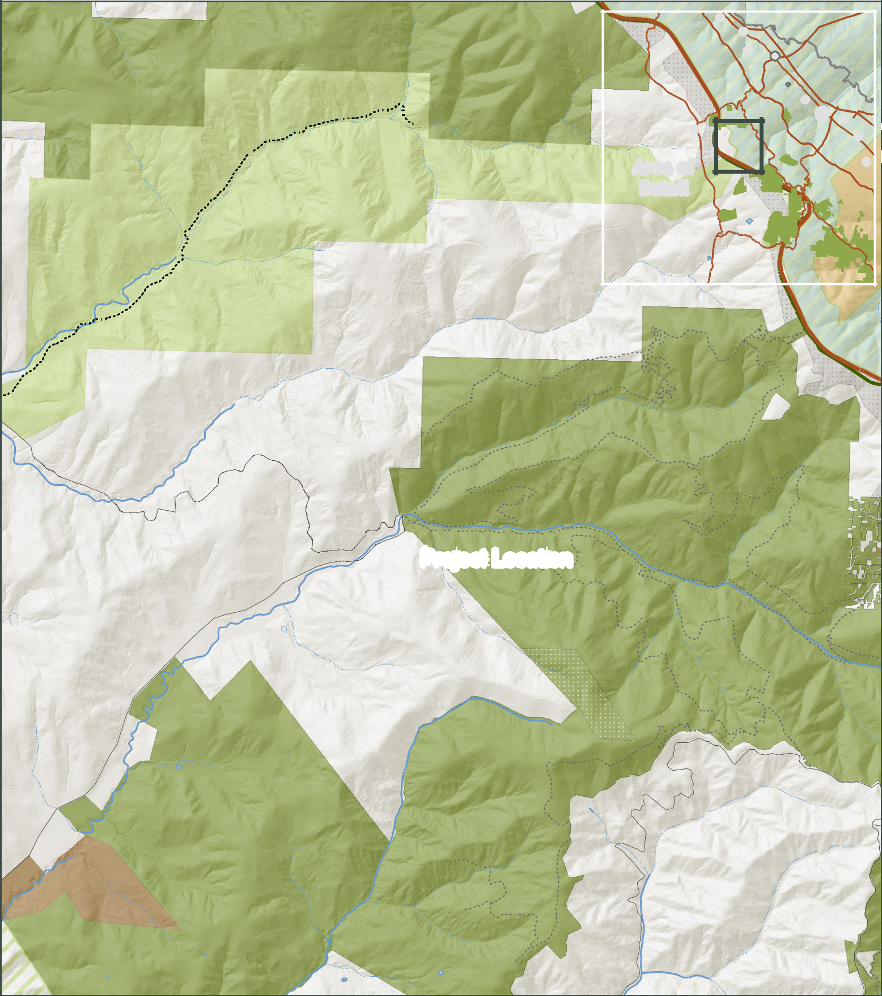

! |  | Crystal | Springs
! |  | Crystal | Springs
 | ! | Watershed
 | ! | (City! Mateo!
 |  | and Co.

 |  |  |  |  | k
 |  |  |  | e
 |  |  | e
 |  | s | Cr
 | l
l
i |  |  | Murray
Burleigh H.
M
Ranch S tate Park
EXHIBIT 1

 |  |  |  | k
 |  |  |  | e
M |  |  | e
M | i |  | r
 | i | C
 | lls

!

Area of

Detail

of San | Francisco
! |  | Co.)
Water |  | Co.)
!
 | ! | !
Pise Hill 2 |  | !
 |  | !
Pise Lookout

 |  |  |  |  | k
 |  |  |  | e
 |  |  | e
 |  |  | r |  |  |  |  | n
 |  | C
 |  |  |  |  |  | A |  | o
 | s |  |  |  |  | A | e
l |  |  |  |  |  | r
l |  |  |  |  |  |  | royo
 |  |  |  |  |  |  | L
i |  |  |  |  |  |  |  |  |  |  |  |  |  | i
M |  |  |  |  |  |  |  |  |  |  |  |  |  | i
 |  |  |  |  |  |  |  |  |  |  |  |  |  | l
 |  |  |  |  |  |  |  |  |  |  |  |  | a
 |  |  |  |  |  |  |  |  |  |  |  |  | r
 |  |  |  |  |  |  |  |  |  |  |  | T
 |  |  |  |  |  |  |  |  |  |  | e
 |  |  |  |  |  |  |  |  |  |  | d
 |  |  |  |  |  |  |  |  |  |  | Ri
 |  |  |  |  |  |  |  |  |  | h | g
 |  |  |  |  |  |  |  |  | t
 |  |  |  |  |  |  |  | r
 |  |  |  |  |  |  |  | o
 |  |  |  |  |  |  |  | N

Bridges\ProjectLocationV2.mxd

 |  |  |  |  |  |  |  | n
 |  |  |  |  |  |  | o
 |  |  |  |  |  | e
 |  |  |  |  |  | L
 |  |  |  | o
 |  |  | y
 |  |  | o
r
A |  |  |  |  |  |  |  | Ridge | H
McGovern
 |  |  |  |  |  |  |  | d
 |  |  |  |  |  |  |  | R
 |  |  |  |  |  | k
 |  |  |  |  |  | e
 |  |  |  |  |  | e
 |  |  |  |  | r
 |  |  |  | C
 | a
im
s
i

 |  |  |  |  |  |  |  |  |  |  |  |  |  |  |  |  |  |  | il
 |  |  |  |  |  |  |  |  |  |  |  |  |  |  |  |  | a
 |  |  |  |  |  |  |  |  |  |  |  |  |  |  |  |  | r
 |  |  |  |  |  |  |  |  |  |  |  |  |  |  |  | T
 |  |  |  |  |  |  |  |  |  |  |  |  |  |  | h
 |  |  |  |  |  |  |  |  |  |  |  |  |  |  | c
 |  |  |  |  |  |  |  |  |  |  |  |  |  |  | l
 |  |  |  |  |  |  |  |  |  |  |  |  |  |  | u
 |  |  |  |  |  |  |  |  |  |  |  |  |  |  | G
 |  |  |  |  |  |  |  |  |  |  |  |  |  | e |  |  |  |  |  | kins
 |  |  |  |  |  |  |  |  |  |  |  |  | r
 |  |  |  |  |  |  |  |  |  |  |  |  | o |  |  |  |  |  |  |  |  |  |  |  |  |  | R
 |  |  |  |  |  |  |  |  |  |  |  | m |  |  |  |  |  |  | r
 |  |  |  |  |  |  |  |  |  |  | e |  |  |  |  |  |  |  | a |  |  |  |  |  |  |  |  |  | i
 |  |  |  |  |  |  |  |  |  | t |  |  |  |  |  |  |  |  |  |  |  |  |  |  |  |  |  |  |  |  | d
 |  |  |  |  |  |  |  |  |  | t |  |  |  |  |  |  |  | H
 |  |  |  |  |  |  |  |  | hi |  |  |  |  |  |  |  |  |  |  |  |  |  |  |  |  |  |  |  |  |  |  |  | g
 |  |  |  |  |  |  |  |  | W |  |  |  |  |  |  |  |  |  |  |  |  |  |  |  |  |  |  |  |  |  |  |  |  |  | e |  | T
 |  |  |  |  |  |  |  |  |  |  |  |  |  |  |  |  |  |  |  |  |  |  |  |  |  |  |  |  |  |  |  |  |  |  |  |  | r
 |  |  |  |  |  |  |  |  |  |  |  |  |  |  |  |  |  |  |  |  |  |  |  |  |  |  |  |  |  |  |  |  |  |  |  |  | a
 |  |  |  |  |  |  |  |  |  |  |  |  |  |  |  |  |  |  |  |  |  |  |  |  |  |  |  |  |  |  |  |  |  |  |  |  | il |  |  |  |  |  |  |  |  |  |  |  |  |  |  |  |  |  |  |  |  |  | l
 |  |  |  |  |  |  |  |  |  |  |  |  |  |  |  |  |  |  |  |  |  |  |  |  |  |  |  |  |  |  |  |  |  |  |  |  |  |  |  |  |  |  |  |  |  |  |  |  |  |  |  |  |  |  |  |  | ai
 |  |  |  |  |  |  |  |  |  |  |  |  |  |  |  |  |  |  |  |  |  |  |  |  |  |  |  |  |  |  |  |  |  |  |  |  |  |  |  |  |  |  |  |  |  |  |  |  |  |  |  |  |  |  | r
 |  |  |  |  |  |  |  |  |  |  |  |  |  |  |  |  |  |  |  |  |  |  |  |  |  |  |  |  |  |  |  |  |  |  |  |  |  |  |  |  |  |  |  |  |  |  |  |  |  |  |  |  | T
 |  |  |  |  |  |  |  |  |  |  |  |  |  |  |  |  |  |  |  |  |  |  |  |  |  |  |  |  |  |  |  |  |  |  |  |  |  |  |  |  |  |  |  |  |  |  |  |  |  |  |  | n
 |  |  |  |  |  |  |  |  |  |  |  |  |  |  |  |  |  |  |  |  |  |  |  |  |  |  |  |  |  |  |  |  |  |  |  |  |  |  |  |  |  |  |  |  |  |  |  |  |  |  | o
 |  |  |  |  |  |  |  |  |  |  |  |  |  |  |  |  |  |  |  |  |  |  |  |  |  |  |  |  |  |  |  |  |  |  |  |  |  |  |  |  |  |  |  |  |  |  |  |  |  | t
 |  |  |  |  |  |  |  |  |  |  |  |  |  |  |  |  |  |  |  |  |  |  |  |  |  |  |  |  |  |  |  |  |  |  |  |  |  |  |  |  |  |  |  |  |  |  |  |  | t
 |  |  |  |  |  |  |  |  |  |  |  |  |  |  |  |  |  |  |  |  |  |  |  |  |  |  |  |  |  |  |  |  |  |  |  |  |  |  |  |  |  |  |  |  |  |  |  | i
 |  |  |  |  |  |  |  |  |  |  |  |  |  |  |  |  |  |  |  |  |  |  |  |  |  |  |  |  |  |  |  |  |  |  |  |  |  |  |  |  |  |  |  |  |  |  |  | r
 |  |  |  |  |  |  |  |  |  |  |  |  |  |  |  |  |  |  |  |  |  |  |  |  |  |  |  |  |  |  |  |  |  |  |  |  |  |  |  |  |  |  |  |  |  |  | B
 |  |  |  |  |  |  |  |  |  |  |  |  |  |  |  |  |  |  |  |  |  |  |  |  |  |  |  |  |  |  |  |  |  |  |  |  |  |  |  |  |  |  |  |  | g
i |  |  |  |  |  |  |  | n R d |  |  |  |  |  |  |  |  |  |  |  |  |  |  |  |  |  |  |  |  |  |  |  |  |  |  |  |  |  |  |  |  |  |  |  |  | i
i |  |  |  |  |  |  |  | n R d |  |  |  |  |  |  |  |  |  |  |  |  |  |  |  |  |  |  |  |  |  |  |  |  |  |  |  |  |  |  |  |  |  |  | a
i |  |  |  |  |  |  |  | n R d |  |  |  |  |  |  |  |  |  |  |  |  |  |  |  |  |  |  |  |  |  |  |  |  |  |  |  |  |  |  |  |  |  |  | r
i |  |  |  |  |  |  |  | n R d |  |  |  |  |  |  |  |  |  |  |  |  |  |  |  |  |  |  |  |  |  |  |  |  |  |  |  |  |  |  |  |  |  | C
g |  |  |  |  |  | o |  | n R d |  |  |  |  |  |  |  |  |  |  |  |  |  |  |  |  |  |  |  |  |  |  |  |  | Purisima Creek
 | g | i
 |  | i |  |  | y |  | ^
 |  | n | s
 |  |  | s | n |  |  |  |  |  |  |  |  |  |  | isima |  |  | Cre
 |  |  |  | Ca |  |  |  |  |  |  |  |  |  |  |  |  |  |  |  |  | e
 |  |  |  |  |  |  |  |  |  |  |  |  |  | Pur |  |  |  |  |  |  |  |  |  |  |  |  |  |  |  |  |  |  |  |  |  |  |  | Redwoods
 |  |  |  |  |  |  |  |  |  |  |  |  |  |  |  |  |  |  |  |  |  | k
 |  |  |  |  |  |  |  |  |  |  |  |  |  |  |  |  |  |  |  |  |  |  | T
 |  |  |  |  |  |  |  |  |  |  |  |  |  |  |  |  |  |  |  |  |  |  |  |  | r
 |  |  |  |  |  |  |  |  |  |  |  |  |  |  |  |  |  |  |  |  |  |  |  |  | a
 |  |  |  |  |  |  |  |  |  |  |  |  |  |  |  |  |  |  |  |  |  |  |  |  |  |  | i
 |  |  |  |  |  |  |  |  |  |  |  |  |  |  | Br |  |  |  |  |  |  |  |  |  |  |  | l |  |  |  |  |  |  |  |  |  | Purisim a
 |  |  |  |  |  |  |  | Project Locationden Hatc |  |  |  |  |  |  |  |  |  |  |  |  |  |  |  |  |  |  |  |  |  |  |  |  |  |  |  |  |  |  |  |  |  |  |  |  |  | C
 |  |  |  |  |  |  |  |  |  |  |  |  |  |  |  |  |  |  |  |  |  | h |  |  |  |  |  |  |  |  |  |  |  |  |  |  | G
 |  |  |  |  |  |  |  |  |  |  |  |  |  |  |  |  |  |  |  |  |  |  | M |  |  |  |  |  |  |  |  |  |  |  |  |  |  |  |  |  |  |  |  |  |  |  | r
 |  |  |  |  |  |  |  |  |  |  |  |  |  |  |  |  |  |  |  |  |  |  |  |  |  |  |  |  |  |  |  |  |  |  |  |  | r |  |  |  |  |  |  |  |  |  |  | e
 |  |  |  |  |  |  |  |  |  |  |  |  |  |  |  |  |  |  |  |  |  |  | i |  |  |  |  |  |  |  |  |  |  |  |  |  | a |  |  |  |  |  |  |  |  |  |  |  |  | e
 |  |  |  |  |  |  |  |  |  |  |  |  |  |  |  |  |  |  |  |  |  |  |  |  | l |  |  |  |  |  |  |  |  |  |  |  |  |  |  |  |  |  |  |  |  |  |  |  |  |  | k
 |  |  |  |  |  |  |  |  |  |  |  |  |  |  |  |  |  |  |  |  |  |  |  |  | l |  |  |  |  |  |  |  |  |  |  |  | b
 |  |  |  |  |  |  |  |  |  |  |  |  |  |  |  |  |  |  |  |  |  |  |  |  |  |  | T |  |  |  |  |  |  |  |  |  |  |  | t
 |  |  |  |  |  |  |  |  |  |  |  |  |  |  |  |  |  |  |  |  |  |  |  |  |  |  |  |  |  |  |  |  |  |  |  |  |  |  |  | o
 |  |  |  |  |  |  |  |  |  |  |  |  |  |  |  |  |  |  |  |  |  |  |  |  |  |  |  |  | r |  |  |  |  |  |  |  |  |  |  |  | w
 |  |  |  |  |  |  |  |  |  |  |  |  |  |  |  |  |  |  |  |  |  |  |  |  |  |  |  |  |  |  | a |  |  |  |  |  |  |  |  |  |  | n |  | G
 |  |  |  |  |  |  |  |  |  |  |  |  |  |  |  |  |  |  |  |  |  |  |  |  |  |  |  |  |  |  |  |  | i
 |  |  |  |  |  |  |  |  |  |  |  |  |  |  |  |  |  |  |  |  |  |  |  |  |  |  |  |  |  |  |  |  | l |  |  |  |  |  |  |  |  |  |  |  | u
 |  |  |  |  |  |  |  |  |  |  |  |  |  |  |  |  |  |  |  |  |  |  |  |  |  |  |  |  |  |  |  |  |  |  |  |  |  |  |  |  |  |  |  |  |  | l
 |  |  |  |  |  |  |  |  |  |  |  |  |  |  |  |  |  |  |  |  |  |  |  |  |  |  |  |  |  |  |  |  |  |  |  |  |  |  |  |  |  |  |  |  |  | c
 |  |  |  |  |  |  |  |  |  |  |  |  |  |  |  |  |  |  |  |  |  |  |  |  |  |  |  |  |  |  |  |  |  |  |  |  |  |  |  |  |  |  |  |  |  |  | h
 |  |  |  |  |  |  |  |  |  |  |  |  |  |  |  |  |  |  |  |  |  |  |  |  |  |  |  |  |  |  |  |  |  |  |  |  |  |  |  |  |  |  |  |  |  |  |  | T
 |  |  |  |  |  |  |  |  |  |  |  |  |  |  |  |  |  |  |  |  |  |  |  |  |  |  |  |  |  |  |  |  |  |  |  |  |  |  |  |  |  |  |  |  |  |  |  | r
 |  |  |  |  |  |  |  |  |  |  |  |  |  |  |  |  |  |  |  |  |  |  |  |  |  |  |  |  |  |  |  |  |  |  |  |  |  |  |  |  |  |  |  |  |  |  |  |  | a
 |  |  |  |  |  |  |  |  |  |  |  |  |  |  |  |  |  |  |  |  |  |  |  |  |  |  |  |  |  |  |  |  |  |  |  |  |  |  |  |  |  |  |  |  |  |  |  |  |  | i
 |  |  |  |  |  |  |  |  |  |  |  |  |  |  |  |  |  |  |  |  |  |  |  |  |  |  |  |  |  |  |  |  |  |  |  |  |  |  |  |  |  |  |  |  |  |  |  |  |  | l

By: ahebert Path: G:\Projects\Purisima _Creek_Redwoods\Purisima Creek

 |  | r
 |  | u
 |  | P | Blue
 |  | k | Blue
 |  | e | Blue
 |  | e | Brush
 |  | r | Brush
 |  | C | Brush
 |  | a
 |  | m
 |  | i
 | s
 |  | i
 | r |  | Purisima
u |  |  | Purisima
P |  |  | Purisima
 |  |  | Creek
Elkus |  |  | Redwoods
 |  |  | Open Space
Ranch |  |  | Preserve

e e k

C r

s
o
it
b
L o

L o b it o s

C

re

e
k
T
r
a
i |  |  | l
l |  |  | l
 |  |  | i
 |  |  | a
 |  |  | r
 |  |  | T
 |  |  | e
 |  |  | g
 |  | d
 |  | i
 | hR
s
i
r
I

 |  |  |  |  |  |  |  |  |  |  |  |  |  |  |  |  |  |  | G
 |  |  |  |  |  | il |  |  |  |  |  |  |  |  |  |  |  |  |  | rab
 |  |  |  |  |  |  |  |  |  |  |  |  |  |  |  |  |  |  |  |  |  |  | tow
 |  |  |  |  | ra
 |  |  |  |  |  |  |  |  |  |  |  |  |  |  |  |  |  |  |  |  |  |  |  | n
 |  |  | b |  | T
 |  | o |  |  |  |  |  |  |  |  |  |  |  |  |  |  |  |  |  |  |  |  |  | Gulc
 | n
l | K
l |  |  |  |  |  |  |  |  |  |  |  |  |  |  |  |  |  |  |  |  |  |  |  |  | h
d
Ba |  |  |  |  |  |  |  |  |  |  |  |  |  |  |  |  |  |  |  |  |  |  |  |  |  | Tr
 |  |  |  |  |  |  |  |  |  |  |  |  |  |  |  |  | k |  |  |  |  |  |  |  |  | ail
 |  |  |  |  |  |  |  |  |  |  |  |  |  |  |  | e
 |  |  |  |  |  |  |  |  |  |  |  |  |  |  | e
 |  |  |  |  |  |  |  |  |  |  |  |  |  | r
 |  |  |  |  |  |  |  |  |  |  |  | C
 |  |  |  |  |  |  |  |  |  |  | s
 |  |  |  |  |  |  |  |  |  | a
 |  |  |  |  |  |  |  | t
 |  |  |  |  |  |  | i
 |  |  |  |  |  | n
 |  |  |  |  | u
 |  |  |  | T |  |  |  |  |  |  |  |  |  |  |  |  |  |  |  |  |  |  |  |  |  | k
 |  |  |  |  |  |  |  |  |  |  |  |  |  |  |  |  |  |  |  |  |  |  |  |  | e
 |  |  |  |  |  |  |  |  |  |  |  |  |  |  |  |  |  |  |  |  |  |  |  | e
 |  |  |  |  |  |  |  |  |  |  |  |  |  |  |  |  |  |  |  |  |  |  |  | r
 |  |  |  |  |  |  |  |  |  |  |  |  |  |  |  |  |  |  |  |  |  |  | C
 |  |  |  |  |  |  |  |  |  |  |  |  |  |  |  |  |  |  |  |  |  | l
 |  |  |  |  |  |  |  |  |  |  |  |  |  |  |  |  |  |  |  | e
 |  |  |  |  |  |  |  |  |  |  |  |  |  |  |  |  |  |  | h
 |  |  |  |  |  |  |  |  |  |  |  |  |  |  |  |  |  |  | c
 |  |  |  |  |  |  |  |  |  |  |  |  |  |  |  |  |  |  | t
 |  |  |  |  |  |  |  |  |  |  |  |  |  |  |  |  |  | i
 |  |  |  |  |  |  |  |  |  |  |  |  |  |  |  |  |  | M
 |  |  |  |  |  |  |  |  |  |  |  |  |  |  |  | k
 |  |  |  |  |  |  |  |  |  |  |  |  |  | e
 |  |  |  |  |  |  |  |  |  |  |  |  | e
 |  |  | Mit |  |  | c |  |  |  |  |  | r
 |  |  |  |  |  | c | h |  |  |  | C
 |  |  |  |  |  | c | h |  |  | el

Created

Harkins Project Location Map | Management Agreement | Private Property |  | Midpeninsula Regional
MROSD Preserves | Management Agreement |  |  | Open Space District
Other Protected Open Space | Non MROSD Conservation | Developed Land |  |  | (MROSD)
or Park Lands | or Agricultural Easement
Watershed Land | MROSD Conservation | _{I} Miles₀ | 0.25 | 0.5 | July, 2014
Watershed Land | or Agricultural Easement

While the District strives to use the best available digital data, this data does not represent a legal survey and is merely a graphic illustration of geographic features.

EXHIBIT 3
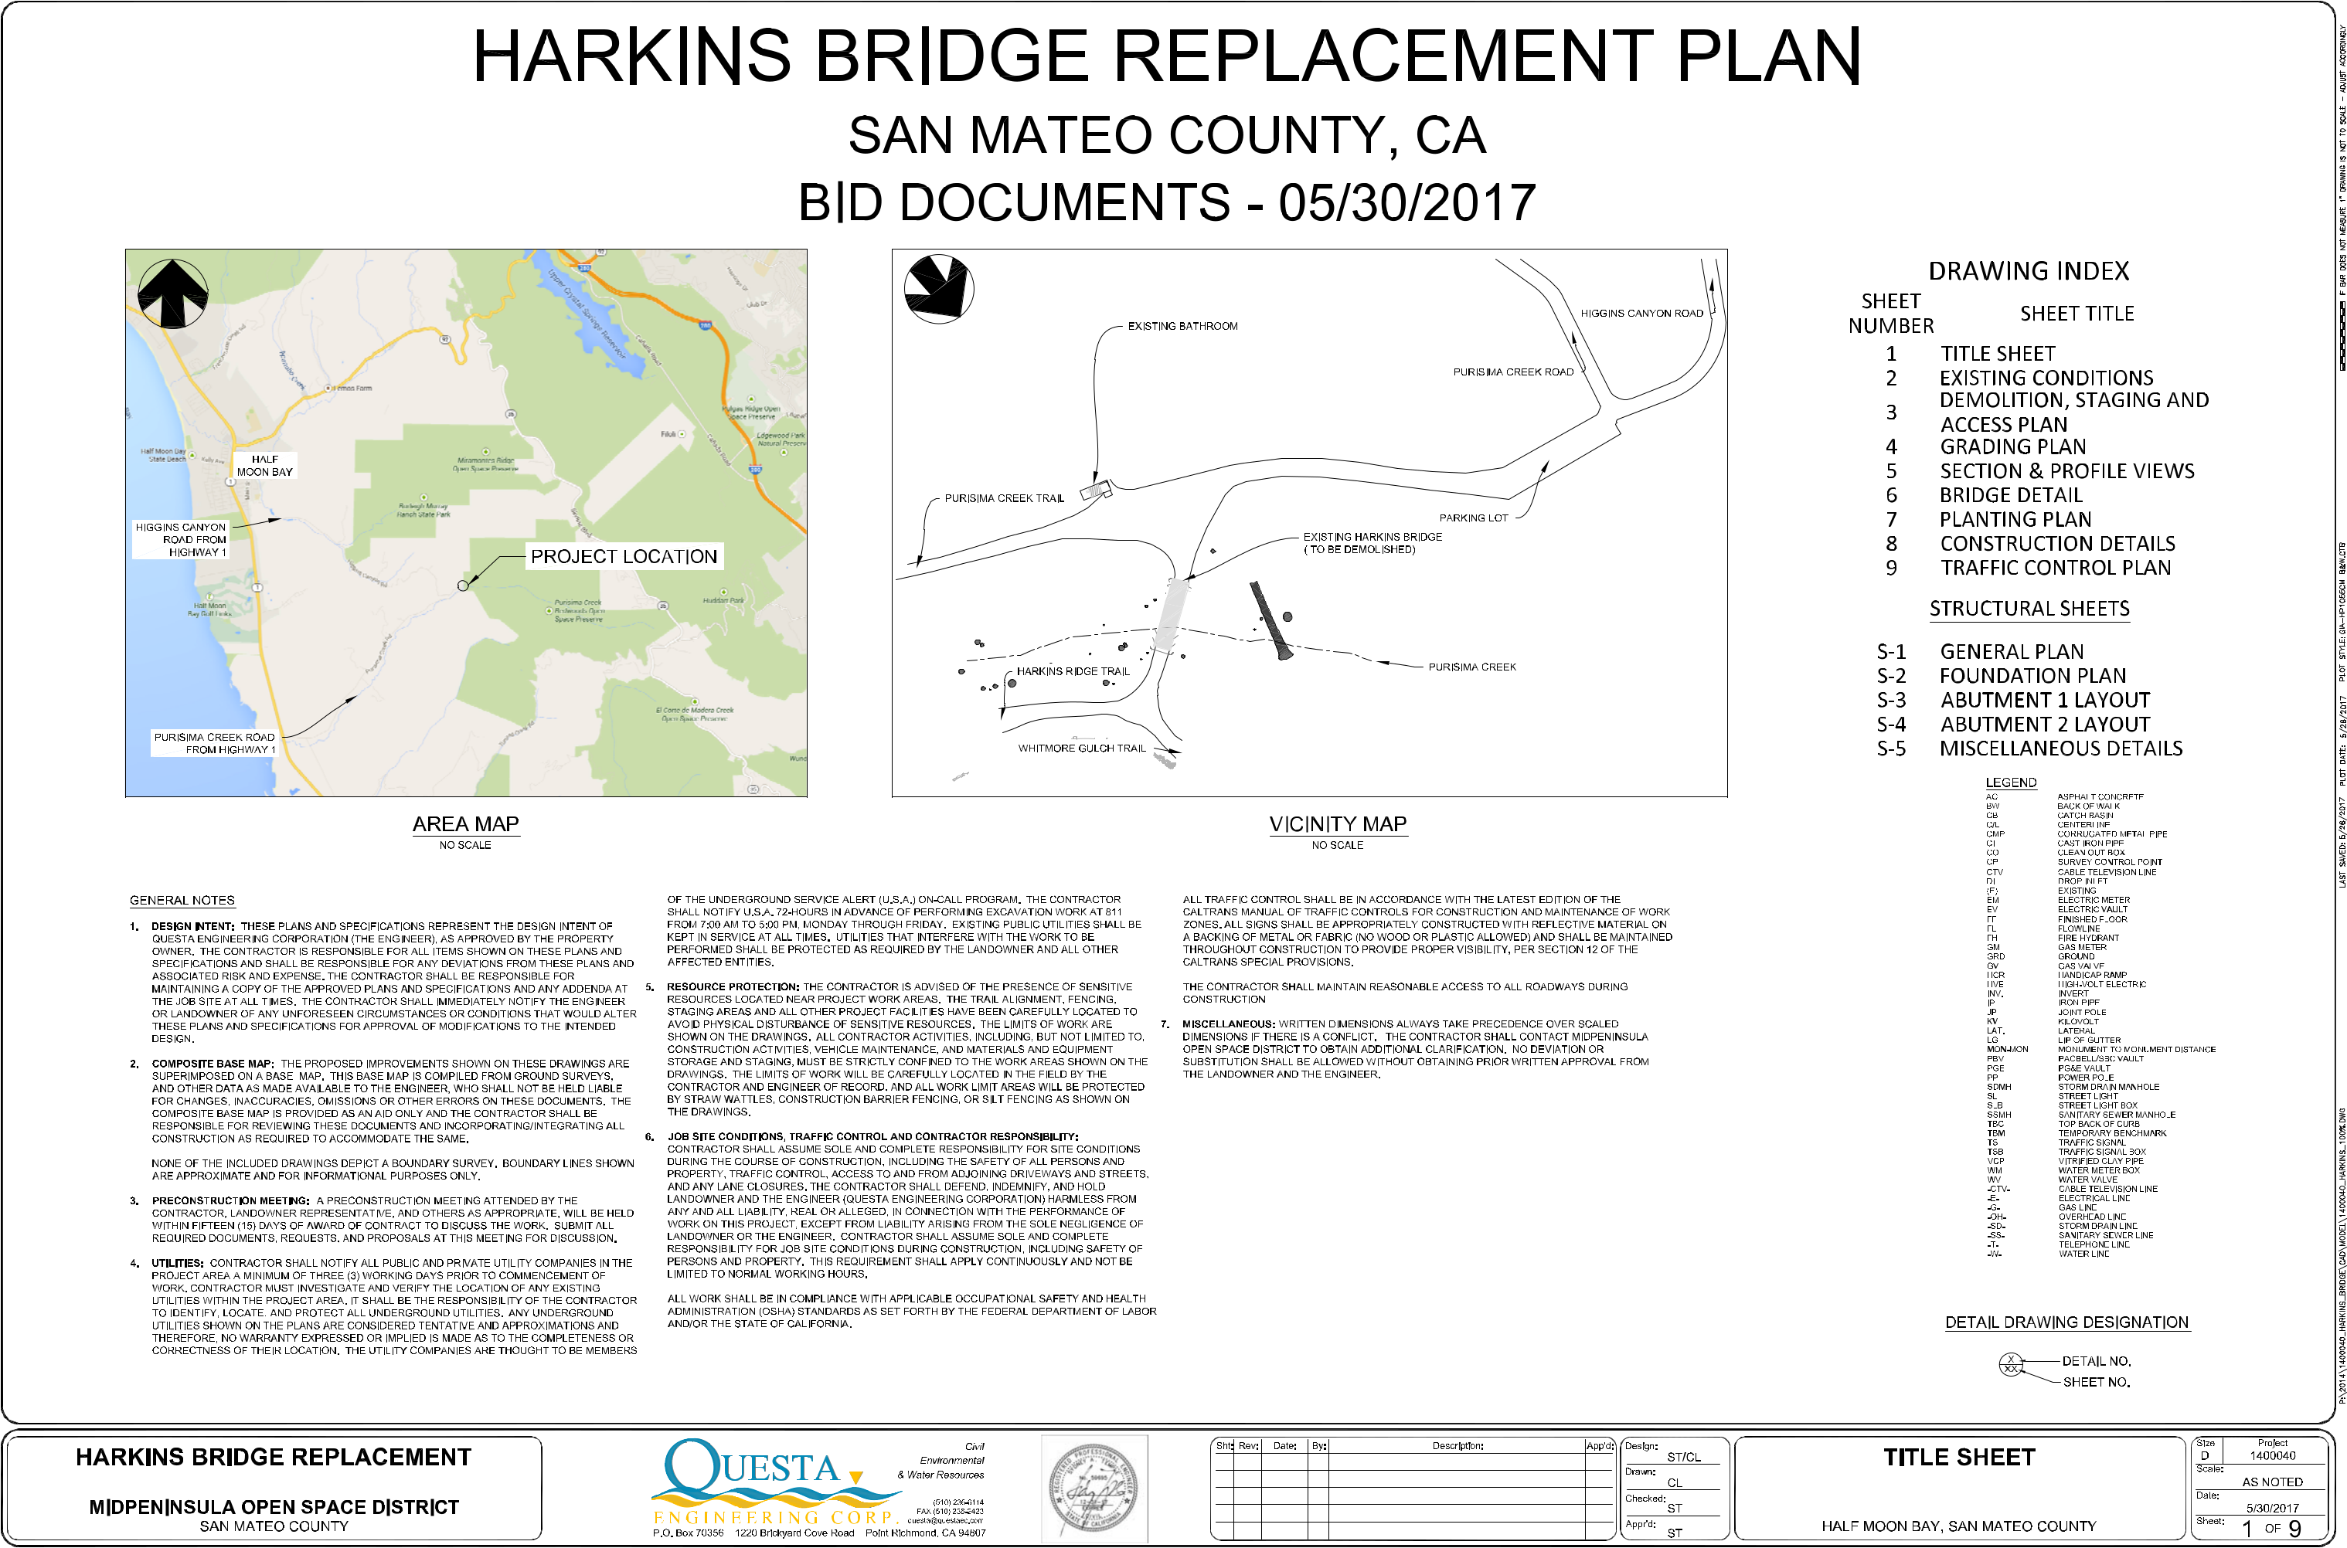
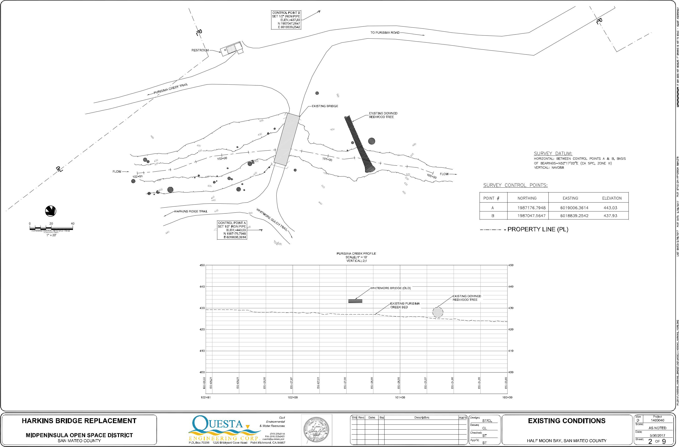
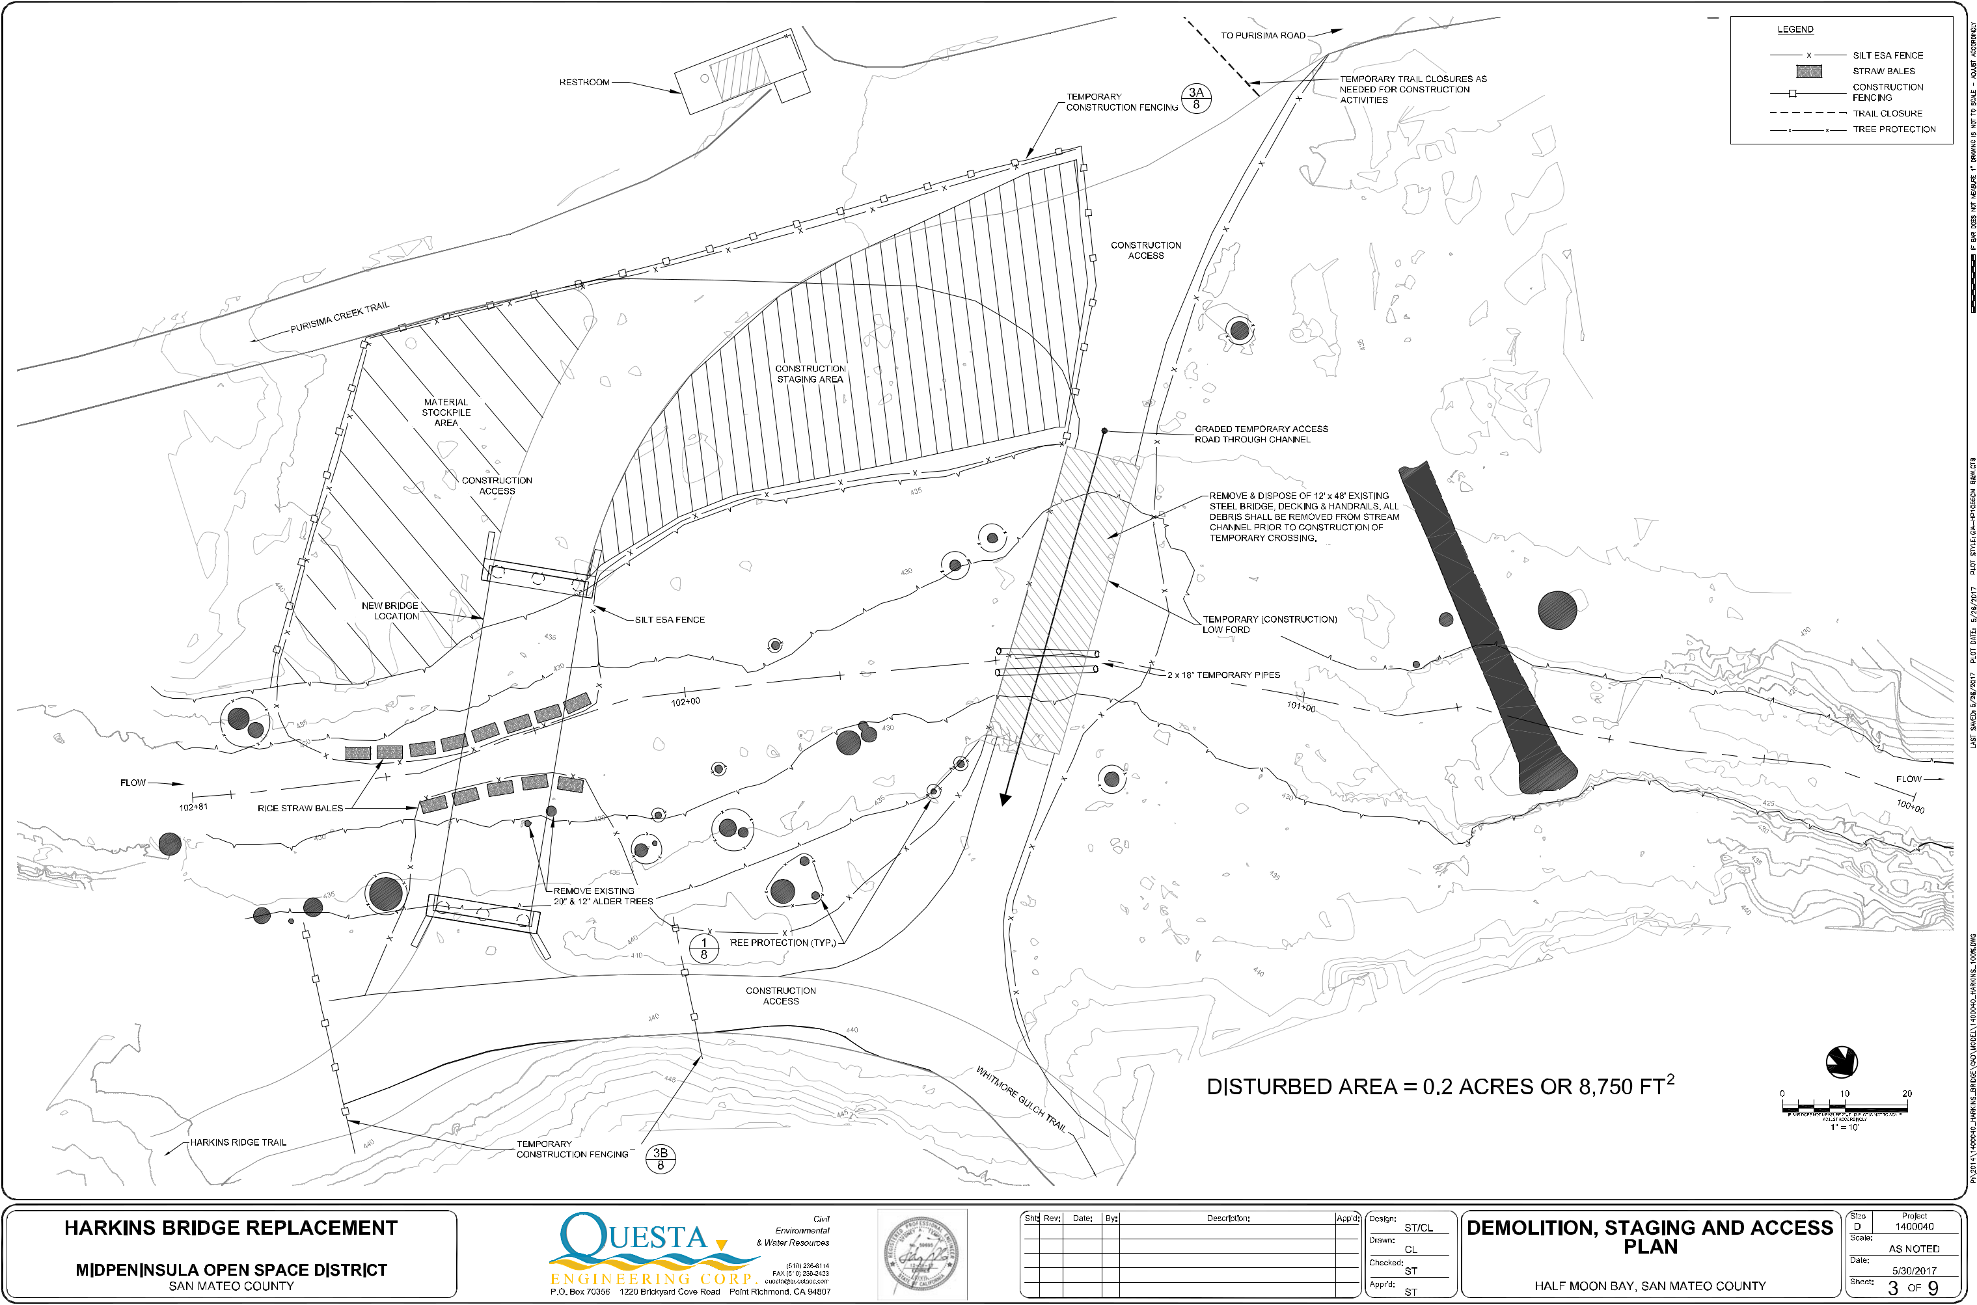
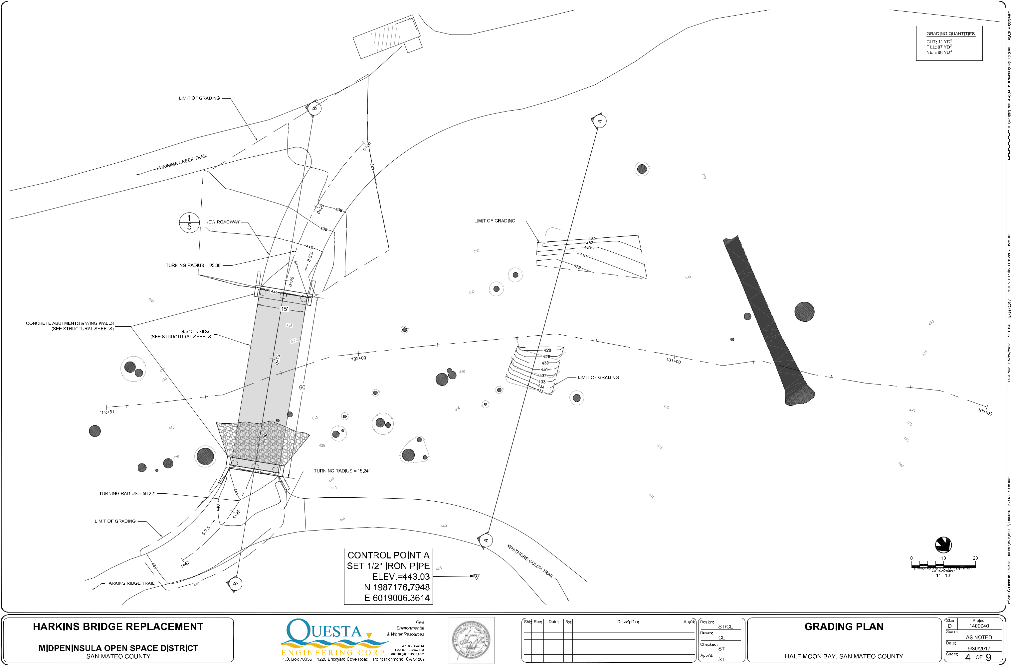
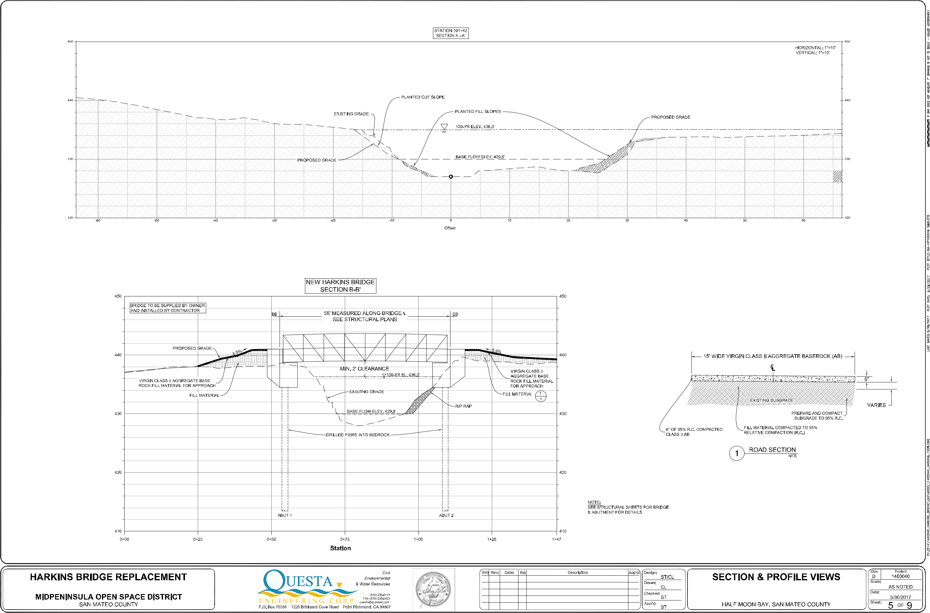
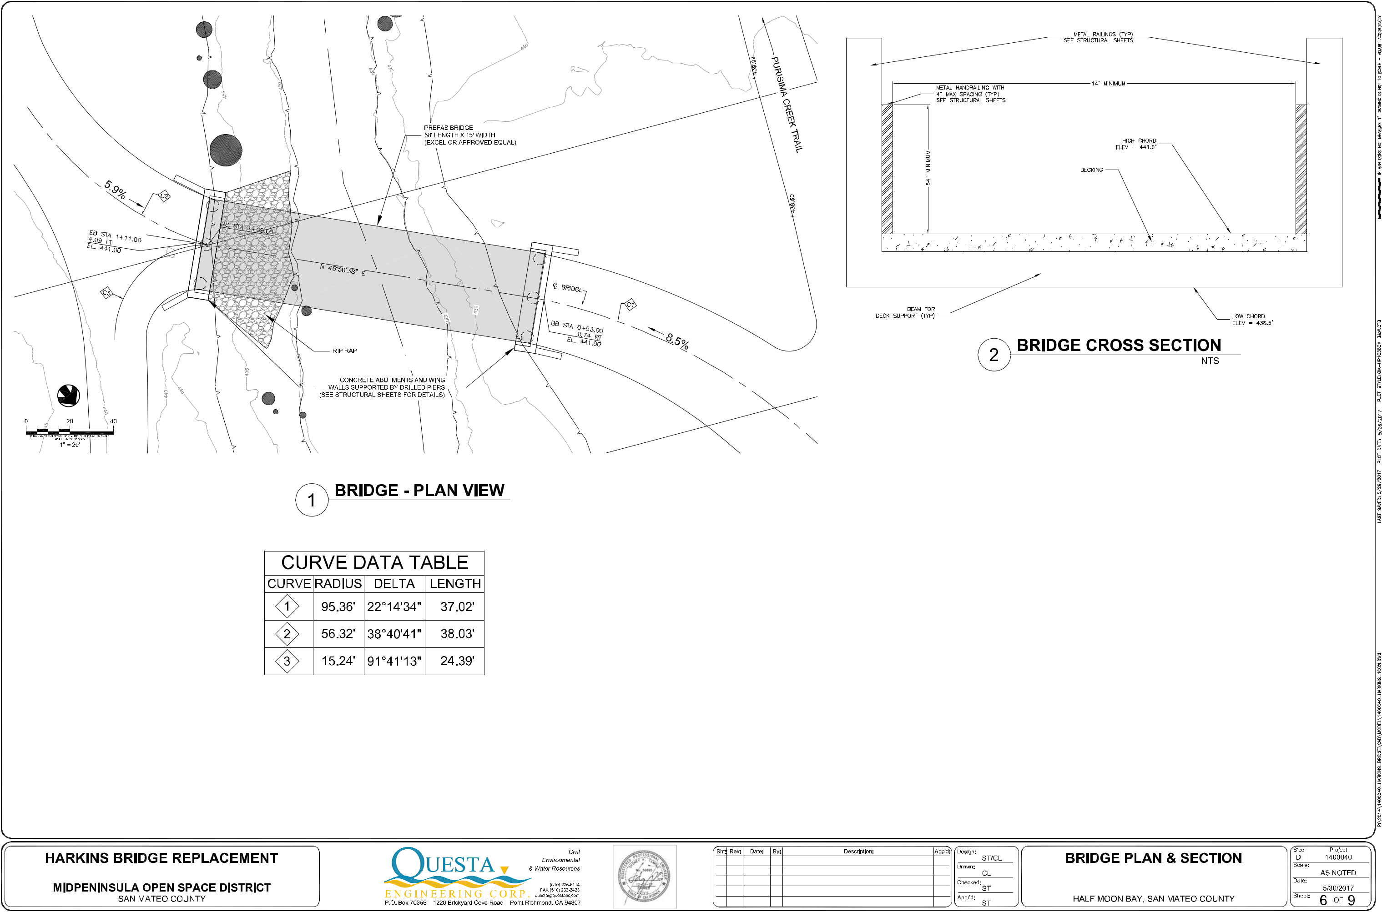
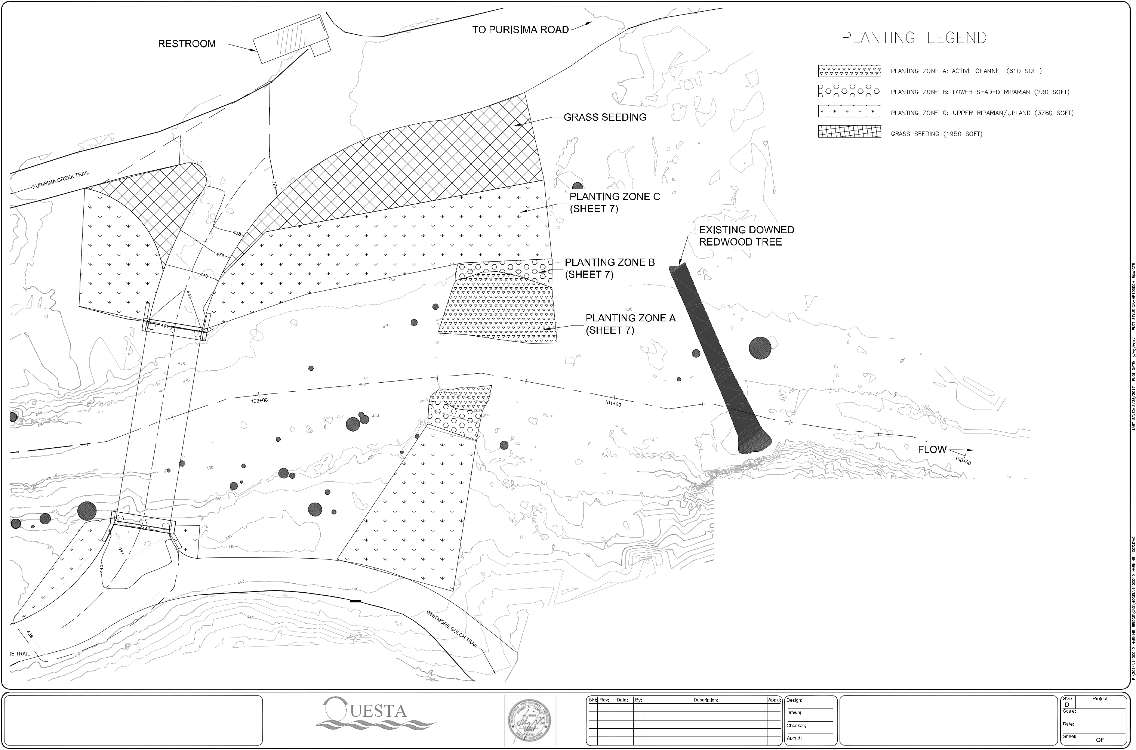

Planting Zone | Name | Spacing | Size | Quantity
A: Active Channel
Arroyo willow Salix lasiolepis |  | Rock toe, 3 ft o.c. | Live stakes | 50
Pacific willow Salix lasiandra |  | Rock toe, 3 ft o.c. | Live stakes | 50
B: Lower Shaded Riparian
Dogwood Cornus sericea |  | 20‐30 ft | TP | 5
Coffeeberry Rhamnus californica |  | 8‐10 ft | DP | 12
Currant Ribes sanguineum |  | 8‐10 ft | DP | 15
Red elderberry Sambucus racemosa |  | 8‐10 ft | DP | 6
C: Upper Riparian/Upland
Redwood Sequoia sempervirens |  | 6‐8 ft | 1 GC | 5
Buckeye Aesculus californica |  | 30‐40 ft. | 5 GC | 5
Red alder Alnus rubra |  | 20‐30 ft | 5 GC | 5
Blue blossom Ceanothus thrysiflorus |  | 8‐10 ft. | DP | 40
Direct seeding (all disturbed areas)
Native Erosion Control Mix**: |  |  |  | 25 lbs/ac
Bromus carinatus/California Brome
Hordeum brachyantherum/Meadow Barley

Vulpia microstachys/Three Weeks Fescue

Trifolium wildenovii/Tomcat Clover

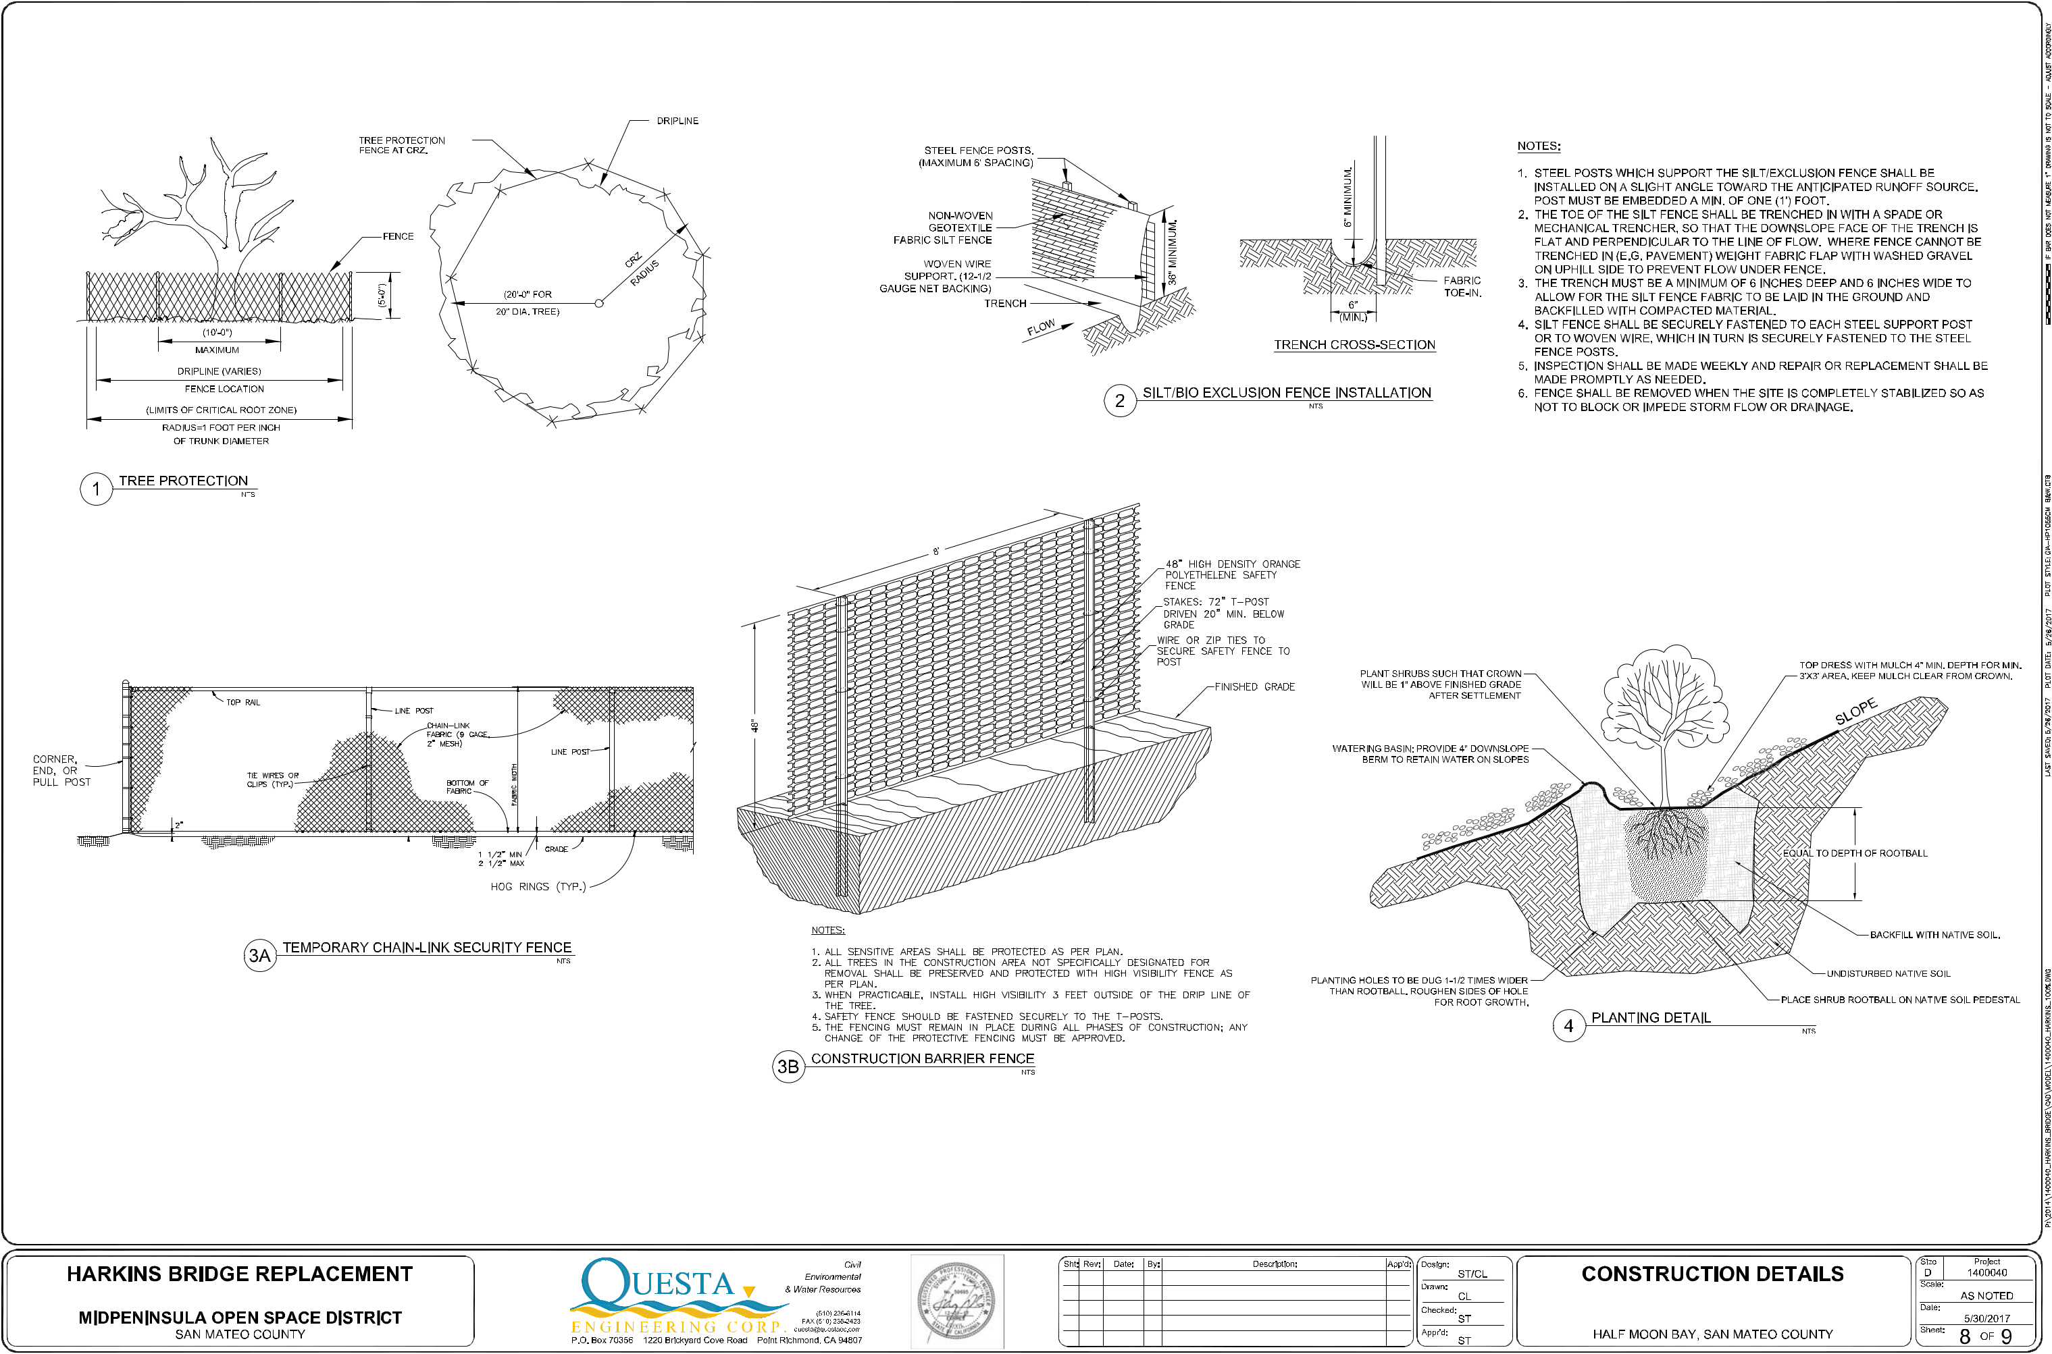
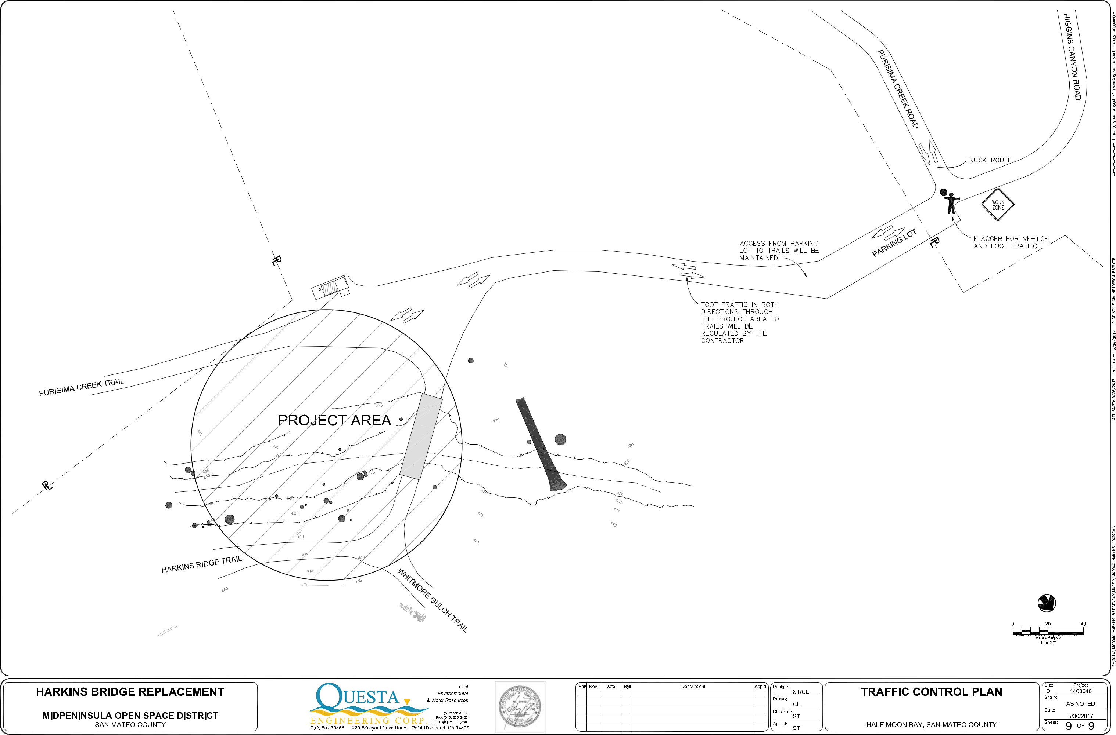
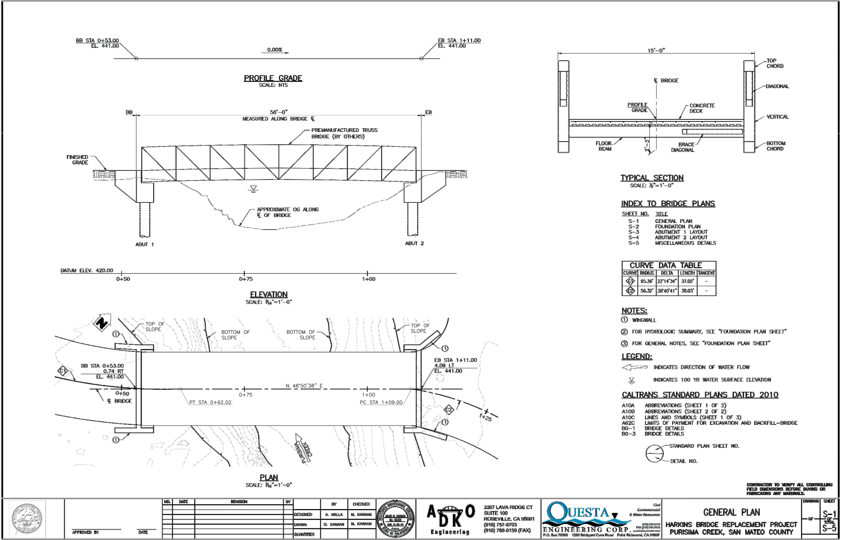
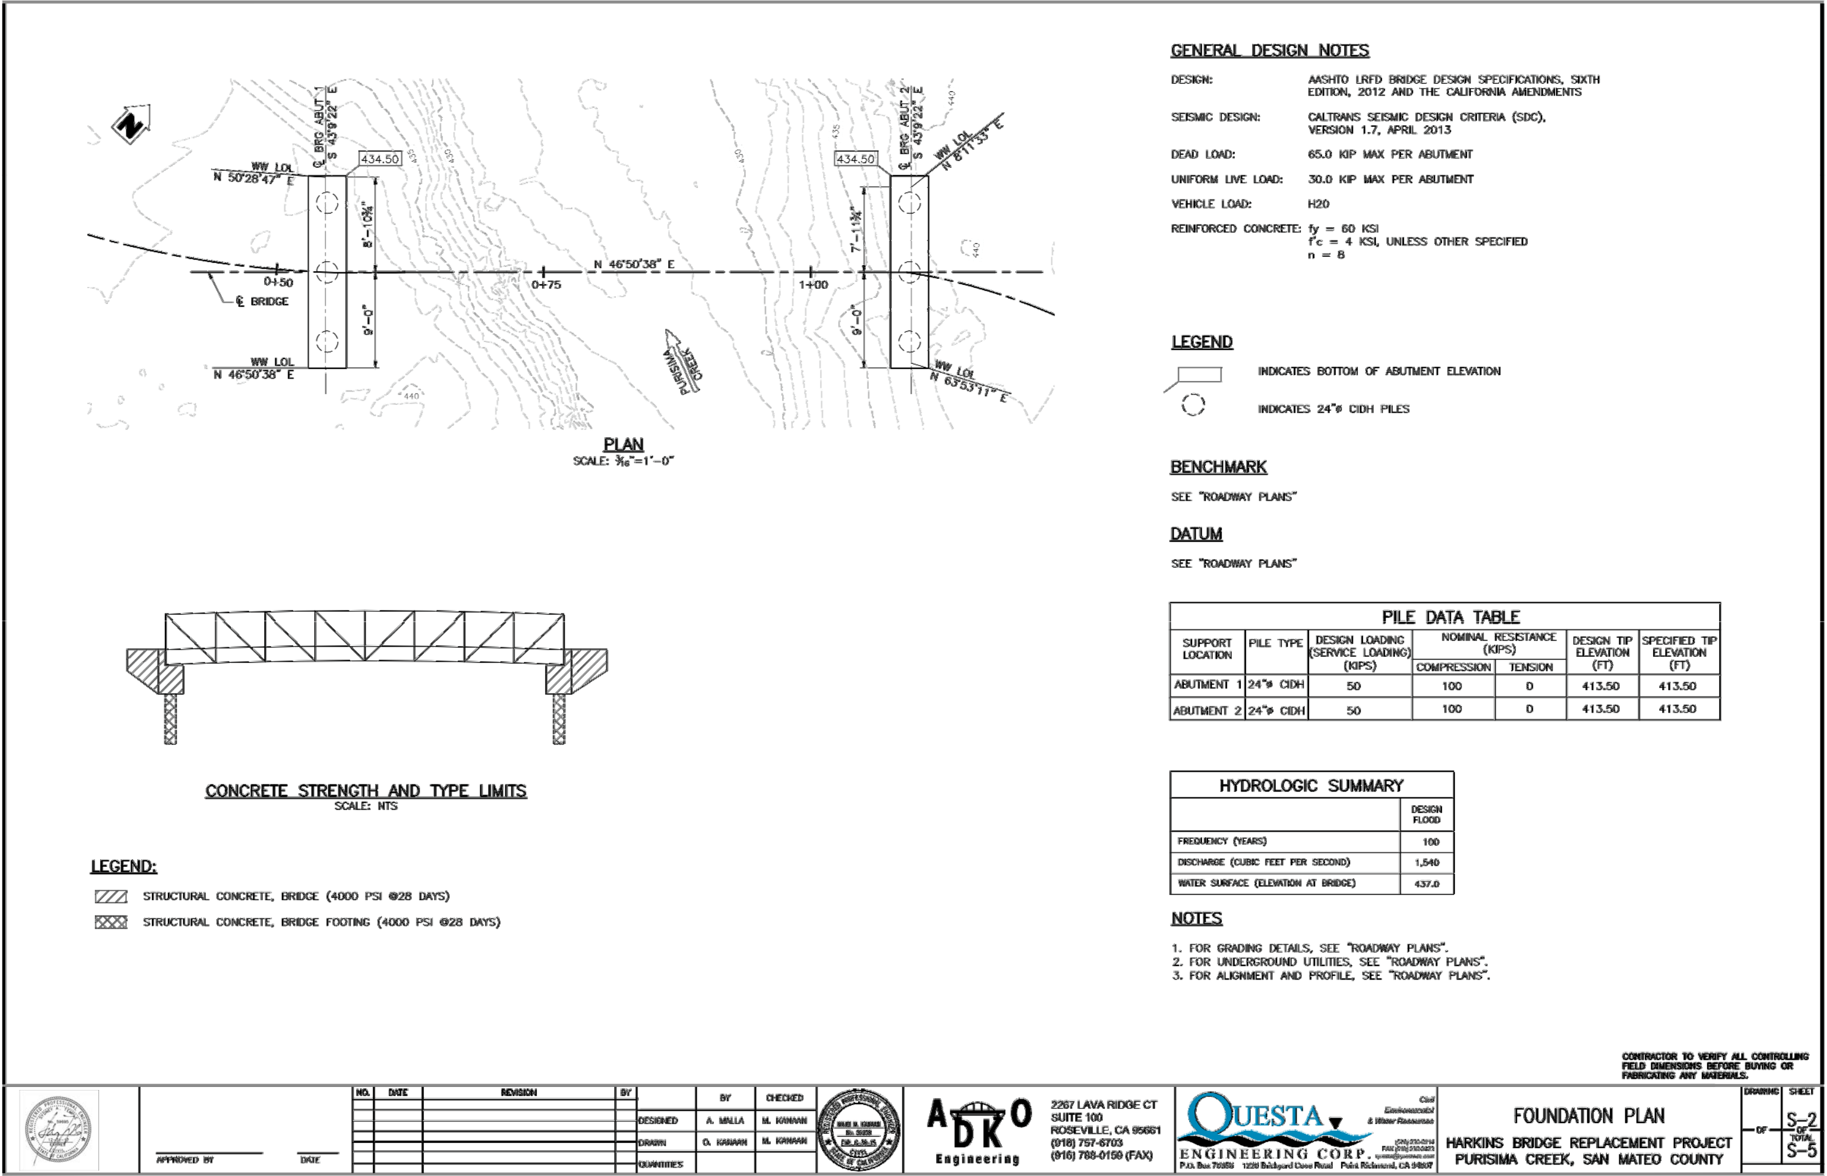
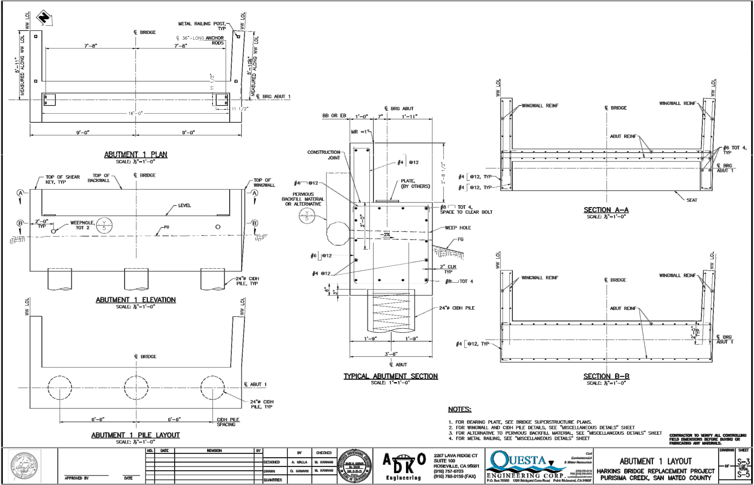
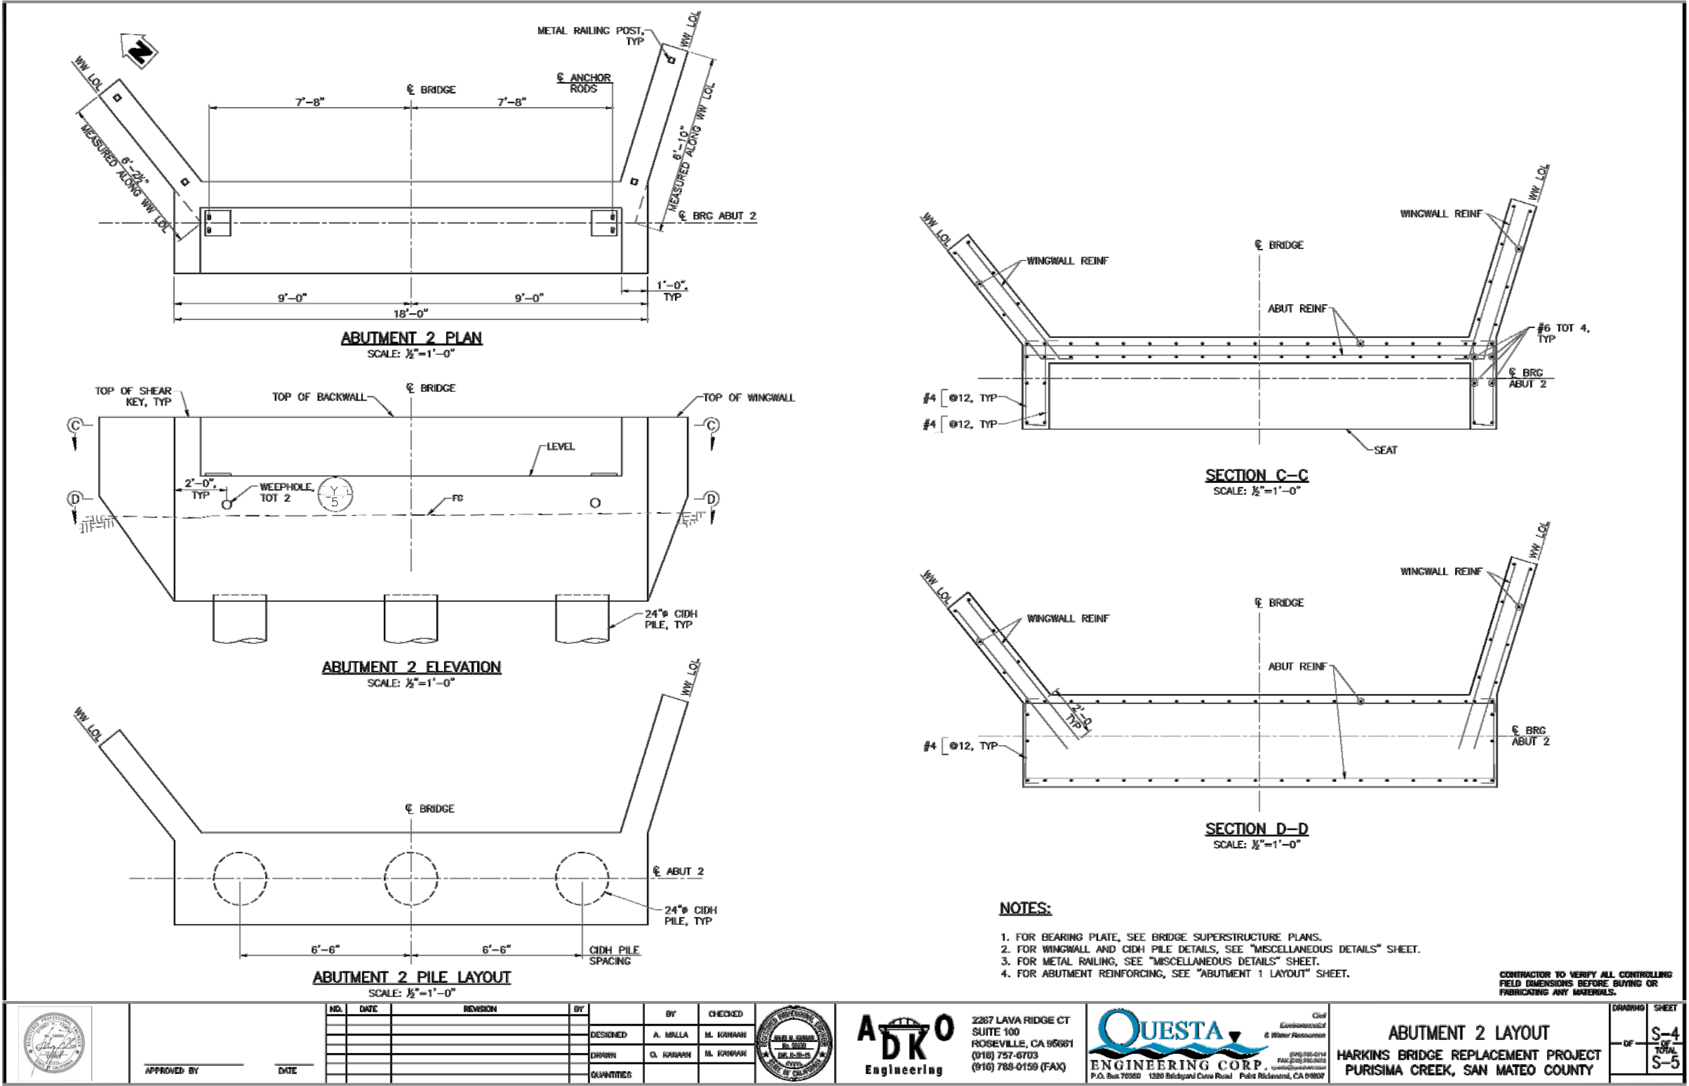
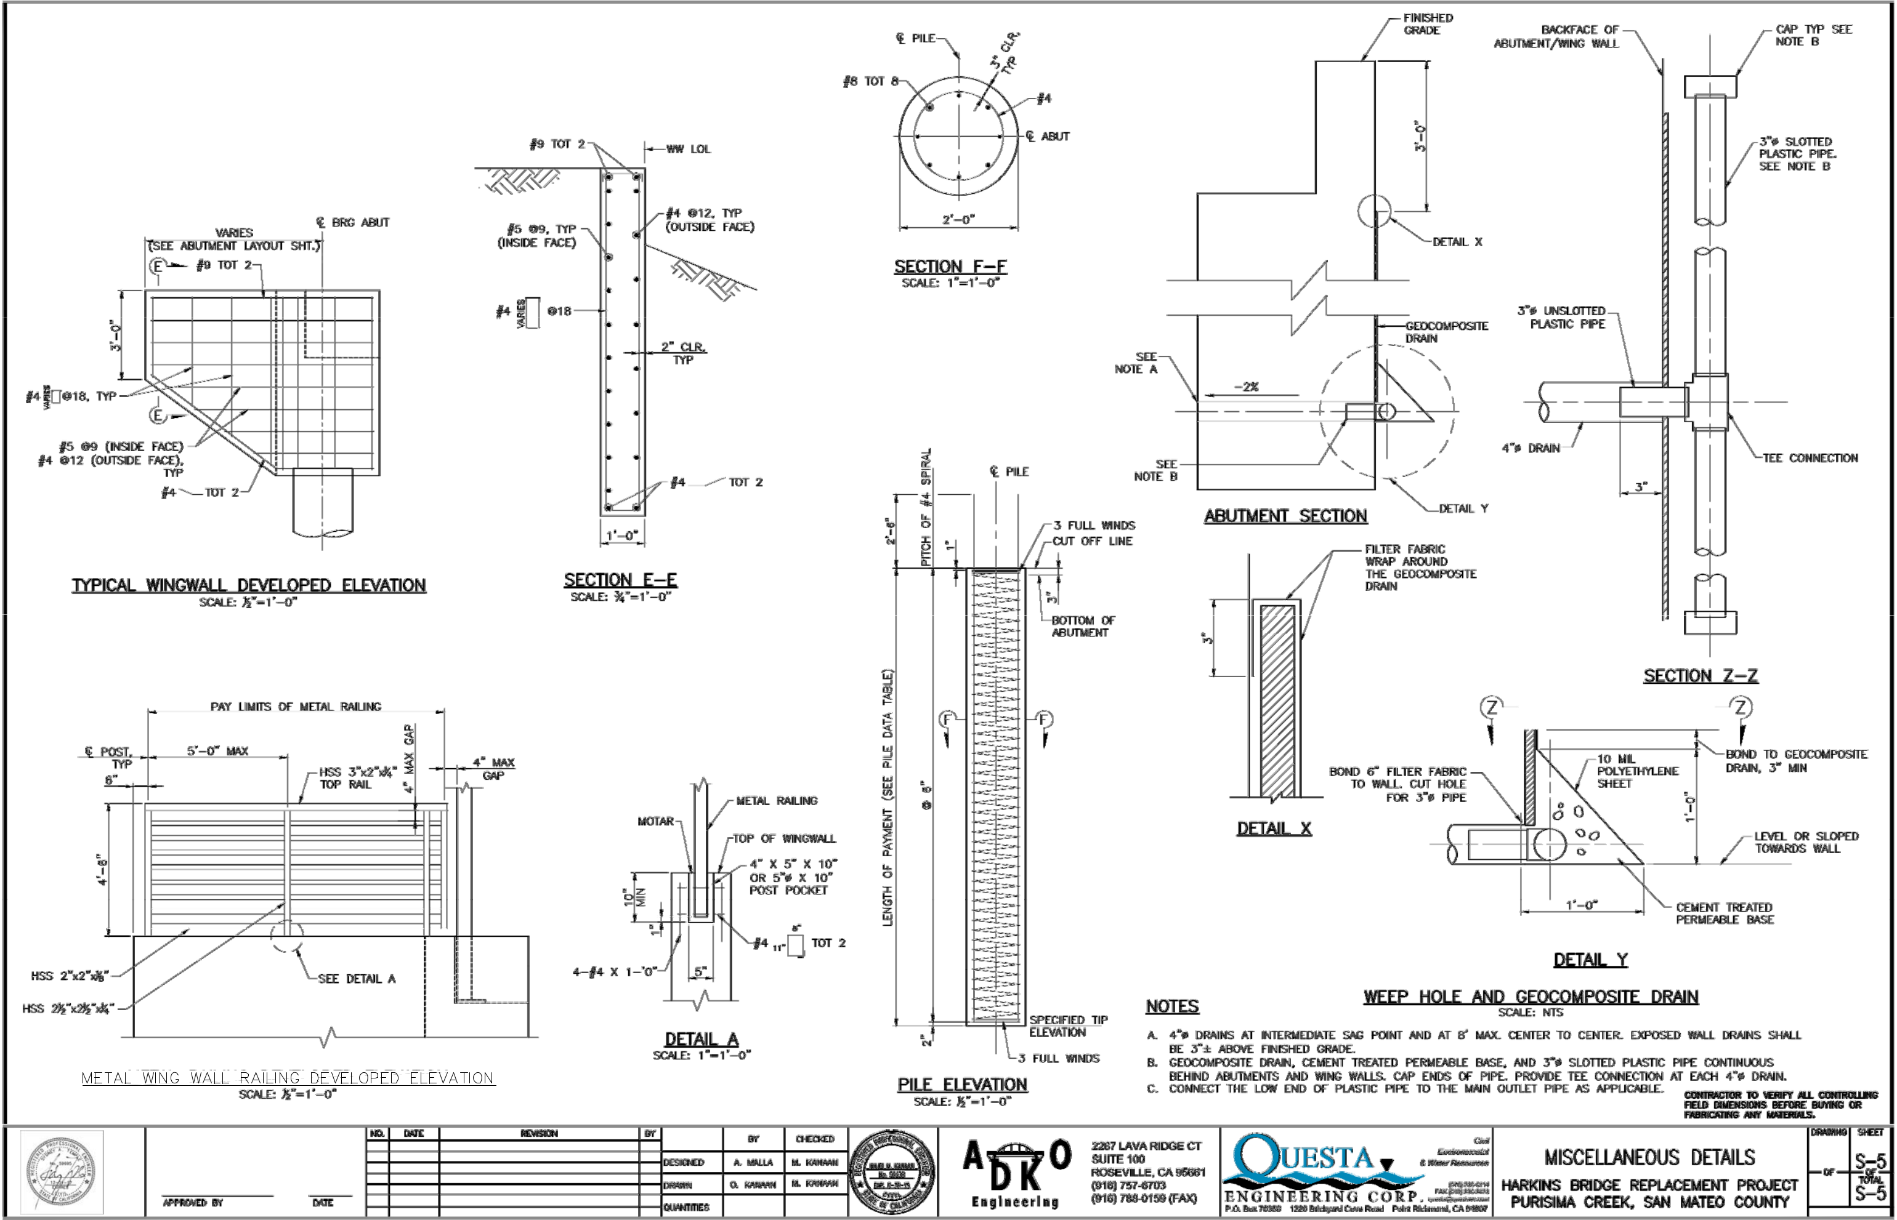
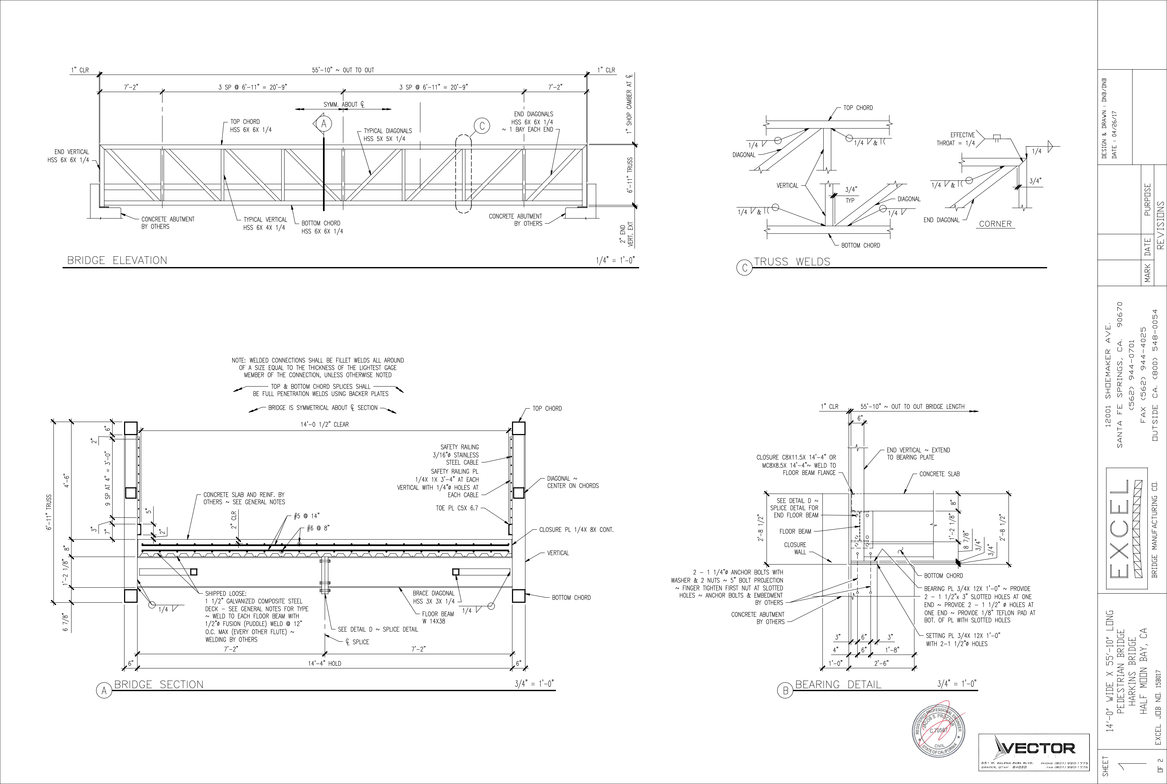

APR 26 2017

U0009-457-171
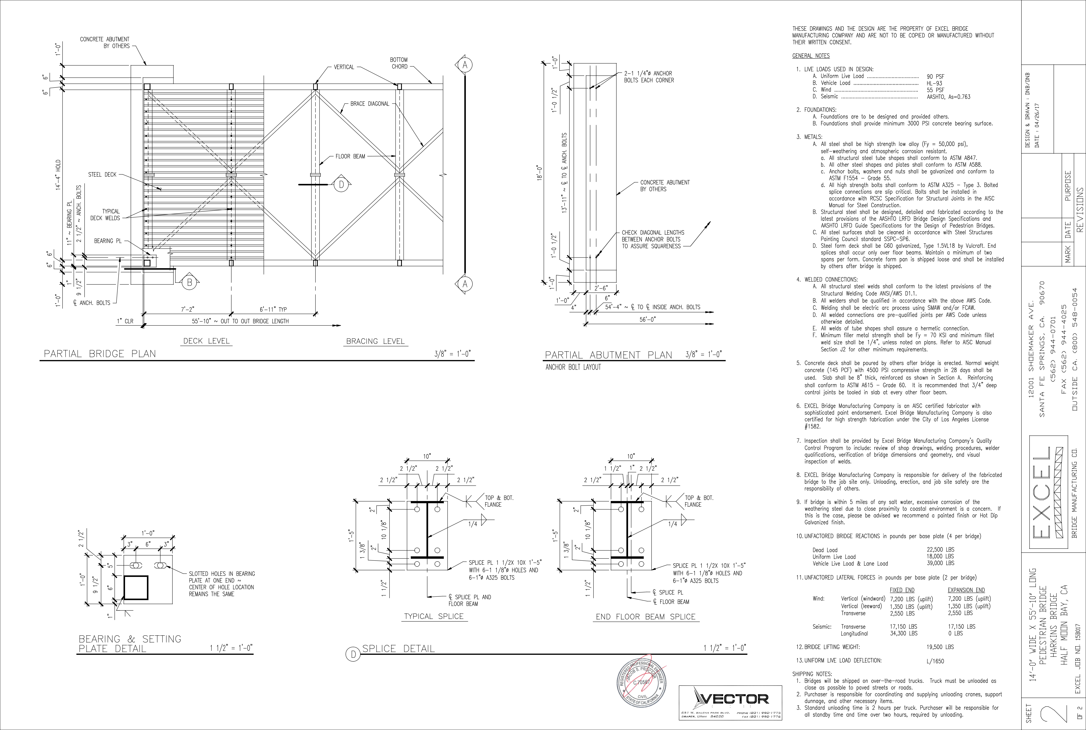

APR 26 2017

U0009-457-171
EXHIBIT 4

MITIGATION MONITORING AND REPORTING PROGRAM
FOR THE HARKINS BRIDGE REPLACEMENT PROJECT

This Mitigation Monitoring and Reporting Program (MMRP) was formulated based on the findings of the Initial Study/Mitigated Negative Declaration (IS/MND) prepared for the proposed Harkins Bridge Replacement Project (proposed project) prepared for the Midpeninsula Regional Open Space District (District). This MMRP is in compliance with Section 15097 of the CEQA Guidelines, which requires that the Lead Agency “adopt a program for monitoring or reporting on the revisions which it has required in the project and the measures it has imposed to mitigate or avoid significant environmental effects.” The MMRP has been prepared in tabular form (see Table 1). The MMRP lists mitigation measures recommended in the IS/MND and identifies mitigation monitoring requirements.

Table 1 presents the mitigation measures identified for the proposed project. Each mitigation measure is numbered with a symbol indicating the topical section to which it pertains, a hyphen, and the impact number. For example, Mitigation Measure AIR-1 is the first mitigation measure identified in the IS/MND.

The first column of Table 1 identifies the mitigation measure. The second column, entitled “Party Responsible for Implementation,” names the party responsible for carrying out the required action. The third column, “Implementation Timing,” identifies the time the mitigation measure should be initiated. The fourth column, “Party Responsible for Monitoring,” names the party ultimately responsible for ensuring that the mitigation measure is implemented. “Action by Monitor” outlines the steps for monitoring the action identified in the mitigation measure. The last column, entitled “Monitoring Timing,” states the time the monitor must ensure that the mitigation measure has been implemented.

1

Table 1: |  |  |  | Mitigation Monitoring and Reporting Program
 |  |  |  |  |  |  |  |  | Party
 |  |  |  |  |  |  | Party |  | Responsible
 |  |  |  |  | Mitigation Measures |  | Responsible for | Implementation | for
 |  |  |  |  |  |  | Implementation | Timing | Monitoring
 |  |  | IV. Biological Resources
 |  |  | BIO-1 Special-status Plants Species: |  |  |  | Qualified District | In the spring | Operations
 |  |  |  |  |  |  | Natural | prior to | Project
 |  |  | Focused plant surveys for each species listed in the Biological Assessment shall be conducted |  |  |  | Natural | prior to | Project
 |  |  | in the spring prior to initial ground breaking to determine the species’ presence or absence in |  |  |  | Resources Staff | construction of | Manager
 |  |  | areas that would be disturbed by construction and earth movement activities. If any special- |  |  |  | or Qualified | the project.
 |  |  | status plant species are found, areas supporting the species shall be avoided, where feasible. |  |  |  | Consulting
 |  |  | Work shall not start if a special-status plant specimen and its required habitat conditions are |  |  |  | Biologist.
 |  | found within the impact area while a plan detailing on-site mitigation is developed based on
 |  | consultation with CDFW. Construction work may start once such plan has been approved by
 |  | CDFW.
 |  |  | BIO-2 San Francisco Dusky-footed Woodrat |  |  |  | Qualified District | The February | Operations
 |  |  |  |  |  | biologist shall conduct San Francisco dusky- | Natural | prior to | Project
 |  |  | 1. | Preconstruction Surveys. A qualified
 |  |  | footed woodrat nest surveys prior in the February prior to initial ground breaking and just prior |  |  |  | Resources Staff | construction and | Manager
 |  |  | to groundbreaking to determine the presence or absence of nests in areas that would be |  |  |  | or Qualified | just prior to
 |  |  | disturbed by construction and earth movement activities. If feasible, disturbance of woodrat |  |  |  | Consulting | construction
 |  |  | nests shall be avoided by staging construction-related equipment and materials away from |  |  |  | Biologist, project
 |  |  | known nest sites. |  |  |  | supervisor and
 |  |  |  |  |  |  | project crew
 |  |  | If during the survey, a woodrat nest is detected, the District will complete one of the following |  |  |  | members.
 |  |  | avoidance minimization measures. These measures are listed in order of priority, where the
 |  |  | first measure is the preferred measure to be implemented as it provides the least amount of
 |  |  | impact to the woodrat. If the first measure cannot be implemented due to extenuating site
 |  |  | conditions, the second shall be implemented and so forth down the list.

- Any trail alignment, access road or staging area will be relocated to avoid the woodrat nest by at least 5 feet. Safety and/or silt fencing (for nests downslope) will be erected around all nests within 25 feet of the trail alignment, road or staging area to avoid impacts during construction.

- For all woodrat nests that cannot be avoided by project activities (i.e. will require relocation), the CDFW should be consulted with one of the two following options:
i. If the nest appears inactive (e.g. no scat or fresh leaves and twigs), approval will be sought from CDFW to dismantle the nest and replace the lost resource by building an artificial nest. One artificial nest should be built for every one existing inactive nest that is dismantled.

2

Table 1 Continued

 |  |  |  | Party
 |  | Party | Implementation | Responsible
 |  | Responsible for | Implementation | for
 | Mitigation Measures | Implementation | Timing | Monitoring

Bio-2 Continued…

  - If the nest appears active, approval will be sought from CDFW to (1) trap the occupant(s) of the nest, (2) dismantle the nest, (3) construct a new artificial nest with the materials from the dismantled nest, and (4) release the occupant into the new artificial nest. The new nest should be placed no more than 20 feet from its original location and as far from the project footprints as necessary to be protected from construction activities. Nests should only be moved in early morning during the non-breeding season (October through February). If trapping has occurred for three consecutive nights and no wooodrats have been captured, the nest should be dismantled and a new nest constructed. A CNDDB form shall be filled out and submitted to CDFW for any San Francisco dusky-footed woodrats that are trapped. Once trapped, nests shall be torn down and rebuilt surrounding an inverted wooden planter (or similar structure) having at least one entrance and exit hole that is slightly buried into the ground to anchor. Any nest material encountered shall be placed within the nest structure during rebuilding. A small handful of seeds shall be placed within the relocated structure. Relocated nests are intended to provide a release site and opportunity for the woodrats to relocate to another nest (most woodrats average more than one nest and often do not remain with a relocated nest). Once nests are moved, any trapped woodrats should be released into the reconstructed nest during daylight hours so that they seek refuge in the reconstructed nests. In most instances it is expected that the animal will remain in the reconstructed nest until it has an opportunity to relocate to another nest site at night. Relocated nests are expected to eventually be re-colonized and should be monitored one year post construction using visual surveys to determine if a relocated nest has returned to use. A monitoring report should be submitted to CDFW to document use or non/use of relocated nests.

- Employee and Contractor Education Program. The District will conduct an employee education program prior to the initiation of project activities. The program will consist of a brief presentation by persons knowledgeable in special status species biology and legislative protection to explain concerns to contractors and their employees. The program would include the following: a description of woodrat and their habitat needs; an explanation of the status of the woodrat and their protection under state law; and a list of measures being taken to reduce impacts to woodrat during project activities. If a woodrat nest is found on the project footprint, it is to be left alone and all operations should stop. Notify Project site lead and District Staff (if the site lead is a contractor) or notify District Natural Resources Program Manager if Project Lead is District Staff.

3

Table 1 Continued

 |  |  |  | Party
 |  | Party | Implementation | Responsible
 |  | Responsible for | Implementation | for
 | Mitigation Measures | Implementation | Timing | Monitoring

Bio-2 Continued…
- Daily Monitoring. During the construction phase of the project, a qualified biologist, District Natural Resources staff or a trained, on-site monitor will check the site in the morning every day before construction activities begin for the presence of woodrat or other wildlife present within the work area. If a woodrat is found, the monitor shall have the authority to stop construction in the immediate area and immediately notify appropriate District Staff (Natural Resources Program Manager or designated staff). If the monitor is the District’s Natural Resources Staff, or qualified biologist, they will have the authority to notify the CDFW for guidance on procedure. Subsequent recommendations made by the CDFW shall be followed. The monitor would not handle or try to relocate any special-status species.

- Speed Limit. Vehicles shall not drive more than 5 miles per hour within the construction area if these species have been determined to be present. If any woodrat is seen in the path of a vehicle, the vehicle shall stop until the animal is out of the path. Parked vehicles shall be thoroughly checked underneath before they are moved to ensure that no woodrat is on the ground below the vehicle.

BIO-3 California Red Legged Frog: |  |  | Qualified District | Prior to | Operations
 |  |  | Natural | construction | Project
1. | Pre-Construction Surveys for Special-Status Amphibians including California Red- |  | Resources Staff | during | Manager
Legged Frog (CRLF). Surveys for CRLF and other special-status amphibians shall be |  |  | or Qualified | construction as
conducted before construction begins. In the unlikely event CRLF eggs or tadpoles are |  |  | Consulting | specified
found, a 100-foot buffer shall be established around the location until juveniles disperse |  |  | Biologist, project
from the breeding site, as determined by a qualified biologist. If adults are present in the |  |  | supervisor and
construction area, work shall be stopped until individuals are allowed to disperse on their |  |  | project crew
own volition or the species is relocated by a qualified biologist with permission to handle |  |  | members.
CRLF. With these measures in place, the impact for CRLF would be reduced to a less
than significant level.

- Employee and Contractor Education Program. An employee and contractor
education program shall be implemented to educate all construction personnel on CRLF identification and procedures should CRLF be observed in the project area. If a CRLF is found on the project footprint, it is to be left alone and all operations should stop. Notify Project site lead and District Staff (if the site lead is a contractor) or notify District Natural Resources Program Manager if Project Lead is District Staff.

4

Table 1 Continued

 |  |  |  | Party
 |  | Party | Implementation | Responsible
 |  | Responsible for | Implementation | for
 | Mitigation Measures | Implementation | Timing | Monitoring

Bio 3 Continued….

- Daily Monitoring. During the construction phase of the project, a qualified biologist, District Natural Resources staff or a trained, on-site monitor will check the site in the morning every day before construction activities begin for the presence of CRLF or other wildlife present within the work area. If a CRLF is found, the monitor shall have the authority to stop construction in the immediate area and immediately notify appropriate District Staff (Natural Resources Program Manager or designated staff). The monitor would not handle or try to relocate any special-status species.

- Speed Limit. Vehicles shall not drive more than 5 miles per hour within the construction area if these species have been determined to be present. If any CRLF is seen in the path of a vehicle, the vehicle shall stop until the animal is out of the path. Parked vehicles shall be thoroughly checked underneath before they are moved to ensure that no CRLF is on the ground below the vehicle.

BIO-4 Compliance with Other Permits: |  | Qualified District | Prior to | Operations
Project Compliance with All State and | Federal Permits. The project may potentially affect | Natural | construction | Project
a number of species that fall under the jurisdiction of CDFW, USFWS, and NMFS. Each of |  | Resources Staff | during | Manager
these permits would be reviewed by agency personal experts in conservation of these |  | or Qualified | construction as
sensitive species. The federal permits granted under Section 404 of the |  | Consulting | specified
 |  | Biologist, project
Clean Water Act would be required for the construction of the project. The State of |  | supervisor and
 |  | project crew
California would also have to issue a streambed alteration and agreement for the project. |  | members.
The project shall attain and comply with all state and federal permits for the project.
Implementation of this mitigation would reduce the impacts on candidate, sensitive, or
special-status species to less than significant level.

5

Table 1 Continued

 |  |  |  |  |  |  | Party
 |  |  |  |  | Party | Implementation | Responsible
 |  |  |  |  | Responsible for | Implementation | for
 |  |  |  | Mitigation Measures | Implementation | Timing | Monitoring
 | BIO-5 Marbeled Murrelets: |  |  |  | Contractor and | During | Operations
 |  |  |  |  | District staff | construction from | Project
 | If noise generating construction activity takes place during the breeding season (April 1 to |  |  |  | District staff | construction from | Project
 | September 15), construction activity shall be restricted between 1.5 hours after sunrise to 1.5 |  |  |  |  | April 1st to | Manager
 | hours before sunset to minimize disturbance of potential nesting murrelets using forest habitat |  |  |  |  | September 15th
 | as a travel corridor between inland nesting and coastal habitat.
 | BIO-6 Nesting Birds: A qualified biologist will conduct pre-construction nesting bird surveys |  |  |  | District Biologist | 30 days prior to | Operations
 | within 30 days of the |  | onset of all trees and snags greater than 6 inches DBH and all shrubs |  |  | construction, | Project
 | taller than 8 feet proposed for removal. If bird nests are observed, an appropriate buffer zone |  |  |  |  | February 15 to | Manager
 | will be established around all active nests to protect nesting adults and their young from |  |  |  |  | August 15
 | construction disturbance. Removal of trees, snags, or woody shrubs with identified avian nests
 | shall be postponed until all young are fledged and tree
 | BIO-7 Pallid Bats |  |  |  | Qualified | Prior to tree | Operations
 | If mature trees or | snags will be removed during the bat breeding season (April 1 through |  |  | consulting | removal and | Project
 | August 31), a qualified bat biologist shall inspect trees and the bridge for potential roost sites. |  |  |  | biologist | bridge | Manager
 | If no potential roost sites are found, no additional mitigation is necessary. Surveys will consist |  |  |  |  | demolition, April
 | of a daytime pedestrian survey looking for evidence of bat use (e.g., guano) and/or an evening |  |  |  |  | 1st and August
 | emergency survey to note the presence or absence of bats. If evidence of bat use is observed, |  |  |  |  | 31st.
 | the number and species of bats using the roost will be determined. Bat detectors may be used
 | to supplement survey efforts, but are not required.
 | If roosts of pallid bats are determined to be present and must be removed, the bats will be
 | excluded from the roosting site before the bridge is removed. A program addressing
 | compensation, exclusion methods, and roost removal procedures will be developed in
 | consultation with CDFW before implementation. Exclusion methods may include use of one-
 | way doors at roost entrances (bats may leave but not reenter), or sealing roost entrances when
 | the site can be confirmed to contain no bats. Exclusion efforts may be restricted during periods
 | of sensitive activity (e.g., during hibernation or while females in maternity colonies are nursing
 | young). The loss of each roost (if any) will be replaced in consultation with CDFW and may
 | include construction and installation of bat boxes suitable to the bat species and colony size
 | that was excluded from the original roosting site. Roost replacement will be implemented
 | before bats are excluded from the original roost sites. The District has successfully constructed
 | bat boxes elsewhere that have subsequently been occupied by bats. Once the replacement
 | roosts are constructed and it is confirmed that bats are not present in the original roost site, the
 | bridge may be removed.

6

Table 1 Continued

 |  |  |  |  |  |  |  |  | Party
 |  |  |  |  |  |  | Party | Implementation | Responsible
 |  |  |  |  |  |  | Responsible for | Implementation | for
 |  |  |  | Mitigation Measures |  |  | Implementation | Timing | Monitoring
 | BIO-8 Riparian Habitat |  |  |  |  |  | Contractor and | During | Operations
 |  |  |  |  |  |  | District Staff | construction, the | Project
 | Replant appropriate vegetation at a 2:1 ratio in the project area, as seen in Figure 5. This would |  |  |  |  |  | District Staff | construction, the | Project
 | include planting within the rock slope protection placed on the channel banks. Planting within |  |  |  |  |  |  | fall and winter | Manager
 | the site shall occur in four general planting zones: active channel, lower shaded riparian, upper |  |  |  |  |  |  | following
 | riparian/upland, and direct seeding (upland). Active channel is the zone nearest to |  |  |  |  | the channel |  | construction
 | flow and represents the planting that shall be completed around the pools, habitat |  |  |  |  | structures,
 | and riffle edges. This zone is comprised of willows. The second zone, lower shdade riparian, is
 | comprised of riparian shrub like dogwood, coffeberry, and current. The third zone is upper
 | riparian/upland that is largely composed of trees, such as red alders and redwoods, and woody
 | shrubs. The highest elevation zone shall consist of a native erosion control mix.
 | BIO-9 Federally protected wetlands |  |  |  |  |  | Contractor and | During | Operations
 | To mitigate for impacts on federally |  |  | protected wetlands, Mitigation Measure BIO-4 shall be |  |  | District Staff | construction | Project
 | implemented. This mitigation measure would reduce impacts to wetland habitats to less than |  |  |  |  |  |  |  | Manager
 | significant by requiring the area to be revegetated with native grasses and other herbaceous
 | perennial wetland species.
 | V. Cultural Resources
 | CULT-1 Subsurface Cultural Resources |  |  |  |  |  | District staff, | During a pre- | Operations
 | Prior to the initiation of construction or |  |  |  | ground disturbing activities, District staff or |  | archaeological | construction field | Project
 | archaeological monitor shall conduct a meeting to train all construction personnel of the |  |  |  |  |  | monitor | meeting with | Manager
 | potential for exposing subsurface cultural resources and to recognize possible buried cultural |  |  |  |  |  |  | Contractors and
 | resources. |  |  |  |  |  |  | Sub-Contractors
 | CULT-2 Archaeological Deposits |  |  |  |  |  | District | Throughout the | Construction
 | If there is an unanticipated discovery of archaeological deposits or remains during project |  |  |  |  |  | archaeologist | construction | contractor
 | implementation, construction crews shall stop all work within 100 feet of the discovery and |  |  |  |  |  |  | period | and
 | notify District staff. A qualified archaeologist will assess the discovery, complete an |  |  |  |  |  |  |  | Operations
 | archaeological evaluation and provide recommendations. |  |  |  |  |  |  |  | Project
 |  |  |  |  |  |  |  |  | Manager

7

Table 1 Continued

 |  |  |  |  | Party
 |  |  | Party | Implementation | Responsible
 |  |  | Responsible for | Implementation | for
 |  | Mitigation Measures | Implementation | Timing | Monitoring
 | CULT-3 Human Remains: |  | District staff and | During | Construction
 | In the event human remains, | including skeletal remains, graves, or Native American burial | Contractor | construction | contractor
 | sites or graves, are discovered, such as during the course of any ground disturbing activities |  |  |  | and
 | (grading, excavating, trenching, digging), construction or maintenance activities, the following |  |  |  | Operations
 | procedures shall be followed: |  |  |  | Project
 | • All work shall immediately cease and there shall be no further excavation or |  |  |  | Manager
 | disturbance of the site or the area in the vicinity of the discovery.
 | • Notify District staff immediately.
 | • District staff shall immediately notify the San Mateo County Coroner to
 | evaluate the remains, and follow the procedures and protocols set forth in
 | §15064.5(e) of the CEQA Guidelines (California Code of Regulations, Title 14,
 | Division 6, Chapter 3, Sections 15000-15387).
 | • Secure the area and no further disturbance of the site or any nearby area
 | reasonably suspected to overlie adjacent remains shall occur until the County
 | Coroner has made a determination of origin and disposition, which shall be
 | made within two working days from the time the Coroner is notified of the
 | discovery, pursuant to State Health and Safety Code Section 7050.5 and Public
 | Resources Code Section 5097.98.
If the Coroner determines that the remains are or may be of a Native American, the Coroner
shall notify the California Native American Heritage Commission (NAHC) pursuant to
subdivision (c) of the State Health and Safety Code within 24 hours, which will determine and
notify the Most Likely Descendant (MLD). The MLD may recommend within 48 hours of
their notification by the NAHC the means of treating or disposing of, with appropriate dignity,
the human remains and grave goods. In the event of difficulty locating a MLD or failure of the
MLD to make a timely recommendation, the human remains and grave goods shall be reburied
with appropriate dignity on the property in a location not subject to further subsurface
disturbance.

8

Table 1 Continued

 |  |  |  | Party
 |  | Party | Implementation | Responsible
 |  | Responsible for | Implementation | for
 | Mitigation Measures | Implementation | Timing | Monitoring

Cult 3 Continued…
- If the Coroner determines that the remains are not those of a Native American, the Coroner would make recommendations for the treatment and disposition of the remains.

Construction work shall not begin again until the County Coroner has examined the remains, assessed their significance, and offered recommendations for any additional exploratory measures deemed necessary for the further evaluation of, and/or mitigation of adverse impacts.

 | Mitigation measure CULT-2 under section V(b) calls for stopping work and evaluating
 | significance if an artifact find is made, which will also reduce the potential for disturbance of
 | human remains.
 | VIII. Hazards and Hazardous Materials
 | Haz-1 through 4 Wildland Fire |  |  | Contractor | During | Operations
 | HAZ-1. All equipment to be used during construction must have an approved spark arrestor. |  |  |  | Construction | Project
 |  |  |  |  |  | Manager
 | HAZ- 2. Cut grass and reduce fuels around construction sites where vehicles are allowed to
 | park.
 | HAZ-3. Minimize use of mechanical construction equipment during hot, dry, windy weather.

HAZ-4. Hired contractors shall be required to:
- Provide water to suppress potential fires caused by the work performed.
- Remind workers that smoking is prohibited at the work site and on any District land per contract conditions and District Ordinance.
- Maintain working ABC fire extinguishers on all vehicles in the work area.

Contact both Mountain View Dispatch at (650) 968-4411 and the California Department of Forestry, Skylonda, at (650) 851-1860 for emergency response in the event of a fire (these numbers are to report emergencies only).

9



E.1 Project Specifications

Harkins Bridge Replacement

Purisima Creek Open Space Preserve San Mateo County, California

Date: May 30, 2017

Harkins Bridge Replacement
E1 Project Specifications
1

(Page left intentionally blank)

Harkins Bridge Replacement
E1 Project Specifications
2
HARKINS BRIDGE REPLACEMENT

E.1 – PROJECT SPECIFICATIONS

TABLE OF CONTENTS

SECTION 01400 QUALITY CONTROL AND ASSURANCE SECTION 01500 TEMPORARY TRAFFIC CONTROL SECTION 01505 MOBILIZATION AND DEMOBILIZATION SECTION 01560 ENVIRONMENTAL PROTECTION SECTION 02050 EXISTING FACILITIES - DEMOLITION SECTION 02100 CLEARING AND GRUBBING

SECTION 02110 WATER POLLUTION CONTROL - SWPPP AND EROSION CONTROL SECTION 02140 DEWATERING

SECTION 02150 SHEETING, SHORING AND BRACING SECTION 02200 EARTHWORK

SECTION 02270 LIVE WILLOW STAKING SECTION 02520 CONCRETE STRUCTURES SECTION 02380 ROCK SLOPE PROTECTION SECTION 02850 PREFABRICATED BRIDGE

SECTION 02950 PLANTING

SECTION 03200 REINFORCEMENT

SECTION 03500 CONCRETE BRIDGE DECK

Harkins Bridge Replacement
E1 Project Specifications
3
SECTION 01400

QUALITY CONTROL AND ASSURANCE

PART 1 - GENERAL

1.01 SUMMARY

- Section includes administrative and procedural requirements for quality assurance and quality control.

- Testing and inspecting services are required to verify compliance with requirements specified or indicated. These services do not relieve Contractor of responsibility for compliance with the Contract Document requirements.

  - Specific quality-assurance and -control requirements for individual construction activities are specified in the Sections that specify those activities. Requirements in those Sections may also cover production of standard products.

  - Specified tests, inspections, and related actions do not limit Contractor's other quality-assurance and -control procedures that facilitate compliance with the Contract Document requirements.

  - Requirements for Contractor to provide quality-assurance and -control services required by District’s Representative or authorities having jurisdiction are not limited by provisions of this Section.

1.02 RELATED DOCUMENTS

- Drawings and general provisions of the Contract, including General and Supplementary Conditions and other Division 01 Specification Sections, apply to this Section.

1.03 QUALITY CONTROL

- District Responsibilities: Where quality-control services are indicated as District's responsibility, District will engage a qualified testing agency to perform these services.
  - District will furnish Contractor with names, addresses, and telephone numbers of testing agencies engaged and a description of types of testing and inspecting they are engaged to perform.

  - Payment for these services will be made from testing and inspecting allowances by the District
  - Costs for retesting and reinspecting construction that replaces or is necessitated by work that failed to comply with the Contract Documents will be charged to Contractor.

Harkins Bridge Replacement
Section 01400 – Quality Control and Assurance
01400 - 1
- Contractor Responsibilities: Tests and inspections not explicitly assigned to District are Contractor's responsibility. Perform additional quality-control activities required to verify that the Work complies with requirements, whether specified or not.

  - Unless otherwise indicated, provide quality-control services specified and those required by authorities having jurisdiction. Perform quality-control services required of Contractor by authorities having jurisdiction, whether specified or not.

  - Where services are indicated as Contractor's responsibility, engage a qualified testing agency to perform these quality-control services.
    - Contractor shall not employ same entity engaged by District, unless agreed to in writing by Owner.
  - Notify testing agencies at least 24 hours in advance of time when Work that requires testing or inspecting will be performed.
  - Where quality-control services are indicated as Contractor's responsibility, submit
    - certified written report, in duplicate, of each quality-control service.

  - Testing and inspecting requested by Contractor and not required by the Contract Documents are Contractor's responsibility.
  - Submit additional copies of each written report directly to authorities having jurisdiction, when they so direct.

- Retesting/Reinspecting: Regardless of whether original tests or inspections were Contractor's responsibility, provide quality-control services, including retesting and reinspecting, for construction that replaced Work that failed to comply with the Contract Documents.

- Testing Agency Responsibilities: Cooperate with District’s Representative and Contractor in performance of duties. Provide qualified personnel to perform required tests and inspections.

  - Notify District’s Representative and Contractor promptly of irregularities or deficiencies observed in the Work during performance of its services.
  - Determine the location from which test samples will be taken and in which in-situ tests are conducted.
  - Conduct and interpret tests and inspections and state in each report whether tested and inspected work complies with or deviates from requirements.
  - Submit a certified written report, in duplicate, of each test, inspection, and similar quality-control service through Contractor.
  - Do not release, revoke, alter, or increase the Contract Document requirements or approve or accept any portion of the Work.
  - Do not perform any duties of Contractor.

- Associated Services: Cooperate with agencies performing required tests, inspections, and similar quality-control services, and provide reasonable auxiliary services as requested. Notify agency sufficiently in advance of operations to permit assignment of personnel. Provide the following:
  - Access to the Work.

Harkins Bridge Replacement
Section 01400 – Quality Control and Assurance
01400 - 2
  - Incidental labor and facilities necessary to facilitate tests and inspections.

  - Adequate quantities of representative samples of materials that require testing and inspecting. Assist agency in obtaining samples.
  - Facilities for storage and field curing of test samples.

  - Delivery of samples to testing agencies.

  - Preliminary design mix proposed for use for material mixes that require control by testing agency.
  - Security and protection for samples and for testing and inspecting equipment at Project site.

- Coordination: Coordinate sequence of activities to accommodate required quality-assurance and control services with a minimum of delay and to avoid necessity of removing and replacing construction to accommodate testing and inspecting.

  - Schedule times for tests, inspections, obtaining samples, and similar activities.

1.04 SURVEYING

- Attention is directed to Section 2-9, “Surveying” of the Standard Specifications and these Special Provisions. Delete Sections 2-9.1, “Permanent Survey Markers” and 2-9.2, “Survey Service” of the Standard Specifications and substitute the following:

- The Contractor shall be responsible for all project construction surveying. Surveying shall be performed by a Land Surveyor or Civil Project Engineer registered to perform these services in the State of California. The Project Engineer reserves the right to check the Contractor’s work at any time during the project. Checks performed by the Project Engineer will not relieve the Contractor of responsibility to properly locate and construct the work in accordance with the Contract Documents.

- No lines and/or grades will be set by the City or the Project Engineer. The Contractor shall be responsible for establishing the lines and grades required for the completion of the work specified in the specifications, on the plans, and in the special provisions.

- Existing survey monuments located adjacent to and outside of construction areas shall be adequately protected from any damage that may result from the Contractor’s operations. All survey monuments damaged or displaced by Contractor shall be replaced in accordance with the provisions of the Land Surveyor’s Act, Code of the State of California, at Contractor’s expense. The Contractor shall immediately notify the Project Engineer if any survey monument in the work area is accidentally disturbed or damaged.

Harkins Bridge Replacement
Section 01400 – Quality Control and Assurance
01400 - 3
PART 2 - PRODUCTS (NOT USED)

PART 3 - EXECUTION

3.01 TEST AND INSPECTION LOG

- Prepare a record of tests and inspections. Include the following:

  - Date test or inspection was conducted.

  - Description of the Work tested or inspected.

  - Date test or inspection results were transmitted to Engineer.

  - Identification of testing agency or special inspector conducting test or inspection.

- Maintain log at Project site. Post changes and modifications as they occur. Provide access to test and inspection log for District’s Representative’s reference during normal working hours.

3.02 REPAIR AND PROTECTION

- General: On completion of testing, inspecting, sample taking, and similar services, repair damaged construction and restore substrates and finishes.
  - Provide materials and comply with installation requirements specified in other Specification Sections or matching existing substrates and finishes. Restore patched areas and extend restoration into adjoining areas with durable seams that are as invisible as possible. Comply with the Contract Document requirements for cutting and patching in Division 01 Section "Cutting and Patching."

- Protect construction exposed by or for quality-control service activities.

- Repair and protection are Contractor's responsibility, regardless of the assignment of responsibility for quality-control services.

PART 4 - MEASUREMENT AND PAYMENT

4.01 Full compensation for conforming to the provisions in this section, not otherwise provided for, shall be considered as included in prices paid for the various contract items of work involved and no additional compensation will be allowed therefor.

END SECTION

Harkins Bridge Replacement
Section 01400 – Quality Control and Assurance
01400 - 4
SECTION 01500

TEMPORARY TRAFFIC CONTROL

PART 1 - GENERAL

1.01 SUMMARY OF WORK

- This item shall consist of controlling construction traffic in the project area during the construction period as shown on the plans and specified in the Standard Specifications and these Special Provisions.

1.02 SUBMITTALS

- The Contractor shall submit, prior to or at the Preconstruction Meeting, a traffic control plan which conforms to all requirements of these Special Provisions and the Standard Specifications. This plan shall include all lane closures, construction area signs, flag protection, changeable message signs, detours, and parking prohibitions. Traffic control plans shall conform to the most current edition of the “California Manual on Uniform Traffic Control Devices for Streets and Highways”. No work shall commence prior to the submittal and approval of a satisfactory traffic control plan. A traffic control plan shall not be deemed satisfactory unless it conforms to the requirements of the aforementioned manual. More than one traffic control plan may be required for different phases of the work, and each traffic control plan shall conform to the requirements of these Special Provisions and the Standard Specifications.

1.03 REQUIREMENTS

- Attention is directed to Sections 7 1.03, "Public Convenience," 7 1.04, "Public Safety", and 12, "Temporary Traffic Control," of the Standard Specifications and to the Section entitled, “Public Safety” elsewhere in these Special Provisions. Nothing in these Special Provisions shall be construed as relieving the Contractor from his responsibility as provided in said Section 7-1.04. All traffic control shall conform to the provisions contained in the Manual of Uniform Traffic Control Devices Latest Edition.

- The Contractor shall provide a traffic control plan at least 10 working days prior to any modifications to public vehicle road and pedestrian trail closures.

- The Contractor shall notify Engineer of his intent to begin work at least 5 days before work is begun. The Contractor shall cooperate with local authorities relative to handling traffic through the area and shall make his own arrangements relative to keeping the working area clear of parked vehicles.

- The conceptual construction staging plan is shown on the Plans. Any revisions shall be submitted to the Engineer in writing for review.

- Designated legal holidays are: January 1st; the third Monday in January; the third Monday in February; the last Monday in May; July 4th; the first Monday in September;

Harkins Bridge Replacement
Section 01500 – Temporary Traffic Control
01500 - 1
September 9, November 11th; Thanksgiving Day; and December 25th. When a designated legal holiday falls on a Sunday, the following Monday shall be a designated legal holiday. When November 11th falls on a Saturday, the preceding Friday shall be a designated legal holiday.

- Minor deviations from the requirements of this section concerning hours of work which do not significantly change the cost of the work may be permitted upon the written request of the Contractor if in the opinion of the Engineer, public traffic will be better served and the work expedited. Such deviations shall not be adopted until the Engineer has indicated his written approval. All other modifications will be made by contract change order.

- Signs, flags, lights and other warning and safety devices shall conform to the requirements set in the current “Manual of Warning Signs, Lights and Other Devices for Use in Performance of Work Upon Highways” issued by the Department of Public Works, State of California.

- A traffic control system shall consist of closing traffic lanes in accordance with the provisions of Section 12, “Temporary Traffic Control,” of the Standard Specifications.

- The provisions in this section will not relieve the Contractor from his responsibility to provide such additional devices or take such measures as may be necessary to comply with the provisions in Section 7-1.04, “Public Safety,” of the Standard Specifications.

- Each vehicle used to place, maintain, and remove components of a traffic control system on multi-lane highways shall be equipped with a Type II flashing arrow sign which shall be in operation when the vehicle is being used for placing, maintaining, or removing said components. The sign shall be controllable by the operator of the vehicle while the vehicle is in motion. The flashing arrow sign shown on the Plans shall not be used on the vehicles which are doing the placing, maintaining, and removing, of components of a traffic control system, and shall be in place before a lane closure requiring its use is completed.

PART 2 - PRODUCTS (Not Used)

PART 3 - EXECUTION (Not Used)

PART 4 - MEASUREMENT AND PAYMENT

4.01 Full compensation for conforming to the provisions in this section, not otherwise provided for, shall be considered as included in prices paid for Mobilization and Demobilization and no additional compensation will be allowed therefor.

END SECTION

Harkins Bridge Replacement
Section 01500 – Temporary Traffic Control
01500 - 2
SECTION 01505

MOBILIZATION AND DEMOBILIZATION

PART 1 - GENERAL

1.01 SUMMARY OF WORK

- Provide all materials, labor, and equipment necessary to complete all work as shown on the Plans and as specified herein, including, but not limited to, mobilization, staging, and demolition.

- Attention is directed to Section 9-1.16D, “Mobilization,” of the “Progress Payments” section of the Caltrans Standard Specifications and these Special Provisions.

1.02 SUBMITTALS

- Construction Schedule, at Preconstruction Meeting

- Construction Management Plan (CMP) including the following:

  - Site access, staging areas, haul routes, temporary soil and material stockpile areas.

  - The proposed construction access and staging areas, materials hauling, off-haul, and disposal locations are as shown on the Plans and in these Technical Specifications. Contractor to modify access and staging Plans as needed and submit to District for approval.
  - Location and placement of temporary construction fencing, gates, ESA fencing.

  - Construction Plan for the bridge, including piling, foundations, decking, superstructure and railings.
  - Name and location of appropriate landfill for off-haul of demolition debris.

- As-built plan certified by Licensed Land Surveyor and Civil Engineer in CAD electronic format, AutoCAD Civil 3D 2012, or compatible, and at a scale and topographic contour interval similar to the project Plans.

PART 2 - PRODUCTS (Not Used)

PART 3 - EXECUTION

3.01 STAGING AREAS AND WORK AREAS

- Contractor is advised of the necessity to restrict his/her activities only to those staging areas and work areas shown on the Plans, or proposed by Contractor, unless otherwise authorized by District. Contractor is to make arrangements for staging on adjacent private property, as required. All disturbed and damaged areas must be repaired by Contractor.

Harkins Bridge Replacement
Section 01505 – Mobilization and Demobilization
01505 - 1
3.02 FENCING

- Contractor shall install and maintain temporary fencing as required for safety at all private properties during construction so as to discourage public access into private yards and construction areas. Before start of work, Contractor shall install temporary construction barrier fencing adjacent to the creek. This fence shall be installed prior to the start of clearing and grubbing operations.

- Temporary fences shall be removed at the end of construction and shall become the property of Contractor and shall be disposed of in accordance with the provisions of the Standard Specifications.

3.03 ACCESS AND MAINTAINING ACCESS

- No area within the contract limits is available for the exclusive use of Contractor. Use of Contractor’s work areas and any mobilization areas shall be at Contractor’s own risk, and the District shall not be held liable for any damage or loss of materials or equipment located within such areas.

- Contractor shall take care to minimize pavement damage. Construction entrances and new temporary access roads and storage areas including fencing shall be constructed as necessary. New access roads, storage areas, fencing and construction entrances shall only be permitted in locations shown on the Plans, or as approved by District.

3.04 AVOIDANCE OF SENSITIVE AREAS

- Contractor shall mark the boundaries of the designated work areas within the channel with a fixed and continuous temporary barrier consisting of plastic construction fencing or other material as approved by Engineer that will prevent disturbance by Contractor’s equipment and activities outside of work areas. The temporary barrier shall remain in place for the duration of the project, to avoid creek disturbance and intrusion into private property outside of work zones, beyond the limit of work.

- All banks adjacent to work areas shown on the plans shall be protected from erosion to assure that any earthwork or site grading minimizes disturbance to the creek area. Silt fences and/or other erosion control measures shall be used at strategic points at all times to assure that the creek is not impacted by construction activities.

- Contractor’s attention is directed to the District’s CEQA mitigated negative declaration. Contractor shall conform to the protocols established in this document to ensure the avoidance of disturbance to endangered species that may inhabit the job site. These protocols shall be observed and coordinated with Engineer with appropriate procedures submitted prior to creek work.

3.05 SITE LAYOUT AND AS-BUILT SURVEY

- Contractor shall be responsible for the project site layout and survey control.

Harkins Bridge Replacement
Section 01505 – Mobilization and Demobilization
01505 - 2
- Contractor will complete an as-built survey of the new structure and stream channel. The As-built plan shall be certified by Licensed Land Surveyor and provided in CAD electronic format, AutoCAD Civil 3D 2012, or compatible, and at a scale and topographic contour interval similar to the project Plans.

3.06 ACCESS ROADS

- Existing access roads to be maintained in existing condition. Any damage to existing access roads shall be repaired to the satisfaction of the District.

- New access roads and construction entrances shall only be permitted as approved by District.

3.07 CONSTRUCTION AREA SIGNS

- Construction area signs shall be furnished, installed, maintained, and removed when no longer required in accordance with the provisions in Section 12, “Construction Area Traffic Control Devices,” of the Standard Specifications.

- One (1) project sign with a minimum dimension of 0.9 m x 1.2 m x 190 mm plywood and bolted to two 100 mm x 100 mm posts shall be furnished and installed by Contractor at each site. Letter and numbers shall be black on a white background. The sign information shall be as shown below:

DO NOT DISTURB
Harkins Bridge Replacement Project

Mid Peninsula Open Space District
Expected Completion Date: ________

- The sign shall be posted adjacent to work area. Contractor shall return the above referenced sign to the District at the end of the project. All costs involved shall be considered as included in the prices paid for mobilization items of work and no additional payment will be made therefor.

- Any construction area traffic control signs will be installed prior to start of construction and maintained in place for the duration of the project by Contractor. Signs shall be repaired or replaced at no cost to the District, if damaged or stolen. Contractor shall remove the signs and posts at the completion of the project and with prior approval of District.

PART 4 - MEASUREMENT AND PAYMENT

4.01 The contract lump sum price for Mobilization and Demobilization shall include full compensation for furnishing all labor, materials, tools, equipment, and incidentals and for performing all the work involved as shown on the plans and as specified in these Special Provisions, the Standard Specifications, and as directed by the Engineer and no additional compensation will be allowed.

END SECTION

Harkins Bridge Replacement
Section 01505 – Mobilization and Demobilization
01505 - 3
SECTION 01560

ENVIRONMENTAL PROTECTION

PART 1 - GENERAL

1.01 SUMMARY OF WORK

- This work includes education about protecting regulated species and their habitat.

- The project is within or near potential habitat for several regulated species, including but not limited to:
  - Marbled Murlet

  - California Red Legged Frogs

PART 2 - PRODUCTS (Not Used)

PART 3 - EXECUTION

3.01 All construction personnel shall attend an environmental education program delivered by a District-provided, CDFW-approved biologist prior to working on the project site. The program shall include an explanation of how to best avoid harm to endangered species potentially present. The biologist(s) shall conduct a training session that would be scheduled as a mandatory informational field meeting for contractors and all construction personnel. The field meeting shall include topics on species identification, life history, descriptions, and habitat requirements during various life stages. Emphasis shall be placed on the importance of the habitat and life stage requirements within the context of project maps showing areas where minimization and avoidance measures are being implemented.

3.02 Only the District -provided biologist with experience in sensitive species capture and handling shall participate in the capture, handling, and monitoring of sensitive species. Following installation of any water diversion structures, and prior to the placement of fill, the biologist shall perform surveys for any sensitive species in the project site vicinity, and collect and transfer them to the nearest suitable habitat downstream of the work area.

PART 4 - MEASUREMENT AND PAYMENT

4.01 Full compensation for conforming to the provisions in this section, not otherwise provided for, shall be considered as included in prices paid for the various contract items of work involved and no additional compensation will be allowed therefor.

END SECTION

Harkins Bridge Replacement
Section 01560 – Environmental Protection
01560 - 1
SECTION 02050

EXISTING FACILITIES - DEMOLITION

PART 1 - GENERAL

1.01 SUMMARY OF WORK

- This item shall consist of furnishing all labor, materials and equipment necessary for removal and disposal of existing bridge and abutments and shall be in accordance with the Standard Specifications, the plans, and these Special Provisions.

PART 2 - PRODUCTS (Not Used)

PART 3 - EXECUTION

3.01 Remove and dispose of the existing bridge structure and appurtenances shown on the plans including but not limited to concrete, base, and all accessories to extent and depth shown on the plans.

3.02 Structures, fences, walls, and any other features which are not designated to be removed shall be protected in place. Any existing improvements, drainage facilities, sanitary sewage facilities, water facilities, etc., damaged as a result of the Contractor’s construction activities shall be replaced by the Contractor at no cost to the District entirely at his or her expense as directed by the District.

- The contractor shall take care to place tarps or other material to catch debris from the bridge during demolition. No paint chips and bridge pieces shall be left in the stream corridor.

3.03 Removed materials that are not to be salvaged or used in the reconstruction shall become the property of the Contractor and shall be disposed of in conformance with the provisions in the State Standard Specifications.

PART 4 - MEASUREMENT AND PAYMENT

4.01 The contract lump price for Existing Facilities- Demolition shall include full compensation for furnishing all labor, materials, tools, equipment, and incidentals and for performing all the work involved in site demolition, including saw-cutting, excavation to required sub grade depth, disposal of material, and protection of existing facilities, as shown on the plans and as specified in these Special Provisions, the Standard Specifications, and as directed by the Engineer and no additional compensation will be allowed.

END SECTION

Harkins Bridge Replacement
Section 02050 – Existing Facilities Demolition
02050 - 1
SECTION 02100

CLEARING AND GRUBBING

PART 1 - GENERAL

1.01 SUMMARY OF WORK

- This item shall consist of clearing and grubbing the project work area and disposal of materials removed including grass, vegetation, shrubs, bush, tree branches, trash and all other materials blocking the construction activities. Clearing and grubbing shall follow the demolition as shown on the plans and shall conform to the provisions Division 16 of the Standard Specifications. Burning of materials shall not be allowed.

- All trees slated for removal on the demolition plan shall become the property of the Contractor and shall be disposed of in conformance with the provisions in the State Standard Specifications.

- Existing rock revetment shall be reworked according to the plans and excess rock shall be salvage and used within the project.

PART 2 - PRODUCTS (Not Used)

PART 3 - EXECUTION

3.01 Vegetation shall be cleared and grubbed only within the excavation and embankment slope lines.

3.02 Clearing and grubbing shall include the removal and disposal of all vegetation, objectionable material including debris and loose rocks, and other items within the construction areas in order to perform the work. Within the limits of clearing, the areas below the natural ground surface shall be grubbed to a depth necessary to remove all stumps, roots, buried logs and all other objectionable material.

3.03 All existing vegetation, highway facilities, and private property that have not been identified for removal shall be protected from injury or damage. In the event that existing vegetation and/or facilities to remain are damaged by the Contractor’s operations, the Contractor shall replace the damaged items in kind and to the satisfaction of the property owner and the District. Such items may include, but are not limited to, the reconnection of landscape electrical and/or irrigation to function as did prior to Contractor’s operations.

3.04 Construction and/or demolition debris, including but not limited to: vegetative matter, trees, roots, chips, etc., shall be hauled off site and disposed of by the Contractor at the end of each workday.

3.05 No trees shall be removed without the prior written approval of the Engineer. Prior to excavation and removal of tree root systems, the Contractor shall verify the locations of existing utilities or other obstacles within the vicinity of the tree.

Harkins Bridge Replacement
Section 02100 – Clearing and Grubbing
02100 - 1
3.06 All materials removed under this item shall become the sole property of the Contractor upon removal and shall be disposed of in the following order of priority: 1) at a District-recognized recycling/buyback facility, 2) lawfully at a site in accordance with local ordinances.

PART 4 - MEASUREMENT AND PAYMENT

4.01 The contract lump sum price for Clearing and Grubbing shall include full compensation for furnishing all labor, materials, tools, equipment, and incidentals and for performing all the work involved as shown on the plans and as specified in these Special Provisions, the Standard Specifications, and as directed by the Engineer and no additional compensation will be allowed.

END SECTION

Harkins Bridge Replacement
Section 02100 – Clearing and Grubbing
02100 - 2
SECTION 02110

WATER POLLUTION CONTROL - SWPPP AND EROSION CONTROL PART 1 - GENERAL
1.01 SUMMARY OF WORK

- This item shall consist of preventing, controlling, and abating discharges of pollutants from the construction site, and shall be performed in accordance with the Standard Specifications, the plans, and these Special Provisions.

1.02 SUBMITTALS

- Within 5 days of Notice to Proceed, Contractor shall implement a Storm Water Pollution Prevention Plan (SWPPP) attached these specifications. Work includes filing the NOI and SWPPP with SWRCB SMARTS, including addendum and any needed monitoring results.

PART 2 - PRODUCTS

2.01 EROSION CONTROL FABRIC

- The erosion control blanket shall be BioDMat 70, Nedia C400B, Rolanka 700, North American Green C125BN, or equal, heavy weight mattress capable of withstanding a water velocity of twelve feet per second. Substitutions must be submitted to the Engineer for approval, and samples and manufacturer’s specifications must be provided. Erosion control fabric shall be completely biodegradeable.

2.02 SILT FENCE

- Silt fence fabric must comply with:

Property | ASTM | Specification
Property | Designation
Property | Designation | Woven | Non-woven
Grab breaking load
1-inch grip, lb, min. in each | D 4632 | 120 | 120
direction
Apparent elongation | D 4632 | 15 | 50
percent, min., in each direction | D 4632 | 15 | 50
Water Flow Rate
max. average roll value, gallons | D 4491 | 10-50 | 100-150
per minute/square foot
Permittivity | D 4491 | 0.05 | 0.05
1/sec., min. | D 4491 | 0.05 | 0.05
Apparent opening size
max. average roll value, U.S. | D 4751 | 30 | 30
Standard sieve size

Harkins Bridge Replacement
Section 02110 – Water Pollution Control – SWPPP and Erosion Control

02110 - 1

Ultraviolet Degradation

percent of original unexposed D 4595 70 grab breaking load 500 hr,
minimum

2.03 STRAW WATTLES

- Rolled erosion control fabric must be 100% biodegradable and comply with Section 13-10.02B, “Fiber Roll,” of the Standard Specifications.

Fasteners

- Wood stakes must be manufactured from hardwood and be 12 inches in total length. The head must be notched 1.25 inches wide and 0.40 inches thick. The leg shall be 0.60 inches wide and 0.40 inches thick.

2.04 EROSION CONTROL SEEDING

- Following completion of earthwork, all disturbed areas other than the rock slope protection shall be seeded with a mix of annual and perennial grasses and forbs to prevent soil erosion and provide habitat enhancement. Seed under erosion control blankets prior to blanket installation.

The seed mix shall be composed of the grass and herbaceous species listed in Table.

HYDROSEED MIX

POUNDS PER
ACRE

SEED SPECIES | PLS^{b}

Harkins Bridge Replacement
Section 02110 – Water Pollution Control – SWPPP and Erosion Control

02110 - 2

Bay Area Habitat Mix¹

Bromus carinatus (Native California Brome)

7.5

Elymus glaucus (Blue Wildrye) | 6

Hordeum californicum (California Barley)

6

Festuca idahoensis (Idaho Fescue) | 3.75

Nassella pulchra (Purple Needlegrass) | 3.75

- Seed Mix available from Pacific Coast Seed 925-373-4417

Harkins Bridge Replacement
Section 02110 – Water Pollution Control – SWPPP and Erosion Control
02110 - 3

Poa secunda (Native Pine Bluegrass) | 3
Eschscholzia californica (California
Poppy) | 3
Lasthenia glabrata (Goldfields) | 1.5
Lupinus nanus (Sky Lupine)² | 3
Clarkia bottae (Showy Clarkia) | 1.5
Castelleja exerta (Purple Owls Clover) | 1

- Seed will be treated with nitrogen-fixing bacteria inoculants by the seed supplier on the supplier’s recommendation.

Harkins Bridge Replacement
Section 02110 – Water Pollution Control – SWPPP and Erosion Control
02110 - 4
PART 3 - EXECUTION

3.01 EROSION CONTROL BLANKETS

- Install lengths of erosion control blankets per manufacturer’s specifications, as shown on the plans, and as directed by Engineer. The erosion control blanket should be keyed into the top of slope and tucked under the edge of the rock slope protection.

- This element of work consists of slope preparation and placement of erosion control blankets at the locations marked on the Plans, and in accordance with the details and Specifications herein. While seeding of disturbed areas is a separate work item, seeding shall be performed prior to erosion control blanket installation.

- SITE PREPARATION

  - Proper site preparation is essential to ensure complete contact of the protection matting with the soil. Grade and shape area of installation. Remove all rocks, clods, vegetative or other obstructions so that the installed blankets, or mats will have direct contact with the soil (no bridging).

- ANCHORING

  - U-shaped wire staples, metal geotextile stake pins, or triangular wooden stakes can be used to anchor mats to the ground surface. Wire staples shall be a minimum of 11 gauge. Metal stake pins shall be 3/16-inch diameter steel with a 1½ inch steel washer at the head of the pin. Wire staples and metal stakes should be driven flush to the soil surface. All anchors should be 6-10 inches long and have sufficient ground penetration to resist pullout.

- INSTALLATION

  - Erosion control blankets shall be installed in strips running across the slope, parallel to the creek channel, and following manufacturer’s recommendations for overlap between sheets. The bottom edge of the bottom layer shall be installed behind the uppermost layer of rock riprap in the key trench at the bank toe. The bottom edge of the fabric shall be stapled on one-foot centers. The upper edge of each layer of fabric (including the lowest layer) shall be anchored in a 1-ft deep by 6-in wide trench to be excavated across the slope, as shown in the Plans. This trench should be backfilled with soil and compacted to make a smooth surface before the next higher layer of fabric is placed. The lower edge of all but the lowest layer shall overlap the next lower strip by at least 6 inches. The upper edge of the upper layer should be anchored 2-3 ft above the top of slope.

3.02 SILT/BIO-EXCLUSIONARY FENCE

Harkins Bridge Replacement
Section 02110 – Water Pollution Control – SWPPP and Erosion Control

02110 - 5

- This work includes installing, maintaining, and removing temporary silt/bio-exclusionary fence as shown on the plans, as specified in these special provisions, environmental permit requirements, and as directed by the Engineer. The SWPPP must describe and include the use of temporary silt fence as a water pollution control practice for sediment control. Geosynthetic fabric for temporary silt fence must consist of one of the following:

  - Polyester

  - Polypropylene

  - Combined polyester and polypropylene

- POSTS

  - Posts must be wood or metal.

  - Wood posts must be:

    - Untreated fir, redwood, cedar, or pine and cut from sound timber

    - Straight and free of loose or unsound knots and other defects that would render the stakes unfit for use
    - Pointed on the end to be driven into the ground

    - At least 2" x 2" in size, and 4 feet long

  - Metal posts must:

    - Be made of steel.

    - Have a "U," "T," "L," or other cross sectional shape that can resist failure from lateral loads.
    - Be pointed on the end to be driven into the ground.

    - Weigh at least 0.75-pound per foot.

    - Be at least 4 feet long.

    - Have a safety cap attached to the exposed end. The safety cap must be orange or red plastic and fit snugly to the metal post.
  - Silt fence must be:
        - Constructed with silt fence fabric, posts, and fasteners
        - Prefabricated or assembled at the job site

        - 13

  - Silt fence fabric must be attached to posts using these methods:

    - If prefabricated silt fence is used, posts must be inserted into sewn pockets

    - If assembled on the job site:
      - If wood posts are used, fasteners must be staples or nails
      - If steel posts are used, fasteners must be tie wires or locking plastic fasteners
      - Spacing of the fasteners must be no more than 8 inches apart

  - Place silt fence approximately parallel to the slope contour. For any 50 foot section of silt fence, do not allow the elevation at the base of the fence to vary more than 1/3 of the fence height.

Harkins Bridge Replacement
Section 02110 – Water Pollution Control – SWPPP and Erosion Control

02110 - 6

- Install silt fence by:

  - Placing the bottom of the fabric in a trench that is 6 inches deep

  - Securing with posts placed on the downhill side of the fabric

  - Backfilling the trench with soil and hand or mechanically tamping to secure the fabric in the trench
- If you reinforce the silt fence fabric with wire or plastic mesh, you may increase the post spacing to a maximum of 10 feet. The field-assembled reinforced silt fence must be able to retain saturated sediment without collapsing.

- Connect silt fence sections by:

  - Joining separate sections of silt fence to form reaches that are no more than 500 feet long
  - Securing the end posts of each section by wrapping the tops of the posts with at least two wraps of 16-gage diameter tie wire
  - Ensuring that each reach is a continuous run of silt fence from end to end or from an end to an opening, including joined panels
- Maintain temporary silt fence to provide sediment holding capacity and to reduce runoff velocities.
- Maintain temporary silt fence by:

  - Removing sediment from behind the silt fence when sediment is 1/3 the height of the silt fence above ground
  - Repairing or adjusting the silt fence when rills and other evidence of concentrated runoff occur beneath the silt fence fabric
  - Repairing or replacing the silt fence fabric when it become split, torn, or unraveled
- Repair temporary silt fence within 24 hours of discovering damage unless the Engineer approves a longer period. If your vehicles, equipment, or activities disturb or displace temporary silt fence, repair temporary silt fence at your expense.
- When the Engineer determines that temporary silt fence is not required, remove and dispose of fence in accordance with the Standard Specifications.
- Ground disturbance, including holes and depressions, caused by the installation and removal of the temporary silt fence must be backfilled and repaired under Section 15-1.02, "Preservation of Property," of the Standard Specifications.

- Temporary silt fence is measured by the linear foot along the centerline of the installed fence.

3.03 STRAW WATTLES

Harkins Bridge Replacement
Section 02110 – Water Pollution Control – SWPPP and Erosion Control

02110 - 7

- Straw rolls shall be placed as shown on the Drawings. The rolls are a temporary stabilization measure. They are biodegradable and will be left in place.

- Prior to install the rolls, the Contractor shall meet with the Restoration Specialist to review areas for straw rolls. The rolls shall be placed at the top of erosion control blankets in trench used for keying in

3.04 HYDROSEED

- SEED SOWING METHODS

Disturbed areas shall be hydromulched, hand seeded or seeded with a mechanical seed spreader and protected by straw.

Hydromulch and Straw. The application rate shall be at 2 tons per acre (90 pounds per 1,000 sq.

ft.). Straw shall be applied uniformly over surface immediately after seeding.

Hand Broadcasting and Mechanical Seed Spreaders. Seed shall be applied at the application rate indicated above. Broadcast seeds shall be covered by raking or dragging with chain or other approved means.

APPLICATION

Seeding of slope prior to blanket installation is crucial. Prepare seedbed by loosening 2 inches of soil above final grade. Hand broadcast seeding is acceptable, provided area is raked or dragged with a chain to bury seed. Incorporate 200 lbs acre (16-20-0 fertilizer) into top soil layer, by broadcast spreading, or in hydromulch mix.

Seeding shall be uniformly distributed and applied at the rate indicated above.
Apply seed evenly and into two intersecting directions. Rake seed in lightly. Do not seed area in excess of that which can be mulched on the same day. Immediately following seeding, apply mulch at the indicated rate. Do not sow immediately following rain, when the ground is too dry, or during windy periods.

Hydroseeding. If hydroseeding, Contractor shall apply seeded slurry at the equivalent rate for the seed mixture as indicated and evenly in two intersecting directions, with a hydraulic seeder. Do not hydroseed area in excess of what can be mulched on the same day. Immediately following seeding, apply mulch to a thickness of 2-3 in at a rate of 2 tons per acre.

PART 4 - MEASUREMENT AND PAYMENT

4.01 The contract price for Water Pollution Control – SWPPP and Erosion Control shall be set forth in the bid form. Straw wattles and silt fence shall be paid for by in place linear feet installed. Erosion control fabric shall paid for by square foot area installed and seeding shall paid for as a lump sum. All contract prices shall include full compensation for furnishing all labor, materials, tools, equipment, and incidentals and for performing all the work involved as shown

Harkins Bridge Replacement
Section 02110 – Water Pollution Control – SWPPP and Erosion Control

02110 - 8

on the plans and as specified in these Special Provisions, the Standard Specifications, and as directed by the Engineer and no additional compensation will be allowed.

END SECTION

Harkins Bridge Replacement
Section 02110 – Water Pollution Control – SWPPP and Erosion Control

02110 - 9

SECTION 02140

DEWATERING

PART 1 - GENERAL

1.01 SUMMARY OF WORK

- This item shall consist of diversion, control, and removal of all water entering into the construction area or otherwise affecting construction activities, and shall be performed in accordance with the Standard Specifications, the plans, and these Special Provisions.

1.02 SUBMITTALS

- The Contractor shall submit a dewatering plan for dewatering the project site in the event of rain or other upstream discharge to the creek for review and approval by the District at least seven (7) working days prior to the start of in-channel earth or demolition work. The Engineer shall approve all work for diversion, control and removal of water proposed by the Contractor.

PART 2 - PRODUCTS (Not used)

PART 3 - EXECUTION

3.01 The Contractor shall maintain the work site in a de-watered condition. No work shall begin until the de-watering system has been installed and such installation has been approved by the Engineer. The dewatering plan shall be approved by the Engineer prior to beginning excavation.

3.02 DEWATERING DRILLED PILES

- During drilling operations, any present groundwater shall be pumped to storage tanks located on the project site. The water from pumping shall remain in the storage tanks until it is hauled off-site and disposed of properly. The tanks shall be provided by the Contractor.

3.03 VISQUEEN/SANDBAG COFFER DAM

Coffer damns are not anticipated for this project however they be used if the contractor see fit. If coffer dams and pumping system is to be used then the following applies:

- In general, dewatering by pumping should be done with screened intakes with mesh not larger than 5 mm, establish filtration/settling system (i.e. filter fabric, turbidity curtain) downstream of work area to reduce turbidity, and if possible small amounts of water may be discharged to vegetated upland areas, where the water may be absorbed by the ground and not flow back into the creek. In no case shall sediment laden, or any contaminated water be discharged downstream directly to Purisima Creek. Bypass pipe diameter will be sized to accommodate, at a minimum, twice the summer baseflow. Temporary siltation basins are required when pumping to dewater a work site to ensure sediment does not re-enter the wetted channel.

Harkins Bridge Replacement
Section 02140 - Dewatering
02140 - 1
- The Contractor shall furnish, install, and operate all necessary machinery, appliances, and equipment to divert flowing water around work areas, and to keep excavations and trenches reasonably free from water during construction. Contractor shall dispose of the water so as not to cause injury to public or private property, or to cause a nuisance or a menace to the public, or to degrade water quality.

- Contractor shall at all times have on hand sufficient pumping equipment and machinery in good working condition for all ordinary emergencies and shall have available at all times competent mechanics for the operation of all pumping equipment.

- Pumps shall be placed in flat areas and be well away from the stream channel. Secure the pumps by tying to a tree or stake to prevent movement caused by the vibrations. Refuel pumps in an area that is well away from stream channel and place fuel absorbent mats under pump while refueling.

- A shallow sump, if needed, may be constructed in the channel bed and submersible pump shall be placed in the sump surrounded by plastic screening to prevent entrainment of aquatic organisms. Screens are to be installed prior to relocation or diversion. The channel dewatering shall follow all applicable protocols and permits.

- A diversion pipe shall be located along the banks and shall discharge downstream of the construction zone with appropriate desilting and outfall protection.

- The dewatering system shall remain and operate 24 hours a day, 7 days a week until the project channel work is completed. Once in channel work is completed the diversion shall be completely removed and natural flow shall be restored to the channel.

- If needed, Coffer dams should be constructed upstream and downstream from work area to divert all flow from upstream of the upstream coffer dam to downstream of the downstream coffer dam. The coffer dams can be constructed of clean river gravel or sand bags, and may be lined with sheet plastic. Clean river gravel may be left by grading into natural bed elevation following construction, whereas sandbags and sheet plastic must be removed.

- Return flow shall be filtered through clean aggregate base and filter cloth. Procedure for diversion shall be reviewed with and approved by the Engineer prior to commencement of any work in creek channel. Submit sketch plan to Engineer for approval.

- The Contractor shall remove water that may accumulate in the excavation while the construction work is in progress so that all work can be done in de-watered conditions. All contaminated water shall be removed from the excavation before it is backfilled. The excavation shall be kept free from water until backfilling has progressed to a height above the water source. The discharge of water shall not result in the deposition of sediments that could cause current or future nuisance or adversely affect the beneficial uses of the receiving water area.

- Once project is completed water should be released slowly back into work area so as to prevent erosion and increased turbidity. When construction is completed, the flow

Harkins Bridge Replacement
Section 02140 - Dewatering
02140 - 2
diversion structure shall be removed as soon as possible in a manner that will allow flow to resume with the least disturbance to the substrate. Cofferdams will be removed so surface elevations of water impounded above the cofferdam will not be reduced at a rate greater than one inch per hour.

PART 4 - MEASUREMENT AND PAYMENT

4.01 The contract lump price for Dewatering shall include full compensation for furnishing all labor, materials, tools, equipment, and incidentals and for performing all the work involved as shown on the plans and as specified in these Special Provisions, the Standard Specifications, and as directed by the Engineer and no additional compensation will be allowed.

END SECTION

Harkins Bridge Replacement
Section 02140 - Dewatering
02140 - 3
SECTION 02150

SHEETING, SHORING AND BRACING

PART 1 - GENERAL

1.01 SUMMARY OF WORK

- This item includes furnishing and installing sheeting, shoring, and bracing required to support adjacent earth and for protection and safety of all personnel working in the excavations, as required by local, state, and federal regulations, and shall be complied with as specified in the Standard Specifications, the plans, and these Special Provisions.

PART 2 - PRODUCTS (Not used)

PART 3 - EXECUTION

3.01 Where shoring, sheeting, bracing, or other supports are necessary, they shall be furnished, placed, maintained and removed by the Contractor. At all times, the rules of the State Industrial Accident Commission, OSHA, or other governmental agencies having jurisdiction over the work, shall be strictly adhered to. Where shoring over 5 feet high is deemed necessary by Contractor, provide Engineer with shoring plan prepared by California Registered Civil or Geotechnical Engineer.

3.02 The Contractor shall be responsible for the design and safety of temporary excavations. Temporary excavations should be monitored for stability during construction and be modified if necessary.

3.03 For braced shoring, a uniform soil pressure of 25H pounds per square foot (psf) can be used for design, where H equals the depth of the excavation in feet. Moderate vehicle traffic (live loads) is anticipated near the top of the trench. Live loads imposed on the shoring system from vehicle traffic within a 1:1 (horizontal : vertical) line projected from the bottom of the excavation should be included in the shoring design. Live loads imposed from construction equipment within this same envelope also should be considered.

PART 4 - MEASUREMENT AND PAYMENT

4.01 The payment for Sheeting, Shoring and Bracing shall be included in the full compensation for construction of the concrete abutments and includes all furnishing all labor, materials, tools, equipment, and incidentals and for performing all the work involved needing shoring and as specified in these Special Provisions, the Standard Specifications, and as directed by the Engineer and no additional compensation will be allowed.

END SECTION

Harkins Bridge Replacement
Section 02150 – Sheeting, Shoring and Bracing
02150 - 1
SECTION 02200

EARTHWORK

PART 1 - GENERAL

1.01 SUMMARY OF WORK

- This item includes site preparation and grading, fill placement, rough grading, and finish grading to the lines and grades shown on the grading plans and shall be complied with as specified in the Standard Specifications, the plans, and these Special Provisions.

PART 2 - PRODUCTS (Not Used)

PART 3 - EXECUTION

3.01 GENERAL

- This work shall consist of performing all operations necessary to excavate all materials of whatever nature necessary for the reconstruction of the creek channel and other facilities; to place engineered backfill resulting from the removal of obstructions within the grading area, to place and compact material or filter material for construction on creek banks, to prepare basement material for the placement of other material thereon; all as shown on the plans, as specified in the Standard Specifications section 300, as directed by the District, and these Special Provisions.

- Whenever reference to finish grade is made, it shall be considered to be the finished surface of the completed facility (bottom of channel or grade lines) as shown on the plans

3.02 SITE CONDITIONS AND PROTECTION

- The Contractor shall visit the site and be familiar with existing site conditions. The Contractor shall not be relieved of liability under the contract for any loss sustained as a result of any variance between conditions indicated on the Drawings and actual conditions encountered during the course of work.

- The Contractor shall, upon becoming aware of surface and/or subsurface conditions differing from the plans, promptly notify the District as to the nature and extent of the differing conditions, first verbally to allow verification of the conditions, and then in writing. No claim by the Contractor for any conditions differing from those anticipated in the Plans and Specifications will be allowed unless the Contractor has so notified the District, verbally and in writing, as required above, of such changed conditions.

- Existing structures, pavements, curbs and gutters, conduits, fences, and other facilities to remain, both above and below ground shall be properly protected and maintained in a satisfactory manner. Contractor shall repair and restore any damage to original condition caused by neglect or construction operations at the Contractor’s expense.

Harkins Bridge Replacement
Section 02200 - Earthwork
02200 - 1
- Contractor shall be responsible for dust control during all grading operations, as required for health and safety. Wherever practical, water spray shall be used to keep dust to a minimum. Any damage, such as compaction or rutting, caused to existing grades on the site during the grading operations shall be repaired, and the damaged areas returned to their original grade and state of permeability. Settlement or erosion that occurs during the grading operations shall be repaired, and grades reestablished to the required elevations and slopes.

- Protect above and below grade utilities that are to remain.

3.03 WORK LAYOUT

- The Contractor will be responsible for the accuracy of all layout work and, if necessary, will retain the services of a licensed surveyor or civil engineer to set lines and grades for all construction. Contractor is to cooperate with the District in coordinating staking with grading operators. Equipment operators and workers are to be skilled in grading operations and are to be supervised by a competent superintendent who is familiar with the nature of the work, these provisions, and all permit conditions. All grading, subgrading, and finished grading areas shall be controlled by such intermediate grade stakes and lines as may be necessary to obtain the slopes and levels required by the finished grade elevations shown on the plans.

- All bench marks, monuments and other reference points shall be carefully protected and maintained at no increased cost and, if disturbed or destroyed, shall be replaced as directed by the Engineer at Contractor’s expense.

3.04 BENCH MARK

- The benchmark for establishment of elevations and grades for all grading and structures will be established and/or located by the District prior construction.

3.05 SLOPE RATIOS

- The maximum slope ratio shall be not more than 2 feet horizontal to 1 foot vertical, or 2:1, unless otherwise shown on the plans or approved by the Engineer. Alert Engineer to any soft soils and potentially unstable slopes necessitating flatter slopes.

3.06 GRADING

- Rough Grading

  - Construct smooth and even grade transitions at changes of slope or grade and transitions between disturbed and undisturbed areas.
  - Conform lines are approximate only. Contractor shall match existing grades and make smooth transitions.
  - Proposed grades shown on the Drawings (spot elevations and contours) are finished grades.

Harkins Bridge Replacement
Section 02200 - Earthwork
02200 - 2
  - Grading shall be reviewed in the field by the Engineer. Minor changes in grading and shaping may be required and shall be made by the Contractor at no increase in the contract price.

  - Engineer shall be notified 48-hours prior to commencement of rough and final grading for inspection and must approve of the finished grades prior to planting.
  - Contractor shall identify known above grade and below grade utilities, stake and flag their locations, and maintain and protect existing utilities remaining which pass through work area. Upon discovery of unknown utility or concealed conditions, contractor shall discontinue affected work and notify Engineer for a decision before continuing the work.

  - Maintain a minimum of 12 feet undisturbed area between excavation and known utilities, unless otherwise approved by Engineer and appropriate utility.

- Placement of Engineered Fill

  - No fill shall be placed on any part of the embankment or fill slopes until the area to be covered has been inspected and approved by the Engineer. The distribution of materials shall be such that the embankment will be free from lenses, pockets, streaks, and layers of material differing substantially from the surrounding material.

  - Fill for the embankment and fill slopes shall be placed in uniform layers not greater than eight inches in thickness before compaction. Each layer shall be watered or dried as required to bring the material between two and four percent above the optimum moisture content for proper compaction, and then compacted by means of a vibratory compactor sheepsfoot, roller, or other suitable equipment as approved by the Engineer, to a minimum relative compaction of 90 percent of the maximum dry density at two to four percent above the optimum. Field density and moisture content tests will be taken periodically by the Engineer to verify that results meet the compaction requirements. All layers not meeting the specified compaction shall be recompacted and/or replaced and recompacted at no additional cost.

  - The placing of fill shall be under the control of the Engineer. The control will consist of all tests and observations deemed necessary to ensure compliance with this section of the Specifications. Fill shall not be placed until the areas receiving fill have been stripped, observed, and approved and scarification and recompaction of subgrade is completed, tested, and approved.

  - The selection of suitable material for use as fill will be under the control of the Engineer. In general, the material from the excavation can be used as engineered fill on the upper embankment slopes unless rejected by the Engineer. Basin Liner material will be select material as described above.
  - All fill will be tested by the Engineer. Testing will include moisture content and dry density determination by nuclear methods. A minimum of one field density and moisture content test will be performed for each 250 cubic yards of soil placed.
  - Maximum dry density and optimum moisture content of soils shall be confirmed through laboratory testing in accordance with ASTM D 1557. A minimum of one

Harkins Bridge Replacement
Section 02200 - Earthwork
02200 - 3
sample per 2,500 cubic yards of soil placed will be tested in the laboratory for compaction characteristics. More frequent tests will be performed in the event of changes in material.

- Finish Grading

  - Fine grade channel slopes to eliminate rough or low areas and maintain channel slope. Maintain levels, profiles, and contours of subgrade.
  - Grades at planting areas shall conform to the Drawings after settlement. Depressed or mounded surfaces shall not be accepted. Finished grades are to be within 0.2 feet of the elevation shown on the Drawings, or interpreted from typical sections.
  - Finish each area to present a neat and uniform appearance satisfactory to the Engineer.
  - Grades not otherwise indicated shall be uniform levels (1 percent minimum) or slopes between points where elevations are given. Finished grades shall be smooth, even, and on a uniform plane with no abrupt change of surface.

  - All grades shall provide for positive runoff of water and without low spots or pockets of water ponding more than 2 inches in depth. The Engineer shall inspect final grades prior to authorizing planting.

- Disposal of Excess Material

  - All excess soil/spoils excavated as part of this work shall be disposed of at the Contractor’s expense.
  - Arrangements for disposing of excess excavated material shall be made by the Contractor at no cost to the District. Excavated material suitable for backfill shall be stored temporarily in such a manner as will facilitate work under the contract. Any required testing and disposal of contaminated soil will require a change order.

  - Contractor shall be responsible for the transportation to, and the disposal of all affected materials (soil, concrete rubble, and debris) at a pre-approved disposal facility, in accordance with all applicable local, State and Federal agencies and regulations. All trucks shall be properly cleaned prior to leaving the site. Contractor may be required to clean truck tires, tarp loads, and provide a crushed rock construction entrance if work is in wet ground conditions.

  - Prior to the off-site shipment of any materials, the Contractor shall supply the Project Engineer with the name and location of the disposal facility or fill site to be used. Any concrete debris must be taken to a certified concrete recycler and verification of this must be submitted to the District.
  - Copies of any required permits, receipts, load weight certificates and other documentation of waste transportation and disposal activities (if otherwise required by law) shall be provided to the Project Engineer within 24-hours of availability to Contractor.

Harkins Bridge Replacement
Section 02200 - Earthwork
02200 - 4
PART 4 - MEASUREMENT AND PAYMENT

4.01 The lump sum price for Earthwork shall include full compensation for furnishing all labor, materials, tools, equipment, and incidentals and for performing all the work involved as shown on the plans and as specified in these Special Provisions, the Standard Specifications, and as directed by the Engineer and no additional compensation will be allowed.

4.02 Any estimates of yardage to be excavated are Engineer’s best approximation; Contractor is responsible for his/her own estimates based on the Drawings and actual field conditions. Additional earthwork, grading and spoils disposal for areas added outside work limits shown on the Drawings would be considered as additional work.

4.03 All additional work must be agreed to in advance by the Engineer, who will issue a written change order to the Contractor, and agree to the price based on the unit bid price. Full compensation for the earthwork, grading and spoils disposal as shown on the Drawings shall be included in the lump sum contract price, as appropriate. Additional grading and spoils disposal outside the contract Drawings shall be compensated for on the bid unit price basis. The Contractors may at his/her own discretion and expense bring in an independent licensed surveyor or civil engineer to verify actual quantities for per-unit payable items.

END SECTION

Harkins Bridge Replacement
Section 02200 - Earthwork
02200 - 5
SECTION 02270

LIVE WILLOW STAKING

PART 1 - GENERAL

1.01 SUMMARY OF WORK

- Willow cutting work shall consist of obtaining, transporting and planting willow cuttings in conformance with the provisions in Section 20-4, "Highway Planting," of the Standard Specifications and these special provisions. This includes willow poles used during installation of rock rip-rap revetment, gradient control rock weirs, and habitat structures.

PART 2 - PRODUCTS (NOT USED)

PART 3 - EXECUTION

3.01 Willow cuttings shall not be planted until the soil is moist to a minimum depth of 6 inches, unless otherwise permitted, in writing, by the Engineer.

3.02 The Contractor shall notify the Engineer, in writing, at least 3 working days prior to gathering willow cuttings. The cuttings shall be taken only from the areas shown on the plans or other areas designated by the Engineer.

3.03 Willow cuttings shall be taken at random from healthy, vigorous plants. No more than 50 percent of the plants in a designated area shall be cut. No more than 25 percent of each individual plant shall be cut. Cuts shall be made with sharp, clean tools.

3.04 Willow cuttings must be harvested from local sources, either on the site or from nearby drainages. Willow cuttings shall be reasonably straight, 6-ft (minimum) in length, and 1.5-3 inches in diameter at the base of the cutting. The top of each willow cutting shall be cut square above a leaf bud, and the base of each willow cutting shall be cut below a leaf bud at an angle of approximately 45 degrees. Willow cuttings shall have leaves and branches trimmed off flush with the stem. Pruned branches and trimmings shall be spread in the designated willow cutting areas so that no areas are left unsightly.

3.05 Willow cuttings shall be placed while river rock is being placed. Willow cuttings shall be planted within 48 hours after cutting and shall be kept wet until planted. Cut willows should be stored in water prior to planting no longer than 72 hours.

3.06 Willow cuttings not planted within 48 hours after cutting, or allowed to dry out, shall not be used.

3.07 Willow cuttings not used shall be disposed of in conformance with the provisions in Section 7-1.13, "Disposal of Material Outside the Highway Right of Way," of the Standard Specifications.

3.08 Planting holes shall be made perpendicular to the ground line and shall be formed with a steel bar or excavated by use of an auger, post hole digger or similar tools. Plant holes shall be large

Harkins Bridge Replacement
Section 02270 – Live Willow Staking
02270 - 1
enough to receive the willow cuttings in order that the willow cuttings may be planted to the proper depths without damage to the bark.

3.09 If the soil in and around the plant hole is not wet prior to planting, the soil shall be watered and maintained in a wet state until the willow cuttings are planted.

3.10 Plantings shall average 3 feet on center, inserted into soil. Willows should be planted as soon as possible after harvesting. The base of willow cuttings shall be planted from 1 ft to 2 ft deep (approximately one-half the willow cutting's length).

3.11 After planting, the plant holes shall be backfilled with excavated material. The excavated material shall be distributed evenly within the hole without clods, lumps or air pockets and compacted without damage to the willow cutting's bark. Compaction shall be adequate to prevent the willow cutting from being easily removed from the soil.

3.12 Cuttings shall be watered and maintained in a healthy condition from the time the cuttings are planted until acceptance of the contract. Cuttings that die shall be replaced at the Contractor's expense. The method of planting replacement cuttings shall be as specified in this section for willow cuttings.

3.13 The quantity of willow cuttings will be measured as units determined from actual count in place, excluding additional willow cuttings required for replacement cuttings.

PART 4 - MEASUREMENT AND PAYMENT –

4.01 The payment for Live Willow Staking including full compensation for obtaining and transporting willow cuttings, preparing planting holes, furnishing and placing and maintaining willow cuttings shall be included in the contract prices contract prices paid for rip-rap revetment, unless specified otherwise and no additional compensation will be allowed therefor.

END OF SECTION

Harkins Bridge Replacement
Section 02270 – Live Willow Staking
02270 - 2
SECTION 02520

CONCRETE STRUCTURES

PART 1 - GENERAL

1.01 SUMMARY OF WORK

- This item includes furnishing and installing Portland cement concrete structures, including bridge abutments and bridge deck, and shall be complied with as specified in the Standard Specifications, the plans, and these Special Provisions.

- Shotcrete shall not be used as an alternative construction method for reinforced concrete members unless otherwise specified.

- Plastic pipe located at vertical drains used behind retaining walls, including horizontal or sloping drains down slopes and across sidewalk areas shall be polyvinyl chloride (PVC) plastic pipe, Schedule 80, conforming to the provisions for pipe for edge drains and edge drain outlets in Section 68 3.02, "Materials," of the State Standard Specifications. The vertical drain pipe shall be rigidly supported in place during backfilling operations.

- Reinforcement shall conform to the provisions in Section 52, "Reinforcement," of the State Standard Specifications.

1.02 SUBMITTALS

- Furnish a Certificate of Compliance under Section 6-3.05E, "Certificates of Compliance," of the State Standard Specifications for the geocomposite drain certifying that the drain complies with these special provisions. The Certificate of Compliance must be accompanied by a flow capability graph for the geocomposite drain showing flow rates and the externally applied pressures and hydraulic gradients. The flow capability graph must be stamped with the verification of an independent testing laboratory.

PART 2 - PRODUCTS

2.01 Portland cement concrete shall conform to the provisions in Section 90, "Portland Cement Concrete," of the Standard Specifications and these special provisions.

2.02 References to Section 90 2.01, "Portland Cement," of the Standard Specifications shall mean Section 90 2.01, "Cement," of the Standard Specifications.

2.03 Mineral admixture shall be combined with cement in conformance with the provisions in Section 90 4.08, "Required Use of Mineral Admixtures," of the Standard Specifications for the concrete materials specified in Section 56 2, "Roadside Signs," of the Standard Specifications.

Harkins Bridge Replacement
Section 02520 – Concrete Structures
02520 - 1
2.04 The requirements of Section 90 4.08, "Required Use of Mineral Admixture," of the Standard Specifications shall not apply to Section 19 3.025C, "Soil Cement Bedding," of the Standard Specifications.

PART 3 - EXECUTION

3.01 The Department maintains a list of sources of fine and coarse aggregate that have been approved for use with a reduced amount of mineral admixture in the total amount of cementitious material to be used. A source of aggregate will be considered for addition to the approved list if the producer of the aggregate submits to the Transportation Laboratory certified test results from a qualified testing laboratory that verify the aggregate complies with the requirements. Prior to starting the testing, the aggregate test shall be registered with the Department. A registration number can be obtained by calling (916) 227 7228. The registration number shall be used as the identification for the aggregate sample in correspondence with the Department. Upon request, a split of the tested sample shall be provided to the Department. Approval of aggregate will depend upon compliance with the specifications, based on the certified test results submitted, together with any replicate testing the Department may elect to perform. Approval will expire 3 years from the date the most recent registered and evaluated sample was collected from the aggregate source.

3.02 Qualified testing laboratories shall conform to the following requirements:

- Laboratories performing ASTM Designation: C 1293 shall participate in the Cement and Concrete Reference Laboratory (CCRL) Concrete Proficiency Sample Program and shall have received a score of 3 or better on all tests of the previous 2 sets of concrete samples.

- Laboratories performing ASTM Designation: C 1260 shall participate in the Cement and Concrete Reference Laboratory (CCRL) Pozzolan Proficiency Sample Program and shall have received a score of 3 or better on the shrinkage and soundness tests of the previous 2 sets of pozzolan samples.

3.03 Aggregates on the list shall conform to one of the following requirements:

- When the aggregate is tested in conformance with the requirements in California Test 554 and ASTM Designation: C 1293, the average expansion at one year shall be less than or equal to 0.040 percent; or

- When the aggregate is tested in conformance with the requirements in California Test 554 and ASTM Designation: C 1260, the average of the expansion at 16 days shall be less than or equal to 0.15 percent.

3.04 The amounts of cement and mineral admixture used in cementitious material shall be sufficient to satisfy the minimum cementitious material content requirements specified in Section 90 1.01, "Description," or Section 90 4.05, "Optional Use of Chemical Admixtures," of the Standard Specifications and shall conform to the following:

- The minimum amount of cement shall not be less than 75 percent by weight of the specified minimum cementitious material content.

Harkins Bridge Replacement
Section 02520 – Concrete Structures
02520 - 2
- The minimum amount of mineral admixture to be combined with cement shall be determined using one of the following criteria:
  - When the calcium oxide content of a mineral admixture is equal to or less than 2 percent by weight, the amount of mineral admixture shall not be less than 15 percent by weight of the total amount of cementitious material to be used in the mix.
  - When the calcium oxide content of a mineral admixture is greater than 2 percent by weight, and any of the aggregates used are not listed on the approved list as specified in these special provisions, then the amount of mineral admixture shall not be less than 25 percent by weight of the total amount of cementitious material to be used in the mix.

  - When the calcium oxide content of a mineral admixture is greater than 2 percent by weight and the fine and coarse aggregates are listed on the approved list as specified in these special provisions, then the amount of mineral admixture shall not be less than 15 percent by weight of the total amount of cementitious material to be used in the mix.

  - When a mineral admixture that conforms to the provisions for silica fume in Section 90 2.04, "Admixture Materials," of the Standard Specifications is used, the amount of mineral admixture shall not be less than 10 percent by weight of the total amount of cementitious material to be used in the mix.
  - When a mineral admixture that conforms to the provisions for silica fume in Section 90 2.04, "Admixture Materials," of the Standard Specifications is used and the fine and coarse aggregates are listed on the approved list as specified in these special provisions, then the amount of mineral admixture shall not be less than 7 percent by weight of the total amount of cementitious material to be used in the mix.

- The total amount of mineral admixture shall not exceed 35 percent by weight of the total amount of cementitious material to be used in the mix. Where Section 90 1.01, "Description," of the Standard Specifications specifies a maximum cementitious content in pounds per cubic yard, the total weight of cement and mineral admixture per cubic yard shall not exceed the specified maximum cementitious material content.

PART 4 - MEASUREMENT AND PAYMENT

4.01 The contract quantity price for Concrete Structures shall include full compensation for furnishing all labor, materials, tools, equipment, and incidentals and for performing all the work involved as shown on the plans and as specified in these Special Provisions, the Standard Specifications, and as directed by the Engineer and no additional compensation will be allowed.

END SECTION

Harkins Bridge Replacement
Section 02520 – Concrete Structures
02520 - 3
SECTION 02380

ROCK SLOPE PROTECTION

PART 1 - GENERAL

1.01 SUMMARY OF WORK

- This item includes purchase, delivery, site preparation, and placement of rock rip-rap according to Standard Specifications Section 72, “Rock Slope Protection” at the locations shown on the Plans and at the direction of the District. Placement of loose rock is along the bank slopes upstream, downstream and below the bridge as shown on the Plans, and according to the rock gradation classes indicated below. Considerable care will be required to select and place the rock in a stable position.

- The work also includes placement of creek sediments in voids in the rock, joint planting with live willow cuttings, and watering the cuttings. All planting work is to be accomplished concurrent with rock placement, as work progresses upslope.

1.02 SUBMITTALS

- Contractor shall submit information on quarry producer, rock durability, and a picture of its color.

PART 2 - PRODUCTS

2.01 Rock:

- Density (apparent specific gravity): 2.5 min per Caltrans

B. | Gradation: | As shown on Plans
C. | Durability Index: | 52 min. per Caltrans
D. | Soil Material: | Back fill rock with slope soil or channel sediment
 | excavation materials

- Rock shall be a brown or dark color, no light colored rock will be allowed

2.02 Willow Cuttings: 1.5-inch to 3-inch diameter; minimum 6 feet long.

- Pre-soak cuttings a minimum of 36 hours prior to use. Plant within 10 hours of removal from water.

2.03 Angular Bedding Material: Backing No. 2 Class Rock Gradation per Caltrans.

- Density (apparent specific gravity): 2.5 min per Caltrans

B. Gradation: As shown on Plans

Harkins Bridge Replacement
Section 02380 – Rock Slope Protection
02380 - 1
C. Bedding Layer Thickness: 1.0 feet

PART 3 - EXECUTION

3.01 Before laying riprap and filler, prepare the subgrade to the required lines and grades shown on the Plans and cross-sections. Compact any local fill required in the subgrade to a density approximating that of the surrounding undisturbed material. Overfill any depressions with small riprap or channel cobbles. Remove brush, trees, stumps and other objectionable material.

3.02 Cut the subgrade sufficiently deep so that the finished grade of the riprap will be at the approximate elevation of the surrounding area. Channel toe should be excavated sufficiently to allow placement of the riprap in a manner such that the finished inside dimensions and grade of the riprap meet design specifications for toe depth and thickness shown on the Plans. Allow for smooth transition and bank key-in at upstream and downstream ends.

3.03 Place granular bedding immediately after the ground foundation is prepared. Spread filter stone in a uniform layer to the depth specified in the Plans.

3.04 Place riprap and soil backfill to its full thickness in a sequencing operation proceeding up-slope from the toe in sections no more than 3 to 4 feet in slope length. Place riprap so that it forms a dense, well -graded mass of stone with a minimum of voids. Before finishing one section and proceeding to the next, voids in the newly placed riprap shall be backfilled with soil, watered, and planted with live willow cuttings (see below). Do not place riprap by dumping through chutes or other methods that cause segregation of stone sizes. (Use Caltrans Type A placement). Take care not to dislodge the underlying base or filter when placing the stones. The toe of the riprap slope should be keyed to a stable foundation at its base. The toe should be excavated to the depth about 1.5 times the design thickness of the riprap and should extend horizontally from the slope, or as shown on the Plans. The finished slope should be free of pockets of small stone (except where chinked into voids or clusters of large stones. Some final hand placing (with a cable or wrecking bar) may be necessary to achieve the proper distribution of stone sizes to produce a relatively smooth, uniform surface. The finished grade of riprap should be apparent and should transition smoothly to adjacent slopes.

3.05 Riprap placement shall be reasonably homogeneous with larger rocks uniformly distributed and firmly in contact with one another, with smaller rocks and spills filling voids between larger rocks. Stones shall be placed by equipment suitable for handling material of the sizes required. Armor and toe stones shall be placed to the grades shown on the Plans and sections, within a tolerance of 6 inches above grade or 6 inches below grade, measured perpendicular to the grade lines. The intention is for the stone protection to be built to at least the grade lines, with the outer surfaces reasonably even and uniform in appearance, and without extreme ranges in tolerance between adjacent stones. Hand labor shall be utilized as required to improve rock arrangement and produce thickness and surface as specified, and a neat appearance.

3.06 Construct slope to slope gradient and dimensions shown on Plans to avoid or minimize impingement of toe section into low-flow channel.

3.07 Willow cuttings shall be placed while the rock is being placed as shown on the plans. Plantings shall average 2 to 3 feet on center, inserted into soil. Willows should be planted as soon as possible after harvesting. Cut willows should be stored in water prior to planting no longer than 72 hours. Willow cuttings must be harvested from local sources, either on the site or from nearby drainages.

Harkins Bridge Replacement
Section 02380 – Rock Slope Protection
02380 - 2
3.08 Backfill joint/voids with soil to near top of crowns of rock after placement of willow cuttings. Cut off willow cuttings to no more than 10 inches above grade. Minimize damage to willow cuttings by final course local hand placement of soil. If necessary, trim off damaged ends of willow cuttings.

PART 4 - MEASUREMENT AND PAYMENT

4.01 The contract Unit price for Rock Slope Protection shall include full compensation for furnishing all labor, materials, tools, equipment, and incidentals and for performing all the work involved as shown on the plans and as specified in these Special Provisions, the Standard Specifications, and as directed by the Engineer and no additional compensation will be allowed.

END SECTION

Harkins Bridge Replacement
Section 02380 – Rock Slope Protection
02380 - 3
SECTION 02850

PREFABRICATED BRIDGE

PART 1 - GENERAL

1.01 SUMMARY OF WORK

- The contractor shall provide all material, to unload and erect as indicated on the plans the prefabricated steel bridge spans in accordance with these special provisions and the contract plans. One fully engineered clear span arch steel truss bridge shall be installed as shown on the plans. The contractor is expected to coordinate with the bridge manufacture for shop drawings, anchor bolt layout, and delivery times.

PART 2 - PRODUCTS

2.01 The District will supply the bridge delivered to the project site. The bridge manufacture is Excel bridges DATA to BE FILLED IN

PART 3 - EXECUTION

3.01 DELIVERY AND ERECTION:

- The Contractor shall be responsible for delivery and erection of the bridge superstructure. The Contractor shall provide necessary temporary access and ground preparation as required within the limits of work shown on the plans for delivery of the bridge superstructure to the location of erection.

- The manufacturer will provide detailed, written instruction in the proper lifting procedures and splicing procedures (if required). The Contractor shall submit a Certificate of Compliance in accordance with Section 6-1.07 of the Standard Specifications indicating that all of the bridge manufacturer's lifting and splicing procedures have been adhered to during the bridge span erection process.

- The bridge manufacturer shall provide written inspection and maintenance procedures to be followed by the bridge owner.

PART 4 - MEASUREMENT AND PAYMENT

4.01 The contract lump sum price for erect prefabricated steel bridge shall include full compensation for furnishing all labor, materials, tools, equipment and incidentals and providing ground clearing, providing temporary access road fill and removal of the fill in the channel as required, and other ground preparation for access to the bridge site as may be needed, and for doing all work involved in erecting the prefabricated truss structures, complete in place, including connecting and splicing the steel, adjusting steel plates to proper position, checking bolt tension; and conforming to qualifications and testing requirements associated with member erection,

Harkins Bridge Replacement
Section 02850 – Prefabricated Bridge
02850 - 1
connections or splicing; as shown on the plans, as specified in these Special Provisions, and as directed by the Engineer.

END SECTION

Harkins Bridge Replacement
Section 02850 – Prefabricated Bridge
02850 - 2
SECTION 02950

PLANTING

PART 1 - GENERAL

1.01 SUMMARY OF WORK

- This section describes work necessary for replanting the newly graded channel bank slopes with native plant species and shall be performed in accordance with the Standard Specifications, the plans, and these Special Provisions. This section includes: site preparation, preparation of planting holes, obtaining nursery stock of native plants, and planting. The scope of work for this item includes site preparation and planting container plants or rooted cuttings.

- The planting program has a 90-day warranty period. Watering at the time of installation, and during the 90-day warranty period (i.e., during a dry winter) is included in this work item.

- Plants are to be planted as shown on the plans and at the discretion of the project manager. Contractor shall propose appropriate native riparian plant substitutions and price adjustments to Engineer at the pre-construction meeting for plant materials/sizes not available at the time of planting, if any.

1.02 SUBMITTALS

- Certificates:

  - Submit to District for approval certificates from the manufacturer or supplier certifying that the materials including plants and products in this section meet or exceed the requirements of these specifications.

  - Certificate information shall include delivery date, material type, and quantity.

- Warranty Documentation:

  - Completed documents confirming coverage specified in subpart 1.09 "Warranty."

PART 2 - PRODUCTS

2.01 MATERIALS CONDITION

2.02 Shrubs, and Ground Cover: Quality and size shall conform to the State of California Grading Code of Nursery Stock, No. 1 grade and ANSI Z60.1. Use only nursery-grown stock that has been grown in the containers in which delivered for at least one growing season, but not over two. Obtain Engineer approval of plants prior to any installation.

- Appearance: Plants shall be exceptionally heavy, symmetrical, tightly knit, and so trained or favored in development and appearance as to be superior in form for their species, with regard to number of branches, compactness, and symmetry.

Harkins Bridge Replacement
Section 02950 – Planting
02950 - 1
- Vigor: Plants shall be sound, healthy and vigorous, well branched and densely foliated when in leaf. They shall be free of disease, insect pests, eggs, or larvae. They shall have healthy, well-developed root systems. Plants shall be free from physical damage or adverse conditions which would prevent thriving growth.

- C. Condition of Root System: Samples shall prove to be completely free of circling, kinked or girdling trunk surface and center roots, and show no evidence of a pot-bound condition. Upon inspection by Consulting Engineer at the job site, if 5% or more of the plants of each species are found to contain kinked, circling, or girdling roots, all plants of that species will be rejected.

- Plant label shall identify each species and variety. Substitutions are not desired.

- Measurements:

  - Measure foliage across mean foliage dimension when branches are in their normal upright position. Foliage origin along main trunk shall be measured from soil line.
  - Height and spread dimensions specified refer to main body of plant and not branch tip to tip. Properly trimmed plants shall measure the same in any direction. If a plant is unevenly grown, it shall be classified in the size category of the smallest dimension.
  - Size Range: If a range of size is given, do not use plant materials less than the minimum size. The measurements specified are the minimum size acceptable and are the measurements after pruning, where pruning is required. Plants that meet the measurements specified, but do not possess a normal balance between height and spread will be rejected.

- Provide quantities necessary to complete the work shown on the drawing.

2.03 Commercial Fertilizer: Slow-release fertilizer tablet, Agriform 21 gram tablets with 20-10-5 (N-P-K); Sierra Grace, Chemical Co., W. R. Grace Co., or equal.

2.04 Pre-Emergence Weed Control: Rhone-Poulenc Chemical Co., Chipco "Ronstar G," Dow Elanco "Surflan," or equal.

2.05 Root Control Barrier: High density, high impact polystyrene conforming to and complying with ASTM D638, E638, and D246. Minimum wall thickness 0.06 inches by 24 inches high with 1/2 inch (13 mm) high vertical ribs on the inner surface at 6 inches O.C.; Deep Root Corp "UB 24-2," or equal (no known equal).

2.06 Perforated Pipe: PVC pipe, 4 inch inside diameter, ASTM D2729.

2.07 Wrapping Materials: Quality burlap.

PART 3 - EXECUTION

3.01 DELIVERY, STORAGE, AND HANDLING

- Do not deliver disease-infected plant materials to the site.

Harkins Bridge Replacement
Section 02950 – Planting
02950 - 2
- Deliver plant material to the site with the proper label indicating genus/species and name of grower or supplier.

- Protect plants from sun and wind on job site and in transit, and adequately water them until planted.

- Plant material shall not be handled by the tops, stems, or trunks at any time. Plant material with broken root balls, upper structure damage, or too overgrown shall be removed from the site and replaced at no additional cost.

- Provide products in manufacturer's standard containers bearing original labels clearly showing quantity, analysis, and name of manufacturer.

3.02 SEQUENCING AND SCHEDULING

- Acceptance: Do not install plant materials prior to acceptance of finish grades and main line trenching/installation of irrigation system. Drip irrigation system shall be installed and operable prior to installation of plant materials.

3.03 WARRANTY

- All plants planted under this subcontract shall be healthy and in flourishing condition of active growth for 90 days from date of final acceptance.

- Correct Species: Warrant that all plant materials are true to species and variety.

- Delays: Delays caused by Contractor in completing planting operations that extend the planting into more than one planting season shall extend the warranty period correspondingly.

- Condition of Plants: Plants shall be free of dead or dying branches and branch tips, with foliage of normal density, size, and color.

- Exclusions: Contractor will not be held responsible for failures due to neglect by property owner, vandalism, and acts of God during warranty period.

- Failed Materials:

  - Repair and/or replace at no additional cost to the property owner all plant materials exhibiting conditions which are determined as unacceptable due to workmanship by Contractor.

  - Match replacements to adjacent specimens of the same species. Apply requirements of these specifications to replacements.

- Incorrect Materials:

  - During warranty period, replace at no additional cost to property owner plants revealed as being untrue to name and species.

Harkins Bridge Replacement
Section 02950 – Planting
02950 - 3
- Provide replacement of a size and quality to match the planted materials at the time the mistake is discovered.

3.04 PLANTING

- GENERAL

  - Verification of Conditions:

    - Finish Grades: Verify that all grades are within 1-inch of required finish grade.
    - Irrigation: Verify that irrigation system has been installed and accepted.

  - Lay out plants at locations shown on the drawing. Use 3-foot lath, color-coded for each species of plant material. Plantings shall be grouped so that clusters of at least three of one species are planted together. Layout plants according to environmental preference (dogwoods in shade, willows in sun) but with some mixing of shade-tolerant species in sunny areas or sun-loving species in shady areas to increase site diversity.

  - Locations of plants will be checked in the field and shall be adjusted to exact position before planting begins. Right is reserved to refuse review at this time if, in the Consulting Engineer’s opinion, an insufficient quantity of plants is available.
  - Dig plant pits and scarify all sides of the plant pit after excavation to the following measurements. Deepot (one-gallon) containers: 18 inch diameter and 6 inches deeper than depth of root ball.

  - Planting Pattern: Plantings shall be staggered at variable distances utilizing the species noted on the drawings to create a natural, pleasing appearance, unless otherwise specified. Plantings shall be grouped so that clusters of at least three of one species are planted together.
  - Mycorrhizal Inoculation: Plantings, both potted plants and cuttings, shall be inoculated with a mycorrhizal inoculant prior to planting. The inoculant shall be a powder containing a mix of both Endo- and Ecto- types of mycorrhiza. Contractor shall use Bio-Organics “Landscape Inoculant (LA)” (Bio-Organics Corporation, 53606 Bridge Drive, La Pine, Oregon, 97739, Phone: 1-888-332-7676), or equivalent, according to manufacturer’s specifications.

  - Planting Procedures:

    - Immediately before planting, Contractor shall dig a planting hole at each previously prepared planting site (area cleared and all weeds eradicated), as shown on the drawings. Contractor shall remove the plant from the container, trim any curled or bent roots, and hold the seedling in the planting hole at the desired planting level. The planting level shall be at a point where the root crown is level with the original grade. Any roots touching the bottom of the planting hole and bending to the side, back, or upwards shall be trimmed so that the roots no longer bend. While keeping the seedling at the desired planting level, the native soil shall be backfilled. Contractor shall manually compress the soil as it is backfilled to remove air pockets and ensure good root-to-soil contact. Contractor shall ensure that

Harkins Bridge Replacement
Section 02950 – Planting
02950 - 4
the seedlings are properly positioned. Soil shall be level with the root crown and the seedling shall be centered and pointing straight up. Each plant shall be watered immediately after the backfilling is completed. If the seedling settles after watering, Contractor shall raise the seedling back to the desired planting level. Watering basins shall be provided for all planted stock.

  - As-Built Plan: An as-built project inventory, sketch map, and brief initial letter report shall be prepared and submitted to the Consulting Engineer by Contractor within 90 days of final acceptance. This will begin the effective date of the 90-day plant establishment and maintenance period.

B. PLANT INSTALLATION

  - Container Planting:

    - Avoid damage to containers and wrappings and root balls. If root ball is cracked or broken during handling and de-potting, plant will be rejected. Do not remove plant from container prior to completion of plant pit preparation.
    - Installation:
      - Scarification:
        - Plant Root Ball: After removing plant from container, scarify the sides of the root ball to a depth of 1 inch at four to six equally-spaced locations around the perimeter of the ball or at 12-inch intervals on sides of boxed materials. Cut and remove circling roots over 3/8 inch diameter.

        - Plant Pit: Scarify sides of plant pit, thoroughly breaking up surfaces and eliminating "glazed" areas.
      - Positioning:
        - Backfill plant pit to allow setting crown of tree 2 inches above new finish grade. Thoroughly foot tamp all backfill. Position plant in planting pit, maintaining plumb condition. Maintain throughout all planting operations.

      - Backfilling:
        - Use backfill mix to backfill plant pits as shown on the drawings. Brace each plant plumb and rigidly in position until planting soil has been tamped solidly around the ball and roots.

        - When plant pits have been backfilled approximately 2/3 full, water thoroughly and saturate root ball before installing remainder of the backfill mix to top of pit, eliminating all air pockets.

      - Slow-Release Fertilizer Tablets:
        - Place evenly distributed in plant pits in accordance with manufacturer's current specifications.
    - Watering: Immediately water all plants after completion of planting operations to the full depth of the hole.
  - Fertilizing

    - Place fertilizer during backfilling at twice the amount recommended on the manufacturer's label.
  - Pre-emergence Weed Control Treatment

Harkins Bridge Replacement
Section 02950 – Planting
02950 - 5
  - Apply pre-emergence weed control treatment to all areas receiving mulch no later than two weeks after planting and in accordance with manufacturer's recommendations.

  - Apply at the rate specified by the manufacturer.

  - Do not apply pre-emergence weed control materials to areas to be sodded.

  - Check the phytotoxicity of materials used with the ground cover or shrubs to be treated. Do not use incompatible materials.
  - Remove by hand any weeds escaping the pre-emergence treatment within the maintenance period, and until acceptance of the project by the Consulting Engineer. Take care to prevent disturbing the plant material.

- Cleanup

  - Completely clean the work area before the preliminary inspection. Remove from the work area all cans, rocks, debris, and other foreign material resulting from work of this section.

  - Maintain this condition of cleanliness, to the satisfaction of the Consulting Engineer, throughout the landscape work and maintenance period.
- Preliminary Inspection

  - Upon completion of all planting and cleanup work, request a preliminary inspection. Completion of all corrective landscape work, including irrigation, inspections, and approval of the work shall be the basis for final Installation acceptance of the landscape subcontract and to establish the beginning of the 90-day Establishment Period.

- Maintenance

  - General Requirements:
    - Continue maintenance for 90 calendar days and until final acceptance of the entire planting operation.
    - Protect all areas against damage, including erosion and trespass, and provide proper safeguards. Maintain and keep in good repair all temporary barriers erected to prevent trespass.
    - Keep all walks and steps clean. Keep parking areas free from debris resulting from landscape work or maintenance.
    - Repair all damaged planted areas, and replace plants with new stock of same size and specie as specified, immediately upon discovery of damage or loss, at no additional cost.
    - Check all barriers and temporary fencing daily during the work week, and repair or replace damaged material immediately.
    - Maintain adequate moisture depth in soil to ensure vigorous growth.
    - Keep contract areas free of weeds by cultivating, hoeing, or hand pulling. Use of chemical weed killers shall not relieve Contractor of the responsibility of keeping areas free of weeds over 1 inch high at all times.
  - Final inspection for acceptance will be made at the conclusion of the maintenance period. If project improvements and corrective work are not completed, then continue the planting maintenance at no additional cost

Harkins Bridge Replacement
Section 02950 – Planting
02950 - 6
until all work has been completed and accepted by the Consulting Engineer. This condition may be waived by the Consulting Engineer, wherein the Consulting Engineer has granted an extension of time to permit the completion of a particular portion of the work.

- Final Planting Inspection and Acceptance

  - Prior to final inspection, weed and rake all planting areas. Repair plant basins and clear the work site of all debris. Present the work of this section in a neat, orderly fashion. All plants stakes shall be plumb.

PART 4 - MEASUREMENT AND PAYMENT

4.01 The contract lump sum price for Planting shall include full compensation for furnishing all labor, materials, tools, equipment, and incidentals and for performing all the work involved as shown on the plans and as specified in these Special Provisions, the Standard Specifications, and as directed by the Engineer and no additional compensation will be allowed. Price includes material, staking, furnishing plants, and planting, and all local excavation and backfill required for their installation, in addition to a 90-day maintenance period.

END SECTION

Harkins Bridge Replacement
Section 02950 – Planting
02950 - 7
SECTION 03200

REINFORCEMENT

PART 1 - GENERAL

1.01 SUMMARY OF WORK

- Reinforcement shall consist of furnishing and placing reinforcement of the shape and dimensions shown on the plans and as described in these special provisions in the CIDH piles, piers, abutments, wingwalls, and abutment and wingwall footings.

- Bar Reinforcing Steel (Bridge) shall conform to the provisions in Section 52, "Reinforcement," of the State Standard Specifications and these special provisions.

1.02 SUBMITTALS

A.

PART 2 - PRODUCTS

2.01 Attention is directed to Section 52, "Reinforcement," of the State Standard Specifications.

PART 3 - EXECUTION

3.01 ULTIMATE BUTT SPLICE

- Attention is directed to section 52-6.01D(4) “Production Testing” of the State Standard Specifications.

- Splices may be encased in concrete prior to having the QCM review, approve, and forward each Production Test Report to the Engineer. Should the Contractor exercise this option, it is expressly understood that the Contractor will not be relieved of the Contractor's responsibility for incorporating material in the work that conforms to the requirements of the plans and specifications. Material not conforming to these requirements will be subject to rejection.

PART 4 - MEASUREMENT AND PAYMENT

4.01 The contract price for Reinforcement shall be included in the full compensation for furnishing all labor, materials, tools, equipment, and incidentals and for performing all the work involved for concrete structures as shown on the plans and as specified in these Special Provisions, the Standard Specifications, shall be included in the lump sum price for concrete structures/bridge abutments.

END SECTION

Harkins Bridge Replacement
Section 03200 - Reinforcement
03200 - 1
SECTION 03500

CONCRETE BRIDGE DECK

PART 1 - GENERAL

1.01 SUMMARY OF WORK

- This item includes providing concrete bridge deck and reenfrocement complete and in place, as shown and specified. The work includes but is not limited to:
  - Final preparation and base.

  - Concrete deck and reenforcement

1.02 RELATED DOCUMENTS

- The General Conditions of the Contract, including General and Special Provisions and General Requirements apply to the work in this section.

1.03 QUALITY ASSURANCE

- Materials and methods of construction shall comply with the following standards:

  - American Society of Testing and Materials, (ASTM).

  - American Concrete Institute, (ACI).

  - State Standard Specifications, California Department of Transportation.

- Maintain field records of time, date of placing, curing and removal of forms of concrete in each portion of work.

1.04 SUBMITTALS

- Submit concrete mix designs to District. Obtain approval before placing concrete.

- Product data:

  - Submit complete materials list of items proposed for the work. Identify materials source.
  - Submit admixture, curing compound, retarder, and accessory item product data, if used.
  - Submit material certificates for aggregates, reinforcing, and joint fillers.

- Submit concrete delivery tickets. Show the following:

  - Batch number.

  - Mix by class or sack content with maximum size aggregate.

  - Admixtures.

  - Slump.

  - Time of loading.

Harkins Bridge Replacement
Section 03500 – Concrete Bridge Deck
03500 - 1
- Submit concrete test reports.

1.05 DELIVERY, STORAGE AND HANDLING

- Work notification: Notify District Public Works at least 24 hours prior to installation of concrete.

- Establish and maintain required lines and grade elevations. All concrete shall slope to drain with no ponding of water.

- Do not install concrete work over wet, saturated, muddy, or frozen subgrade.

- Do not install concrete when air temperature is below 40 degrees F. Use of calcium chloride, salt, or any other admixture to prevent concrete from freezing is prohibited.

- Protect adjacent work.

- Provide temporary barricades and warning lights as required for protection of project work and public safety.

PART 2 - PRODUCTS

2.01 MATERIALS

- Portland Cement: ASTM C150, Type 1, natural color, unless otherwise noted.

- Aggregate: Provide ASTM C33 normal weight aggregates, 3/4" maximum size, clean, uncoated crushed stone or gravel coarse aggregate free of materials which cause staining or rust spots; fine aggregate shall be clean natural sand.

- Water: Clean, fresh, and potable.

- Water-reducing admixture: ASTM C494.

- Glare Reducing Agents

  - Lampblack in dry form, in accordance with the requirements of ASTM “ Standard Specification for Lampblack”, Designation D 209, in the proportion of from ½ to ¾ pound over cubic yard of concrete.

  - An approved liquid or semi-paste black colorant intended for use integrally in concrete mixes. The proportion required, generally from 10 to 40 ounces liquid measure per cubic yard of concrete, may be affected by the colorant used. Curing in this case shall be by the pigmented curing compound method.

- Steel Reinforcing bar per section 03200 of these specifications

2.02 MIXES

- Provide Class A ready-mixed concrete. Batch mixing at site not acceptable.

Harkins Bridge Replacement
Section 03500 – Concrete Bridge Deck
03500 - 2
  - For roadway paving: Use Portland Cement Concrete containing not less than 658 pounds of Portland Cement per cubic yard to allow for 7 day cure time, with a compressive strength of not less than 4000 p.s.i.

- Indicate water added to mix at job site on each delivery ticket. Show quantity of water added. Site water tempered mixes exceeding specified slump range will be rejected as not complying with specification requirements.

2.03 ACCESSORIES

- Forms: Wood or metal of sufficient strength to resist concrete placement pressure and to maintain horizontal and vertical alignment during concrete placement. Provide forms straight, free of defects and distortion, and height equal to full depth of concrete work.

  - Provide 2" nominal thickness, surfaced plank wood forms for straight sections. Use flexible metal, 1" lumber or plywood forms to form radius bends.

- Joint Filler: ASTM D1751, premolded non-extruding asphalt-impregnated fiberboard, thickness indicated.

- Curing compound: ASTM C309, non-yellowing, non-staining liquid membrane-forming type containing a fugitive dye. Chlorinated rubber compounds not acceptable for exterior use.

- Joint Sealants: Two-components polysulfide or polyurethane elastromeric type complying with FS TT-S-00227, self-leveling, designed for foot traffic.

- Reinforcing steel: ASTM A615, A616, or A617, Grade 60, new domestic deformed steel bars.

- Form release agent: Non-staining chemical form release agent free of oils, waxes, and other materials harmful to concrete.

- Provide all stirrups, ties, anchors, shown or required to be cast into precast members.

- Bolts, Nuts, and Washers: ASTM A307. Provide hot-dip galvanized fasteners for exterior use. Paint to match adjacent metal work.

PART 3 - EXECUTION

3.01 INSPECTION

- Examine subgrades and installation conditions. Do not start concrete work until unsatisfactory conditions are corrected.

3.02 PREPARATION

- Remove loose material and debris from base surface before placing concrete.

Harkins Bridge Replacement
Section 03500 – Concrete Bridge Deck
03500 - 3
- Install, align, and level forms. Stake and brace forms in place. Maintain following grade and alignment tolerances:
  - Top of form: Maximum 1/8" in 10'-0".

  - Vertical face: Maximum ½" in 10'-0".

- Coat form surfaces in contact with concrete with form release agent. Clean forms after each use and coat with form release agent as necessary to assure separation from concrete without damage.

- Install, set, and build-in work furnished under other specification sections. Provide adequate notification for installation of necessary items.

3.03 PLACING REINFORCEMENT

- Place all reinforcement as shown on the drawings. Place accurately and securely fasten and support reinforcement to prevent displacement before or during pouring. Hang footing bars from forms. Support wire mesh with suitable metal cradles.

- Clean, bend and place reinforcement in accordance with current requirements of the ACI Manual of Concrete Practice.

- Reinforcement Splices:
Reinforcing bars - 24 bar diameter minimum, except as otherwise noted.

3.04 INSTALLATION

- Concrete placement:

  - Comply with ACI 304 “Recommended Practice for Measuring, Mixing, Transporting, and Placing Concrete”, and as specified.
  - Protect concrete from physical damage or reduced strength due to weather extremes during mixing, placing, and curing. In cold weather comply with ACI 306, “Recommended Practice for Cold Weather Concreting”. In hot weather comply with ACI 305, “Recommended Practice for Hot Weather Concreting”.
  - Moisten base to provide a uniform dampened condition at the time concrete is placed. Verify structures are at required finish elevation and alignment before placing concrete.

  - Place and spread concrete to the full depth of the forms. Use only square-end shovels or concrete rakes for hand-spreading and consolidating operations to prevent segregation of aggregate and dislocation of reinforcement.

  - Place concrete in a continuous operation between expansion joints. Provide construction joints where sections cannot be placed continuously.
  - Place concrete as indicated on the plans in one course, monolith construction, for the full width and depth of concrete work.
  - Strike-off and bull-float concrete after consolidating. Level ridges and fill voids. Check surface with a 10'-0" straightedge. Fill depressions and refloat repaired

Harkins Bridge Replacement
Section 03500 – Concrete Bridge Deck
03500 - 4
areas. Darby the concrete surface to provide a smooth level surface ready for finishing.

- Joints:

  - Provide expansion joints using premolded joint filler at concrete work abutting curbs, walls, structures, walks, and other fixed objects.
    - Locate expansion joints as indicated.

    - Install joint fillers full-width and depth of joint. Recess top edge below finish grade for joint sealants.
    - Provide joint fillers in single lengths for the full slab width, whenever possible. Fasten joint filler sections together when multiple lengths are required.

    - Protect the top edge of the joint filler during concrete placement.

    - Brooming. After the curing period, expansion joints shall be carefully cleaned and filled with approved joint sealant to just below adjacent paved surface in such a manner as to avoid spilling on paved surfaces or overflow from joint.

- Finishes:

  - Broom Finish: Shall be obtained by drawing a stiff bristled broom across a floated finish. Direction of brooming to be perpendicular to direction of work or otherwise shown on drawings.

- Curing:

  - Cure concrete with a clear, non-staining liquid membrane-forming compound. Spray apply in accordance with manufacturer’s recommended coverage rate. Apply curing compound immediately after completing surface finish.

3.05 TESTING

- Provide slump test on first load of concrete delivered each day and whenever requested due to changes in consistency or appearance of concrete.

3.06 PROTECTION

- Protect concrete work from damage due to construction and vehicular traffic until Final acceptance. Exclude construction and vehicular traffic from concrete pavements for at least 14 days.

- Protection: Protect precast concrete items from chipping, spalling, cracking, or other damage until the Work is accepted by the Owner.

Harkins Bridge Replacement
Section 03500 – Concrete Bridge Deck
03500 - 5
3.07 CLEANING

- Perform cleaning during installation of the work and upon completion of the work. Remove from site all excess materials, debris, and equipment. Repair damage resulting from concrete operations.

- Sweep concrete sidewalks and pavement; wash free of stains, discoloration, dirt, and other foreign material immediately prior to final acceptance.

PART 4 - MEASUREMENT AND PAYMENT

4.01 The contract unit price for Concrete bridge deck shall include full compensation for furnishing all labor, materials, tools, equipment, and incidentals and for performing all the work involved as shown on the plans and as specified in these Special Provisions, the Standard Specifications, and as directed by the Engineer and no additional compensation will be allowed.

END SECTION

Harkins Bridge Replacement
Section 03500 – Concrete Bridge Deck
03500 - 6

