P H O T O S H O O T C A L L S H E E T

Client: Spendmore Shopping Centre

Campaign: Christmas 2014 Photography

Photographer: Gina Milicia

Location:

Parking: Metered street parking
(recommend to bring coins – approx $3 p/h)

Date: Wednesday 10th September 2014

8.15am Photographer, H&MU, Stylist, arrive to set up

Call Times:
(everyone is required on set)
8.30am Client & Agency arrive

8.30am Kerry arrive for H&MU
8.30am Santa arrive for wardrobe & H&MU 9am Jenny arrive for H&MU
9.45am Peter arrive for H&MU

9.15am – 9.45am SHOT 1 (30mins):
Santa photos (Kerry & Santa)

  - am – 12.15am SHOT 2 (30mins per shot)
“couple shots with Jenny and Peter”

    - Gift Guide
    - Trading hours
    - Gift wrapping
    - Gift Card
    - 12 days of Christmas

< 12.30pm – 12.45pm lunch break >
< Jenny,Peter & H&MU wrap > 1.30pm – 2.15pm (still life) Christmas pudding
< Approx wrap 2.30pm 3pm >

Attendees:
James Brown (agency) 0411 1234
Penny Lane (agency) 0422 666 222
Justin doit (agency) 0432 333 123
Iwana Spundoola (client) 0416 888 777
Kurt Kerching (client) 0412 444 333
Shome Damoney (client) 0401 000 999
Gina Milica (photographer) 0412 333 111
Johnny Blowout (Hair & Make Up) 0402 155 000
Rachel Zoe (Stylist) 0418 100 444

Talent:
Jenny Beautiful 0402 064 034
Peter Handsome 0413 239 022
XXXXXXX (santa) 04xx xxx xxx

Props & Wardrobe:
- Wardrobe, props etc to be supplied by Stylist
- Santa costume being supplied by talent
- Pudding being supplied by client

Meeting Place: At Studio

Comments: Talent, please ensure you do not wear hair product or any make-up prior to arrival

MAP VIEW
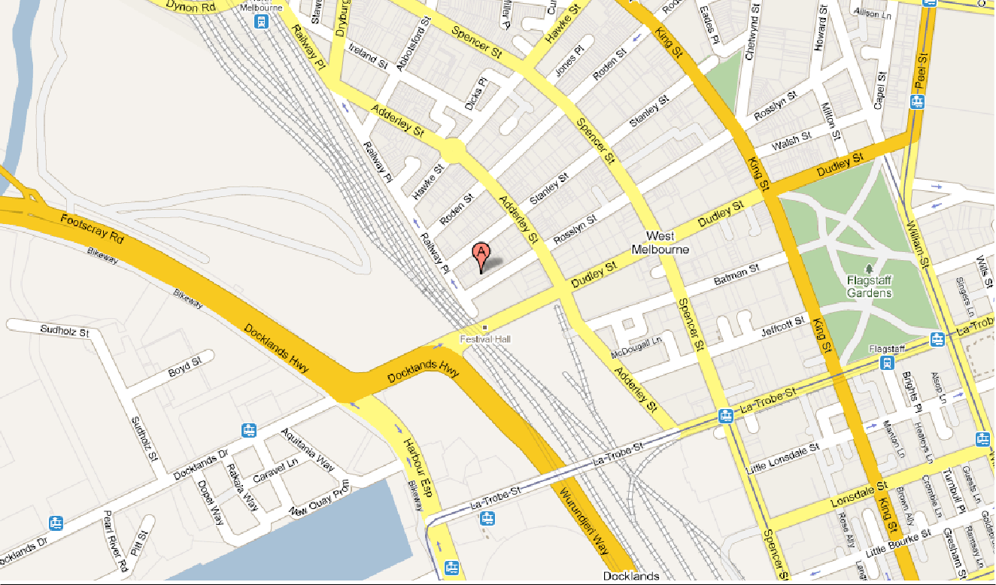

STREET VIEW
