Escape Trailer Industries LP

43851 Industrial Way, Chilliwack, BC, V2R 4L2

Telephone 604 703 1650 / Fax 604 703 1651

GST# 743701286 / PST# 1110-7313

Sold To
(Legal Name): 2019 Escape 19' INVENTORY |  | Order Date:
Address: |  | Completion Date: | 2-Dec-19
 |  | QAI Certification:
 |  | QAI Certification: | 221574
email address: |  | QAI Nameplate | Q00216853
Phone Number |  | Trailer VIN: | 2E9TF6B57KC068430

Bill Of Sale

Floor Plan: | MODEL 2019, 21' Escape Travel Trailer
Options: | Please Note: Your Deadline for Confirmation is SEPTEMBER 9, 2019
 |  | MAPLE INTERIOR
 | Standard Options: |  |  |  |  | Qty
 | Oven with 3 Burner Cooktop (Includes Bi-Fold Stove cover ) |  |  |  |  | 1
 | Microwave (Built into Cabinet) |  |  |  |  | 1
 | Two Way Hot Water Tank (Propane & 120V) |  |  |  |  | 1
 | Foot Flush Toilet |  |  |  |  | 1
 | Toilet Shut Off Valve |  |  |  |  | 1
 | Exterior shower (Driver AND Passenger Side) |  |  |  |  | 2
 | Dual 6V Batteries (225 amp hrs) |  |  |  |  | 1
 | Inverter 1500W Includes Transfer Switch and all outlets *This Option will require Dual 6V |  |  |  |  | 1
 | Batteries |  |  |  |  | 1
 | 190W Solar Panel with Charge Controller ** Additional Panels cannot be added |  |  |  |  | 1
 | aftermarket |  |  |  |  | 1
 | Surge Protector |  |  |  |  | 1
 | Removable Power Cord |  |  |  |  | 1
 | Power Awning (Dometic 9500E) |  |  |  |  | 1
 | LED Awning Light Strip |  |  |  |  | 1
 | Air Conditioner with Digital Thermostat (11,000 BTU Dometic) |  |  |  |  | 1
 | Wireless Back - Up Camera (Display Monitor wired with 12V Plug) |  |  |  |  | 1
 | Jack' TV Antenna (Includes TV Ready with 120V) **Cannot be combined with 2 - Solar |  |  |  |  | 1
 | Panels |  |  |  |  | 1
 | Extra Insulation & Frame-less Thermal Windows (Includes Opening Rear Window) |  |  |  |  | 1
 | Opening Window in Bathroom (Frame-less Non-Thermal) *Cannot be added |  |  |  |  | 1
 | aftermarket |  |  |  |  | 1

2019 Escape 21' INVENTORY VIN# 430 2/26/2020 - 9:35 AM Page 1 of 4

 |  | Aluminum Rim Package (Includes 5 Aluminum Rims) | 1
 |  | High Lift Axle | 1
 |  | Power Tongue Jack | 1
 |  | Exterior Access Hatch (Rear Driver Side or Rear Passenger Side) | 2
 |  | Exterior Propane Quick Connect with 12' Propane Hose and Adapter (Low Pressure) | 1
 |  | Spray Foam Insulation for Under Trailer | 1
 |  | Additional Cabinet Door under Bed beside Bathroom Door | 1
 |  | Storage Box (Front of Trailer) | 1
 |  | Convert Bench Seat to U Shaped Dinette | 1
 |  | Additional Options:
 |  | Exterior 12V/USB Outlet ($75 each) #8 | 1
 |  | ADDITIONAL 12V/USB Interior Outlet ($75 each) #2 & #5 | 2
 |  | ADDITIONAL Exterior LED Light ($75/each) Front centered over belly band | 1
 |  | LOWER Standard Exterior LED Light #6 to just below striping (photo in file) | 1
 |  | ADDITIONAL LED Captains Reading Lamps ($40/each) #1 & #2 | 2
 |  | Zamp Solar Port Rear P/S beside battery vent - Wire to charge controller | 1
 |  | Double Step | 1
 |  | REINFORCE Wall ($100/ea) #6, #1, #2, #4 & #5 | 5
 |  | INSTALL Cx. Provided Assist Bar in Wet Bath @ Or. | 1
 |  | Counter Extension ($85/each) #1 | 1
 |  | DO NOT INSTALL Table or Hardware | 1
 |  | INSTALL Table Slider Assy | 1
 |  | INSTALL Cx. Supplied Springfield Table Pedestal @ Or. | 1
 |  | NEW STD Flooring - Mannington Millcreek Axle 4182 | 1
 |  | NEW STD Formica - Silver Shalestone 9307-58 Trim - BLACK | 1
 |  | NEW STD Fabric - Chincilla Ultra Leather | 1
 |  | Graphic Color: #870 Battleship Gray Rec-30-Oct-19-AQ | 1
 |  | Additional Options:
 |  | Starter kit with X Chocks (Includes: 4 Rolls RV Toilet Tissue, 1 ltr Toilet Chemical, 10 prs
 |  | of Lg Latex Gloves, 25’ Water Hose, City Water Pressure Regulator, X Chocks, Propane | 1
 |  | Tanks Purged & Filled, Hitch Lock)
 |  | Customer Supplied Umbra Hooks (Install Only at Orientation) | 1
 |  | E2 by FastWay Integrated Sway Control and Weight Distribution Hitch *Not Compatible | 1
 |  | with vehicles that have an Air Leveling Suspension System | 1
 |  | Extendable Wall Mount TV Arm (For 15" - 22" TVs) | 1
 |  | Sand Pads (Set of 4) | 1
 |  | Step Cover | 2
 |  | Water Filter | 1

Customer Referral:

Subtotal (Base Price + Options)

Discount

Importation Fees (US Customers ONLY)

Tire Levee

Trailer Delivery

Documentation Fees

2019 Escape 21' INVENTORY VIN# 430 2/26/2020 - 9:35 AM Page 2 of 4

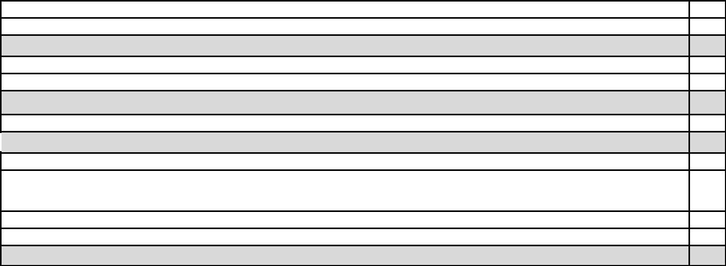
Customization Fee

Subtotal A (Subtotal + Misc. Fees)

Total (Subtotal A + Taxes)

Less Deposit

Payments in Canadian

Funds

Payments in US Funds

Dealer # 40600 Balance Due

Prices are subject to change without notice. Escape Trailer Industries reserves the right to change the option based on market fluctuations. The customer will be notified of all changes when they come into eff

Build Sheet is Confirmed, the Options Price List becomes fixed.

Build Sheet Confirmation

Please note Escape Trailer Industries is more than happy to offer various forms of customization for ea Travel Trailer. However, additional charges may apply. When a customer chooses to provide custom installation or replace a standard component in their trailer, Escape Trailer Industries will provide each cus much information as possible to help them make an informed decision. With new trends and developmen Industry some items provided for installation have never been installed before, and although the item is pr

Escape Trailer Industries may encounter unforeseen complications during the installation process. In the a complication we will notify the customer immediately and work with them to arrive at a solution. For the r

above sometimes Customization Charges may not be finalized until after the trailer has entered prod

Please note: The Build Sheet Confirmation is an important stage in the manufacturing of your trailer. AN made to your Build Sheet once you have signed off will directly impact the manufacturing process and m completion of your trailer. Depending on where the trailer is in production AND when the changes are ma be additional fees associated with the changes requested in relation to the two lines below. As a manufact hard to maintain our Production Schedule to ensure our customers receive their trailer on or before thei

Completion Date. Please initial here __________

Please note once you have confirmed your build sheet there will be a $200.00 fee for any changes m Options List. Please initial here __________

Please note once you have confirmed your build sheet AND your trailer is in production, there will be a $5 any changes made to the Options List. Please initial here __________

2019 Escape 21' INVENTORY VIN# 430 2/26/2020 - 9:35 AM Page 3 of 4



