Department/Service/Functional Area
Department:
Service:
Functional Area:

Accident Location (eg school, roadway, graveyard etc)

About the person reporting the accident/incident
Full Name: |  |  |  |  | Work Address
Occupation:
Contact Number:

About the injured person
Type of injured person (✓)
Employee |  | Contractor |  | Sub-Contractor |  | Visitor |  | Customer
Pupil |  | Unknown |  | Member of Public |  | Other

Full Name: |  |  |  |  |  |  |  |  | Home Address
Employee: (✓)
Non – Employee: (✓)
Job function: |  |  |  |  |  |  |  | Gender: (✓) |  |  | Male: |  | Female
Date of Birth: |  |  |  |  |  |  |  | Telephone:

Check this box if the injured party gives permission for the report to be given to third parties

About the incident

How serious was the accident/incident: (✓) |  |  | Minor |  |  | Serious |  |  | Major
Date of accident/incident: |  |  |  | What time did it happen? |  |  |  |  |  | 24hr
Where did the accident/incident happen:
Describe the task being carried out, any equipment being used at the time and what went wrong?
Conditions at the time of the accident/incident

Lighting (✓)
Indoor………… | Excellent |  |  | Poor |  | Satisfactory |  | Unknown
Outdoor ……… |  | Excellent |  | Poor |  | Satisfactory |  | Unknown

Surface (✓)
AstroTurf |  | Carpet |  |  |  | Concrete |  |  |  |  | Grass |  |  |  |  |  |  | Mud |  |  |  |  |  |  |  |  | Painted
Stones |  | Tarmac |  |  |  | Stones |  |  |  |  | Tiled |  |  |  |  |  |  | Woodchip |  |  |  |  |  |  |  |  | Wooden
Metal |  | Vinyl flooring |  |  |  |  | Robber safety |  |  |  |  |  |  |  | other

Condition of surface (✓)
Dry |  | Wet |  | Slippery |  | Uneven |  | Unknown |  | N/a

Weather conditions (✓)
Fog |  | Icy |  |  |  | Raining |  |  |  | Snow |  | Sunny |  | Windy
Dull/overcast |  |  |  | Unknown

About any treatment given

Describe what treatment was given (if any) and by whom

How many days were lost due to this incident?
When did the injured person return to work |  | / /
 | Check this box if the injured person required hospital treatment

Part of the body injured (✓)
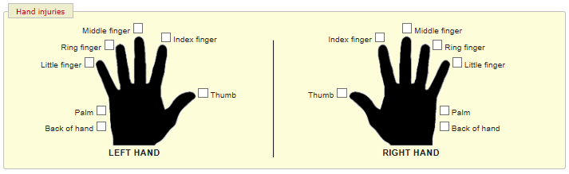
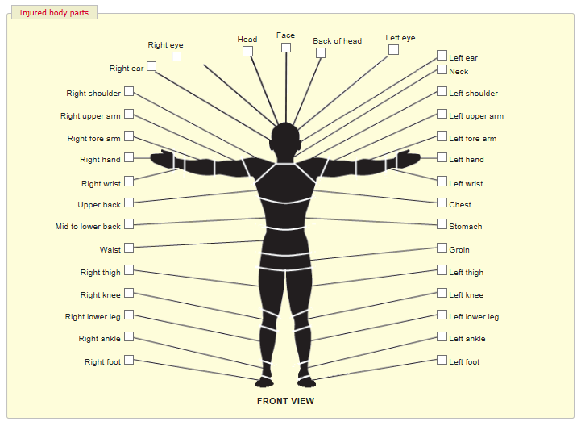
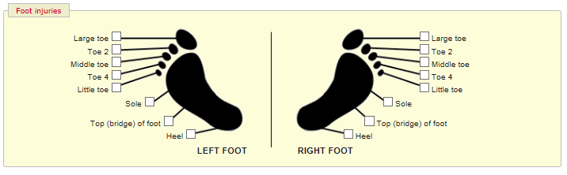
What type of Personal Protective Equipment (PPE) was being worn at the time of the accident (✓)
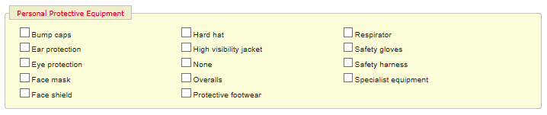
Cause of injury (✓)

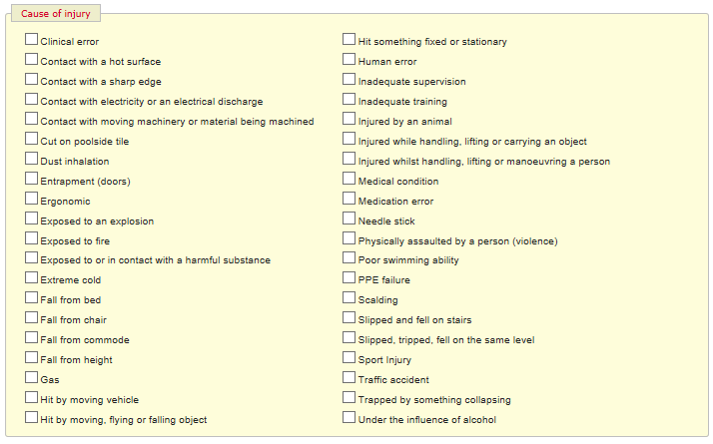
Effect of the accident (✓)
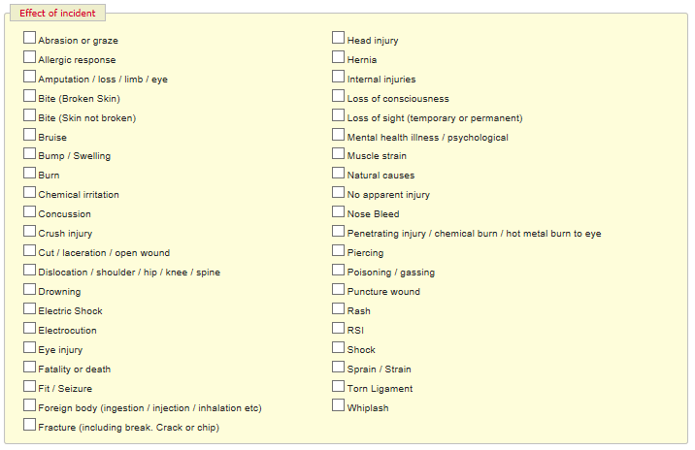
Related documents

If you wish to attach any documents to this report, please indicate below what these documents are

Incident questions (✓)

 | Yes  (✓) | No  (✓) | Don’t know (✓) | N/A  (✓)
Did the injured person continue to work after the accident/incident?
Did the injured person require medical assistance or hospital treatment?
Did the injured person require resuscitation?
Is the injured person likely to stay in hospital for more than 24 hours?
Is the injury likely to prevent the person from working or carrying out their normal duties for more than 7 days?
Was first aid offered to the injured person?
Was first aid accepted by the injured person
Was the injured person taken to hospital from the scene of the accident?

Witness details
Full Name: |  |  |  |  | Address
Occupation:
Contact Number:

Full Name: |  |  |  | Address
Occupation:
Contact Number:

Full Name: |  |  |  | Address
Occupation:
Contact Number:

If you feel you require further support, either completing this form or following the accident please speak to your line manager.
Please give the completed report to your line manager under confidential cover to process and allow an investigation to take place into the circumstances of the accident.

