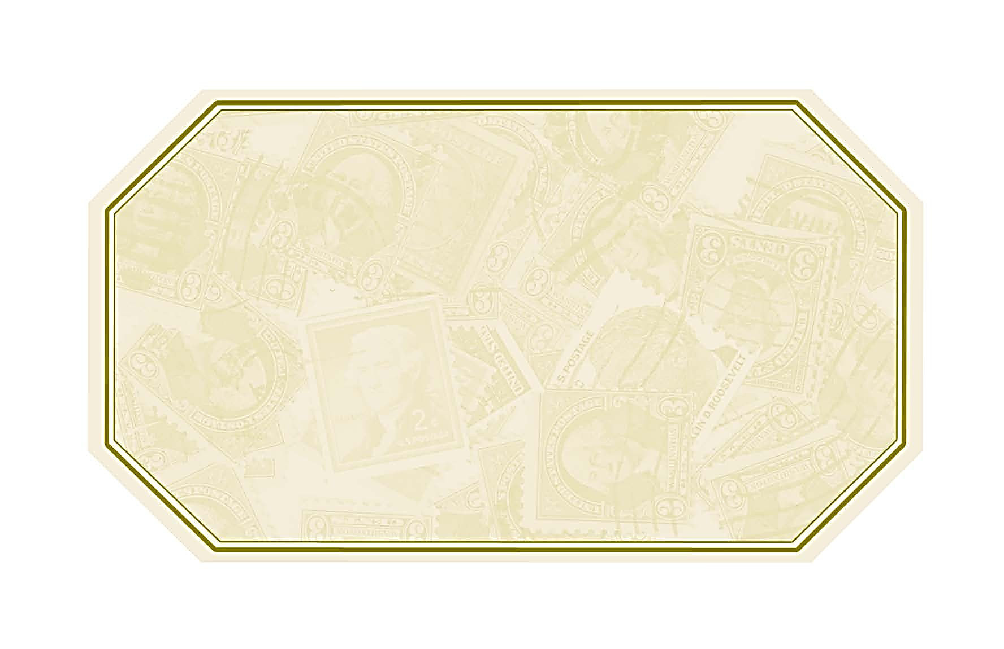

Wine Name Here

Place any other text you would like to add to the label in this spot.

Made specially for [Name]

Wine Name Here

Place any other text you would like to add to the label in this spot.

Made specially for [Name]