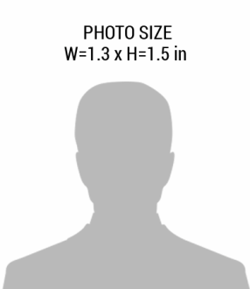pic.png

**EXP.**

01-01-2018

01-08-1985

**D.O.B**

FIRST, LAST NAME

**DESIGNATION**

+92 41 654 7890

123 ANYWERE STREET, CITY

XYZ SECURITY