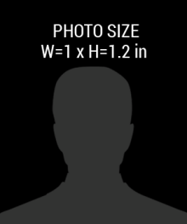

JOINED: MARCH 2017

FIRST, LAST NAME

DESIGNATION

NEWS MEDIA

123 ANYWERE STREET, CITY 0000