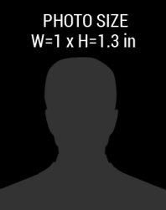barcode.png

+92 41-654-7890

December, 2018

Phone Number:

Date of Birth:

01-08-1985

Expiry Date:

January, 2017

Member Since:

+92 41 657 7890

DESIGNATION

LAST NAME

**FIRST**

ASSOCIATION

NATIONAL PRESS

123 Anywere Street, City

PRESS