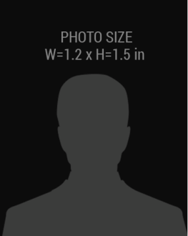

**EXP.**

**ISSUED**

01-08-2018

01-03-2017

**01 AUG 1985**

MOBILE NO:

DATE OF BIRTH:

PRIVATE

**+1 6765-9098**

**FIRST, LAST NAME**

INVESTIGATOR

HIS 00AB1234

SER NO.