barcode.png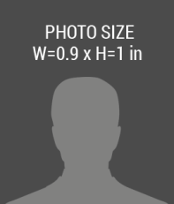

123 Anywere Street, City, 0000 +1 000 888 1111

02/02/2017

***ISSUE***

02/02/2018

***EXPIRES***

*First Name, Last Name*

Designation Title Here