barcode.png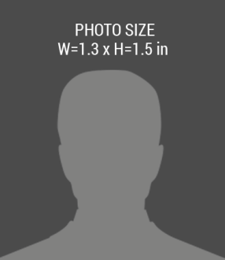

EXPIRES

02/02/2018

02/02/2017

123 Anywhere Street, City,

DESIGNATION

First Name, Last Name

ISSUE