barcode.png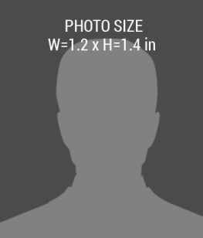

**First Name, Last Name**

**+1 000 888 1111**

PHONE:

**Street, City**

**123 Anywhere**

ADDRESS:

EXPIRIES:

**02/02/2018**

**02/02/2017**

ISSUE:

DESIGNATION