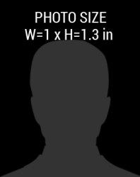

**BIRTHDATE:**

01-08-1985

123 Fake St,

Fake Town, USA, 0000

**FIRST, LAST NAME**

6.0”

**HEIGHT**

**EYES**

Black

**HAIR**

Brown

Male

**SEX**

**EXPIRES**

01-01-2018

00AB3210

01-01-2017

**ISSUED**

**CODE #**

EDIT YOUR TEXT HERE

DESIGNATION