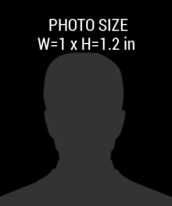pic.png

**01-Aug-1985**

DATE

**2017 - 2018**

**:**

**:**

D.O.B

CODE

**HIS00AB3214**

**:**

**:**

**First - Last Name**

NAME

123 ANYWERE STREET, CITY +111 654 7890

Company Name Here

**IDEBTITY CARD**