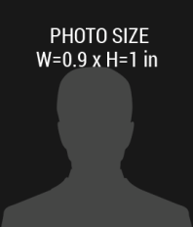

COM ID

**HIS00AB3214**

**01-AUG-1985**

123 Anywhere Street, City +1 000 888 1111

D.O.B

DESIGNATION

**First – Last Name**

**EXPIRES**

02/02/2017

**ISSUE**

02/02/2018