REAL ESTATE “OPEN HOUSE” SIGN PERMIT APPLICATION

PERMIT REQUESTED: □ Annual Permit: $50.00 □ Semi-Annual Permit: $25.00

GENERAL SIGN INFORMATION

APPLICANT TO READ/CHECK ALL BOXES BELOW AND SUPPLY ADDITIONAL INFORMATION AS REQUIRED.

- Permittee may have a total of five (5) signs per permit at any one time per “Open House,” including a combination of Entrance Signs and Directional Signs. The maximum display area per sign is four (4) square feet per side.
- All signs under this permit are required to have the name and phone number of the licensed real estate agent or applicant (if for sale by owner) who filed for the sign permit permanently affixed to each sign.
- Signs will not be allowed on state or federal highway rights of way (U.S. Highway 75, State Highway 117, State Highway 67) or associated access roads.
- Signs are allowed on City rights of way but shall not impede or negatively affect the line of sight of drivers.
- No paper, cardboard or homemade signs are allowed.
ENTRANCE SIGNS:
- Up to the maximum number of five (5) signs (including Directional Signs) are allowed at the entrance of a subdivision from arterial streets in order to advertise the “Open House” inside that subdivision.
- The maximum display area per sign is four (4) square feet per side.
- The hours the signs may be posted are from 4:00 P.M. Thursday until 8:00 P.M. the following Sunday.
- A fine of fifty dollars ($50.00) per sign, per day shall be imposed if the “Subdivision Entrance Signs” are not removed by 8:00 A.M. the following Monday morning.
DIRECTIONAL SIGNS:
- Up to the maximum number of five (5) signs (including Subdivision Entrance Signs), are allowed in the interior of a subdivision in order to direct the public to an “Open House” for sale.
- These signs are allowed to remain for the duration of the listing agreement for the “Open House” property.
Listing agreement duration: From: to
- Obtained permission from owners of private property inside subdivision? □ Provided copy of agreement from each private property owner with this application. 1
- Signs are in compliance with the subdivision’s Covenants, Conditions and Restrictions?
□ Yes, in compliance, or □ No Restrictions. 1
- Obtained permission of the subdivision’s Homeowners Association. □ If yes, provided copy with this application, or □ Not required. 1
1 City of Glenpool relies upon the representations of the Applicant regarding any required permission from property owners, compliance with subdivision CCR’s and permission of homeowners association and assumes no liability with respect to same.

ADDRESS OF “OPEN HOUSE”
- Entrance/Directional Sign Location:

Property Owner Name: Address

Owner Approval obtained by: Property Owner Phone:

- Entrance/Directional Sign Location:

Property Owner Name: Address

Owner Approval obtained by: Property Owner Phone:

- Entrance/Directional Sign Location:

Property Owner Name: Address

Owner Approval obtained by: Property Owner Phone:

- Entrance/Directional Sign Location:

Property Owner Name: Address

Owner Approval obtained by: Property Owner Phone:

- Entrance/Directional Sign Location:

Property Owner Name: Address

Owner Approval obtained by: Property Owner Phone:

I agree to abide by Title 11, Zoning Regulations; Chapter 12, Use Units; Section 21, Signs; Subsection L, Residential District Use Conditions Paragraph (g), Off-Site Temporary Directions Signs (Real Estate “Open House”) of the Code of Ordinances of the City of Glenpool, Oklahoma per Ordinance #692 and acknowledge that a fine $50.00 per day per sign will be imposed if found to be in violation.

Signature: Date:

Realtor Name: Real Estate Company:

Address: Phone:

Email:
Application Received Date:
□ Approved: Date:
□ Denied: Date:
Permit No.:
□ Need More Information: Date:

AGREEMENT TO ALLOW THE PLACEMENT OF REAL ESTATE DIRECTIONAL “OPEN HOUSE” SIGNS ON PRIVATE PROPERTY.

Date of agreement:

Address of “Open House”

Duration of agreement: Beginning: Ending:

Property address of directional sign location:

Property owner(s) name(s):
(print)

(print)

Phone# ( ) - Email Address:
[Optional] [Optional]

Signature of Property Owner(s):

Signature of Real Estate Agent/Private Seller:

Name of Real Estate Company/Private Seller: Phone #:

*According to Ordinance #692 approved by the Glenpool City Council on 12/15/14.

Private Property Agreement

AGREEMENT TO ALLOW THE PLACEMENT OF REAL ESTATE DIRECTIONAL “OPEN HOUSE” SIGNS BY SUBDIVISION HOMEOWNERS ASSOCIATION.

Date of agreement:
Address of “Open House” Duration of agreement: Beginning: Ending:

- Property address/location of sign:
- Property address/location of sign:
- Property address/location of sign:
- Property address/location of sign:
- Property address/location of sign:

Name of Homeowners Association:
(print)

Officer from Homeowners Association:
(print)

Phone# ( ) - Email Address:

- The Homeowners Association listed above does agree to allow the placing of Entrance Signs and Directional signs in this subdivision for locations and period of time listed above.

Signature of Homeowners Association(s) officer:

Signature of Real Estate Agent/Private Seller:

Name of Real Estate Company/Private Seller:

Phone#:

*According to Ordinance #692 approved by the Glenpool City Council on 12/15/14.

Subdivision Homeowners Association agreement

CITY OF GLENPOOL ORDINANCE 692

AN ORDINANCE AMENDING TITLE 11, ZONING REGULATIONS; CHAPTER 12, USE UNITS; SECTION 21, USE UNIT 21, SIGNS; SUBSECTION L, RESIDENTIAL DISTRICT USE CONDITIONS; PARAGRAPH (g), OFF-SITE TEMPORARY DIRECTIONAL SIGNS (REAL ESTATE "OPEN HOUSE"), OF THE CODE OF ORDINANCES OF THE CITY OF GLENPOOL, OKLAHOMA, (2013), REPEALING ALL ORDINANCES OR PARTS OF ORDINANCES IN CONFLICT HEREWITH; AND DECLARING AN EMERGENCY

WHEREAS, on August 13, 2014, members of the Glenpool Chamber of Commerce, including residential property realtors, had a discussion with City staff pertaining to, and recommending amendments to, real estate signs and what kind of signage is allowable per the Glenpool Zoning Code; and
WHEREAS, on October 6, 2014, the subject of the proposed amendments was placed as an item on the City Council agenda for discussion and possible action amending the Glenpool Zoning Code as it pertains to "Open House" real estate signs; and
WHEREAS, on October 20, 2014, there was further discussion and recommendations regarding possible action to amend the Glenpool Zoning Code as it pertains to "Open House" real estate signs; and
WHEREAS, on November 10, 2014, the City Council gave staff specific direction with respect to amending the Glenpool Zoning Code as it pertains to "Open House" real estate signs; and
WHEREAS, it would be in the best interest of the City of Glenpool, Glenpool residential realtors and Glenpool residential homeowners to amend Title 11, Zoning Regulations; Chapter 12, Use Units; Section 21, Use Unit 21, Signs; Subsection L, Residential District Use Conditions; Paragraph (g), Off-Site Temporary Directional Signs (Real Estate "Open House"), of the Code of Ordinances of the City of Glenpool, Oklahoma, (2013) for the purpose of clarifying and enlarging the lawful use of real estate open house signage.

THEREFORE, BE IT ORDAINED BY THE CITY COUNCIL OF THE CITY OF GLENPOOL, OKLAHOMA, THAT:
§ 1. That Title 11, Zoning Regulations; Chapter 12, Use Units; Section 21, Use Unit 21, Signs; Subsection L, Residential District Use Conditions; Paragraph (g), Off-Site Temporary Directional Signs (Real Estate "Open House"), of the Code of Ordinances of the City of Glenpool, Oklahoma, (2013), shall be and hereby is amended to read as follows:
  - Off-site temporary directional signs (real estate "open house"):

    - A sign permit application and fee is required:

      - Annual permits: $50.00.

      - Semi-annual permits: $25.00.

    - Permittee may have a total of five (5) signs per permit at any one time per "Open House," including a combination of Entrance Signs and Directional Signs, as defined in this subsection.
    - All signs under this permit are required to have the name and phone number of the licensed real estate agent or applicant (if for sale by owner) who filed for the sign permit permanently affixed to each sign.
    - Types of signs allowed for "Open House" advertising with this permit include:

      - Entrance Signs: Up to the maximum number of five (5) signs (including Directional Signs) are allowed at the entrance of a subdivision in order to advertise the "Open House" inside that subdivision. The maximum display area per sign is four (4) square feet per side. The hours the signs may be posted are 4:00 P.M. Thursday until 8:00 P.M. the immediately following Sunday. A fine of fifty dollars ($50.00) per sign, per day shall be imposed if the "Entrance Signs" are not removed by 8:00 A.M. Monday morning.
      - Directional Signs: Up to the maximum number of five (5) signs (including Entrance Signs), are allowed in the interior of a subdivision in order to direct the public to an "Open House" for sale. The maximum display area per sign is four (4) square feet per side. These signs are allowed to remain for the duration of the listing agreement for the "Open House" property. Directional signs may be allowed on private property with the permission of the property owner, in compliance with the subdivision's Covenants, Conditions and Restrictions and with permission of the subdivision's Home Owners Association, if required. Signs may also be allowed on City rights of way but shall not impede or negatively affect the line of sight of

drivers on public rights of way.
    - No paper, cardboard or homemade signs are allowed.

    - Signs will not be allowed on state or federal highway rights of way (U.S. Highway 75, State Highway 117, State Highway 67) or access roads.
§ 3. Except as otherwise amended by this Ordinance, Title 11, Zoning Regulations; Chapter 12, Use Units; Section 21, Use Unit 21, Signs; Subsection L, Residential District Use Conditions, of the Code of Ordinances of the City of Glenpool, Oklahoma, (2013), shall remain in full force and effect.
§ 4. All ordinances or parts of ordinances in conflict herewith shall be and the same are hereby repealed.
§ 5. The City Council, by separate vote, finds that this ordinance shall be immediately effective in order to protect the public safety, health and welfare, and declares an emergency for that purpose.

PASSED AND APPROVED by the City Council of the City of Glenpool this 15th day of December 2014.
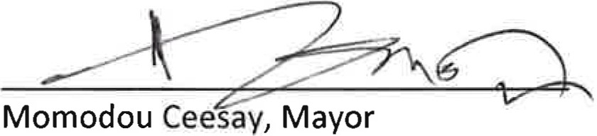

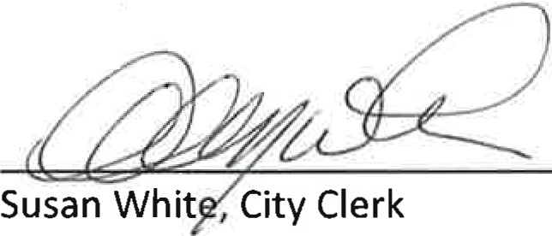At t est:

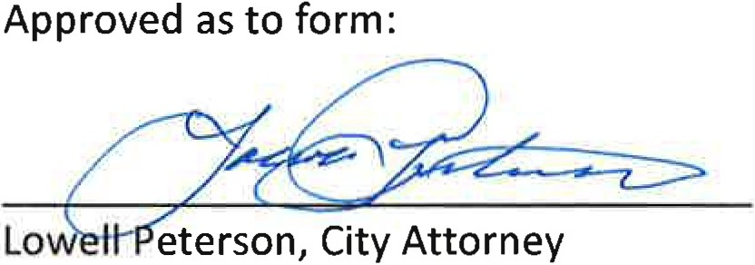

EMERGENCY CLAUSE

Whereas, the immediate operation of the provisions of Ordinance No. 692, An Ordinance Amending Title 11, Zoning Regulations; Chapter 12, Use Units; Section 21, Use Unit 21, Signs; Subsection L, Residential District Use Conditions; Paragraph (g), Off-Site Temporary Directional Signs (Real Estate "Open House"), Of The Code Of Ordinances Of The City Of Glenpool, Oklahoma, (2013), Repealing All Ordinances Or Parts Of Ordinances In Conflict Herewith; And Declaring An Emergency, is necessary for the preservation of the public safety, health and welfare of the City of Glenpool and the inhabitants thereof, an emergency is declared to exist and the Ordinance shall take effect and be in full force from and after its passage as provided by law.

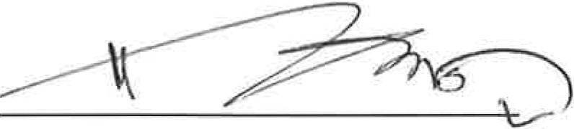
PASSED and this Emergency Clause ruled upon separately and approved this 15t h day of December 2014 .

Momodou Ceesay, Mayor

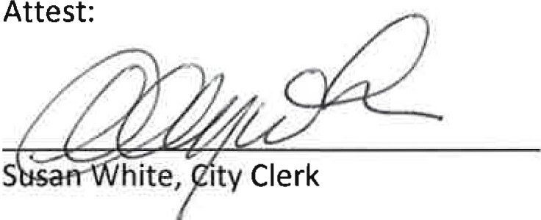
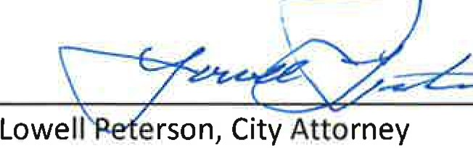
Approved as to form:- - - --

