**Title in Delius!**

by

Your name in Garamond

(See detailed instructions on the following page)

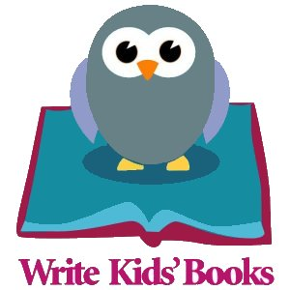

*Your Awesome Title* © 2015 Your Wonderful Name Here

**NOTES:**

Change the background colour in this document using Microsoft Word’s “page color” feature to anything you want. Specify “Full Bleed” when uploading to Createspace so the colour goes right to the edge of your pages!

Make sure “reveal codes,” near the top of the screen, is turned on. The button looks like this: . You must be able to see the spaces and carriage returns to format your book properly. You should see two “Section Breaks” in this template – one on this page and one at the end of the “story” section of the book. Whatever you do, don’t erase them, as each section has different settings for page numbers. The section breaks look like this:



All Rights Reserved.  No part of this publication may be reproduced, stored in a retrieval system, or transmitted, in any form or in any means – by electronic, mechanical, photocopying, recording or otherwise – without prior written permission

ISBN-13: Paste yours here

ISBN-10: Paste yours here

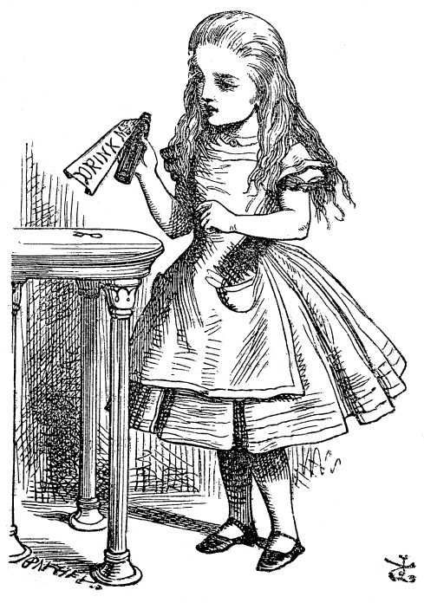

This is the beginning of the “Story” section.

This part has page numbers (the sections before and AFTER this do not; see the note about Section Breaks on page 2). If you want text on your first page, you can add it here. You will have less room if you use a larger picture. The image on this page floats above the text so you can format your page more tightly if you need to.

Add your page text here and/or more illustrations.

Add your page text here and/or more illustrations.

Add your page text here and/or more illustrations.

Look, here’s one!

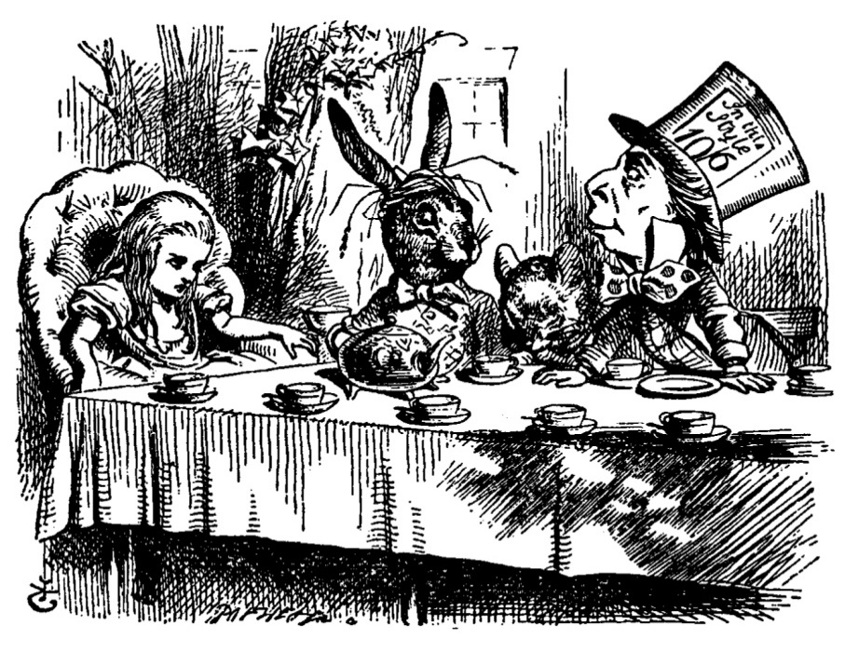

This picture is formatted to sit “In Line” with the text. It won’t float around and that is sometimes a very good thing.

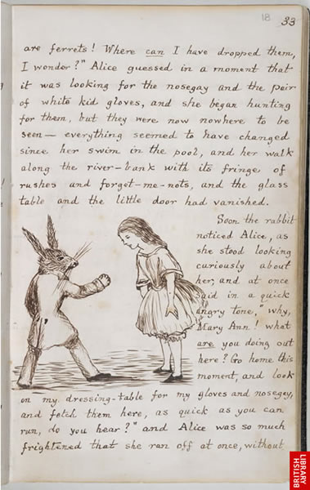One last page with the coolest illustration of all (I like saving the best for last!).

Even the classics start out as a humble manuscript!

I hate to admit it, but this story’s just about done.

**THE END**

(you don’t have to say “THE END” – it’s up to you)

The following line contains the next section break. This page has a page number, but the next page does not.

About this story:

This is the “back matter” of your book. Front and back matter pages are not generally numbered.

You can use this section for whatever extra information you want to add to your book. Whatever is on this page will be automatically centered from top to bottom – if you have a lot of text, it’ll be close to the top. If you don’t have much, it’ll appear more towards the center.

*The seeds of this story were first planted when…*

About the author:

[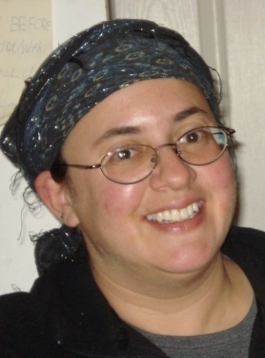](mailto:Tzivia@tzivia.com)

Swap out my mug and add in your own here! Don’t forget a few lines of biography. It’s okay to refer to yourself in the third person. Brag a little, but not too much.

Don’t forget to tell them where to find you:

<http://writekidsbooks.org>

For help editing and formatting your children’s book, email me directly at [Tzivia@tzivia.com](mailto:Tzivia@tzivia.com)

Have fun writing – and formatting – your book!

☺