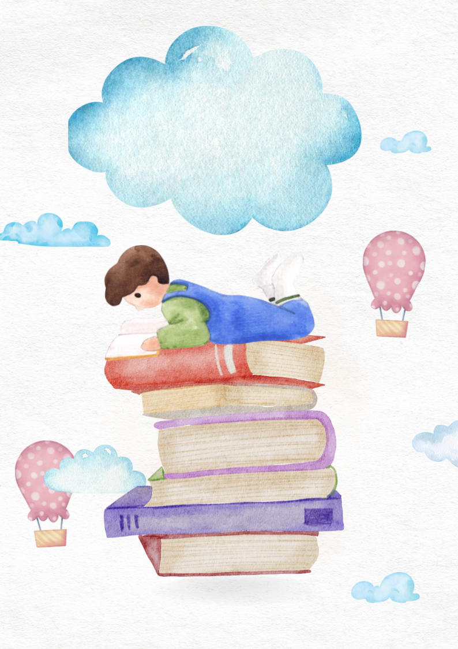

Children's book

By: John Doe

set amet



TEXT



TEXT