Your Children’s Book!
Subtitle Goes Here
(Series Title Here)
NOTE: I have chosen a purple colour for this book. Word will let you choose any colour you like instead of purple. Including plain white. I just like purple!

This template is based on STYLES. Try to use the built-in styles, updating them as needed for things like fonts, size, centering, etc. Don’t just format one line, change its style so every similar line gets changed at the same time!

This template will work best if you download and install the free AlphaClouds and Teen fonts. But you can substitute any fonts you think work well together.

by Your Name Here
Your Book! © 2014 Your Name Here

NOTE: Your book should have no PAGE NUMBERS until the actual story begins!!!

Images used with permission from Wikimedia Commons (Creative Commons Attribution 2.0 Generic license):
List Wikimedia images used here.

All other images (foreground) © 2014 Your name here

All Rights Reserved. No part of this publication may be reproduced, stored in a retrieval system, or transmitted, in any form or in any means – by electronic, mechanical, photocopying, recording or otherwise – without prior written permission

ISBN-13: goes here
ISBN-10: goes here

Here is your text

DRAWING
Wow – more text??? Awesomesauce!

DRAWING
Here’s a little more text.

Of course,
This text
Can go anywhere
On the page!
One last page of text to make my point

DRAWING

Goodbye!

DRAWING
The page of extra information:
Sometimes, at the end of a book, I like to include a page of “extra facts,” useful either for parents who are interested or kids who are precocious readers.
In our family, we have both.
If you make sure this information page is an ODD number, then it will smile up at the reader as she flips through your book.
That also ensures that your author page will be on an even-numbered page, which will smile at anyone who peeks inside the back cover.
This page can have a page number, but the author page that follows shouldn’t.

You can also include photographs or other images on this page if it makes it more meaningful, or leave it out altogether if your story needs this amount of room.

About the Author:
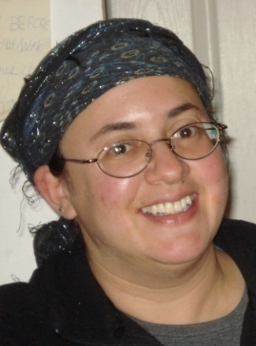

This is ME. Naturally, you will want to include a picture of you instead. Unless I wrote your book… which is just plain weird.

Thanks for reading! I hope this template is useful to you!!

By the way, in terms of page count in Microsoft Word, even though this page has no number showing at the bottom, when you’re finished, this should be Page 32 in any standard-length children’s picture book

Feel free to email me with your questions, comments, etc. Click my smiling face for the link.

DRAWING

