APPENDIX H
SWORN STATEMENT
For use of this form, see AR 190-45; the proponent agency is PMG.
PRIVACY ACT STATEMENT
AUTHORITY: Title 10, USC Section 301; Title 5, USC Section 2951; E.O.9397 Social Security Number (SSN).
PRINCIPAL PURPOSE: To document potential Criminal activity involving the U.S. Army, and to allow Army officials to maintain discipline, law and order through investigation of complaints and incidents.
ROUTINE USES: Information provided may be further disclosed to federal, state, local, and foreign government law enforcement agencies, prosecutors, courts, child protective services, victims, witnesses, the Department of Veterans Affairs, and the Office of Personnel Management. Information provided may be used for determinations regarding judicial or non-judicial punishment, other administrative disciplinary actions, security clearances, recruitment, retention, placement, and other personnel actions.
DISCLOSURE: Disclosure of your SSN and other information is voluntary.
1. LOCATION | 2. DATE (YYYYMMDD) |  | 3. TIME | 4. FILE NUMBER
5. LAST NAME, FIRST NAME, MIDDLE NAME |  | 6. SSN |  | 7. GRADE/STATUS
8. ORGANIZATION OR ADDRESS
9.
I, , WANT TO MAKE THE FOLLOWING STATEMENT UNDER OATH:

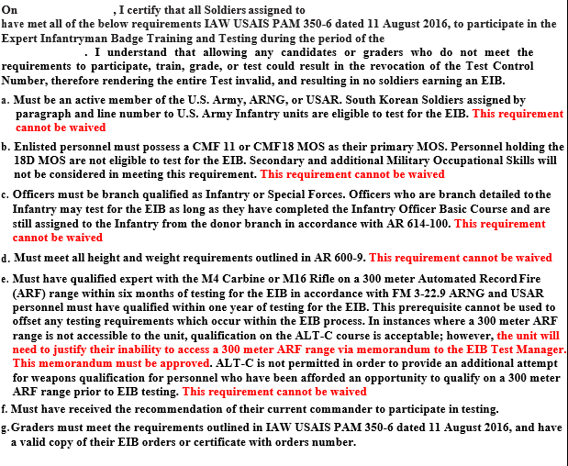
10. EXHIBIT 11. INITIALS OF PERSON MAKING STATEMENT
PAGE 1 of 2 PAGES
ADDITIONAL PAGES MUST CONTAIN THE HEADING “STATEMENT OF TAKEN AT DATED

THE BOTTOM OF EACH ADDITIONAL PAGE MUST BEAR THE INITIALS OF THE PERSON MAKING THE STATEMENT, AND PAGE NUMBER MUST BE INDICATED.

DA FORM 2823, NOV 2006
DA FORM 2823, DEC 1998, IS OBSOLETE
APD V1.00

STATEMENT OF TAKEN AT DATED

9. STATEMENT (CONTINUED)

AFFIDAVIT

I, , HAVE READ OR HAVE HAD READ TO ME THIS STATEMENT WHICH BEGINS ON PAGE 1, AND ENDS ON PAGE 2 . I FULLY UNDERSTAND THE CONTENTS OF THE ENTIRE STATEMENT MADE BY ME. THE STATEMENT IS TRUE. I HAVE INITIALED ALL CORRECTIONS AND HAVE INITIALED THE BOTTOM OF EACH PAGE CONTAINING THE STATEMENT. I HAVE MADE THIS STATEMENT FREELY WITHOUT HOPE OF BENEFIT OR REWARD, WITHOUT THREAT OF PUNISHMENT, AND WITHOUT COERCION, UNLAWFUL INFLUENCE, OR UNLAWFUL INDUCEMENT.
(Signature of Person Making Statement)

WITNESSES: Subscribed and sworn to before me, a person authorized by law to administer oaths, this

ORGANIZATION OR ADDRESS

ORGANIZATION OR ADDRESS
(Signature of Person Administering Oath)

(Typed Name of Person Administering Oath)

(Authority Administer Oath)

INITIALS OF PERSON MAKING STATEMENT

PAGE 2 OF 2 PAGES

DA FORM 2823, NOV 2006

APD V1.00

