Certified Cuddlers Application Form
FacebookInstant Message
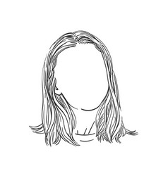  Send eMailVisit Website | Location: Los Angeles, California  Name: Jane Doe  About Me: 5’3”, early 30’s  I already love you unconditionally. In our sessions together, you’ll experience a profound acceptance. That often leads to growth and deep insight. "The Lap of Luxury" is my favorite: put your head in my lap and I'll play with your hair.  Come as you are; leave feeling nurtured, seen, and oh-so-loved.  Session Types Offered: Inbound / Outbound  Inbound Session Location: West Los Angeles (90025)  Travel Options: Up to 15 miles  Travel Cost: $40/hour round trip  Session Length Available: 1-3 hours  Cost: $80/hour  Payment Options: Cash, Credit/Debit, Paypal/Venmo  Contact: abc@cuddlesanctuary.com, (323) 905-4847, www.cuddlesanctuary.com

