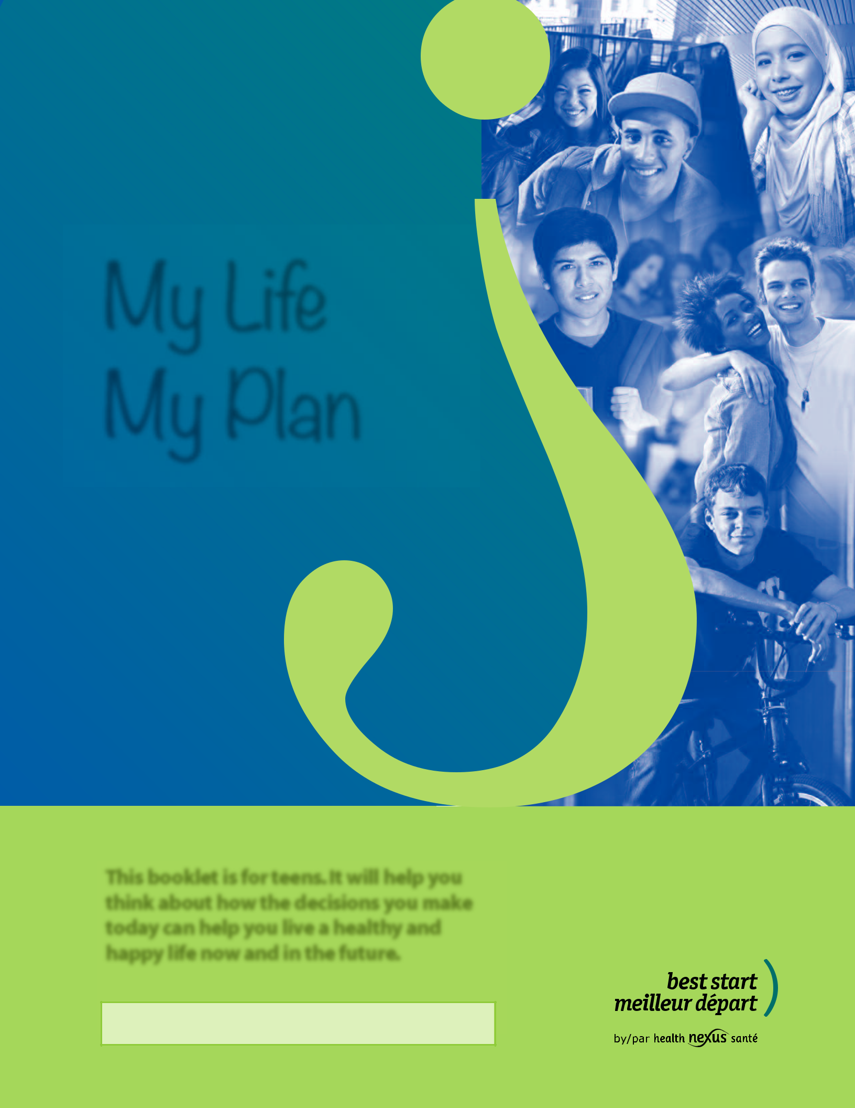

My Life My Plan

This booklet is for teens. It will help you think about how the decisions you make today can help you live a healthy and happy life now and in the future.

Property of:

Now could be a great time to think about...

How are things going and where are you headed?

You may have some goals for right now and some ideas for the future. That’s where having a “life plan” comes in. A life plan can help you achieve your goals and plan for the future. Thinking ahead may help you stay safe and healthy. It will help you make healthy decisions regarding physical activity, healthy eating, sleep, relationships, sex and other areas of your life.

Use this booklet to think about your goals and ultimately, your own life plan. The information and facts in this booklet can help you to stay true to yourself and take the best care possible of your health, and yourself.

Add today’s date and signature below. Then add your own goals on each page and your life plan on the My Focus – My Plan page. Put your plan into action and take time to review it regularly as things in your life may change or you may see them differently at a later date. Make changes and revisions to your plan as needed.

Date:

Signature:

This booklet will guide you through six topics that will help you build your life plan. Start with the topic that you feel most comfortable with and work through the other topics at your own pace. There is a space on every page to add your own notes, goals and plans.
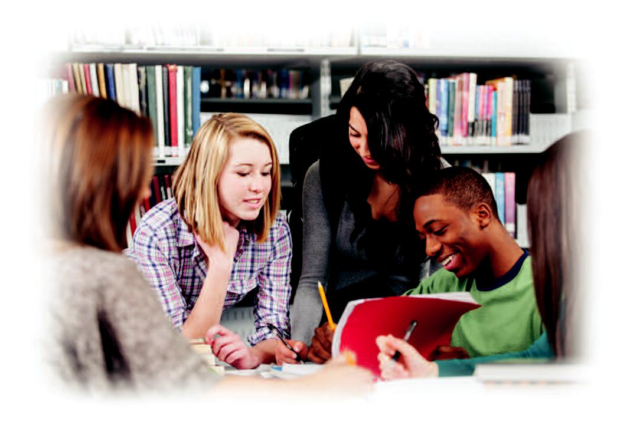

Best Start Resource Centre

1

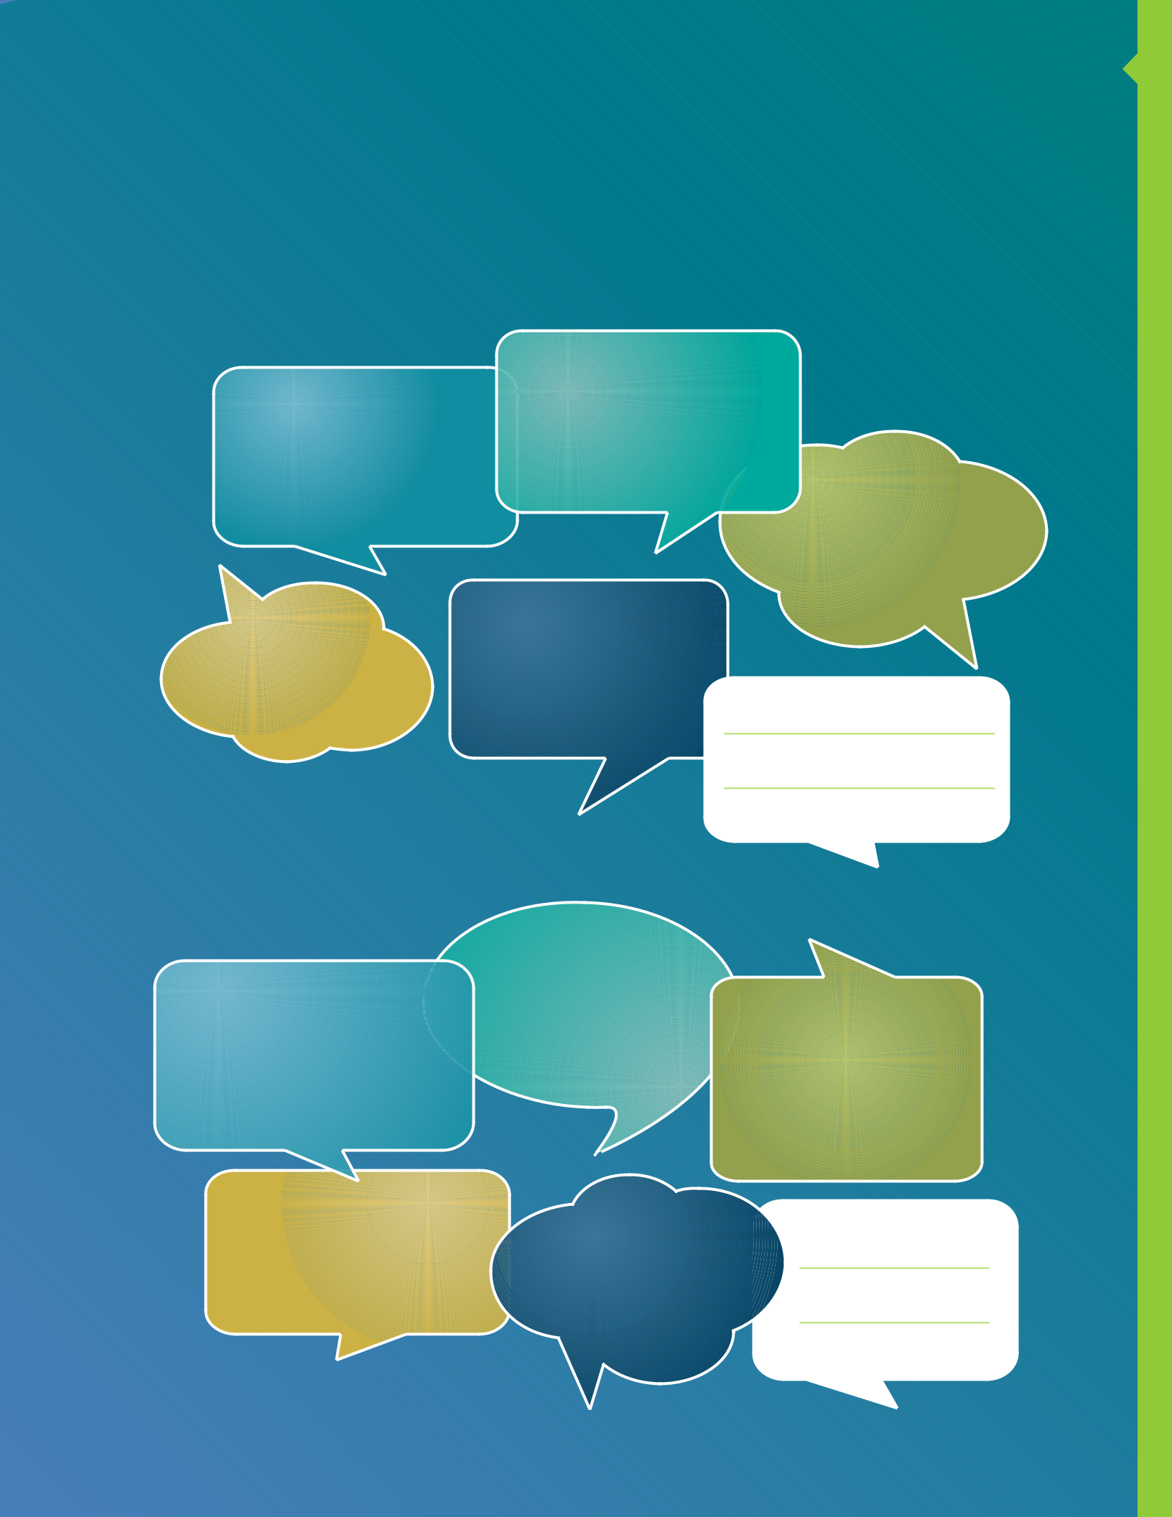
My Life – My Self

Read the following statements and circle the one that best describes you right now.

Or, write your own statement in the bubble provided.

My life is...

... Great; I like it the

... Filled with way it is right now possibilities

... Challenging

at times

... Not so great | ... Challenging
... Not so great | most of the time

The way I look at life is to...

- Take opportunities that come my way

  - Make the best decisions for a healthy future

- Keep things as they are
for now | ... Enjoy and
 | celebrate
 | my life

- Live happy and healthy

My Life My Plan

2

Best Start Resource Centre
My Life – My Health

What healthy eating habits do I practice? Do I follow Eating Well with Canada’s Food Guide?

How physically active am I?
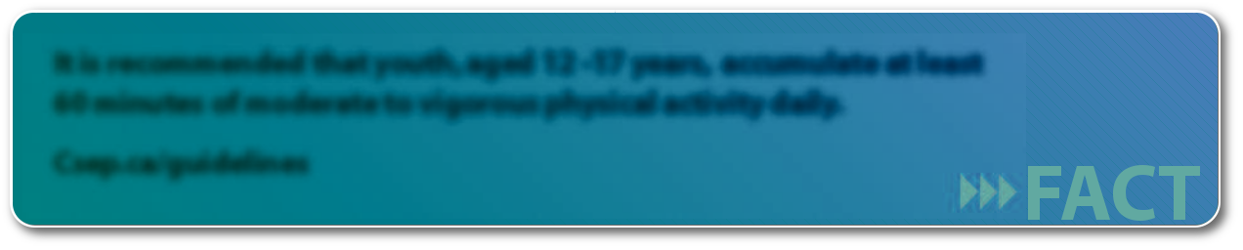

It is recommended that youth, aged 12 -17 years, accumulate at least 60 minutes of moderate to vigorous physical activity daily.

Csep.ca/guidelines

What immunizations do I have? What immunizations do I need and when should I get them?

How do I feel about my body?

How does the use of alcohol, smoking or drugs affect my health, my plan or my future?
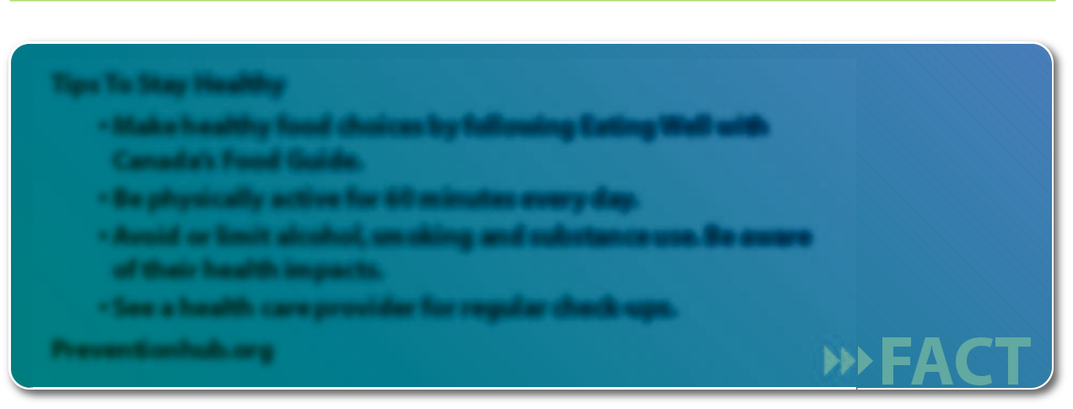

Tips To Stay Healthy

- Make healthy food choices by following Eating Well with Canada’s Food Guide.

- Be physically active for 60 minutes every day.

- Avoid or limit alcohol, smoking and substance use. Be aware of their health impacts.

- See a health care provider for regular check-ups.

Preventionhub.org

How often do I brush and floss my teeth?

My Plan

Example: I will eat 6-8 servings of veggies and fruits a day. I will consider the health effects of my behaviours.

3

My Life – My Mental Health

What helps me relax and feel good – music, time with friends, a good movie, ...?

How many hours of sleep do I get most nights?
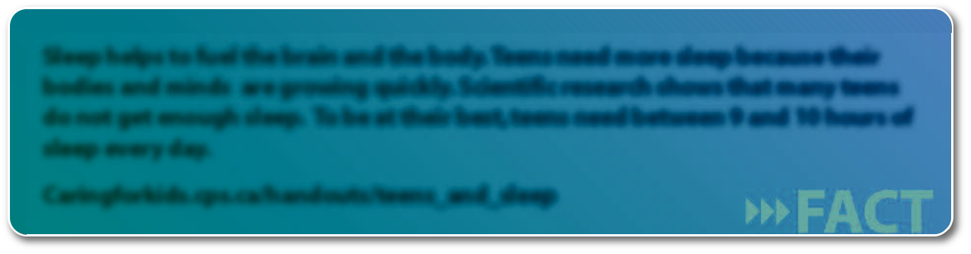

Sleep helps to fuel the brain and the body. Teens need more sleep because their bodies and minds are growing quickly. Scientific research shows that many teens do not get enough sleep. To be at their best, teens need between 9 and 10 hours of sleep every day.

Caringforkids.cps.ca/handouts/teens_and_sleep

How do I feel about helping others? What can I do to help others?

Who can I talk to when I am feeling sad or stressed, or need help?
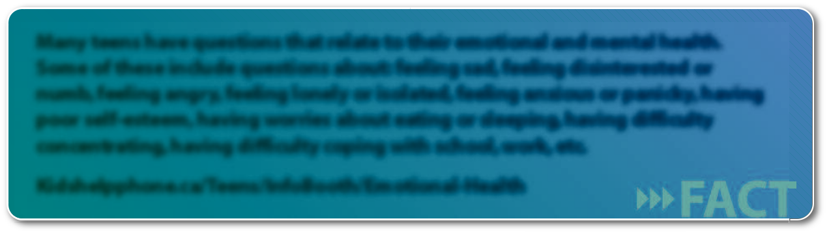

Many teens have questions that relate to their emotional and mental health. Some of these include questions about: feeling sad, feeling disinterested or numb, feeling angry, feeling lonely or isolated, feeling anxious or panicky, having poor self-esteem, having worries about eating or sleeping, having difficulty concentrating, having difficulty coping with school, work, etc.

Kidshelpphone.ca/Teens/InfoBooth/Emotional-Health
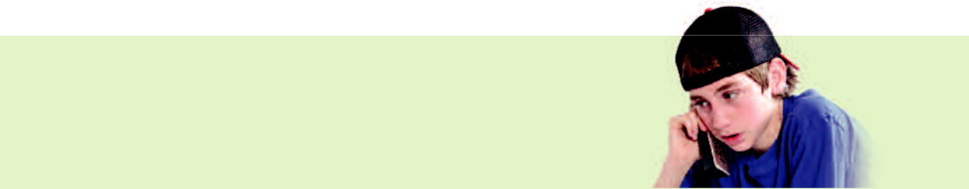

- Kid's Help Phone: 1-800-668-6868

- Mental Health Hotline: 1-866-531-2600

My Plan

Example: I will talk to a trusted adult if I have questions about my emotional and/or

mental health. Plan

Life My

My

4

Best Start Resource Centre
My Life – My Relationships

Do I enjoy being with friends and family?

Do I enjoy spending time alone?

Do I want to be in a relationship now or wait until later?

Do I feel safe in my relationship?
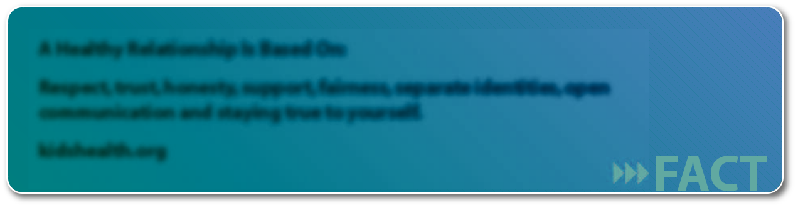

A Healthy Relationship Is Based On:

Respect, trust, honesty, support, fairness, separate identities, open communication and staying true to yourself.

kidshealth.org

Do I want to be sexually active? What does this mean to me?

How much pressure do I feel to be sexually active?

Can I talk with my partner about sex and what my limits are right now?
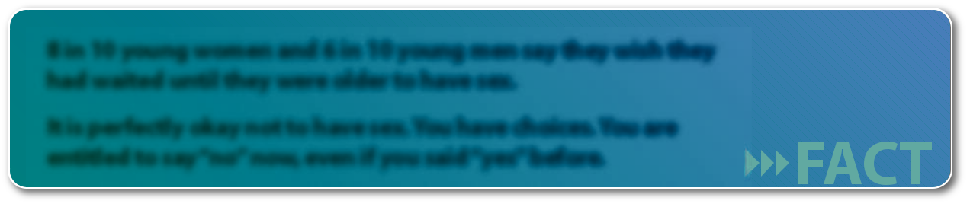

8 in 10 young women and 6 in 10 young men say they wish they had waited until they were older to have sex.

It is perfectly okay not to have sex. You have choices. You are entitled to say “no” now, even if you said “yes” before.
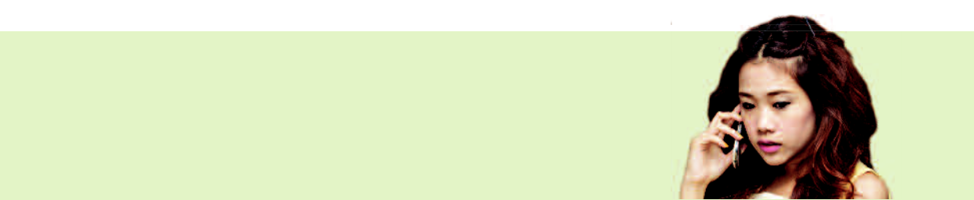

- www.teenhealthsource.com

- If in danger, call 911

- Kid’s Help Phone: 1-800-668-6868

- Assaulted Women’s Help Line: 1-866-863-0511

My Plan

Example: I will decide what is right for me in all of my relationships.

5

My Life – My Reproductive Health

Do I want to be a parent someday?

How many children would I like to have and when?

How would being a teen parent affect my other goals?

What is my plan to prevent an unplanned pregnancy (if appropriate)? What kind of protection from Sexually Transmitted Infections (STIs) and unplanned pregnancy (if appropriate,) do I choose?

If I choose not to talk to anyone, I can visit www.sexualityandu.ca

for trust worthy information
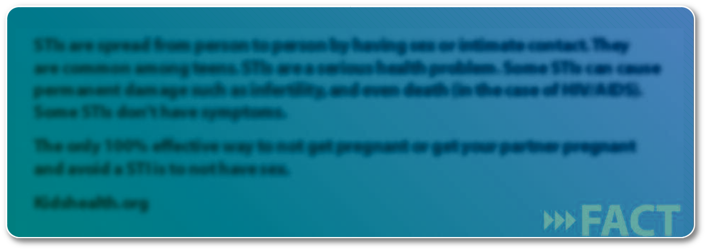

STIs are spread from person to person by having sex or intimate contact. They are common among teens. STIs are a serious health problem. Some STIs can cause permanent damage such as infertility, and even death (in the case of HIV/AIDS). Some STIs don’t have symptoms.

The only 100% effective way to not get pregnant or get your partner pregnant and avoid a STI is to not have sex.

Kidshealth.org

Who will I talk to (e.g., doctor, nurse, counsellor, parent) if I have questions about my sexual health?
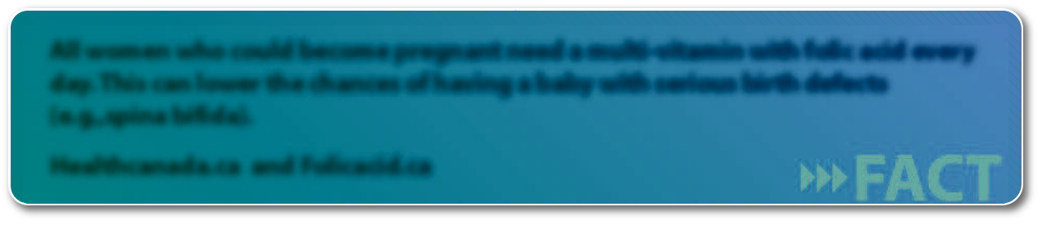

All women who could become pregnant need a multi-vitamin with folic acid every day. This can lower the chances of having a baby with serious birth defects (e.g.,spina bifida).

Healthcanada.ca and Folicacid.ca

My Plan

Example: I will talk to a trusted adult (e.g., doctor, nurse, counsellor, parent) and my partner

about protection from STIs and unplanned pregnancy (if appropriate). Plan

Life My

My

6

The realities of a teen pregnancy
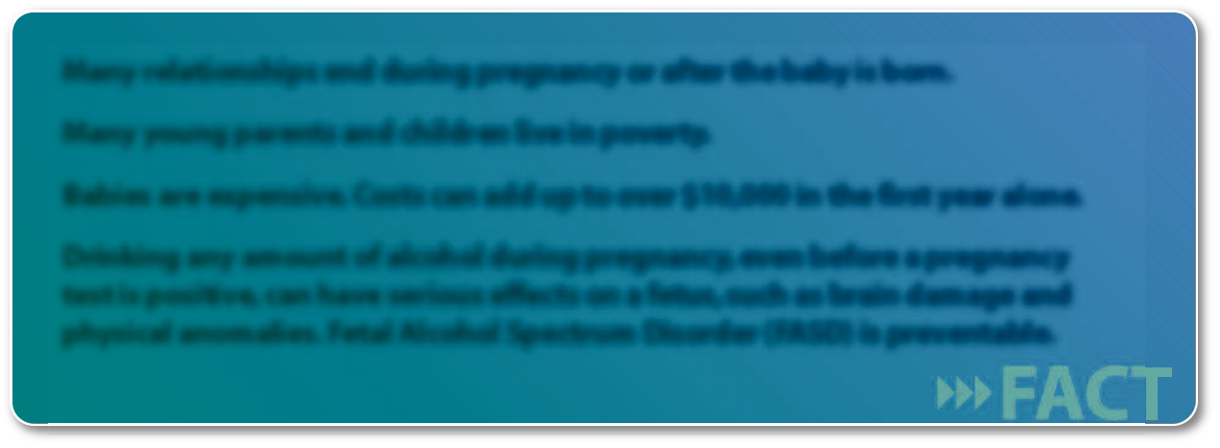

Many relationships end during pregnancy or after the baby is born.

Many young parents and children live in poverty.

Babies are expensive. Costs can add up to over $10,000 in the first year alone.

Drinking any amount of alcohol during pregnancy, even before a pregnancy test is positive, can have serious effects on a fetus, such as brain damage and physical anomalies. Fetal Alcohol Spectrum Disorder (FASD) is preventable.

Thoughts of a teen parent:
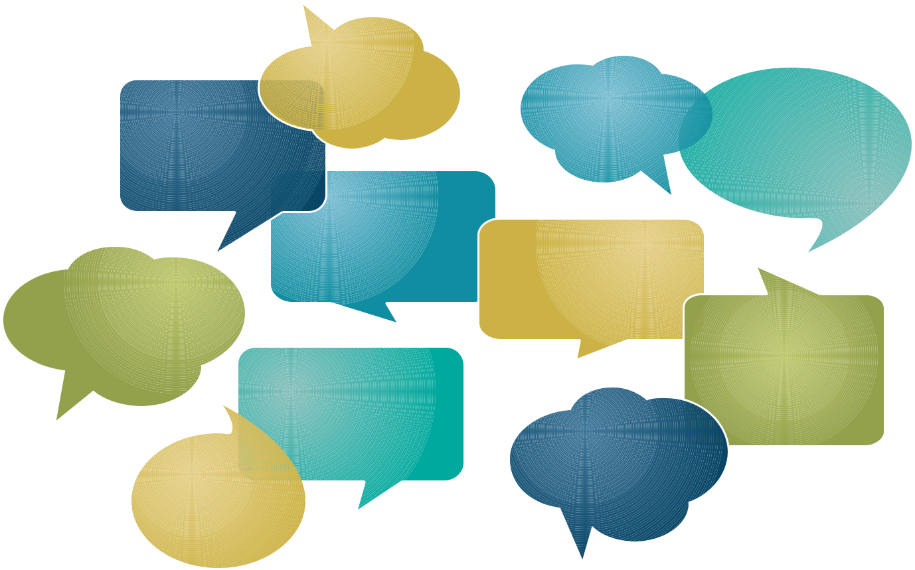

How can I
support a kid?

Am I ready
for this?

What am I

going to do?

How can I support

myself and my
child?

I have to
find a job

I’m scared

I’m stressed | How will my
 | habits affect
 | the baby?

What will

others think?

I should book
a doctor’s
appointment

I’m going to be
a good parent

Best Start Resource Centre

Becoming a parent would force me to grow up quickly.

7

My Life – My Family Health History

Your family history can affect your future health. Find out if any health concerns exist in your family and who has them. For example, it is important to be aware of diabetes, asthma, heart disease, mental illness, and babies born prematurely or with birth defects. These health concerns could affect you and any children you might have some day.

My Plan

Example: I will ask my parents and relatives what kind of health concerns run in my family.
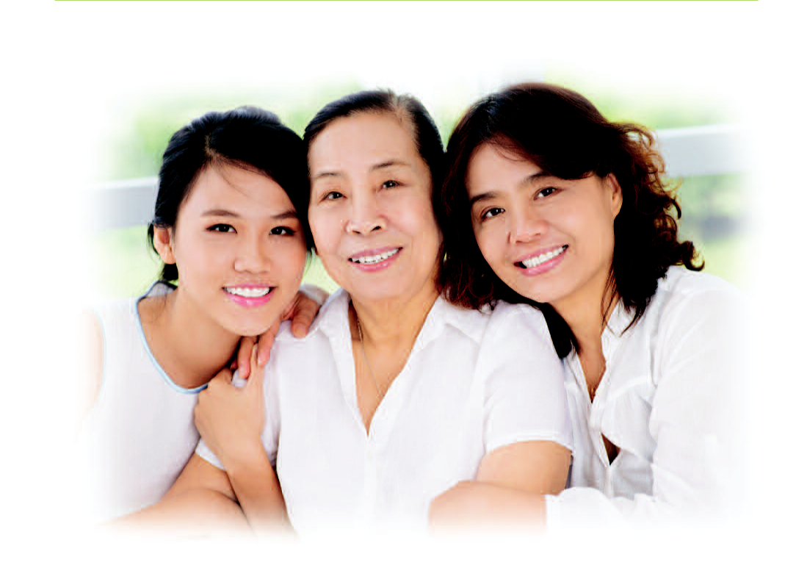

My Life My Plan

8

My Life – My Future

What are my interests? What am I passionate about? What motivates me?

What do I want to be doing next year?

Examples: Getting my driver’s licence? Being part of a club, team or group? Graduating from high school? Volunteering?

What do I want to be doing in the next five years?

What level of education do I want to achieve? High school, apprenticeship, college, university?

What level of education do I need so that I can be doing what I want to in five years?

What kind of work do I want to be doing?

My Plan

Example: I will talk to someone I trust (e.g., counsellor, parent, teacher, friend) to help me achieve my education goals. I will put more effort into school.

Best Start Resource Centre

9

My Focus – My Plan

I have thought about what’s right for me. I will choose things I want to focus on.

Based on the 6 topics:

- My health

- My mental health

- My relationships

- My reproductive health

- My family health history

- My future

I plan to:

This plan will help me:
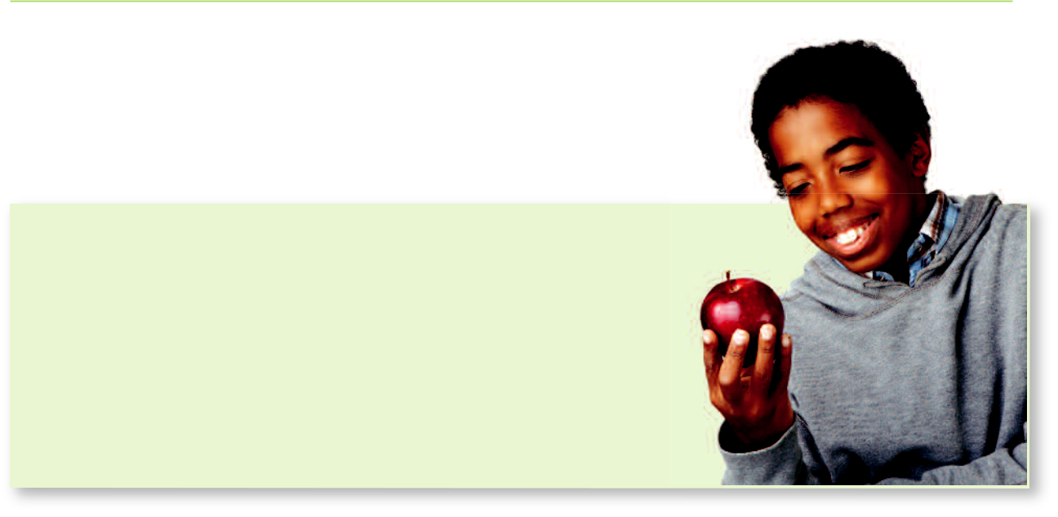

I will make a promise to myself to stay healthy. This will make me feel good about myself. It will help me keep the options for my future open.
It will also help me have the best chance of having a healthy family, if this is my choice, when the time is right.

My Life My Plan

10

My Life – My Personal Resources
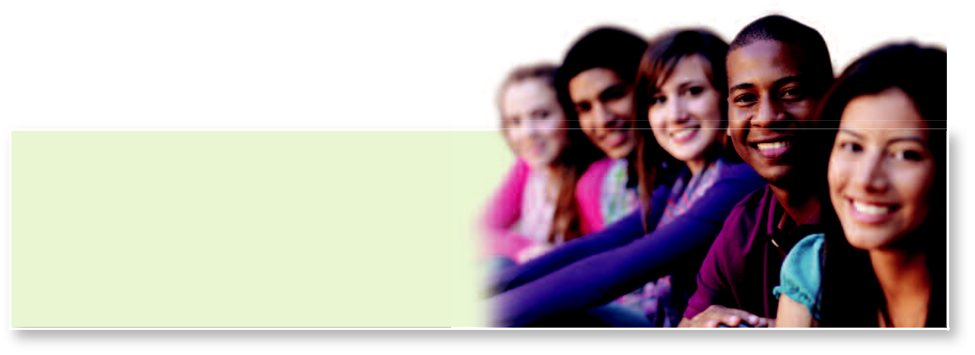

To find health services or a public health unit near you visit www.211Ontario.ca or dial 2-1-1.

My local services:

Dentist

Family doctor or nurse practitioner

Mental health counsellor

Public Health Nurse

Guidance counsellor

Sexual health clinic

Other services

Notes:
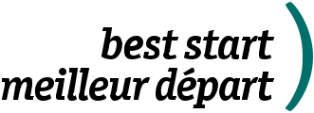
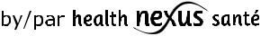

www.beststart.org • www.healthnexus.ca

This document is adapted from an original concept of the Delaware Division of Public Health and Delaware Healthy Mother and Infant Consortium.
This document has been prepared with funds provided by the Government of Ontario. The information herein reflects the views of the authors
and does not necessarily reflect the views of the Government of Ontario. The resources and programs cited throughout this guide
are not necessarily endorsed by the Best Start Resource Centre or the Government of Ontario. While the participation of the advisory was
critical to the development of this Best Start resource, final decisions about content were made by the Best Start Resource Centre. | 2014

