 |  | A | B | C | D | E | F | G | H | I | J
1
2
3 | 907 West Fifth Street Suite 117
4 | Dayton, OH. 45402
5 | T. 937.838.7008
6 | w w w . D P R A g r o u p . c o m
7
8 | CLIENT: Gem City Hilltop Community Development & Housing Inc. 501(c)3
9 | LINDEN COMMUNITY CENTER - 334 Norwood Ave. - Dayton, Ohio
10 | ADAPTIVE REUSE CONSTRUCTION BUDGET COST ESTIMATE
11
12 | Existing Bldg: 22,000SF Gross Floor Area
13 | Interior Adaptive Additions: interior floor 1000SF + interior stairwell modifications+ interior elevator
14
15 | Date: October 10, 2019
16 |  |  |  |  |  |  |  |  |  | Stabilization
18 | Construction Scope Descriptions, Building Stabilization & ADA Accessiblity |  |  |  |  |  |  | Improvements |  | Measures
19 | Preparation Measures for Historic Buildings |  |  | Quantity | Unit | Cost |  | Budget Cost |  | Costs (current)
20
21 | Selective Demo @ Interiors (Basement, 1st floor, 2nd floor) [total gross floor areas = 22,000SF] |  |  | 17,800 | 18 | 20 |  | $320,400
22 | Remove Masonry Infills/repair opngs |  |  | 34 | EA | 500 |  | $17,000
23
24 | Interior | Renovations @ 1st floor gym@ 4200SF (refinished) |  | 4,200 | SF | 30 |  | $126,000
25 | Interior | Renovations @ 1st floor @ 4800SF (partitioned) |  | 4,800 | SF | 100 |  | $480,000
26
27 | Interior | Renovations @ 2nd floor @ 4,000SF general floor area (open interior) |  | 4,000 | SF | 80 |  | $320,000
28
29 | Interior | Renovations @ Basement @ 9,000SF (partitioned & specialized) |  | 9,000 | SF | 150 |  | $1,350,000
30
31 | Upper Gymnasium Balcony |  |  | 2 | EA | 150,000 |  | $300,000
32 | New Floor Above Exist Stage Platform (new floor sys. w part'ns) |  |  | 1,000 | SF | 100 |  | $100,000
33 | New Elevator, Shaft Enclo, Machine Rm. |  |  | 1 | LS | 117,000 |  | $117,000 |  | $117,000
34 | New Metal Stair flights & Enclo.@ Southeast (Interior) |  |  | 1 | LS | 30,000 |  | $30,000 |  | $30,000
35 | Misc. Interior Natatorium (pool) Repairs |  |  | 1 | allow | 25,000 |  | $25,000 |  | $25,000
36 | Lighting, power, plumbing, HVAC,Technology Infastructure & security system upgrades |  |  | 1 | allow | 175,000 |  | $175,000 |  | $175,000
37
38 | Roofing repairs incl./ 4" polyiso (with exist. tearoff to deck) |  |  | 9,000 | SF | 10 |  | $90,000 |  | $90,000
39 | Reset Stone copings |  |  | 400 | LF | 50 |  | $20,000 |  | $20,000
40 | Clean masonry or stone |  |  | 12,000 | SF | 2 |  | $24,000 |  | $24,000
41 | Tuckpoint @ 33% |  |  | 3,900 | SF | 4 |  | $15,600 |  | $15,600
42
43 | New Windows (All fenestration to match historic) @ Large Bay 6'x19' |  |  | 8 | EA | 4,000 |  | $32,000
44 | New Windows (All fenestration to match historic) @ 3.5' x 6' |  |  | 39 | EA | 2,000 |  | $78,000
45 | New Windows (All fenestration to match historic) small @ 4' x 6' |  |  | 29 | EA | 2,500 |  | $72,500
46 | New Exterior Transoms |  |  | 2 | EA | 3,000 |  | $6,000
47
48 | New Exterior Doors & Hardware: (wood paneled) |  |  | 17 | EA | 2,500 |  | $42,500
49 | Repair/Refinish exterior railings & stairs |  |  | 5 | allow | 10,000 |  | $50,000
50
51 | Misc. Exterior Repairs to brick, stone, lintels, sealants, incl. painting, handrails & security closures |  |  | 1 | allow | 25,000 |  | $25,000 |  | $25,000
52
53 | Exterior Sitework & Demo |  |  | 1 | allow | 200,000 |  | $200,000
54
55 |  | Subtotal Direct Construction Costs |  |  |  |  |  | $4,016,000 |  | $521,600
56
57 | General Conditions, Bonds, Fees, Reimburseables, Insurance & Permits @ 11% |  |  |  |  |  |  | $441,760
58 | General Contractor Overhead and Profit @ 15% |  |  |  |  |  |  | $602,400
59 |  | Subtotal Construction Overhead Costs |  |  |  |  |  | $1,044,160
60
61 |  | Subtotal Construction Costs |  |  |  |  |  | $5,060,160
62
63 |  | Construction Contingency @ 10% |  |  |  |  |  | $506,016
64
65 |  | TOTAL FACILITY CONSTRUCTION BUDGET |  |  |  |  |  | $5,566,176
66
67 |  | Architect & Engineer Fees @ 10% |  |  |  |  |  | $556,618
68
69 | TOTAL PROJECT BUDGET |  |  |  |  |  |  | $6,122,794
70
71
72
73
74
75


Page 1 LindenCenterConceptEstimate

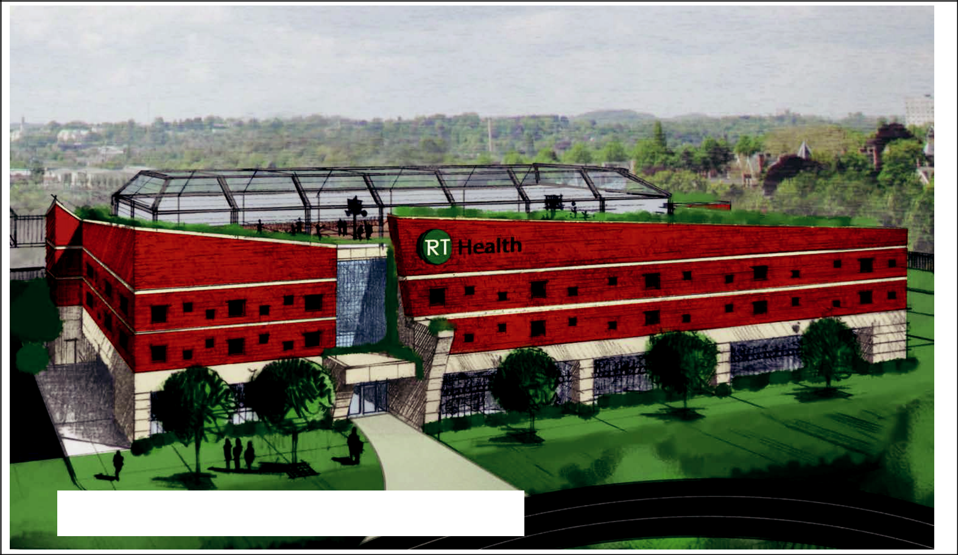

New on Site Recreational Therapy Residence Facility

Copyright @ 2017
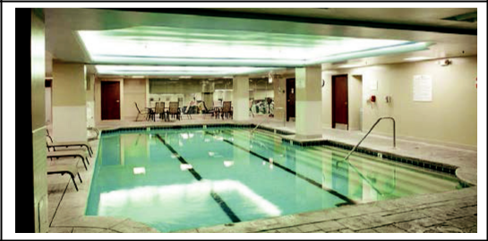

Linden Center (Existing Building) Renovation:

Partial Lower Level View

