Sample Portland General Electric Utility Bill – front
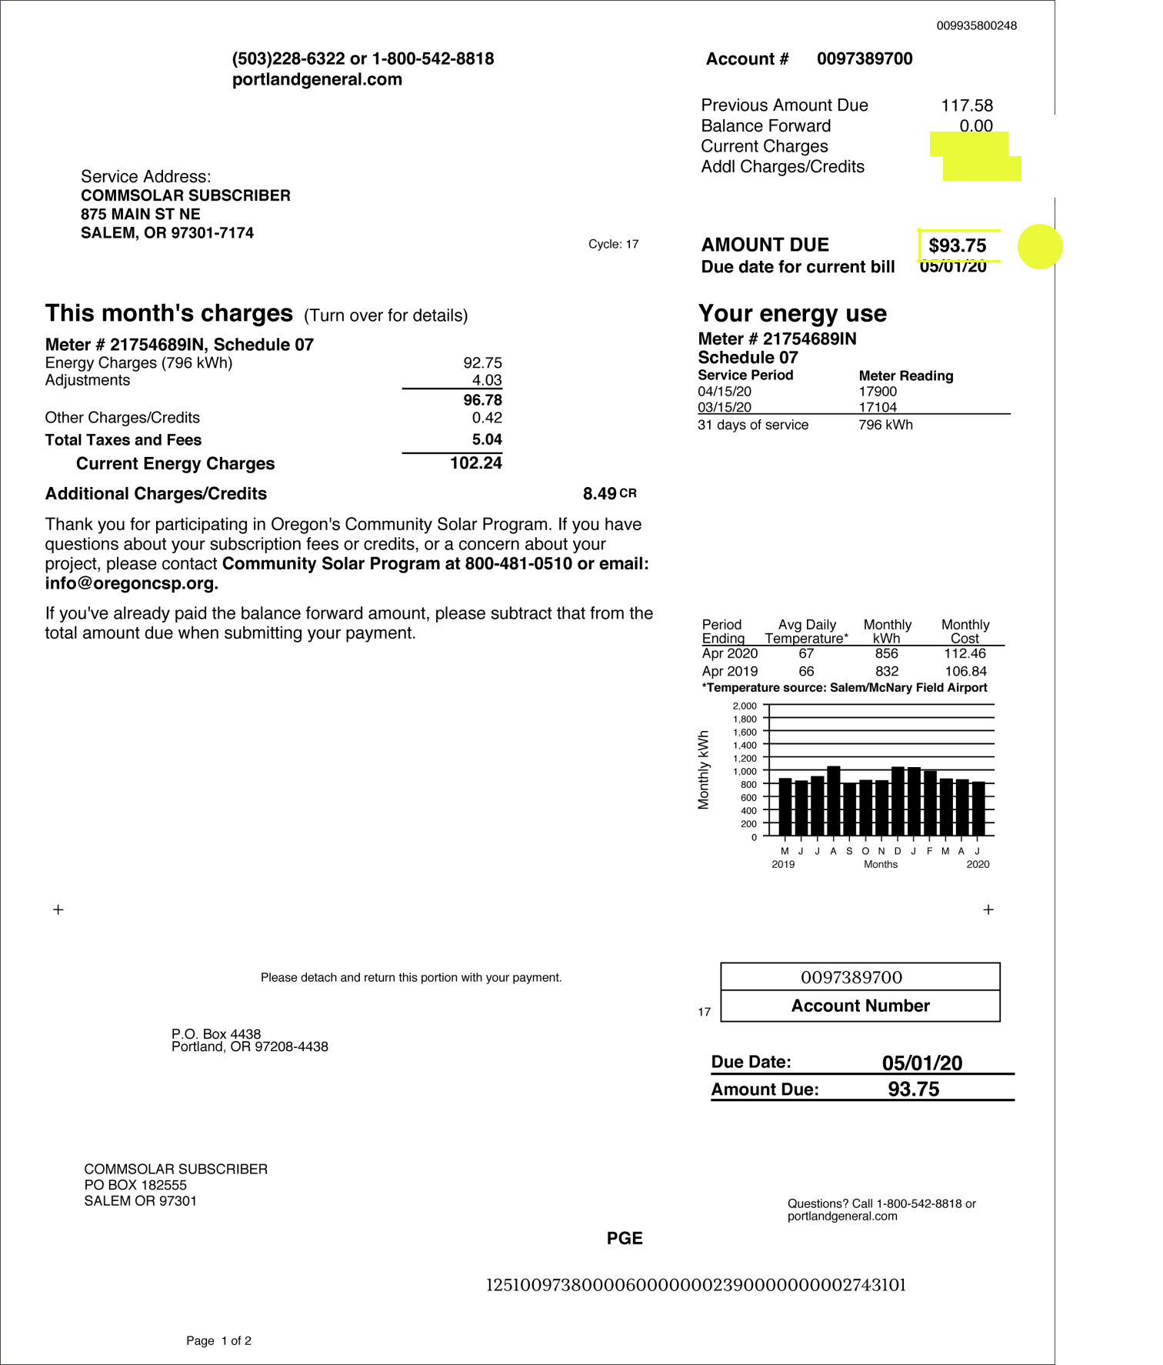

} Detailed
breakdown on

back page

 5

Total utility bill

3

Sample Portland General Electric Utility Bill – back
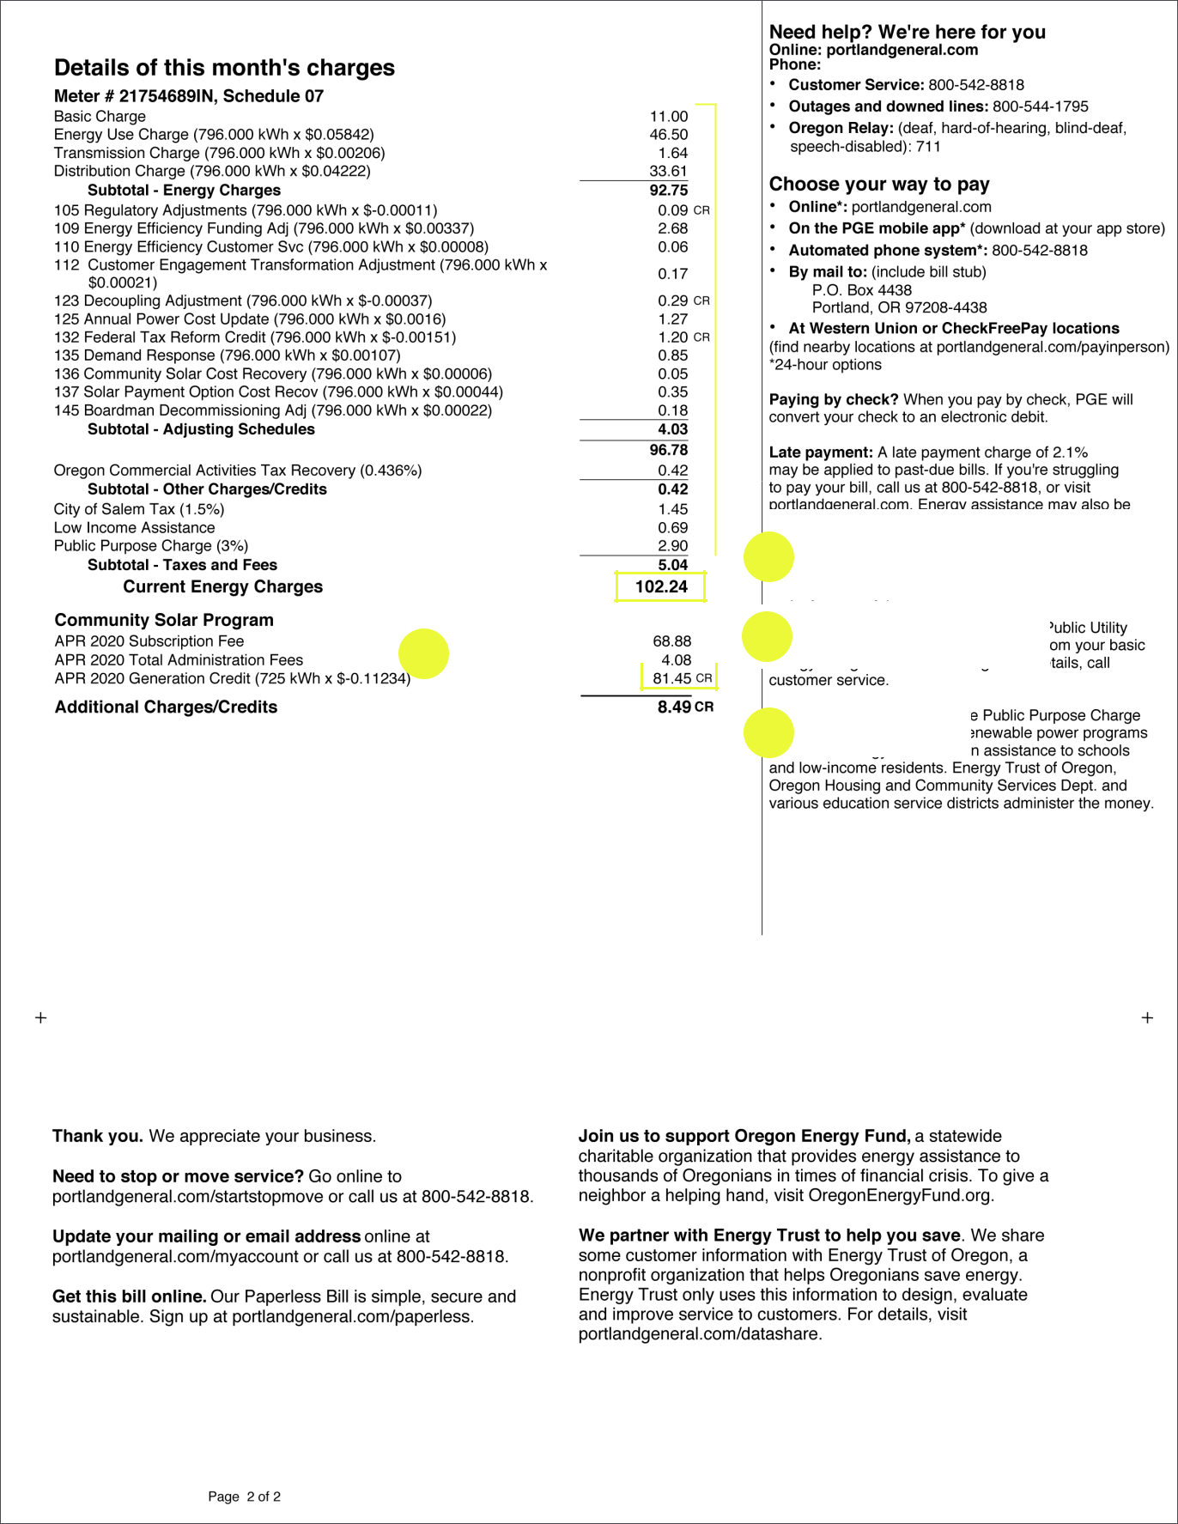

1

4 |  |  |  |  |  |  |  |  |  |  | 3
4 | Program fees |  |  |  |  |  |  |  |  |  | 3

2

Normal utility bill charges

Subscription fee

Bill credits

4

