

TAKE STOCK IN YOUR FUTURE

1

Team Workbook NAME_______________
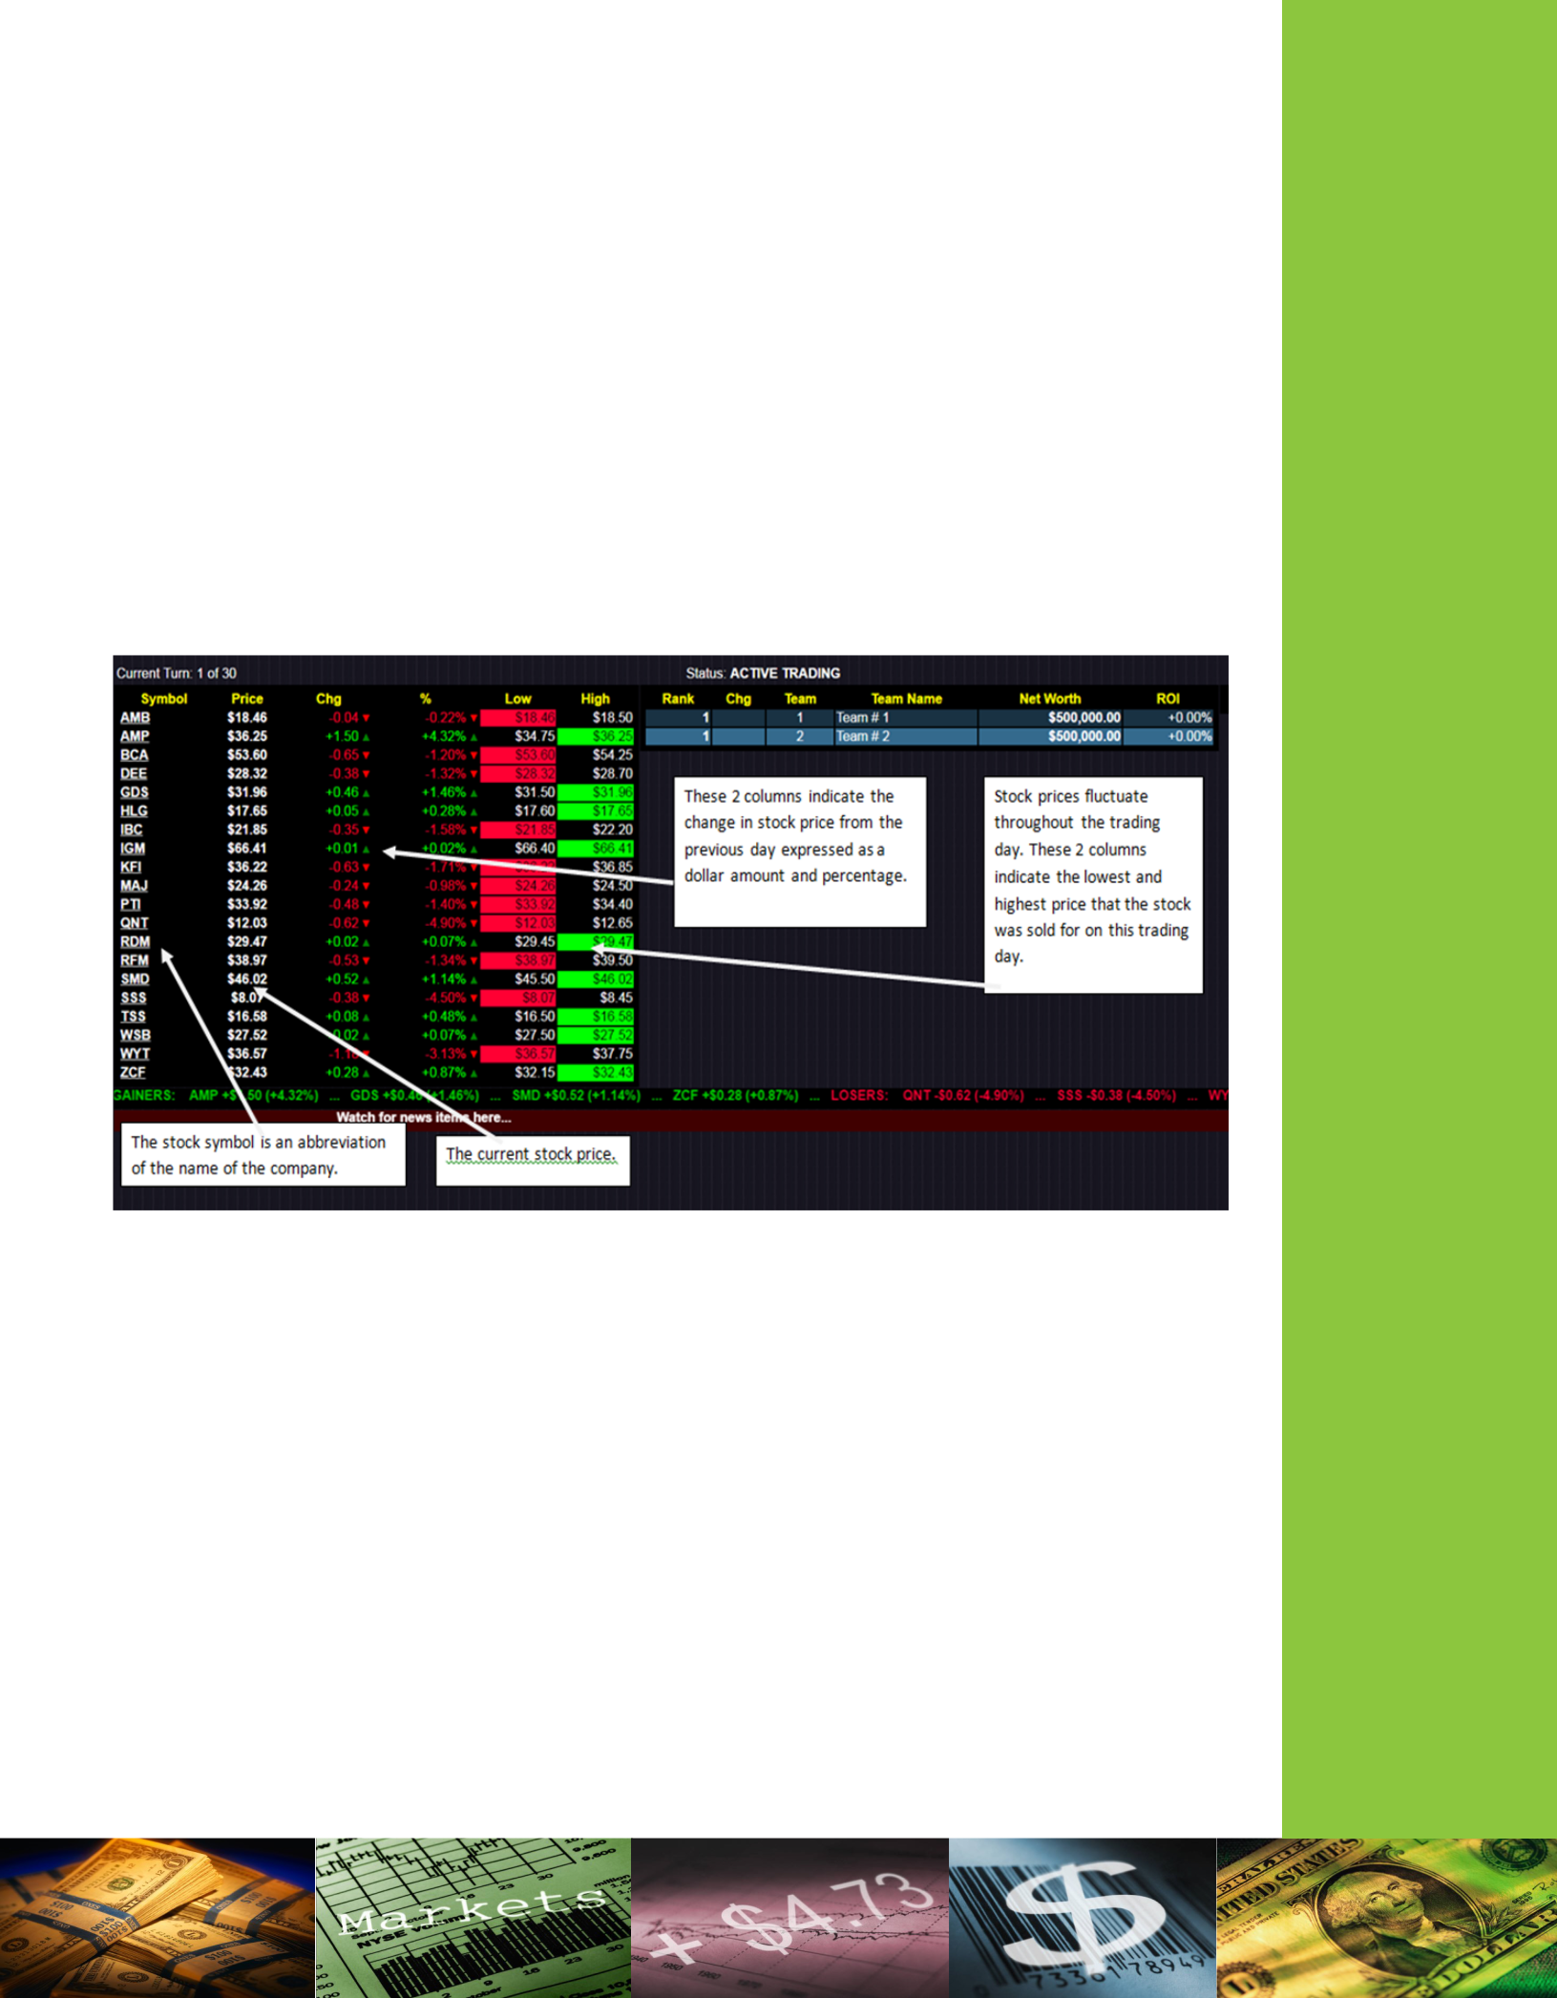
SESSION ONE
UNDERSTANDING STOCKS

Welcome to Junior Achievement's Take Stock in Your Future. You will be using this guide during the 5 sessions that make up the classroom portion of the program. By the end of the program, you will understand the fundamentals of the stock market, and participating students will be prepared to compete in the JA Student Stock Market Challenge event.

During the JA Student Stock Market Challenge, you will see boards that look like this. Notice that company names are abbreviated. This is called the stock symbol. Some familiar companies and their corresponding stock symbols are: American Eagle Outfitters (AEO); Bank of America (BAC); Delta Airlines (DAL); Domino’s Pizza (DPZ) and Sea World Entertainment (SEAS).

In these activities, we are going to use a fictitious exchange made up of 6 different stocks. Your job will be to select a portfolio from these stocks. A portfolio is a grouping of financial assets such as

stocks, bonds, and cash equivalents. You will have $10,000 in fictitious cash to spend on your initial investment. Whatever money you do not use to buy stock will be held in cash.

Over the next sessions, you will see how your stocks perform. You will need to buy and sell the stocks you own in order to maximize the value of your portfolio.

2

Stock Options

Today we will be purchasing stocks to put into your individual portfolio. You have $10,000 to spend. You must purchase stock in lots of 100 shares only (100, 200, 300, etc). Whatever you do not spend on stock will remain in cash. Can you think of any advantages of leaving some of your money in cash? Hint: what would happen if a
major event caused stock prices to fall | Symbol | Price | Chg | %
across many industries? Would having |  | Price | Chg | %
across many industries? Would having | GHA | 23.00 | +1.00 | +4.5%
cash create a buying opportunity?
The stock symbols and today’s prices are | TTO | 12.40 | -0.60 | -4.6%
The stock symbols and today’s prices are | FBR | 14.50 | +.35 | +2.41%
shown in the table. A brief description of
the companies is below.
the companies is below. | BBP | 6.70 | -.50 | -6.94%
 | ISL | 34.90 | -.20 | -.57%
1.) Globehopper Airlines
1.) Globehopper Airlines | RAG | 29.40 | +.70 | +2.44%
(GHA). Globehopper Airlines

is a relative newcomer to the
industry. This airline offers discounted fares to exotic locations. It caters to the leisure traveler more than to the business traveler. While the fares are competitive, the company has had difficulties with reliability. After a couple of close-calls on the runway, the stock price fell from an all-time high of $30 per share to $22 per share. Now, it has hired a new COO (Chief Operating Officer) from a major competitor. The stock has recovered somewhat, and is currently trading for $23 per share.

2.) Texas Tea Oil Company (TTO). Texas Tea Oil Company is a natural gas and crude oil exploration and production company based in Houston, Texas. It operates mainly in the Gulf Coast region of the United States.

3.) Freedom Bank Corporation (FRB). Freedom Bank is a leading US Banking and financial services corporation headquartered in Charlotte, North Carolina.

4.) Burger Bell Palace (BBP). Burger Bell Palace offers fast-food options across the United States. It has recently ventured into the international market in Europe, with very limited success. It’s in a highly competitive market, and is less well known than its major competitors. They have recently revised their menu, and are offering a new, spicy, Tex-Mex burger they hope will set them apart from their competitors.

5.) Insta-snap-link (ISL). Insta-Snap Link operates as a mobile application and website that connects users on mobile devices and personal computers. It is relatively new to the market and faces steep competition from other, more well-established companies as well as new start-ups. The company went public only a few months ago, and stock performance has been disappointing.

6.) Rags, Inc. (RAG). Rags Inc. is a clothing retailer. You can find stores in nearly every shopping mall across the United States. The clothing is especially appealing to young millennials and is known for having an urban vibe. Quality control has been a recent problem and some criticize it for being overpriced for the quality. It is currently negotiating with a popular teen musician but an agreement has not been reached.

3


Session One Worksheet 1: Initial Stock Purchase

 | Share | Number of | Total Cost of Stock
Stock Symbol | Share | Shares | (Share price multiplied by number of
Stock Symbol | Price | Shares | (Share price multiplied by number of
 | Price | Purchased | shares purchased)
GHA | $23.00
TTO | $12.40
FBR | $14.50
BBP | $6.70
ISL | $34.90
RAG | $29.40
Total Stock Purchases
(add up all $ from “Total Cost of Stock”)
Remaining Cash ($10,000-Total Stock
Purchase)
Total Assets |  |  | $10,000

4
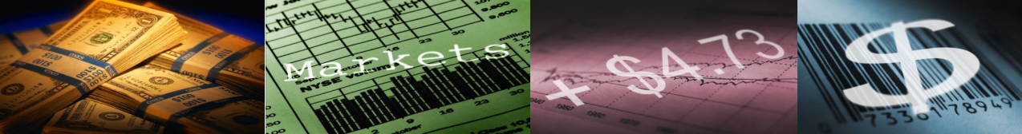
Session One Worksheet 2: MARKET ANALYSIS

Price Changes
Time has passed since you purchased the stock to make up your portfolio and stock prices have changed (as indicated on the chart below). The amount of cash and number of shares of stock you own will remain the same but the value of the shares of stock has changed. Calculate the new value of your portfolio using the chart below. Fill in the number of shares of stock that you purchased in the last activity, and multiply by the new share price. Consider these questions:
•Have you made or lost money?
•Is it time to sell existing stock or buy a new stock?

 | NEW |  | Number of Shares Owned | Total Value of Stock
Stock Symbol | NEW |  | (same number purchased in | (NEW share price multiplied
Stock Symbol | Share Price |  | (same number purchased in | (NEW share price multiplied
 | Share Price |  | Worksheet One) | by number of shares owned)
XYZ | $29.29 |  | 175 | $5125.75
GHA | $27.70
TTO | $10.30
FBR | $14.70
BBP | $3.00
ISL | $47.40
RAG | $30.10
Total Dollar Value of Stock (add up all amounts from
Total Value of Stock Column)
Remaining Cash (same amount left from Session One
Worksheet 1)
Total Assets (Cash on hand plus your Total Dollar Value
of Stock)

Market Events
What happened to affect the prices of these stocks? Oil prices dropped slightly, which was good for the airline industry but not so good for the oil and gas industry as a whole. There was an outbreak of salmonella at Burger Bell Palace, causing sales to decline sharply. The company also announced that they would be closing their stores overseas and concentrating on the US market. The new COO of Globehopper Airlines was featured in a news article which was favorable. Insta-snap-link stock soared after a new app went viral.

5
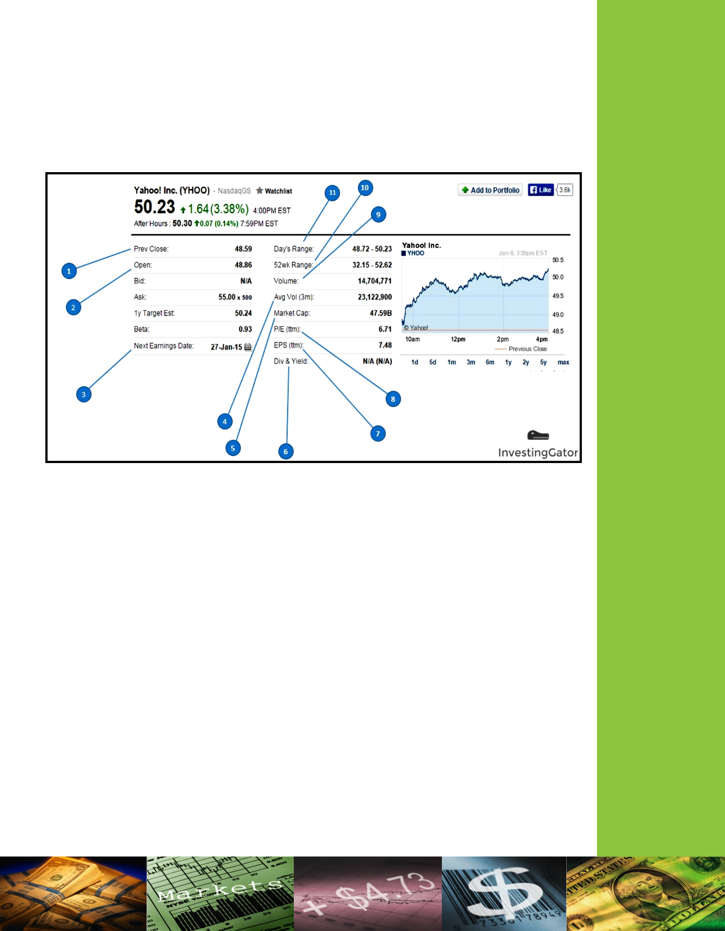
SESSION TWO
STOCK TRADING

How To Read a Stock Table
- Previous Close: Closing price of the previous trading day

- Open: Opening price of the current day

- Next Earnings Date: Day announced by the company where they will report last Quarter’s results.

- Average Volume(3m): Average daily volume traded in the past 3 months

- Market Cap: The total value of the shares outstanding of a publicly traded company.

- Dividends & Yield: If the company is paying dividends, the first number will show how much the company is paying per share. Number in ( ) shows a dividend yield and it would be presented as a percentage. Dividend yield tells you what percentage of your purchase price the company will return to you in dividends. Example: If a stock pays an annual dividend of $2 and is trading at $50 a share, it would have a yield of 4%.

- EPS: Earnings Per Share is a ratio that tells you how much the company is earning per single

common share. Example: If the company’s Net Income is $10M and there is 5M shares outstanding –EPS would be 2 ($10M/5).

- P/E: Price to Earnings is a ratio that compares company’s current stock price to its per share

earnings. Example: if a company is currently trading at $100 a share and earnings over the last year were $4 per share, the P/E ratio for the stock would be 25 ($100/$4).

- Volume: The number of shares traded on the market daily.

- 52Wk Range: A range showing the lowest and highest stock price during the last 52 weeks.

- Day’s Range: Daily price range of the stock

6

BUY, SELL, HOLD
Now you must decide what to do: BUY, SELL, or HOLD stocks in your current portfolio. Should you sell stock that has performed poorly? If you do, you might risk selling low and losing money. Should you sell stocks that performed well and lock in the capital gains? Consider what you think might happen from here and decide whether to BUY, SELL, or HOLD what you currently own.

Activity
You can now make changes to your portfolio.
Consider the following:

- Decide which stocks (if any) you would like to sell. You can only sell what you already own! Selling stocks will increase your cash amount.

- Decide which stocks (if any) you would like to buy. You must have enough cash on hand.
- Be strategic. You can take a loss and get rid of stock you do not think will recover or take advantage of price drops that you think are temporary and buy stock cheaply! Make adjustments, do the math, and record your new portfolio on the worksheet on page 8.

- Use the space below as a scratchpad for your math.

7



_____________

 |  | A | B | C | D | E | F | G | H
 |  |  |  |  | # of Shares | Updated # of | $ Amount |  | Updated $
SymbolStock | PriceShareWeek’sPrevious | PriceShareCurrent |  | $ Amount of | # of Shares | Shares | $ Amount |  | Updated $
SymbolStock | PriceShareWeek’sPrevious | PriceShareCurrent |  | $ Amount of | buying or | Shares | Spent or |  | Amount of
 |  |  | # of | Stock Owned | buying or | Owned | Spent or | Updated Cash | Amount of
 |  |  | # of | Stock Owned | selling | Owned | Received | Updated Cash | Shares Owned
 |  |  | Shares | (current share | (how much | (# of shares | (current share | (start with current cash | (current share
 |  |  | Owned | price times # | (how much | owned plus or | (current share | (start with current cash | (current share
 |  |  | Owned | price times # | you would | owned plus or | price times # of | on hand) | price times
 |  |  | (from | of shares | you would | minus # of | price times # of | on hand) | price times
 |  |  | (from | of shares | like to buy or | minus # of | shares bought |  | updated # of
 |  |  | previous | owned) | like to buy or | shares buying | shares bought |  | updated # of
 |  |  | previous | owned) | sell) | shares buying | or sold) |  | shares owned)
 |  |  | portfolio |  | sell) | or selling) | or sold) |  | shares owned)
 |  |  | workshe
 |  |  | et) | (A |  | (B plus/ | (A | (current cash on hand plus | (A multiplied
 |  |  |  | multiplied by | (+ or -) | (B plus/ | multiplied by | (current cash on hand plus | (A multiplied
 |  |  |  | multiplied by | (+ or -) | minus D) | multiplied by | or minus amount in F) | by E)
 |  |  |  | B) |  | minus D) | D) | or minus amount in F) | by E)
 |  |  |  |  |  |  |  | Beginning Cash: $4,200
XYZ | $35.17 | $29.29 | 175 | $5125.75 | buying 50 | 225 | -$1,464.50 |  | $6590.25
 |  |  |  |  |  |  |  | $4200-$1464 = $2735.50
ABC | $22.50 | $32.11 | 150 | $4816.50 | selling 100 | 50 | +$3,211 | $2735.50 + $3211 = $5946.50 | $1605.50
GHA | $23.00 | $27.70
TTO | $12..40 | $10.30
FBR | $14.50 | $14.70
BBP | $6.70 | $3.00
ISL | $34.90 | $47.40
RAG | $29.40 | $30.10
Total $ of Stock Owned (add ALL “Updated $ Amount of Shares Owned” from column H)

Cash on hand (ending total from “Updated Cash” in column G)

Total Assets (“$ of Amount of Stock Owned” plus “Updated Cash”)

Session Two Worksheet 2: BUY, SELL, HOLD

8

CURRENT

CASH

ON

HAND:

(MUST

HAVE

CASH

ON

HAND

TO

BUY)

SESSION THREE
INITIAL PUBLIC OFFERINGS AND DIVIDENDS

INITIAL PUBLIC OFFERINGS (IPOs)
An Initial Public Offering is the very first sale of a stock by a company that had been privately held but is now going to become a public company.

Examples in History

- In July, 2011, Dunkin' Donuts (NASDAQ: DNKN) had an IPO with an initial price of $19. By the end of the first day, it closed at $27.85, a gain of $8.85 per share, or

47%! Someone investing in 1,000 shares would have a profit of $8,850 in just one day! In December 2015 each share was worth $42.67.

- Some IPOs don’t make a huge impact the first day but end up having a long history of success. In March, 1986, Microsoft (NASDAQ: MSFT) had an IPO with an initial price of $21. By the end of the first day, it closed at $27.75, and while not as much of a single-day gain as Dunkin' Donuts, over time the price has more than doubled. In December 2015, each share was worth $55.35.

Real- Life IPOs

- Zynga (December 2011) (NASDAQ: ZNGA) develops online games like CityVille, FarmVille, CastleVille and Mafia Wars which reach hundreds of millions of users every month. It is quickly on its way to being one of the fastest high-tech companies to earn over $1 BILLION annually. How can it miss? Launching their IPO on December 16, 2011 at $10 per share, within hours it had dropped 12%! A brief rally brought the price back up to $9.00 by the end of the day. Yet just 7 months later in July, 2012, Zynga was trading at just $3.00 a share - a 70% loss!

- Facebook (May 2012) (NASDAQ: FB) is the largest social media company in the world with over 845,000,000 users. How could it miss? It set its IPO price at $38 a share, raising 16 BILLION dollars. Despite some technical glitches, the stock quickly rose to $45 - an 18% return in just a few hours. However, the excitement began to wear off and by the end of the day the stock was down to $38.23 - a profit of just 23 cents per share. More bad news was to follow. The stock continued to fall and 9 days later was selling for just $27.72 per share - a loss of $10.28 per share and only about 25% of its original value.

9
IPOs - Things to look for
What should be considered when deciding if an IPO is for you?

- Profitability: Warren Buffet (one of the most successful investors in history) says, "It’s far better to buy a wonderful company at a fair price than a fair company at a wonderful price." and by wonderful, he means profitable. If a company has a history of profitable operations, how likely is it to become unprofitable with more money?

- Long-term Growth Potential: Is a company able to continue to grow? For example, a recent IPO had already signed almost 10,000 customers. Analysis showed that there was only a total of about 25,000 to 30,000 possible customers in the country. If the company was able to sell to every single customer, it could only triple in growth. Compare this to a company like Starbucks or Dunkin' Donuts which can open many more locations or Walmart which can expand and offer a wide array of products.

- How is the money to be used? What is the company going to be using the money
for? Typically companies use the influx of money from an IPO to reward employees and executives, pay off loans, invest in operations, and acquire other companies. A company that is using more money to pay off loans and pay employees and executives is paying for past performance compared to a company that is using the money to expand new products. Which is better for investors to see?

- Company Management: Some people are better at starting small companies than running big ones. Steve Jobs is an excellent example - he was an innovator but he had difficulty his first time at Apple. Is management up to the task of handling a large company? What is the reputation of its management (a brash CEO may make for exciting headlines - until he gets sued). A good company has good management.

DIVIDENDS
When a company makes a profit, it does two things with the money. The company either REINVESTS IT or SHARES THE PROFITS with its stockholders.

TYPES OF DIVIDENDS
- Cash Dividends: pays the owner of shares a certain dollar amount per share owned.
- Stock Dividends (scrip dividends): pays owner in additional shares of stock
*The JA Student Stock Market Challenge pays in cash dividends. Teams receive a set dollar amount per share.

Dividend Dates
There are three very important dates to consider with dividends.

- Declaration Date: the date when a company announces it is paying a dividend. It announces the amount per share (for example $3), as well as the Ex-Dividend Date and Payment Date, both of which are typically at least a week or two later.

- Ex-Dividend Date: the day in which purchases of shares must be purchased
BEFORE. Anyone purchasing stock before this date, and holding it until on or after this date, will receive the declared dividend.

- Payment Date: the date when shareholders receive their dividend. A stockholder does not need to own the stock at the time of the Payment Date in order to receive their dividend. So long as they own the stock before the Ex-Dividend Date, they will receive the dividend.

10
Session Three Worksheet : DIVIDENDS PAY

You will now receive dividends for the stocks that you own. Using the worksheet, find out what your dividends will make and pay out for you.

CURRENT CASH ON HAND:____$3892____

 |  |  |  |  | Value of Shares | $ Amount
 | Current |  | Total # of | # of Stocks | Owned | $ Amount
Stock | Current | Dividend Payout | Total # of | # of Stocks | Owned | Received
Symbol | Price of |  | Stocks | Received for | (add shares | for CASH
Symbol | Stock |  | Owned | STOCK Payouts) | distributed as | for CASH
 | Stock |  | Owned | STOCK Payouts) | distributed as | Payouts
 |  |  |  |  | dividend) | Payouts
GHA | $29.10 | $1.43 per | 200
GHA | $29.10 | share owned | 200
TTO | $10.45 | 2 Shares | 100
FBR | $15.05 | NONE | 175
BBP | $7.25 | 3 Shares | 200
ISL | $47.30 | $2.91 per | 370
ISL | $47.30 | share owned | 370
RAG | $27.60 | NONE | 105
Total $ of Stock Owned (add ALL Update $ Value
of Shares Owned)
Cash on hand (add ALL “Cash on Hand Added” to
“Current Cash on Hand”)
Total Assets (add “Total $ Stock Owned” and “Cash
on Hand”)

11
Session Three Worksheet 2: STOCK PRICES CHANGE

You will now calculate the final value of your stock portfolio. Since Session Two there have been some changes in the market. Below are the market events that may have had possible implications on stock prices.

Market Events

- Burger Bell Palace (BBP) The new Tex-Mex burger has proved to be a big hit, and it would seem that the company made the right decision by closing stores in Europe. The stock has rebounded.

- Globehopper Airlines (GHA) Leisure travel seems to be increasing, and a busy holiday travel season is expected.
- Texas Tea Oil Company (TTO) Oil prices have remained mostly unchanged.

- Rags, Inc. (RAG) Rags was accused of taking advantage of unfair labor practices in China, and has come under heavy criticism for possible human rights violations.

- Insta-snap-link (ISL) The new Insta-snap-link app is still going strong, but there has been little new growth. It appears to have reached market saturation.

 |  |  | Number of Shares | Total Value of Stock
 |  | NEW | Number of Shares | (NEW share price
Stock Symbol |  | NEW | Owned | (NEW share price
Stock Symbol |  | Share Price | Owned | multiplied by number
 |  |  |  | of shares owned)
GHA |  | $29.10
TTO |  | $10.45
FBR |  | $15.05
BBP |  | $7.25
ISL |  | $47.30
RAG |  | $27.60
Total Dollar Value of Stock (add up all amounts from Total
 | Value of Stock Column)
Cash on Hand (same amount left from Session Two Worksheet
 | 1)
Total Assets (Cash on hand plus your Total Dollar Value of
 |  | Stock)

12
SESSION FOUR
REFLECTION, RISK AND RETURN

An Asset Class is a way of classifying financial assets such as cash, bonds, and stocks into groups that perform similarly in the stock market.
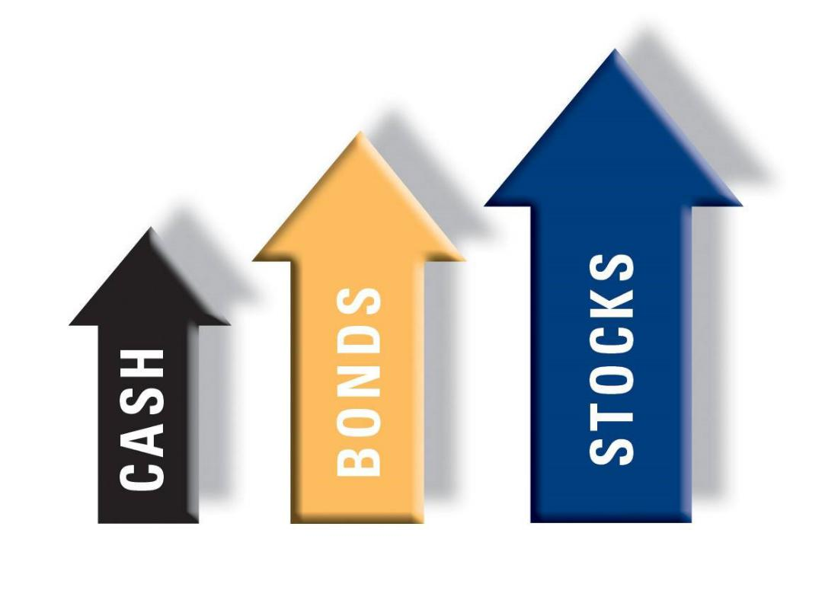

Potential Lower Reward

Potential Higher Reward

Low Risk
Higher Risk

Remember: This chart does not illustrate or predict the risk or return of any specific investment.

Investments may fluctuate with market conditions and results may be worth more or less at
redemption.

13


Financial Goals

S.M.A.R.T. Goal:
Specific: Be specific in your details and what you are targeting.
Measurable: Include an indicator of progress.
Attainable: Is your goal able to be achieved?
Realistic: Are the end results and time frames within your reach?
Time Frame: Have a time line to reach your goal or milestones by.

Use the space below to write three S.M.A.R.T. financial goals for your team. Be sure to include all of the components of a S.M.A.R.T. goal.

My S.M.A.R.T. Short-Term Savings Goal:

My S.M.A.R.T. Intermediate Savings Goal:

My S.M.A.R.T. Long-Term Savings Goal:

14

SESSION FIVE BEST IN CLASS:

In-Class Competition

Introduction
You will now participate in an exciting simulation of the stock market. With you and your team making decisions, you will be buying and selling stocks in an attempt to obtain the highest net worth at the end of the simulation. Be sure to pay attention to news flashes at the bottom of your screen and the highs, lows, and changes of the stock prices. With each transaction you make your team will pay a 1.25% transaction fee. This will be automatically deducted from the transaction. Good Luck!

Tip: Google Chrome and Microsoft Internet Explorer work best with the simulation.

Student Login and Game-Play Instructions:
- Sit together in teams around a computer, open a browser and go to the Future Financier’s website: www.futurefinanciers.com/
- Click on the Login tab in the upper-right corner.
- Type Username and Password jagmstudent.
- Enter your student access code given by the teacher (C.____._____)
- Under the classroom Menu, select “Practice Game” to open a new window.
Note: If a window does not open, you may need to enable pop-ups on your browser.
- On this menu, select “Play Simulation”. This will open a new pop-up. Do not close the other window—you will need it to logout at the conclusion of the event, though you can minimize it to save screen space.

- The left portion of the screen shows stucks, their current price, the change in price since the previous day, and their all-time highs and low.

Tip: You may click on the stock symbol to read more information about a company.
- The middle portion of the screen shows the team standings.
- The right portion of the screen shows the trades that have taken place over the past several turns.
- Click on the “Open Transaction Screen” link at the top of the page. This is where you will enter your transactions.
Tip: Resize your transaction and information screens to fit your screen so you can flip easily back and forth.

- Select your team number from the drop down menu.
- Enter your unique PIN given to you by the teacher. Do not share this outside your team. Tip: If you leave this screen open, you will not need to re-enter your PIN.

- To make a transaction, choose “Buy”, “Sell”, “Buy All”, or “Sell All” from the drop down. Then select the stock to be traded and enter in dollar amount. (The 1.25% transaction fee will be deducted after trade is made)

- Click “Submit” once team has entered transaction details
- If the bo x underneath remains green, your trade went through.. Note the information it gives you.

- If the box turns red, there was a problem with your trade and it did not go through. It will tell you why the transaction failed.

15

For students participating in JA Student Stock Market Challenge

The JA Student Stock Market Challenge is a very fast- paced game. Each day lasts 60 seconds. It is hectic and loud, just like an actual trading floor would be. It is very exciting and filled with energy. Remember to read the newsletters at the event and listen to the tips that the Emcee is sharing. They will give you important information so you can make informed decisions on whether to sell or buy.

Plan on:
- Dress professionally. Dress code is strictly enforced.

- Decide on your team member roles, team names, and stock picks. Team names cannot have abbreviations and must be appropriate.
- Return JA’s permission slip and photo release form. Students without these will NOT be
allowed onto the trading floor.

- Shorts, jeans, and immodest attire are not acceptable.

- Every team of students begins with $1,000,000 in fictitious cash. They can make commission-free purchases before the event.

- Teams must be comprised of students only; teachers and classroom volunteers are not allowed on the trading floor. Coaching is permitted during the 15 minute break only. Any team that receives coaching during the simulation will be disqualified.

- Stocks include fictitious and real names and 3-letter stock symbols. A brief description, will be provided to enable teams to identify the stocks available.

- Three large screens display the following: each team’s net worth, daily changing stock prices, and graphical depictions of stock performance.

- Floor traders with tablets come to the tables to take trading orders. Traders serve 3-4 teams. Students can ‘call out’ to attract the attention of a trader, but trades must occur at your table. Please be courteous to your trader.

- To track progress, portfolio statements and trading history may be obtained from the help desks.

- You may also obtain portfolios on your smartphones by scanning the QR Code located on your table.

- Initial stock picks are based on information provided in the Stock Information section at www.futurefinanciers.com. Stock picks must be chosen online at least 2 weeks prior to the event by submitting them to your teacher/volunteer. If you do not submit your initial team stock picks by the deadline, your team will begin with only cash.

- All trades made after the initial stock picks will be subject to a trading commission of 1.25%, which will be automatically deducted from the team’s total.

- Throughout the simulation, students will receive updates on world events and industry developments. This news will affect stock values and will challenge participants to think on their feet. These news items will appear on the central screen News Ticker.

- Newsletters will be delivered directly to the students’ tables on specific trading days.
- There are 60 total trading days.

- Trading commences with the ringing of a bell and will continue for 30 “days”. After a 15 minute break, trading resumes for another 30 days and finishes at the ringing of the bell.
- Each trading day is 60 seconds long.
- For the safety of all participants, running is not permitted.

16
Team Member Roles:
At the JA Student Stock Market Challenge, teams must work together quickly in order to succeed. Organize your roles as a team before the event. Decisions must be made fast—remember that you only get 60 seconds in a trading day! Disputes must be resolved in seconds, not minutes, and in a way that’s fair to all members of the team.

It is important that each member of your team knows their responsibilities. Here are some team member roles, responsibilities, and the skills required. There is no requirement on how you organize your team. After all, this is your team!

The Asset Manager role : The Asset Manager has the answer to the three most critical questions every team has: (1) How much cash do we have ? (2) What stocks do we own? (3) How many shares do we own of them? As prices change, a good Asset Manager can quickly tell the team how much (in dollars) is invested in any given stock. Since these prices change very quickly, this is a lot of work!

The Market Analyst role: The Market Analyst tracks the market and news affecting the market. They will spend most of their time watching the screens. Did a pharmaceutical company announce a miracle drug? Did a company CEO resign unexpectedly? A good market analyst is on top of all this important information, and most importantly, communicating it with the team.

The Portfolio Manager: Every team must decide which stocks to buy, when to buy them, when to hold them, and when to sell them. This is the job of the Portfolio Manager. While the Portfolio Manager makes these decisions, it isn't done alone. Without information from the Market Analyst and Asset Manager, the Portfolio Manager is doing little more than flipping a coin. Some teams use a single Portfolio Manager making the decision. Some use a teamwork approach with the Asset Manager, Market Analyst and Portfolio Manager each having a vote.

Trade Execution Specialist: Regardless of how your team decides what trade to make, it does not matter until it is handled by a floor trader. The Trade Execution Specialist's job is to make sure the team's trade is processed correctly. Each floor trader is surrounded by a sea of others trying to get their trades executed. Your Trade Execution Specialist must be able to get the trader's attention, give them the order clearly and concisely, and report the results back to the team. Sometimes a trade cannot go through. Perhaps the price has risen and the team cannot buy as many shares of a stock as they thought. The Trade Execution Specialist must be able to adapt quickly to make sure the team is able to purchase the stock, even if isn't for as many shares as hoped.

Placing Transactions: Tips & Strategies
- Get in front of the trader - it is loud and many people are trying to get his/her attention. The traders may not hear you unless you are in front.

- Use the stock symbols. Traders know the stocks by their three-letter symbol, not by company name.

- Write your transaction down. Traders will not wait for you to remember and will move on to the next person.

- Give the Trader the transaction in order: BUY / SELL, Symbol, Amount
- Always give sell orders first so you have the money for your buy orders.
- If you are selling all your shares, say, "SELL ALL" as the first words - it saves traders time.
- Buy and sell in even amounts - it will be easier to remember.
- It is OK to buy and sell in dollar amounts instead of shares, but you must say "DOLLARS".
- Be sure to find out how many shares your team has purchased.
- After a trade, the trader can tell you how much free cash you have if you ask.
- Don't walk away until the trader has confirmed your trade.

17
Glossary of Terms

Asset Class: A way of classifying financial assets such as cash, bonds, or stocks into groups that perform similarly in the market.

Bear Market: The trend of the stock market going down over a number of months.

Broker: Acts as a go-between for the buyer and seller of stocks.

Bull Market: The trend of the stock market rising over a number of months.

Capital: Wealth in the form of money or other assets owned by a person or organization or available or contributed for a particular purpose such as starting a company or investing

Diversification: Owning different stocks in various industries that perform differently under a variety of economic conditions.

Dividend: A percentage of profits that are paid periodically to stockholders.

Goal: The end towards which effort is directed; an aim or intention.

Initial Public Offering: The very first sale of a stock by a company that had been privately held but is now going to become a public company.

Intermediate goal: A goal that can be reached within one year.

Long-term goal: A goal that takes more than one year to reach.

Mutual Fund: A managed collection of stocks.

Partnership: A company owned by a small group of people.

Portfolio: A grouping of financial assets such as stocks, bonds, and cash equivalents.

Private Company: A company owned by an individual or a small group of individuals.

Publicly Owned Companies: A company owned by stockholders or shareholders.

Risk: The probability of making a profit or losing money on one’s investments.

Risk Management: A process involved with making and implementing decisions that minimize the adverse effects of accidental losses upon a person or organization.

Savings: The money left over after expenses have been paid.

Short term goal: A goal that can be reached within 3 months.

SMART goal: Specific, Measurable, Attainable, Realistic, Time Frame.

Stock: A share of the ownership of a company.

Stock Exchange Floor: The location in which stocks are bought and sold.

Stock Index or Average: A group of companies in different industries whose performance represents the market trends and is tracked to gauge the movement of the market.

Stockholder / Shareholder: Individuals who have purchased a share, or many shares, of stock in a publicly owned company.

18


Supplemental Activity, Student Worksheet 1

Name:

Go to www.nyse.com and look for Symbol Lookup in the top right corner. Here you can look up-companies you are interested in that are publicly traded (if they are not public, you will not be able to look up their symbol). Complete the worksheet filling in the blanks for each company. You can review these options after several weeks to determine your return on investment. You have $1000 to invest in each company.

Company #1

Name:

Symbol: Price per Share: Investment: $1000

What product or service does the company provide?

What do you think the future outlook is for this product or service? Why?

Company #2

Name:

Symbol: Price per Share: Investment: $1000

What product or service does the company provide?

What do you think the future outlook is for this product or service? Why?

19



Supplemental Activity, Student Worksheet 2

Name:

Revisit www.nyse.com to learn the current price of the stocks that you originally selected. Using the formulas below, determine if your investment has grown in value.

Company #1

Name: _____________ Symbol: _______ Current Price per share=

- Total Number of Shares= $1000/Original Price per share_________

- Current Value= Current Price per share x Number of Shares - Total Investment ($1000) What do you think the future outlook is for this product or service?

______________________________________________________________________________

______________________________________________________________________________

______________________________________________________________________________

Company #2

Name: _____________Symbol: _______Current Price per share=

- Total Number of Shares= $1000/Original Price per share_________

- Current Value= Current Price per share x Number of Shares - Total Investment ($1000) What do you think the future outlook is for this product or service?

______________________________________________________________________________

______________________________________________________________________________

______________________________________________________________________________

20
Live Event Only—Preparation

If your team is participating in the live event, there is some final preparation required.

Prior to the event, teams are allowed to submit a team name. Remember that you are presenting yourselves, your family and your school to the local businesses that are sponsoring your team. While it OK to use something clever, it should be something appropriate.

There are other teams from others schools participating as well, so if another team has already selected your team, you’ll need to choose another.

Gather as a team and review the list of stocks to be traded in the live event. Review this list carefully. You should know who each company is, what line of business they are in, and their starting price. It is also useful to note if the company is an IPO, as it cannot be traded until that day.

Any stocks you purchase will decrease the cash you start the game with, but will give you an opportunity to make (or lose) money from the moment the bell rings.

Tip: While you want to keep your money invested heavily during the game, you might want to leave a little reserve cash in case you see an opportunity early in the game.

- You may invest any amount in your initial stock picks up to your full bankroll.
- If your initial picks exceed the total amount you can invest, the last picks will be ignored.
- You may invest in up to five (though it can be fewer) stocks to begin.
- Initial stock picks are commission-free—this saves you 1.25% per purchase.
- You may not invest in an IPO until the day that stock is traded.
- If your initial picks are not submitted at least two weeks prior to the live event, they will not be processed and you will begin with all cash.

- To avoid problems, be sure to submit your picks to your teacher several days in advance of the two-week deadline.

Team Name

Stock Symbol

Price

Shares to purchase

Total invested in this stock

21

Extra Session
Reviewing Your Success

Introduction
If everything went well, you had a good time at our live event and learned a lot. If everything went great, you finished in the Top 10. If everything went perfectly, you won!

For real-world investors, they are constantly reviewing their decisions, learning from the mistakes and improving. You can do so in this event as well.

The Monday following your live event, the results of the simulation are uploaded to the website for review. Not only can you review your own team, but every other team as well. You can step through the event turn-by-turn, read the news, see if your interpretation of the headline matched what happened in the game. If not, why?

Tip: Google Chrome and Microsoft Internet Explorer work best with the simulation.

Student Login and Review Instructions:
- Sit together in teams around a computer, open a browser and go to the Future Financier’s website: www.futurefinanciers.com/

- Click on the Login tab in the upper-right corner.
- Type Username and Password jagmstudent.
- Enter your student access code given by the teacher (C.____._____)
- Under the classroom Menu, select “Review Event” to open a new window.
- Choose your team in the drop down menu and choose Select.
Be patient—it is loading thousands of transactions and can take a few seconds. Note: If a window does not open, you may need to enable pop-ups on your browser.

- The screen will start on Turn 0.
The left columns show the current stock prices for that day.
The middle columns show the team standings for that day (selected team appears in red) The right column shows a summary of all transactions that day.

- Use the Prev Turn button to go back one turn.
- Use the Next Turn button to advance to the next turn.
- Use the Change Team button to see what another team was doing that turn.

22

