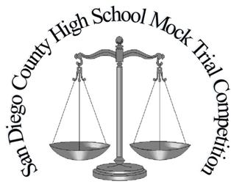
Please note: Witnesses might appear in a different order than they are listed on this roster.
2022 San Diego High School Mock Trial Competition
Defense Trial Team Roster

School Code:

Instructions: Please fill out completely and click on box to include a photo of each student. Bring 5 copies to give to Judge and Scorers before each trial.

Photo |  | Role |  | Student Name |  | Photo |  | Role |  | Student Name
 |  | Defense Pretrial Motion Attorney |  |  |  |  |  | Defendant  Jamie Cobey
 |  | Defense Attorney |  |  |  |  |  | Defense Witness  Francis Yazzie
 |  | Defense Attorney |  |  |  |  |  | Defense Witness  Dr. Tyler Clay
 |  | Defense Attorney |  |  |  |  |  | Defense Witness  Dani Emling
 |  | Bailiff

