PAY FOR DELETE REQUEST [SAMPLE]

From:
Omura Masumi
123 Debtor Street
San Diego, CA 92126

To:
Isaac Goodwin
Creditor Company Corp
321 Creditor Lane
Los Angeles, CA 90001

Date: January 20th, 2022

RE: REGARDING THE FOLLOWING ACCOUNT

Account Number: 123456789
Original Creditor: Sample Company, LLC
Amount Listed: $5,500.00

Dear Isaac Goodwin,

I, Omura Masumi, am writing this letter to offer your credit department the one-time offer to settle the alleged amount due for $3,000.00. Please note that while I am offering this amount of money to settle the debt, this is not my acknowledgment of its liability.

However, as I do disagree with the total amount owed, I am willing to agree to settle this debt so long the following circumstances are met:

- Remove all information regarding this debt from the credit reporting agencies Experian, Equifax, and TransUnion;
- Payment will be made to satisfy the payment in-full under the Account;
- This debt will be deleted from your records; and
- There will be no mention of this debt or settlement to any third (3rd) parties.

If the above-mentioned items are able to be met I am willing to make payment on this debt immediately. I will only answer to an individual who is an official representative of this Company with the terms of this offer expiring in thirty (30) days upon receipt.

I can be contacted via the following:

Email: sender@email.com Phone: +1 (123) 456-7899
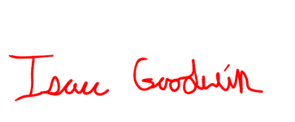
Sincerely,

