
National Behaviour Support Service

KWL Charts
Reading and Learning Strategy

Before, During and After Reading Strategy

KWL Charts

Purpose of KWL Charts:

The KWL (Know, Want, Learn) strategy (Ogle 1986) provides a structure for activating and building prior knowledge, establishing a purpose for reading and for summarising what was learned. The strategy can help students reflect and evaluate their learning experience, as well as serve as a useful assessment tool for teachers. Similarly, the KNWS strategy (know - K/what information is not relevant-N/ what the problem wants them to find out-W/ and what strategy can be used to solve the problem-S), can be used to plan, organise and analyse how to solve word problems .

Explicitly teaching KWL:

Step 1

Choose a general topic and create a table with three columns and two rows — one row for the headings and one larger one in which to write. Label the first column with a K for “What I Know,” the second with a W for “What I Want to know,” and the third with an L for “What I Learned” or a variation of this. Introduce the KWL strategy and model how to use it with the topic.

Step 2

As a class group brainstorm what students already know about a specific subject topic. Highlight the importance of prior learning and how life experience and making connections to what we already know is a very important part of learning. Write these ideas under the K column.

Step 3

Now have students generate a list of what else they want to learn or questions they want answered. Continue to demonstrate how to organise and categorise their suggestions and how to use this information to set a purpose for reading. Students can also turn textbook headings and subheadings into questions for the W column. Students now read (or listen) the text and actively look for answers to their questions as well as to verify their knowledge.

Step 4

After reading with purpose they discuss and record what they learned in the L column, especially paying attention to W questions that were answered from the text or activity. Provide multiple opportunities for students to use the strategy in pairs or small groups until they can use the strategy independently. The L column can also serve as notes for review and revision.

* In this resource there are also several variations to KWL e.g. KWHL, KNWS (for maths), KWLUM, KWL+

Strategy – KWL Charts National Behaviour Support Service

KWL Example


K |  | W | L
What I know | What I want to |  | What I learned
 |  | know | After reading or
Introduce the |  | Record any | listening record
Introduce the |  | questions the | what students say
topic and |  | questions the | what students say
topic and | class has about |  | they have learned.
brainstorm with |  |  | they have learned.
brainstorm with | the topic and/or |  | Note any W
the class. Note |  |  | Note any W
the class. Note |  | turn textbook | questions that
down responses. |  | turn textbook | questions that
down responses. | subheadings into |  | were answered.
 |  | questions.
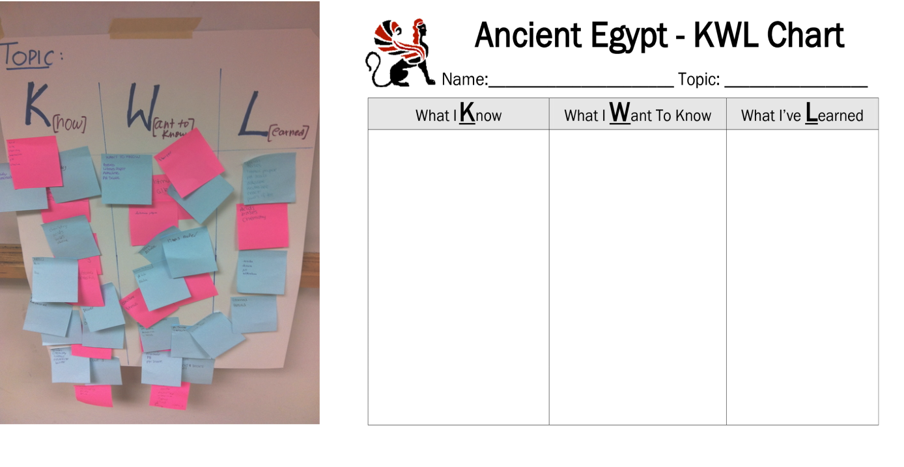
National Behaviour Support Service frichardson@nbss.ie

2
Strategy – KWL Charts National Behaviour Support Service

KWL Example


K | W | L
What I know | What I want to know | What I learned
Content area literacy | What strategies can I | Comprehension and
is a student’s ability to | use to teach the | learning strategies
read, write and | content literacy | tailored to the literacy
comprehend in a | needed in my subject? | demands of my
particular subject |  | subject.
area.
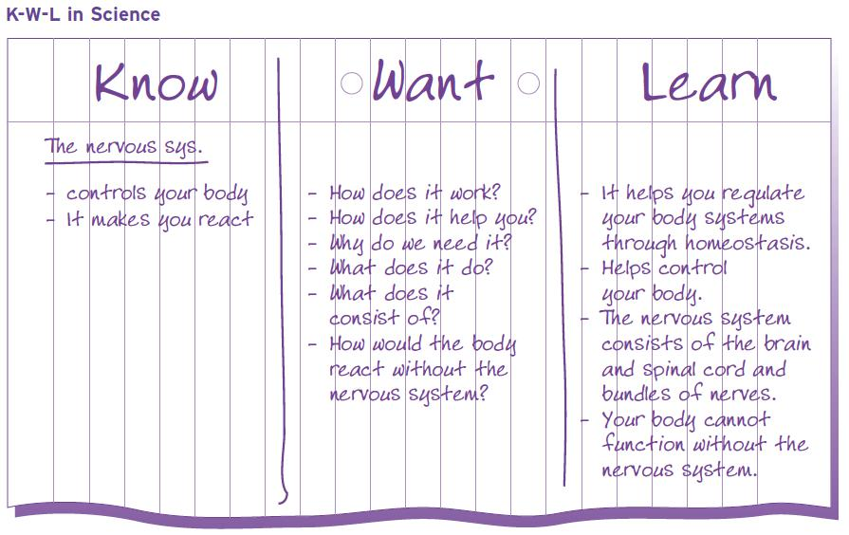

National Behaviour Support Service frichardson@nbss.ie

3
Strategy – KWL Charts National Behaviour Support Service

KWNS Example
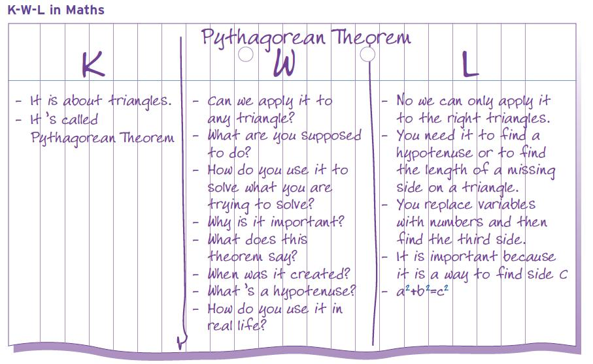

To Kill a Mockingbird - KWL Chart is introduced before the students start the novel to activate prior knowledge and interest.

Before we study/learn about a new topic it’s a good idea to gather all of the information we know on the topic. We need to also come up with questions that will help us focus our reading and give us a better understanding of what we need to find out. Finally, we need to be able to say what it is we have learned

 | about the topic. |  |  |  | TOPIC: Prejudice
 |  | What I KNOW |  |  | What I WANT to Learn |  | What I LEARNED
 |  | - It is when people |  |  | - Is there prejudices
 |  | treat people badly. |  |  | Today? Where?
 |  | - There was a lot of |  |  | Today? Where?
 |  | - There was a lot of |  |  | - Is any form of
 |  | prejudices against |  |  | - Is any form of
 |  | prejudices against |  |  | prejudice justified?
 |  | different races a long |  |  | prejudice justified?
 |  | time ago. There is |  |  | - How do people who
 |  | still some today. |  |  | have been discriminated
 |  | - I’ve heard of it in |  |  | against feel?
 |  | CSPE.
 | National Behaviour Support Service |  |  |  |  |  | frichardson@nbss.ie
 |  |  |  |  |  |  | 4

Strategy – KWL Charts National Behaviour Support Service

KWNS Example

Movievision rents films for €3 a night. The shop also offers a yearly club membership that costs €100. The yearly club membership allows unlimited rentals at €1 per film per night, plus two free rentals per month. How many films must you rent a year to make the membership worthwhile?

K | N | W | S
What do I KNOW | What information do | WHAT exactly does | What STRATEGY
from the information | I NOT need in order | this problem ask | or operation will I
stated in this | to solve this | me to find? | use to solve this
problem? | problem? |  | problem?
€3 to rent 1 film | The yearly club | How many films must be | Make a chart to
 | membership allows an | rented to make joining the | compare the costs
€100 for a yearly club | unlimited number of rentals | club worthwhile?
membership
With club membership film
cost €1
With club membership 2
films free per month
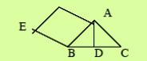

A tent will have the shape shown when it is pitched. When Andy unpacks the tent he measures length AB as 1.3m. He measures length BD as 1.2m and length BE as 2.4m. What will be the length of the pole, AD, when the tent is pitched?
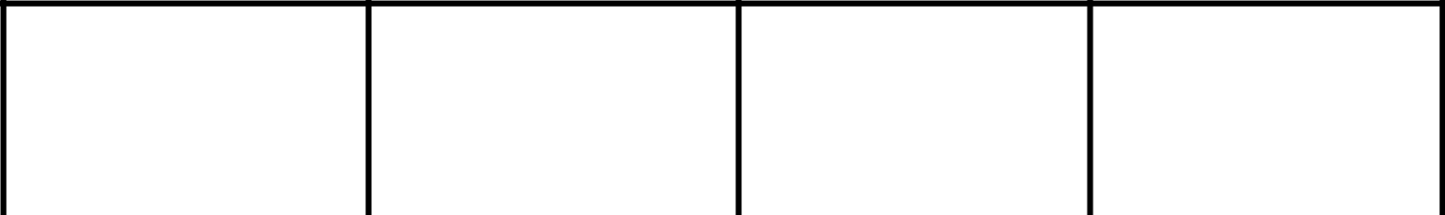

K

What do I KNOW
from the
information stated
in this problem?

N

What information do I NOT need in order to solve this problem?

W

WHAT exactly
does this problem

ask me to find?

S

What STRATEGY or operation will I use to solve this problem?

 | [AB]=1.3m |  |  | Person’s name - Andy | [AD] | Using Pythagoras
 | [BD=1.2m |  |  | and that he unpacks |  | Theorem:
 |  |  |  | the tent. |  | [AB]2=[BD]2+[AD]2
 |  |  |  | [BE]=2.4m |  | [AB]2-[BD]2=[AD]2
 |  |  |  |  |  | [1.3]2-[1.2]2=[AD]2
 |  |  |  |  |  | 1.69-1.44=[AD]2
 |  |  |  |  |  | 0.25m=[AD]2
 |  |  |  |  |  | 0.5m=[AD]
National Behaviour Support Service |  |  |  |  |  | frichardson@nbss.ie
 | Source: Reading Strategies in Math:9 | T | Grade Algebra I by Tom Stull and Reading and Writing to Learn in Mathematics: Strategies to Improve Problem
 | Solving by Clare Heldema. |  |  |  |  | 5

Strategy – KWL Charts National Behaviour Support Service

KWL


What Do I | What Do I | What Have I
Think I Know? | Want to | Learned?
 | know?

National Behaviour Support Service frichardson@nbss.ie

6
Strategy – KWL Charts National Behaviour Support Service

KWL
Title:
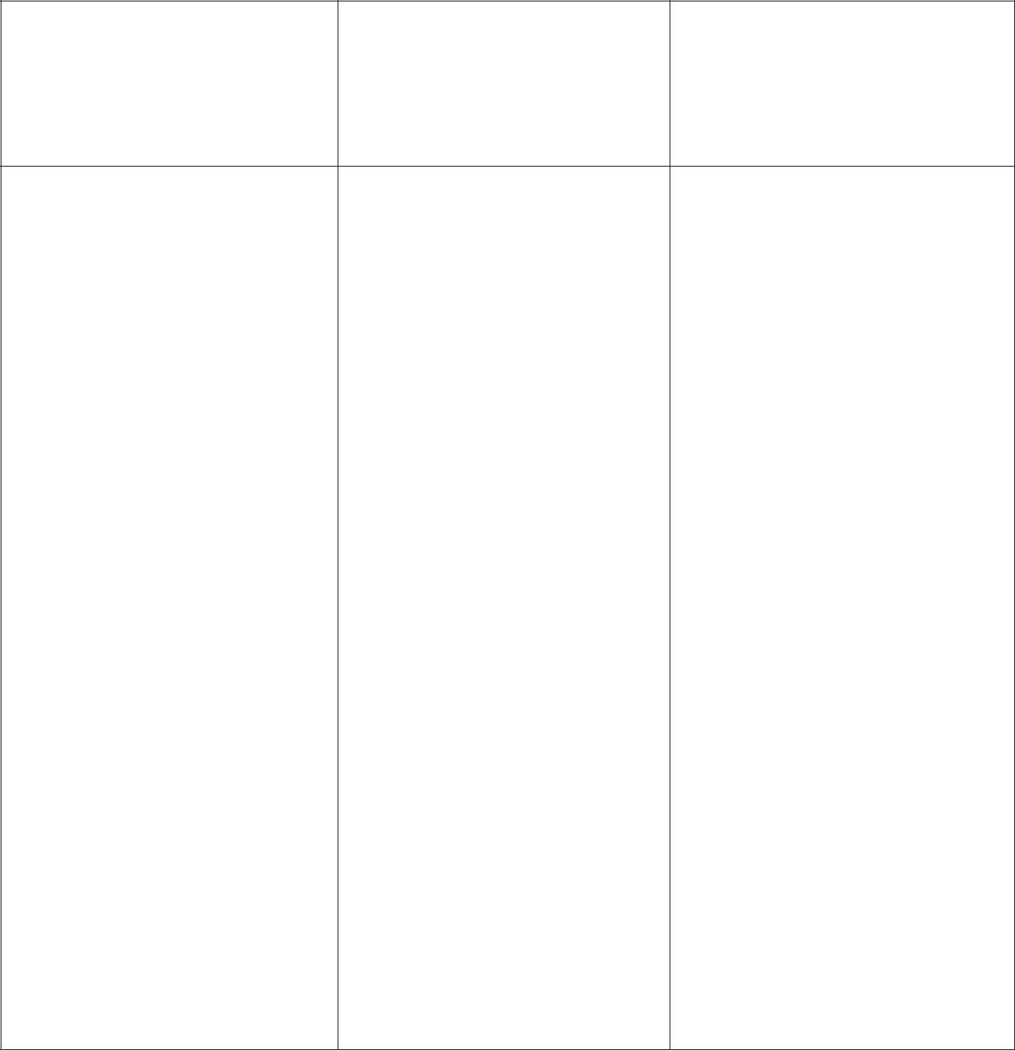

What I Already
KNOW

What I WANT to

Know

What I
LEARNED

National Behaviour Support Service frichardson@nbss.ie

7

Strategy – KWL Charts National Behaviour Support Service

KWL
Title:
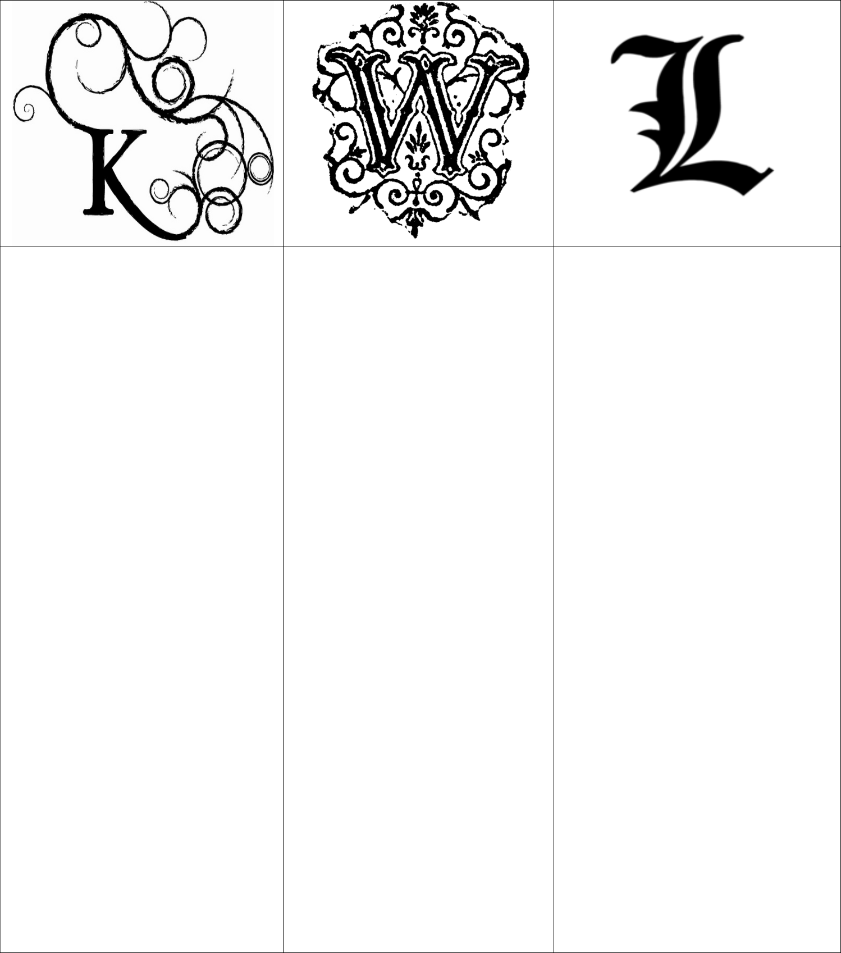

National Behaviour Support Service frichardson@nbss.ie

8
Strategy – KWL Charts National Behaviour Support Service
Title: ^{KWL}
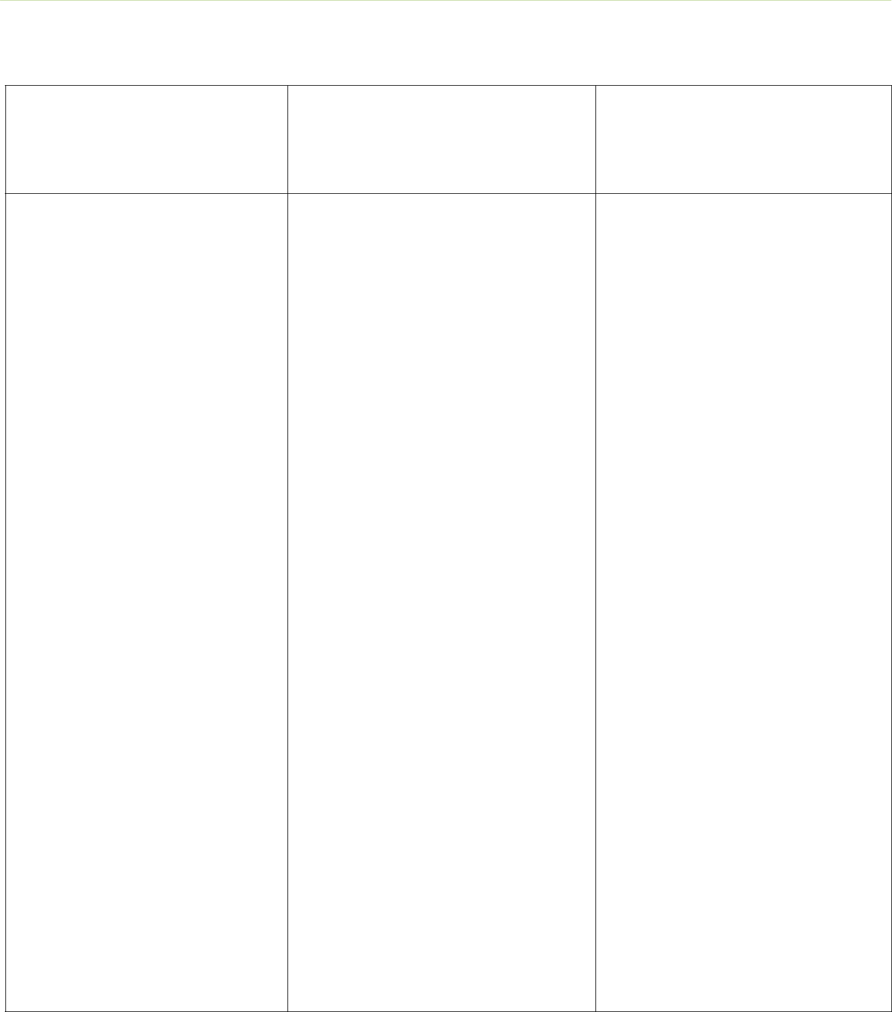

What Do I

- now?

What Do I W ant to

Solve?

What Have I

- earned?

National Behaviour Support Service frichardson@nbss.ie

9

Strategy – KWL Charts National Behaviour Support Service

KWHL
Title:


What I

- now

What I

- onder

about

How I Will

Find Out

What I

- earned

National Behaviour Support Service frichardson@nbss.ie

10
Strategy – KWL Charts National Behaviour Support Service

KWL
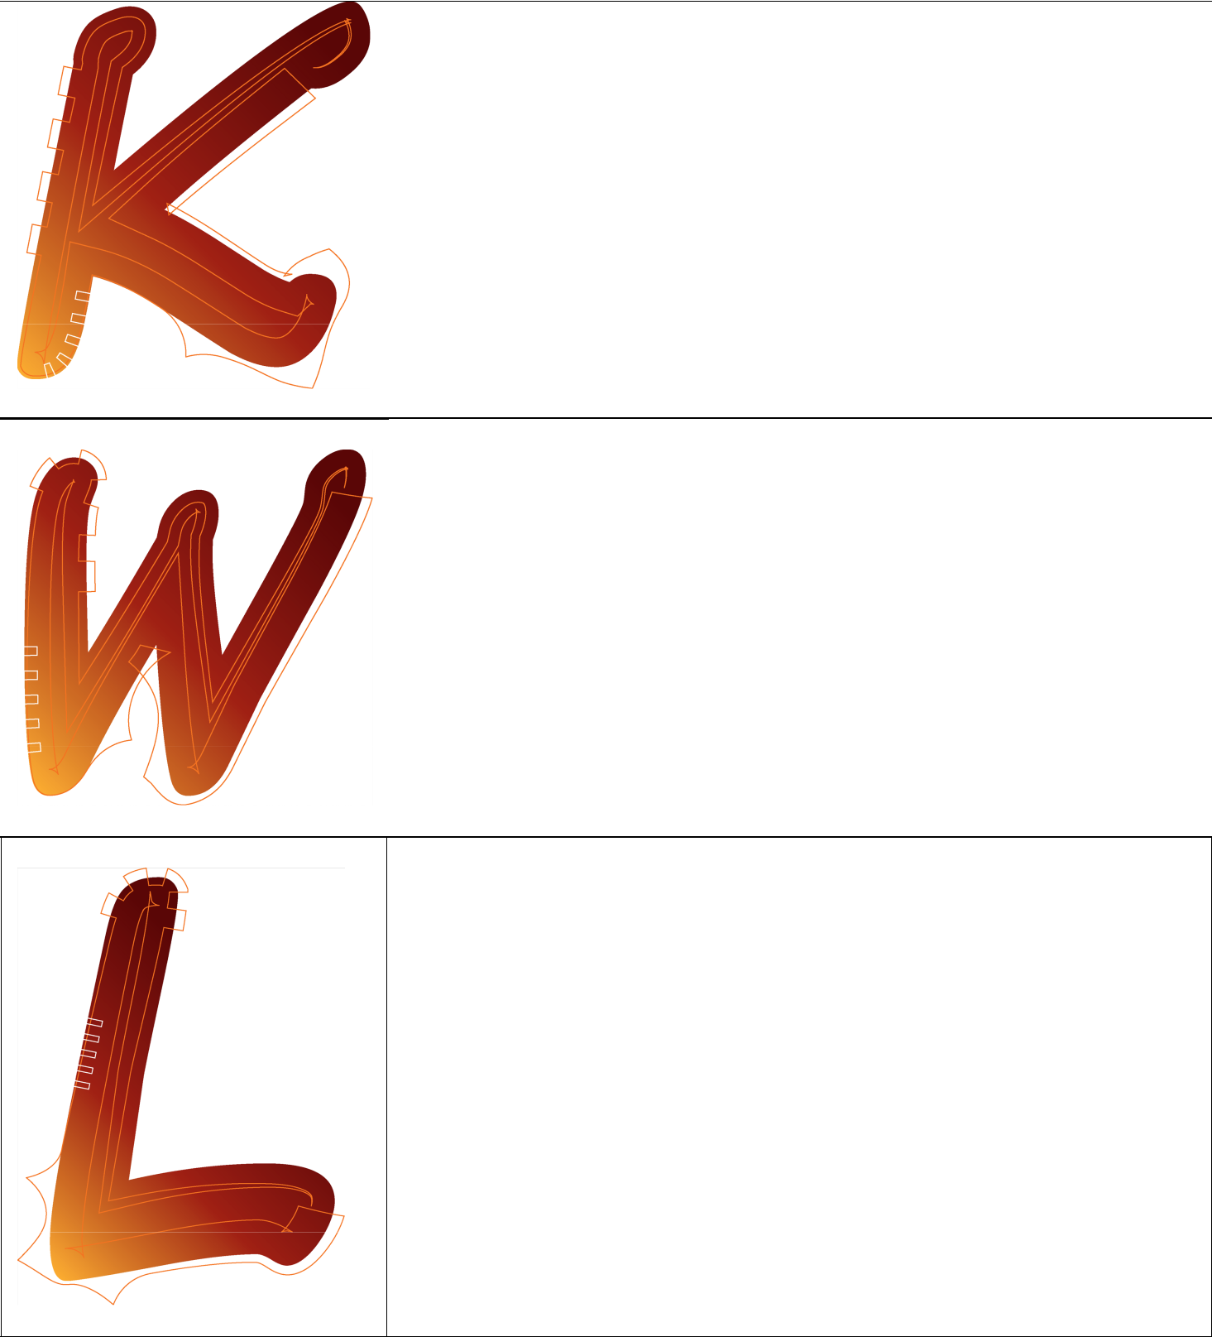

National Behaviour Support Service frichardson@nbss.ie

11
Strategy – KWL Charts National Behaviour Support Service

KWHL

What I Know


What I Want to Know

How will I find out?

(what resources will I
use or actions will I
take?)


What I Learned

National Behaviour Support Service frichardson@nbss.ie

12
Strategy – KWL Charts National Behaviour Support Service


KWHLAQ

K

What do I

Know?

W

What do I

Want to know?

H

How do I find

out?

L

What have I

Learned?

A

What Action

will I take?

Q

What

Questions do I

have?

National Behaviour Support Service frichardson@nbss.ie

13
Strategy – KWL Charts National Behaviour Support Service

KNWS

In this version students analyse and plan how to approach solving a word problem. They decode the given information, determine the question and select an appropriate solution method/operation.

K | N | W | S
What do I | What | WHAT exactly | What STRATEGY
KNOW from the | information do I | does this | or operation will I
information | NOT need in | problem ask | use to solve this
stated in this | order to solve | me to find? | problem?
problem? | this problem?

National Behaviour Support Service frichardson@nbss.ie

14
Strategy – KWL Charts National Behaviour Support Service


KNWS

K

What do I

KNOW?

N

Which

information do I

NOT need?

W

WHAT does the

problem ask me

to find?

S

What

STRATEGY/

operation will I

use to solve the

problem?

National Behaviour Support Service frichardson@nbss.ie

15
Strategy – KWL Charts National Behaviour Support Service

KWLUM
Title:

 | Before |  |  |  |  |  | During |  |  |  | After
 | Reading |  |  |  |  | Reading |  |  |  |  | Reading
What we think |  |  | What we WANT |  |  |  | What we |  |  | How we will |  | What MORE we
we KNOW. |  |  |  |  |  |  | LEARNED. |  | USE what we
 |  |  | to learn. |  |  |  |  |  |  |  |  | need to learn.
 |  |  |  |  |  |  |  |  |  | learned.

National Behaviour Support Service frichardson@nbss.ie

16
Strategy – KWL Charts National Behaviour Support Service

KWL+

Title:

K |  |  | W |  |  |  | L |  | +
What you KNOW |  |  | What you WANT to |  |  |  | What did you |  | + What do you
about the topic? |  |  | know about the |  |  |  | LEARN about the |  | still want to learn
 |  |  | topic? |  |  |  | topic? |  | about the topic?

National Behaviour Support Service frichardson@nbss.ie

17
Strategy – KWL Charts National Behaviour Support Service

Knowing and Thinking Chart


Knowing and Thinking about... Title:

What I know I know:

What I think I know:

What I think I’ll learn:

What I know I learned:

National Behaviour Support Service frichardson@nbss.ie

18
Strategy – KWL Charts National Behaviour Support Service

KWL Student Checklist
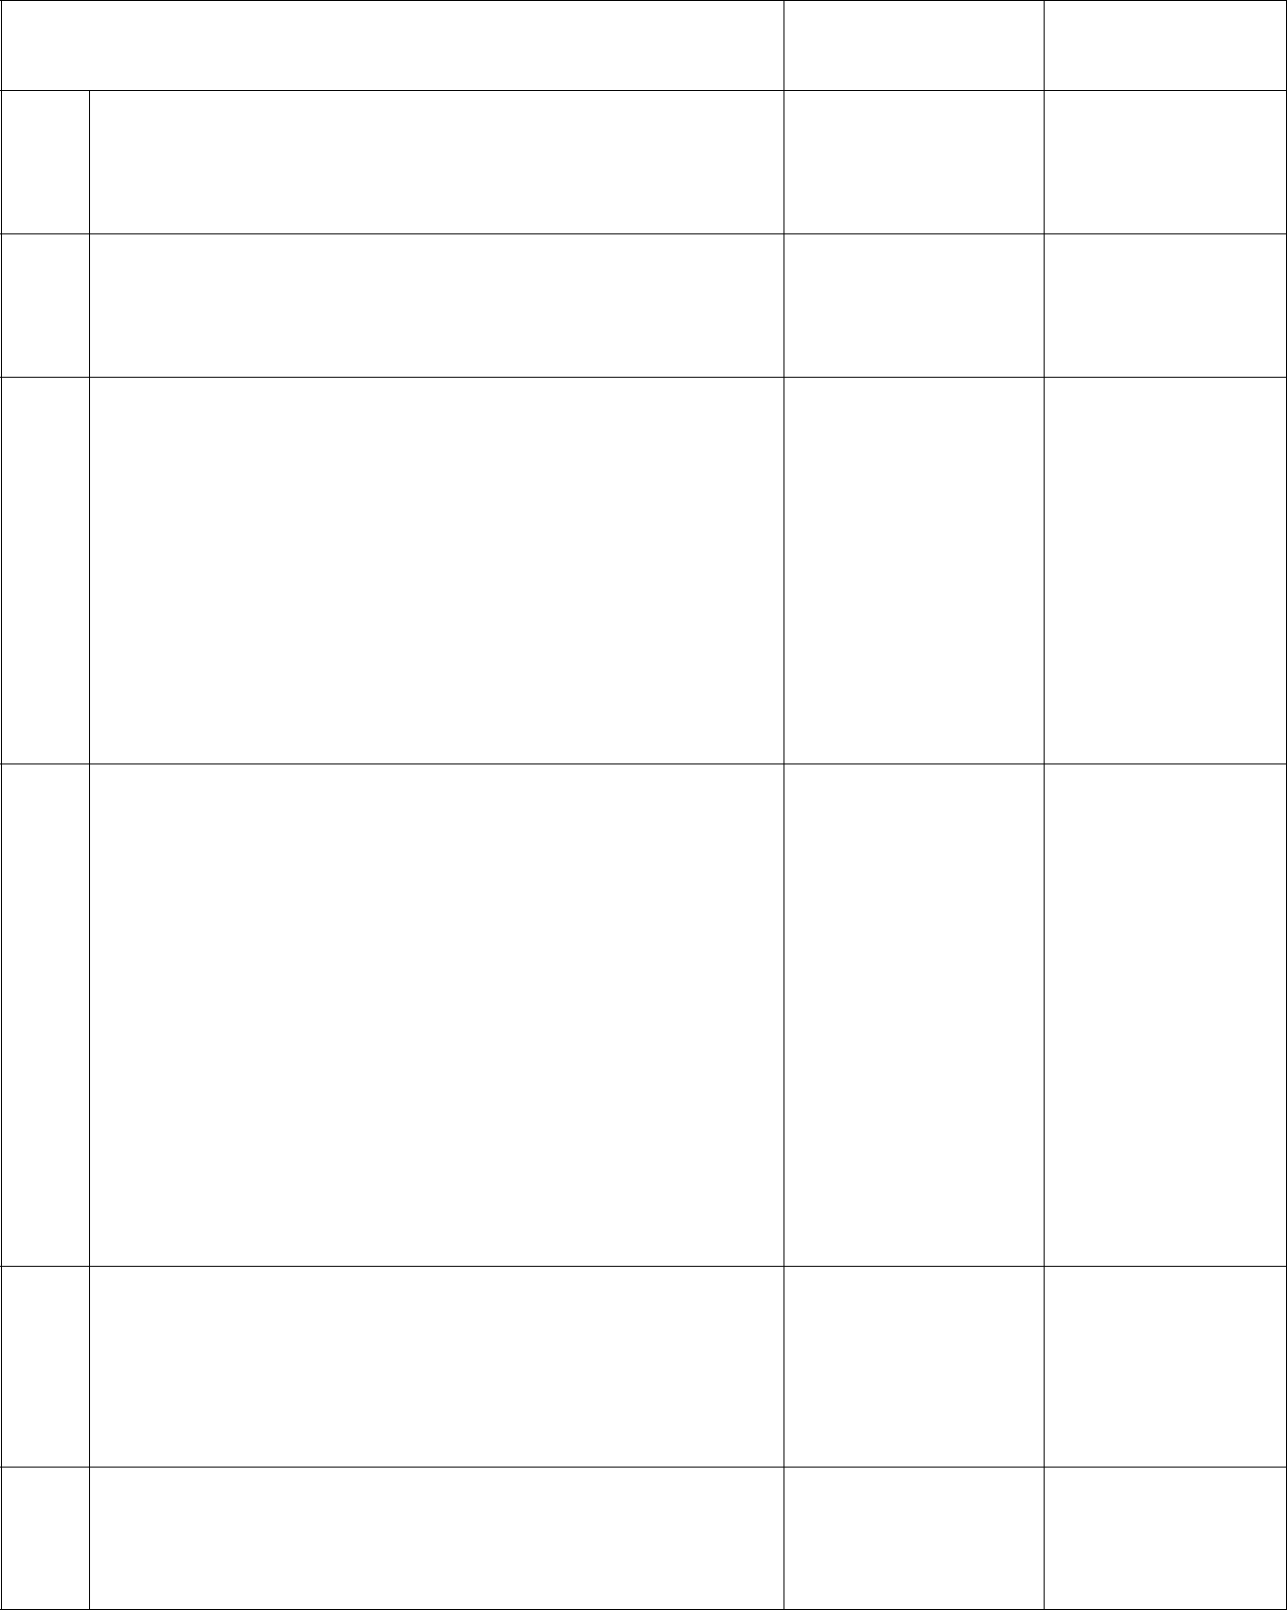

KWL Student Checklist | Student ✓ Teacher ✓

- Before reading I wrote everything I think I know about the topic in the K column.

- I listed a number of questions I had about the topic in the W column.

- As I read I kept two column notes:

  - Recording things I was learning in one column.
  - Recording new questions that came to mind as I read in the other column.
- I looked back over my KWL chart and

  - Put a tick beside everything I wrote in the K column that was the same as what I found out as I read.

  - I put a line through anything that was incorrect.
  - I put a question mark ? beside anything that was not in the text.

- After reading I looked back over the W column and put a tick beside any questions that were answered.

- I put a star* beside any questions that I still needed to answer.

National Behaviour Support Service frichardson@nbss.ie

19

Strategy – KWL Charts National Behaviour Support Service


National Behaviour Support Service (NBSS)

Navan Education Centre

Athlumney

Navan

Co. Meath

Telephone: +353 46 909 3355

Fax: +353 46 909 3354

Email: nbss@ecnavan.ie

Web: www.nbss.ie

National Behaviour Support Service frichardson@nbss.ie

20

