Partnerships for Reform through Investigative Science and Math


CORAL REEF

ECOLOGY

Concepts Scientific Inquiry Coral

HCPS III Benchmarks SC 4.4.1

Duration

2 hours

Source Material

PRISM
MARE

Vocabulary

Endemic
Nematocyst
Nutrient Availability
Photosynthesis
Plankton
Polyps
Reef-building
Salinity
Sediments
Wave Action

KWL Chart and Background Reading

Summary

Students will be able to work cooperatively and with the teacher to ask questions about coral.

Objectives

- Each student will make a statement and a ask a question about coral.

- Students will learn vocabulary pertaining to coral

- Students will learn corals are animals and not plants

Materials (1 per student)

What is Coral?” background article (pgs. 8-9)
KWL Chart (pg. 3)

Making Connections

Students will recall what they know about coral and form questions and statements about what they want to learn about coral. Prior knowledge will be based upon past educational experiences and recreational visits to coral reefs.

Teacher Prep for Activity

Photocopy the background article and KWL chart for the class. Read for yourself the additional background material included called: “Reef Researching” and “Coral Reefs: A Fact Sheet”.

Background

Read “Reef Researching” and “Coral Reefs: A Fact Sheet” on pgs. 4-7.

Procedure

- Write on chart paper, “What I know about coral.” Ask the students: What do you know about coral?

- Have each student present one thing that they know about coral. You can make sure there is 100% participation by choosing students that generally do not take risks first.
- Have the students fill in this section of the their KWL chart as they list their answers. Write each different answer on the chart paper as a class list.

- Next, ask students “what would you like to know about coral?” Repeat the procedure that was used for what students know about coral.

KWL Chart and Background Reading 1.2

1

Partnerships for Reform through Investigative Science and Math

NOTE: The students will come back to these charts and fill in what they learned about corals later. This chart is evidence of what each student knows and will give you a gauge of class knowledge as a whole.

- Have students read the short background article. At the point where photosynthesis is introduced, you can do a mini-lesson: on the board, draw the process of photosynthesis using a diagram of a tree (see Figure 1 below).

- Ask the class if this article has answered any of their questions from earlier in the lesson. Also ask the class if they have any additional questions based on the reading. Make note of
additional questions under the “L” portion of the KWL class chart.
If time permits, watch a video about coral reefs. Any video will do.

Homework: Have students write what they learned about coral reefs in their KWL chart
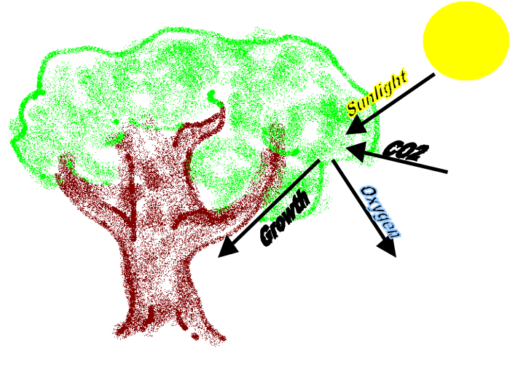

Figure 1: A diagram of photosynthesis that can be used to relate how zooxanthellae photosynthesize.

Assessments

Completed KWL chart

Resources

Center for Marine Conservation

KWL Chart and Background Reading 1.2

2

Partnerships for Reform through Investigative Science and Math

Name:_________

Date:__________


What you know about coral

What you want to know about coral

What you learned

about coral

KWL Chart and Background Reading 1.2

3

Partnerships for Reform through Investigative Science and Math
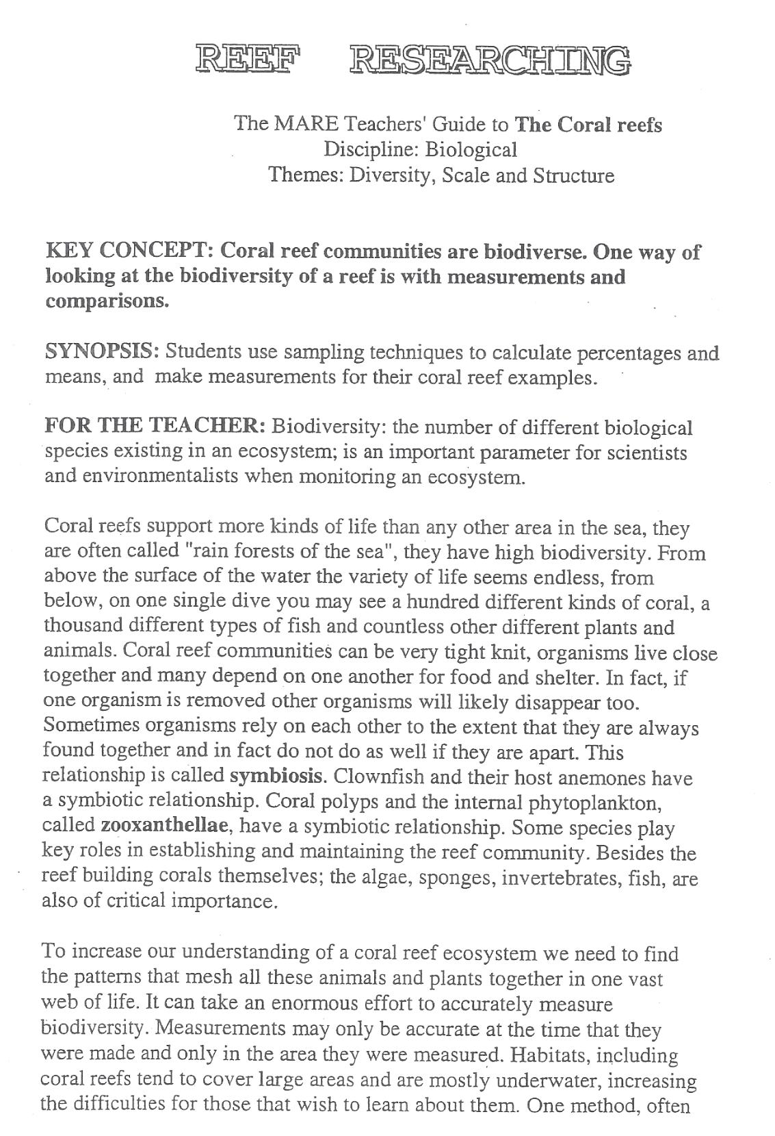

KWL Chart and Background Reading 1.2

4

Partnerships for Reform through Investigative Science and Math
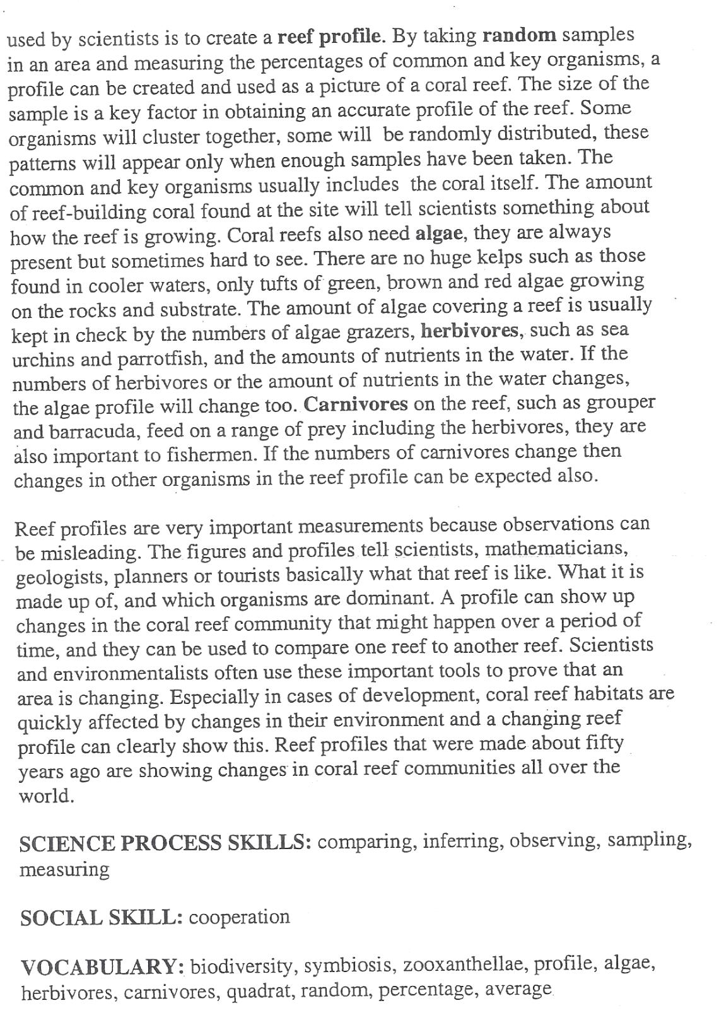

KWL Chart and Background Reading 1.2

5

Partnerships for Reform through Investigative Science and Math
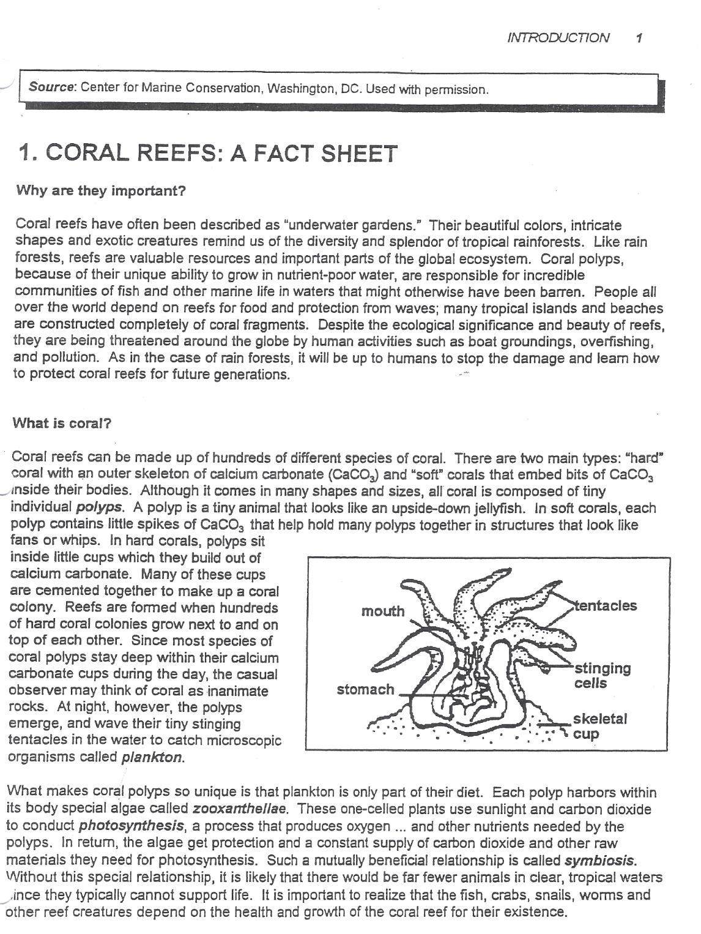

KWL Chart and Background Reading 1.2

6

Partnerships for Reform through Investigative Science and Math
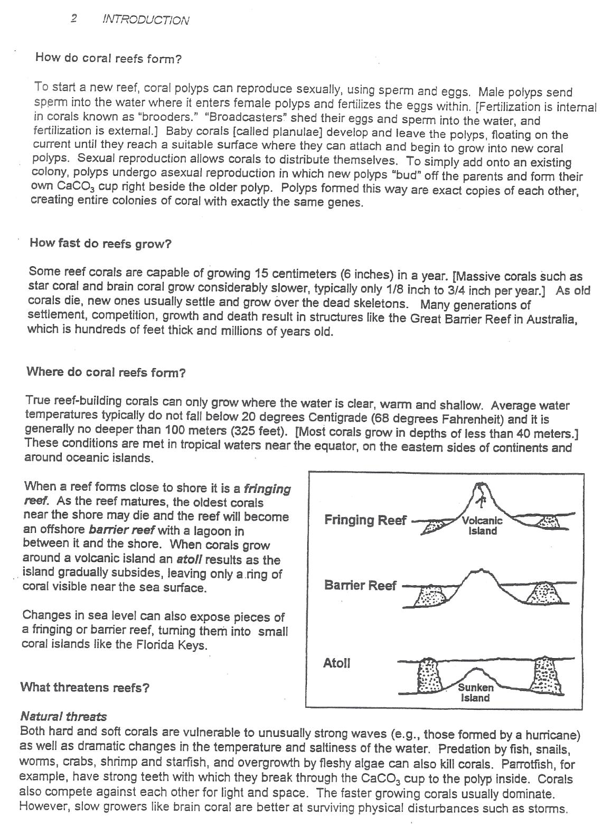

KWL Chart and Background Reading 1.2

7

Partnerships for Reform through Investigative Science and Math

Background Article: What is a Coral?

Corals are found in tropical and subtropical oceans between 30˚S and 30˚N latitude. The distribution of corals is influenced by nutrient availability, light, salinity, temperature, sediments and exposure to wave action. Why do you think corals do not grow near Antarctica?

Hawaii is very special because it has many corals that are only found here and nowhere else on earth. These types of corals are called endemic species. Endemic species can be defined as being native to a relatively small geographic area. The reason Hawaii has a high amount of endemism is because of it is located far away from mainland continents.

There are two types of corals: “hard” coral with an outer skeleton of calcium carbonate and “soft” corals that embed bits of calcium carbonate inside their bodies. Corals are made up of small, colonial, plankton-eating invertebrate animals called polyps. Plankton includes tiny crustaceans, mollusks, and larvae of reef animals, floating in the water. Corals use their stinger lined tentacles, called nematocysts, to capture
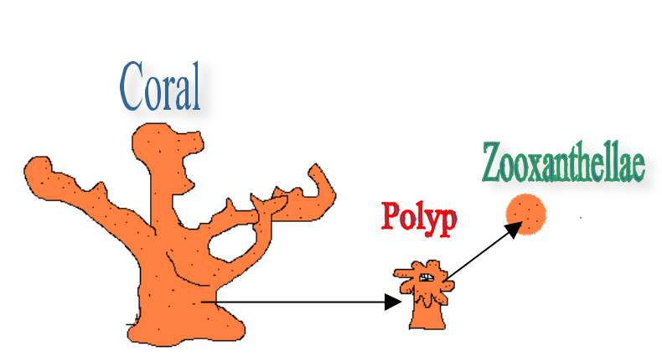
plankton that drift by in ocean

currents. Polyps of  shallow

water, reef building species

KWL Chart and Background Reading 1.2

8

Partnerships for Reform through Investigative Science and Math

have a symbiotic relationship with single celled algae called zooxanthellae (see picture).

Zooxanthellae live inside the coral tissue where they use photosynthesis to the sun’s energy to convert water and carbon dioxide into sugar. The zooxanthellae only use about 5% of the energy that was produced by photosynthesis, while the rest goes to the coral. Corals with the algae have an advantage over corals that do not because algae acts as an extra energy source for the coral.

The hard or reef building corals that generate coral reefs in Hawaii are made up of several types of coral including branching, finger-like, massive, encrusting and table-like forms. Each coral growth form is adapted to live in a different type of habitat such as shallow waters to withstand wave action or deeper waters where there is less wave action.

Non-reef building corals are composed of soft corals and corals that live in very deep water. Black coral is the official Hawai`i state gem and is found at depths past 40 meters. Deep sea corals live below where light and sun penetrates and for this reason these corals are not able to form a symbiosis with zooxanthellae. Deep sea corals derive all their energy, from captured plankton.

KWL Chart and Background Reading 1.2

9

