Senior 1

2. Fitness Management

The student will demonstrate the ability to develop and follow a personal fitness plan for lifelong physical activity and well-being.
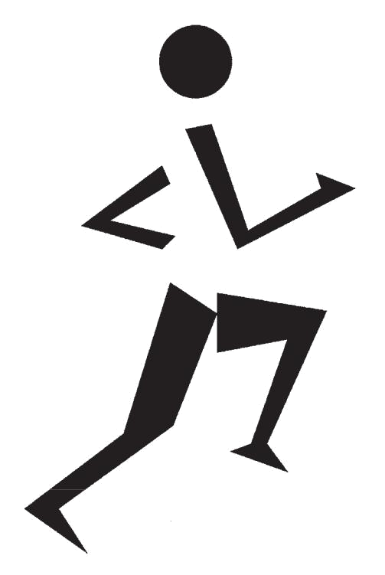
Senior 1 Physical Education/Health Education: A Foundation for Implementation


PRESCRIBED LEARNING OUTCOMES

Students will...

K.2.S1.A.1 Identify the skill-related fitness components (e.g., balance, agility, power, reaction time, speed, coordination...) and relate their importance to sport/physical activity performance (e.g., reaction time in goalkeeping...).

SUGGESTIONS FOR INSTRUCTION

- Fitness Components in the Wide World of Sports

Arrange students in small groups. Review with them the definitions of the six skill-related fitness components and have them identify a general physical activity or a sport-specific activity that relates to each component. (For example, balance is important in the sport-specific activity of cross-country skiing, as well as in a general physical activity such as balancing on balance boards or skateboards.) Each group completes a chart such as the following and posts it for all students to view.



The Wide World of Sports

Skill-Related Fitness |  | Examples of General Physical Activities and
 | Components | Sport-Specific Activities
 |  | General | Sport-Specific
• | agility
• | balance
• | coordination
• | power
• | reaction time
• | speed

- Demonstration of Fitness Components

Arrange students in small groups (as for the previous activity). Each group selects one of the six skill-related fitness components and sets up a physical-activity station in the gym, where students demonstrate to the class the selected component.

- Sport Connections

For each physical activity or sport performed in class, students identify the skill-related fitness component(s) that connect with that particular activity or sport.

S1–40

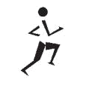
Senior 1: Fitness Management–Knowledge

TEACHER NOTES


SUGGESTIONS FOR ASSESSMENT


Glossary

- agility

- balance

- coordination

- power

- reaction time

- speed

Tip

- Individual sports/physical activities contribute to the development of more than one skill-related fitness component. Examples:

— Ballet: balance, coordination, flexibility

— Fencing: agility, balance, coordination, reaction time, speed
— Sprinting: agility, balance, coordination, power, reaction time, speed

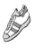

- Paper and Pencil Task: Fitness Components in the Wide World of Sports
Self-Assessment: Inventory

Groups view each other’s responses and compare them to the answer key provided.

The Wide World of Sports:

Answer Key

 | Skill-Related |  | Examples of General Physical Activities and
 | Fitness |  | Sport-Specific Activities
 | Components
 | Components |  | General |  | Sport-Specific
• | agility | • | beanbag | • | soccer footwork
 |  |  | shuttle-run test | • | basketball (person-to-person
 |  |  |  |  | defence)
 |  |  |  | • hockey (stop, start, change
 |  |  |  |  | direction)
• | balance | • | balance board | • | unicycle
 |  |  | activities | • | balance beam gymnastics
• | coordination | • | juggling three | • | basketball layup
 |  |  | tennis balls | • | volleyball bump, set, spike
 |  |  |  | • serving in racquet sports
 |  |  |  | • | hockey stick handling
• | power | • | medicine ball | • | running long jump
 |  |  | toss | • | power lift (as in weightlifting)
• | reaction time | • | metre stick drop | • | goalkeeping for floorball, ice
 |  |  |  | • | hockey, soccer, field hockey
 |  |  |  | • | juggling
• | speed | • | tire run | • | sprinting (e.g., 100 metres)
 |  |  |  | • | pitching a fastball

- Paper and Pencil Task: All Activities

Peer Assessment: Inventory

Have students write a quiz that measures their knowledge of the six skill-related fitness components and how each component relates to a physical activity or sport performance (see Teacher Notes).

Display an answer key on an overhead. Students exchange papers and mark each other’s responses.

S1–41

Senior 1 Physical Education/Health Education: A Foundation for Implementation


PRESCRIBED LEARNING OUTCOMES

Students will...

K.2.S1.B.1 Differentiate between the benefits of active living and physical fitness development, based on a health and fitness

continuum (e.g., mild activity for health benefits, moderate to vigorous activity for fitness benefits...).

Curricular Connections

ELA:

GLO 5—Celebrate and build community.

SUGGESTIONS FOR INSTRUCTION

- Health and Fitness Benefits

Students brainstorm to create a master list of health and/or fitness benefits that may be achieved as an individual participates in exercise of various intensity levels. Encourage class discussion after the master list has been created.

- Knowing the Difference: Health Versus Fitness

Designate areas of the gym to represent various intensity levels of activity, with the health benefits of active living at one end of the room and the benefits of physical fitness development at the other end.


Activity Intensity Continuum

Sedentary |  | Mild |  | Moderate |  | Vigorous |  |  | Maximum
 |  | Benefits of |  |  |  | Benefits of Physical
 |  | Active Living |  |  |  | Fitness Development
Examples:
• watch |  | • bowling |  | • baseball |  | • soccer |  | • | 100-metre sprint
television

Have students line up in the centre of the gym. Call out different sports or physical activities. Students move toward either end of the gym according to where they would place the activity on the Activity Intensity Continuum. Students defend their decisions in a class discussion.

S1–42

 |  |  |  | Senior 1: Fitness Management–Knowledge
TEACHER NOTES |  |  |  | SUGGESTIONS FOR ASSESSMENT
Glossary |  |  |  |  Journal/Reflection: Health and Fitness Benefits
• active living |  |  |  | Teacher Assessment: Anecdotal Notes
• active living |  |  |  | Students reflect, in their journals, on the following questions:
Tip
Tip |  |  |  | 1. What defines a physical activity as “active living” or as
• As one moves toward the
• As one moves toward the |  |  |  | “physical fitness development”?
vigorous end of the Activity |  |  |  | 2. At what level on the Activity Intensity Continuum do you
Intensity Continuum, the fitness
Intensity Continuum, the fitness |  |  |  | participate when involved in the following activities?
components (e.g., muscular
components (e.g., muscular |  |  |  | a. intramural activities
strength and endurance) will
strength and endurance) will |  |  |  | b. physical education class
usually develop. There will
usually develop. There will |  |  |  | c. after-school activity
usually be an improvement in
health (e.g., decrease in blood |  |  |  | 3. How can you maintain or improve your position on the
pressure) as well, but increasing |  |  |  | continuum?
intensity does not necessarily |  |  |  | 4. What are the benefits of moving toward the high (vigorous)
cause the same increase in health |  |  |  | end of the continuum?
benefits (or make one healthier).
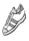

S1–43

Senior 1 Physical Education/Health Education: A Foundation for Implementation


PRESCRIBED LEARNING OUTCOMES

Students will...

K.2.S1.C.1a Explain the structure of skeletal muscle (i.e., belly, bundle, fibre, myofibril) as it relates to muscular development.

SUGGESTIONS FOR INSTRUCTION

- Structure of Skeletal Muscle

Students identify the structure of skeletal muscle, using the unlabelled illustration provided.


Refer to BLM S1-1: Skeletal Muscle Cross-Section (Unlabelled and Labelled).

- Band Together

Provide each student with a stretchy band or tubing. Have students perform a series of exercises that include the major muscle groups as part of a resistance or flexibility training program.

Upon completion of the exercise routine, have students form groups of four. Ask each group to

  - tie bands or tubing together to represent the structure of a skeletal muscle

  - illustrate and explain their model

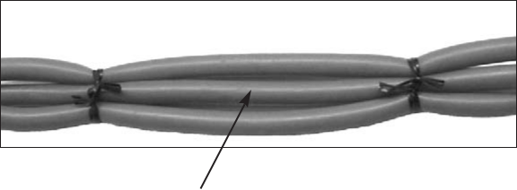

Model of Skeletal Muscle

Muscle belly

(each band represents

a muscle fibre)

S1–44

 |  |  |  | Senior 1: Fitness Management–Knowledge
TEACHER NOTES |  |  |  | SUGGESTIONS FOR ASSESSMENT
Resource |  |  |  Paper and Pencil Task: Structure of Skeletal Muscle
Blackline Master |  |  |  | Peer Assessment: Inventory
Blackline Master |  |  |  | On an overhead transparency, show a labelled diagram of the
• BLM S1–1: Skeletal
• BLM S1–1: Skeletal |  |  |  | structure of skeletal muscle. Arrange students in pairs and have
Muscle Cross-Section
Muscle Cross-Section |  |  |  | them check each other’s answers on their completed BLMs.
(Unlabelled and Labelled)
 |  |  |  | Refer to BLM S1–1: Skeletal Muscle Cross-Section
 |  |  |  | (Labelled).
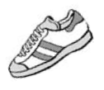



S1–45

Senior 1 Physical Education/Health Education: A Foundation for Implementation

PRESCRIBED LEARNING OUTCOMES

Students will...

K.2.S1.C.1b Explain the structure of fibre types (i.e., slow-

twitch, fast-twitch) as they relate to muscular development.

SUGGESTIONS FOR INSTRUCTION

- The Way I Move

Students review the definitions of slow-twitch and fast-twitch muscle fibres and associated terms.


Refer to RM S1–1: Muscle Fibre Types.

Students identify (with a check mark) the muscle fibre types that predominate in each activity/sport listed in the following chart.

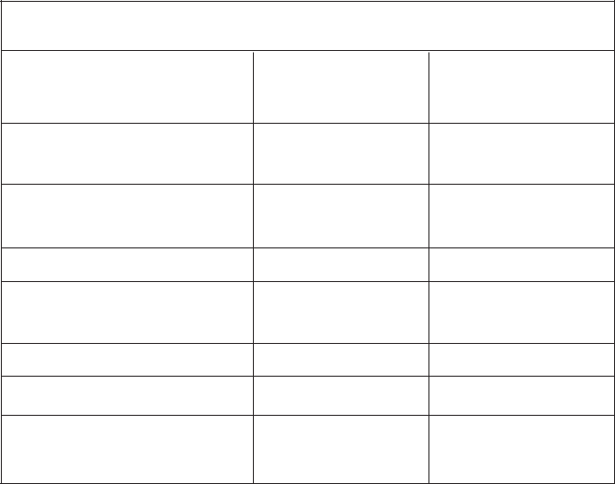

The Way I Move: Activity Chart

Activity/Sport | Slow-Twitch | Fast-Twitch
 | Fibre Types | Fibre Types

- running marathon (42 km; 26.2 miles)

- lifting weights (power lifting)

- canoeing

- throwing a discus (one throw)

- playing soccer

- sprinting (100 m)

- cross-country skiing (15 km)

Arrange students in pairs and have them research and explain how the distribution of fast-twitch and slow-twitch muscle fibres differs between athletes in various sports (e.g., aerobic activities rely primarily on slow-twitch fibres).

S1–46

 |  |  | Senior 1: Fitness Management–Knowledge
TEACHER NOTES |  |  | SUGGESTIONS FOR ASSESSMENT
Glossary |  |  |  Paper and Pencil Task: The Way I Move
• fast-twitch muscle fibre |  |  | Teacher Assessment: Checklist
• fast-twitch muscle fibre |  |  | Students complete The Way I Move: Activity Chart. Students
• slow-twitch muscle fibre
Resources |  |  | could outline a weekly and a monthly activity plan for
Resources |  |  | improving muscular development, keeping in mind that an
Publications |  |  | individual who enjoys and succeeds in aerobic activities such as
• Temertzoglou, Ted, and Paul |  |  | long-distance running presumably has a greater percentage of
• Temertzoglou, Ted, and Paul |  |  | slow-twitch fibres.
Challen. Exercise Science: An
Introduction to Health and
Physical Education. Toronto, ON:
Thompson Educational
Publishing, Inc., 2003.
• Wilmore, Jack H., and David L.
Costill. Physiology of Sport and
Exercise. 3rd ed. Windsor, ON:
Human Kinetics, 2004.
Resource Master
• RM S1–1: Muscle Fibre
Types
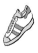


S1–47

Senior 1 Physical Education/Health Education: A Foundation for Implementation


PRESCRIBED LEARNING OUTCOMES

Students will...

K.2.S1.C.1c Identify types of strength exercises (i.e., isometric,

dynamic) and stretching exercises (i.e., static, ballistic, passive) for personal fitness development (i.e., strength, endurance, range of motion).

Curricular Connections

PE/HE:

K.2.S2.A.1

SUGGESTIONS FOR INSTRUCTION

- Strength and Stretching Exercises

Students brainstorm to create a list of strength and stretching exercises.

Arrange students in pairs and have each pair

  - select a muscle/muscle group from the following list, which includes both the anterior and its corresponding posterior muscle/muscle group (Ensure that all muscles/muscle groups are selected.)

  - demonstrate to the class what isometric and/or dynamic strength exercises are appropriate to develop strength and endurance
  - identify the appropriate stretching exercise to develop range of motion around the selected muscle/muscle group



Muscles/Muscle Groups

Anterior Muscle/Muscle Group |  | Posterior Muscle/Muscle Group
• | trapezius | • | trapezius
• | deltoid | • | deltoid
• | pectoralis major | • | latissimus dorsi
• | bicep | • | tricep
• | rectus abdominus | • | erector spinae
• | quadriceps/iliopsoas | • | hamstring/gluteus maximus
• | tibialis anterior | • | gastrocnemius/soleus

S1–48

 |  |  |  |  | Senior 1: Fitness Management–Knowledge
 | TEACHER NOTES |  |  |  | SUGGESTIONS FOR ASSESSMENT
Glossary |  |  |  |  Performance Task: Strength and Stretching Exercises
• | ballistic stretching |  |  | Teacher/Peer Assessment: Checklist
• | dynamic contraction |  |  | Assess student presentations, using the following
• | isometric contraction |  |  | checklist/criteria.
• | muscular endurance
• | muscular endurance |  |  |  | Strength and Stretching Exercises:
• | muscular strength
• | passive stretching |  |  |  | Presentation Checklist
• | passive stretching |  |  |  | Students
• range of motion (see flexibility)
• | static stretching |  |  |  | identify anterior muscle strength exercise
Resources |  |  |  |  | identify posterior muscle strength exercise
 |  |  |  |  | differentiate between isometric and dynamic
Publications
 |  |  |  |  | contraction for the selected exercise
• | Anderson, Bob. Stretching. 20th |  |  |  | identify anterior muscle stretching exercise
 | anniversary rev. ed. Illus. Jean |  |  |  | identify posterior muscle stretching exercise
 | Anderson. Bolinas, CA: Shelter
 | Anderson. Bolinas, CA: Shelter |  |  |  | differentiate between static, ballistic, and passive
 | Publications, 2000.
 | Publications, 2000. |  |  |  | methods of stretching for the selected exercise
• Stark, Steven D. The Stark
 | Reality of Stretching: An
 | Informed Approach for All
 | Activities and Every Sport. 4th ed.
 | Richmond, BC: Stark Reality
 | Corp., 1999.
Blackline Master
• BLM G–1a and G–1b: Skeletal
 | Muscles: Anterior View,
 | Posterior View
 | (Unlabelled and Labelled)
Resource Master
• RM G–3: Exercise Do’s
 | and Don’ts

S1–49

Senior 1 Physical Education/Health Education: A Foundation for Implementation

PRESCRIBED LEARNING OUTCOMES

Students will...

K.2.S1.C.2 Describe the principles of training and conditioning for physical activities
(i.e., progressive overload, specificity, reversibility, regularity, individual variability, starting point).

SUGGESTIONS FOR INSTRUCTION

- Discovering What We Know

To identify what students know about the principles of training and conditioning for physical activities, have them match the following words with their correct descriptor.


Discovering What We Know: Match-Up

 | Term | # |  |  | Descriptor
• | progressive |  | 1. |  | the highly trained individual who
 | overload |  |  |  | achieves small incremental performance
 |  |  |  |  | gains through repeated training
• | specificity
• | specificity |  | 2. |  | prevention of over-training
 |  |  |  | 3. | stop training a muscle or muscle group
• | reversibility/ |  |  | 3.
• | reversibility/ |  |  |  | and muscles lose the benefits that were
 | regularity
 | regularity |  |  |  | achieved through training
• | diminishing |  | 4. |  | reducing training frequency but
 | return |  |  |  | maintaining intensity and duration
 |  |  |  | 5. | a minimum of three or more times a
• | stress/rest |  |  | 5.
 |  |  |  |  | week for 45 to 60 minutes to develop
 |  |  |  |  | and/or sustain cardiovascular fitness
• | ceiling
• | ceiling |  | 6. |  | a muscle-training program in which the
 |  |  |  |  | amount of resistance is systematically
• | maintenance |  |  |  | increased as the muscles gain strength
 |  |  | 7. |  | a baseline from which to develop a
 |  |  |  |  | fitness program and assess results
• | individual
• | individual |  | 8. |  | no two individuals respond the same to
 | variability
 |  |  |  |  | a particular training/exercise program
• | starting point
• | starting point |  | 9. |  | a plateau
 |  |  |  | 10. | developing the leg muscles by
• | FITT principle |  |  | 10.
• | FITT principle |  |  |  | performing squats would benefit the
 |  |  |  |  | execution of the basketball jump shot
 |  |  |  |  | (continued)

S1–50

 |  |  |  |  |  | Senior 1: Fitness Management–Knowledge
 | TEACHER NOTES |  |  |  |  | SUGGESTIONS FOR ASSESSMENT
 |  |  |  |  Paper and Pencil Task: Discovering What We Know
Tip
• Encourage students to incorporate |  |  |  | Self-Assessment: Inventory
 | the principles of training and |  |  | Students assess their responses, using the answer key provided.
 | conditioning in their personal
 | fitness plans. |  |  |  |  | Discovering What We Know: Match-Up
 |  |  |  |  |  | (Answer Key)
Resources
 |  |  |  |  | Term |  |  | Descriptor #
Publications |  |  |  |  |  |  |  | Descriptor #
 |  |  |  |  | • | progressive overload |  | 6
• | Manitoba Education, Citizenship |  |  |  | • | progressive overload |  | 6
• |  |  |  |  | • | specificity |  | 10
 | and Youth. Guidelines for Fitness
 |  |  |  |  | • | reversibility/regularity |  | 3
 | Assessment in Manitoba Schools: |  |  |  | • | reversibility/regularity |  | 3
 |  |  |  |  | • | diminishing return |  | 1
 | A Resource for Physical |  |  |  | • | diminishing return |  | 1
 | Education/Health Education. |  |  |  | • | stress/rest |  | 2
 | Winnipeg, MB: Manitoba
 |  |  |  |  | • | ceiling |  | 9
 | Education, Citizenship and Youth,
 |  |  |  |  | • | maintenance |  | 4
 | 2004. |  |  |  | • | maintenance |  | 4
 | 2004. |  |  |  | • | individual variability |  | 8
• Manitoba Fitness Council. Active |  |  |  |  | • | individual variability |  | 8
 |  |  |  |  | • | starting point |  | 7
 | Healthy People: Fitness Theory |  |  |  | • | starting point |  | 7
 |  |  |  |  | • | FITT principle |  | 5
 | Manual. Winnipeg, MB: |  |  |  | • | FITT principle |  | 5
 | Manitoba Fitness Council, n.d.
• | ---. Resistance Training Manual.
 | Winnipeg, MB: Manitoba Fitness
 | Council, n.d.
• Temertzoglou, Ted, and Paul
 | Challen. Exercise Science: An
 | Introduction to Health and
 | Physical Education. Toronto, ON:
 | Thompson Educational
 | Publishing, Inc., 2003.


Resource Masters


• RM G–2: Active Learning

Strategies

- RM G–4: Principles of Training and Conditioning for Physical Activities
- RM G–5: FITT Principle Guidelines

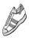


(continued)

S1–51

Senior 1 Physical Education/Health Education: A Foundation for Implementation

PRESCRIBED LEARNING OUTCOMES

Students will...

K.2.S1.C.2 (continued)

SUGGESTIONS FOR INSTRUCTION

(continued)

- Rotating Reel

Have students form groups of three and assign each person a number (e.g., 1, 2, 3). Ask each small group to distribute themselves evenly on a large circle.

Ask the class a question about the principles of training and conditioning for physical activities and have each group

X X | X X
X | X
X X | X X
X | X
X X | X X
X | X


discuss the question to determine a small-group answer. Choose a number and ask students with that number to move in a clockwise direction to the next group, share their answer with the new group, and generate further discussion. As groups share their answers with the class, clarify and correct answers as needed. Continue the sequence of asking and answering a question, identifying the persons who will move to the next group in the circle, and sharing the answer.

Refer to Rotating Reel in RM G–2: Active Learning

Strategies. For background information, refer to

RM G–4: Principles of Training and Conditioning

for Physical Activities.

- Designing a Fitness Program

Arrange students in groups of two or three and have each group design a fitness program that incorporates the principles of training and conditioning for either a thrower (shot put, discus, hammer, or javelin) or a long-distance runner (cross-country or marathon runner). (Ensure that both thrower and long-distance runner are selected.) Groups post their programs and view each other’s work.

S1–52

 |  | Senior 1: Fitness Management–Knowledge
TEACHER NOTES |  | SUGGESTIONS FOR ASSESSMENT


(continued)

- Observation: Designing a Fitness Program

Peer Assessment: Inventory

Groups compare and contrast their fitness programs with those of other groups that selected the same athlete. Then, as a class, students identify the differences between programs for the two athletes.

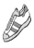

S1–53

Senior 1 Physical Education/Health Education: A Foundation for Implementation


PRESCRIBED LEARNING OUTCOMES

Students will...

K.2.S1.C.3 Design and implement effective warm-up and cool-down routines for specific team-related physical activities

(e.g., volleyball, soccer, rugby...).

Curricular Connections

ELA:

GLO 3—Manage ideas and information.

SUGGESTIONS FOR INSTRUCTION

- Sport-Specific Stretches

Students collect diagrams or pictures of various flexibility exercises and post them around the gym. Students visit each diagram or picture and record two or three team sports for which the illustrated exercise could be used as a warm-up and/or cool-down routine. Encourage an open classroom discussion in which students share their information.

- Designing Warm-up and Cool-down Routines

Arrange students in groups of four and ask each group to

  - choose a team sport (e.g., volleyball, basketball, soccer, rugby)

  - research, design, and implement effective warm-up and cool-down routines for their chosen team sport

  - justify why they chose the particular exercise they did and explain its relationship to their sport

  - demonstrate and relate the importance of their exercises to the class

S1–54


Senior 1: Fitness Management–Knowledge

TEACHER NOTES


SUGGESTIONS FOR ASSESSMENT


Review

- Review the importance of participating in appropriate warm-ups and cool-downs before and after physical activity. Explain that warm-ups should be designed with the specific physical activity in mind.

Tip

- Encourage students to lead warm-up and/or cool-down routines during physical activities performed in class.

Resources

Publications

- Anderson, Bob. Stretching. 20th anniversary rev. ed. Illus. Jean Anderson. Bolinas, CA: Shelter Publications, 2000.

- Heyward, Vivian H. Advanced Fitness Assessment and Exercise Prescription. 4th ed. Champaign, IL: Human Kinetics, 2002.

- Stark, Steven D. The Stark Reality of Stretching: An Informed Approach for All Activities and Every Sport. 4th ed. Richmond, BC: Stark Reality Corp., 1999.

Resource Master

• RM G–3: Exercise Do’s and Don’ts

- Performance Task: Designing Warm-up and Cool-down Routines
Group Assessment: Rating Scale

Groups assess each other’s presentations using the following rating scale and criteria.

Assessment of Warm-up and Cool-down Routines

Rating | The student
Scale | The student
3 | • identified numerous team-specific exercises
3 | • provided clear and detailed demonstrations of the
Exemplary | exercises
 | • provided strong justification for the selection of
 | exercises in relation to the sport
2 | • identified some team-specific exercises
2 | • provided clear demonstrations of the exercises
Satisfactory | • provided some justification for the selection of
 | exercises in relation to the sport
1 | • identified a few team-specific exercises
1 | • provided somewhat unclear demonstrations of the
Developing | exercises
 | • provided limited justification for the selection of
 | exercises in relation to the sport

S1–55

Senior 1 Physical Education/Health Education: A Foundation for Implementation


PRESCRIBED LEARNING OUTCOMES

Students will...

K.2.S1.C.4 Identify the factors related to health and fitness

development (e.g., health benefit, physical attributes, interpersonal interaction, influence of family, availability of facilities/equipment, competition, cooperation, personal success, time management...) that affect choices of physical activities for self and others.

Curricular Connections

ELA:

GLO 5—Celebrate and build community.

SC (Biology):

S3B-3-18 Identify personal lifestyle choices that contribute to cardiovascular and respiratory wellness.

SUGGESTIONS FOR INSTRUCTION

- Factor Analysis

Arrange students in groups of four or five and have them brainstorm to create a master list of factors that affect choices of physical activities for self and others (e.g., influence of family). Have them discuss the master list and share with others how some factors would affect students differently.

Encourage class discussion by asking how students might deal with (i.e., change or avoid) negative influences.

- Support Your Choice

Students select a fitness facility, a physical activity, or a sport team that they would like to join and identify the factors that affected their choice. Using the factors identified in the previous exercise (Factor Analysis), students identify which factors influenced them in their choice. Each student shares his or her information with a peer.

S1–56

 |  |  |  |  | Senior 1: Fitness Management–Knowledge
TEACHER NOTES |  |  |  |  |  |  | SUGGESTIONS FOR ASSESSMENT
Tips |  |  |  Performance Task: Support Your Choice
• Look at this learning outcome |  |  |  | Peer Assessment: Checklist
from the point of view of |  |  |  | Peers assess whether or not students are able to identify the
“throughout life.” |  |  |  | factors that influence their choices.
• For more ideas, see The Canadian |  |  |  Interview/Questioning: Support Your Choice
Active Living Challenge: Leader’s
Resource Tool Kit, Program 3 |  |  |  | Teacher Assessment: Inventory
(CAHPERD/CIRA). |  |  |  | Have students complete the following chart, reflecting on their
• Remind students that increasing
 |  |  |  | own choice of physical activities and noting interview responses
physical activity increases level of |  |  |  | from a friend and a family member.
fitness and aids in the prevention
of disease. Note that one still |  |  |  |  |  |  | Physical Activity Choices: What and Why?
might be genetically predisposed
 |  |  |  |  | Self and |  | What physical |  | Why?
to disease. |  |  |  |  | Self and |  | What physical
 |  |  |  |  | Others |  | activity do you |  | What factors affect your activity choice?
 |  |  |  |  |  |  | like to do?
Aboriginal Link
 |  |  |  |  | Self
• For information, refer to the
 |  |  |  |  | Friend
following resources (see Aboriginal
 |  |  |  |  | Family
Websites in Bibliography): |  |  |  |  | Family
 |  |  |  |  | Member
— Manitoba Aboriginal Sport and
Recreation Council (MASRC)
Inc. provides opportunities for
Aboriginal youth and adults in
Manitoba to sustain/improve
their physical, emotional,
mental, and spiritual well-
being through sport, fitness,
recreation, and social and
leisure activities. This
organization also focuses on
the development and
enhancement of Aboriginal
culture.
 |  |  |  |  |  |  | TEACHER NOTES (continued)
— Winnipeg Aboriginal Sport
Achievement Centre (WASAC) |  |  |  | Resource
provides opportunities for |  |  |  | Publication
Aboriginal children and youth
 |  |  |  | • The Canadian Association for Health, Physical Education,
to participate in sport and
recreation activities and build |  |  |  |  | Recreation and Dance and Canadian Intramural Recreation
the self-esteem and self- |  |  |  |  | Association (CAHPERD/CIRA). The Canadian Active
confidence necessary to any |  |  |  |  | Living Challenge: Leader’s Resource Tool Kit, Program 3:
person’s success in life. |  |  |  |  | Ages 12 to 14: Theme: Making Choices and Setting
 |  |  |  |  | Goals. Gloucester, ON: CAHPERD/CIRA, 1994.



S1–57

Senior 1 Physical Education/Health Education: A Foundation for Implementation


PRESCRIBED LEARNING OUTCOMES

Students will...

S.2.S1.A.1a Participate in physical activities at a level that contributes to the goals of an individualized fitness plan.

Curricular Connections

PE/HE:

S.2.S1.A.1b

ELA:

GLO 3—Manage ideas and information.

SUGGESTIONS FOR INSTRUCTION

- Personal Fitness Plan

Students identify their goal(s) for a personal fitness plan (e.g., increase cardiovascular endurance to allow running 1600 metres [1 mile] without stopping) that they could achieve by the end of a six-week program. Using a Progress in Motion chart such as the one below, students

  - state their goal(s) for a six-week personal fitness plan

  - identify the physical activities in which they plan to participate each week to accomplish their goal(s)

  - record what they did each week (in and out of class) that demonstrated a level of participation contributing to their fitness goal(s)

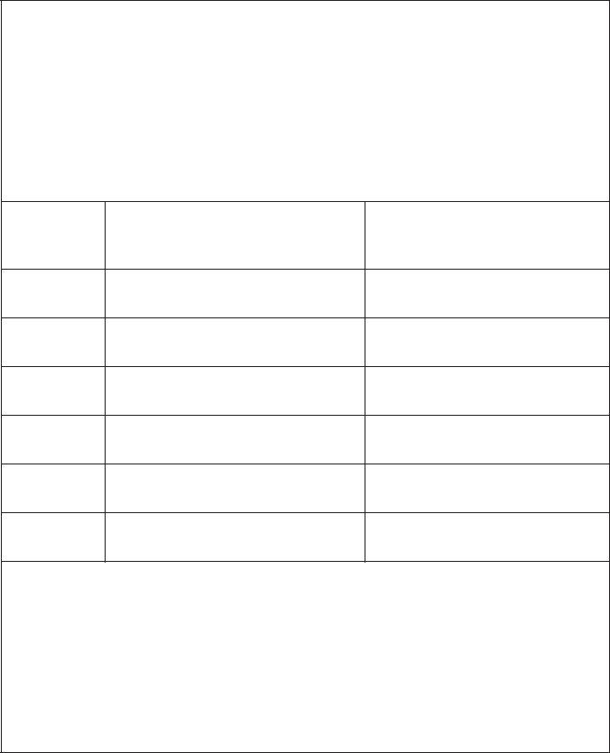

Progress in Motion

Name: _________________________ Length of Time: Six weeks

Goal Statement: _________________________________________

_______________________________________________________

Progress | In what physical activities | What did I do?
Log | do I plan to participate?

Week 1

Week 2

Week 3

Week 4

Week 5

Week 6

Did I achieve my goal(s)? Explain.

- Fun and Fitness

Students participate in a variety of fitness-related activities (e.g., resistance training circuits, walking, obstacle courses, paarlauf, scavenger hunts, step-bench activities, aerobics or group fitness activities). Following the activities, students indicate how each activity contributes to their personal fitness goals.

S1–58

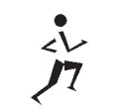 |  |  |  |  | Senior 1: Fitness Management–Skills
TEACHER NOTES |  |  |  |  | SUGGESTIONS FOR ASSESSMENT
 |  |  |  Performance Task: Personal Fitness Plan
Tip
• Encourage weekly check-ins to |  |  | Self-Assessment: Rating Scale
discuss how students are |  |  | Students complete their six-week fitness plan and use the
progressing with their personal |  |  | following rating scale to assess their physical activity
fitness plans. |  |  | participation in terms of how it contributed to their goal(s).
Resource
 |  |  |  |  | Progress in Motion:
Resource Master |  |  |  | Personal Participation Rating
• RM G–5: FITT Principle |  |  |  | Rating Scale:
Guidelines |  |  |  | 4 – consistently participated in physical
 |  |  |  | activities (on task)
 |  |  |  | 3 – usually participated in physical activities
 |  |  |  | 2 – sometimes participated in physical
 |  |  |  | activities
 |  |  |  | 1 – rarely participated in physical activities
 |  |  |  | (not on task)
 |  |  |  | Progress |  | Weekly Rating
 |  |  |  | Log
 |  |  |  | Log | 4 | 3 | 2 | 1
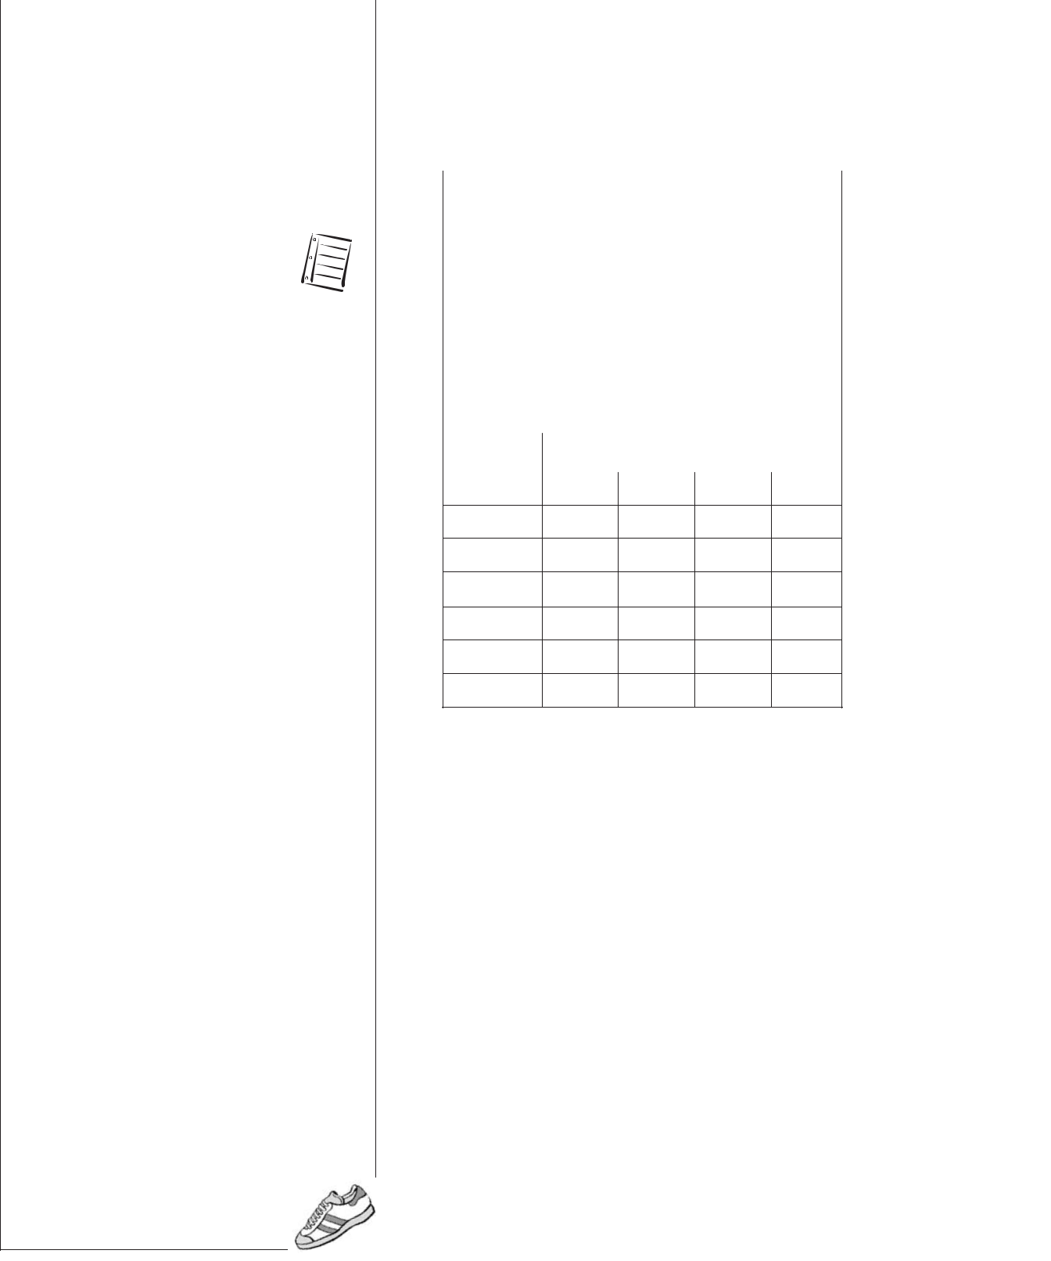

Week 1

Week 2

Week 3

Week 4

Week 5

Week 6

- Performance Task: All Activities

Teacher/Self-Assessment: Scoring Rubric

With teacher direction, students develop criteria for assessing physical activity participation in class activities.

S1–59

Senior 1 Physical Education/Health Education: A Foundation for Implementation


PRESCRIBED LEARNING OUTCOMES

Students will...

S.2.S1.A.1b Participate in planned and self-directed activities that maintain heart-rate levels in
various zones (e.g., general health, basic fitness, healthy heart...).

Curricular Connections

PE/HE:

K.2.S1.B.1

S.2.S1.A.1a

S.2.S1.A.2

SUGGESTIONS FOR INSTRUCTION

- Personal Fitness Journal

Before participating in activities that maintain the heart-rate levels in various training zones, students review the heart-rate zone levels and formula. Using this information, students determine their maximum heart rate and calculate the five target heart-rate zones.

Refer to RM G–6: Heart-Rate Zone Levels and

RM G–7: Heart-Rate Zone Formula.

Students create a Heart-Rate Zone Participation chart in their journals, as shown below. They participate in and chart both planned and self-directed activities that maintain their heart rates in the five target heart-rate zones. Either heart-rate monitors or the rate of perceived exertion method can be used to identify heart-rate zones. Students keep their participation charts in their journals and add to them daily or weekly.



Heart-Rate Zone Participation

My maximum heart rate:

My target heart-rate range: |  |  |  | Zone |  | Zone |  | Zone |  | Zone |  | Zone
 |  |  |  | 1 |  | 2 |  | 3 | 4 |  |  | 5
 | Date |  | Activity |  |  | Heart-Rate |  |  |  | Approximate
 |  |  |  |  |  | Zone Level |  |  |  | Time in Zone
 |  |  |  |  |  |  |  |  |  |  | Level
Example: |  | • | intramural |  |  | • Zone 3: |  |  |  | • 20 minutes
• | Monday, | •
• | Monday, |  | basketball game |  |  | moderate
 | March 3

S1–60

 |  |  |  |  | Senior 1: Fitness Management–Skills
TEACHER NOTES |  |  |  |  | SUGGESTIONS FOR ASSESSMENT
Glossary |  |  Performance Task: Personal Fitness Journal
• rate of perceived exertion and |  |  | Self-Assessment: Inventory
category-ratio pain scales (Borg) |  |  | At the end of every week, students assess their level of
 |  |  | participation in all five heart-rate zones, using the following
Tips |  |  | inventory.
• Research suggests that maximum
• Research suggests that maximum |  |  |  | Level of Participation in Heart-Rate Zones
heart rate (MHR) has more to do
with leg strength than with |  |  |  | Date | Number of Times I Participated In
anything else, as stronger legs
anything else, as stronger legs |  |  |  |  | Zone | Zone | Zone |  | Zone |  | Zone
pump more blood to the heart, |  |  |  |  | Zone | Zone | Zone |  | Zone |  | Zone
pump more blood to the heart, |  |  |  |  | 1 | 2 | 3 |  | 4 |  | 5
which results in a faster heart
which results in a faster heart |  |  |  | Monday
rate. |  |  |  | Monday
rate. |  |  |  | Tuesday
• The popular formula for MHR of |  |  |  | Tuesday
• The popular formula for MHR of |  |  |  | Wednesday
220 for males (or 226 for |  |  |  | Wednesday
220 for males (or 226 for |  |  |  | Thursday
females) minus age tends to |  |  |  | Thursday
overestimate heart rate in |  |  |  | Friday
“younger” people and
“younger” people and |  |  |  | Saturday
underestimates heart rate in
underestimates heart rate in |  |  |  | Sunday
“older” people. Therefore, a new |  |  |  | Sunday
formula that is applicable to both
males and females should be
males and females should be |  |  |  |  | TEACHER NOTES (continued)
used: MHR = 208 minus (70% of
age) (Tanaka 153-56). |  |  | Resources
For example, see step 2 (b) in
For example, see step 2 (b) in |  |  | Publications
RM G–7: Heart-Rate Zone
RM G–7: Heart-Rate Zone |  |  | • Borg, Gunnar. Perceived Exertion and Pain Scales.
Formula.
• Simplify the five heart-rate zone |  |  |  | Windsor, ON: Human Kinetics, 1998.
• Simplify the five heart-rate zone |  |  | • Howard, Mike. “Cardiovascular Programming.” Fitness
levels into three zones:
1. easy (mild) zone: 60% to |  |  |  | Trainer Canada (February/March 2003): 26-29.
1. easy (mild) zone: 60% to |  |  | • Kirkpatrick, Beth, and Burton H. Birnbaum. Lessons from
75% MHR
2. moderate zone: 75% to 85% |  |  |  | the Heart: Individualizing Physical Education with Heart
2. moderate zone: 75% to 85% |  |  |  | Rate Monitors. Windsor, ON: Human Kinetics, 1997.
MHR
MHR |  |  | • Manitoba Education, Citizenship and Youth. Guidelines
3. hard (vigorous) zone: 85% to
3. hard (vigorous) zone: 85% to |  |  |  | for Fitness Assessment in Manitoba Schools: A Resource
100% MHR
100% MHR |  |  |  | for Physical Education/Health Education. Winnipeg, MB:
• Explain to students that target
• Explain to students that target |  |  |  | Manitoba Education, Citizenship and Youth, 2004.
heart-rate zone levels serve as
heart-rate zone levels serve as |  |  | • Tanaka, H., K.D. Monahan, and D.R. Seals. “Age-
guidelines, since determining
guidelines, since determining |  |  |  | Predicted Maximal Heart Rate Revisited.” Journal of the
one’s target heart rate is
one’s target heart rate is |  |  |  | American College of Cardiology 37.1 (2001): 153-56.
individual, depending on
individual, depending on |  |  | Resource Masters
individual fitness levels, physical
abilities, age, and so on. |  |  | • RM G–6: Heart-Rate Zone Levels
 |  |  | • RM G–7: Heart-Rate Zone Formula


S1–61

Senior 1 Physical Education/Health Education: A Foundation for Implementation


PRESCRIBED LEARNING OUTCOMES

Students will...

S.2.S1.A.2 Demonstrate use of heart-rate monitoring (e.g., pulse points, heart monitors, software programs...) to compare exertion level in a variety of activities.

Curricular Connections

PE/HE:

S.2.S1.A.1b

SUGGESTIONS FOR INSTRUCTION

- The Fartlek Training Method

To demonstrate heart-rate monitoring during activities of different exertion levels, have students do the following in the suggested sequence:
  - Participate in an appropriate warm-up for a walking, jogging, or running activity.

  - Set monitors to a Zone 2 (mild activity level: 60% to 70%

MHR) (as identified in RM G–6: Heart-Rate Zone Levels).

  - Walk, jog, or run for five minutes within the Zone 2 level.

  - Pick up the pace to a Zone 3 (moderate activity level: 70% to 80% MHR) for as long as possible, up to a maximum of five minutes, and then return to the Zone 2 level for five minutes.

  - Pick up the pace again to a Zone 4 (vigorous activity level: 80% to 90% MHR) for as long possible, up to a maximum of five minutes, and then return to the Zone 2 level for five minutes.

  - Participate in an appropriate cool-down before downloading the information from the heart-rate monitor to a computer and generating a printout.

- In the Zone

Students set their heart-rate monitors to the training zone of their choice. After an appropriate warm-up, they start a workout of their choice at the low end of the training zone. They then pick up the pace to the high end of the training zone. Once they reach the high end of the zone, they slow down their workout to the low end of the zone and continue to move from low to high to low for 20 minutes. They download the information from the monitor to a computer and create a printout.

S1–62

 |  |  |  | Senior 1: Fitness Management–Skills
TEACHER NOTES |  |  |  | SUGGESTIONS FOR ASSESSMENT
Review |  |  |  Performance Task: The Fartlek Training Method
• Review the heart-rate zone |  |  | Self-Assessment: Checklist/Inventory
formula and the use of heart-rate |  |  | Once students have completed the Fartlek Training workout and
monitors. |  |  | downloaded their results to create a printout, they use the
Tips |  |  | following checklist/inventory to assess their use of heart-rate
• Refer to the Suggestions for |  |  | monitors through various exertion levels.
Instruction for learning outcome
Instruction for learning outcome |  |  |  | Self-Assessment of Heart-Rate Monitoring
S.2.S1.A.1b before addressing
S.2.S1.A.1b before addressing |  |  |  | I was
this learning outcome. |  |  |  | I was
this learning outcome. |  |  |  | • successful in creating a printout that showed my heart rates
• Fartlek is a Swedish term
• Fartlek is a Swedish term |  |  |  | from Zone 2 to Zone 4, back to Zone 2 and up to Zone 4, and
meaning speed play. |  |  |  | back to Zone 2 | Yes ___ No ___
• If a class set of heart-rate |  |  |  | • active in Zone 3 for ______ minutes (maximum five)
monitors is not available either by |  |  |  | • active in Zone 4 for ______ minutes (maximum five)
purchase or loan through the
school division, these activities
may need to be done on an |  |  |  Questioning/Interview: All Activities
individual rotation basis with |  |  | Teacher Assessment: Checklist
only a limited number of |  |  | Use the following checklist to assess whether students used the
monitors.
monitors. |  |  | heart-rate monitors through various exertion levels, with an
• Explain to students that target
• Explain to students that target |  |  | analysis of their printouts.
heart-rate zone levels serve as
guidelines, since determining |  |  |  | Heart-Rate Monitoring Checklist
one’s target heart rate is
one’s target heart rate is |  |  |  | The student was able to identify on the printout
individual, depending on
individual fitness levels, physical |  |  |  | the figure showing that he or she successfully
abilities, age, and so on. |  |  |  | worked in various heart-rate zone levels
Resources |  |  |  | the various zone levels and the length of time in
Publications |  |  |  | each
• Borg, Gunnar. Perceived Exertion
and Pain Scales. Windsor, ON:
Human Kinetics, 1998.
• Kirkpatrick, Beth, and Burton H.
Birnbaum. Lessons from the
Heart: Individualizing Physical
Education with Heart Rate
Monitors. Windsor, ON: Human
Kinetics, 1997.
Resource Masters
• RM G–6: Heart-Rate
Zone Levels
• RM G–7: Heart-Rate
Zone Formula
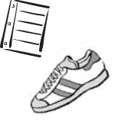

S1–63

Senior 1 Physical Education/Health Education: A Foundation for Implementation


PRESCRIBED LEARNING OUTCOMES

Students will...

S.2.S1.A.3a Assess the level of ability in one or more skill-related

components (e.g., balance, agility, power, reaction time, speed, coordination...) of physical fitness.

Curricular Connections

PE/HE:

S.2.S1.A.3b

SUGGESTIONS FOR INSTRUCTION

- Skill-Related Physical Fitness Components

Students perform one task for each of the six skill-related fitness components: agility, balance, coordination, power, reaction time, and speed. They record and analyze their results on the BLM provided.

Refer to BLM G–2: Skill-Related Physical Fitness Components.

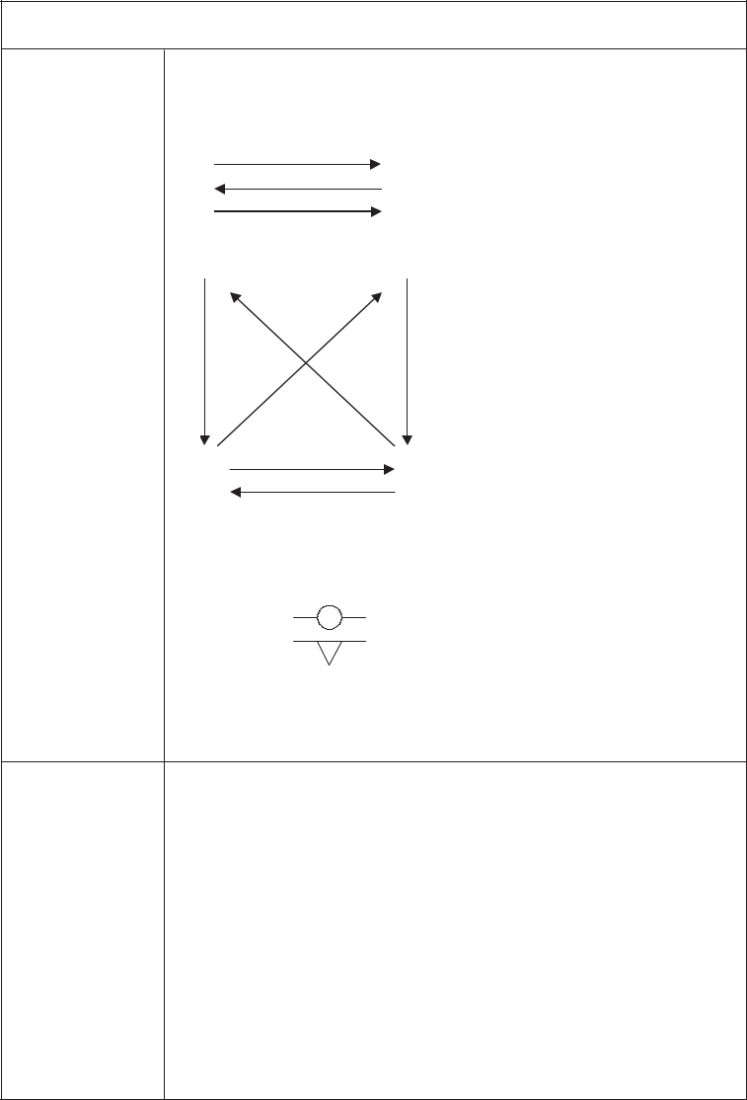

Skill-Related Performance Tasks

Skill-Related |  |  | Tasks
Components
Agility | • | Agility Run
 | • King’s Crown (use basketball key)
 |  |  |  |  | 1 | side shuffle
 | 3 | 2 | 4 | 5 | 2 | run diagonally to corner
 |  |  |  |  | 3 | run backwards to corner
 |  |  |  |  | 4 | run diagonally to corner
 |  |  |  |  | 5 | run backwards to corner
 |  |  | 1 |  | 6 | side shuffle
 |  |  | 6
Balance (Time) | • | Stork Stand (L-R)
 | • | Balance Board with
 |  | —Ball
 |  | —Ridge
Coordination | • | Juggling (use beanbags or foam balls)
- Kick-Sack

- Sepak Takraw

Power | • Running Long Jump
Reaction Time | • Metre Stick Drop and Catch (work in pairs)
 | — Partner A holds stick at one end, with the lowest end
 | of the measure pointing down.
 | — Partner B holds hand at 0 cm.
 | — Partner A drops stick.
 | — Partner B grabs stick.
 | — Measure where stick was grabbed.
Speed | • Run/Sprint a Chosen Distance (50 m, 100 m)

S1–64

Senior 1: Fitness Management–Skills

TEACHER NOTES


SUGGESTIONS FOR ASSESSMENT


Glossary

- agility

- balance

- coordination

- power

- reaction time

- speed

Tips

- Other reliable fitness tests may be substituted for the ones identified.
- Refer to Guidelines for Fitness Assessment in Manitoba Schools (Manitoba Education, Citizenship and Youth) for selected tests that provide valid and reliable measures of fitness, and for specific task instruction.

- Avoid using fitness tests for grading purposes or for student competition. Self-assessment is encouraged, based on individual improvement.

- To allow for individualized testing, set up stations through which students can rotate, recording their own scores. Provide alternative tasks at the stations for students who may not feel comfortable participating in a specific fitness-testing activity.

Resources

Publication

- Manitoba Education, Citizenship and Youth. Guidelines for Fitness Assessment in Manitoba Schools: A Resource for Physical Education/Health Education.

Winnipeg, MB: Manitoba Education, Citizenship and Youth, 2004.

- Journal/Reflection: Skill-Related Physical Fitness Components
Self-Assessment: Inventory

Students regularly record and assess their results for all skill-related components of physical fitness, using the BLM provided.



Refer to BLM G–2: Skill-Related Physical Fitness Components.



TEACHER NOTES (continued)

Blackline Master

• BLM G–2: Skill-Related Physical Fitness

Components

S1–65

Senior 1 Physical Education/Health Education: A Foundation for Implementation


PRESCRIBED LEARNING OUTCOMES

Students will...

S.2.S1.A.3b Analyze own fitness test results (e.g., using information technology...) to establish personal fitness goals.

Curricular Connections

PE/HE:

S.2.S1.A.3a

SUGGESTIONS FOR INSTRUCTION

- How Fit Am I?

Students complete tasks related to the major physical fitness components.
Suggested Task Options:

  - cardiovascular endurance

— 1600-metre (1 mile) run

— 1600-metre (1 mile) walk

— Léger’s 20-metre shuttle run (beep-test)

  - muscular strength and endurance

— push-up

— pull-up

— modified pull-up

— flexed arm-hang

— abdominal curl-up

  - flexibility

— modified sit and reach

— shoulder stretch

  - body composition (optional)

— two-site skinfold

— four-site skinfold

— body mass index (BMI)

Students record and analyze their test results for three assessment periods, using the BLM provided. There should be at least six weeks between each of the three assessment periods.


Refer to BLM G–3: Major Physical Fitness Components.

S1–66

 |  |  |  | Senior 1: Fitness Management–Skills
 | TEACHER NOTES |  |  | SUGGESTIONS FOR ASSESSMENT
 |  |  |  |  Journal/Reflection: How Fit Am I?
Glossary
• | body composition |  |  | Self-Assessment: Inventory
• |  |  |  | After students have completed the third assessment period, they
• | cardiovascular endurance
• | flexibility |  |  | answer the following question in their journals:
• |  |  |  | • Based on your analysis of your fitness-test results, what are
• | muscular endurance
• |  |  |  | your personal fitness goals for the duration of your high
• | muscular strength
• |  |  |  | school years and into adulthood?


Tips

- It is difficult to separate testing for muscular strength from testing for muscular endurance. Usually they are assessed together.

- For the purpose of assessing muscular strength and muscular endurance, use one task for the upper body (e.g., flexed arm-hang) and a different task for the abdominal muscle group (e.g., curl-up).

- Do not use fitness tests for grading purposes or for competition among students. Encourage student self-assessment based on change (i.e., improvement).

- Refer to Guidelines for Fitness Assessment in Manitoba Schools

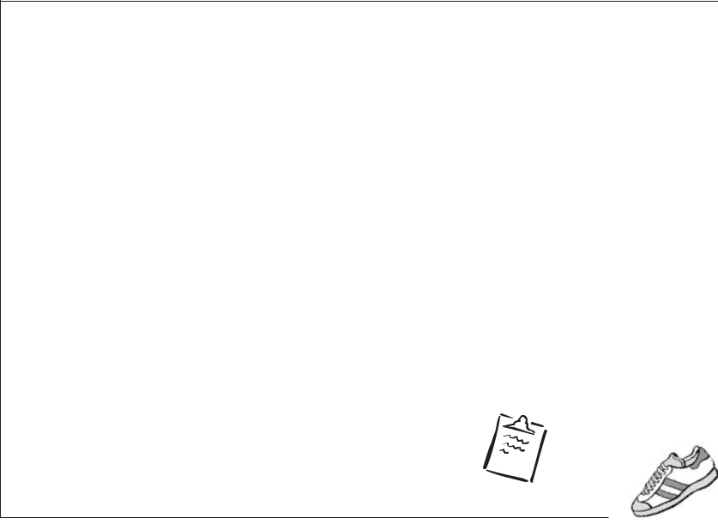
(Manitoba Education, Citizenship | TEACHER NOTES (continued)
and Youth) for selected tests that
and Youth) for selected tests that | Resources
provide valid and reliable | Resources
provide valid and reliable | Publications
measures of fitness and for | Publications
specific task instruction. | • Kirkpatrick, Beth, and Burton H. Birnbaum. Lessons from
• To allow for individualized | the Heart: Individualizing Physical Education with Heart
testing, set up stations through | Rate Monitors. Windsor, ON: Human Kinetics, 1997.
which students can rotate, | • Manitoba Education, Citizenship and Youth. Guidelines
recording their own scores. | for Fitness Assessment in Manitoba Schools: A Resource
Provide alternative tasks at the | for Physical Education/Health Education. Winnipeg, MB:
stations for students who may not | Manitoba Education, Citizenship and Youth, 2004.
feel comfortable participating in a | Blackline Master
specific fitness-testing activity. | Blackline Master
 | • BLM G–3 Major Physical Fitness
 | Components.

S1–67

Senior 1 Physical Education/Health Education: A Foundation for Implementation
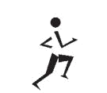
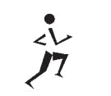

Fitness Management Outcomes: Senior 1

Knowledge Skills


K.2.S1.A.1 Identify the skill-related fitness components (e.g., balance, agility, power, reaction time, speed, coordination...) and relate their importance to sport/physical activity performance (e.g., reaction time in goalkeeping...).

K.2.S1.B.1 Differentiate between the benefits of active living and physical fitness development, based on a health and fitness continuum (e.g., mild activity for health benefits, moderate to vigorous activity for fitness benefits...).

K.2.S1.C.1a Explain the structure of skeletal muscle (i.e., belly, bundle, fibre, myofibril) as it relates to muscular development.

K.2.S1.C.1b Explain the structure of fibre types (i.e., slow-twitch, fast-twitch) as they relate to muscular development.

K.2.S1.C.1c Identify types of strength exercises (i.e., isometric, dynamic) and stretching exercises (i.e., static, ballistic, passive) for personal fitness development (i.e., strength, endurance, range of motion).

K.2.S1.C.2 Describe the principles of training and conditioning for physical activities (i.e., progressive overload, specificity, reversibility, regularity, individual variability, starting point).

K.2.S1.C.3 Design and implement effective warm-up and cool-down routines for specific team-related physical activities (e.g., volleyball, soccer, rugby...).

K.2.S1.C.4 Identify the factors related to health and fitness development (e.g., health benefit, physical attributes, interpersonal interaction, influence of family, availability of facilities/equipment, competition, cooperation, personal success, time management...) that affect choices of physical activities for self and others.

S.2.S1.A.1a Participate in physical activities at a level that contributes to the goals of an individualized fitness plan.

S.2.S1.A.1b Participate in planned and self-directed activities that maintain heart-rate levels in various zones (e.g., general health, basic fitness, healthy heart...).

S.2.S1.A.2 Demonstrate use of heart-rate monitoring (e.g., pulse points, heart monitors, software programs...) to compare exertion level in a variety of activities.

S.2.S1.A.3a Assess the level of ability in one or more skill-related components (e.g., balance, agility, power, reaction time, speed, coordination...) of physical fitness.

S.2.S1.A.3b Analyze own fitness test results (e.g., using information technology...) to establish personal fitness goals.

Attitude Indicators


2.1 Show an interest in and responsibility for personal fitness.

2.2 Appreciate the role and contribution of regular participation in physical activity for health and fitness.

2.3 Show respect and acceptance for physical and performance limitations of self and others.

S1–68

