

POWER FOR LIFE FITNESS

MONTHLY FITNESS PLANNER

June

J u n e

2021

S M T W T F S

notes

My Monthly Goals


1.

2.

3.

4.

5.

I'm grateful for

Your Body
Loves You .

Love it Back .


POWER FOR

LIFE FITNESS

JUNE FITNESS SCHEDULE

 | MONDAY |  |  | TUESDAY
 | 6PM EST, 4PM MT |  | 6:30PM EST, 4:30PM MT
45 Minutes: Bootcamp by |  |  | 45 Minutes: Zumba by Kristyn
 | Monica
 | 7PM EST, 5PM MT
60 Minutes: Vinyasa Flow by
 | Melissa L

THURSDAY

6PM EST, 4PM MT

45 Minute: Insanity by Jill

 | FRIDAY |  |  | SATURDAY
 | 8:30AM EST, 6:30AM MT |  |  | 10AM EST, 8AM MT
45 Minute: Slow Flow by Amy |  |  | 60 Minutes: Power Yoga by Erin


MONTHLY

WORKOUT PLAN

EXERCISE PLAN FOR JUNE WORKOUT SCHEDULE

MEAL PLANNER
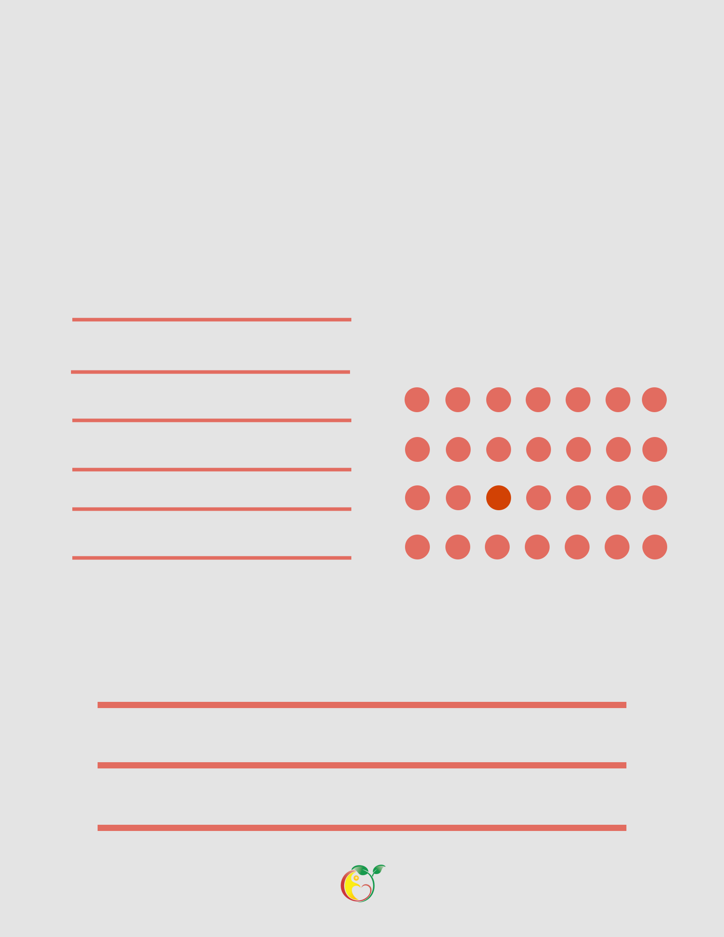
MONTHLY FITNESS CHECKLIST

MONTHLY WINS
DID YOU WORKOUT?

CHECK IT OFF BELOW

S M T W TH F S

IMPORTANT DATES AND REMINDERS:

