

CIF GUIDANCE NOTE

HOW TO HOST ENGAGING ONLINE EVENTS
www.climateinvestmentfunds.org | 2

Acknowledgements:

This guidance note was authored by Daniel Waas for the Climate Investment Funds (CIF) and European Bank for Reconstruction and Development (EBRD). This document was funded by the Climate Investment Funds and developed in collaboration with the following colleagues:

Climate Investment Funds: Hanna Schweitzer, Neha Sharma, and Joseph Dickman.

European Bank for Reconstruction and Development: Franka Klingel and Eliana Gregorio.

The guidance note greatly benefited from the valuable insights provided by the head of the CIF, Mafalda Duarte, and interviews conducted with the following colleagues (in alphabetical order of last name): Sarah Abramowitz, Amal Ali, Ines Angulo, Diksha Bijlani, Neil Bird, Ezgi Canpolat, Andrea Carega, Nacibe Chemor, Amel El Abed, Nicoletta Forlano, John Garrison, Matthew Harris, Anne Kuriakose, Tim Larson, Youqiao Lu, Renata Lukasiewicz, Chibulu Luo, Daniel Morris, Jean Mukumwa, Regina Nesiama, Jimmy Pannett, Eirini Pitta, Sandra Romboli, Loreta Rufo, Madushini Selvakumar, Regan Smurthwaite, Dan Storey, Shelby Thomas, Rob van den Berg, and Qi Zhu.

Disclaimer:

© CIF 2021

www.climateinvestmentfunds.org

This publication was commissioned by the Climate Investment Funds (CIF), however, the views expressed do not necessarily represent those of the CIF or the World Bank.

While reasonable efforts have been made to ensure that the contents of this publication are factually correct, the CIF and the World Bank do not take responsibility for the accuracy or completeness of its contents and shall not be liable for loss or damage that may be occasioned directly or indirectly through the use of, or reliance on, the contents of this publication.

Photo credits: All photos by CIF, unless otherwise noted.
www.climateinvestmentfunds.org | 3

TABLE OF CONTENTS

Introduction |  | 5
1. Define your event |  | 6
1.1 Determine the goal of your event |  | 6
1.2 Identify your audience |  | 9
1.3 Define the event theme |  | 11
1.4 Decide on the optimal event format |  | 13
1.5 Choose the right platform and interaction tools |  | 17
2. Plan your event |  | 21
2.1 | Secure interesting speakers | 21
2.2 | Set the date and time | 24
2.3 | Craft a compelling title and description | 26
2.4 | Set up a well-structured registration page | 27
3. Prepare your event |  | 29
3.1 | A framework for structuring any event | 29
3.2 | Avoid the 7 deadly sins of poor presentations | 29
3.3 | Planning for interaction | 31
3.4 | Create the presentation content | 34
3.5 | Prepare your speakers | 39
3.6 | Have a backup plan | 40
4. Publicize your event |  | 41
4.1 Write a concise email invite |  | 41
4.2 Set up the email sequence |  | 42
4.3 Ask your partners to spread the word |  | 43
4.4 Consider your audience when selecting the best way to reach them |  | 44
5. Host your event |  | 45
5.1 | Prepare in the green room | 45
5.2 | Welcome participants and set the tone | 46
5.3 | Housekeeping | 46
5.4 | Tell them why they should listen | 47

www.climateinvestmentfunds.org | 4

5.5 (Briefly!) introduce the speakers | 47
5.6 Actively moderate for engagement | 47
5.7 Propose actions and next steps | 48
6. Follow-up with your audience | 49
6.1 Make the recording available | 49
6.2 Follow-up with your audience | 49
6.3 Pull and analyze the event report | 50
7. Frequently asked questions | 52
Increasing engagement | 52
Creating content | 53
Facilitation | 55
Event planning | 56
Tools and technology | 57
Annex 1: A simple worksheet to define your goals and audience | 58
Annex 2: A guide for virtual speakers | 59
Annex 3: Example of Run-of-Show document | 60

www.climateinvestmentfunds.org | 5

Introduction
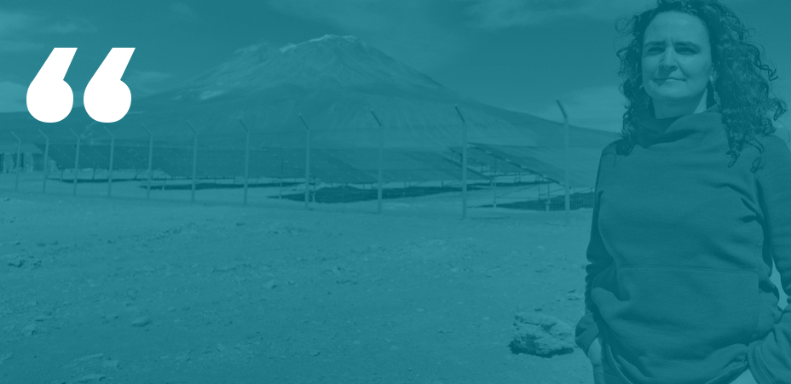

“My aspiration is that CIF events get people hopeful and inspired about climate action.”

Mafalda Duarte in response to the question of what she hopes CIF’s events will achieve.

COVID-19 has rapidly and profoundly changed our lives and ways of doing business, including the events landscape. As a result, this guidance note was prepared for the Climate Investment Funds (CIF) and its partner Multilateral Development Banks (MDBs), in collaboration with the European Bank for Reconstruction and Development (EBRD). Given the new reality of more frequent virtual engagements and events, the guidance note is relevant for any organization delivering online events.

This guidance note aims to provide practical guidance for organizations to create the type of engaging virtual events that inspire audiences to take action. It focuses on practical advice that can be implemented right away to increase audience engagement, the impact of events, and ensure active participation from attendees.

The structure of the guidance note mirrors the event planning process so it can be used as a checklist to complete each step. It is comprised of six main sections and an extensive FAQ that is based on real questions by event organizers from the CIF and its partner organizations.
www.climateinvestmentfunds.org | 6


01Define your event

To maximize the impact of your event, you first need a clear understanding of your target audience and the goal for your event. Armed with that understanding, you’ll find it much easier to select the right event format.

1.1 Determine the goal of your event

Table 1.1a – Potential event goals

Raise awareness and |  |  |  | Disseminate research |  |  |  |  | Capture know-how from |  |  |  | Foster idea exchange
buy-in for your
 |  |  |  | insights |  |  |  |  | guest speakers |  |  |  | between participants
organization
 | Drive participants to take |  |  |  |  |  | Build relationships |  |  |  | Initiate investment
 |  | specific action |  |  |  |  | between participants |  |  |  | opportunities

Rank your goals from most to least important. You now have a better sense of what you are trying to accomplish. Below are some considerations based on the prioritized goals.
www.climateinvestmentfunds.org | 7

Table 1.1b – Considerations for each goal

Prioritized goal | Impact on event format
Raise awareness and | To raise awareness, you will need to maximize the number of people that
buy-in for your | register for the event. Focus on publicizing the event through your available
organization | communication channels and by collaborating with your partners.
 | Take your time defining an attractive topic and creating a strong speaker line-up
 | of recognized experts. Ensure the title and description are compelling and have a
 | strong promise of being actionable.
Disseminate research | To disseminate research insights, your primary concern is to ensure that the
insights | audience understands the significance of the research and ways to apply the
 | findings in their day-to-day work.
 | Take extra care to understand the composition of your audience, their
 | knowledge level, and what they stand to gain from the new insights.
 | Prepare your speakers to answer three critical questions:
 | ● Why should the audience care?
 | ● What are the top 3-5 takeaways?
 | ● What action can/should the audience take next?
Capture know-how | To best capture the guest speaker’s unique insights, provide participants the
from guest speakers | speakers’ presentation ahead of time (as a “pre-read”). This gives participants the
 | opportunity to look through the content in advance, providing ample time to
 | discuss underlying insights during the live event.
 | To optimize time with the guest speaker during the live event, encourage and
 | collect questions before the live event. This can be done by simply adding an
 | open text field to your registration form asking “What questions would you like
 | our presenter to answer during the session?”.
 | Request that your speaker prepare a slide that summarizes the key takeaways in
 | a way that is tailored to your expected audience. That is especially important if
 | the speaker is from an academic background. Consider sharing the key takeaways
 | in a one-pager after the event is over.
 | Focus especially on giving the audience a set of recommended actions that help
 | them turn the insights from the event into action.

www.climateinvestmentfunds.org | 8

Prioritized goal |  |  | Impact on event format
Foster idea exchange | To foster an exchange of ideas in an online format, the key is to keep the groups
between participants | small. If the audience size allows, use Zoom Meetings as your platform and make
 | extensive use of breakout groups. While there are no hard size limits, it is difficult
 | to foster active discussion with groups beyond 25 members. For best results, aim
 | for breakout groups of no more than 5-7 participants.
 | During the breakout sessions, give the participants pre-defined assignments to
 | complete. Then have one designated speaker per breakout group summarize the
 | discussion for the wider group.
 | Use Mural as a whiteboarding tool to capture the results from each breakout
 | group. If feasible, after the breakout discussions, bring the entire group together
 | again for a virtual sticky note voting activity. Each participant can place sticky
 | notes next to the ideas/points that they find most interesting, surprising, etc. –
 | this helps determine which discussion points from the breakouts resonates most
 | with the wider group.
Drive participants to | To get the participants to take action, make sure that it is obvious which action
take specific action | you prescribe. Conclude the main presentation with a clear list of possible actions
 | to take.
 | Ask all participants to commit to taking one or more of those actions. Facilitate an
 | exercise to split the participants into small groups with a shared interest or
 | action. To encourage accountability, assign a group leader to facilitate a check-in
 | meeting at a predetermined future date.
Build relationships | The best way to build relationships between participants is to give them an
between participants | opportunity to connect in small groups. Plan a breakout activity with groups no
 | larger than 3-5 people each.
 | For people unfamiliar with each other, provide a short list of prompts suitable for
 | starting a conversation. These prompts can be as simple as a recommended
 | format for everyone’s introduction (e.g. name, role, and first job they ever
 | worked) or a list of thematically relevant questions. For groups that already know
 | one another, working hand-in-hand on an assignment helps build on that
 | relationship.
 | At the end of the event or during post-event follow-up, designate smaller groups
 | of people and assign them a reflection activity that they need to organize
 | themselves and a timeframe in which to complete it. This will provide another
 | opportunity to connect and build the relationship. .
Initiate investment | It is difficult to fully recreate the serendipitous moments of connection that
opportunities | happen organically at an in-person event. Your best chance is to provide a virtual
 | space where participants with similar interests can gather. Incidentally, Gather is
 | also the name of a tool that is well-suited for a networking activity (both one-on-
 | one and large group discussions).

www.climateinvestmentfunds.org | 9

1.2 Identify your audience

The best path to reaching your goal is dependent on the composition of your audience. Below are some of the typical participant groups for events run by organizations operating in the climate finance landscape.

Table 1.2a – Potential audience groups

Donor country |  | Recipient country |  | Non-governmental |  | Multilateral
members/ |  | members/ |  | organizations (NGOs) |  | Development Banks
representatives |  | representatives |  | and Local Communities |  | (MDBs)
Climate funds |  | Private sector/clients |  | Academia/ |  | Youth
Climate funds |  | Private sector/clients |  | Think tanks |  | Youth

Make a note of the audience groups you are expecting and take a few minutes to answer the following questions for each of them:

- What defines this audience? How would you characterize and describe the participants from this group?

- What can this group contribute to the event? What might other participants learn from them?

- What keeps this group from participating more actively? What inhibits them?

- What does this group hope to learn and gain from the event?


www.climateinvestmentfunds.org | 10

To help you answer the questions above, consider some of these points:

Table 1.2b – Considerations for each audience group

Audience group | Characteristics and considerations
 | Donor country representatives hope to see the impact of their financial
Donor country members/ | contributions and lessons learned from the project or initiative. They also want to
representatives | learn more about ways to increase their impact through promising new investment
 | opportunities and sector-relevant global learning.
 | Recipient country representatives want to build a more sustainable future for their
Recipient country members/ | communities by learning more about successful projects and initiatives in other
Recipient country members/ | countries, as well as funding opportunities. They also want to showcase valuable
representatives
representatives | lessons from implemented projects. Their networks and access to constituents can
 | amplify your reach locally.
 | Official observers from stakeholder groups (e.g. indigenous and local communities,
Non-governmental | women and gender-related groups, etc.) have a good understanding of the situation
organizations (NGOs) and | on the ground and the issues faced by local communities. They can contribute
Local Communities | topical expertise, local-level knowledge, and help foster a new perspective. They are
 | interested in advocating on behalf of their constituents and raising awareness.
 | MDBs want to raise visibility for their initiatives, on both the global and project level.
Multilateral Development | They are looking to influence new developments by sharing their insights and
Multilateral Development | expertise and because sharing knowledge is part of their mandate. Additionally,
Banks (MDBs)
Banks (MDBs) | MDBs want to connect with relevant stakeholders to drive business activities and
 | learn about new developments.
 | Participants that work for climate funds are interested in increasing the global
Climate funds | impact of climate action by providing financial resources and thought leadership.
Climate funds | They want to identify promising investment areas, learn from real world examples of
 | successful projects, and increase the visibility of its organization.
 | To get active participation from the private sector, you will need a clear business
Private sector | case showing the potential gains that sector can expect. If they see an opportunity,
 | they can bring funding and expertise to the table.
 | Participants from academia come with high authority, an expert perspective, and
 | can contribute a rigorous approach and sound research. They are motivated by the
Academia / Think tanks | opportunity to build their own credibility, further advance global learning on a topic,
 | and are looking for real world examples and data to inspire or support their
 | theoretical models.
 | Youth activists want to make their voice heard, raise awareness for issues they have
Youth | identified, and influence policy decisions. They may lack a platform and the access
Youth | that comes with it but if embedded into the conversation, bring high energy and
 | fresh perspectives suited to changing the status quo.

You can find a simple worksheet for defining your goals and audience in Annex 1.

www.climateinvestmentfunds.org | 11

1.3 Define the event theme
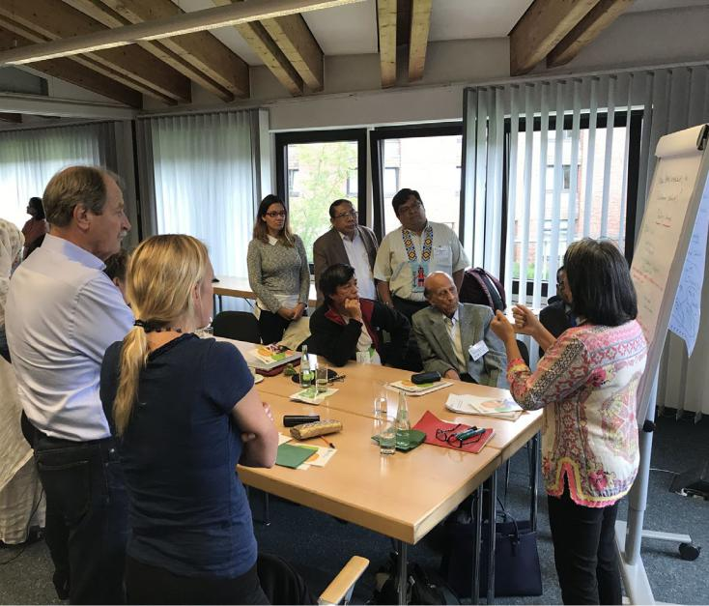

A topic that strongly resonates with the audience will, unsurprisingly, lead to more interest and a larger audience. On the contrary, no amount of promotion will excite an audience to attend an event they consider irrelevant.

Accordingly, defining an event theme that matches the needs of the audience is the single most critical element in hosting a successful online event and deserves extra attention.

In a survey of over 3,000 business professionals, web conferencing provider GoToMeeting found three top motivators that led individuals to consume content. These are:

- Learning new knowledge or skills for work

- Staying up-to-date with prevailing and emerging trends

❸ Being exposed to fresh ideas to try

These motivations are relatively universal. Closely aligned to the above motivations, the three top topics the surveyed professionals consider most valuable are (in order of importance):

- Best practices and educational topics

- Work-relevant statistics and research findings

❸ News and trends

You’ll find the perfect event theme at the intersection of your audience’s interests and their motivation for consuming content. The interests determine your topic while the motivators give you different angles to present the content.
www.climateinvestmentfunds.org | 12

Identify common interests and challenges

The topic you will cover will most likely be self-evident based on the initiative to highlight or the dissemination of a specific piece of research. If that is the case, it is still valuable to canvas the audience for what they consider most relevant about the topic and to include those aspects in the event title and description. An informal question to a few potential attendees can already suffice to get directional insights.

If no obvious topic presents itself, it is time to identify interests or challenges that might resonate with your audience. A simple method to do that is to survey your audience. This could be as simple as using your organization’s social media channels to ask “What topics would you like us to cover at our next virtual event?” or including that same question in a post-session survey for an online event you have already scheduled. Alternatively, you can create a more robust survey and send it to your email list.

A shortcut to identify potential topics is to scour the agendas of conferences your audience typically attends for inspiration. This can also be a good way to identify potential speakers.

To determine if a topic resonates, you can first include it in a social media post or blog article to see how much audience engagement it drives.
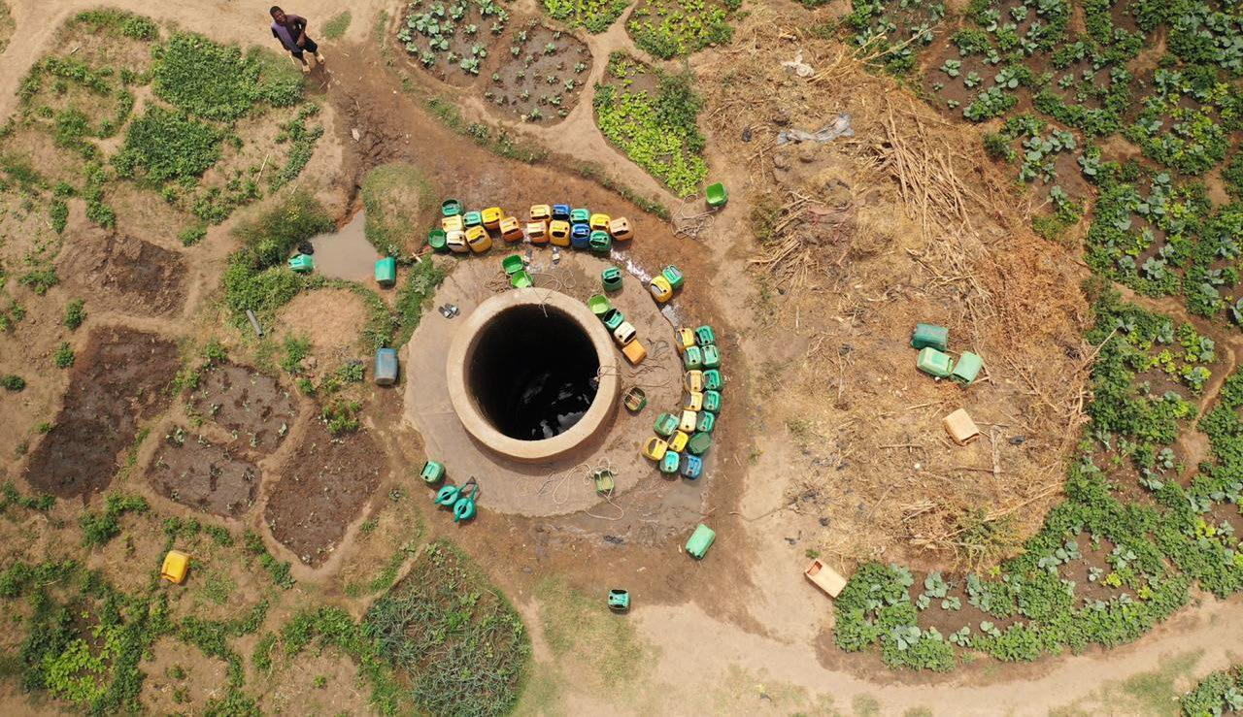

www.climateinvestmentfunds.org | 13

1.4 Decide on the optimal event format

The optimal event format is closely tied to the goal you are pursuing with the event. If your main goal is:

- Increasing awareness and/or sharing information, you’ll want to pursue the largest possible audience.

- Fostering an exchange of ideas and/or building relationships, you’ll want a smaller audience (for a more intimate and interactive experience).

This simple grid gives you a rough idea of the right format for your event:


Large

Audience Size

Virtual Summit

Webinar

Meeting

Workshop

Small

Low Level of Interaction High

No matter the format, it is important to plan ahead and proactively include opportunities for interactivity to drive participant engagement. We’ll cover engagement tools in detail in chapter 3.

The most common online event formats are meetings and webinars, which are the focus of this guidance note. You’ll find a detailed example for how to best structure a webinar and exceed your audience's expectations in chapter 3.

www.climateinvestmentfunds.org | 14

You’ve now already decided on the key goals of your event and the interests of your audience. Now take the time to determine what insights you want the audience to walk away with. You can use the event canvas template on the next page to capture your thoughts, planned activities, and calls-to-action. We’ll fill in these elements later when we get to chapter 5.

Print out the event canvas on the next page and capture your thinking as you work your way through this guidance note.

Event Canvas


Goals to achieve

Audience interests



Actions to take

Insights to impart


Planned activities

www.climateinvestmentfunds.org | 15

Creative event formats
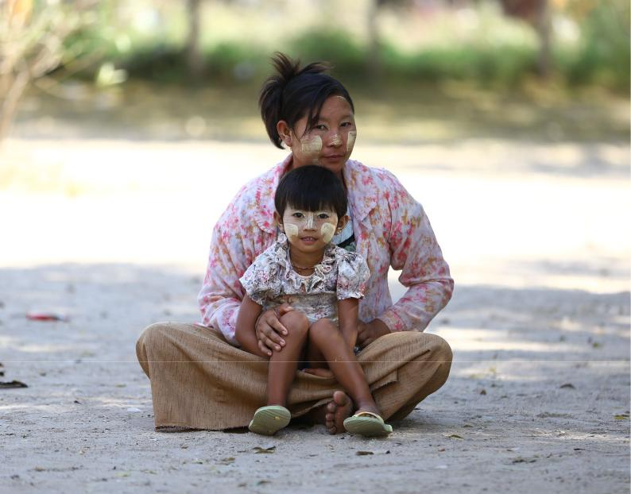

Mixing up the format is a great way to keep an audience engaged over the long term. The traditional webinar often follows the same format: introduction, lecture-style presentation, Q&A. While this guidance note covers many tips to maximize the impact of that format (content presentation), it is still a good idea to get creative from time to time. Below are a few alternative event formats worth considering.

AMA (ask me anything)

A format popularized on the social site Reddit, an AMA gives the audience the opportunity to ask an interesting guest a series of questions. This format works best with well-known influencers but can also be used with topical experts.

The concept translates really well into an online event, by pairing a moderator with a guest who is interesting to your audience. To maximize time during the live event, make sure to collect questions ahead of time. The easiest way is to include a custom field on the registration page where registrants can write-in questions they’d like answered. For the live session, use a tool like Slido to share the questions collected ahead of time as well as let the audience upvote them or add new questions.

Fireside chat

A more creative take on a standard interview, the fireside chat provides a more informal atmosphere. Have your guest join from their home and ask them to set up next to their fireplace. Your moderator does the same. Voilá, you’ve got the online equivalent of a fireside chat. No fireplace handy? Use Zoom’s green screen feature and replace the background with a video of a fireplace.
www.climateinvestmentfunds.org | 16

Online panel

A staple of every in-person and virtual conference you’ve ever been to, the panel discussion brings together a group of experts to share their views on a common topic.

Panels are a quick and easy way to break from your standard format and try something new. While they don’t need as much preparation as a content presentation, their success hinges on the moderator. The moderator needs to ensure everyone on the panel has an equal opportunity to contribute and be quick-witted so as to ask revealing follow-up questions. Don’t pose each question to every panelist. Instead, ask the third or fourth panelist a related question, a concrete example, or simply shift gears and move on to the next question.
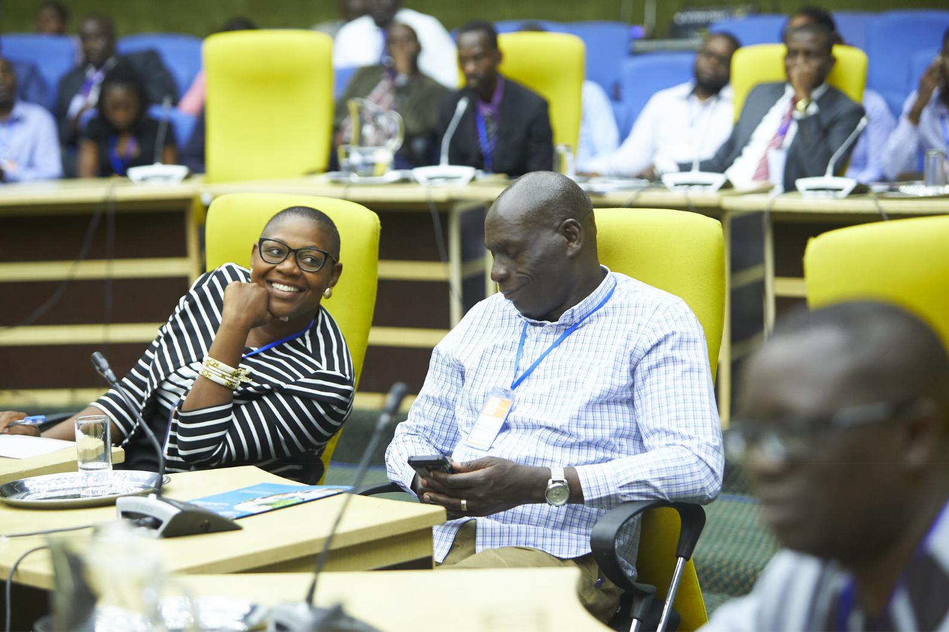

www.climateinvestmentfunds.org | 17

1.5 Choose the right platform and interaction tools

Choosing the right platform can be tricky as the boundaries between different event types and audience sizes are fluid. That said, the two main dimensions are the level of interaction desired for the event and the size of the expected audience. Below is a simple grid to help you select the right platform and engagement tools (when appropriate) for your purpose.
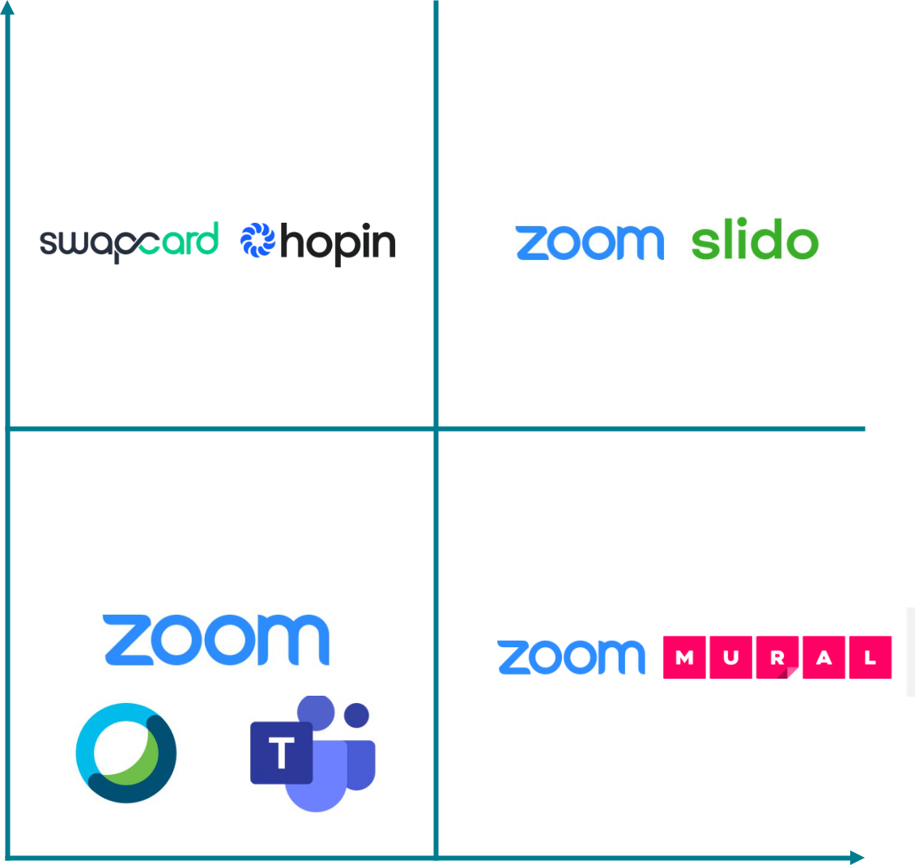

Large

Audience Size

Virtual Summit | Webinar

Meeting | Workshop

Small

Low Level of Interaction High

www.climateinvestmentfunds.org | 18

Selecting the web conferencing platform

- For internal meetings, any of the major web conferencing platforms are viable (e.g. Zoom, Webex, and Microsoft Teams).

- For workshops, Zoom is the best solution due to its robust breakouts functionality. A whiteboarding tool like Mural is a great addition, as it will allow you to mimic the experience of an in-person workshop.

- For webinars, Zoom’s webinar product is a solid solution, especially if you also use Zoom’s meeting product. Many other webinar solutions exist, but it is fair to say that Zoom has the highest familiarity for most users, offers relatively user-friendly language interpreting, and holds up relatively well across geographies.

- For virtual summits (which are beyond the scope of this guidance note), swapcard and hopin are provided as examples rather than endorsements.

Selecting interaction tools

Web conferencing platforms typically come with built-in interaction tools like polls, chat, drawing tools, and Q&A. In many cases, these tools are sufficient to create audience engagement. However, for events that require a deeper level of engagement, below are two categories of add-on technologies that can be helpful.

Advanced polling

The built-in interaction polls typically only allow for simple polls. Tools like Slido, Mentimeter, and AhaSlides have stepped in to provide richer functionality. Examples include word clouds (see example below), ranking polls, quizzes, and improved Q&A. Aside from the additional features, these tools also help you create consistency across your virtual and in-person events. By selecting and standardizing use of an interaction tool across your events, you can simplify both the user experience and event reporting.

www.climateinvestmentfunds.org | 19
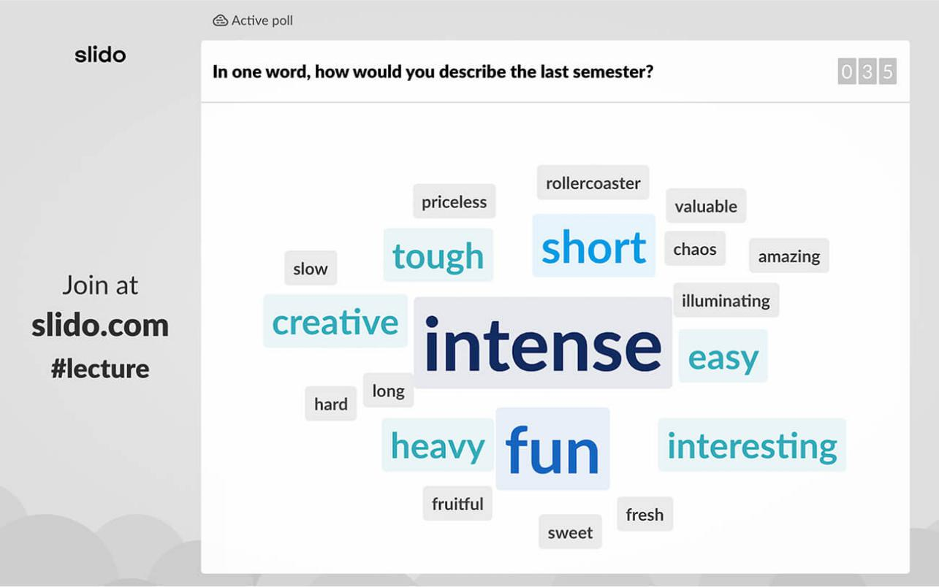

Virtual whiteboards

When your event is designed to create a specific output based on participant collaboration, you should consider adding a virtual whiteboard tool. The drawing tools that come with the major web conferencing platforms do not create persistent documents and are ill-suited to capture workshop results. Instead, use a tool like Mural or Miro. Both tools come with additional complexity and a learning curve but are essential to replicating the experience of an in-person workshop. This blog post from Miro is a good starting point for getting started with remote workshops.

www.climateinvestmentfunds.org | 20

Putting the team together

Online events come with a good deal of complexity and typically require a team that collaborates to create an engaging experience. The structure of the team depends on the complexity of your event and your organization. The list below references some common roles.

- Moderator

The moderator is the most visible part of the event team. The moderator’s role is to lead the audience through the format, set expectations, introduce speakers, moderate interactive aspects of the session, and generally keep the session moving.

- Co-Moderator

The co-moderator works in the background, monitoring and answering Q&A, executing interactive elements like polls or videos, and standing by to take over if the moderator is experiencing technical difficulties.

- Producer

The producer is a specialized role found mainly in complex event setups. The producer manages different video streams for content and speakers as well as queueing intro segments or transitions. The producer is typically part of a dedicated video production service provider hired to execute large-scale events.

- Technical support

The technical support role attends to and resolves any technical issues individual audience members may have, allowing the moderator and co-moderator to focus on the event itself. Technical issues are common in online events, be it through user inexperience, poor local Internet connectivity, or stability issues of the web conferencing platform.

www.climateinvestmentfunds.org | 21

02Plan your event

2.1 Secure interesting speakers

The topic of the event provides you the boundaries within which to find the right speaker. Expertise and the ability to provide a relevant contribution are more important than high energy and ample public speaking experience. Ideally, you’ll find a speaker that is both knowledgeable and engaging but the reality is that you will frequently have to compromise.

The exceptions to this rule are inspirational keynote speakers whose role is to increase interest for the event and inspire the participants. For this type of keynote, a general interest topic you can connect to the event theme is sufficient.

Ways to identify relevant speakers include:

- Relying on your organization’s network or the team member’s personal networks

- Soliciting recommendations from your partner organizations

- Monitoring the events of other similar organizations for engaging speakers

- Working with a professional speaker bureau

- Reviewing the agendas of major conferences attended by the target audience

- Looking for authors of relevant publications on the topic

Consider diversity as one key element in selecting speakers. Aim for a varied speaker line-up and give room to voices that are frequently underrepresented. A more diverse roster of speakers will give your audience a better chance to learn and be inspired.

Take a few minutes to research and review each potential speaker’s area of expertise, publications, and especially past talks. A short video of a past speaking engagement will quickly reveal if a speaker is at all engaging.

A warm introduction through a common connection or through a speaker bureau is the easiest way to start a conversation, however, cold outreach to the speaker is often equally effective. Reach out through email, LinkedIn, or a website contact form and include a short message (see below an example).
www.climateinvestmentfunds.org | 22

/// Speaker outreach template ///

Subject line: Potential speaking engagement

Body copy:

[First name],

The [name of organization, with hyperlink] is planning an event about [event theme].

Given your expertise in [list potential speaker expertise], I was hoping to secure your participation as a speaker.

The event is titled [title] and is planned for [weekday|, [date].

Would [select a date you’re available] next week be a good time for a short initial conversation?

Thank you and kind regards,

[Signature]

//////


Give speakers the necessary background information and clear guidance

You need to set clear expectations with your guest speakers to create an insightful discussion that follows your defined theme consistently. It’s good practice to send speakers a document outlining all the necessary background information (see Annex 2 for a speaker guidance template).
www.climateinvestmentfunds.org | 23

Generally, guest speakers need to know:

- The theme of the overall event

- The topic of their own talk or presentation and how it feeds into the larger event

- The overall run-of-show (introductions, panel discussions, Q&A, etc.) and how their part fits into the larger event

- The dates and times of the event itself, as well as any dry runs or preparation calls

- The size and composition (type of organizations, roles, experience-level) of the expected audience

- Your expectations on providing pre-read materials and/or document handouts

- Guidance on your expectations for their presentation

- Time allotted

  - Use of their own slide template or your organization’s template o General speaker recommendations (see below)

o How to structure their presentation o Any do’s and don’ts

- It is good practice to document all of the above in an email or a speaker agreement that both sides sign. Consult with your legal counsel to ensure the document meets your organization’s needs.

Your guest speakers want to leave a good impression and have a self-interest in providing the audience with a positive experience. They will generally appreciate your help and guidance.

If you have invited multiple presenters to speak, ask your speakers to build elements into their presentation that repeat across the different speakers (see list below for examples). This gives the audience a recognizable structure that helps them understand how each speaker’s content fits in.
www.climateinvestmentfunds.org | 24

Below are some ideas for questions to ask every speaker to answer in their part of the presentation. You can ask the speakers to use one slide each to answer the following questions:

- How is your topic connected to the overall event theme?

- Why must the audience pay attention to/care about this topic?

- What are the 1-5 top takeaways the audience needs to remember?

- What are the 1-5 recommended actions you want the audience to take?

- How can the audience connect with you and learn more?


2.2 Set the date and time

While you will generally want to share a proposed event date with your potential speakers, it is a good idea to stay flexible until you have your speaker line-up confirmed (to accommodate great speakers when possible).

Multiple analyses have shown that the best days to host a virtual event are Tuesday, Wednesday, and Thursday.
www.climateinvestmentfunds.org | 25
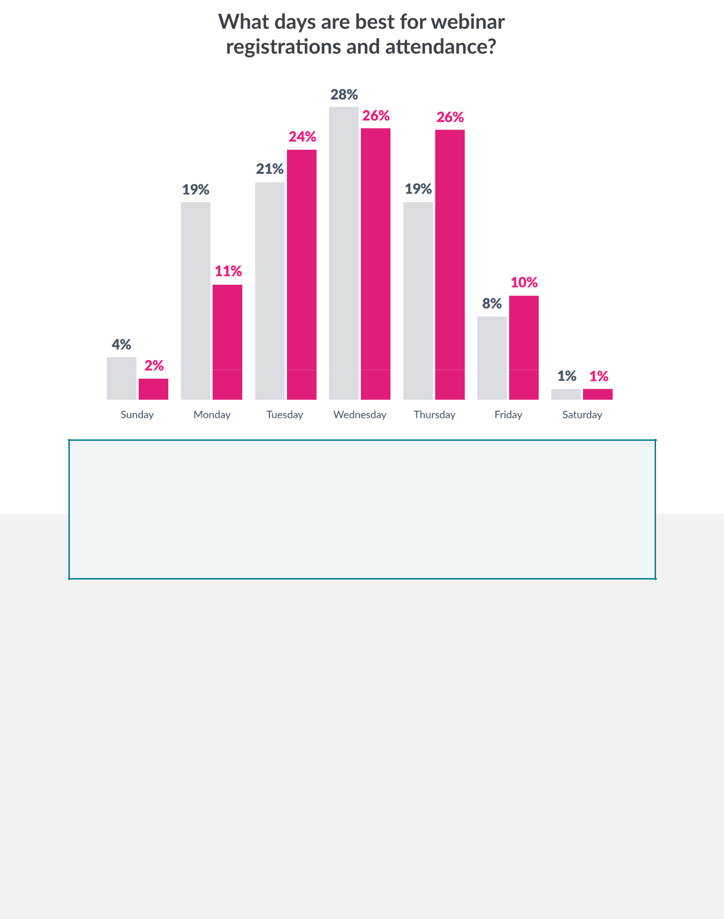

To find the best date for your event, you’ll also want to avoid:

- Dates with competing major events and conferences relevant to your audience

- Dates with public holidays in the countries your audience is from. If possible, avoid the weeks prior to and after major holidays.

To find the best time for your event, here are some considerations:

- If you are mainly targeting a local audience, 10 AM and 11 AM work best.

- If you are targeting the United States, planning for 1 PM, 2 PM, or 3 PM ET works well.

- If your audience is distributed globally, you’ll have to make a compromise.

- 11 AM ET gives you a chance to capture both the US and Europe. This tool can help you determine the best compromise for a global audience: https://everytimezone.com/.

Aside from the start time, it’s important to consider the length of the event. 60 minutes is the most common session length, followed by 30 minutes. Few people have the stamina for sessions 90 minutes and longer. If your event will run for longer than 90 minutes, consider splitting it into multiple individual sessions or at least plan ample time for breaks every 60 minutes.
www.climateinvestmentfunds.org | 26

2.3 Craft a compelling title and description

To increase the number of people attending your virtual events, you need to craft a compelling title. An analysis of online event attendance revealed five simple title formulas that consistently outperform. Use one (or more) of these title formulas to reframe your topic.

Make the content timely

Example: “Climate conferences that will shape 2021”.

Including the current year in the title led to a 12% increase in attendees.

Use the word “New”

Example: “This new technology leads to a 13% decrease in global CO2 emissions”.

Titles using the word “new” resulted in a 16% increase in attendees.

Target it at beginners

Example: “An introduction to climate finance”.

Titles including “101” or “Introduction” resulted in a 31% increase in attendees.

Make it a “How to”

Example “How to stop deforestation in South America”

One of the easiest ways to make your topic more compelling: simply add the word “How to”.

How to’s led to a 36% increase in attendees.

Turn it into a list

Examples: “3 climate initiatives that have led to real change”, “12 proven methods to increase stakeholder engagement in climate projects”, etc.
Leading to an impressive 43% increase in attendees, lists turned out to be the most compelling type of online event title.

Below is an example title that was revised based on the title formulas:

Before | After
● Strengthening Synergies: The Role of Climate Finance | ● How climate finance can help implement the Paris
in implementing the Paris Agreement | agreement
 | ● 5 ways climate finance can help meet the goals of
 | the Paris agreement
 | ● The new approach to climate finance and its role in
 | implementing the Paris agreement

www.climateinvestmentfunds.org | 27

2.4 Set up a well-structured registration page

Aside from a compelling title, you’ll need a clear, well-structured registration page on your organization’s website to turn interested visitors into registered attendees.

Here are the “rules” for what makes a good landing page:

- A simple layout

- A bold title

- A 2-3 sentence description

- 3-5 “What you‘ll learn“ bullets

- Speaker images and bios

- A short registration form

- The event details (e.g. date and time)

- A clear call-to-action

A good example for an effective landing page is the registration page from Cornell University on climate injustice shown on the next page.

www.climateinvestmentfunds.org | 28
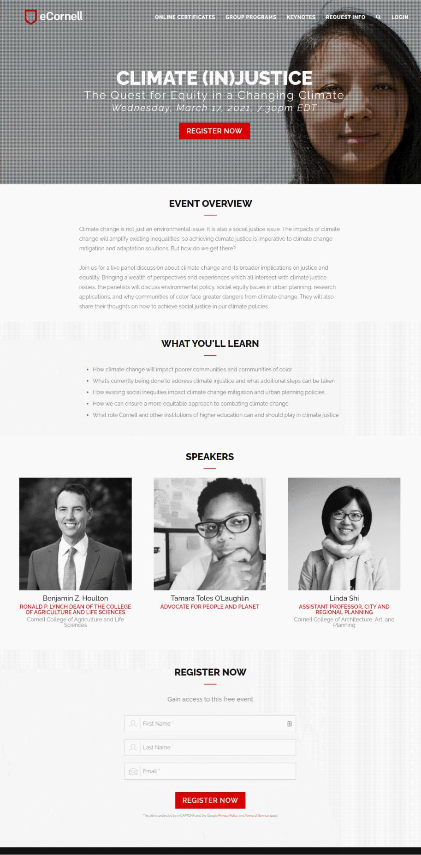
www.climateinvestmentfunds.org | 29

03Prepare your event

3.1 A framework for structuring any event

Preparation is key. To keep your audience’s attention, you need a clear and logical structure that will be easy for them to follow.

A simple framework that works well is “Tell, tell, told”: Tell them what you are going to tell them, tell them why they should listen, tell them, and then tell them what you just told them.

Tell them what you’re going to tell them

Give a short summary at the beginning, of what the event is about and how each presentation relates to the event theme, so the audience knows their expectations will be met.

Tell them why they should listen

Share three to five reasons why paying attention to your content will be worthwhile for the audience. Examples include the speaker’s experience and credentials, the data analysis and research, interactive elements built into the session, or simply the insights that the audience will be able to apply after the event.

Tell them

With expectations clearly set, this is where you convey the main content of your presentation.

Tell them what you told them

Conclude with a quick recap of the key takeaways. This is much more powerful than simply letting the event end. By reminding the audience of the key elements of what was just presented, you increase the chance for learning retention and action.

3.2 Avoid the 7 deadly sins of poor presentations

In reviewing your own content and that of your speakers, you need to avoid the common reasons that leave attendees disappointed:
www.climateinvestmentfunds.org | 30

Too self-serving

Minimize the time you spend talking about the presenters, the organizations you represent, and their feats and accomplishments. Focus instead on the insights that are valuable to the audience. Some presenters will have the urge to only celebrate their success. Instead, ask them to address the challenges they were faced with, what they did to overcome them, and what the audience can learn from their approach.

Too verbose

Online audiences lose interest even quicker than participants of an in-person event. Follow a TED format and give each presenter 18 minutes or less to cover their topic. Let presenters know that you will set a timer and ensure they stay on track. Make sure the moderator relentlessly enforces that timeline.

Too high-level

Help presenters understand that the knowledge-level of the audience will vary greatly and that they will need to adjust their content accordingly. That means simplifying complex topics, avoiding jargon and acronyms, briefly explaining key concepts, and focusing on how to leverage the insights in practice rather than covering the theory.

Not actionable

As discussed in chapter 2, the top motivations to attend an online event are to learn new knowledge and skills, keep up with emerging trends, and get fresh ideas. That means the audience is looking for insights that can be turned into action. If they’re not inspired to change their behavior or start a new practice, they’ll wonder what value they got from the event.

Poor format/design

The content needs to be designed and formatted with the online medium in mind. Parts of the audience might be joining from a mobile device or have poor connectivity. That means you need to avoid busy, overly complex slides. Reduce the information density per slide, provide supplemental information as handouts, and use large font and a clear structure. See chapter 2 for specific tips on how to design an effective presentation for an online event.

Poor delivery

When selecting presenters - all else being equal - favor experienced, engaging speakers. You won’t be able to train external speakers to increase the quality of their delivery but you can take this into account in your selection process. You can also impact the delivery by reviewing the speaker’s slides and helping edit them for clarity. Additionally, schedule a dry-run where you have the speaker present and get feedback on their entire presentation.

www.climateinvestmentfunds.org | 31

Does not deliver on the promise

With the title and description of your event, you are setting expectations with your potential audience about what they will learn. Once you have a good sense of the presenter’s content, you need to go back to that description and ensure the event will deliver on those expectations. Keeping your promise to the audience will build trust and you’ll see your attendance rates improve over time.

3.3 Planning for interaction

The best way to engage an online audience is to encourage active participation. Attendees that have participated in a poll, asked a question through in-session chat, or have been part of a breakout group will be more engaged, more likely to stay for the entire duration of the session, and more likely to attend your future virtual events.

Interaction in an online event doesn’t happen organically - you have to plan for it ahead of time.

The good news is that there are a few simple methods that are proven to increase engagement.

The list below covers the key eight methods roughly in order of difficulty (from easiest to hardest).

Ask a closed question

One of the easiest ways to provide your attendees with an opportunity to participate is by asking a closed question - a question that can be answered with a simple yes, no, or a show of hands. Two examples might be: “A quick show of hands, please. Are you familiar with the term [insert relevant term]?” or “Am I going too fast?”

Combine the questions with instructions on how you want the audience to answer - either by using the “Raise hand” feature in Zoom or Webex, or by typing “yes” or “no” into the chat box.

Apart from getting your audience to “lean in”, these questions also give you insights to tailor the delivery to their needs. For example, if you find many people are unfamiliar with key terms, you’ll know you need to provide more explanation.

www.climateinvestmentfunds.org | 32

Encourage Q&A all throughout

Getting their questions answered is an important motivation for attendees. The typical online event format holds the Q&A until the end. That is a mistake and missed opportunity to create engagement. Instead, let the audience know early on that you will be taking and answering questions throughout the event. Prompt for questions within the first 15 minutes of the event and make it a point to answer the first one you receive verbally right away. Your listeners will take this as a signal that their questions will be taken seriously, resulting in you receiving more questions than you otherwise would.

Most web conferencing tools include Q&A functionality but it is often relatively limited. One recommended alternative is the tool called Slido. With Slido, you can include various interaction tools in your events. For example, you can share an open view of Q&A where the audience can submit new questions or upvote questions posed by other audience members. Other Slido tools include simple polls, word clouds, ranking polls, and quizzes.

Include polls

Polls are a simple but very effective strategy to engage participants. Try to include two or three polls in every session. Answering a poll makes the participants “lean in”. They interact with the event software, feel heard, and get a better sense of the larger group following the event. Suggestions for some good polls to try are:

- What’s your experience level with [TOPIC]? Beginner / Intermediate / Advanced

- What are the biggest challenges you have experienced with [TOPIC]?

- Would you agree that [STATEMENT]?

Strongly disagree / Somewhat disagree / Somewhat agree / Strongly agree

Use hand-raising, the built-in polls, or the in-session chat to collect the answers.

Start with an icebreaker

An icebreaker is a simple activity designed to encourage active participation. It can be as simple as asking an open question and receiving answers in the chat. Ideally, the question is loosely connected to the topic at hand.

A question that encourages free association typically works well. An example might be opening an event about forest management asking “Picture yourself in a large, dense forest. What words come to mind?”

www.climateinvestmentfunds.org | 33

While simple questions work well for large audiences, small group workshops and workshops that have teams collaborating for half a day or longer benefit from more involved icebreakers. This post from MURAL has many fun examples you can try.

Assign a hands-on activity

One of the best options for engaging people in an online event is to prepare a short work assignment related to the discussion that people can complete during the event.

Keep the task simple. It should take no more than two minutes to complete. Then ask your participants to share their results through the chat and actively call out and comment on some of the submissions. This helps turn passive listeners into active participants. That active participation makes your audience feel some level of ownership of the event and generally leads to higher engagement.

Add a quiz or game

For longer sessions, incorporating a quiz or game can help change the pace, give your audience a moment to recharge, and set a positive tone. This type of interaction is not suited for every situation and audience, so use your judgement for when to apply it.

Divide people into breakout groups

One of the best ways to create true engagement is to break up your audience into smaller groups for a more intimate conversation. Many web conferencing tools have a functionality called “Breakouts” that is designed to mimic the experience of breaking into groups during an in-person workshop. The recommended technology option for this type of workshop is Zoom but Webex also has this capability.

This type of activity works best if the participants receive a clear assignment and sufficient instruction on how to self-organize during the breakout. You’ll also need to provide clear expectations of the desired output and a clear timeframe for completing the assignment.

It is helpful if a facilitator moves from group to group during the breakout session, to help check-in with individual groups to have a productive exercise (and put them on the right track when needed).

www.climateinvestmentfunds.org | 34

Create a true workshop with a whiteboard exercise

A hands-on workshop designed to spur collaborative creativity is one of the most difficult in-person experiences to replicate online. To get as close to the physical experience as possible, incorporate a virtual whiteboard tool like Mural. This type of application allows you to bring staples of in-person workshops like sticky notes, dot voting, or collages to a virtual group. Tools like Mural provide a blank canvas that allows you to replicate almost any activity you would otherwise use paper for. Mural itself also provides a large library of pre-built templates for activities ranging from SWOT analysis to flowcharts or team charters. See the screenshot below for an example of a workshop exercise completed in Mural. Watch this video and read these quick tips to learn more.

A good workshop requires considerable time to prepare and that is even more true for an online workshop. Most participants will have little experience with this type of technology, requiring the workshop facilitator to thoughtfully consider and prepare each workshop activity and help participants familiarize themselves with the chosen whiteboard technology ahead of time.
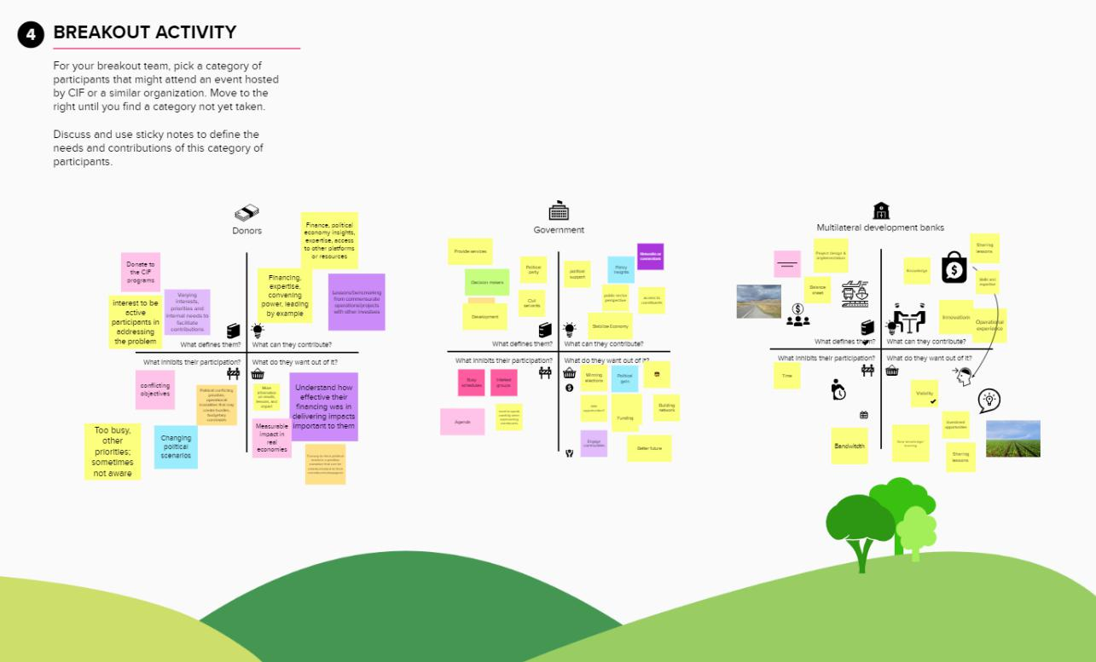

www.climateinvestmentfunds.org | 35

3.4 Create the presentation content

Online events are a visual medium. For a large part of the event, your audience will see a large window with the presentation content and a smaller webcam view of the presenters. Whenever you are having a conversation between speakers, consider turning screen sharing off so that the webcam view is maximized for your audience. It will be a welcome change of pace and can help reengage them. Even still, most of the time the audience’s eyes will be on the presentation content. This section covers the best practices for creating compelling presentations.

Slide design best practices

When it comes to presentation slide decks, less is more. Less text on each slide. Less jargon. Fewer, more impactful images. Below are some ground rules to follow for presentations and to give to external speakers as a recommendation. Please review your organization’s master presentation template to ensure any changes you make are in line with the applicable guidelines.

Limit each slide to just one idea

A simple rule is to limit each slide to just one major idea. That means a slide with ten bullets in small font will turn into ten slides each covering only one idea.

A common mistake is trying to shorten the presentation by limiting the number of slides. That approach typically fails to accomplish its goal and instead increases the amount of information contained in each slide. If you limit each slide to one idea, your presentation will be easier to follow and its higher pace will keep your listeners attentive. Data shows that online audiences stay more engaged when the screen content frequently changes. Each new slide is an opportunity to recapture your audiences’ attention.

This is especially important in online events with international audiences that come with varying levels of prior knowledge.

Note that this guideline is not a dogma and there will be slides that this does not apply to. Examples are slides showing complex charts and diagrams, data tables, and many of the standard elements of your presentation like an agenda, speaker introduction, recap, etc. Just try to make “one idea per slide” the rule rather than the exception.

www.climateinvestmentfunds.org | 36

Use large images for clarity and impact

The proverb is true. Images do say more. High impact images are the backbone of your presentation design and will make your event stand out to the audience. This concept is actually quite simple to implement if you follow the concept of one idea per slide. All you need is a beautiful, relevant image and a simple headline. Encourage your presenters to illustrate all major parts of their presentation with high-resolution images that fill the entire slide.

You will need to find an image that is a close match to what you want to communicate. Sometimes that requires some creative thinking. Write down the concept you’re trying to illustrate, then do some free association to come up with ideas. Here is an example that works in the context of a climate fund:


The unexpected benefits of using images in this way are that they give the presenter a visual cue that jolts their memory and helps keep them on track.

Use large font

If you heed the two tips above, you will find a lot of white space on your slides. This is intentional to allow you to convey the one idea in large font.

Make the limited text you have large enough so that everyone will be able to read it, even if they are attending from a mobile device. This especially helps community organizers in areas with more limited infrastructure to follow along.

www.climateinvestmentfunds.org | 37

Experts recommend a font size of 30 points or larger. In experiments asking online audiences to pick the font size they found most comfortable to read, the majority chose 42 points or larger.

Use animation to synchronize with your audience

As mentioned before, limiting each slide to one idea will not always work. In cases where more text is needed, it is important to recognize that the audience reads faster than the presenter can speak.

Showing too much text at once means the audience will read ahead instead of listening to the presenter. Ask your presenters to use light animation to avoid this and instead synchronize with their listeners. Avoid distracting animations - the new element quickly appearing in place is sufficient.

The following slides are an example of a presentation that takes the tips from this guidance note and puts them into practice along the “tell/tell/told” framework.

A simple title slide serves the purpose of telling your audience what lies ahead - the first part of the tell/tell/told framework.



Notice that the event title starts with the words “How to”, taking into account the insights about compelling titles from chapter 2.
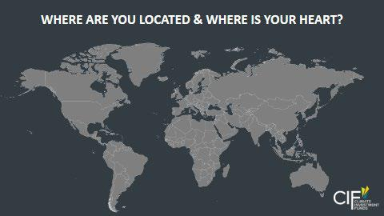

The first activity designed to drive engagement is an icebreaker asking the participants to use the web conferencing software’s annotation tools to share their location.

www.climateinvestmentfunds.org | 38
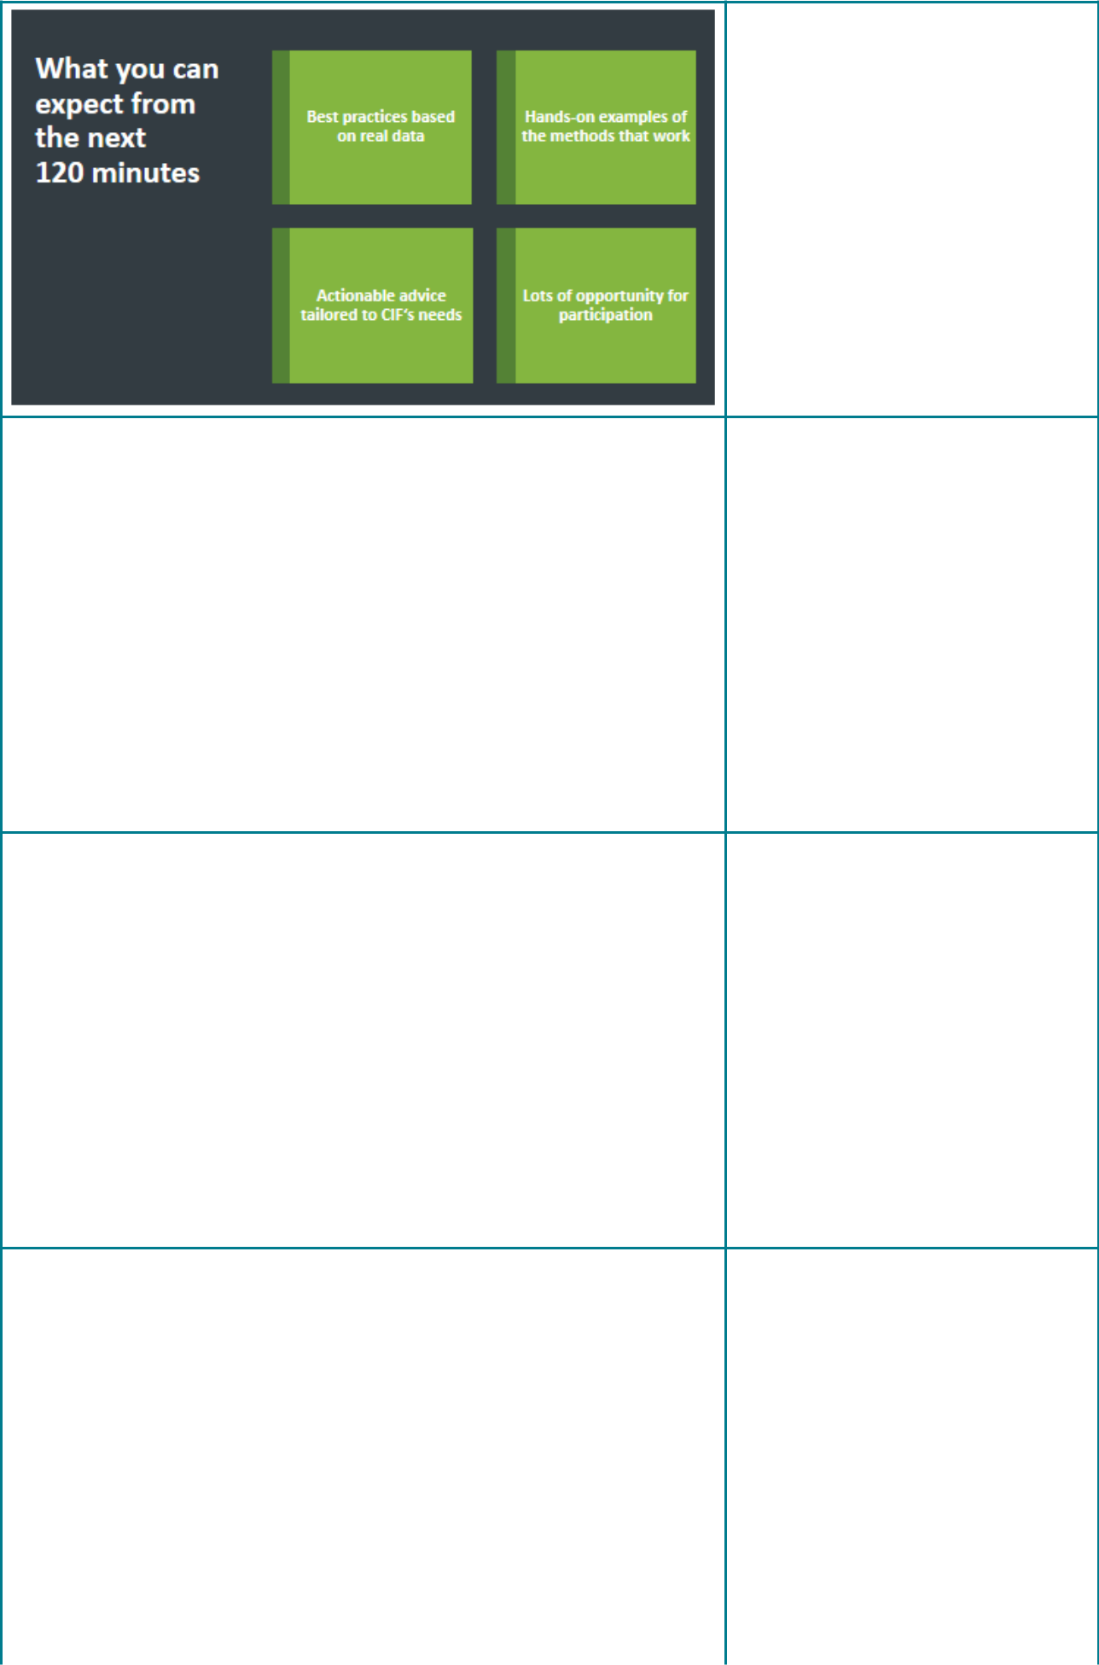

This slide serves as the second part of the tell/tell/told framework and gives the audience a series of reasons why they should pay attention.



This slide is an example of the concept of “one idea per slide”, combining a powerful image with large font.


This slide serves as a reminder for the presenter to ask a closed question designed to engage the audience by eliciting a response.
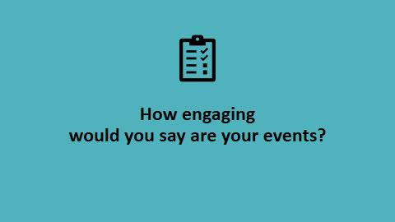

As mentioned in chapter 3, polls are a simple but effective way to increase interactivity. As a best practice, include a reminder slide like this one to prompt the moderator to launch the poll.

www.climateinvestmentfunds.org | 39
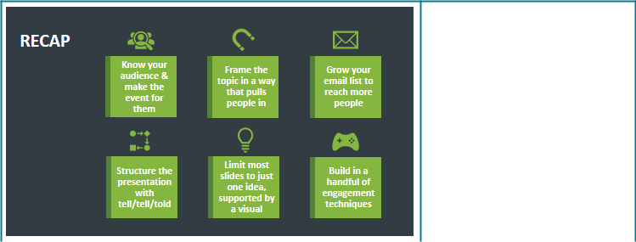

End the presentation with a recap of the key points covered and when relevant, a call-to-action, asking the audience to identify a change they can make based on new insights shared.

3.5 Prepare your speakers

Making a presentation seem effortless is hard work. Steve Jobs, considered one of the best business speakers in recent history, rehearsed his keynotes two days straight before the event and over many weeks leading up to it.

Confidence is the key to delivering a great presentation and the best way to gain confidence is practice. Being confident and at ease translates into smooth delivery and leaves you free to be spontaneous and react to your audience in the moment.

Impart the importance of rehearsing their content on your speakers. If Steve Jobs managed to get that into his undoubtedly super-busy schedule, what is your and your speakers’ excuse for not being able to?

Once content is complete, host a dry run with your speakers. This is a good opportunity for a technology check, making sure speakers are comfortable with the platform you’re using to host the event, and for clarifying and practicing the different steps in the run-of-show document (see the speaker guidance document and run-of-show template in the Annex).

The main purpose, however, is to have speakers present a part or all of their presentation content. You’ll want to go through the motions of the run-of-show and have speakers vocalize the words of the presentation as if you were already live. This can feel awkward, but it will uncover the weak spots in the event blueprint and in your speaker’s delivery. Record the dry run so less experienced presenters can watch themselves and work on the mistakes they make.

www.climateinvestmentfunds.org | 40

If getting all speakers into the same rehearsal is challenging to schedule, you can instead rely on 1:1 sessions with each of them. Position this session as a helpful opportunity to ensure their presentation resonates with the audience.

There is really no limit as to how often you should practice. Simply rely on your own judgment and practice until you feel confident you can deliver an outstanding online event.

3.6 Have a backup plan

No virtual event platform can guarantee 100% reliability and there are a myriad of things that can and occasionally will go wrong. The key is to be prepared and have a backup plan. Here are some tips for virtual preparedness:

- Have a co-organizer/co-moderator in the session if possible. If the organizer unexpectedly loses connection, the co-organizer/co-moderator can keep the event running and keep the attendees abreast of the situation.

- Have a backup laptop ready and logged into the session with the presentation already loaded. The laptop will keep working even if the power goes out and having it logged into the session means you’ll quickly be able to switch if your primary computer crashes.

- Pair the backup laptop with your mobile phone’s internet hotspot. If your Ethernet or wireless Internet connection drops, your laptop will still have connectivity.

Be transparent with the audience when things go wrong and don’t get flustered. Online audiences are well familiar with these common issues and are generally quite forgiving if you acknowledge the mishap and move quickly to resolve it.
www.climateinvestmentfunds.org | 41


04Publicize your event
Email is the best-performing tactic for generating online event registrations. Studies show that email typically drives around 70% of total sign-ups.

If you’ve followed the guidance note step-by-step, you already have a compelling session-title and a well-structured landing page. The next element you need is a short email invite to get the word out.

4.1 Write a concise email invite

KISS is the principle you’ll want to apply to your email invite: Keep it Simple, Stupid. You really don’t need much:

- A compelling subject line

- Use “You” instead of “We / Our”. Focus on what your audience stands to gain.

❸ State the key benefits of what your audience will learn in 3-5 bullets.

❹ Don’t forget the core details: date, time, topic, speaker, and how to register.

❺ Have a strong call-to-action: “Save your seat” or “Sign-up now” will do nicely

It is perfectly acceptable to write a text-only invitation email. Text-based invites perform similar to visual HTML invites. If you host a series of events, you can optimize response rates by switching between the two formats every now and then.

You can also experiment with the sender name. You might have the invite come from your organization’s leader or from the individual hosting the event. If the person is not well known, consider combining the person’s name with that of the organization or send in the name of the organization only.
www.climateinvestmentfunds.org | 42

4.2 Set up the email sequence


The average attendance rate for a virtual event is about 37%. That means even after your best efforts, many of those that signed up won’t be there for the live session. You will never get every registrant to attend but with a strong sequence of reminders, you can get those who are available.

The tried and true recipe for reminders is pretty simple. Send reminders:

- 1 week before

- 1 day before

- 1 hour before

This is easy to implement in most online event platforms that are designed to accommodate large groups.

Note that these reminder settings are not available for the lower-cost product tiers Zoom Meeting and Webex Meet. A reminder sequence is still possible but you will need to rely on integrating an email service like MailChimp with Zoom or Webex.
www.climateinvestmentfunds.org | 43

4.3 Ask your partners to spread the word


As mentioned at the beginning of this chapter, email is the main driver of online event registrations. One of the easiest ways to extend your reach is to find a partner that has access to a relevant audience. You’re looking for a partner that has a self-interest in sharing your event with the contacts in their email list.

For organizations working in climate change, likely partners are:

- Colleagues at the World Bank and other UN institutions

- MDB partners

- Non-profit organizations

- Philanthropic organizations or individuals

- University partners and think tanks

- Climate funds

You can increase your chances of appealing to these partners by inviting a representative from their organization to deliver a talk, join a panel session, or by aligning your topic with an area of shared interest.

If your goal is to raise awareness, it is imperative that you maximize these types of partnership opportunities to amplify your message.
www.climateinvestmentfunds.org | 44

4.4 Consider your audience when selecting the best way to reach them

Not all audiences are equally easy to reach through email. For example, youth are less likely to heavily use email, while some international audiences will be far more likely to use a mobile phone instead of a computer.

Social media is the third major method for publicizing your event. The social media networks that are effective will heavily depend on the location of the intended audience. US and European audiences may favor Facebook, Twitter, and LinkedIn while international audiences may favor their respective local equivalents (like Sina Weibo in China or VKontakte in Russia). Results will also depend heavily on how well-known and popular your organization’s social media accounts are.

The graphic below lists a few more channels you can consider when it comes to promoting your online events. “Owned” refers to your organization, “Paid” refers to advertising, and “Earned” refers to getting additional visibility by other’s sharing the event because they consider it interesting.
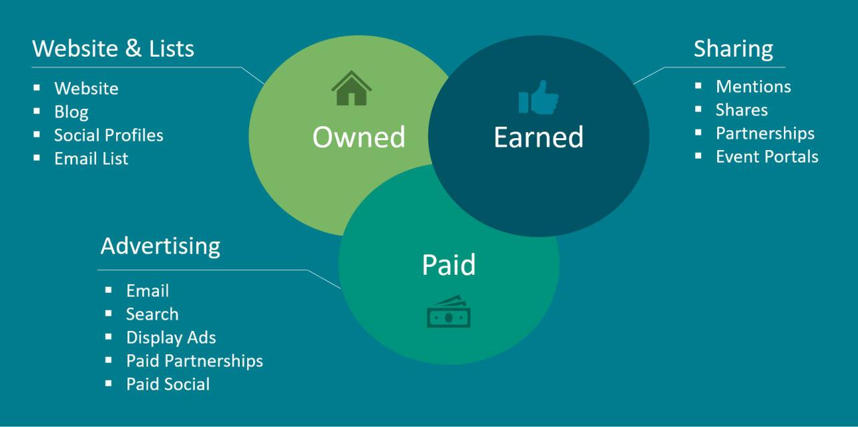

www.climateinvestmentfunds.org | 45


05Host your event

The big moment is here. You’ve done your best to prepare an amazing virtual event experience. Now it’s time to deliver.

5.1 Prepare in the green room

Start the online event 30 minutes early with all support staff and speakers present. Keep these 30 minutes even if you have a VIP speaker. Having ample time for preparation will put speakers and staff at ease and significantly increase your chances for a successful event. The webinar versions of your web conferencing platform will typically have a green room or practice mode. This gives you a safe environment to prepare for the session while the audience is still on hold. You can achieve a similar experience in the Meeting versions of both Zoom and Webex by setting it so that participants first wait in the “lobby”.

Use this time to do a last-minute tech check. Is the audio and video crisp for each speaker? Are lighting and background appropriate? Are the presentations ready to be shared?

This is also a good time to go over the speaker introduction, align on who will be on camera at which time, and practice handovers between speakers. In addition, recap on when the polls will be launched, Q&A breaks, and who is responsible for this.
www.climateinvestmentfunds.org | 46

5.2 Welcome participants and set the tone

Consider letting attendees into the meeting 2-3 minutes before the scheduled start time. This gives you an opportunity to welcome the early birds among your participants and ease the anxiety of your moderator and speakers. It’s the equivalent to mingling with a live audience before you go on stage.

It also sets a relaxed and friendly tone. You go from the green room chat with your co-presenters to a small, intimate audience. Amicable chat ensues. Everyone feels good.

As new attendees join, if possible, have the moderator make it a point to greet people by first name. It helps the audience get a sense of the scale of the event and to feel part of a group.

If you have an icebreaker activity prepared, this is a good time to do it. Alternatively, asking simple questions works well to start engaging the audience and will get them familiar with the chosen web conferencing platform. Examples of talk triggers that work well to start engaging the audience are “Where are you joining from?”, “How’s the weather where you are?”, and “What do you see when you look out your window?”

At the scheduled start time, take a moment for an official welcome and for announcing the title of the webinar. And now you’re off to the races.

5.3 Housekeeping

It’s helpful to set a few expectations with the audience upfront. If the audience size allows for it, make sure to encourage everyone to turn their webcams on. You’ll see higher engagement and you’ll have an easier time building rapport with the participants.

This is also a good opportunity to make people familiar with the event technology platform you are using and to preempt the two most frequent questions: “Will there be a recording?” and “Can I get the slides?”

If a housekeeping slide feels too formal, you can also just verbally mention these aspects and post them to all attendees through the in-session chat.

www.climateinvestmentfunds.org | 47

5.4 Tell them why they should listen

We covered the tell/tell/told framework in chapter 2. Early in the session, take the time to tell the participants why they should pay attention. Use what you captured under goals, insights, and actions in the event canvas to make your case. It’s an opportunity to remind your viewers what they stand to learn and highlight the combined experience of your speaker line-up and the audience’s unique opportunity to get their questions answered.

5.5 (Briefly!) introduce the speakers

Many online events make the mistake of starting with lengthy introductions of the speakers and the organizations they represent. For the audience, this is largely a waste of time. Avoid having the presenters introduce themselves.

Instead, have the moderator introduce all speakers with their name, their organizations, and a maximum of three reasons why their expertise is relevant to the topic at hand and why you are excited about what they will share. The introduction serves the audience, not the speaker.

If you keep the introductions brief and quickly get to the actionable insights, you will see higher audience engagement.

5.6 Actively moderate for engagement

Whenever possible, staff the event with a dedicated moderator as well as at least one supporting role in the background that can help handle the chat or handhold attendees with technical issues. Having a moderator that has no presenting role really helps give structure to an event. The moderator needs to be present at all rehearsals and build a relationship with each speaker beforehand.

An active moderator is the connective tissue of the event, connecting individual presentations to the larger theme, facilitating interaction with the audience and between speakers, and adding a dynamic element to the event.

The moderator also handles questions from the audience and interjects to put them in front of the presenters. It is recommended to weave Q&A into the entire session, instead of holding until the end. Knowing that their questions are being heard and answered leads to higher engagement and a higher volume of questions being asked.

www.climateinvestmentfunds.org | 48

The moderator controls the overall flow of the session, keeps speakers on time, and initiates and moderates the interaction you pre-planned for the event (see chapter 2). The moderator’s ability to create a genuine connection with the speakers will lead to a more natural and more engaging conversation. Think of the moderator as a radio or late-night talk show host. The best moderators are knowledgeable about the topic, genuinely curious, and senior enough to build rapport with the speakers.

The supporting role’s responsibility is to support attendees with technical issues, monitor Q&A to flag interesting questions from the audience for the moderator, and help with the technical aspect of the interaction - e.g. launching and closing polls, broadcasting chat messages, posting handouts, etc.

5.7 Propose actions and next steps

As we saw in chapter 1, presentations that aren’t actionable are one of the most common complaints of event participants.

Continuing with the tell/tell/told framework, end each speaker’s delivery with a recap. Capture the key takeaways your audience just learned on one simple, visual summary slide. This slide serves as a memory aid for your listeners.

The last slide of each presenter section needs to outline the actions the audience can take next. Be prescriptive of the actions you recommend and consider helping the participants take the actions by providing a handout or inviting them to join an accountability group that meets at intervals to discuss progress.


www.climateinvestmentfunds.org | 49

06Follow-up with your audience


6.1 Make the recording available

It is good practice to always record your event. Up to 40% of your audience will typically not attend live. Many of them will instead opt to watch the replay of the event.

Use a video editing software to trim the recording so it starts and ends with the main programming. Share the link to the recording in a follow-up email to your audience and through the event registration page (which has now turned into a replay page).

6.2 Follow-up with your audience

Immediately after the event, write a follow-up email and send it to everyone that registered.

Recap the webinar briefly. Make sure you include:

- the slides as a link or an attachment

- a link to the recording (see above)

- a brief summary of what was discussed

- a repeat of your call-to-action
www.climateinvestmentfunds.org | 50

Both Zoom Webinar and Webex Events allow you to automatically distinguish between attendees and absentees and will send the emails for you. Alternatively, you can send the follow-up email through MailChimp for more control over the content and design of the email.

6.3 Pull and analyze the event report

To know if your online events are achieving your goal of getting people hopeful and inspired about climate action, you will have to analyze event performance. True success ultimately comes from practice, being willing to try new things, and slowly improving over time. To know if you are improving, you will need a set of metrics as your yardstick and to track those metrics over time.

Here is an overview of the relevant key performance indicators (KPIs):

KPI | Explanation | Source
Email List Size* | The number of contacts in your organization’s email list | MailChimp
Open Rate* | The percentage of recipients that open an email | MailChimp
Click-to-Open Rate* | The percentage of openers that click through to the | MailChimp
Click-to-Open Rate* | registration page | MailChimp
Registration Page Visits | The number of visits to the registration page | Web Analytics
Event Registrants | The number of people registered for the event | Zoom or Webex
Event Attendees | The number of people that attended live | Zoom or Webex
Audience Rating | The rating attendees give the event | Zoom or Webex

*The email KPIs are all standard metrics that MailChimp reports will provide.

To assess the impact the event has had on the audience, each online event should include two questions that are asked right at the end of the event. Depending on the tool the event is run on, this can either be accomplished through an in-session poll (Zoom or Webex Meeting) or a post-session survey (Zoom Webinar or Webex Events).

www.climateinvestmentfunds.org | 51

The questions to ask are:

“How would you rate this event?”

[Poor | Fair | Good | Excellent]

“Based on this event, how hopeful and inspired do you feel about climate action?”

[Less hopeful & inspired | The same as I did before | More hopeful & inspired | Much more hopeful & inspired]

If possible, it is worthwhile to include a third question to understand what led to the rating.

“What is the reason for your rating?”

This question will often yield deeper insight into what worked well and what did not.

After the event is over, collect all reporting data and add it to your organization’s event tracking sheet. Review how your session performed in comparison to past events and review the open-ended feedback for ideas on how to improve next time.


www.climateinvestmentfunds.org | 52

07Frequently asked questions

Increasing engagement

Q: How can we ensure the conversation continues beyond the live event?

- A simple way to inspire action after the event is to end the presentation on a set of recommended actions the audience can take. Ask the audience to select one of the potential actions and commit to executing it in a reasonable timeframe.

Q: How can we foster discussion between individual participants?

- The best way to foster discussion is to split the audience into small groups. Use the “Breakouts” functionality of your web conferencing software to create a more intimate and thereby less intimidating environment. It can be helpful to provide discussion prompts, assign a facilitator per group, or to give each group an assignment to work on.

Q: How can we evaluate audience engagement during and after the event?

- The best indicator for engagement is active participation. A lively chat, high percentage participation in polls, and a high volume of questions are all indicators for high engagement. A simple method to gauge engagement across events is to end every event with a consistent survey question asking the participants to rate the session on a set scale. See chapter 6 for details.

Q: How can we make the interaction in breakout groups less awkward?

- A little discomfort is a normal part of an online breakout activity. Consider a breakout exercise in an in-person workshop. If you are unfamiliar with the other participants, you will spend the first few minutes familiarizing yourself with the rest of the group. That same dynamic plays out in an online breakout, albeit with a few inhibitors: you cannot rely on body language and only one person can speak at a time. Add the inherent difficulty of dealing with the web conferencing software and you understand the additional time it takes to get to a productive virtual breakout. Provide clear instructions and consider assigning a facilitator to each breakout to combat these challenges.
www.climateinvestmentfunds.org | 53

Q: What are some great ways to incentivize participation?

- Remember that the audience is on your side and wants the event to be successful. Every participant is contributing their valuable time and wants to maximize their return. That means that the audience is generally happy to participate if given the opportunity. Set the tone early on by including a planned activity to drive engagement within the first 15 minutes. Closed questions and polls are great tools to elicit an early response from the attendees. Another great option is to announce that you will take and answer questions all throughout. As soon as the first question comes in, make a point of answering it verbally right away. Seeing that their questions will be answered will lead to higher engagement and more questions asked.

Q: How can we promote participant engagement before the meeting?

- Three methods to drive audience engagement pre-event are to provide pre-read materials, interview or survey some or all of the participants, or to assign a pre-work exercise. Your success will depend on the audience’s motivation for attending.

Creating content

Q: How can we balance using more casual language with keeping our events professional?

- A good start is to consciously review event title, description, and presentation content for stilted, overly formal language as well as for acronyms and jargon. Find simpler terms that express the same. Shorten sentences. Use “you” instead of “we” messages. E.g. “you will learn” instead of “we are hosting this event to”.

Q: How can we become better in using presentations to tell stories?

- Use storytelling when the source material of your presentation lends itself well to that format. An example might be a local climate project. Stories typically follow one of six patterns as identified by Kurt Vonnegut. A simple pattern to apply to a climate project could work as follows: Vividly describe the original situation and the negative impact it had. Outline the hopes and promises of the project idea. Next, describe the inevitable challenges the project ran into. Lastly, describe how those challenges were overcome and contrast the new, improved situation to the original starting point.

www.climateinvestmentfunds.org | 54

- How can we make sure presenters truly share their insights rather than stick to their standard script?

- Ensuring your event provides actionable insights to participants begins with the selection of the right speaker. If at all possible, view recordings of past talks by the speakers you are considering. Poor speakers are typically easy to spot from video footage. If you have doubts about the speaker, see if someone else from the same organization can present the topic.

Once you have selected your speaker, set up an introductory call and provide a briefing that sets clear expectations. Help the speaker understand the overall event theme, the expected audience, why you chose them, and what you want them to focus on. Don’t be afraid to be prescriptive. See chapter 3 for examples of questions you can ask the presenter to answer in their talk.

Q: How can we account for multicultural contexts and messaging for a global target audience?

- Spend time understanding the audience you believe will attend. Take extra care to accommodate their needs. For multicultural audiences that means scheduling for a time convenient to the audience, having equitable participation from speakers that mimic the audience composition, and considering local factors like Internet access and access to technology.

Q: When should we use slides in our online events and what is the best way to use them?

- Slides have gotten a bit of a bad reputation but they are an effective tool for conveying information. Make sure to use presentation best practices like those outlined in chapter 3. That said, consider alternative event formats like those reviewed in chapter 2 to keep your audience engaged.

Q: Where can we get striking images for presentations?

- Your organizations’ communications or design team will likely have a library of photography that can be used in your organization. Stock photography websites - both free and paid - offer a good and potentially more readily accessible alternative. Good paid options for standard stock photos are iStock, Shutterstock, and Adobe Stock Photo. Pexels and Unsplash are two free sources of high-quality images.

www.climateinvestmentfunds.org | 55

Q: Are there any copyright considerations when using images?

- The photos you use must be licensed for your usage. Stock photo sites outline the license they grant in their terms and conditions. All stock photo sources mentioned in the answer above provide a license for commercial use.

Q: How do we create visual consistency when presenters bring their own slide deck?

- If the situation allows for it, you can require your speakers to use your presentation template. While not always feasible, this allows for complete consistency at the potential cost of frequent content reviews. A lighter touch alternative is to provide “bookends” in the form of a title slide and a summary slide that kick off and end the speaker’s presentation. The speaker’s own content sits between these bookends. Chapter 3 provides a few recommendations of pre-defined slides you can ask your speakers to include.

- Should the slide deck that is shared out with the audience after the event be different from the slide deck that is presented live?

- If you have the time, it is better to create two separate versions of the slide deck. One for the actual live presentation and a more detailed version as a handout or leave behind. If the presenter uses the notes section in PowerPoint, an easy way to accomplish this is to export the slides as handouts: File > Export > Create Handouts. This creates a Word document where slides and notes are shown side-by-side.

Facilitation

- How do we balance the recommendation to use “one idea per slide” with our approach of having the moderator advance the presentation slides for the speaker?

- It is generally preferable to have any presenter with a major speaking part advance their own slides unless the speaker is uncomfortable doing this.

- If we use additional tools like Slido or Mural, how can we make it easier for moderators to manage multiple streams of conversation vying for attention?

- Adding a second software tool to the mix increases the cognitive load for both moderators and participants. If possible, assign ample time for the activity. Consider splitting roles and assigning someone to support the moderator. Meet with a small group ahead of time to practice using the chosen tools.

www.climateinvestmentfunds.org | 56

- How do we encourage speakers, who are oblivious to the time limit and at risk of losing the audience, to wrap up their presentation without appearing impolite?

- Give speakers a clear understanding of how you will handle timekeeping as part of your initial briefing. Include a full dry run / dress rehearsal in your event project plan to get a sense of how long each speaker needs. Explicitly assign the responsibility for keeping the speakers on time to one of the moderators. That moderator then actively interjects and gives the speaker an early sense of the time remaining if it seems as if the speaker might run out of time. If possible, use a natural pause or a slide transition to inform the speaker. That said, don’t shy away from interrupting the speaker if necessary.

- Is there a rule of thumb regarding how many people and which roles you need for running an online session?

- It is generally preferable to have at least two people host the event. One acts as the moderator and has an active speaking role. The other person handles the technical aspects of the session, responds to chat messages, and provides support to participants. Having two hosts also helps if one of the hosts loses their connection. The co-host can keep the session running and step in as a backup moderator. Depending on the size and complexity of your event you may decide to involve more people in moderating roles - especially if you plan to have breakout sessions.

Event planning

Q: Are event series a good idea?

- ThThere is no inherent advantage or disadvantage to event series. They ultimately are a matter of preference.

- What is the recommended maximum number of attendees if we want to have an interactive meeting?

- With the interaction tips laid out in chapter 3, you can make any online event more engaging. For events with hundreds of participants, you should keep the interaction methods simple. Closed questions, polls, and Q&A are all good options for large audiences. For workshop-type events where you need a group of people to collaborate to get to an end result, you should limit the group to up to 25 people. For individual exercises, create breakout rooms with no more than 5 participants each.

www.climateinvestmentfunds.org | 57

Q: Which is the best day and best local time to host a virtual event?

- The best days to host a virtual event are Tuesday, Wednesday, and Thursday. The best times are

10 or 11 AM local time. For international audiences, the optimal time depends on the overlap in time zones. A convenient tool for determining the optimal time for internationally attended events is https://everytimezone.com/.

- We often try to pack too much into our virtual meetings, leaving little time for tools, discussion, and participant engagement. How can we convince our team to use a lighter agenda?

- Create a run-of-show document that lists each activity planned during the meeting with an estimate for how long it will take. Be realistic in your assumptions. Timing recordings of past events can help get a sense of time spent on introductions, transitions, and average time per slide. Consider shortening the introduction and reducing the time allocated per speaker. Have the moderator time each activity and interject as necessary to keep the session moving. As the moderator, don’t shy away from interrupting a speaker if no pause presents itself. Chances are the audience will thank you.

Tools and technology

Q: What tool should we use to host the registration page?

- Web conferencing platforms like Zoom and Webex come with simple registration pages. While functional, the built-in registration pages offer limited branding and customization options. That typically means you can only upload your organization’s logo and adjust the color scheme. For more customization options, consider hosting the registration page on your own website through your content management system or use a dedicated landing page builder like Unbounce.

Q: Is it ok to send event invites from MailChimp?

- You should send all your invites from a dedicated email marketing platform instead of from a personal email account. While there are many others, MailChimp is a perfectly acceptable platform.

www.climateinvestmentfunds.org | 58

Annex 1: A simple worksheet to define your goals and audience

Rank the following goals with a number from 1 (most important) to 8 (least important).

Ranking | Goal
 | Raise awareness and buy-in for your organization
 | Disseminate research insights
 | Capture know-how from guest speakers
 | Foster idea exchange between participants
 | Drive participants to take specific action
 | Build relationships between participants
 | Initiate investment opportunities
 | Other

Check the box for each audience group you believe will make up more than 10% of the audience.

Donor country members/ |  |  | Recipient country |  |  | Non-governmental |  |  | Multilateral Development
representatives |  |  | members/ representatives |  |  | organizations (NGOs) and |  |  | Banks (MDBs)
 |  |  |  |  |  | Local Communities
Climate funds |  |  | Private sector |  |  | Academia/ |  |  | Youth
 |  |  |  |  |  | Think tanks

For each goal and audience pair, capture what you consider the key considerations the event needs to cover. Tables 1.1a and 1.2a provide a series of thought starters for each audience and goal.

Considerations

www.climateinvestmentfunds.org | 59

Annex 2: A guide for virtual speakers

Speaking tips

- Speak directly into the camera using a conversational tone.

- In a virtual event, the audience cannot see your body language. Compensate for this by conveying extra energy and excitement. Smile. Use your voice. Your audience will take your cue and be more engaged.

- Don’t get flustered when making a mistake. Make light of it and keep moving forward.

- Pay attention to your allotted speaking time. Setting a timer can be helpful so you can adjust the speed of your delivery.

- Consider delivering your online speech while standing. It helps your voice project better and can help you keep the energy high.

- Practice, practice, practice. A well-rehearsed speech sounds more natural.

Technology tips

Setup

Choose a quiet room with ample natural light. Ensure your computer is fully charged and connected to a power outlet. Turn notifications off and close any unnecessary applications running in the background. If presenting from home, reduce the bandwidth consumption by other users or applications in the home (e.g. streaming services). Consider uncluttering your desktop if you will be sharing your screen.

Headphones

Using headphones will minimize the chance of an unwanted echo occurring. Use a wired headset instead of a Bluetooth headset if possible. If you have to use a Bluetooth headset, make sure it is fully charged.

Webcam

Use an internal or external webcam with a resolution of 1080p or better. Make sure to keep your camera roughly at eye level. Avoid a camera angle from below. Center yourself relative to the camera and ensure a little headroom. Look directly into the camera when you speak.

Video backdrop

Make sure your background looks clean and uncluttered and that you are comfortable with anything visible to the audience.

Lighting

Avoid having a light source behind you. Instead, position a soft light directly in front of you. This may be as simple as facing a window or pointing a desk lamp at your face. If you have access to a video ring light, even better.

Attire

Avoid busy patterns and stripes, as they may create a distracting visual effect for the audience. Avoid high contrast colors like white and black as well as colors that blend too much with your background. Also avoid jewelry that may create unwanted noise during your presentation.

www.climateinvestmentfunds.org | 60

Annex 3: Example of Run-of-Show document

TITLE Webinar
DATE – TIME (DURATION)

RUN OF SHOWx

Time | Who |  | Slide
 |  | Open WebEx Webinar room | Housekeeping Holding
 |  |  | Slide
 |  | Host to set participant privileges (Menu-
7:40 am |  | Participant) | Host: (person monitoring
7:40 am |  | • >Mute on Entry: Mute everyone on entry | muting, giving presenter
 |  | • >Anyone Can Share: Limit sharing privilege | rights to specific person)
 |  | • >Assign Privileges: Click to set more | Presenter: (person sharing
 |  | participant privileges | screen)
 |  | Welcome attendees + House Keeping
 |  |  | Webinar
 |  | Welcome to "TITLE” Webinar. | Instruction/House Keeping
7:55 am |  | We have a few minutes before we begin. As | Holding Slide
 |  | you wait, please read our webinar | Start recording
 |  | instructions and housekeeping rules.
 |  | Welcome attendees + House Keeping
 |  | Thank you everyone for joining today’s | Housekeeping Holding
 |  | webinar on “TITLE”. | Slide
 |  | Before we begin, I would like to inform
 |  | everyone to make sure their microphone is
 |  | muted. We will not be taking questions
8:00 am |  | through audio, please use Slido to submit
 |  | your questions and we will address them
 |  | during our Q&A.
 |  | We would also appreciate if attendees do not
 |  | turn on video.
 |  | This session is being recorded and will be
 |  | available for viewing on a later date.

www.climateinvestmentfunds.org | 61

Time | Who |  | Slide
 |  | Introduction + Overview
8:02 am |  |  | Session Title Slide
8:02 am |  | Agenda/Overview
 |  | Introduce Speakers
8:05 am |  | Introduce all speakers first. | Speakers Profiles Slide
 |  |  | Presentation Slides
8:10 am |  | Presentation | Presenter: ??
8:20 am |  | Speakers Discussion | NO SLIDES
9:10 am |  | Moderated Audience Q&A | Q&A Holding Slide
9:25 am |  | Take last question | Q&A Holding Slide
 |  | Thank speakers and attendees + Conclude
 |  | Webinar
 |  | Please contact us if you have any questions.
9:30 am |  | Visit our website for more information. | Follow Us on LinkedIn
9:30 am |  | Visit our website for more information. | Slide
 |  | Please follow us on LinkedIn for more
 |  | updates on upcoming webinars and other
 |  | programs!


COVID-19 has rapidly and profoundly changed our

lives and ways of doing business, including the

events landscape. As a result, this guidance note

was prepared for the Climate Investment Funds

(CIF) and its partner Multilateral Development

Banks (MDBs), in collaboration with the European

Bank for Reconstruction and Development (EBRD).

Given the new reality of more frequent virtual

engagements and events, the guidance note is

relevant for any organization delivering online

events.

This guidance note aims to provide practical

guidance for organizations to create the type of

engaging virtual events that inspire audiences to

take action. It focuses on practical advice that can

be implemented to increase audience

engagement, the impact of events, and ensure

active participation from attendees.

The structure mirrors the event planning process

so it can be used as a checklist. It is comprised of

six main sections and an extensive FAQ that is

based on real questions by event organizers from

CIF and its partner organizations.

THE CLIMATE INVESTMENT FUNDS | @CIF_action |  | CIFaction
c/o The World Bank Group
1818 H Street NW, Washington, D.C. 20433 USA | CIFaction |  | CIFaction
Telephone: +1 (202) 458-1801 | CIFaction |  | @CIF_action
Internet: www.climateinvestmentfunds.org | CIFaction |  | @CIF_action

