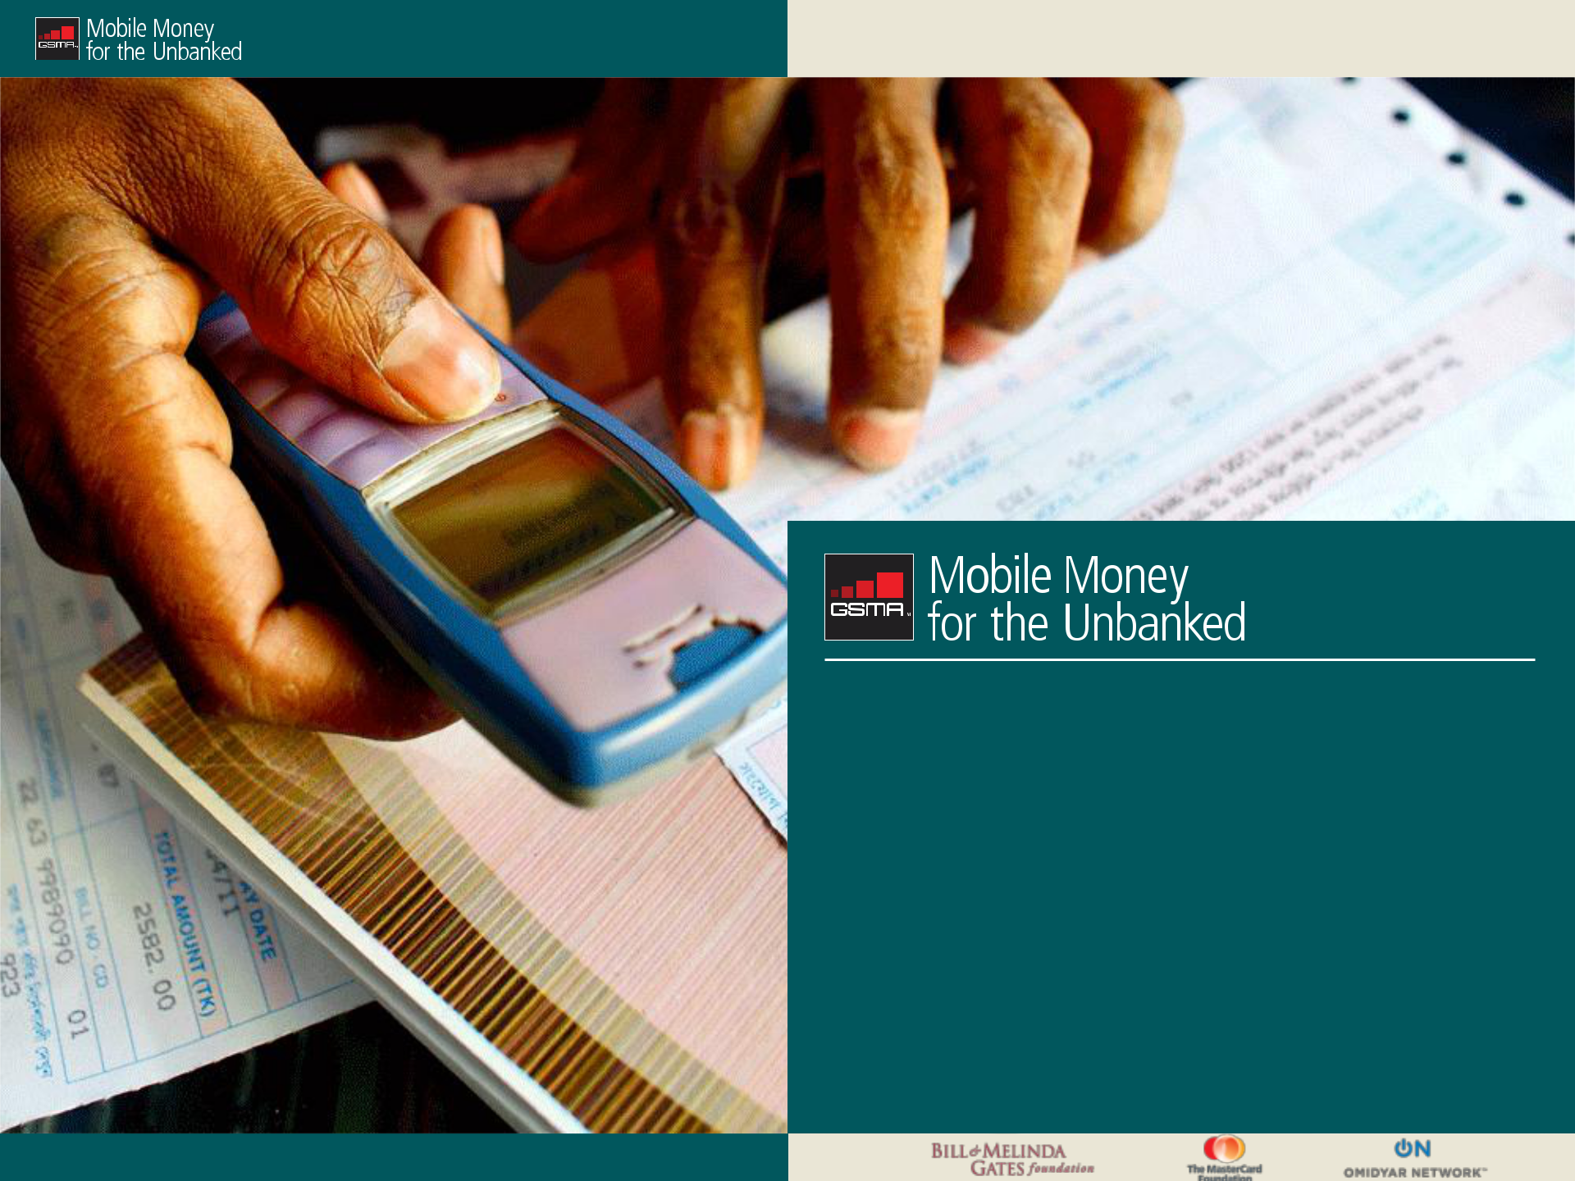

KPIs in Mobile Money:

A Reference Guide

October 2013

Restricted - Confidential Information © GSMA 2013

Introduction

Key Performance Indicators (KPIs) are a powerful tool that MNOs use to foster sustainable commercial growth because KPIs are what links strategic objectives to daily activities. KPIs also create visibility on operational issues and provide managers insight on what needs to be done to drive the business forward.

However, misguided or vague KPIs can lead to inactive agents, inactive customers and a team lacking in accountability and motivation. How do you ensure you have the most effective KPIs for your team?

This presentation aims to address this question through defining a KPI, identifying pitfalls in creating KPIs and illustrating some examples of effective KPIs for mobile money teams. While these examples are not exhaustive, they illustrate the fundamental elements of effective KPIs.

Restricted - Confidential Information © GSMA 2013

Defining a KPI

Defining a Key Performance Indicator

What is it?

A KPI is a type of performance measure used to evaluate the success of a particular activity in facilitating a business to reach its strategic objectives.

3 questions to answer to create effective KPIs:
- What daily actions are necessary for us to reach our objectives?

- Who is responsible for each action?

- What metrics can we use to measure it?

Restricted - Confidential Information © GSMA 2013

 |  |  | Defining a KPI
 | Common pitfalls to avoid when creating KPIs
 | Pitfalls |  | What’s the risk?
 |  | Operational metrics, such as number of subscribers and
 | (1) Using operational metrics as KPIs | transaction volumes or financial metrics provides an
 |  | overview of the business – but no one person is responsible
 |  | and therefore, as KPIs, these lack accountability.


 | Some KPIs can risk unintended consequences for operators.
(2) KPIs that result in unintended | For example, take a sales team with a KPI to recruit x
(2) KPIs that result in unintended | number of agents. Without qualitative recruitment
consequences | number of agents. Without qualitative recruitment
consequences | requirements, an operators may end up with the right number
 | of agents, but the wrong kind of agents.

- Creating too many KPIs or KPIs that are confusing or vague

KPIs need to be clear and actionable. What do I need to do today/this week/this month to reach my objectives? The more KPIs a team or individual is given, the more divided his or her time and focus is. Operators who decide to leverage synergies by using their GSM team need to be especially aware of this risk.

Restricted - Confidential Information © GSMA 2013

Defining a KPI

Components of an effective KPI

All KPIs should have a(n):
- Objective → What is my target?

- Deliverable → What do I need to do to be successful?
- Measurement criteria→ How do I measure success?

….so, what can this look like in mobile money?

Restricted - Confidential Information © GSMA 2013
Defining a KPI

A reference guide for KPIs in mobile money

The following section of the presentation focuses on effective KPIs for:
- Operations team

- Sales & Distribution team

- Marketing team

These examples are meant to illustrate tangible & relevant KPIs for mobile money deployments. Our aim is to provide managers a structure for creating KPIs as well as highlighting specific examples of effective KPIs used in the industry.

Restricted - Confidential Information © GSMA 2013
Examples of KPIs in Mobile Money


KPIs for Operations:

Back Office, Call Centre, Risk Management KPIs

Restricted - Confidential Information © GSMA 2013 | Restricted - Confidential Information © GSMA 2012

Operations KPIs: Back Office, Call Centre, Risk Management

Back Office KPIs

Objective | Deliverable | Measurement Criteria
Validate and activate agent and | • All accounts to be verified and | • % of accounts validate within
customer accounts | activated within x hours. | timeframe versus target
 |  | • Accuracy in account creation (up
 |  | to 100%)
Execute necessary reporting | • Remote Agent monitoring: Monitor & | • 100% of all required reporting is
requirements | report the transaction volume and | completed accurately on a
 | number of transactions via the system | weekly/monthly/quarterly basis.
 | • Dashboard updates: Report monthly
 | status and activity (active customers,
 | active agents, etc.)
Delivery of high quality | • Execution of all escalated queries | • % of queries closed/addressed
customer/channel service | from all 1st line customer or agent | correctly (up to 100%)
 | contact points

Restricted - Confidential Information © GSMA 2013
Operations KPIs: Back Office, Call Centre, Risk Management

Call Centre KPIs

Objective | Deliverable |  | Measurement Criteria
Resolution of client questions | • | Time to answer | • | % of calls answered/ completed
 | • | Call handling time |  | within time frame of x min
 | • | Abandon rate | • % of calls abandoned (0-5%)
 | • | First Call resolution | • % of questions/queries that can be
 |  |  |  | resolved on a first call
Encourage a good customer | • | Phone etiquette | Qualitative metrics including:
experience through positive | • | Adherence to escalation procedures | • Internal spot-checks or external
customer service |  |  |  | agency review
 |  |  | • Satisfaction scoring via follow-up
 |  |  |  | surveys
Knowledge and ability to educate | • | Complete regular training on | • Regular training completed every
on mobile money service |  | refresher courses and any new |  | x (month, quarter, etc.)
 |  | developments or products | • | Successful completion evaluation
 |  |  |  | of service products and service
 |  |  |  | (100%)

Restricted - Confidential Information © GSMA 2013
Operations KPIs: Back Office, Call Centre, Risk Management

Risk Management KPIs (1/2)

Objective | Deliverable | Measurement Criteria
Develop and update risk | • Defined & accessible risk | • Completed and successful annual
management strategy | management strategy, including | audit conducted by
 | identified key risks and controls to | external/objective team.
 | mitigate them. | • % of high and medium risk items
 | • Schedule for review of strategy | which were only identified during
 | versus commercial and risk appetite | external audit versus target
 | objectives.
Maintain reliable and relevant | • Regular reporting of suspicious | • x% of all required reporting is
dashboards to monitor key risks | activities versus thresholds | completed accurately on a
 |  | weekly/monthly/quarterly basis (up
 |  | to 100%)
 |  | • x% of suspicious activities are
 |  | escalated via appropriate
 |  | channels (up to 100%)

Restricted - Confidential Information © GSMA 2013
Operations KPIs: Back Office, Call Centre, Risk Management

Risk Management KPIs (2/2)

Objective | Deliverable | Measurement Criteria
Implement & review controls | • Defined internal processes and | • x% revenue loss due to fraudulent
(preventive & detective) to | procedure to reduce risks including | activity or human error
mitigate key risks | processing errors, internal fraud, | • Number of fraud instances
 | business continuity failures, etc. | identified versus target
 |  | • % of unresolved cases versus
 |  | target
 |  | • Average loss per fraud incident

Restricted - Confidential Information © GSMA 2013

KPIs for Sales & Distribution:

Agent Recruitment, Training & Management

Restricted - Confidential Information © GSMA 2013 | Restricted - Confidential Information © GSMA 2012

Sales & Distribution KPIs: Agent Recruitment, Training and

Management

Agent Recruitment KPIs

Objective | Deliverable |  | Measurement Criteria
Maintain guidelines on agent | • Submission to manager on plans for |  | • Monthly target of x agent recruited
selection |  | prospecting | against guidelines
 | • Schedule for updating guidelines
 |  | depending on portfolio of existing
 |  | agents
Prospect & recruit agents | • Identify and pitch appropriate agents |  | • x target of new agents per (month,
 |  | (verification of outlets before on- | quarter)
 |  | boarding) | • % of agents who are pitched and
 | • | Signed contract | verified to start business
 | • Documentation submitted to the back
 |  | office for validation
Ensure agent launches business | • | Initial investment purchased | • 100% of agents launched within x
 | • Training completed and delivery of |  | days of account validation
 |  | business tools
 | • Notify trade marketing to schedule
 |  | any BTL, where required

Restricted - Confidential Information © GSMA 2013

 |  |  | Sales & Distribution KPIs: Agent Recruitment, Training and
 |  |  | Management
Agent Training KPIs (1/3)
 | Objective | Deliverable |  | Measurement Criteria
 | Ensure mobile money team | • Develop training process for the |  | • Number of agents trained vs.
 | (internal and channel) are | Mobile Money team (agents, staff, |  | target (target is derived from
 | adequately trained and updated | corporate, etc.) |  | number of agents recruited and
 | on new info | • Clear communication to agents and |  | available for training)
 |  | mobile money team on training |  | • Availability of detailed and
 |  | calendar |  | documented training process
 |  |  |  | • Adherence to the developed
 |  |  |  | training process
 |  |  |  | • % of staff trained &
 |  |  |  | evaluated/quarter
 | Identification, set up & monitoring | • Appoint regional trainers for each |  | • Number of operational training
 | of regional | region |  | centres set up vs. target
 | training centres | • Manage regional trainers |  | • Number of regional trainers per
 |  | • Attend x number of regional trainings |  | region vs. target
 |  | in each region per quarter |  | • Number of regional trainings
 |  |  |  | attended vs. target
 |  |  |  | • Quarterly review of regional
 |  |  |  | trainers’ effectiveness

Restricted - Confidential Information © GSMA 2013

 |  |  | Sales & Distribution KPIs: Agent Recruitment, Training and
 |  |  | Management
Agent Training KPIs (2/3)
 | Objective | Deliverable |  | Measurement Criteria
 | Assess quality of agent training | • Visit x number of agents per month to |  | • Accuracy of agent training
 |  | assess quality of service offering |  | curriculum and availability of up-
 |  | using a predetermined template |  | to-date versions
 |  | • Continuous review of agent training |  | • Relevance of agent training
 |  | curriculum to enrich with up-to date |  | material
 |  | info |  | • Number of agents certified vs.
 |  | • Certification of agents |  | target
 | Undertake training needs analysis | • Evaluate current training gaps within |  | • Accuracy of training needs
 |  | the agent network and suggest |  | identified
 |  | improvements |  | • Alignment of training with business
 |  | • Evaluate training gaps within the |  | and technology changes
 |  | mobile money team (internal staff) |  | • Submission of bi-annual training
 |  | and recommend appropriate actions |  | needs analysis report
 |  | • Review training needs based on
 |  | business and technology changes
 |  | • Incorporate feedback from sales team
 |  | and regional trainers

Restricted - Confidential Information © GSMA 2013

Sales & Distribution KPIs: Agent Recruitment, Training and
Management

Agent Training KPIs (3/3)

Objective | Deliverable | Measurement Criteria
Reporting & administration | • Monthly/weekly reports on trainings | • Accuracy of reports (up to 100%)
 | undertaken | • Number of reports sent monthly
 | • Monthly/weekly trade visit reports | • Timeliness of reports
 | • Prepare training plans in advance | • Availability of at least one month
 | • Evaluate/Assess trainees on | training plans
 | completion of training | • Average percentage pass mark
 | • Facilitate training in all the regions | attained by agents

Restricted - Confidential Information © GSMA 2013

 |  |  | Sales & Distribution KPIs: Agent Recruitment, Training and
 |  |  | Management
Agent Management KPIs
 | Objective | Deliverable |  | Measurement Criteria
 | Regular visits and interaction with | • Submission to manager on |  | • | % success rate (weekly/monthly)
 | agents by sales team as per | weekly/monthly visit schedule by |  | • | % of active agents
 | agreed route plans | [date] |  |  | (weekly/monthly)
 |  | • Report on agent challenges, reasons |  | • 100% submission of route plan by
 |  | for inactivity |  |  | set date
 | Onsite monitoring of agents | • Completion of monitor review |  | • Completion of reports (100%)
 |  | including agent visibility, training, |  |  | during monitoring process.
 |  | appropriate documentation available |  | • | Identification & escalation of
 |  | and float monitoring: UV balance & |  |  | under-performing agents (based
 |  | transaction logbook |  |  | float, branding, etc.)
 | Ensure branding & merchandising | • Availability of agent materials in |  | • | % of outlets adhering to
 | standards are maintained | outlets |  |  | merchandising standards
 |  | • Implementation of set merchandising
 |  | standards
 | Consistent internal | • A meeting x times/month with team to |  | • # of meetings held against targets
 | communication on agent | review status, challenges and define |  |  | (% success rate)
 | management | follow-up |  | • Clearly documented & agreed
 |  |  |  |  | action plans

Restricted - Confidential Information © GSMA 2013

KPIs for Marketing

Restricted - Confidential Information © GSMA 2013 | Restricted - Confidential Information © GSMA 2012

Marketing KPIs

Marketing KPIs (1/2)

Objective | Deliverable |  | Measurement Criteria
Build Awareness of mobile money | • Campaigns developed to create |  | • Evaluated by quarterly brand
 |  | awareness of mobile money (recently |  | tracker ( x% of customer aware of
 |  | launched deployment) |  | service)
Educating customers on value | • | ATL/BTL campaigns focused on | • Brand tracker: evaluate levels of
proposition of mobile money |  | customer education and building |  | understanding (% of customers
 |  | knowledge |  | who understand the product
 |  |  |  | offering)
 |  |  | • x% customers who register and
 |  |  |  | trial the service
Driving customer adoption and | • | BTL activities; collaborating with | • | Number of BTL activities
activation |  | distribution channel; promotional |  | completed versus target
 |  | activities including loyalty | • % of local agents activated with
 |  | programmes, referral schemes, etc. |  | initial and on-going BTL
 | • Client activation strategy potentially |  |  | campaigns
 |  | including outbound calls/SMS | • | Effectiveness of BTL measured by
 |  | programs |  | local agent activity (% increase)
 |  |  | • Customer usage consistency: %
 |  |  |  | customers repeat/defined time
 |  |  |  | period

Restricted - Confidential Information © GSMA 2013
Marketing KPIs

Marketing KPIs (2/2)

Objective | Deliverable | Measurement Criteria
Develop branding & | • Avail appropriate agent branding | • % of outlets with appropriate
merchandising guidelines for | materials for the channel | branding (during onsite agent
agents |  | management)
Drive research through identifying | • Identify market research needs, brief | • Accuracy of data analysis
needs, co-ordinating research | the research team on requirements & | • Clear outcomes of research
activities and providing analysis | co-ordinate activities | communicated to the team for
 |  | action

Restricted - Confidential Information © GSMA 2013

