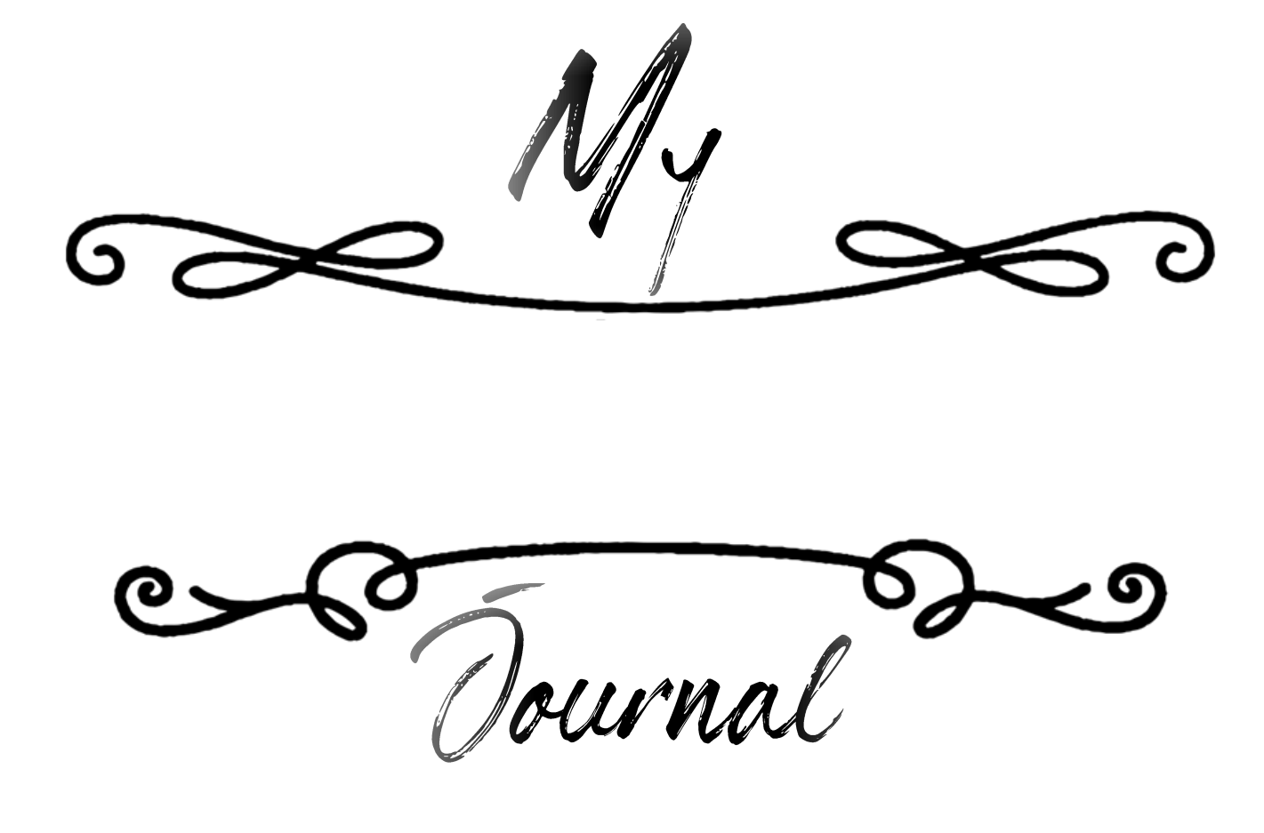

Gratitude

101Planners.com

Gratitude is the gateway

to a positive

life.

A.D. Posey

101Planners.com



- am
Grateful

For

101Planners.com

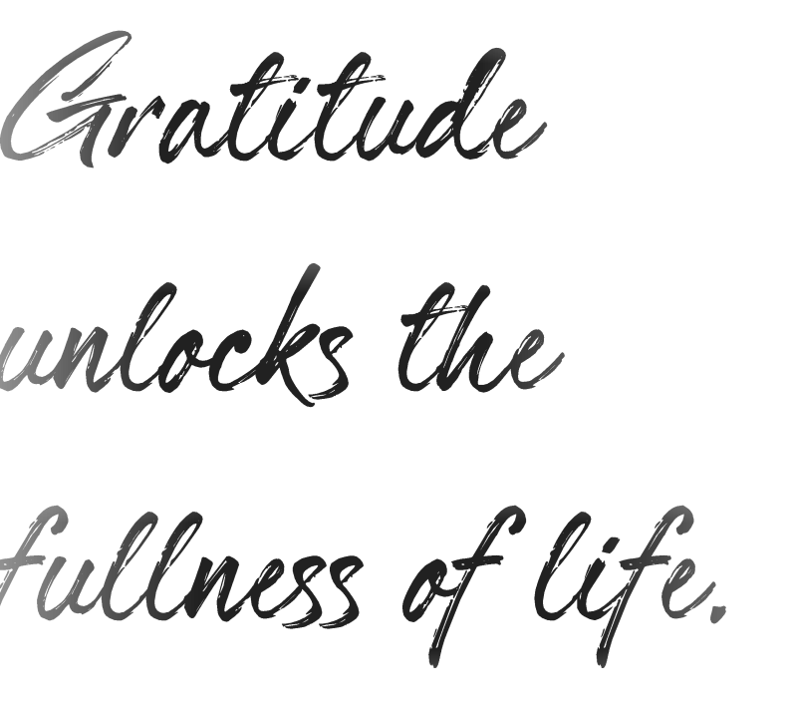

Melody Beattie

101Planners.com

Books
I am Grateful For
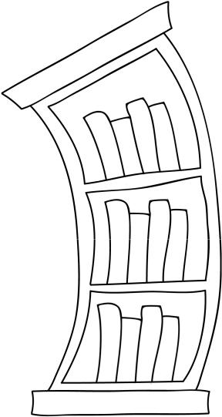

101Planners.com

A grateful


heart

is a magnet

for miracles

101Planners.com


people

I am Grateful For

101Planners.com

We can only be

said to be alive

in those

moments, where

our hearts are

conscious of our

treasures.


101Planners.com

Movies
I am Grateful For


101Planners.com

Gratitude

helps us to see what
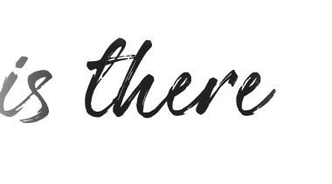

instead of what


101Planners.com

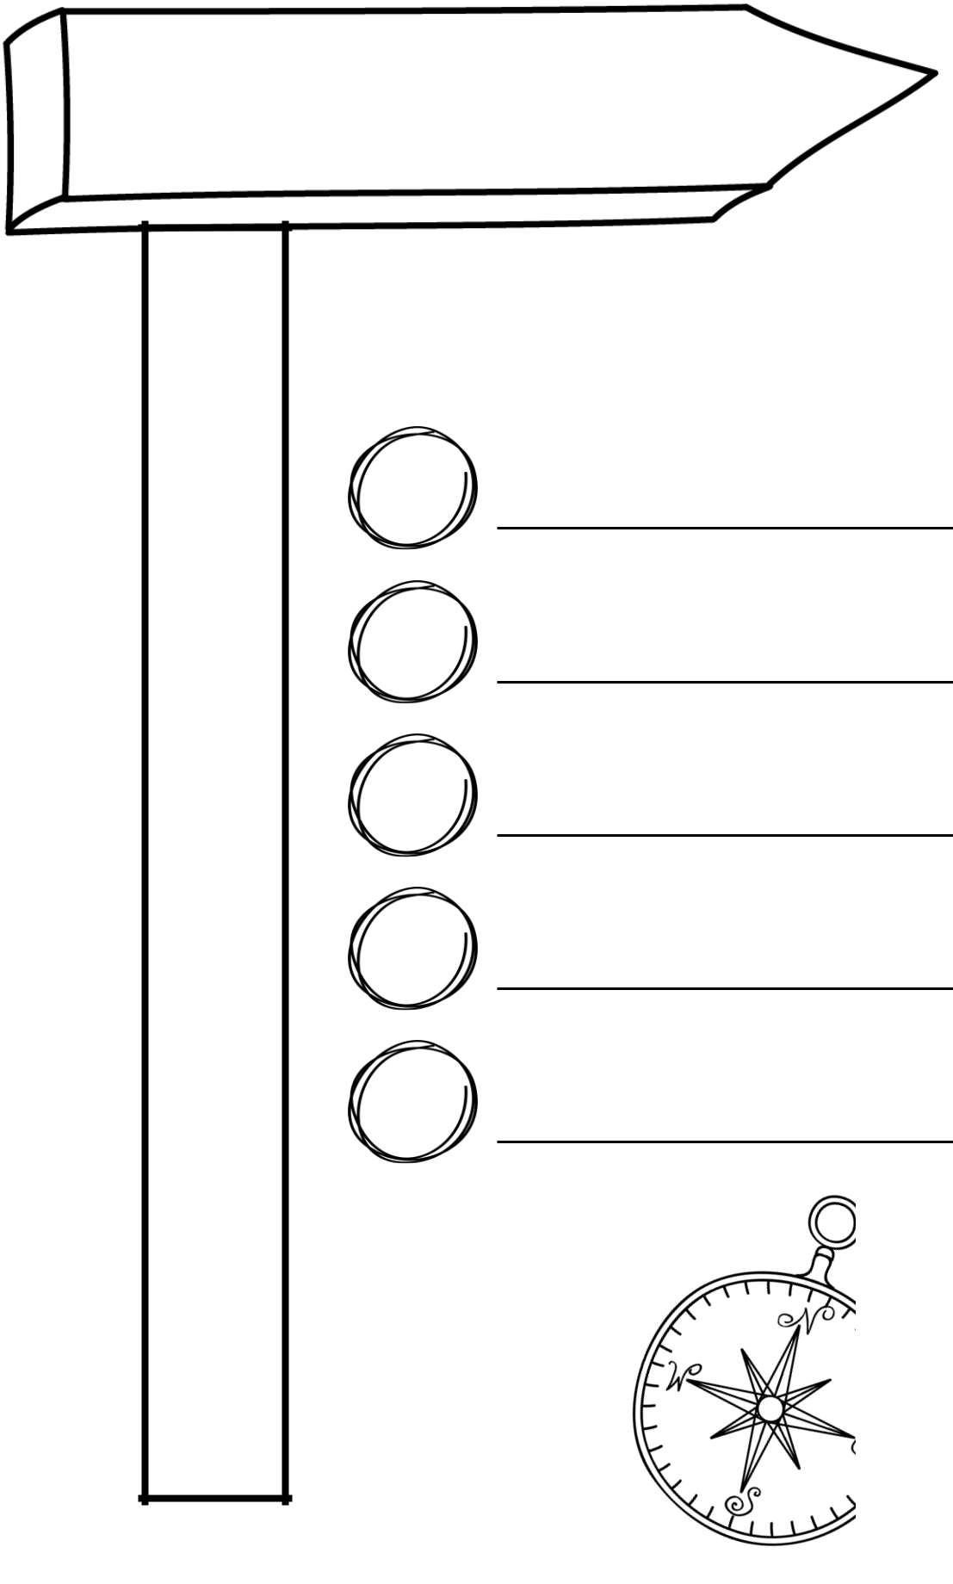
places

I enjoyed visiting

101Planners.com

When you , are
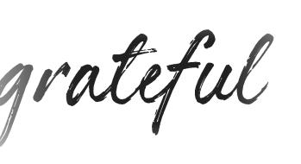

fear disappears and

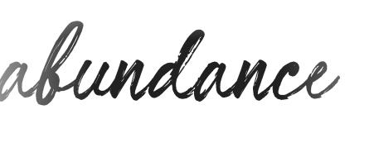appears.

Tony Robbins

101Planners.com

Tv shows
I enjoy watching


101Planners.com

Be

in love
with your life.

Every detail of it.

Jack Kerouac

101Planners.com

Date:


101Planners.com

Start each day with a

positive thought
and a

grateful heart.

Roy T. Bennett

101Planners.com

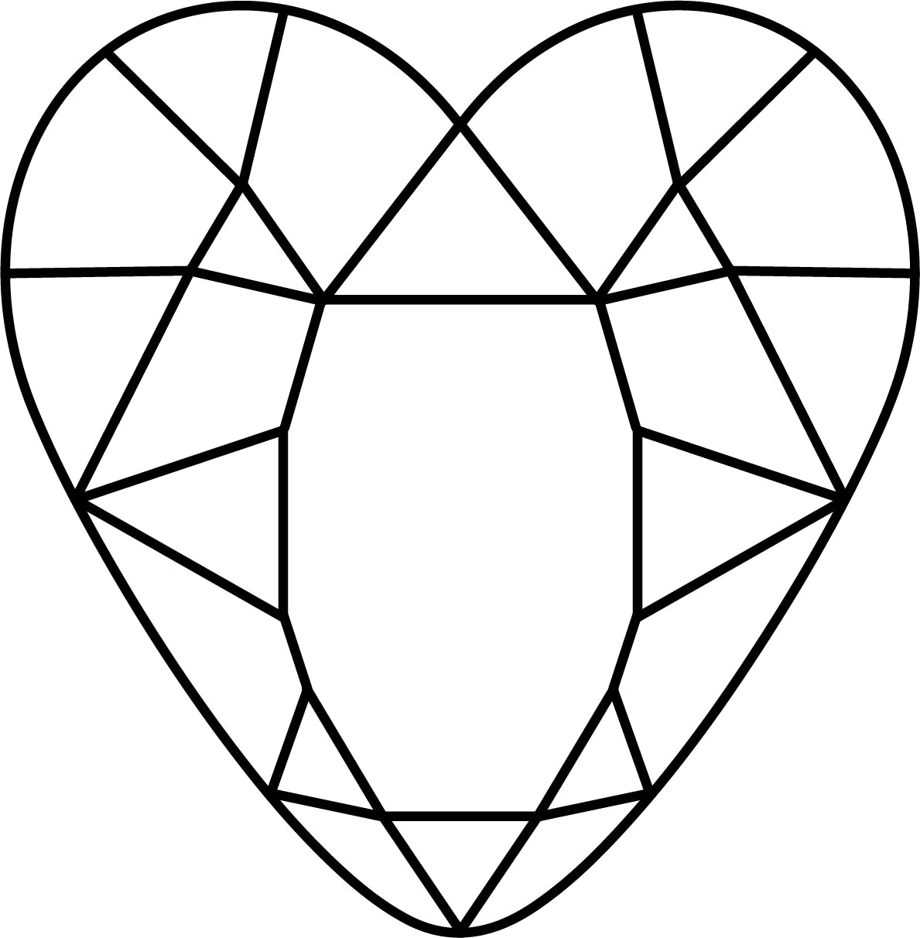

things

I Love

101Planners.com


The activities that make me happy:

I will try to do them more often by


101Planners.com

There is

always
something to be

thankful for

101Planners.com

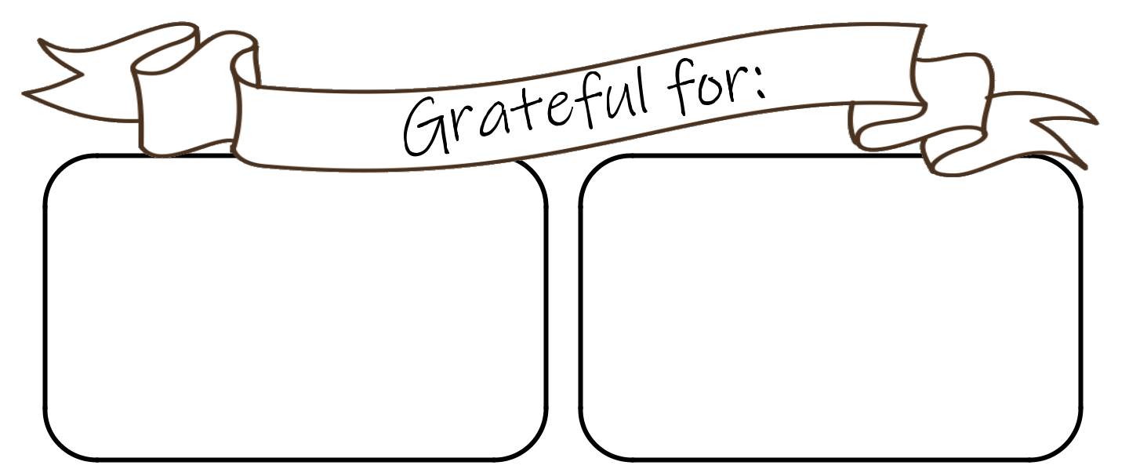

Monday Tuesday


Wednesday Thursday

Friday Saturday


Sunday
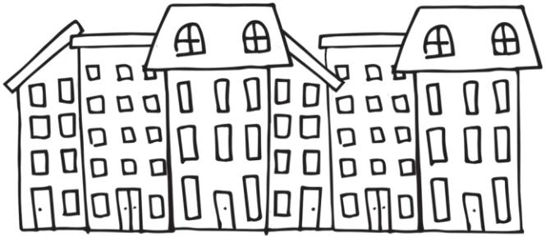

101Planners.com

Inhale

love
Exhale

gratitude

101Planners.com

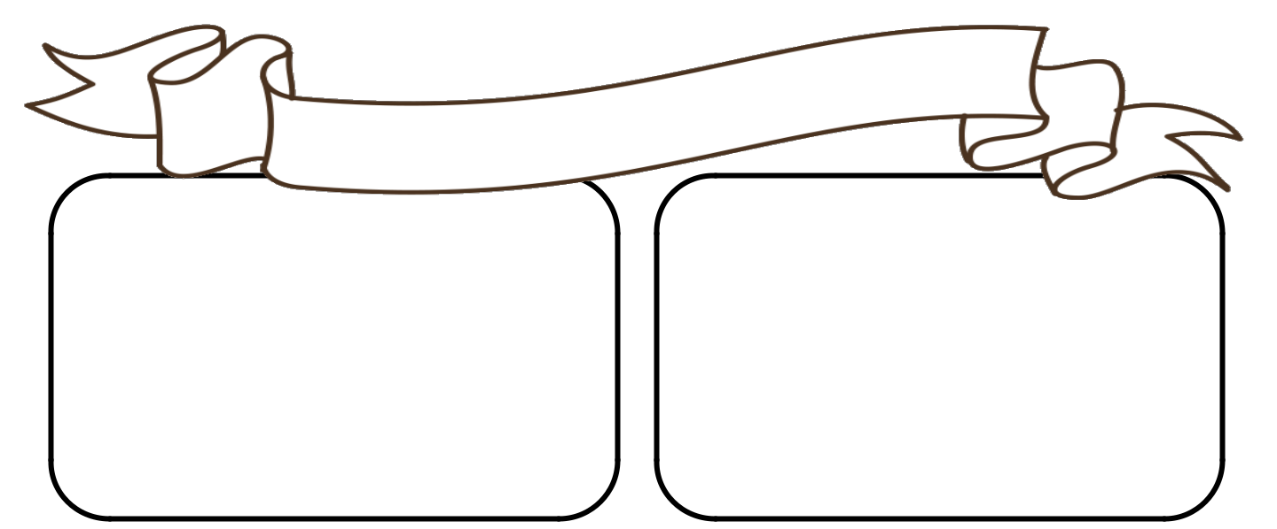

Monday Tuesday

Wednesday

Friday

Sunday

Thursday

Saturday


Write
something
good that
happened
each day

101Planners.com

“To me, beauty is

about being

comfortable in your own skin. It’s about knowing and accepting who you are.”

Ellen Degeneres

101Planners.com

Monday Tuesday

Wednesday Thursday

Friday Saturday


Sunday
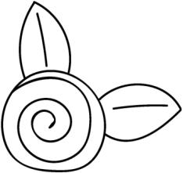

101Planners.com



It is not joy that

makes us

grateful

It is gratitude that makes us

joyful

101Planners.com

Things I love about my life
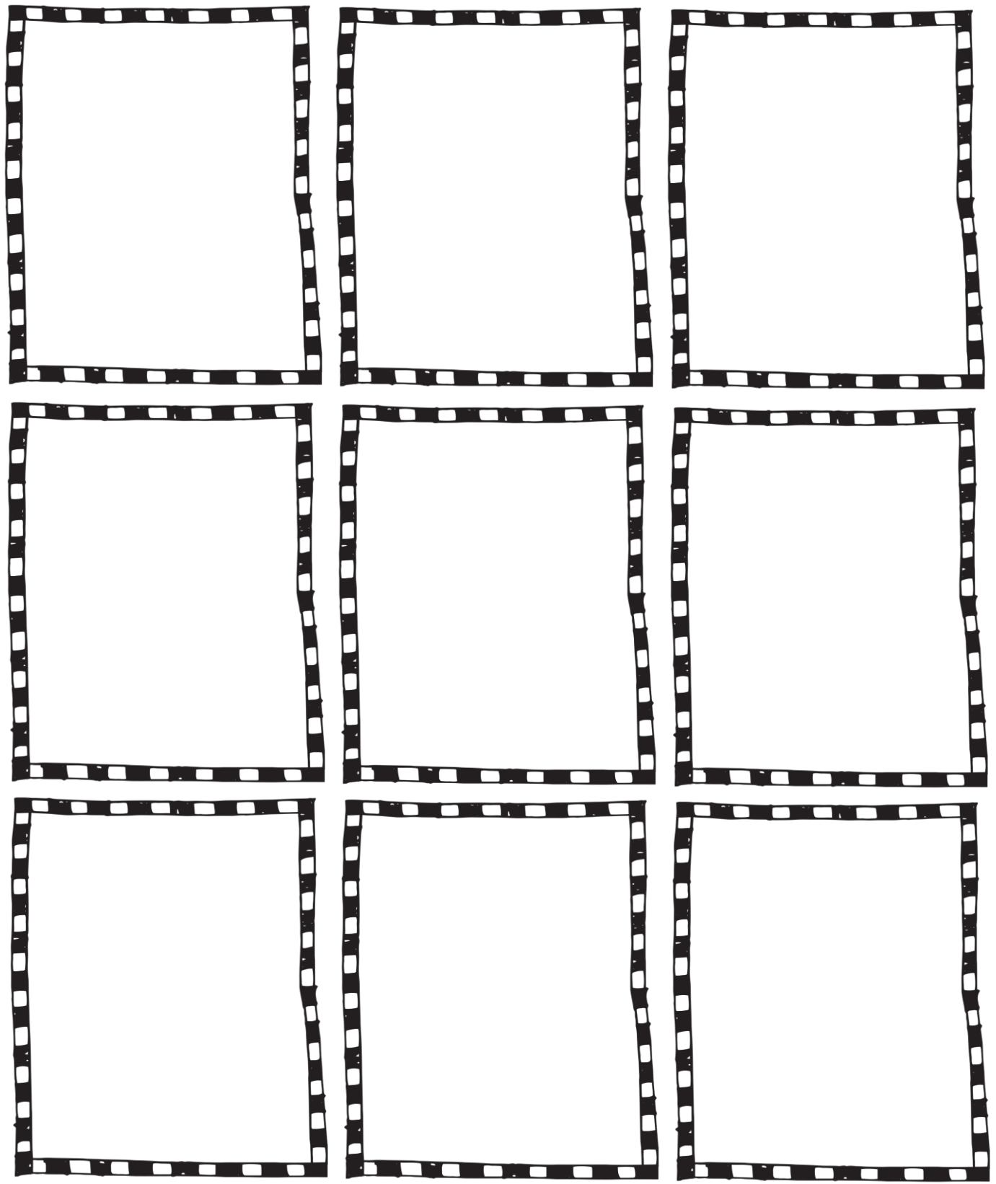

101Planners.com

Monday Tuesday

Wednesday Thursday

Friday Saturday

Sunday

101Planners.com

Gratitude

turns

what we have
into

enough

Aesop

101Planners.com

Things I appreciate about

family or friends
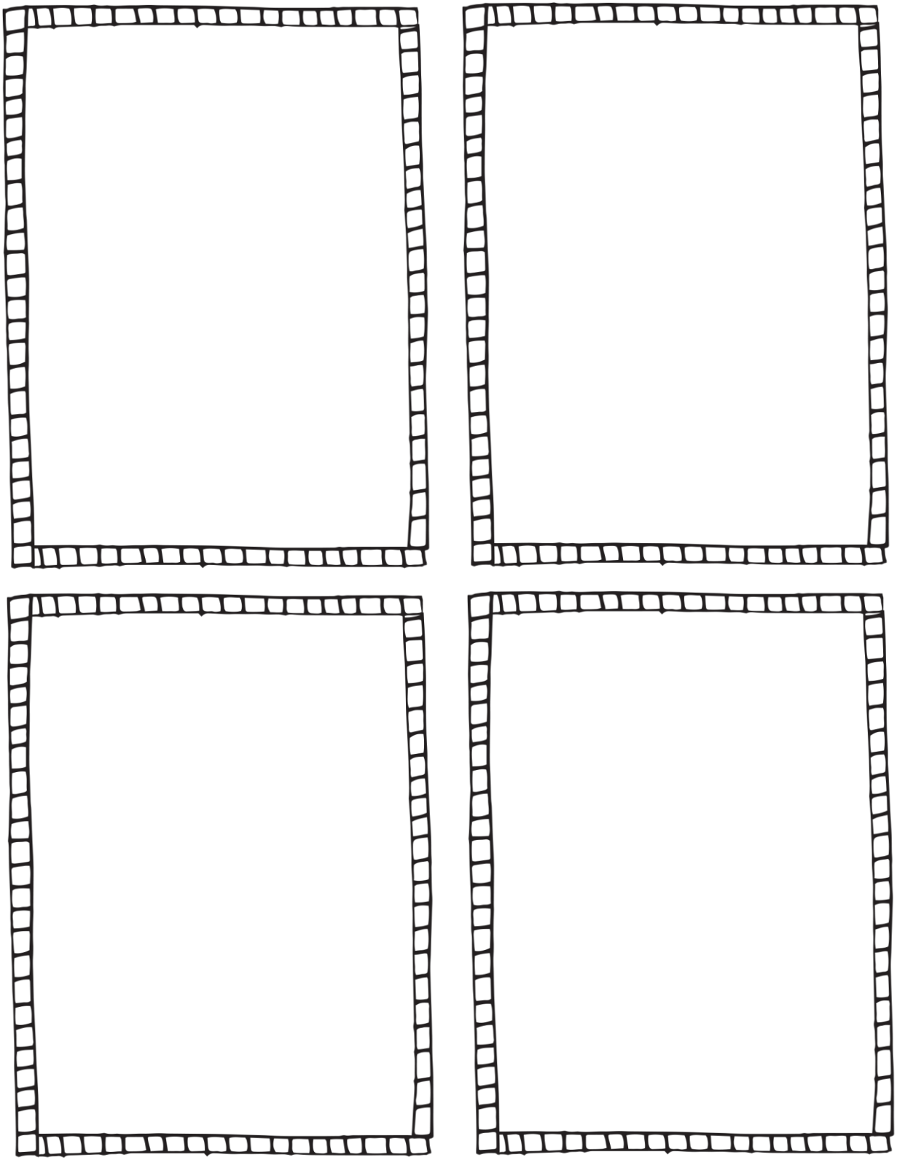

101Planners.com

Monday Tuesday

Wednesday

Friday

Sunday

Thursday

Saturday

Write
something
good that
happened
each day

101Planners.com



A special memory

101Planners.com

Gratitude is

riches
Complaint is

poverty

Doris Day

101Planners.com

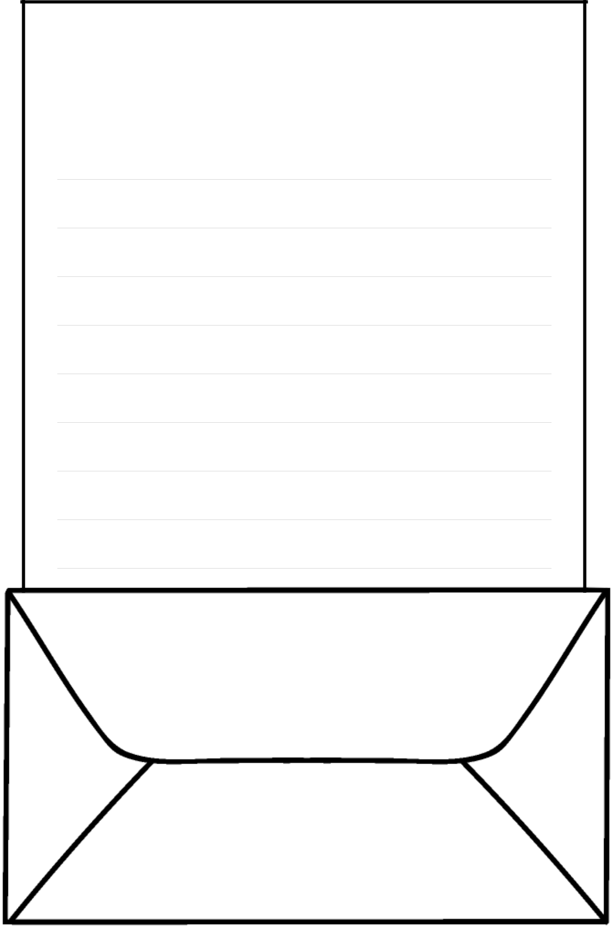
Thank You

Dear

You don’t actually have to send the letter

101Planners.com

It is not happy

people who are

thankful

It is thankful people who are

happy

101Planners.com


Music
I Enjoy
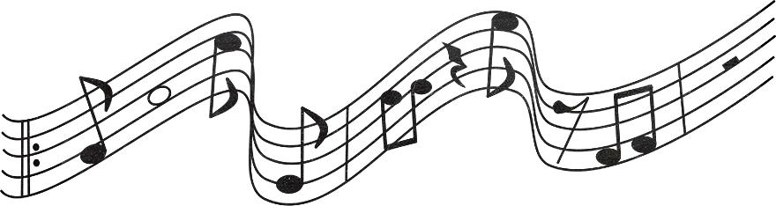


Be Grateful

For Life

Not everyone made it this far

101Planners.com

Monday Tuesday

Wednesday Thursday

Friday Saturday

Sunday

101Planners.com



- Who do you love?

- What made you smile lately?

- Who do you like?

- What are you good at doing?

- Who can you count on?

- What do you love?

- What do you like?

- Where do you like to go?

- What do you enjoy?

- Who inspires you?

- List activities that bring you joy.

- List items that bring you joy.

- List people that bring you joy.

- What makes you happy?

- What relaxes you?

- What makes you special?

- What is your favorite memory?

- Is there anything that you take for granted?

- What is your favorite food?

- Describe one good thing that happened to you this month.

- What is your favorite item?

101Planners.com



- What is your biggest accomplishment?

- Do you have a family tradition that you enjoy?

- What are your good qualities?

- What are your hobbies?

- Is there anything that makes your life better?

- What movie did you like?

- What books did you enjoy?

- Who made you smile?

- Write about a nice thing somebody said to you.

- Who do you enjoy spending time with?

- What songs do you love?

- Where is the best place you visited and what do you like about it?

- What have you learned?

- Has anyone shown you kindness recently?

- What do you love about your home?

- What do you love about your country?

- Describe the last gift you received. Who gave it to you?

101Planners.com



- What do you like about yourself?

- What do you like about your job?

- In what way is your life better today than it was a year ago or ten years ago?

- What is the nicest thing that someone did for you?

- Describe one of your best days.

- What do you enjoy doing after work?

- What do you enjoy doing as you get home?

- Describe a bad experience that made you stronger.

- What do you have today that you didn't have as a child?

- Describe a difficulty that you have overcome.

- What would you take to a desert island?

- What was the last thing that made you laugh?

- What is your favorite animal?

- What cheers you up when you are feeling sad?

- What do you enjoy about your daily routine?

- Describe your last vacation?

- What have you accomplished?

101Planners.com

Date:

101Planners.com

Date:

101Planners.com

Date:

101Planners.com

Date:

101Planners.com

Date:

101Planners.com

Date:

101Planners.com

Date:

101Planners.com

Date:

101Planners.com

Date:

101Planners.com



is the

best
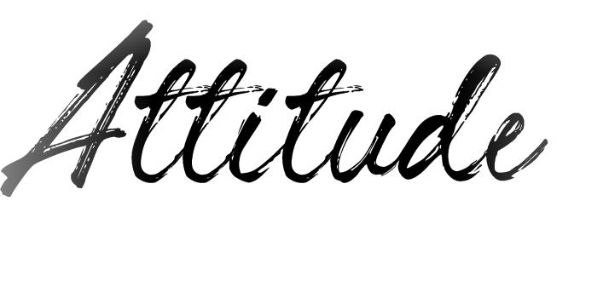

101Planners.com

