
Why
Gratitude?

Life can be challenging.

On days when nothing seems to be going your way, it can be particularly difficult to recognize aspects of your life that you appreciate.

It is during these difficult times when practicing gratitude can be the most helpful.

Practicing gratitude isn’t just about feeling appreciative when things are going well. It’s about acknowledging what you have, instead of focusing on what’s missing. It’s about the glass half full rather than half empty. You may be struggling with school or a relationship, but chances are there is some area in your life in which things are going well…or, perhaps, not as badly.

When you start looking for something to appreciate, the odds are higher that you’ll find it. Doing this can have powerful effects on your mood and the way you see your life.


Research shows that practicing gratitude deepens relationships, increases happiness, and improves physical and mental health. People who practice gratitude are less focused on competing with others, which allows them to focus on their own contentment.

While society seems to promise that a prestigious internship or a new gadget will bring happiness, gratitude is an invitation to be happy with what you already have. Gratitude helps you savor the good things in life—big and small—so that you don’t miss them in pursuit of the elusive next big thing.
Using This Book

We’ve designed this book to help you to reflect on things that make you feel grateful.

Studies have found that grateful writing, which you can practice in this journal, can improve your well-being in meaningful ways.

Use this journal in whatever way feels helpful to you.

While some benefit from practicing gratitude daily, others may prefer to do so a couple of times a week or even weekly. Fill it out when you want and how you want. Don’t worry about spelling, sentence structure, or grammar—the important thing is to write about the things in your life for which you’re thankful.


We want to acknowledge that it’s not always easy identifying things for which you feel grateful, especially in times of stress. That’s okay. Start small and try to identify a few things that are going right in your life, even if you don’t feel grateful for them at the moment.

It may feel like a stretch at first, especially if you’re not used to doing this. Don’t worry: the more you practice and write in this gratitude journal, the more genuine and natural it will become.

Day 1

Date :


3 THINGS I’M GRATEFUL FOR TODAY

REFLECTIONS

“


This is a wonderful

day. I’ve never

seen this one

before.

- Maya Angelou

”



Day 2

Date :


FAVORITE MEMORIES I’M GRATEFUL FOR
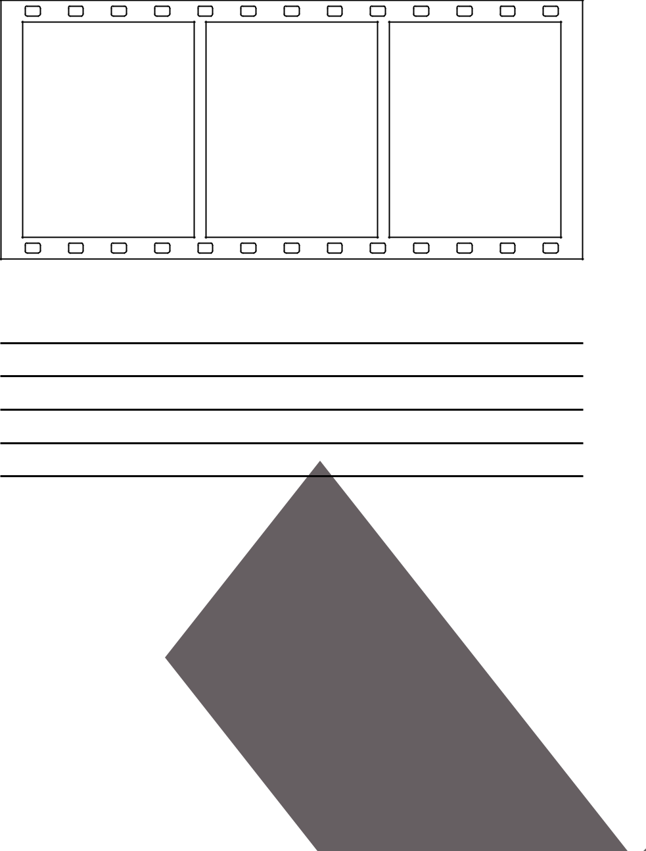

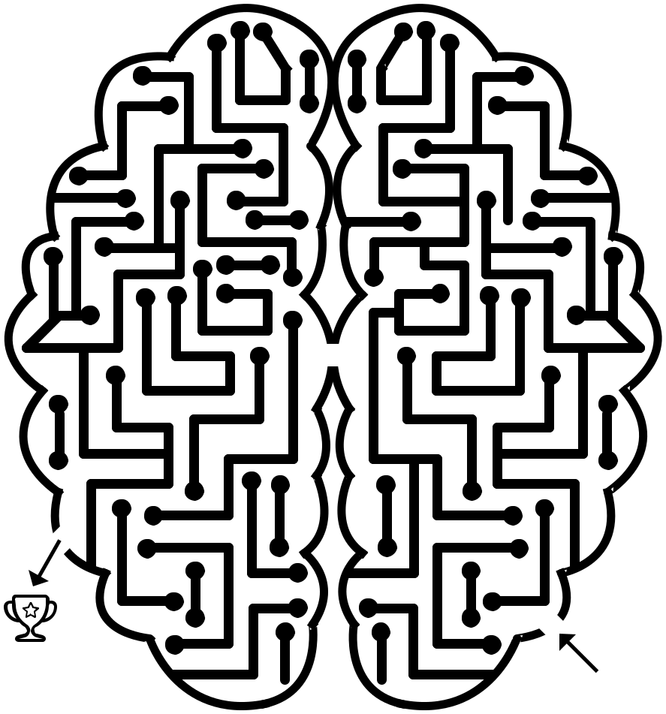

Day 3

Date :


WHAT MADE ME LAUGH TODAY?

REFLECTIONS

“


Gratitude turns

what we have into
enough.

- Melody Beattie

”

Day 4

Date :

THINGS I APPRECIATE ABOUT MYSELF

 | sarcastic | good listener
 | silly |  | hardworking
optimistic |  | adventurous
 |  |  | loyal
 | adaptable
 |  | passionate | funny

practical

stylish

creative


cautious

spontaneous

Day 5

Date :


MY LIFE WOULD BE A LOT LESS SWEET WITHOUT

“

We often take

for granted all

the things that

most deserve our

gratitude.

- Cynthia Ozick

”

Day 6

Date :

DRAW 3 THINGS THAT ADDED JOY TO YOUR DAY

Day 7

Date :

REMEMBER TO REST AND TAKE A BREAK




Day 8

Date :

A MEMORY FROM WHEN I WAS YOUNG THAT MAKES ME SMILE

“

Give thanks for a

little and you will
find a lot.

- Hausa Proverb

”

Day 9

Date :

I AM GRATEFUL FOR

_{Day 10} Date :

WRITE OR DRAW SOMETHING ABOUT YOURSELF FOR WHICH YOU ARE GRATEFUL (E.G. YOUR KINDNESS, YOUR CURIOSITY, ETC)

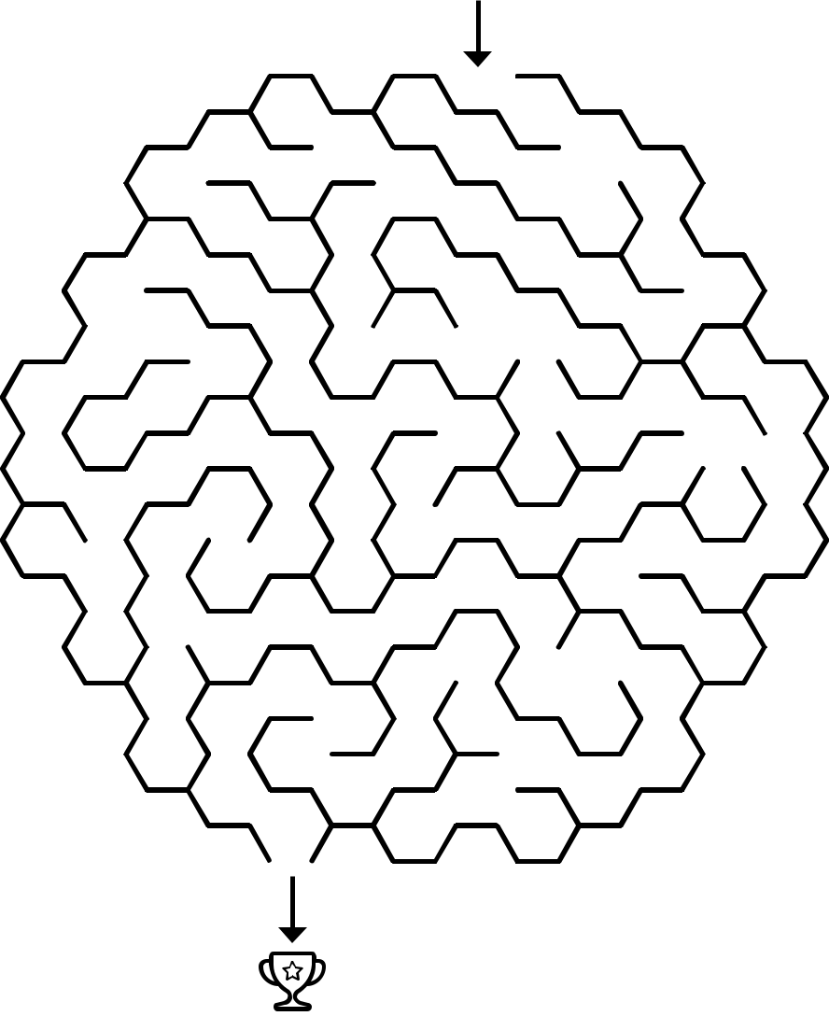
Day 11 Date :

PEOPLE WHO MADE ME LAUGH OR SMILE THIS WEEK


Day 12 | Date :


3 THINGS I’M GRATEFUL FOR TODAY

“


Look up at the

stars and not down

at your feet.

- Stephen Hawking

”

Day 13 Date :

BEFORE YOU BEGIN YOUR DAY, OR AT THE END OF YOUR DAY, LIST 10

THINGS FOR WHICH YOU ARE GRATEFUL:

1.

2.

3.

4.

5.

6.

7.

8.

9.

10.


Day 14 | Date :

THINGS PEOPLE LIKE ABOUT ME

“


The more grateful

I am, the more

beauty I see.

- Mary Davis

”

_{Day 15} Date :

WHAT IS DIFFERENT TODAY THAN A YEAR AGO?


Day 16 | Date :
MY STRENGTHS

ACHIEVEMENTS DREAMS AND GOALS

WHY I DESERVE TO BE HERE


Day 17 | Date :

SOMETHING NICE I WANT TO REMEMBER ABOUT TODAY

“

Feeling gratitude

and not expressing

it is like wrapping

a present and not

giving it.

- William Arthur Ward

”



Day 18 | Date :

WHAT WAS SOMETHING THAT WAS HARD TO DO BUT YOU ARE GRATEFUL YOU DID?

“

It’s not happiness

that brings

us gratitude.

It’s gratitude

that brings us

happiness.

”

JOXSRTANYBEZBRM PZMIAVPZHTHBZII WQOSFDRUECMLEHN EDUTITARGONEYYD PSMGFIEJKJKBKJF SELFCOMPASSIONU YNBWCSKEJDEUMAL BTJRLOSYQXRITTN ZVIEEIVRINAVCUE HLENCASUAMCIBRS EPFRUPTLDOFNRES BREVWMIHCTLLZJJ GXTVZNMUEBEEJQZ ELMQGIQONXSHLJW MINDSETJCPYHSBI

Gratitude Journaling

Self-care Sleep

Mindfulness Breathe

Self-compassion Exercise

Mindset Nature

Community
_{Day 19} Date :


WHAT IS SOMETHING THAT WENT WELL TODAY?
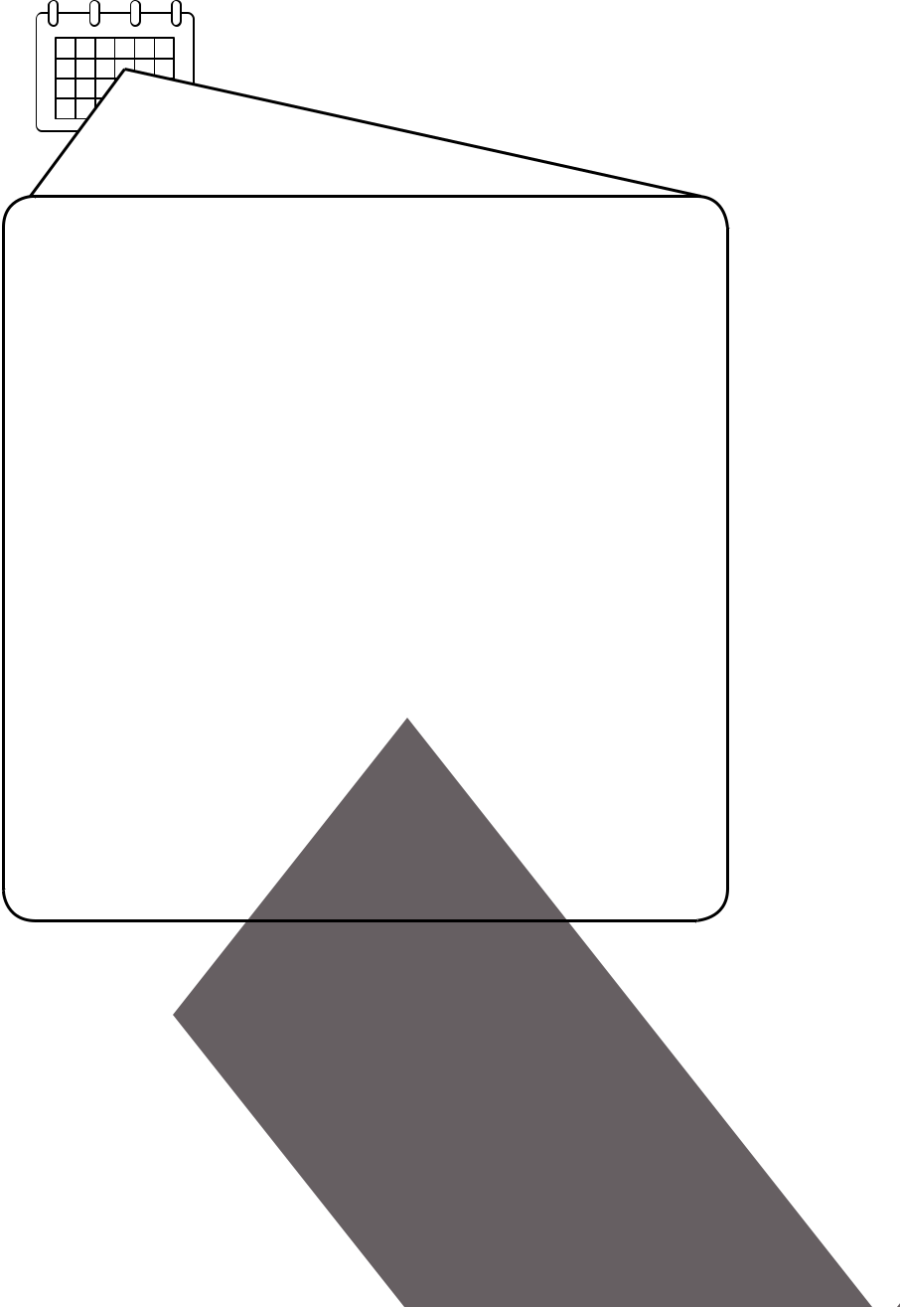

_{Day 20} Date :

FIVE THINGS I LIKED ABOUT MYSELF TODAY

1.

2.

3.

4.

5.


_{Day 21} Date :


THINK OF SOMEONE FROM YOUR PAST THAT TAUGHT YOU SOMETHING ABOUT YOURSELF, AND WRITE ABOUT IT.


Day 22 | Date :


SOMETHING I LEARNED ABOUT MYSELF TODAY

“


Focus on the good

in life.

”

Day 23 Date :

WRITE OR DRAW THREE THINGS YOU RELY ON TO HELP YOU GET THROUGH THE DAY (E.G. HIKING, MUSIC, A FRIEND, ETC)


Day 24 |  | Date :
 | SKILLS I AM PROUD OF

“

Learn to be

thankful for what

you already have,
while pursuing all

that you want.

- Jim Rohn

”

Day 25 | Date :

FIVE THINGS I HAVE ACHIEVED IN MY LIFE SO FAR

1.

2.

3.

4.

5.

Day 26 | Date :

MY FAVORITE MEMORY OF TODAY

“


Expect nothing

and appreciate

everything.

”

Day 27 Date :

DRAW OR WRITE ABOUT SOMETHING BEAUTIFUL YOU SAW TODAY



Day 28 | Date :

WHAT OR WHO MADE YOUR DAY A BIT MORE ENJOYABLE?

“The real gift of

gratitude is that

the more grateful

you are, the more

present you

become.

- Robert Holden”

_{Day 29} Date :

CLOSE YOUR EYES, TAKE A BREATH, AND IMAGINE A PLACE YOU’VE VISITED. DRAW OR DESCRIBE THE PLACE:

Day 30 Date :


LIST THREE OBSTACLES AND WHAT YOU ARE LEARNING FROM YOUR CHALLENGES

1.

2.

3.


Day 31 | Date :

REFLECT ON THE PREVIOUS 30 DAYS OF GRATITUDE

“

Gratitude makes

sense of our past,

brings peace
for today, and

creates a vision for

tomorrow.

- Melody Beattie”

POSITIVE NOTE TO MY FUTURE SELF

Wellness Worksheet

3-5 THINGS I’M LOOKING FORWARD TO THIS MONTH:

3-5 FEARS OR CONCERNS I HAVE FOR MYSELF THIS MONTH:

3-5 AFFIRMATIONS THAT HELP ME TO COUNTER THOSE FEARS:

2-3 THINGS I CAN DO TO GET CONNECTED TO A COMMUNITY:

IF I AM STRUGGLING, I AM WILLING TO TALK TO:

SUCCESS THIS SEMESTER FOR ME WOULD LOOK LIKE:

There are lots of ways to practice self-care.

The important thing is to make self-care a priority in your schedule.

Circle the self-care ideas that resonate with you:

●● Keep practicing gratitude!

●● Journal

●● Sleep

●● Exercise

●● Do something you love ●● Meditate

●● Hang out with friends & family ●● Allow yourself to feel ●● Schedule breaks

●● Go for a walk

●● Cook something

●● Practice yoga

●● Take a stretch break ●● Listen to music

●● Have a 3 minute dance party ●● Practice self-compassion ●● Take time for yourself
●● Do something creative

●● Talk with a counselor

●● Unplug from technology

●● Practice deep breathing

●● Laugh

●● Take a nap

●● Spend time in nature

What are some other things you do to take care of yourself?

Health and Wellness Resources at University of Colorado Boulder

Counseling and Psychiatric Services (CAPS)
- 492-2277 (24/7 support) colorado.edu/counseling

CU Collegiate Recovery Center (CUCRC)
- 492-9642 cucrc@colorado.edu colorado.edu/recoverycenter

Health Promotion
- 492-2937 healthpromotion@colorado.edu colorado.edu/health/promotion

Office of Victim Assistance (OVA)
- 492-8855 (24/7 support) assist@colorado.edu colorado.edu/ova

Medical Services
- 492-5101 (24/7 nurse line) colorado.edu/healthcenter

Recreation Services

- 492-6880 recreation@colorado.edu colorado.edu/recreation






colorado.edu/health

with gratitude for concept and content created by University of Texas at Austin Counseling and Mental Health Center

