


Property of:

____________________________
Why

Gratitude?

Life can be challenging. On days when nothing seems to be going your way, it can be particularly difficult to recognize aspects of your life that you appreciate. It is during these difficult times when practicing gratitude can be the most helpful.

Practicing gratitude isn’t just about feeling appreciative when things are going well. It’s about acknowledging what you have, instead of focusing on what’s missing. It’s about the glass half full rather than half empty. You may be struggling with school or a relationship, but chances are there is some area in your life in which things are going well…or, perhaps, not as badly.

When you start looking for something to appreciate, the odds are higher that you’ll find it. Doing this can have powerful effects on your mood and the way you see your life.

Research shows that practicing gratitude deepens relationships, increases happiness, and improves physical and mental health. People who practice gratitude are less focused on competing with others, which allows them to focus on their own contentment.

While society seems to promise that a prestigious internship or a new gadget will bring happiness, gratitude is an invitation to be happy with what you already have. Gratitude helps you savor the good things in life—big and small—so that you don’t miss them in pursuit of the elusive next big thing.
Using This

Book

Studies have found that grateful writing, which you can practice in this journal, can improve your well-being in meaningful ways.

We’ve designed this book to prompt you to reflect on things that make you feel grateful. Use this journal in whatever way feels helpful to you. While some benefit from practicing gratitude daily, others may prefer to do so a couple of times a week or even weekly. Fill it out when you want and how you want. Don’t worry about spelling, sentence structure, or grammar—the important thing is to write about the things in your life for which you’re thankful.

We want to acknowledge that it’s not always easy identifying things for which you feel grateful, especially in times of stress. That’s okay. Start small and try to identify a few things that are going right in your life, even if you don’t feel grateful for them at the moment. It may feel like a stretch at first, especially if you’re not used to doing this. Don’t worry: the more you practice and write in this gratitude journal, the more genuine and natural it will become.


“This is a wonderful day. I’ve never seen

this one before.”

-Maya Angelou

3 things I’m grateful for today...
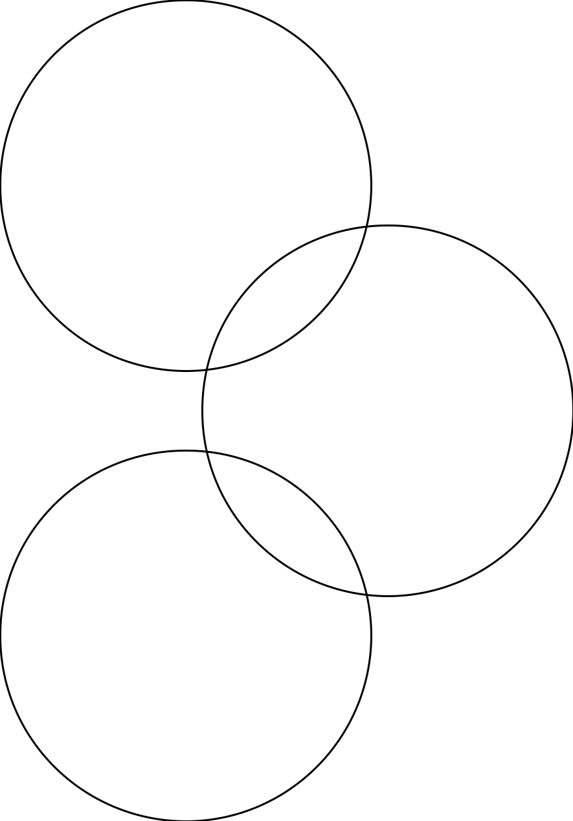

1

2

3

date: / /

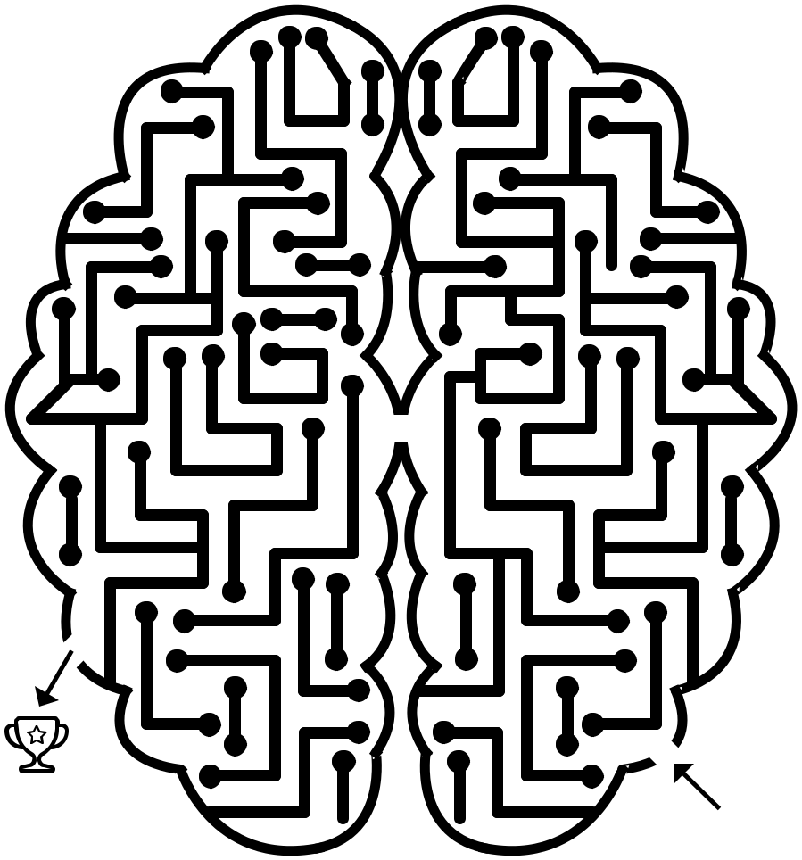
Memories I’m grateful for:


date: / /



What made you laugh today?


date: / /



“Gratitude turns what we have into enough.”

—Melody Bettie

Things I appreciate about myself are...

(circle all that apply and add your own)

sarcastic

silly

optimistic

adaptable

practical

stylish

good listener

hardworking

adventurous

loyal

funny

passionate

creative

cautious

spontaneous

date: / /


Doodle three things that added joy to your day...

1

2

3

date: / /

My life would be a lot less sweet without
(fill in the blanks)

,
,

and

.

date: / /

“Give thanks for a little and you will find a lot.”

—Hausa proverb

Write about a memory from when you were young that makes you smile.

date: / /


Write or draw something you’re grateful for about yourself.

(e.g., your kindness, your curiosity, etc.)

date: / /

Someone who made me laugh or smile this week...


date: / /



“You only live once, but if you do it

right, once is enough.”

-Mae West

Today I am grateful for...

date: / /


What is different today than a year ago that you are grateful for?


date: / /

JOXSRTANYBEZBRM PZMIAVPZHTHBZII WQOSFDRUECMLEHN EDUTITARGONEYYD PSMGFIEJKJKBKJF SELFCOMPASSIONU YNBWCSKEJDEUMAL BTJRLOSYQXRITTN ZVIEEIVRINAVCUE HLENCASUAMCIBRS EPFRUPTLDOFNRES BREVWMIHCTLLZJJ GXTVZNMUEBEEJQZ ELMQGIQONXSHLJW MINDSETJCPYHSBI

Gratitude Journaling
Self-care Sleep
Mindfulness Breathe
Self-compassion Exercise
Mindset Nature
Community
What was something that was hard to do but you are grateful you did?

date: / /


What was something that went well today?


today: / /

date: / /

Think of someone from your past that taught you something about yourself and write about it.

date: / /



“ Focus on the good in life.”
—Unknown
Write or draw three things you rely on to help get you through the day.

(e.g., coffee, music, etc.)


date: / /

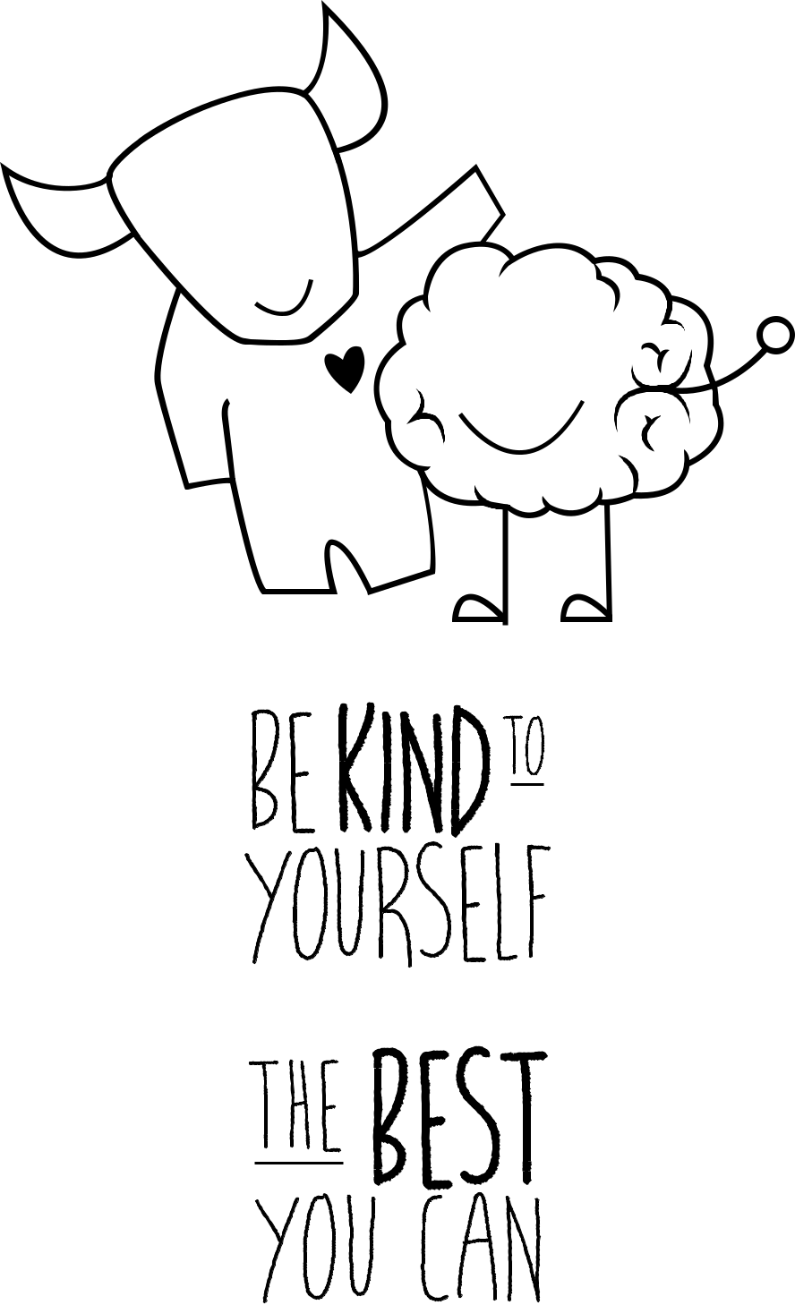
What is something you are good at?


date: / /

“Expect nothing and

appreciate everything.”

—Unknown

What was something beautiful you saw today?

date: / /



Close your eyes, take a breath and imagine a place you’re grateful you’ve visited. Draw or describe the place.

date: / /

“Look up at the stars

and not down at your feet.”

—Stephen Hawking

What or who made your day a bit more enjoyable?







date: / /

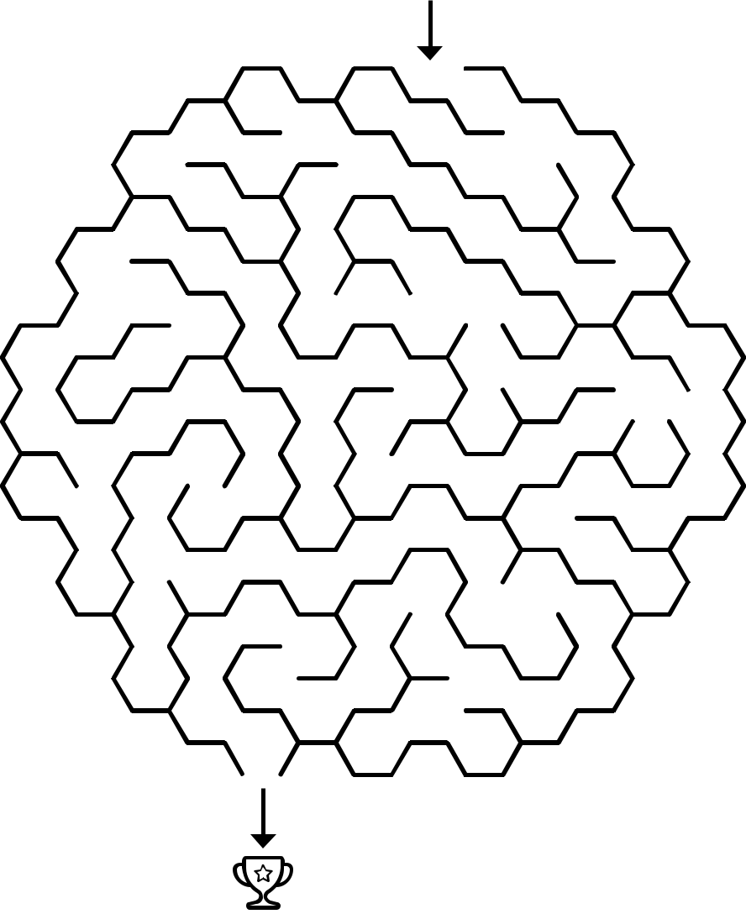
During challenging times I am grateful for…


date: / /

Gratitude is

self-care.

Self-care doesn’t have to stop here. Self-care refers to activities and practices that can help you reduce your stress and enhance your overall well-being,

like practicing gratitude. Self-care is more than an occasional treat, but a way of living each day that incorporates practices and behaviors that help you feel refreshed, re-energized, and rested. Everyone deals with stress differently, and everyone’s preferences for practicing self-care are different as well.
There are lots of ways to practice self-care.

The important thing is to make self-care a priority in your schedule. Here are some ideas for self-care:

●● Keep practicing gratitude!

●● Journal
●● Sleep
●● Exercise
●● Do something you love ●● Meditate
●● Hang out with friends & family

●● Download Thrive at UT smartphone app

●● Schedule breaks ●● Go for a walk ●● Cook something ●● Practice yoga ●● Stretch
●● Listen to music

●● Have a 3 minute dance party
●● Practice self-compassion; treat yourself like you would treat your best friend
●● Take time for yourself ●● Do something creative ●● Visit the Mindbody Labs ●● Unplug from technology ●● Practice deep breathing ●● Take a nap

●● Spend time in nature

For more information on self-care, visit CMHC’s website at cmhc.utexas.edu/selfcare

Resources at UT

Counseling & Mental Health Center (CMHC)
cmhc.utexas.edu, 512-471-3515

CMHC 24/7 Crisis Line
512-471-2255 (CALL)

MindBody Labs
SSB 5th floor and SAC 2.106

Thrive at UT
A free mobile app to enhance the well-being of UT
students
cmhc.utexas.edu/thrive

Student Emergency Services deanofstudents.utexas.edu/emergency 512-471-5017

Behavior Concerns Advice Line besafe.utexas.edu/behavior-concerns-advice-line, 512-232-5050

Student Ombuds: Conflict Management ombuds.utexas.edu, 512-471-3825

Vick Center for Strategic Advising & Career Counseling:

ugs.utexas.edu/vick, 512-232-8400

To get involved at UT:
utexas.edu/campus-life/student-involvement



