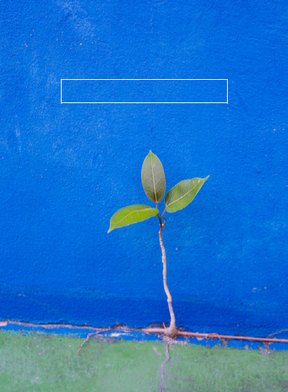

GRATITUDE JOURNAL

Being grateful for your blessings and reflecting on them is a key ingredient of happiness. People who practice gratitude are more optimistic, more likely to achieve their goals, and happier overall. Use this journal to write down the things for which you are grateful—whether it’s the sunset, a good meal, a piece of music, your work, your health, a child’s smile, or the beautiful tree outside your window.

It’s best to use this e-journal on your computer. Simply save it to your desktop or another place where you can easily access it, and then record your daily reflections in the white boxes. Remember to save it each time.

Try to write in this journal often—a few words every day if you can, so that practicing gratitude becomes a habit. It’s a habit that will make you feel better and better.

© 2016 LifeWorks Canada Ltd


JANUARY

“As you live each day, remember to appreciate all that is in front of you, around you, and within you.”

—Dr. Tal Ben-Shahar, author of Being Happy

“Grace
and gratitude have the same Latin root, gratus. Whenever we find ourselves
in
a
stop-the-world-I-want-to-get-off
mindset,
we
can
remember
that
there
is
another
way
and
open
ourselves
to
grace.
And
it
often
starts
with
taking a moment to be grateful for this day, for being alive, for anything.”

—Arianna Huffington, author of Thrive


FEBRUARY

“
Gratitude is an immensely powerful force that we can use to expand our happiness, create loving relationships, and even improve our health.”

—Deepak Chopra, author and physician

“In daily life we must see that it is not happiness that makes us grateful, but gratefulness that makes us happy. And that gratefulness always leads to

- satisfied,
simplified
life.”

—Joshua Becker, author of The More of Less:

Finding the Life You Want Under Everything You Own

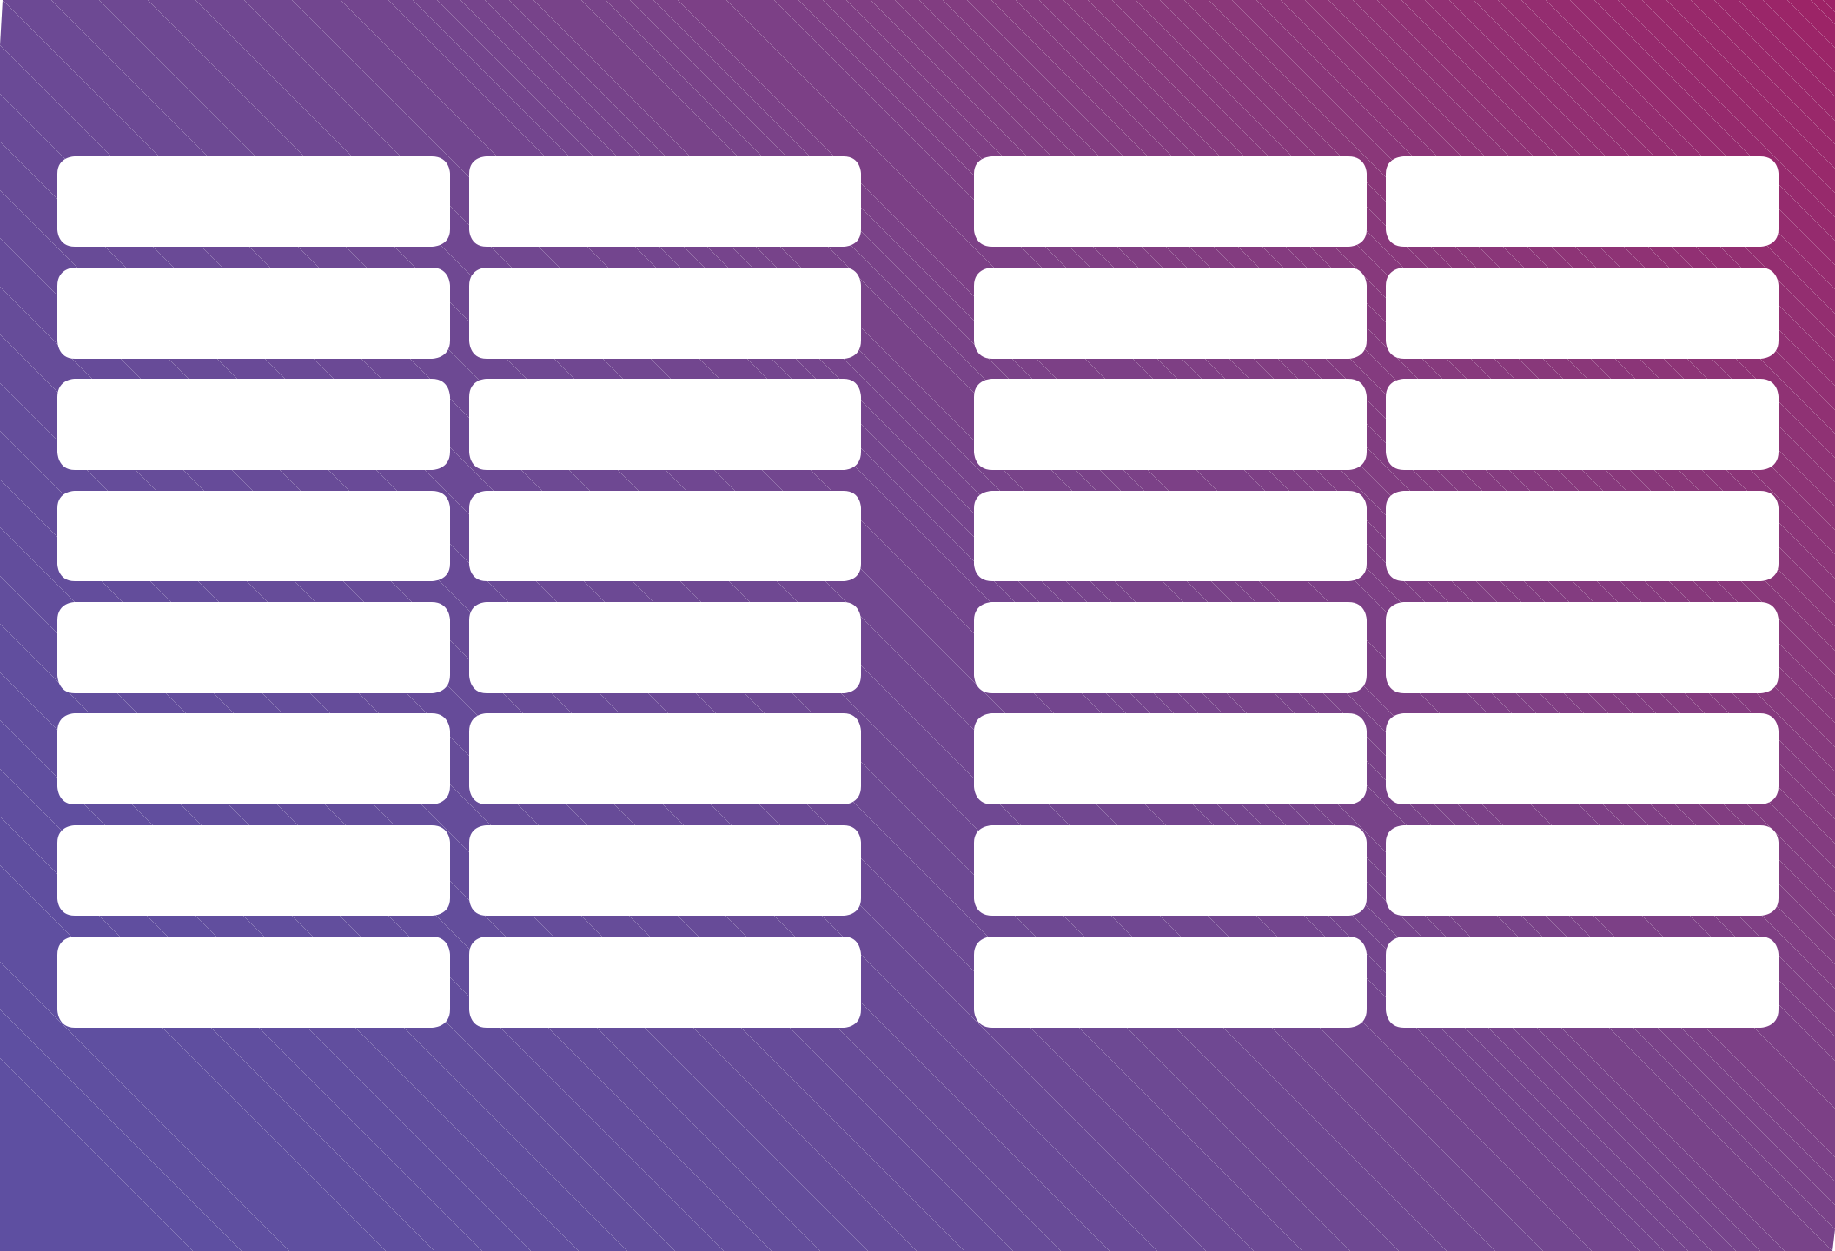
MARCH

“
We all have the ability and opportunity to cultivate gratitude. Simply take a few moments to focus on all that you have—rather than complain about all the things you think you deserve. Developing an ‘attitude of gratitude’ is one of the simplest ways to improve your satisfaction in life.”

—Amy Morin, author of 13 Things Mentally Strong People Don’t Do

“We can only be said to be alive in those moments when our hearts are conscious of our treasures.”

—Thornton Wilder, author


APRIL

“
Be thankful for what you have; you’ll end up having more. If you concentrate on what you don’t have, you will never, ever have enough.”

—Oprah Winfrey, American TV talk show host, actress, and producer

“
Expressing gratitude on a regular basis can help you appreciate your partner ather than taking his or her small favors or kind acts for granted, and that boost
in
appreciation
strengthens
your
relationship
over
time.”

—Suzann Pileggi, wellness consultant, in Scientific American


MAY

“
Piglet noticed that even though he had a Very Small Heart, it could
hold
a
rather
large
amount
of
Gratitude.”

—A. A. Milne, from Winnie-the-Pooh

“All
of us can acquire the skills necessary for happiness—gratitude, a sense of humor, perspective, acceptance, altruism, and the ability to inhabit the present moment.”

—Mary Pipher, author of The Shelter of Each Other: Rebuilding Our Families


JUNE

“
Feeling a breeze on a hot day, seeing a cloud reflected on the glass façade of a high-rise . . . watching a child play with a puppy, drinking a glass of water can all be felt as deeply satisfying experiences that enrich one’s life.”

—Mihaly Csikszentmihalyi, author of Flow: The Psychology of Optimal Experience

“Let
us be grateful to people who make us happy; they are the charming gardeners who make our souls blossom.”

—Marcel Proust, author


JULY

“Just to be is a blessing.” | ‘Thank  you’  is  the  best  prayer  that  anyone  could  say.  I  say  that  one  a  lot.
—Rabbi Abraham Joshua Heschel | Thank  you  expresses  extreme  gratitude,  humility,  understanding.”
 | —Alice Walker, author


AUGUST

“This is a wonderful day. I’ve never seen this one before.” “Five
neglected targets of gratitude: 1. Buttered toast. 2. Warm summer nights.

—Maya Angelou, author | 3. Baths. 4. Clean socks. 5. Just getting by.”
—Maya Angelou, author | —Alain de Botton, philosopher and author


SEPTEMBER

“
Reflect upon your present blessings—of which every man has plenty—not on your past misfortunes, of which all men have some.”

—Charles Dickens, author

“The
hurricane was a good reminder about gratitude. For one thing, it reminded me that I have so much to be grateful for that it seems a bit preposterous that I need to remind myself to be grateful—but I do. When life is taking its ordinary course, it’s so easy to take everyday life for granted.”

—Gretchen Rubin, author of The Happiness Project


OCTOBER

“
I don’t have to chase extraordinary moments to find happiness—it’s right in front of me if I’m paying attention and practicing gratitude.”

—Brené Brown, author of The Gifts of Imperfection

“To
be grateful in your current state, it is helpful to remember the hard times that you once experienced. When you remember how difficult life used to be and how far you have come . . . this contrast is fertile ground for gratefulness.”

—Robert Emmons, author of Thanks! How Practicing Gratitude Can Make You Happier

NOVEMBER

“Enough is as good as a feast.”

—Proverb

“It
seems like in America there’s really only one day a year that you’re supposed to
stop
and
be
grateful
for
what
it
is
that
you
actually
have.
The
other
364
days
a
year
you
run
around
trying
desperately
to
get
more
of
what
you
don’t
have
and
push
away
what
you
don’t
want.
What
I’m
suggesting
is
that
we
reverse
that
and
start
to
really
tune
into
the
miraculous
qualities
of
being
alive.”


—Jon Kabat-Zinn, author of Wherever You Go, There You Are:

Mindfulness Meditation in Everyday Life

DECEMBER

“All that we behold is full of blessings.”

—William Wordsworth, poet

“My
New Year’s resolution this year is to write down three moments of joy before I go to bed each night. This simple practice has changed my life. Because no matter what happens each day, I go to sleep thinking of something cheerful. Try it.”


—Sheryl Sandberg, Chief Operating Officer of Facebook,

at University of California at Berkeley 2016 commencement

