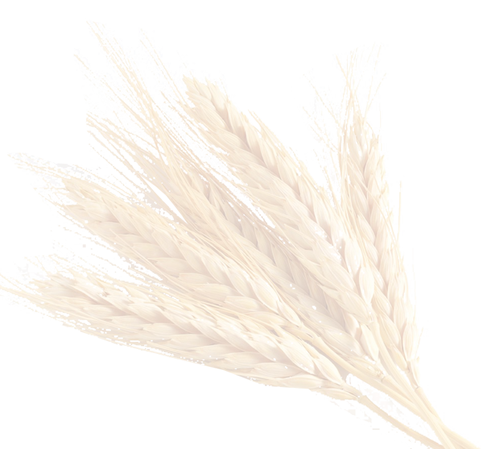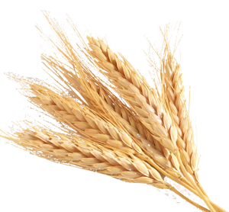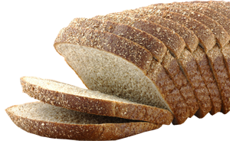

________________________________________________________________________________________________________________________________________________________________________________________________________________________________________________________________________________________________________________________________________________

**My Food Journal**

**Did you Drink 8 Glasses of Water???**

**Date: __________**

**Circle One Option**

|  |  |  |  |  |
| --- | --- | --- | --- | --- |
| **Excellent** | **Great** | **Ok** | **Not Good** | **Very Bad** |

**How Did I Do Today?**

**Day in Review**

|  |  |  |  |  |  |
| --- | --- | --- | --- | --- | --- |
| **Meal** | **Food / Drink** | **Carbs** | **Fat** | **Calories** | **Total Calories** |
| **Breakfast** |  |  |  |  |  |
|  |  |  |  |  |  |
|  |  |  |  |  |  |
|  |  |  |  |  |  |
|  |  |  |  |  |  |
|  |  |  |  |  |  |
|  |  |  |  |  |  |
| **Lunch** |  |  |  |  |  |
|  |  |  |  |  |  |
|  |  |  |  |  |  |
|  |  |  |  |  |  |
|  |  |  |  |  |  |
|  |  |  |  |  |  |
| **Supper** |  |  |  |  |  |
|  |  |  |  |  |  |
|  |  |  |  |  |  |
|  |  |  |  |  |  |
|  |  |  |  |  |  |
|  |  |  |  |  |  |
|  |  |  |  |  |  |
| **Snacks** |  |  |  |  |  |
|  |  |  |  |  |  |
|  |  |  |  |  |  |
|  |  |  |  |  |  |
|  |  |  |  |  |  |
|  |  |  |  |  |  |
| **Total for the Day** |  |  |  |  |  |