
Gratitude Journal:

Cultivating A Space for Grace


The

Well-being

warrior

InternationalAutoimmuneEncephalitisSociety


This guided gratitude journal is a science-based practice for improving your health and happiness. The journal prompts you to reflect on what you are grateful for each day.


Rooted in positive psychology, this gratitude journal encourages science-backed practices for improving your health and happiness. Gratitude, defined as “being thankful and a readiness to show appreciation for and to return kindness,” is more than an emotion.It is a quality that can be learned, exercised, and adopted to cognitively restructure our brains for greater stress relief and healing.

If you start each day by writing down 3 things you are thankful for – maybe a good cup of coffee, the smell of rain, starting a good book - you begin each day on a positive note. The things you list can be relatively small in importance (“The tasty sandwich I had for lunch today.”) or relatively large (“My sister gave birth to a healthy baby boy.”). By identifying areas of satisfaction, you are training your brain to recognize more areas of personal fulfillment moving forward.

Your goal in this exercise is to remember a good event, experience, person, or thing in your life—simply feel the emotions that come with it. By paying attention to the good things you might otherwise take for granted, you become more attuned to the everyday sources of pleasure around you, shifting your focus away from limitations and towards an outlook of abundance and possibility.

Take stock of your “gratitudes” daily – written or orally - and make it a habit to focus on the blessings you have been given! Handwritten documentation, in particular, allows you to look back on your Autoimmune Encephalitis (AE) journey and see how far you have come.

TheWell-beingWarrior'sGratitude Journal:Cultivateanattitudeofgratitude!


Three Acts of Gratitude:

dedicating time each day

Share your thoughts with family and friends, including with your IAES community. Invite others to adopt similar, small habits that can profoundly change their AE journey and narrative.

Coloring has been shown to mitigate symptoms of physical and emotional distress. Try it out! Color the front of this guide for further relaxation. (1)

Together, Warriors are rewriting the AE story from one of dead ends and suffering to one of hope and healing. You too can shift your attention to boosting gratefulness, wellbeing, and health. (2)

Spend two minutes a day scanning the world for three new things you’re grateful for over a 21-day period. We instinctively scan our environment for threats. This powerful exercise trains your brain to scan the world for positives, reinforcing more realistic patterns for perceiving your circumstances. It’s the fastest way to teach optimism. (3) 
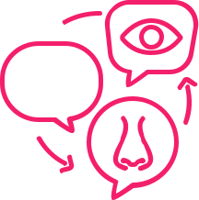

Research has shown that a person with a low-level of pessimism on day 1 of this 21-day exercise will admit to feeling a low-level of optimism by day

- After 21 days, the hope is, the path of least resistance in the brain tilts toward the new habit, rather than away from it. The goal is to re-train the brain by creating not just a daily habit but a life habit.

- A randomized, controlled trial of mindfulness-based art therapy (MBAT) for women with cancer, Daniel A Monti (et al)

- GRATITUDE, PSYCHOLOGY TODAY https://www.psychologytoday.com/us/basics/gratitude

((3) THE HAPPINESS ADVANTAGE

THE SEVEN PRINCIPLES OF POSITIVE PSYCHOLOGY THAT FUEL SUCCESS AND PERFORMANCE AT WORK by Shawn Achor(

“Feelinggratitudeandnotexpressingitislikewrappingapresent

andnotgiving it.”–WilliamArthurWard

As you Write,

here are some important tips ~


Be as specific as possible—specificity is key to fostering gratitude. “I’m grateful that my co-workers brought me soup when I was sick on Tuesday” will be more effective than “I’m grateful for my co-workers.”

Understanding what works for you is another way of knowing more about yourself. If you would like to use photos you have taken, songs that remind you of a particular time of your past, doddle, incorporate art or the use of colorful pens and more!

Get personal. Focusing on people to whom you are grateful has more of an impact than focusing on things for which you are grateful.

Try subtraction, not just addition. Consider what your life would be like without certain people or things, rather than just tallying up all the good stuff. Be grateful for the negative outcomes you avoided, escaped, prevented, or turned into something positive—try not to take that good fortune for granted.

See good things as “gifts.” Thinking of the good things in your life as gifts guards against taking them for granted. Try to relish and savor the gifts you’ve received.

Savor surprises. Try to record events that were unexpected or surprising, as these tend to elicit stronger levels of gratitude.

Revise if you repeat. Writing about some of the same people and things is OK, but zero in on a different aspect in detail.

Find a space that you are comfortable with when writing in your gratitude journal.

Commit to a regular time to journal, then honor that commitment.

“We mustfind timetostop and thank thepeoplewhomakeadifference inourlives.”

~ JohnF. Kennedy

THE WELL-BEING WARRIOR'S
GRATITUDE JOURNAL

DATE:

INTENTION FOR THE DAY
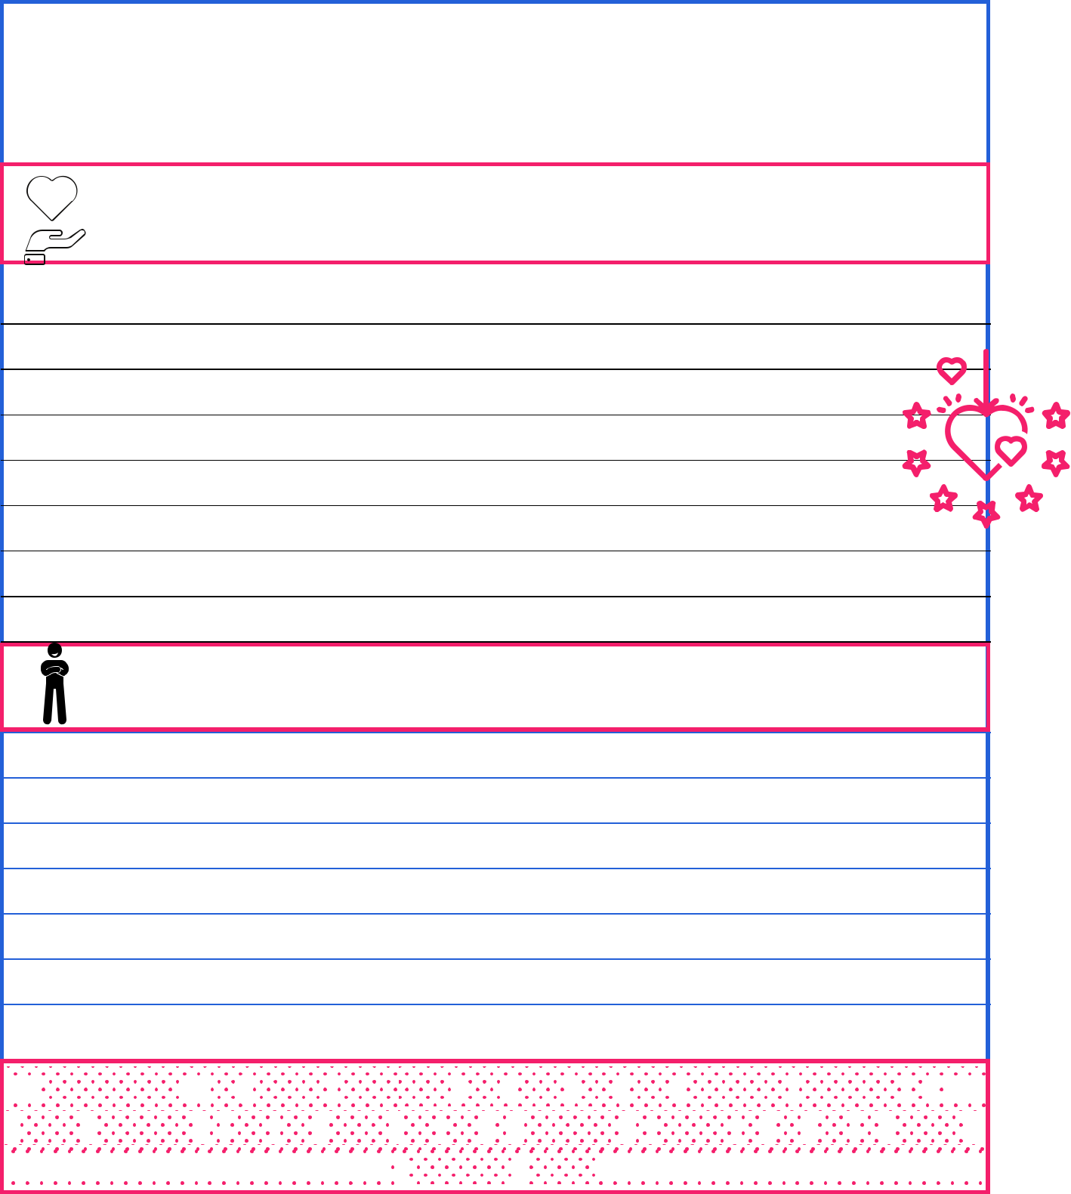

Start each day by writing down 3 things you are thankful for - a good cup of coffee, the smell of rain, starting a good book - begin each day on a positive note. The goal of the exercise is to remember a good event, experience, person, or thing in your life—then enjoy the good emotions that come with it.

I am grateful for

Proud moment of the day

“For my part,Iamalmostcontentedjustnow, andverythankful. Gratitudeisa

divineemotion:itfillsthe heart,butnot tobursting;itwarmsit, butnottofever."

~Charlotte Bronte

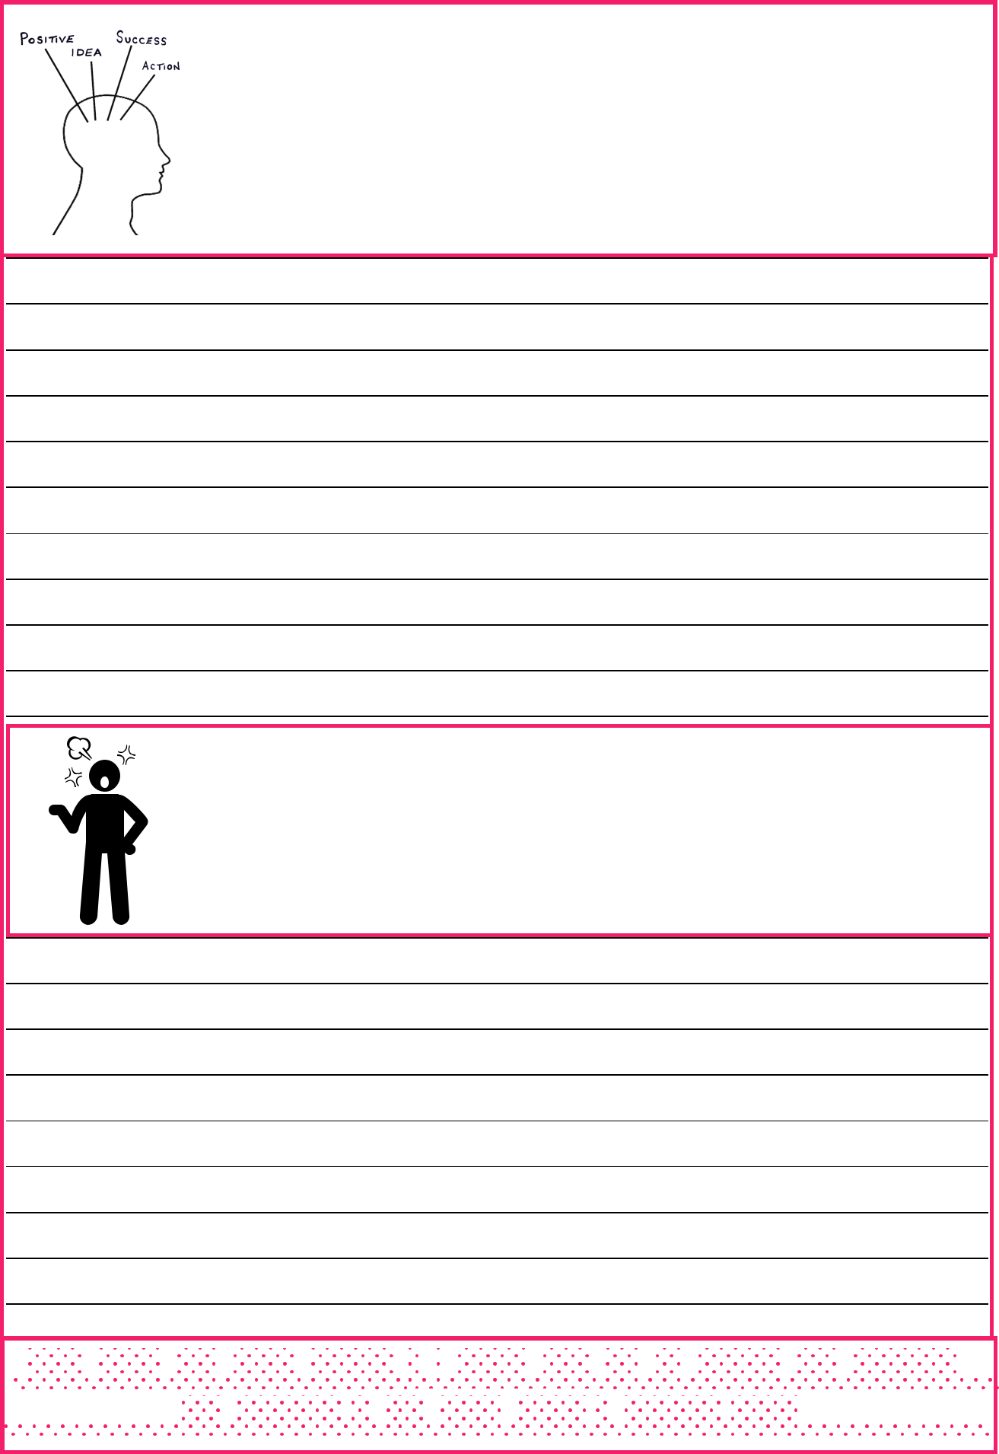
What was challenging today? Is there a viewpoint that changes my story from a negative to a positive?

Let it out and let it go

“The heartthatgivesthanksisahappyone,forwecannotfeelthankfulandunhappyatthesametime.”~DouglasWood
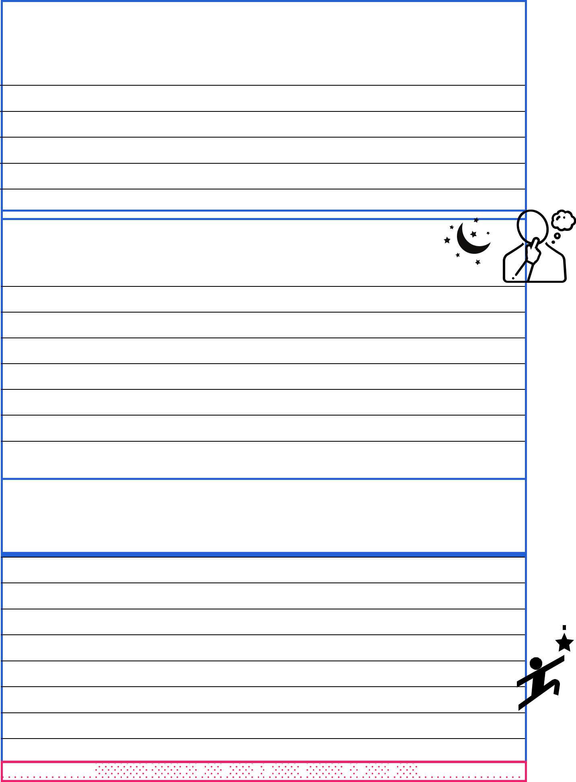
Things I did differently today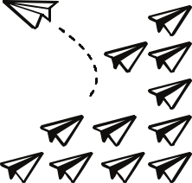

Nightly reflections

Tomorrow’s Intentions

Gratitudehelps usseewhatisthereinsteadofwhatisn’t.

