

 Choose 

Gratitude

A Gratitude Journal

garmentsofsplendor.com



Choose
Thankfulness
Grateful for...

______________________________

______________________________

______________________________

______________________________

______________________________

______________________________

______________________________

______________________________

______________________________

______________________________

Praises

Date

Scripture

Notes



Choose
Thankfulness
Grateful for...

______________________________

______________________________

______________________________

______________________________

______________________________

______________________________

______________________________

______________________________

______________________________

______________________________

Praises

Date

Scripture

Notes




30 | ofDays | Date
Gratitude |  | _____________________________
_____________________________ |  | _____________________________
_____________________________ |  | _____________________________
_____________________________ |  | _____________________________
_____________________________ |  | _____________________________
_____________________________ |  | _____________________________
_____________________________ |  | _____________________________
_____________________________ |  | _____________________________
_____________________________ |  | _____________________________
_____________________________ |  | _____________________________
_____________________________ |  | _____________________________
_____________________________ |  | _____________________________
_____________________________ |  | _____________________________
_____________________________ |  | _____________________________
_____________________________ |  | _____________________________
_____________________________ |  | _____________________________
_____________________________ |  | _____________________________




 |  | Scriptures
Date |  | Scriptures
Date |  | of

Thanksgiving


42
Scriptures
on Thanksgiving

1. Psalm 69:30

2. Psalm 95:2

3. Psalm 100:4

4. Psalm 7:17

5. Psalm 8:2

6. Psalm 9:11

7. Psalm 13:6

8. Psalm 18:3

9. Psalm 21:13

10. Psalm 26:12

11. Psalm 28:6-7

12. Psalm 34:1

13. Psalm 100:1-2

14. Psalm 42:5

15. Philippians 4:6


16. Colossians 3:17

17. 1 Timothy 4:4

18. Ephesians 1:16

19. 1 Thessalonians 1:2

20. Psalm 50:14

21. Psalm 95:2–3

22. Psalm 105:1–2

23. Psalm 107:1, 8–9

24. Psalm 136:1-4

25. Psalm 136:26

26. Psalm 147:7

27. Isaiah 12:1, 4–5

28. Amos 4:5

29. Daniel 2:23

30. Jeremiah 30:19

31. Jeremiah 33:11

32. John 6:11

33. 1 Corinthians 15:57

34. 2 Corinthians 4:15

35. 2 Corinthians 9:11

36. Revelation 11:17

37. Numbers 6:24–26

38. Ruth 1:8
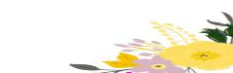

39. Ruth 2:12

40. 2 Samuel 2:6

41. Psalm 141:2

42. 1 Peter 1:6–7



Date ^{My} _{Family} 


Date ^{My} _{Family} 
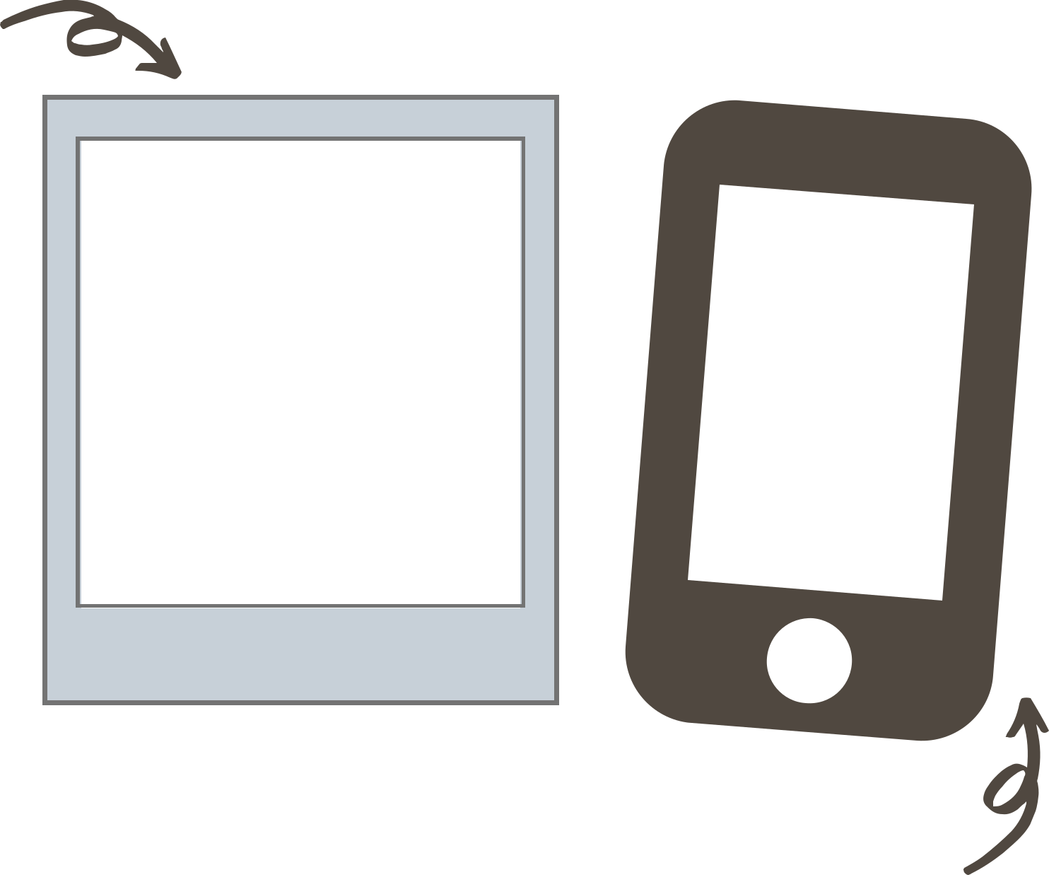

Favorite Memories

____________________________________________________________________

____________________________________________________________________

____________________________________________________________________

____________________________________________________________________

____________________________________________________________________




Date

Blessed


______________________________________________________

______________________________________________________

______________________________________________________

______________________________________________________

______________________________________________________

______________________________________________________

______________________________________________________

______________________________________________________

______________________________________________________

______________________________________________________

______________________________________________________

______________________________________________________

______________________________________________________

______________________________________________________


______________________________________________________

______________________________________________________

_____________________________________________________

Date

Blessed

______________________________________________________

______________________________________________________

______________________________________________________

______________________________________________________

______________________________________________________

______________________________________________________

______________________________________________________

______________________________________________________

______________________________________________________

______________________________________________________

______________________________________________________

______________________________________________________

______________________________________________________

______________________________________________________

______________________________________________________

______________________________________________________

_____________________________________________________

