

Gratitude

Template

by Rachel Havekost

Prompts for cultivating Gratitude, Appreciation, and Joy.

@rachel_havekost www.rachelhavekost.com

  Gratitude | 2

journaling template

Gratitude

Gratitude is the act of appreciating and being thankful for what we have in life.

By focusing on what we already have, experience, or

know, we cultivate deeper connections to what is already within our grasp, rather than reaching for or longing for what we don't have.

Focusing on what is gives us a sense of peace,

contentment, and joy.

Focusing on what is not gives us a sense of anxiety,

despair, and hopelessness.

Gratitude is show to:

Increase joy

Improve relationships

Increase patience

Improve sleep

Decreases depression

Increase endurance

@rachel_havekost www.rachelhavekost.com

  Gratitude | 3

journaling template

Gratitude

Over the next 4 days, you'll be invited to express gratitude in a variety of areas of life.

You'll also be asked to check in with your emotions before and after this journaling experience, so you can witness the impact of a simple gratitude practice.

Tips:

Use the feelings wheel at the end of this template to help when identifying emotions!

When writing your gratitude statements, I encourage you to ALWAYS begin with “I am grateful for” or “I am grateful to,” etc, rather than just listing
what you are grateful for.

Be specific. Instead of, “I am grateful that I have a job,” try, “I am grateful that I have a steady, stable job that I am good at.”

Don't take this or yourself too seriously. Find humor. Be silly. You can be grateful for random crap and you can make gratitude statements about that one nose hair that keeps growing back. This is about generating self-love, excitement, and JOY in your life. It is about getting more grounded in YOUR skin—it is NOT about making you someone or something you’re not.
So make this yours.

@rachel_havekost www.rachelhavekost.com

  Gratitude | 4

journaling template

Pre-Practice

Answer these questions before beginning this 4 day practice. If you can, be really honest. And, be kind with yourself as you do this. It might feel upsetting to see how you feel now, and that's ok! This practice will help shift some of these responses.

How do I feel about myself?

How do I feel about others in my life?

How do I feel about my enviornment or living situation?

How do I feel about my day to day life?

@rachel_havekost www.rachelhavekost.com

Gratitude | 5

journaling template

Day One

Growth & Overcoming

Gratitude for How I’ve Grown

Write three gratitude statements about ways in which you have grown over the last year, and why you are grateful for that growth.

1.

2.

3.

Gratitude for Challenges I’ve Faced

Write three gratitude statements for challenges you’ve faced, and why you are grateful for them.

1.

2.

3.

@rachel_havekost www.rachelhavekost.com

Gratitude | 6

journaling template

Day Two

Relationshps & Others

Gratitude for Friends (online counts!)

Write gratitude statements for three different friends, and why you are grateful for them over this past year.

1.

2.

3.

Gratitude for Family

Write gratitude statements for three different family members, and why you are grateful for them over this past year.

1.

2.

3.

@rachel_havekost www.rachelhavekost.com

Gratitude | 7

journaling template

Day Three

Occupation, Vocation, or Passion

Gratitude for Job/Work

Write three gratitude statements about your current job, OR, if you are not working, gratitude for what you're experiencing in the absence of work (I know this might feel really challenging, and I want to acknowledge that.)

1.

2.

3.

Gratitude for Passion

Write three gratitude statements what you are passionate about, interested in, or have a hobby for.

1.

2.

3.

@rachel_havekost www.rachelhavekost.com

Gratitude | 8

journaling template

Day Four

Self

Gratitude for My Body

Write three gratitude statements for your body.

1.

2.

3.

Gratitude for My Personality

Write three gratitude statements about your personality.

1.

2.

3.

@rachel_havekost www.rachelhavekost.com

Gratitude | 9

journaling template

Post-Practice

Answer these questions before beginning this 4 day practice. If you can, be really honest. And, be kind with yourself as you do this. It might feel upsetting to see how you feel now, and that's ok! This practice will help shift some of these responses.

How do I feel about myself?

How do I feel about others in my life?

How do I feel about my enviornment or living situation?

How do I feel about my day to day life?

@rachel_havekost www.rachelhavekost.com

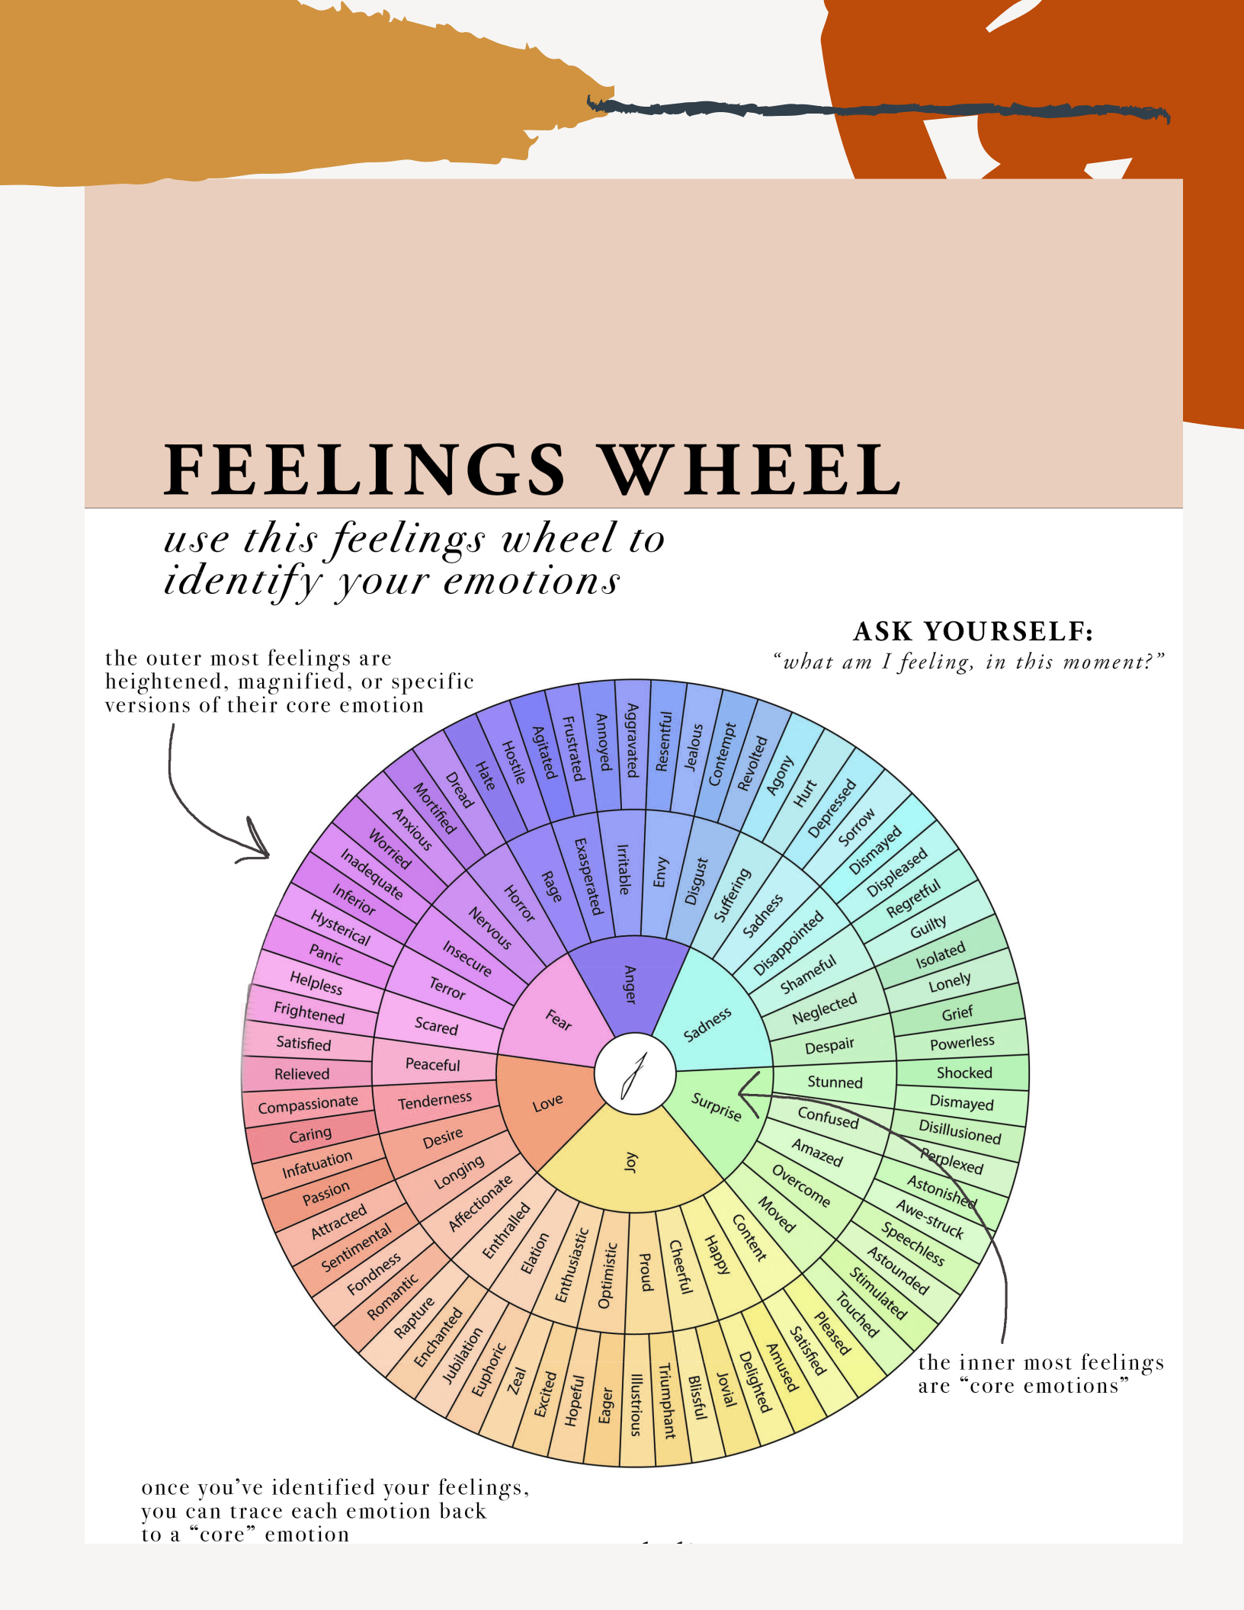

@rachel_havekost www.rachelhavekost.com

