Proven products from ProLabs® helps your

customers protect dogs and cats of all

ages from major pet pests and diseases.

DOGS & PUPPIES

Worm Protector®

- Removal of large roundworms and hookworms in dogs and puppies.
- Also used to prevent reinfection of Toxocara canis and Toxascaris leonina.

2X DOUBLE STRENGTH

SAFE, EASY, GENTLE, ECONOMICAL
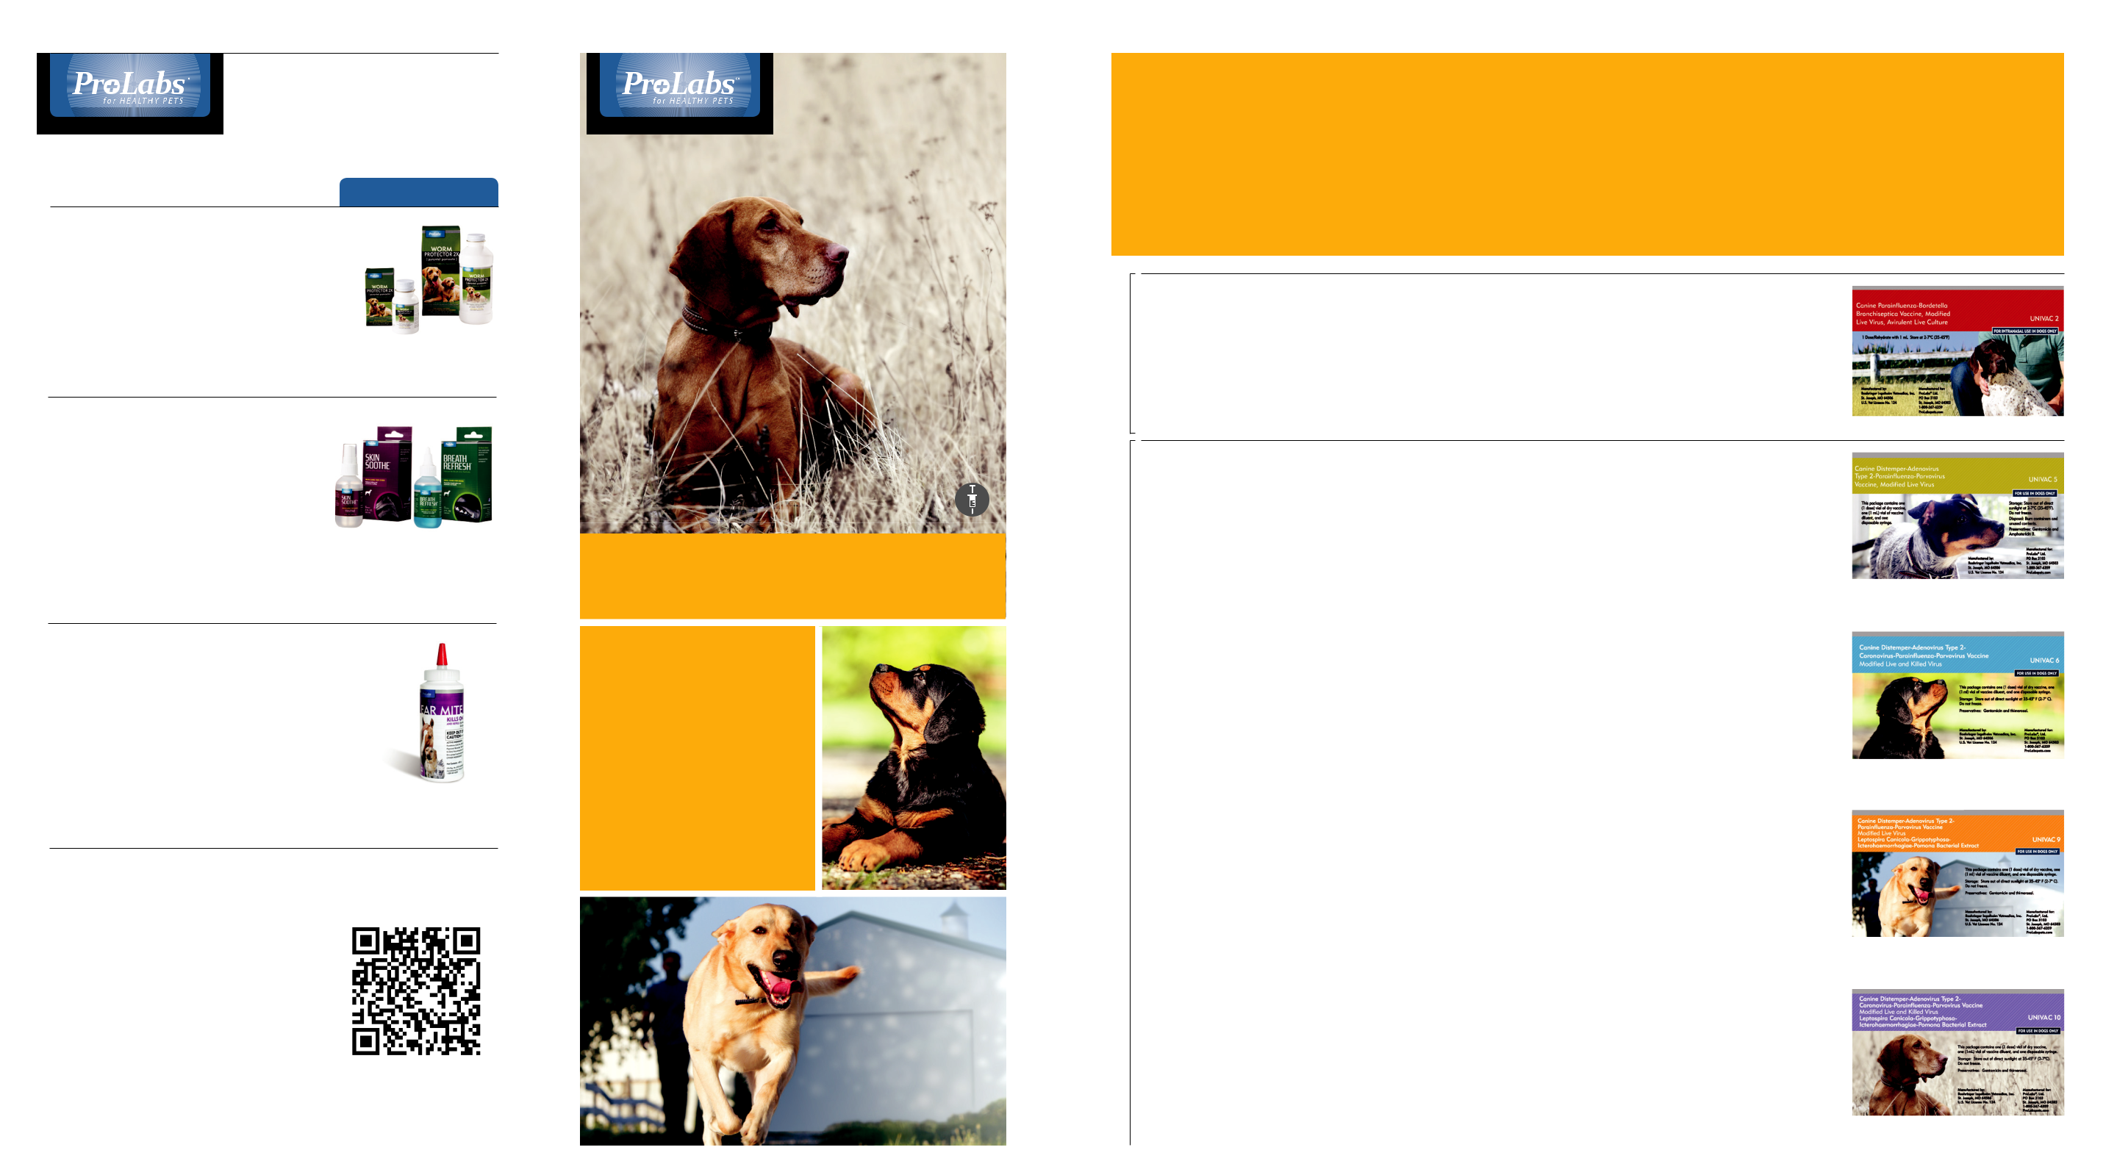

You can count on the ProLabs® family of pet vaccines to give you the convenience of at-home vaccinations to protect dogs from major diseases. Quality vaccines from ProLabs means healthier pets with big savings for pet owners.

INTRANASAL | UNIVAC 2 | For protection against: | Each package
INTRANASAL | UNIVAC 2 | For protection against: | includes everything
INTRANASAL | Vaccinate dogs and puppies | • Canine parainfluenza | you need to vaccinate
INTRANASAL | Vaccinate dogs and puppies | • Bordetella | your dog
INTRANASAL | against Canine Upper Respiratory | • Bordetella | • One (1 dose) vial
INTRANASAL | against Canine Upper Respiratory | bronchiseptica | of dry vaccine
DOSE | against Canine Upper Respiratory | bronchiseptica | of dry vaccine
DOSE | Infection (Kennel Cough). | bronchiseptica | • One (1 mL) vial
DOSE | Infection (Kennel Cough). |  | of vaccine diluent
SINGLE |  |  | • One pipette
SINGLE |  |  | • Instructions

ProLabs Skin Soothe TM and Breath Refresh TM

- Skin Soothe and Breath Refresh

harness the powerful therapeutic benefits and natural healing power of zinc.
- Zinc is an essential trace element that is critical to the health of many body functions including those that support proper skin and oral care.

THE POWER

OF ZINC®

UNIVAC VACCINES

UNIVAC 5 | For protection against: | • Canine parainfluenza | Each package
UNIVAC 5 | For protection against: | • Canine parainfluenza | includes everything
Univac 5 protects healthy dogs and | • Canine distemper | • Canine parvovirus | you need to vaccinate
Univac 5 protects healthy dogs and | • Canine distemper |  | your dog
puppies six weeks of age or older | • Canine Adenovirus |  | • One (1 dose) vial
puppies six weeks of age or older | • Canine Adenovirus |  | of dry vaccine
against five major diseases. | Type 1 |  | • One (1 mL) vial
 | • Canine Adenovirus |  | of vaccine diluent
 | • Canine Adenovirus |  | • One syringe
 | Type 2 |  | • One syringe
 | Type 2 |  | • Instructions
UNIVAC 6 | For protection against: | • Canine parvovirus | Each package
UNIVAC 6 | For protection against: | • Canine parvovirus | includes everything

Ear Mite Killer

- Kills and repels ear mites, flies, gnats, mosquitoes, fleas, ticks, lice, and mange mites on exposed surfaces for 3 to 5 days.

- For use on dogs, puppies, cats, kittens, horses and foals.

TREATS MULTIPLE SPECIES

Vaccine Preparation and Injection Process

For a quick video on vaccine preparation and the injection process, scan the QR code with your mobile device.

800-542-8916 P.O. Box 3103 | St. Joseph, MO 64503 | ProLabspets.com

CANI-0061 Rev 0

KEEPING DOGS

HEALTHY WITH

VACCINATIONS

AT HOME

 |  | Univac 6 protects healthy dogs and | • Canine distemper | • Canine coronavirus | you need to vaccinate
 |  | Univac 6 protects healthy dogs and | • Canine distemper |  | your dog
 |  | puppies six weeks of age or older | • Canine Adenovirus |  | • One (1 dose) vial
 |  | puppies six weeks of age or older | • Canine Adenovirus |  | of dry vaccine
INJECTABLES |  | against six major diseases. The use of | Type 1 |  | • One (1 mL) vial
INJECTABLES |  | Univac 6 is ideal in situations where | • Canine Adenovirus |  | of vaccine diluent
INJECTABLES |  | Univac 6 is ideal in situations where | • Canine Adenovirus |  | • One syringe
INJECTABLES |  | Lepto is not needed nor recommended. | Type 2 |  | • Instructions
INJECTABLES |  |  | • Canine parainfluenza
DOSE |  | UNIVAC 9 | For protection against: | • Canine parvovirus | Each package
DOSE |  | UNIVAC 9 | For protection against: | • Canine parvovirus | includes everything
SINGLE |  | Univac 9 protects healthy dogs and | • Canine distemper | • Leptospira canicola | you need to vaccinate
SINGLE |  | Univac 9 protects healthy dogs and | • Canine distemper | • Leptospira | your dog
SINGLE |  | puppies six weeks of age or older against | • Canine Adenovirus | • Leptospira | • One (1 dose) vial
 |  | puppies six weeks of age or older against | • Canine Adenovirus | grippotyphosa | of dry vaccine
 |  | nine major diseases. | Type 1 | grippotyphosa | • One (1 mL) vial
 |  | nine major diseases. | Type 1 | • Leptospira | • One (1 mL) vial
 |  |  | • Canine Adenovirus | • Leptospira | of vaccine diluent
 |  |  | Type 2 | icterohaemorrhagiae | • One syringe
 |  |  | Type 2 | icterohaemorrhagiae | • Instructions
 |  |  | • Canine parainfluenza | • Leptospira pomona
 |  | UNIVAC 10 | For protection against: | • Canine parvovirus | Each package
 |  | UNIVAC 10 | For protection against: | • Canine parvovirus | includes everything
 |  | Univac 10 protects healthy dogs and | • Canine distemper | • Canine coronavirus | you need to vaccinate
 |  | Univac 10 protects healthy dogs and | • Canine distemper | • Leptospira canicola | your dog
 |  | puppies six weeks of age or older | • Canine Adenovirus | • Leptospira canicola | • One (1 dose) vial
 |  | puppies six weeks of age or older | • Canine Adenovirus | • Leptospira | of dry vaccine
 |  | from ten major diseases. | Type 1 | • Leptospira | • One (1 mL) vial
 |  | from ten major diseases. | Type 1 | grippotyphosa | • One (1 mL) vial
 |  |  | • Canine Adenovirus | grippotyphosa | of vaccine diluent
 |  |  | Type 2 | • Leptospira | • One syringe
 |  |  | Type 2 | • Leptospira | • Instructions
 |  |  | • Canine parainfluenza | icterohaemorrhagiae
 |  |  |  | • Leptospira pomona

 |  |  |  | HEALTHY | WITH | VACCINATIONS | A T | H | M E
 | KEEPING DOGS



ProLabs Canine Vaccination Record
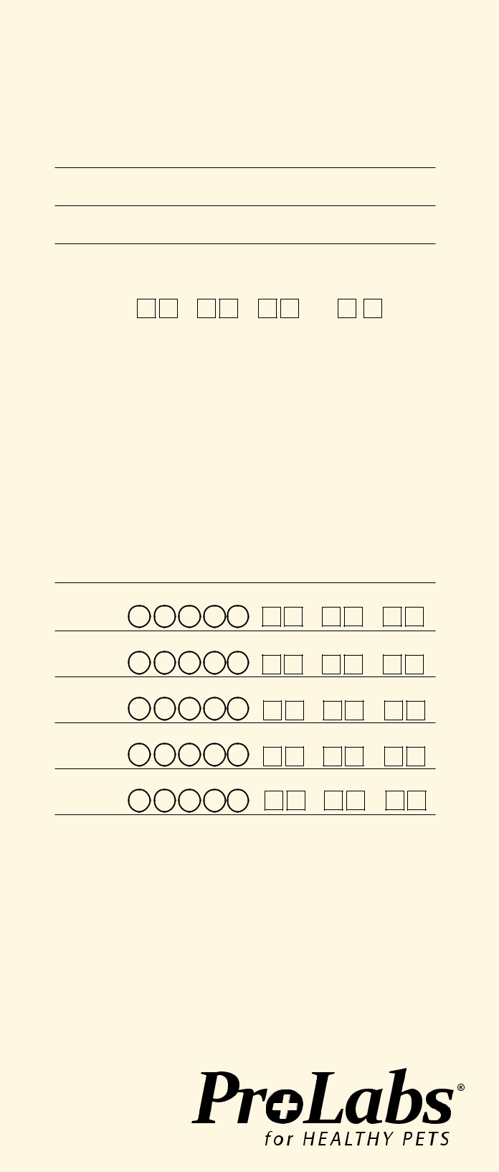

Dog’s Information

Name

Veterinarian

(if applicable)

Registration # & Association

Guide to canine vaccinations

ProLabs offers USDA approved vaccines for use in healthy dogs to protect them against disease. See the listing (above right) for a complete list of vaccination protections.
• Univac 5, 6, 9 & 10 contain a combination of immunogenic, attenu-

ated strains of Canine Distemper, Canine Adenovirus Type 2 (CAV-2),

Canine Parainfluenza and Canine Parvovirus Type 2b, propagated in

cell line tissue cultures

• Vaccines packaged in individually wrapped, tamper-proof polybags for

protection from contamination

• Vaccines are intended to be administered to healthy animals. Animals

Vaccination schedule

Vaccinating your dog with the UNIVAC family of vaccines is simple. The age of your dog at the time you received them will determine the number of shots needed in their vaccination schedule.
Puppies sixteen weeks or younger

Vaccinate healthy puppies at 2-3 week intervals until at least sixteen weeks of age. Give at least 2 doses.
Dogs over twelve weeks

Vaccinate with 1 initial dose and a 2nd dose 2-3 weeks later. Annual revaccination with a single dose is recommended.

Recommended | Recommended | Basic | If Lepto | If Coronavirus | If Lepto &
doses | Age of | Vaccination | is a concern | is a concern | Coronavirus
 | Vaccination | Program |  |  | is a concern
First | 6-8 weeks | UNIVAC 2 & | UNIVAC 2 & | UNIVAC 2 & | UNIVAC 2 &
 |  | UNIVAC 5 | UNIVAC 5 | UNIVAC 6 | UNIVAC 6
Second | 9-11 weeks | UNIVAC 5 | UNIVAC 5 | UNIVAC 6 | UNIVAC 6
Third | 12-14 weeks | UNIVAC 5 | UNIVAC 9 | UNIVAC 6 | UNIVAC 10
Fourth | 15-17 weeks | UNIVAC 5 | UNIVAC 9 | UNIVAC 6 | UNIVAC 10
 | Annual Booster | UNIVAC 5 & | UNIVAC 9 & | UNIVAC 6 & | UNIVAC 10 &
 | For dogs with previous | UNIVAC 2 | UNIVAC 2 | UNIVAC 2 | UNIVAC 2
 | vaccination history


Breed |  | Markings
Date of Birth | / | / | Sex M F
Owner’s Information
Name
Address
City |  | St | ZIP
Phone |  | Email
Vaccination Record

incubating any disease or stressed due to shipping, malnutrition or

parasitism may not achieve or maintain an adequate immune response

• Univac 2 is an easy to administer intranasal vaccine that protects your

dog against Canine Upper Respiratory Infection (Kennel Cough) caused

by canine parainfluenza and Bordetella bronchiseptica

Vaccine handling Vaccines are biological products and should always be handled according to directions. Keep the vaccines refrigerated until used. Never reuse a needle or syringe and safely discard them immediately after use.

COMMON CANINE DISEASES

Choosing the
right vaccine

Vaccine choices are based upon the age

of a dog, knowledge of the diseases

prevalent in your area, risk of exposure

to disease, and the health status of the

pet. Many diseases can be easily prevented

through routine vaccinations.

The chart (at right), outlines the most important diseases for which vaccines are useful and available.

 | UNIVAC 2 |  | UNIVAC 5 |  | UNIVAC 6 |  | UNIVAC 9 |  | UNIVAC 10
Bordetella | x
Parainfluenza | x |  | x |  | x |  | x |  | x
Distemper |  |  | x |  | x |  | x |  | x
Adenovirus types 1 & 2 |  |  | x |  | x |  | x |  | x
Parvovirus |  |  | x |  | x |  | x |  | x
Coronavirus |  |  |  |  | x |  |  |  | x
Leptospira canicola |  |  |  |  |  |  | x |  | x
Leptospira grippotyphosa |  |  |  |  |  |  | x |  | x
Leptospira icterohaemorrhagiae |  |  |  |  |  |  | x |  | x
Leptospira pomona |  |  |  |  |  |  | x |  | x

Age | UNIVAC Vaccine(s) |  |  |  |  | Immunization Date
1st dose (shot) | Check all that apply
6-8 wks | 2 | 5 | 6 | 9 | 10 | / | /
2nd dose (shot) | Check all that apply
9-11 wks | 2 | 5 | 6 | 9 | 10 | / | /
3rd dose (shot) | Check all that apply
12-14 wks | 2 | 5 | 6 | 9 | 10 | / | /
4th dose (shot) | Check all that apply
15-17 wks | 2 | 5 | 6 | 9 | 10 | / | /
Annual | Check all that apply
Booster | 2 | 5 | 6 | 9 | 10 | / | /

Coronavirus | tions, dog shows or frequent a groomer.
Coronavirus infection is a highly conta- | Kennel cough is generally not fatal, but

and upper respiratory systems. Puppies are especially vulnerable to canine distemper

Canine Adenovirus

The two common types of adenoviruses

Vaccination is easy!
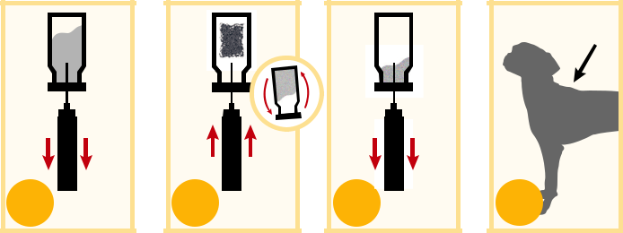

gious disease of puppies that primarily does result in a prolonged hacking cough

attacks the intestinal tract and is more that can irritate both dog and owner.

severe when combined with other viruses Canine Parainfluenza

such as parvo. The disease is spread from This virus affects the respiratory system

dog to dog through contact with feces. and is often associated with kennel cough.

Canine Bordetella This condition is generally mild but can

This bacteria is the primary cause of severely affect puppies and debilitated dogs.

kennel cough. It is highly contagious and Canine Distemper

spread via close contact with infected This virus is widespread globally. All

dogs. This vaccine is recommended for puppies and adult dogs should be

dogs that come in contact with other regularly vaccinated. Distemper is highly

dogs, especially those that are kenneled, contagious, affecting the neurological

attend day care, are involved in competi-

and its onset is often fatal.

Canine Parvovirus

This hardy, highly contagious virus can persist for long periods and is difficult to eliminate. Exposure occurs through contact with infected fecal matter. The virus usually results in bloody diarrhea, vomiting, abdominal pain and fever. Vaccination is an important means of preventing this disease.

affecting dogs are CAV-1 and CAV-2. CAV-1 causes infectious hepatitis, which is cross-protected by CAV-2.

Canine Leptospirosis

Leptospira bacteria are spread through the infected urine of such animals as dogs, cattle, pigs and rodents. They thrive

in wet areas. Regular vaccination is recom-mended for dogs likely to be exposed to the urine of other dogs, wild animals or wet environments.

1 

Fill syringe with

the liquid.

2

Inject the liquid into the dry vaccine and shake well.

3

Fill syringe with

entire mixture.

- See packaging for complete instructions.

*

4

Prepare injection site

with antiseptic & inject

entire syringe contents

subcutaneously.
Vaccination record-keeping is very important.

For your convenience you may download a more extensive vaccination record form at www.prolabspets.com.

