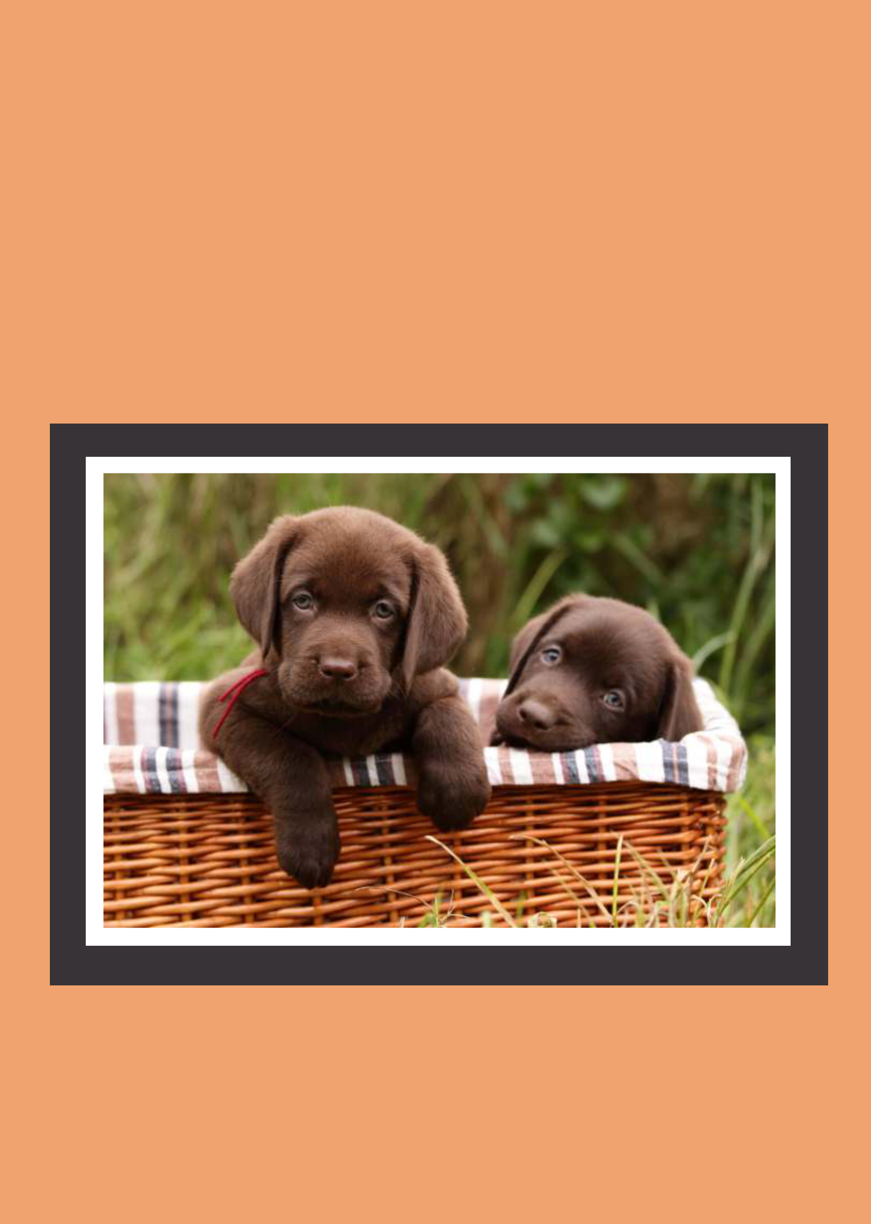

Caring for your
puppy
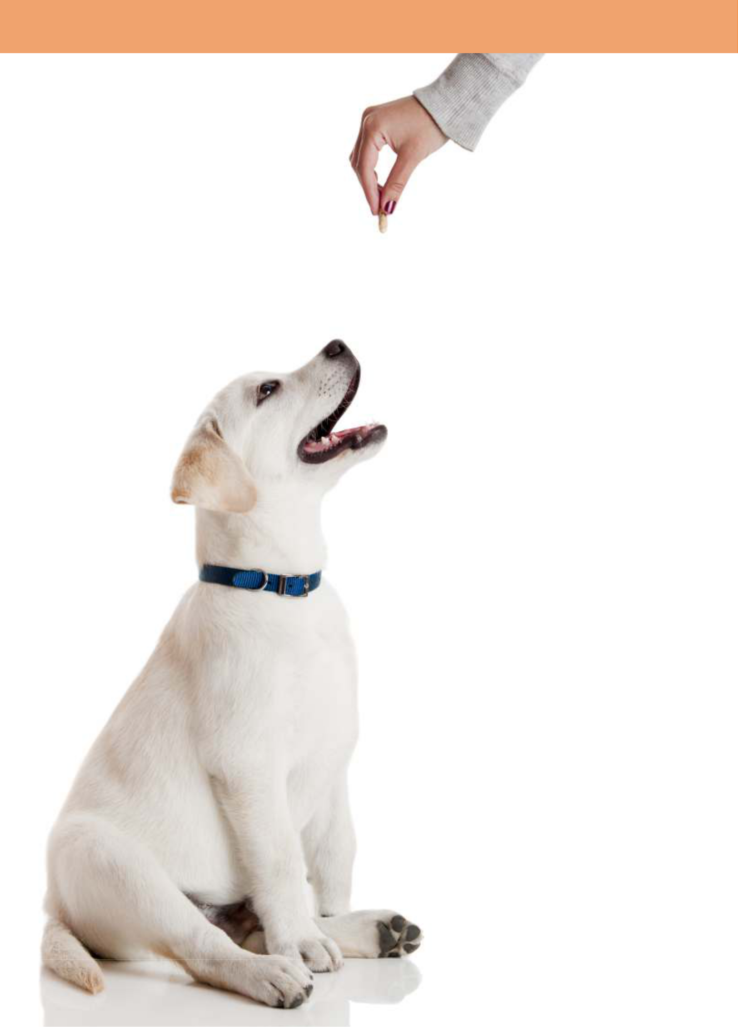

“If you think

dogs can’t

count, try

putting

three dog

biscuits in

your pocket

and then

give him

only two of
them ”
Phil Pastorer

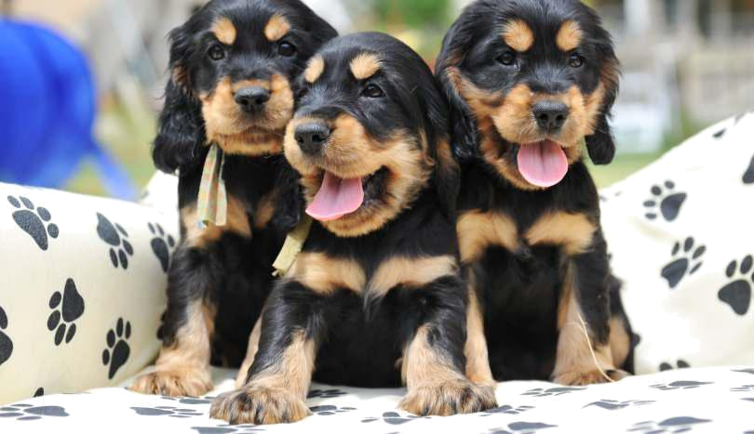

at a glance

VACCINATIONS

1st: 6 - 8 weeks
2nd: 10 -12 weeks
3rd: 14 - 16 weeks
Adult booster: 15-16 months
- Kennel Cough - every year.
- Distemper, Hepatitis, Parvovirus - Every year or every 3 years. We will advise the best plan for your pet.

WORMING - INTESTINAL

žEvery two weeks until 12 weeks of age, then žEvery month until 6 months of age, then žEvery three months for life

HEARTWORM PREVENTION

Start heartworm prevention before your pup reaches 12 weeks of age or at the time of his second vaccination. There are several different types of heartworm preventative available. We will discuss the best type for your pup during your consultation.

FLEA CONTROL

Start your pup on flea control immediately. Fleas breed fast so a good quality flea control product is essential. We will advise you on the most effective and safest flea control for your pup.

TICKS

Ticks live in bushland areas but can be carried through to suburban areas via possums and bandicoots. There are several different products on

the market for tick prevention. A monthly spot on formula is now available and is excellent in the prevention of ticks but we will advise you on the best tick prevention for your pup.

NUTRITION

Start feeding your pup a good quality dry food the moment you get him home. Although not essential, if you would like to give your puppy milk, make sure it is lactose free. Your pup will be teething so give him something to chew on like rubber chew toys. Ensure that fresh water is available at all times.

DESEXING

Have your pet desexed by 6 months of age. It is at this age that your pup will reach sexual maturity. Too many animals are already being destroyed due to the lack of good homes, please be responsible and do not add to this growing problem. Desex your pet.

PET INSURANCE

Accidents and illness happen and at unexpected times, so make sure you are prepared. If you would have trouble paying an emergency veterinary bill then you should have pet insurance. Owning a dog carries a lot of responsibility and one of those responsibilities is to take care of his health needs.

Ask one of our staff for a brochure on pet insurance and relax knowing that if your pet needs veterinary attention you have it covered.
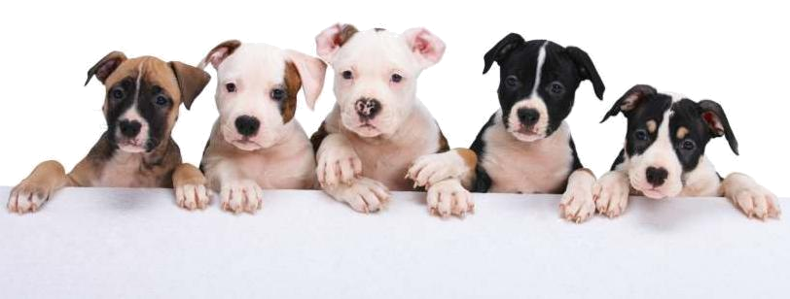

personal health records

for: ..........................................................................................................

vaccination dates

1st Vaccination 2nd Vaccination 3rd Vaccination Adult booster

........................................ ........................................ ........................................ ........................................


INTESTINAL | HEARTWORM | FLEA CONTROL/ | OTHER
MONTH | PREVENTION | TICK PREVENTION | OTHER
WORMING | PREVENTION | TICK PREVENTION
PRODUCT
USED

Jan

Feb

Mar

Apr

May

Jun

Jul

Aug

Sep

Oct

Nov

Dec

Print out this page and fill it in



essentials

TEMPORARY PLAYPEN

A temporary playpen is essential for house-training your pup. You can purchase a puppy playpen or a children’s playpen will do just fine, as long as your pup can’t get through the ‘gaps’. Your puppy should be placed in this area when you cannot keep both eyes on him, like when you are cooking dinner or having a shower. If your puppy is confined, his toileting will be confined also. If your pup will be an outdoor dog, a playpen will not be necessary, as they will not need to be toilet trained in the house. To have your pup inside or outside is a personal choice.

PLENTY OF CHEW TOYS

The best chew toy allows food to be stuffed into it and are made of rubber. Brands like “Kong” are great options. It is best to have approximately 5 chew toys so you can rotate them daily.

TOILET

You can simply use newspaper in layers on the floor (in one area only, not placed all over the room) or for those who want to do it by the book, the best toilet is a cat litter tray with some turf or a special ‘doggy toilet’ which is like fake grass over the top of a grate and are easy to clean.

TREATS

Liver treats are the best as you can put a few in your pocket without ruining your clothes while training your pup, but remember they are a treat. Feeding your puppy a lot of liver will give him diarrhoea. You can also set aside some of his dry food ration to use as treats throughout the day.

LEAD AND COLLAR

For those who have a medium to large breed puppy (german shepherd, border collie etc) choose a collar, which can be adjusted so it will last longer. 'Check chains' or 'choka chains' as they are more commonly known, are not recommended for young puppies.

FOOD

A good quality dry food is best and is available here at the practice. Good quality foods are complete and balanced for all of your pups needs. Some pet foods may not be as balanced or meet all of your puppy's requirements.

HISTORY

Try and get as much history as possible about your puppy and make sure you get all health records with information such as worming tablets, vaccinations, flea control used etc. If you do not have access to this information, it is best to assume nothing has been done and start your puppy's health regime from scratch. If you are unsure at any time what you should be doing for your puppy, call the practice and speak to one of our nurses.

PATIENCE

Your pup is going to make mistakes, please try to be patient! Most of the ‘naughty’ things your puppy is doing, are not ‘naughty’ at all, they are natural puppy behaviours. It is up to you to teach your puppy right from wrong in the human world. Puppy classes are perfect for teaching your pup some manners. Speak to one of our nurses about these classes.

KENNEL

If your pup will be sleeping outside, a good kennel will be required to provide shelter, warmth and security. Choose one with a good roof so when it rains your pet stays dry and the kennel should be large enough for your pet to lie down in when he is an adult. Dogs do feel the cold so provide them with some warm bedding as you would for yourself. Fleas can live in your puppy's bed so wash their bedding weekly or fortnightly and dry the bed in direct sunlight so the fleas don't take over his home.
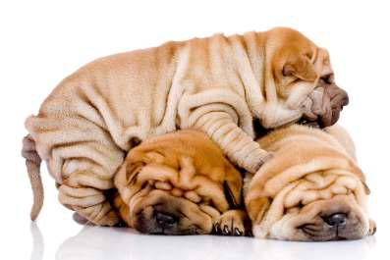

basic health care

Below, are a few ‘maintenance’ tips for keeping your pup in good health, both now and into their adult life.

EARS

It is important to keep your dog’s ears clean using a good quality ear cleaner available here at the practice. Squeeze a small amount of the ear cleaner into your dog’s ear and clean the outer ear by wiping away dirt with a cotton wool ball. Do not use a cotton bud! For lop eared dogs (ears that hang down), clean the ears once a fortnight. Keeping the ears clean can help avoid ear infections.

BATHING

A safe and gentle shampoo to use on your dog is oatmeal shampoo. A dogs PH level is different to humans so never use human shampoo as it is too harsh for their fragile skin. If you want to get rid of any ‘doggy smells’, wipe some pet leave in conditioner onto the coat. This conditioner does not need to be washed off and will not only make your dog smell wonderful, but will help keep their skin healthy.

NAIL TRIMMING

Trimming your dog’s nails is essential, particularly for small breed dogs as they are not heavy enough to wear down their nails themselves. Trimming their nails is easy when you have been taught correctly. Purchase a set of nail clippers from the practice and we will demonstrate how to trim them and then let you try.

GROOMING

Grooming is entirely dependant upon the breed of your dog. Obviously a Maltese Terrier requires far more grooming than a Beagle. We will advise you on the level of grooming required for your breed of pup. A grooming salon is the perfect place for people with busy lifestyles.

EYES

Keep the eyes clean by bathing regularly using a cotton ball with warm water . Some breeds require more frequent cleaning than others eg Maltese, Shih Tzu, Bichon Frise to name a few. Discharge from the eyes should never be severe, if it is, it could

be a sign of infection so contact us immediately. Breeds like Rottweilers and Sharpei’s are predisposed to certain eye conditions which sometimes need surgical correction, so ask us next time you’re in what is the best way to keep your pups eyes clean and free of infection.

TEETH

Imagine not brushing your teeth for 10 years! No wonder dogs commonly have smelly breath, but regular brushing of the teeth will help keep the veterinary dentist away! Feeding a diet formulated to clean the teeth will assist in keeping those pearly whites, white. You can also brush the teeth yourself. A toothbrush and toothpaste can be purchased from the practice. Don’t use human toothpaste, it can upset your dogs stomach.
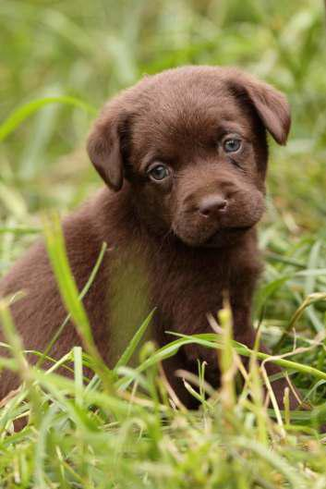
vaccinations

New puppies need a lot of attention in the health department, so if you ever become confused, please don’t hesitate to contact us. Our qualified nurses will be more than happy to help make sure you’re on the right track with your pups needs.

UNDERSTANDING YOUR VACCINATION CARD

The first vaccination is usually given at 6-8 weeks and you will notice it says C3. All this means is 'Canine vaccine with protection against three viruses', and those three viruses are Distemper, Hepatitis and Parvo Virus.

Your second vaccination will then be given at 12-14 weeks of age and you will need a C5 (Canine vaccine with protection against five

viruses) and these are Distemper, Hepatitis, Parvo Virus, Parainfluenza and Bordatella (kennel cough).

Your final puppy vaccination is given at 16-18 weeks of age and you will need another C5, which is the same vaccination as last time.

Vaccinations are then given every twelve months for kennel cough and every twelve months or 3 years for Distemper, Hepatitis or Parvovirus depending on the vaccine used. You must visit annually for the

kennel cough vaccine to be fully protected and to be permitted into kennels.

*In some areas of Australia, further protection is required. We will advise you if additional protection is required for you pup*.

Q - Why only do a C3 for the first needle?

- Para influenza and Bordatella are two strands of the kennel cough virus and it is only necessary to give them twice, not three times like the other viruses, however this can change depending on the vaccine used. We will advise you if this is different.

- I have been told I cannot take my dog out until he has had his needles.

  - Good! Then you have been steered in the right direction. Your pup will not be fully immunised until after his THIRD vaccination, so for his safety, it is best to keep him confined to the safety of the back yard until he is fully immunised. It is simply not worth the risk. Puppy classes, where all the pups are up to date with their vaccinations and have had at least one health check with the vet will give your pup an opportunity to have plenty of fun and exercise outside his own back yard without putting him

at great risk.


Following, are the most common diseases found in Australia, their symptoms and mortality rates.


This is a guide only. If your pet suddenly develops vomiting and diarrhoea it does not necessarily mean he has Parvovirus! If at any time you are worried about your pet's health, call and speak to one of our qualified nurses.

Distemper

Symptoms - Fever, coughing, fits,
muscle tremors, vomiting,
diarrhoea.
Recovery rate - very low, dogs

that do survive may have permanent brain damage.

Hepatitis
Symptoms - Fever, depression,

loss of appetite, vomiting,
diarrhoea, acute abdominal pain Recovery rate - Death in 24 - 48hours in severe cases. Survivors have permanent liver and kidney damage.

Parvovirus

Symptoms - Severe abdominal pain, bloody diarrhoea and bloody vomiting. In young pups, most times there are no warning signs. Recovery rate - Extremely low. Death 24 48 hours.

Kennel Cough

Symptoms - Dry hacking cough which persists for several weeks Recovery rate - High, but illness is distressing for both pets and owners.
worming

A lot of pets may already have worms before you even get them home, therefore it is very important that you ask if your pet has been wormed every two weeks since birth.

Worms can have serious health effects on pups and in more severe cases cause death, so intestinal worming should never be underestimated.

Intestinal worming should not be confused with heartworm as mosquitoes spread heartworm and intestinal worming is usually transmitted via faeces or via the pup's mother. As intestinal worms can have very harmful effects on both your pup and your family, make sure you use a good quality intestinal wormer.

The times you worm your pet will change depending upon his age.

ticks

Ticks are found near bushland areas and can be carried further inland by native animals including possums, bandicoots, birds and reptiles. The paralysis tick which is grey in appearance, affects your pet by injecting a deadly toxin which causes paralysis of the limbs (ie losing strength in the hind limbs) and eventually death.

Symptoms to watch for are loss of co-ordination in the hind limbs (drunken appearance), change in voice, gagging, coughing, vomiting, difficulty breathing and depression.

Recovery rates depend on how quickly your pet is treated. Prevention is once again better than cure, so we will recommend the best prevention for ticks.

There is no prevention 100% effective so on top of your chosen preventative, conduct daily tick searches of your pet. Talk to us about the level of control you will need for the area you live in.

If you think your pet is showing symptoms of tick paralysis, contact us immediately for advice. Do not wait to 'see how it goes' as your pet will not recover without treatment.

YOUR PUPPY SHOULD BE WORMED

Every two weeks until 12 weeks of age then

every month until 6 months of age then
every three months for life.

Sounds confusing but if you fill in the health chart calendar in this book it will be a breeze.
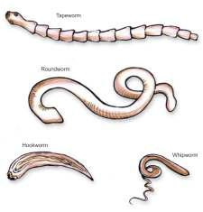

COMMON QUESTIONS

Q - What will happen if I pull off the tick and leave the head in?

- It's fine! Ticks do not have a head, only mouth parts and the toxin is contained in the body. Leaving the mouth parts acts as a splinter and nothing more.

Q - Should I spray it with an insecticide before removal?
A. This is not needed. .

Q - Should I wait until I see the vet before removing the tick?

- No, the tick should be removed immediately to stop toxicity. There is no need to twist it anticlockwise. Simply grasp the body of the tick as close to the skin as
possible, with your fingers, and pull the tick straight out. Keep the tick and bring it down with your pet to the practice so we can identify the type of tick you removed.
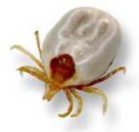

nutrition

THE MOST COMMON NUTRITION QUESTIONS ANSWERED

- Should I keep my dog on the same food the breeder/pet shop is feeding?

- If you would like to feed your pup something different, it is best to 'wean' him off the food he was being fed at the breeder or pet store and slowly switch him over to the preferred food. You can do this by gradually adding in the new food and reducing his old food until he is totally eating your preferred food.

Your pup may still get diarrhoea due to stress caused by the change in environment but it should only ever be mild. If diarrhoea persists longer than 24hours, or is severe, contact us immediately for advice.

Q: What should I feed my puppy?

- It is very important to feed your pup a good quality puppy food, as their nutritional requirements are greater than that of an adult dog. Like people, dogs need a balanced diet and a premium dry food from the practice will deliver just that. Make sure that plenty of fresh water is also available at all times.

- How long should I keep my dog on a puppy food?

- The time you keep your pup on puppy food can vary from 6 months - 18 months depending on the size of your dog. Larger breeds stay on puppy food for much longer than smaller breeds because they take much longer to reach their adult size, so it's best to talk to us about your pup's individual needs.

Q: Should I give my puppy milk?

- No, it is not necessary, providing your pup is on a good quality puppy food.

Q: Can I give my pup table scraps?

- Yes and No. It is best not to get into this habit as table scraps make it difficult for you to balance your pup's diet. You can however stuff some table scraps (like vegetables or meat leftovers) into his 'kong' toy and offer it as a training aid when you want him to be quiet. Please don’t use onion, garlic or a fat off-cuts from meat. Puppy pre-school classes will give you some other clever ways to calm your puppy!

Q: How often should I feed my pup?

reduce it to once or twice a day. It is recommended that with larger breed dogs, feeding should only be reduced to twice daily as some serious stomach complications can occur from once a day feeds. Discuss your pet's needs with your vet as the frequency of meals will vary again according to the breed of dog you have.

- Why can’t dogs eat onion, chocolate or garlic?

- These foods contain certain toxic ingredients which are fine for humans but toxic or deadly for dogs. They are Theobromine in chocolate and Thiosulphate in onion and garlic. Stay away from these foods!

- Should I give my dog a variety of food?

- Having a variety of food is more a human characteristic. Dogs can eat the same type of food for a long period of time but if you offer him a rib fillet steak or a bowl of dry puppy biscuits, we all know which one he would choose. Make the majority of his meals a good quality dry food and stuff his 'Kong' with special treats.

You can even freeze some of your table scraps into his 'Kong' for an icicle on a hot day. Freezing food makes it challenging for your pup to eat and he'll appreciate the mental stimulation.
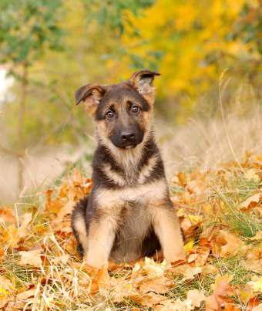

- Start off feeding your pup three times a day then

pet insurance

Unfortunately we can't claim our pets on Medicare so it is important when purchasing a pet that you consider the cost of veterinary bills should your pet become ill or be involved in an accident. Surgery to repair a broken leg can sometimes cost in excess of $1000, or a dog fight wound at the park which requires stitches, can sometimes be in excess of $400.

Owning a pet carries a lot of responsibility and one of those is to pay for his medical bills. Our government heavily subsidises human drugs and surgical procedures, however, our furry friends do not have their own government so they are not sudsidised and pay full price. Therefore, veterinary bills can appear to be expensive.

Most of our own insurance companies now offer pet insurance so you'll be ready for any emergencies. Pet cover can start from around $20 per month for accidents and emergencies, so that's under $250 per

puppy school

year. Phone your insurance company to see if they offer pet insurance or ask us for more information on Pet Insurance.


Be prepared!
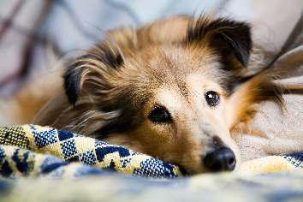

Enroll your pup into a class immediately!


Did you know that your puppy started to learn from the age of two weeks? What this means is by the time you get your puppy home he or she may have already developed some bad habits.

Research has shown that you can make or break a puppy from six weeks to eighteen weeks of age. Scary! Unfortunately, a lot of people wait until their puppy has severe social problems like barking, jumping up, fear of strangers, digging and biting before they start training or seek professional help. It is crucial that you train your pup how to fit into our society between these ages.

Do not expect your pup to know your house rules immediately. In puppy school classes, you will be taught how to teach your dog the 'rules' and not wait for him to get it wrong and then punish him.

Puppy school will also teach your pup how to behave around other dogs. Socialisation is crucial even if you have another dog at home. Your pup will learn how to to behave around his companion dog at home, but how will he be around two boisterous dogs in the park without his bodyguard?

Pups that have not been socialised grow up to fear other dogs and show aggression towards them. These dogs then cannot be taken out to the park or for a walk because they don't get along with other dogs. Trips to the park and going for walks mean the world to dogs and puppy school is where to start. Puppy school will give him confidence and teach him to love playing with strange dogs so you can both enjoy these special outings together. It is simply unfair to let your dog grow up in fear.

Enroll your pup in puppy classes now. Your pup will also learn to love going to the vet!

Contact the practice for more information on puppy classes.

desexing

Whether to desex your pet or not is a decision each |  | Reasons to desex
pet owner is faced with. If you decide to breed your
pet, do some research first, as breeding is |  | Male: reduce aggression, reduce risk of
expensive and time consuming if done |  | prostate and testicular cancer, reduce
correctly. | ‘Breeding is extremely |  | amount of unwanted pets.
Have you considered the cost of any | time consuming and costly |  | Female: reduce number of
birth difficulties eg: caesarian? Have | and should be left to |  | unwanted pets, reduce attention
you considered, or set aside the time? If | the experts’ |  | from male dogs, reduce risk of
your dog does not feed the pups will you |  |  | mammary and ovarian cancer.
be able to feed them every two hours? Have
you considered the cost of worming, vaccinations, |  | In most cases, your pet will stay in the practice for
flea control and microchipping? Have you got spare |  | just the day. Should you have any questions at all on
funds if some of the pups become ill? Have you got |  | desexing, don’t hesitate to contact us.
good homes for the pups? Do you have the time to |  | We also have an e-book
toilet train and prepare the pups for home life (getting |  | available on desexing
them used to noises, strangers, vacuum cleaners |  | which will tell you
etc), training them to sit and drop on command? |  | everything you need to
Have you checked with your vet about potential |  | know about the
defects your dog may pass onto the puppies? |  | procedure. If you would
 |  | like a copy, please don’t
It is recommended that you have your pet desexed |  | hesitate to call the
 |  | practice and request
before 6 months of age for both male and female |  | a copy.

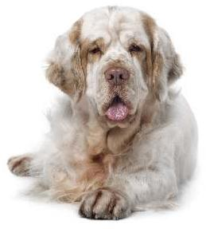
dogs. It is at this age when your dog will reach sexual maturity. It is not only recommended to help us reduce the number of unwanted pets but also for the health of the pet.

microchipping

A microchip is the most effective form of identification for your pet. A microchip is the size of a grain of rice and holds a number exclusively for your pet. It is implanted under the skin in between your pet's shoulder blades and remains there for life. It's as simple as getting any other injection and only takes a few minutes.

It is very heartbreaking to lose a pet and it can happen as easily as someone not shutting the gate. How will your pet get home if he gets out? Name tags on collars are effective but dogs always seem to go missing just after a bath when they weren't wearing the collar! Your pet will never leave home without his microchip.

The database which holds your personal details operates 24hours a day, 365 days a year so your pet can be reunited with you at any time of the day or night. If you change any details, simply contact the database to update your records.

Your pet's microchip number will never change, therefore if you move and change your phone number or address, your pet's microchip number stays the

same, all you need to do is update your contact details. All vets and animal organisations will have a scanner which reads your pets microchip. Every stray or wandering dog brought into a veterinary clinic or welfare organisation are immediately scanned for a microchip. If there is a microchip we can get them home to you!

What if your pet got out and was hit by a car? They are taken to the nearest vet or emergency hospital but who will give permission for particular treatments? If your pet has a microchip the vet can contact you even if it's 2am, notify you of the accident, and discuss their treatment.

Microchips are inexpensive and are a one off cost. What price can you put on your pet returning home to you? It's priceless.

Ask us to microchip your pups at the next vaccination.

Note: Microchips are compulsory in some states.

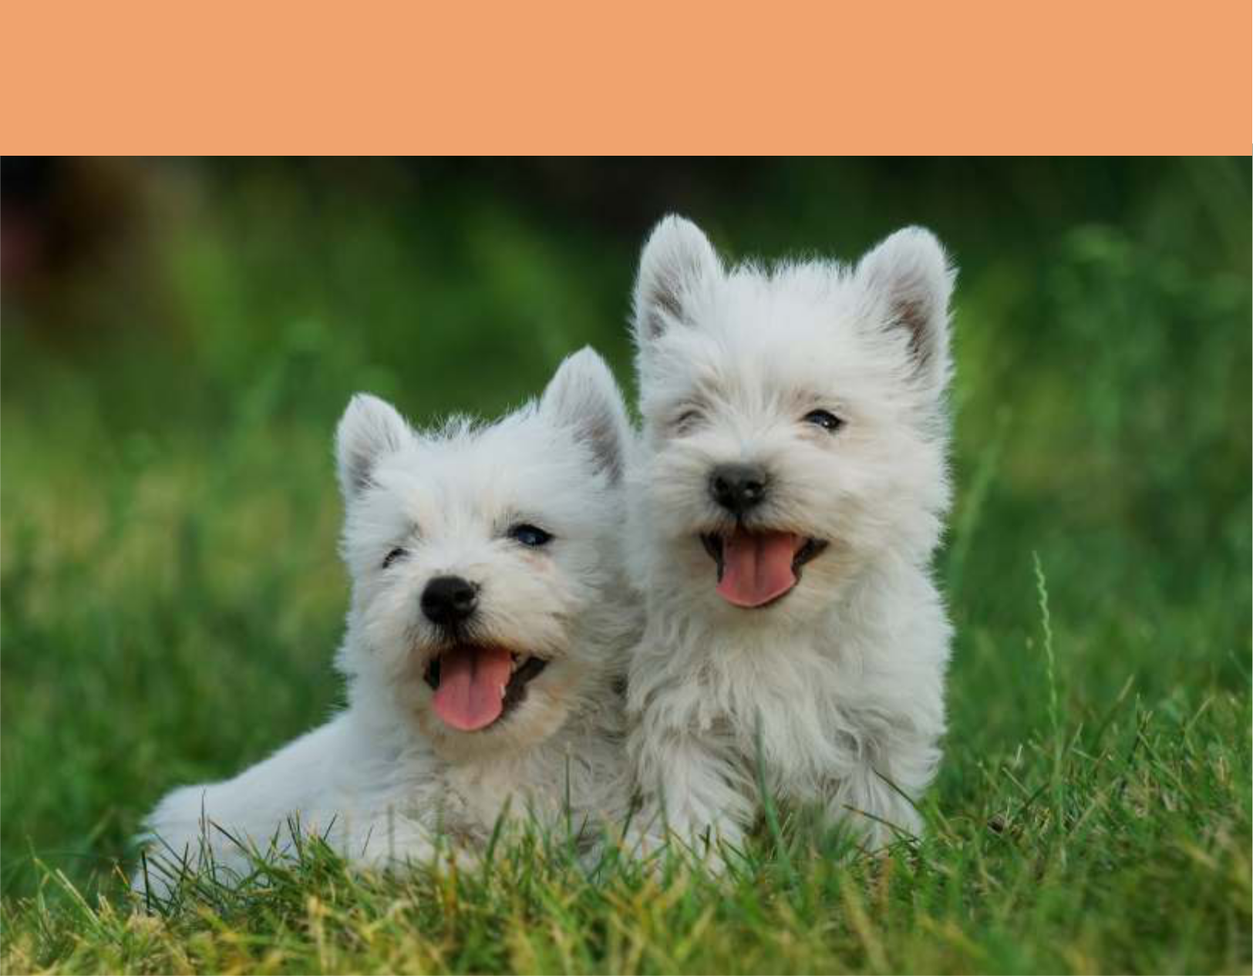

For a healthy and happy puppy

Vaccinate

Prevent heartworm

Protect from intestinal worms

Microchip

Provide good nutrition

Go to puppy classes

Desex

Take out pet insurance

